Shortest path between: (0, 4), (1, 2), (2, 4), (3, 0), (4,1)
File 0 (seed = "93748347651")
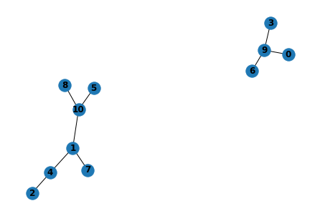
Number of nodes: 11
Number of edges: 9
Components: 2
['1', '10', '2', '4', '5', '7', '8']
['0', '3', '6', '9']
Shortest paths:
[], ['1', '4', '2'], ['2', '4'], ['3', '9', '0'], ['4', '1']
Diameter: None

File 1 (seed = "47586937894")
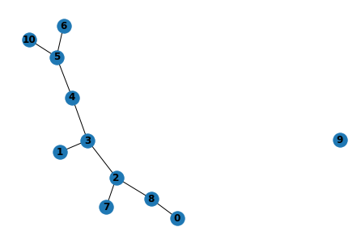
Number of nodes: 11
Number of edges: 9
Components: 2
['0', '1', '10', '2', '3', '4', '5', '6', '7', '8']
['9']
Shortest paths:
['0', '8', '2', '3', '4'], ['1', '3', '2'], ['2', '3', '4'], ['3', '2', '8', '0'], ['4', '3', '1']
Diameter: None

File 2 (seed = "38582562745")
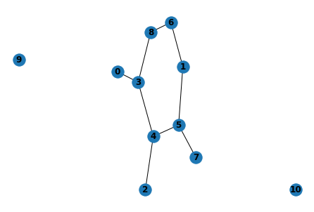
Number of nodes: 11
Number of edges: 9
Components: 3
['0', '1', '2', '3', '4', '5', '6', '7', '8']
['9']
['10']
Shortest paths:
['0', '3', '4'], ['1', '5', '4', '2'], ['2', '4'], ['3', '0'], ['4', '5', '1']
Diameter: None

File 3 (seed = "63498098389")
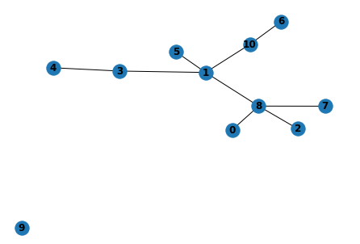
Number of nodes: 11
Number of edges: 9
Components: 2
['0', '1', '10', '2', '3', '4', '5', '6', '7', '8']
['9']
Shortest paths:
['0', '8', '1', '3', '4'], ['1', '8', '2'], ['2', '8', '1', '3', '4'], ['3', '1', '8', '0'], ['4', '3', '1']
Diameter: None

File 4 (seed = "84560368491")
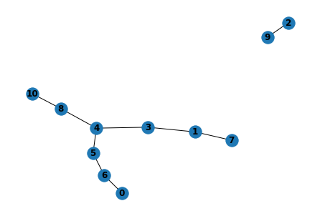
Number of nodes: 11
Number of edges: 9
Components: 2
['0', '1', '10', '3', '4', '5', '6', '7', '8']
['2', '9']
Shortest paths:
['0', '6', '5', '4'], [], [], ['3', '4', '5', '6', '0'], ['4', '3', '1']
Diameter: None

File 5 (seed = "79364783672")
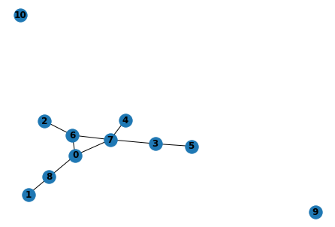
Number of nodes: 11
Number of edges: 9
Components: 3
['0', '1', '2', '3', '4', '5', '6', '7', '8']
['9']
['10']
Shortest paths:
['0', '7', '4'], ['1', '8', '0', '6', '2'], ['2', '6', '7', '4'], ['3', '7', '0'], ['4', '7', '0', '8', '1']
Diameter: None

File 6 (seed = "28075067910")
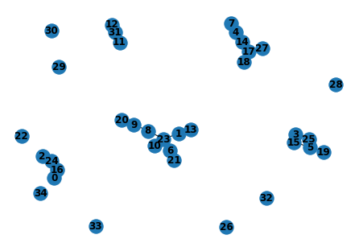
Number of nodes: 35
Number of edges: 22
Components: 13
['1', '10', '13', '20', '21', '23', '6', '8', '9']
['14', '17', '18', '27', '4', '7']
['15', '19', '25', '3', '5']
['0', '16', '2', '24']
['11', '12', '31']
['22']
['26']
['28']
['29']
['30']
['32']
['33']
['34']
Shortest paths: [], [], [], [], []
Diameter: None

File 7 (seed = "58495397832")
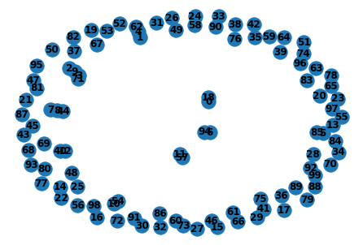
Number of nodes: 100
Number of edges: 13
Components: 87
['2', '3', '71', '9']
['1', '4', '62']
['44', '7', '8']
['0', '18']
['5', '85']
['6', '94']
['10', '54']
['11', '57']
['12', '40']
['13'], ['14'], ['15'], ['16'], ['17'], ['19'], ['20'], ['21'], ['22'], ['23'], ['24'], ['25'], ['26'], ['27'], ['28'], ['29'], ['30'], ['31'], ['32'], ['33'], ['34'], ['35'], ['36'], ['37'], ['38'], ['39'], ['41'], ['42'], ['43'], ['45'], ['46'], ['47'], ['48'], ['49'], ['50'], ['51'], ['52'], ['53'], ['55'], ['56'], ['58'], ['59'], ['60'], ['61'], ['63'], ['64'], ['65'], ['66'], ['67'], ['68'], ['69'], ['70'], ['72'], ['73'], ['74'], ['75'], ['76'], ['77'], ['78'], ['79'], ['80'], ['81'], ['82'], ['83'], ['84'], ['86'], ['87'], ['88'], ['89'], ['90'], ['91'], ['92'], ['93'], ['95'], ['96'], ['97'], ['98'], ['99']
Shortest paths:
[], [], [], [], ['4', '1']
Diameter: None

File 8 (seed = "17836548901")
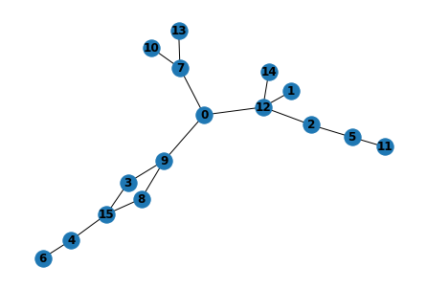
Number of nodes: 16
Number of edges: 16
Components: 1
['0', '1', '10', '11', '12', '13', '14', '15', '2', '3', '4', '5', '6', '7', '8', '9']
Shortest paths:
['0', '9', '3', '15', '4'], ['1', '12', '2'], ['2', '12', '0', '9', '3', '15', '4'], ['3', '9', '0'],
['4', '15', '3', '9', '0', '12', '1']
Diameter: 9

File 9 (seed = "09846738943")
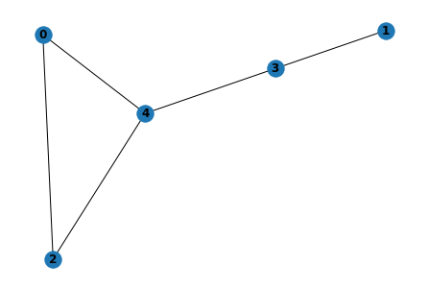
Number of nodes: 5
Number of edges: 5
Components: 1
['0', '1', '2', '3', '4']
Shortest paths:
['0', '4'], ['1', '3', '4', '2'], ['2', '4'], ['3', '4', '0'], ['4', '3', '1']
Diameter: 3

