MADHIRA UGD TRACKER

AEE and Field Inspector Guide
Version 1.1 · October 2026 · for recording work on site with your phone
You record what you see on each road. Every save keeps your name, the time, your phone's GPS position and your photos, and the Commissioner sees it at once. Both of you can work in all 22 wards.

1. Your sign-in

AEE
Item | Your details
Web address | https://______________________ (your IT team will give you this address)
Email (sign-in name) | aee@madhira.local
One-time password | AEE-3V3N-szyw-72

Field Inspector
Item | Your details
Web address | https://______________________ (your IT team will give you this address)
Email (sign-in name) | inspector@madhira.local
One-time password | Field-ovEe-tPC6-56

Keep yours private. The one-time password works only for your first sign-in; you must then choose your own password (at least 8 characters). Do not share accounts: every entry carries the name of the person signed in.

Set up your phone (5 minutes)
- Open the web address in Chrome (Android) or Safari (iPhone).
- Sign in with your email and one-time password, then choose your own password.
- Add it to the home screen: Chrome menu ⋮ → Add to Home screen (iPhone: Share → Add to Home Screen). It now opens like an app.
- When asked, allow location. Updates without GPS, or made more than 200 m from the road, are flagged to the Commissioner.
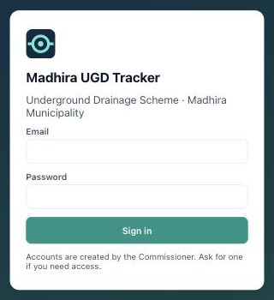
Sign-in screen

2. Record a new road stretch
- Zoom in on the road. Tap + Road stretch.
- Pick pipes (usual): tap each pipe reach along the road; they turn yellow and the length and manholes are counted. Tap again to remove one. For a road without pipes on the map, switch to Draw line and tap along the road (taps near a manhole snap to it).
- Tap Next: record status and fill the six sections (below).
- Add photos if useful, a short note, and Save.
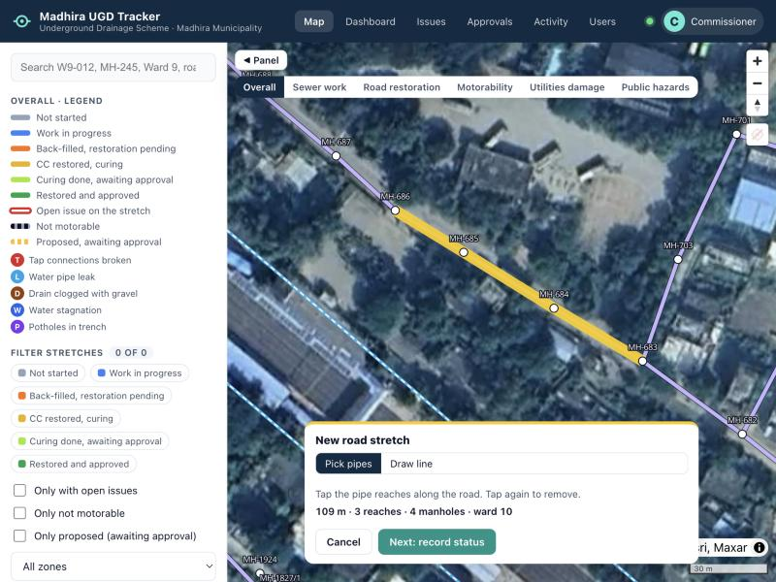
Picking the pipe reaches along a road
Pipes outside the ward outlines on the map can be picked like any other: the stretch goes to the nearest ward, marked "(outside ward boundary)".
Section | What you record (your item numbers)
A Sewer work | Pipeline not started (1) / partly laid, in metres / laid (2); manholes built (3); inspection chambers built (4). The combination is shown automatically (5).
B Road cutting | Road cut (6) → trench open (7) → back-filled with gravel (8)
C CC restoration | Pending (9) → restored, curing not done (11) → restored, curing done (10). Turns green when the Commissioner approves (12).
D Motorability | Motorable / with difficulty / not motorable (13)
E Utilities | Tap connections broken and restored (14), water pipe leakages and leakages fixed (15), drain clogged with gravel (16)
F Hazards | Water stagnation (17), potholes in the trench (18), uneven back-fill

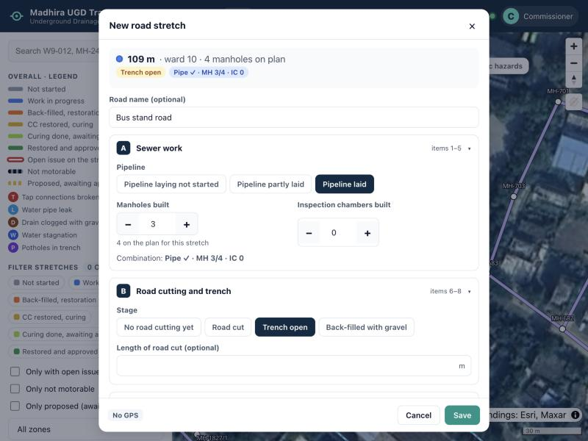
The status form: tags at the top update as you fill it
Photos. A photo is required only when you mark the CC road restored: Save stays grey until you add one. For damage and other updates a photo is optional, but add one when you can.
A new stretch shows as proposed (dashed amber) until the Commissioner approves it. You can keep recording its status meanwhile.

3. Update a stretch
- Tap the coloured line on the map (or search its code, e.g. W15-001).
- Tap Update status, change only what is different today (e.g. Leakages fixed + when a leak is repaired), add a photo if useful, Save.
- Tap History to see every earlier entry and who made it.
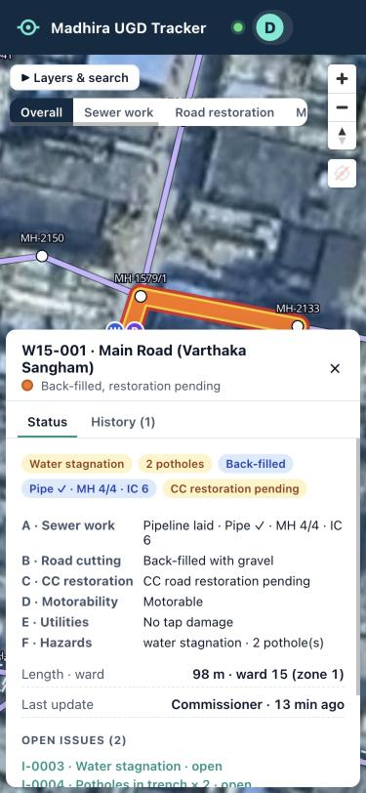
A stretch opened on the phone (sample data)
- When you mark CC restored, curing done, the line turns light green and goes to the Commissioner. It turns green only after approval. If it is rejected, correct the work, then Update status with a new photo to send it again.
- If someone else changed the same item while you were editing, the app asks you to close the form and open the stretch again to see the latest values.
- Line drawn wrongly? Redraw line. Stretch should not exist? Request deletion with the reason.

Several roads at once
Select several → tap the stretches → Next → set only what changed (for example "Back-filled" on five lanes). Each stretch still gets its own history entry. Record CC restoration one stretch at a time, because each needs a photo.

4. Issues
- Damage you record on a stretch opens an issue automatically. Recording it fixed (taps restored, leakages fixed, drain cleared…) closes the issue.
- For a problem at a spot (e.g. gravel dumped in a drain), tap Report issue, tap the spot, choose the problem, write the remark (required) and add a photo if you can.
- On the Issues page: filter by zone, ward, kind, severity or status; Assign an issue to the contractor with a due date; when fixed, Mark resolved with a note (and a photo of the fix if you can).

5. Manholes and pipes missing or wrong on the map
To | Do this
Add a manhole | + Manhole → tap its exact position → enter its number (e.g. MH-2301), ground level and invert level
Add a pipe | + Pipe → tap the first manhole, then the second → choose the diameter (and slope if known)
Remove a wrong pipe or manhole | Tap it → Request deletion → give the reason

These wait for the Commissioner's approval; follow them under My requests. You can withdraw your own request while it waits.

6. No signal, labour, and good practice
- No signal: the app opens with the last data you saw; save as usual. The update and its photos wait on your phone ("1 waiting to send" at the top; tap it to see them) and are sent once, when the signal returns, under your name. Do not clear the browser's data meanwhile. "Not accepted": tap it to read why, then Try again or Discard.
- Labour: tap your initial (top right) → Log labour: date, ward, number of labourers and machines. One entry per ward per day; saving again replaces it.
- Record on site: your GPS position is saved with every update.
- Keep a stretch to one road between two junctions, so its colour tells one story.
- Take photos in daylight showing the road surface and a landmark (house, pole, shop).
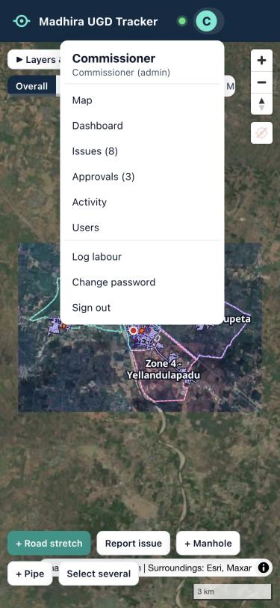
Menu (tap your initial). Shown here for the Commissioner; yours has no Users page.

Map colours
Line colour on the map | Meaning
Grey | Not started: no pipe laid, no road cut
Blue | Work in progress: road cut, trench open or pipe being laid
Orange | Back-filled, CC road restoration pending
Yellow | CC road restored, curing not complete
Light green | Curing done, waiting for the Commissioner's approval
Green | CC road restored and approved by the Commissioner
Red outline | At least one open issue on the stretch
Dashed dark line | Road not motorable
Dashed amber line | Proposed by an AEE, waiting for approval
Letters on a stretch | T taps broken · L water pipe leak · D drain clogged with gravel · W water stagnation · P potholes

