MADHIRA UGD TRACKER

Commissioner's Guide
Version 1.1 · October 2026 · for the Municipal Commissioner (administrator)
The UGD Tracker shows every road of the Underground Drainage scheme on a satellite map of Madhira. Your AEE and Field Inspector record what they see on each road from their phones; you see it live, approve restorations and network changes, and download reports.

1. Your sign-in
Item | Your details
Web address | https://______________________ (your IT team will give you this address)
Email (sign-in name) | commissioner@madhira.local
One-time password | Comm-Bd79-69qU-54

Keep this private. The one-time password works only until you sign in for the first time; you must then choose your own password (at least 8 characters). After that the password above no longer works.

Accounts for your field staff
Two more accounts are ready. Give each person their own sign-in in person or by phone; they are also printed in the AEE and Field Inspector Guide. Both can record and propose in all 22 wards.
Person | Email (sign-in name) | One-time password
AEE | aee@madhira.local | AEE-3V3N-szyw-72
Field Inspector | inspector@madhira.local | Field-ovEe-tPC6-56

You can change these email addresses to real ones later under Users → Edit. Nothing is ever emailed; the address is only the sign-in name.

First sign-in
- Open the web address in Chrome, Edge or Safari (office PC or phone).
- Enter your email and the one-time password, and select Sign in.
- Enter the one-time password again as "Current password", then your new password twice, and select Save password.
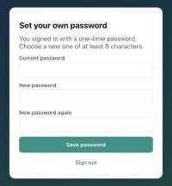
Choosing your own password at first sign-in

2. The screen at a glance
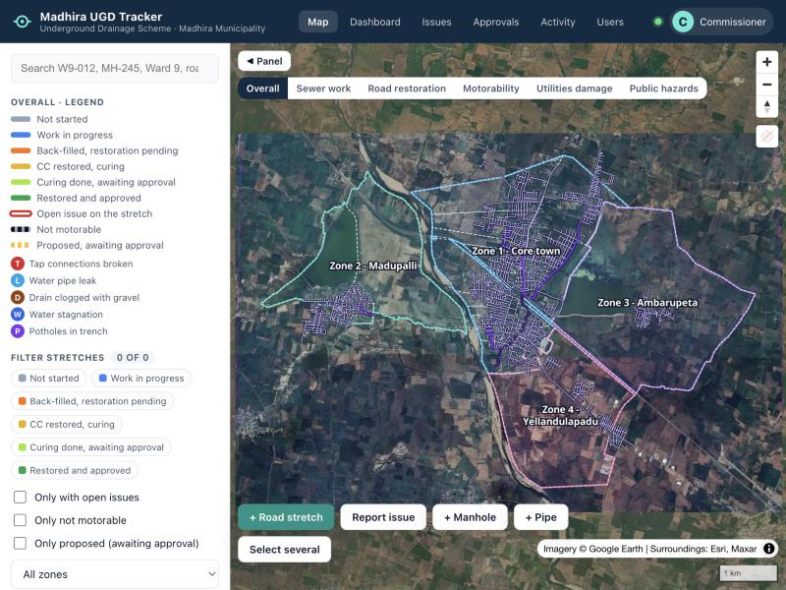
The map page (left: legend, filters and layers; bottom: field tools)
Part of the screen | What it does
Top bar | Map · Dashboard · Issues · Approvals (number waiting) · Activity · Users. The green dot means live updates are on.
Colour by (above the map) | Overall, Sewer work, Road restoration, Motorability, Utilities damage or Public hazards
Left panel | Search, legend, filters, zones (jump to a zone), layers
Bottom buttons | + Road stretch, Report issue, + Manhole, + Pipe, Select several (your changes apply at once)
Click anything | A stretch, manhole, pipe, issue or ward opens its details on the right

Reading the map
Line colour on the map | Meaning
Grey | Not started: no pipe laid, no road cut
Blue | Work in progress: road cut, trench open or pipe being laid
Orange | Back-filled, CC road restoration pending
Yellow | CC road restored, curing not complete
Light green | Curing done, waiting for the Commissioner's approval
Green | CC road restored and approved by the Commissioner
Red outline | At least one open issue on the stretch
Dashed dark line | Road not motorable
Dashed amber line | Proposed by an AEE, waiting for approval
Letters on a stretch | T taps broken · L water pipe leak · D drain clogged with gravel · W water stagnation · P potholes

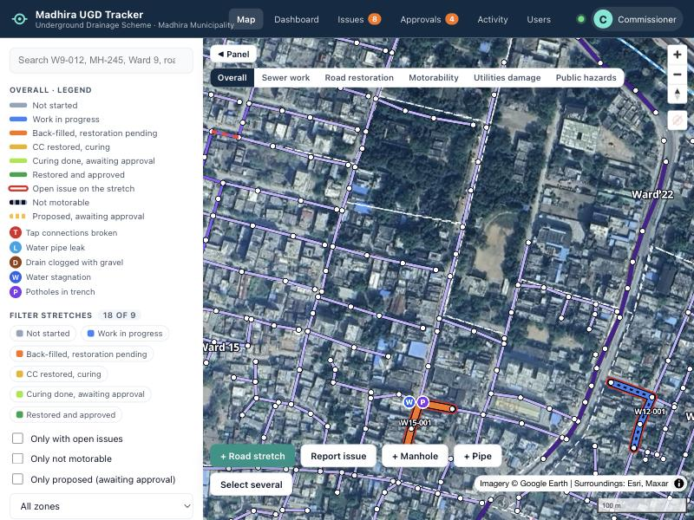
Stretches coloured by stage, with issue badges (sample data)
- Search finds a stretch code (W9-012), a manhole (MH-245), a ward ("Ward 9") or a road name.
- Filters show only stretches at a stage, with open issues, not motorable, or proposed, in one zone.
- About one pipe in seven lies outside the ward outlines drawn on the map. Roads there are counted in the nearest ward; their card says "outside the KML ward outline" and the Excel has an Outside ward boundary column.
- The web address follows the map: copy it from the address bar to send someone the exact spot.

3. Every day: approvals and activity
The Approvals tab shows how many items wait for you. Nothing an AEE adds or deletes changes the official map until you approve it.
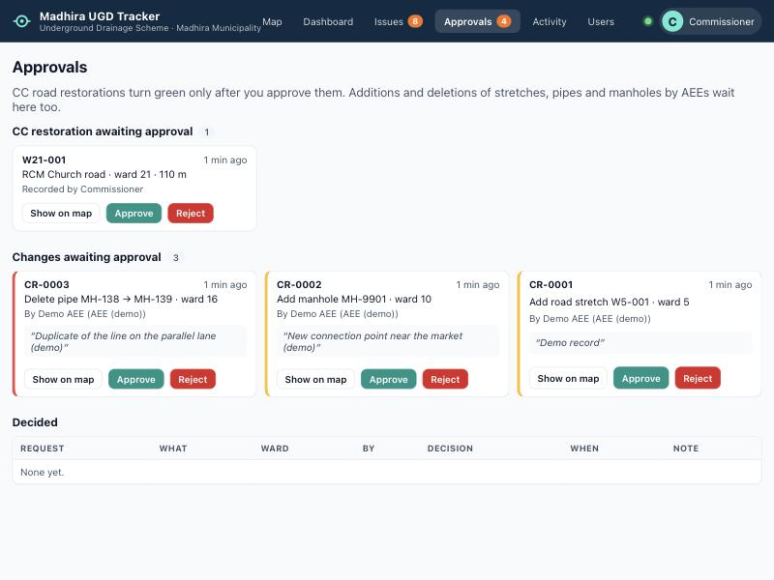
The Approvals page (sample data)

CC road restoration
- Select Show on map to see the stretch, then open History and look at the photos.
- Approve if the road is properly restored and cured: the stretch turns green.
- Or Reject with a reason: the AEE sees it in the history. When they record the corrected work with a new photo, it comes back to your Approvals list.
- A road whose line is redrawn after approval needs approving again.

Additions and deletions proposed by AEEs
- New road stretches, manholes (number, ground level, invert level) and pipes (diameter, slope) appear dashed amber on the map; deletion requests appear dashed red.
- Approve or reject each one; a rejection needs a reason. A new pipe can be approved only after the new manholes at its ends.
- Deleting a manhole also deletes the pipes connected to it.
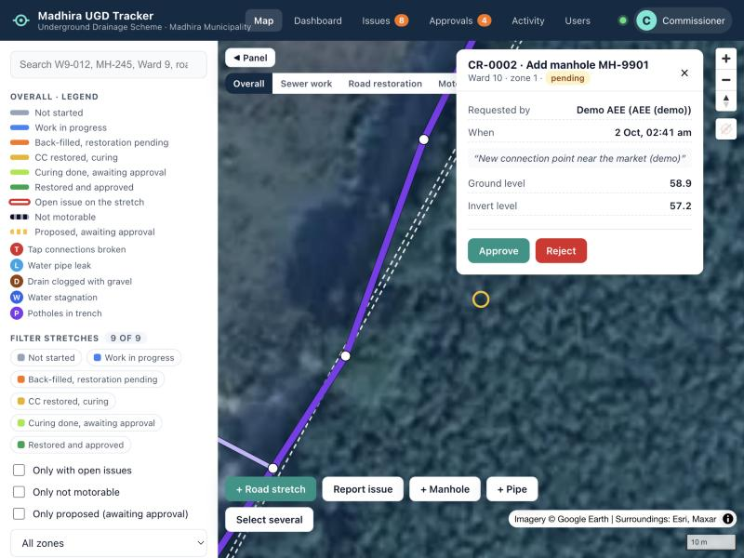
A proposed manhole (amber ring) with its request details

Activity
Every change, newest first, with who made it and where. Tick Only flagged to see updates made more than 200 m away from the road (possible reporting from the office).

4. Dashboard and reports
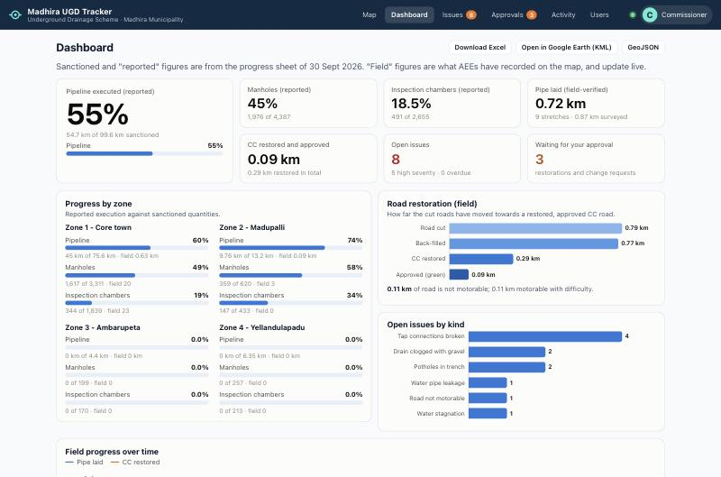
The dashboard (field figures are sample data)
- Reported figures (sanctioned and executed) come from the progress sheet of 30 Sep 2026. Field figures are what your staff recorded on the map and update live.
- Zones and wards (bottom of the page): select a zone to see its wards; Report opens a one-page ward report you can print or save as PDF.
- Download Excel: the progress sheet in its usual layout with field-verified columns added, plus sheets of all stretches, issues, labour and change requests.
- Open in Google Earth (KML): every stretch coloured by stage, and open issues as pins.
- Issues page: filter by kind, zone, ward, severity and status; Download Excel saves exactly the list you are looking at (e.g. open issues of ward 5).
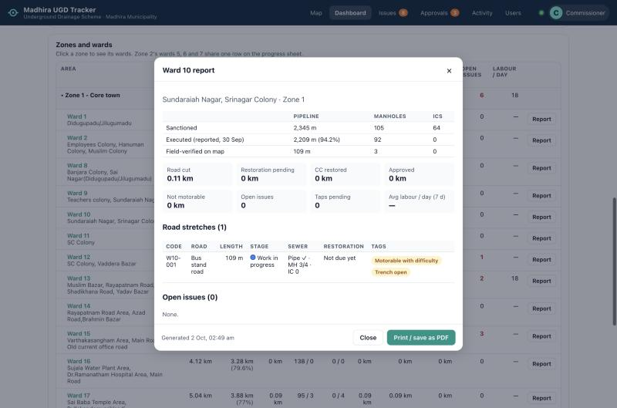
Ward report, ready to print

5. Managing people
Access | Can do
Admin (you) | Everything: approvals, users, corrections
AEE / inspector (editor) | Record, propose and resolve issues in the wards you assign
Viewer | See everything, change nothing (e.g. senior officials, IT monitoring)

- Users → + Add user: name, designation, email, access and wards. The app shows a one-time password once: give it to the person directly.
- Reset password issues a new one-time password; Disable blocks the account at once (its history is kept).

Correcting a record
- Open the stretch → History → Roll back to this version. The rollback is itself recorded; nothing is lost.
- Delete removes a stretch from the map; its history is kept.

Help
For sign-in problems, slowness or a site that does not open, contact your IT team. For a forgotten password of an AEE, use Reset password on the Users page.

6. Storage: staying within your cloud plan
The Storage tab (only you see it) shows how much space the tracker uses and lets you delete old data. Photos use almost all of it (roughly 1–3 GB a year); the records themselves stay small.
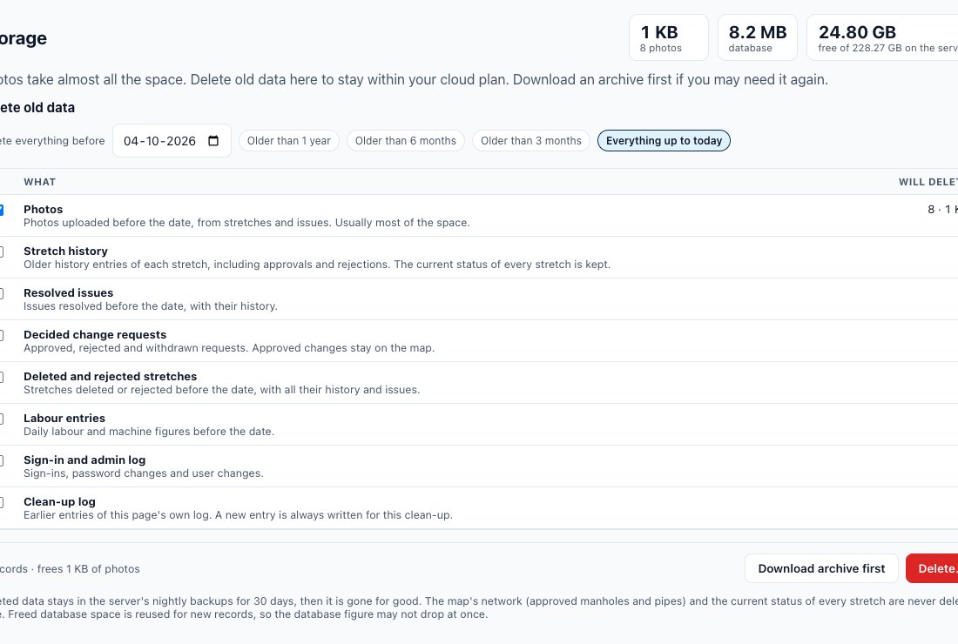
The Storage page: usage at the top, what will be deleted, archive and delete (sample data)
- Choose the date: Delete everything before a day, or a quick choice (older than 1 year / 6 months / 3 months, or everything up to today).
- Tick what to delete: photos, stretch history (the current status of every road is always kept), resolved issues, decided change requests, deleted and rejected stretches, labour entries, the sign-in and admin log, or the clean-up log itself. Will delete shows the exact number of records and the photo space freed before anything happens.
- Download archive first: a zip with an Excel file of every record to be deleted and the photo files. Keep it on the office PC or a pen drive if you may need it again.
- Delete… → read the list → type DELETE → Delete. The deletion is written to the Clean-up log at the bottom.
Cannot be undone in the app. Deleted data stays in the nightly server backups for 30 days, then it is gone for good. The map's sewer network (including approved new manholes and pipes) is never deleted here.
A sensible routine: once a year, download the archive of photos older than one year, then delete them. Watch the free on the server figure at the top; it turns red below 10%.

