LLM Evaluation
  - Comparing the quality, speed, and cost of LLM extraction

Introduction
The ellmer package includes functions that connect to a wide variety of local and remote APIs from a variety of providers. Put simply, we have a great many options. Which are better, and which are worse? We might assume that more expensive models are more effective at data extraction, and that larger and more complex files are more difficult - and require more tokens - than simpler models when extracting data. But can we prove any of these assumptions?
Token size defines the memory space available to the LLM, and the cost of extraction.

Methods
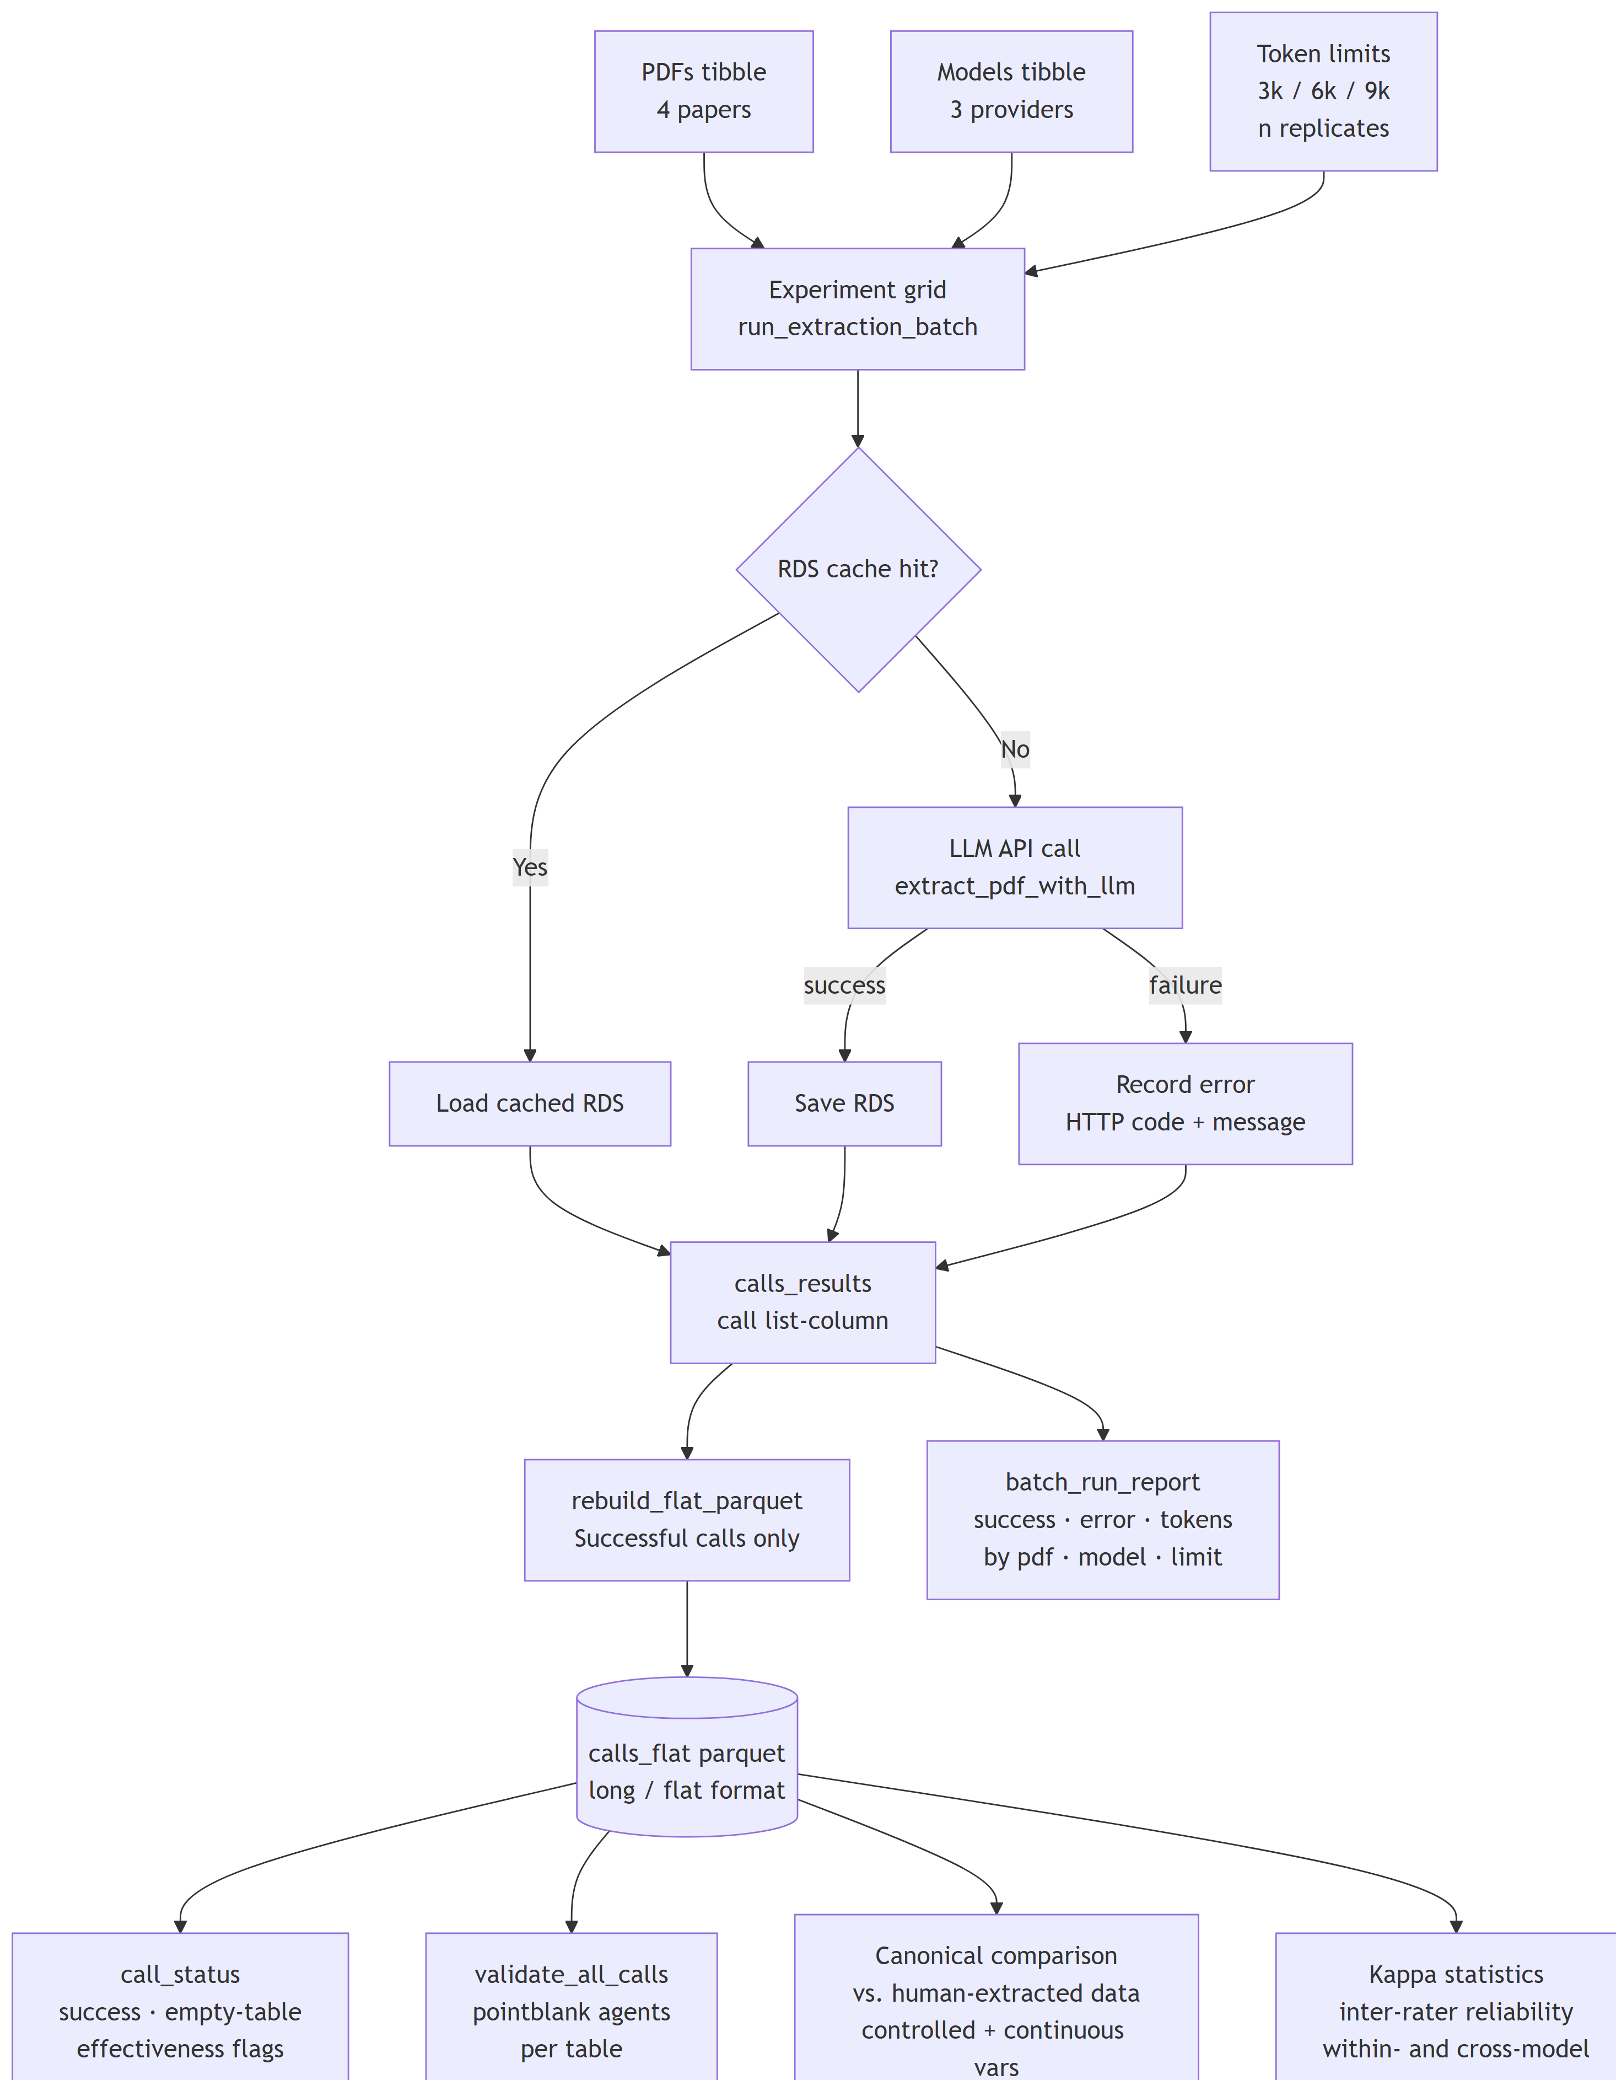
Overview of the LLM evaluation pipeline.

Study Materials
We selected four studies Table 1 that were previously identified as high-quality (score >= 4), covering a variety of time periods, formats, topics, and methods of presenting data.
Table 1: Study materials (portable document format files) selected for LLM evaluation. OCR (Optical Character Recognition) refers to cases where the paper used has been scanned from a printed copy and automatically converted to text. Depending on the quality of this process, information may be lost or corrupted; we would expect such files to be more difficult to extract data from.
ID | Title | Year | Comment | n Images | n Tables | File Size (kb) | n Pages
a | Trace metals in field samples of zooplankton from the Fram Strait and the Greenland Sea | 1997 | Well-OCR'd paper with summary statistics of trace metal concentrations reported across wide range zooplankton taxa. Sampling sites reported in low-quality map. Complex, uneven data structure due to random nature of zooplankton sampling. Methodology reported in moderate detail. | 1 | 7 | 1,390.33 | 16
b | Temporal isolation between two strongly differentiated stocks of the Greenland halibut (Reinhardtius hippoglossoides, Walbaum, 1792) from the Western Barents Sea | 2002 | Native PDF. Sites reported in map. Cu concentrations (and flux) reported from a variety of sediment traps at different timepoints. Methodology reported in moderate detail. | 4 | 2 | 452.14 | 7
c | Transport and sedimentation of Cu in a microtidal estuary, SE Norway | 2021 | Native PDF. Study primarily concerns evolution but includes heavy metal analysis. Sites reported as linear trawls with start/end coordinates. Raw Cu concentrations given for each individual, reported as table. Methodology reported in high detail. | 8 | 8 | 556.57 | 22
d | Distribution pattern of mercury in northern Barents Sea and Eurasian Basin surface sediment | 2022 | Native PDF. Sampling sites and Cu concentrations only reported as summaries/graphics in paper, but raw data (Cu concentrations, site coordinates, depth) provided on request and prepended to file. | 5 | 2 | 4,717.60 | 9

Large Language Models
The R ellmer package includes API integrations for a variety of Large Language Models from various providers. We selected general, “middle-of-the-road” multimodal models from three of the most prominent providers - Anthropic, Google Gemini, and OpenAI, as well as immediately higher and lower tier models. In addition, we wished to validate the performance of local and/or open-source LLMs. This proved technically difficult, and with the computational resources available we were unable to run models locally at acceptable levels of performance (models could technically be run, but lacked the available memory to load PDF files). As a compromise, we also include the open model Gemma. Gemma is developed by Google (and thus accessible via their API to be run on their servers), but can also be loaded and run locally using services such as Ollama (which supports structured data extraction) and LMStudio and accessed locally with ellmer via their APIs.
Our selected models are summarised in Table 2. Details are sourced from providers’ model overview pages.
Sources for model comparisons: https://platform.claude.com/docs/en/about-claude/models/overview, https://developers.openai.com/api/docs/models/compare, https://ai.google.dev/gemini-api/docs/models, https://ai.google.dev/gemini-api/docs/pricing
NB: We can’t report a direct cost for Gemma, because it’s free (but rate-limited) from Google, or “free” if you run it locally.
Table 2: Summary of LLM models included in the evaluation. Tok: tokens, a unit of LLM knowledge; Mtok: million tokens. Note that different providers report tokens to different levels of precision. For example, 1000 kTok and 1050 kTok likely represent the same underlying value of 1,048,576 tokens.
Provider | Model | Model ID | Context Window (Ktok) | Max Output (Ktok) | Input Cost ($/Mtok) | Output Cost ($/Mtok) | Knowledge Cutoff | Open/Closed
Anthropic | Claude Haiku 4.5 | claude-haiku-4-5 | 200 | 64 | 1 | 5 | Feb 2025 | Closed
Anthropic | Claude Sonnet 4.6 | claude-sonnet-4-6 | 1000 | 128 | 3 | 15 | Aug 2025 | Closed
Anthropic | Claude Opus 4.8 | claude-opus-4-8 | 1000 | 128 | 5 | 25 | Jan 2026 | Closed
OpenAI | GPT-5.4 Mini | gpt-5.4-mini | 400 | 128 | 0.75 | 4.50 | Aug 2025 | Closed
OpenAI | GPT-5.4 | gpt-5.4 | 1050 | 128 | 2.5 | 15.0 | Aug 2025 | Closed
OpenAI | GPT-5.5 | gpt-5.5 | 1050 | 128 | 5 | 30.0 | Dec 2025 | Closed
Google Gemini | Gemini 2.5 Pro | gemini-2.5-pro | 1050 | 65 | 1.25 (<= 200k tokens), then 2.5 | 10.00 (<= 200k tokens), then 15.00 | Jan 2025 | Closed
Google Gemini | Gemini 3.1 Pro Preview | gemini-3.1-pro-preview | 1000 | 65 | 2.00 (<= 200k tokens), then 4.00 | 12.00 (<= 200k tokens), then 18.00 | Jan 2025 | Closed
Google Gemini | Gemini 3.5 Flash | gemini-3.5-flash | 1000 | 65 | 1.50 | 9.00 | Jan 2025 | Closed
Google Deepmind | Gemma 4 31B | gemma-4-31b-it | 262 | 8k | Free | Free | Jan 2025 | Open

API Calls
Provider APIs are called using the existing API call functionality developed for eData (STOPeData::extract_pdf_with_llm()). Each call returns a list object containing extracted data and call metadata (cost, tokens, etc.), which is then saved as as an .rds file.
For each manuscript and model multiple calls were made, with token count was set to 3,000, 6,000 and 9,000 to determine if call success, effectiveness, and quality varied with this. Each combination of call, model, token count, and pdf was made 5 times, to provide a measure of inter- and intra-call variation.
Table 3: Experimental design: combinations of PDFs, models, and token limits.
Parameter | Values
PDF IDs | a, b, c, d
Model IDs | claude-haiku-4-5, claude-sonnet-4-6, gpt-5.4-mini, gpt-5.4, gemini-3.5-flash
Token Limits | 3000, 6000, 9000
Replicates per Combination | 3
Total Combinations | 180

Evaluation
Model effectiveness and efficiency was evaluated by considering cost, proportion of data passing evaluation, and proportion of data matching canonical (human-curated) extracted datasets.

Cost
API calls return expended input tokens (used to ingest the data, schema, and prompt) and output tokens (used to create the response). Costs per token are reported for most closed models (see [@tbl-...]). Overall cost is therefore calculated as follows:
$$C=t_{i}c_{i}+t_{o}c_{o}$$
In the case of the open model Gemma 4 (accessed via the Google Gemini API), usage is free, but rate-limited.

eData Validation
Extracted data are validated against the validation functions described in eDataDRF, which check the data against a number of rules per table. These functions are intended to validate final data from the eData application after LLM extraction and subsequent human verification, and therefore some variables were “dummied” to avoid irrelevant failures to validate. The number of validation checks passed per table divided by total number of validation checks was used as a simple measure of LLMs’ ability to return data consistent with the extraction schema.

Comparison with Canonical Data
To determine to what extent the LLM-extracted data agreed with human-extracted data, calls were compared to “canonical” datasets extracted using the eData application using LLMs and human processing. Not all extracted data fields are directly comparable, but numerical and controlled vocabulary variables were compared (see Table 9). Compared variables were converted to strings and checked for strict equality. In tables consisting of multiple rows of data (e.g. sites, parameters), we checked only that LLM-returned data existed in the canonical dataset.
Proportion of correct data was calculated relative to totals, and a score between 0 and 1 was returned to indicate degree of agreement.
Table 9 we check controlled and numerical variables against the “canonical versions” from the source data. This isn’t very sophisticated: - we just check if strings match - for tables (sites, parameters, etc.) with more than one row we only check that what’s in the call table is also in the canonical table (so if the call over-matches we don’t flag that as an issue)

Results

Call Status
?@tbl-batch-report reports the details and status of each call. Broadly speaking, two types of errors are possible. In case of connection issue, system downtime, or a lack of API credit, the call will return an HTTP error (e.g. HTTP 400), and no data. However, it has also been observed that in some cases, the API response will be flagged “successful” by the external provider, but returned only empty data. This is believed to be the result of the extraction process hitting the token limit before completing its response; for example when an unusually large PDF is send with a too-small token limit. This sharp distinction between performance at different token limits
Table 4: Summary of API call success rates and mean token usage by PDF, model, and token limit. Note: Only contains data on most recent API call, not all cached calls.
PDF | Model | Token Limit | id | N | Success | Failed | Error Types | Mean Input Tok | Mean Output Tok
a | claude-haiku-4-5 | 3,000 | 1, 46, 91 | 3 | 3 | 0 |  | 22,708 | 3,000
a | claude-haiku-4-5 | 6,000 | 16, 61, 106 | 3 | 3 | 0 |  | 26 | 3,973
a | claude-haiku-4-5 | 9,000 | 31, 76, 121 | 3 | 3 | 0 |  | 68,071 | 4,466
a | claude-sonnet-4-6 | 3,000 | 4, 49, 94 | 3 | 3 | 0 |  | 22,708 | 3,000
a | claude-sonnet-4-6 | 6,000 | 19, 64, 109 | 3 | 3 | 0 |  | 22,708 | 5,006
a | claude-sonnet-4-6 | 9,000 | 34, 79, 124 | 3 | 3 | 0 |  | 68,072 | 4,830
a | gemini-3.5-flash | 3,000 | 13, 58, 103 | 3 | 0 | 3 | parse error: premature EOF  { "campaign": [ { "  (right here) ------^
a | gemini-3.5-flash | 6,000 | 28, 73, 118 | 3 | 0 | 3 | parse error: premature EOF  { "campaign": [ { "  (right here) ------^  ; parse error: premature EOF  {"campaign":[{"campaign_comment  (right here) ------^
a | gemini-3.5-flash | 9,000 | 43, 88, 133 | 3 | 1 | 2 | parse error: premature EOF  { "campaign": [ { "  (right here) ------^ | 9,293 | 7,904
a | gpt-5.4 | 3,000 | 10, 55, 100 | 3 | 3 | 0 |  | 15,002 | 2,761
a | gpt-5.4 | 6,000 | 25, 70, 115 | 3 | 3 | 0 |  | 2,799 | 2,861
a | gpt-5.4 | 9,000 | 40, 85, 130 | 3 | 3 | 0 |  | 13,551 | 2,888
a | gpt-5.4-mini | 3,000 | 7, 52, 97 | 3 | 3 | 0 |  | 15,002 | 2,289
a | gpt-5.4-mini | 6,000 | 22, 67, 112 | 3 | 3 | 0 |  | 2,799 | 2,262
a | gpt-5.4-mini | 9,000 | 37, 82, 127 | 3 | 3 | 0 |  | 15,002 | 2,245
b | claude-haiku-4-5 | 3,000 | 2, 47, 92 | 3 | 3 | 0 |  | 11,883 | 3,000
b | claude-haiku-4-5 | 6,000 | 17, 62, 107 | 3 | 3 | 0 |  | 26 | 4,429
b | claude-haiku-4-5 | 9,000 | 32, 77, 122 | 3 | 3 | 0 |  | 35,598 | 4,651
b | claude-sonnet-4-6 | 3,000 | 5, 50, 95 | 3 | 3 | 0 |  | 11,884 | 3,000
b | claude-sonnet-4-6 | 6,000 | 20, 65, 110 | 3 | 3 | 0 |  | 26 | 4,634
b | claude-sonnet-4-6 | 9,000 | 35, 80, 125 | 3 | 3 | 0 |  | 35,599 | 4,570
b | gemini-3.5-flash | 3,000 | 14, 59, 104 | 3 | 0 | 3 | parse error: premature EOF  { "campaign": [ { "  (right here) ------^
b | gemini-3.5-flash | 6,000 | 29, 74, 119 | 3 | 0 | 3 | parse error: premature EOF  { "campaign": [ { "  (right here) ------^  ; parse error: premature EOF  {"campaign":[{"campaign_comment  (right here) ------^
b | gemini-3.5-flash | 9,000 | 44, 89, 134 | 3 | 1 | 2 | parse error: premature EOF  { "campaign": [ { "  (right here) ------^ | 4,433 | 8,451
b | gpt-5.4 | 3,000 | 11, 56, 101 | 3 | 3 | 0 |  | 6,878 | 5,087
b | gpt-5.4 | 6,000 | 26, 71, 116 | 3 | 3 | 0 |  | 5,427 | 4,645
b | gpt-5.4 | 9,000 | 41, 86, 131 | 3 | 3 | 0 |  | 990 | 4,261
b | gpt-5.4-mini | 3,000 | 8, 53, 98 | 3 | 3 | 0 |  | 6,878 | 2,326
b | gpt-5.4-mini | 6,000 | 23, 68, 113 | 3 | 3 | 0 |  | 990 | 2,877
b | gpt-5.4-mini | 9,000 | 38, 83, 128 | 3 | 3 | 0 |  | 5,257 | 2,856
c | claude-haiku-4-5 | 3,000 | 3, 48, 93 | 3 | 3 | 0 |  | 24,737 | 3,000
c | claude-haiku-4-5 | 6,000 | 18, 63, 108 | 3 | 3 | 0 |  | 26 | 3,988
c | claude-haiku-4-5 | 9,000 | 33, 78, 123 | 3 | 3 | 0 |  | 74,158 | 3,816
c | claude-sonnet-4-6 | 3,000 | 6, 51, 96 | 3 | 3 | 0 |  | 24,737 | 2,989
c | claude-sonnet-4-6 | 6,000 | 21, 66, 111 | 3 | 3 | 0 |  | 26 | 3,385
c | claude-sonnet-4-6 | 9,000 | 36, 81, 126 | 3 | 3 | 0 |  | 74,159 | 3,586
c | gemini-3.5-flash | 3,000 | 15, 60, 105 | 3 | 0 | 3 | parse error: premature EOF  { "campaign": [ { "  (right here) ------^
c | gemini-3.5-flash | 6,000 | 30, 75, 120 | 3 | 0 | 3 | parse error: premature EOF  { "campaign": [ { "  (right here) ------^  ; parse error: premature EOF  {"campaign":[{"campaign_comment  (right here) ------^
c | gemini-3.5-flash | 9,000 | 45, 90, 135 | 3 | 3 | 0 |  | 8,560 | 6,881
c | gpt-5.4 | 3,000 | 12, 57, 102 | 3 | 3 | 0 |  | 8,965 | 3,281
c | gpt-5.4 | 6,000 | 27, 72, 117 | 3 | 3 | 0 |  | 1,626 | 3,153
c | gpt-5.4 | 9,000 | 42, 87, 132 | 3 | 3 | 0 |  | 10,415 | 2,759
c | gpt-5.4-mini | 3,000 | 9, 54, 99 | 3 | 3 | 0 |  | 8,794 | 2,454
c | gpt-5.4-mini | 6,000 | 24, 69, 114 | 3 | 3 | 0 |  | 1,626 | 2,528
c | gpt-5.4-mini | 9,000 | 39, 84, 129 | 3 | 3 | 0 |  | 10,415 | 2,438
TODO: Some of these input tokens are rather suspect. Is stuff getting cached? Should we use the max instead?
Table 5: Call completeness summary by PDF, model, and token limit.
pdf | models | tokens | IDs | n_calls | n_complete | n_empty_tables | n_failed
a | claude-haiku-4-5 | 3,000 | 1, 46, 91 | 3 | 2 | 1 | 0
a | claude-haiku-4-5 | 6,000 | 16, 61, 106 | 3 | 3 | 0 | 0
a | claude-haiku-4-5 | 9,000 | 31, 76, 121 | 3 | 2 | 1 | 0
a | claude-sonnet-4-6 | 3,000 | 4, 49, 94 | 3 | 2 | 1 | 0
a | claude-sonnet-4-6 | 6,000 | 19, 64, 109 | 3 | 3 | 0 | 0
a | claude-sonnet-4-6 | 9,000 | 34, 79, 124 | 3 | 1 | 2 | 0
a | gemini-3.5-flash | 3,000 | 13, 58, 103 | 3 | 0 | 0 | 3
a | gemini-3.5-flash | 6,000 | 28, 73, 118 | 3 | 0 | 0 | 3
a | gemini-3.5-flash | 9,000 | 43, 88, 133 | 3 | 1 | 0 | 2
a | gpt-5.4 | 3,000 | 10, 55, 100 | 3 | 3 | 0 | 0
a | gpt-5.4 | 6,000 | 25, 70, 115 | 3 | 2 | 1 | 0
a | gpt-5.4 | 9,000 | 40, 85, 130 | 3 | 1 | 2 | 0
a | gpt-5.4-mini | 3,000 | 7, 52, 97 | 3 | 3 | 0 | 0
a | gpt-5.4-mini | 6,000 | 22, 67, 112 | 3 | 3 | 0 | 0
a | gpt-5.4-mini | 9,000 | 37, 82, 127 | 3 | 2 | 1 | 0
b | claude-haiku-4-5 | 3,000 | 2, 47, 92 | 3 | 2 | 1 | 0
b | claude-haiku-4-5 | 6,000 | 17, 62, 107 | 3 | 3 | 0 | 0
b | claude-haiku-4-5 | 9,000 | 32, 77, 122 | 3 | 1 | 2 | 0
b | claude-sonnet-4-6 | 3,000 | 5, 50, 95 | 3 | 2 | 1 | 0
b | claude-sonnet-4-6 | 6,000 | 20, 65, 110 | 3 | 3 | 0 | 0
b | claude-sonnet-4-6 | 9,000 | 35, 80, 125 | 3 | 1 | 2 | 0
b | gemini-3.5-flash | 3,000 | 14, 59, 104 | 3 | 0 | 0 | 3
b | gemini-3.5-flash | 6,000 | 29, 74, 119 | 3 | 0 | 0 | 3
b | gemini-3.5-flash | 9,000 | 44, 89, 134 | 3 | 0 | 1 | 2
b | gpt-5.4 | 3,000 | 11, 56, 101 | 3 | 3 | 0 | 0
b | gpt-5.4 | 6,000 | 26, 71, 116 | 3 | 2 | 1 | 0
b | gpt-5.4 | 9,000 | 41, 86, 131 | 3 | 1 | 2 | 0
b | gpt-5.4-mini | 3,000 | 8, 53, 98 | 3 | 3 | 0 | 0
b | gpt-5.4-mini | 6,000 | 23, 68, 113 | 3 | 3 | 0 | 0
b | gpt-5.4-mini | 9,000 | 38, 83, 128 | 3 | 2 | 1 | 0
c | claude-haiku-4-5 | 3,000 | 3, 48, 93 | 3 | 2 | 1 | 0
c | claude-haiku-4-5 | 6,000 | 18, 63, 108 | 3 | 3 | 0 | 0
c | claude-haiku-4-5 | 9,000 | 33, 78, 123 | 3 | 1 | 2 | 0
c | claude-sonnet-4-6 | 3,000 | 6, 51, 96 | 3 | 2 | 1 | 0
c | claude-sonnet-4-6 | 6,000 | 21, 66, 111 | 3 | 3 | 0 | 0
c | claude-sonnet-4-6 | 9,000 | 36, 81, 126 | 3 | 1 | 2 | 0
c | gemini-3.5-flash | 3,000 | 15, 60, 105 | 3 | 0 | 0 | 3
c | gemini-3.5-flash | 6,000 | 30, 75, 120 | 3 | 0 | 0 | 3
c | gemini-3.5-flash | 9,000 | 45, 90, 135 | 3 | 2 | 1 | 0
c | gpt-5.4 | 3,000 | 12, 57, 102 | 3 | 3 | 0 | 0
c | gpt-5.4 | 6,000 | 27, 72, 117 | 3 | 2 | 1 | 0
c | gpt-5.4 | 9,000 | 42, 87, 132 | 3 | 1 | 2 | 0
c | gpt-5.4-mini | 3,000 | 9, 54, 99 | 3 | 3 | 0 | 0
c | gpt-5.4-mini | 6,000 | 24, 69, 114 | 3 | 2 | 1 | 0
c | gpt-5.4-mini | 9,000 | 39, 84, 129 | 3 | 1 | 2 | 0
Table 6 gives us the failure rate per model and token. It includes both cases where tables are returned empty (i.e. the extraction hit the token limit), and other cases where the call returned an error code.
Table 6: Failure rate by model
Model | Tokens | Calls | Complete | Returned Empty | Call Failed | Failure Rate
claude-haiku-4-5 | 3,000 | 9 | 6 | 3 | 0 | 0.333
claude-haiku-4-5 | 6,000 | 9 | 9 | 0 | 0 | 0.000
claude-haiku-4-5 | 9,000 | 9 | 4 | 5 | 0 | 0.556
claude-sonnet-4-6 | 3,000 | 9 | 6 | 3 | 0 | 0.333
claude-sonnet-4-6 | 6,000 | 9 | 9 | 0 | 0 | 0.000
claude-sonnet-4-6 | 9,000 | 9 | 3 | 6 | 0 | 0.667
gemini-3.5-flash | 3,000 | 9 | 0 | 0 | 9 | 1.000
gemini-3.5-flash | 6,000 | 9 | 0 | 0 | 9 | 1.000
gemini-3.5-flash | 9,000 | 9 | 3 | 2 | 4 | 0.667
gpt-5.4 | 3,000 | 9 | 9 | 0 | 0 | 0.000
gpt-5.4 | 6,000 | 9 | 6 | 3 | 0 | 0.333
gpt-5.4 | 9,000 | 9 | 3 | 6 | 0 | 0.667
gpt-5.4-mini | 3,000 | 9 | 9 | 0 | 0 | 0.000
gpt-5.4-mini | 6,000 | 9 | 8 | 1 | 0 | 0.111
gpt-5.4-mini | 9,000 | 9 | 5 | 4 | 0 | 0.444

eData Validation
Figure 1 describes the relationship between token count and proportion of validation passed, per provider and model. We see:
- Claude models show a clear pattern of frequent failures at 3000 tokens. At 6000 and 9000 tokens, success rates are roughly consistent
- Gemini-3.5-flash fails at all but 9000 tokens
- OpenAI’s models have a consistent validation rate across models and token counts.
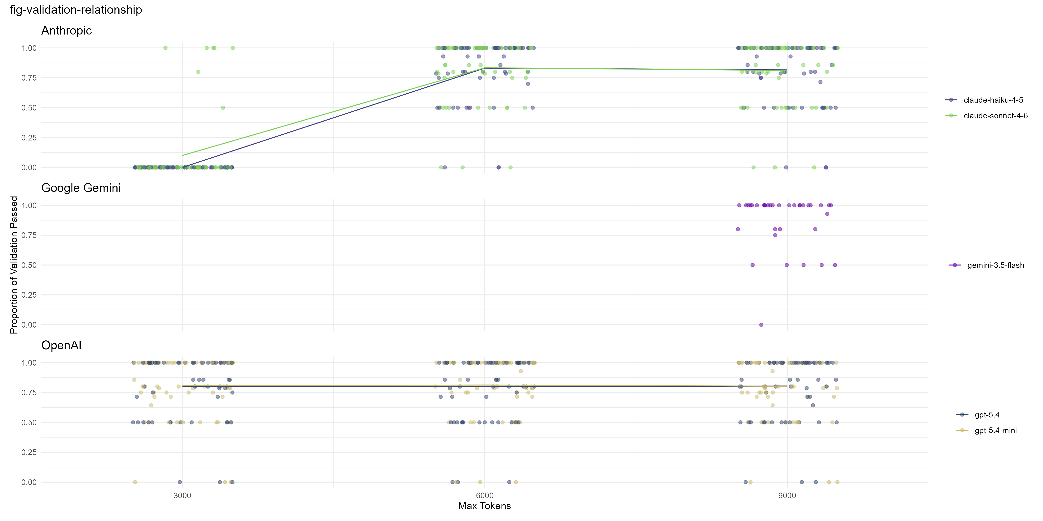
Figure 1: Across all tables, is there a relationship between token count and validation? Trend lines based on mean at each token level. Each point represents a single extraction of pdf a, b, c, or d
Our smaller token calls (3000) end up all excluded here, because with all NA data there’s nothing to compare. Figure 2 is an alternative way of looking at similar data (in this case, matching vs. canonical data as opposed to validation). As you can see, there’s quite a lot of variation within groups and not a lot between groups. The percentages give the number of failed calls (i.e. hit the token limit). Without these, models can end up looking far more reliable than they actually are (e.g. gemini 3.5 flash, 9000 tokens). The lack of any real trends in here may go away as we increase the replicate number, but it may also be an artifact of caching (see above).
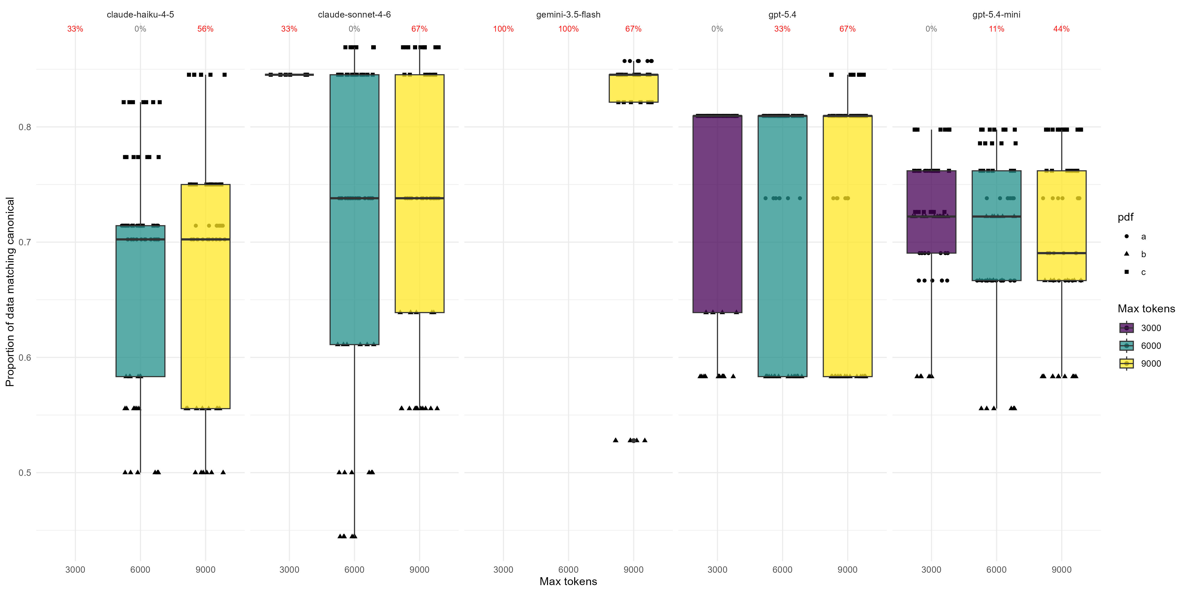
Figure 2: remove?

Cost Analysis
Costs are necessarily an estimate and rather rough - most models provide a cost per token value, and most calls return a token count… but not all of them are trustworthy. I suspect that behind the scenes some data is getting cached between calls, which means subsequent calls with the same/similar data are much cheaper. This is probably a good thing, but I’m not sure how to deal with this in the analysis.
Table 7: Estimated API cost per call (USD) by model and token limit. Costs are computed from actual input and output token counts reported by the API, multiplied by the published per-million-token rates.
Model | Token Limit | N Calls | N Success | Mean Input Tok | Mean Output Tok | Mean Cost (USD) | Total Cost (USD)
claude-haiku-4-5 | 3,000 | 9 | 9 | 19,776 | 3,000 | 0.03478 | 0.31298
claude-haiku-4-5 | 6,000 | 9 | 9 | 26 | 4,130 | 0.02068 | 0.18608
claude-haiku-4-5 | 9,000 | 9 | 9 | 59,276 | 4,311 | 0.08083 | 0.72748
claude-sonnet-4-6 | 3,000 | 9 | 9 | 19,776 | 2,996 | 0.10427 | 0.93846
claude-sonnet-4-6 | 6,000 | 9 | 9 | 7,587 | 4,342 | 0.08789 | 0.79098
claude-sonnet-4-6 | 9,000 | 9 | 9 | 59,277 | 4,329 | 0.24276 | 2.18485
gemini-3.5-flash | 3,000 | 9 | 0 |  |  |  | 0.00000
gemini-3.5-flash | 6,000 | 9 | 0 |  |  |  | 0.00000
gemini-3.5-flash | 9,000 | 9 | 5 | 7,881 | 7,400 | 0.07842 | 0.39210
gpt-5.4 | 3,000 | 9 | 9 | 10,281 | 3,710 | 0.08135 | 0.73212
gpt-5.4 | 6,000 | 9 | 9 | 3,284 | 3,553 | 0.06151 | 0.55356
gpt-5.4 | 9,000 | 9 | 9 | 8,319 | 3,303 | 0.07034 | 0.63303
gpt-5.4-mini | 3,000 | 9 | 9 | 10,225 | 2,356 | 0.01827 | 0.16444
gpt-5.4-mini | 6,000 | 9 | 9 | 1,805 | 2,556 | 0.01286 | 0.11570
gpt-5.4-mini | 9,000 | 9 | 9 | 10,225 | 2,513 | 0.01898 | 0.17079
Surprisingly, cost and max token count correlate for Anthropic models, but don’t seem to for OpenAI Figure 3. This is a surprise. Note the drop in mean costs for Anthropic (and in some cases for OpenAI) at 6000 tokens. I’m fairly sure this is a consequence of caching (as discussed above), while the 9000-token calls were run a day later. I can try and turn caching off and re-run for more accurate numbers, though this may be expensive and time-consuming.
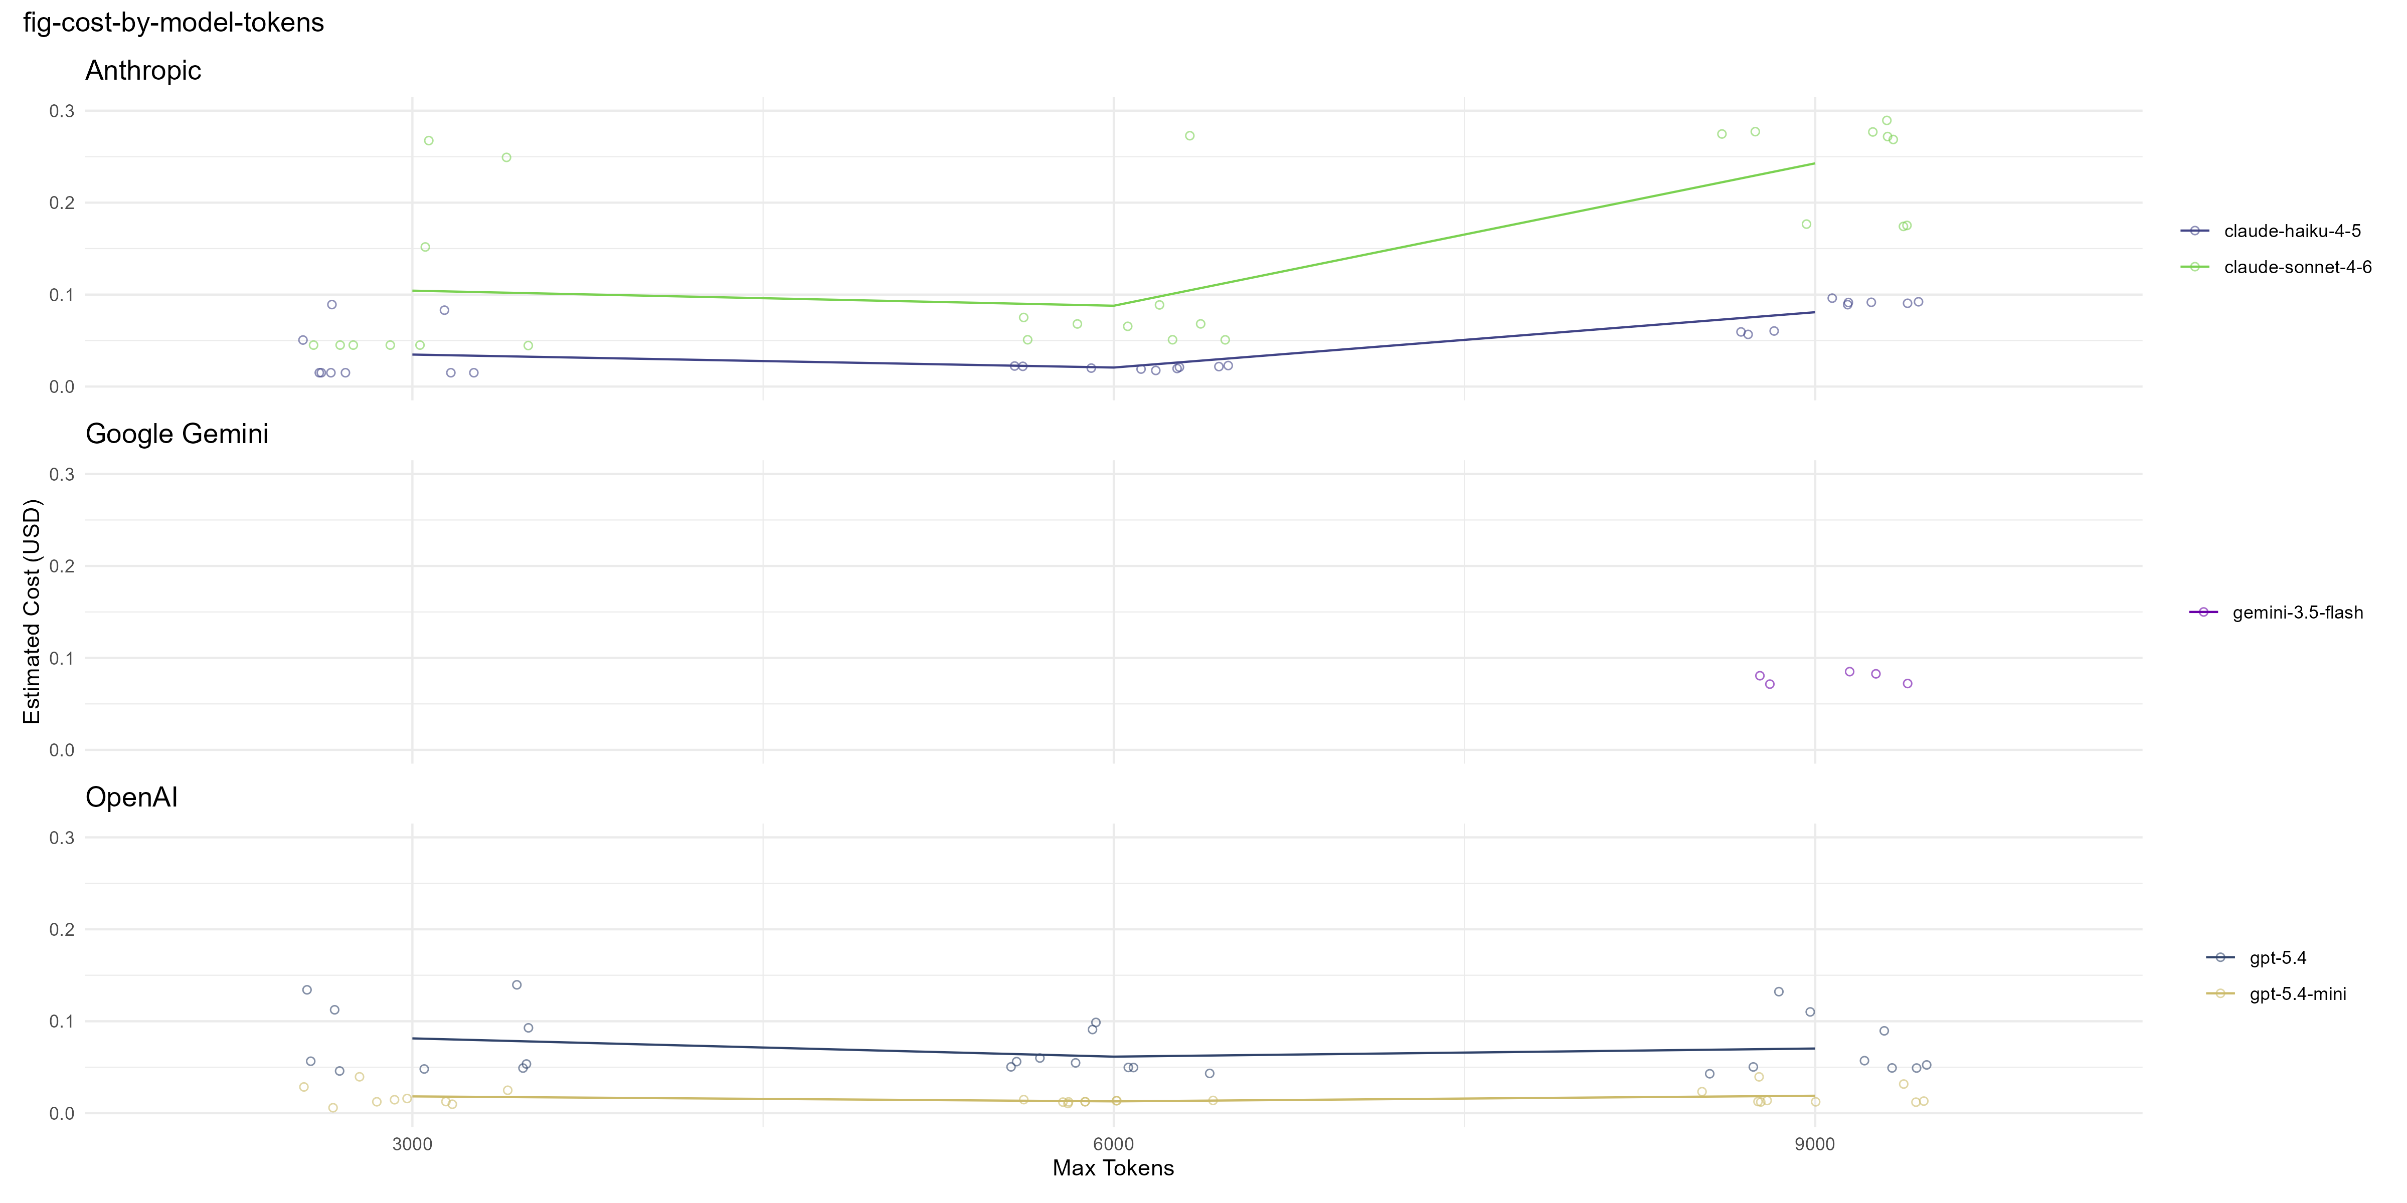
Figure 3: Estimated cost per call (USD) by model and token limit, split by provider. Each point is one replicate call; lines connect group means.
Figure 5 and Figure 4 are difficult to interpret, but I don’t immediately know how to improve this.
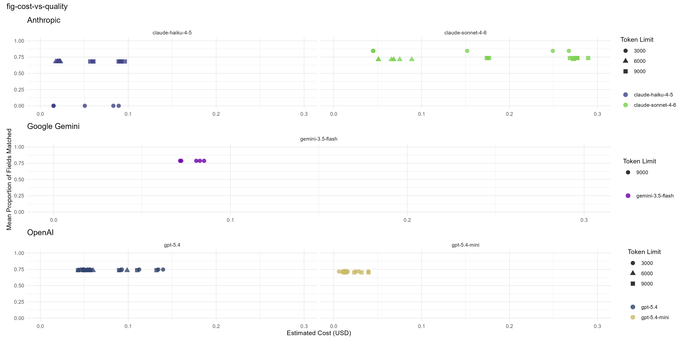
Figure 4: Cost vs. extraction quality (mean proportion of canonical fields matched), by model and token limit. Each point is one replicate; a higher proportion matched at lower cost is preferable.
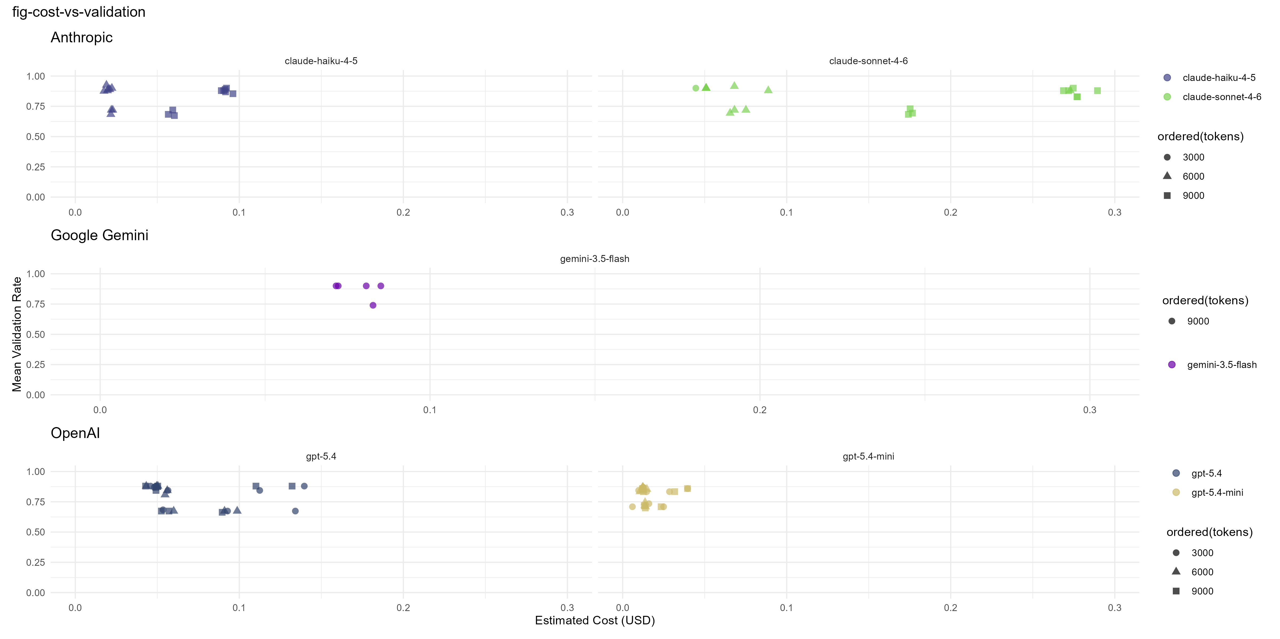
Figure 5: Estimated cost per call (USD) vs. mean eData validation rate (proportion of validation steps passed), split by provider. Each point is one replicate; higher validation at lower cost is preferable. Failed calls (i.e. mean validation pass rate of 0) excluded.

Results Summary Table
Considering our results so far Table 8, Gemini 3.5-Flash (9000 tokens) edges out the other LLMs in terms of strict validation and canonical matching score, but hits the token limit and fails to return any data at all at 3000 and 6000 tokens. Sonnet 4.6 provides good performance at 6000 tokens and 9000 tokens, but Haiku 4.5 is roughly equal and significantly cheaper at 6000 tokens (but not 9000 tokens). However, the difference in performances is not substantial across providers or token limits, except for both Sonnet 4.6 and Haiku 4.5 which perform extremely poorly at 3000 tokens.
As ever, these results should be taken with a pinch of salt, due to the questions around caching raised earlier.
Table 8: Summary of mean eData validation pass rate (proportion of validation steps passed), canonical field matching (mean proportion of canonical fields recovered), and estimated cost per call (USD), by model and token limit. Each row aggregates across all papers and replicates evaluated.
Model | Token Limit | Papers | Replicates | Mean Validation Pass Rate | Mean Canonical Match | Mean Cost (USD)
gemini-3.5-flash | 9,000 | 3 | 3 | 0.87 | 0.79 | 0.08
claude-sonnet-4-6 | 6,000 | 3 | 3 | 0.83 | 0.71 | 0.09
claude-haiku-4-5 | 6,000 | 3 | 3 | 0.83 | 0.68 | 0.02
claude-haiku-4-5 | 9,000 | 3 | 3 | 0.82 | 0.68 | 0.08
gpt-5.4-mini | 6,000 | 3 | 3 | 0.81 | 0.71 | 0.01
claude-sonnet-4-6 | 9,000 | 3 | 3 | 0.81 | 0.73 | 0.24
gpt-5.4-mini | 3,000 | 3 | 3 | 0.81 | 0.72 | 0.02
gpt-5.4 | 9,000 | 3 | 3 | 0.80 | 0.74 | 0.07
gpt-5.4 | 3,000 | 3 | 3 | 0.80 | 0.75 | 0.08
gpt-5.4-mini | 9,000 | 3 | 3 | 0.80 | 0.70 | 0.02
gpt-5.4 | 6,000 | 3 | 3 | 0.80 | 0.73 | 0.06
claude-sonnet-4-6 | 3,000 | 3 | 3 | 0.10 | 0.85 | 0.10
claude-haiku-4-5 | 3,000 | 3 | 3 | 0.00 |  | 0.03

Appendices
Table 9: List of tables and variables returned by LLM extraction, alongside whether these variables are used in the comparison (controlled vocabulary or numeric values), or are skipped (free or descriptive text).
Table | Variable Name | Variable Check
Campaign | CAMPAIGN_START_DATE | Compared
Campaign | CAMPAIGN_END_DATE | Compared
Campaign | CAMPAIGN_NAME | Skipped
Campaign | CAMPAIGN_NAME_SHORT | Skipped
Campaign | ORGANISATION | Skipped
Campaign | CAMPAIGN_COMMENT | Skipped
Campaign | CAMPAIGN_RATIONALE | Skipped
References | REFERENCE_TYPE | Compared
References | YEAR | Compared
References | VOLUME | Compared
References | ISSUE | Compared
References | AUTHOR | Skipped
References | TITLE | Skipped
References | DOI | Skipped
References | PERIODICAL_JOURNAL | Skipped
References | PUBLISHER | Skipped
Sites | LATITUDE | Compared
Sites | LONGITUDE | Compared
Sites | COUNTRY_ISO | Compared
Sites | OCEAN_IHO | Compared
Sites | SITE_GEOGRAPHIC_FEATURE | Compared
Sites | SITE_GEOGRAPHIC_FEATURE_SUB | Compared
Sites | SITE_CODE | Skipped
Sites | SITE_NAME | Skipped
Sites | SITE_COMMENT | Skipped
Parameters | PARAMETER_TYPE | Compared
Parameters | CAS_RN | Skipped
Parameters | PARAMETER_NAME | Skipped
Parameters | PARAMETER_COMMENT | Skipped
Compartments | ENVIRON_COMPARTMENT | Compared
Compartments | ENVIRON_COMPARTMENT_SUB | Compared
Compartments | MEASURED_CATEGORY | Compared
Biota | SPECIES_GROUP | Compared
Biota | SAMPLE_TISSUE | Compared
Biota | SAMPLE_SPECIES_LIFESTAGE | Compared
Biota | SAMPLE_SPECIES_GENDER | Compared
Biota | SAMPLE_SPECIES | Skipped
Biota | SAMPLE_ID | Skipped
Methods | PROTOCOL_CATEGORY | Compared
Methods | PROTOCOL_NAME | Compared
Methods | PROTOCOL_COMMENT | Skipped

