BURRISHOOLE CATCHMENT, IRELAND

The Burrishoole catchment (area = 100 km2) on the west of Ireland is a typical upland peat catchment on the Atlantic fringe of Europe.

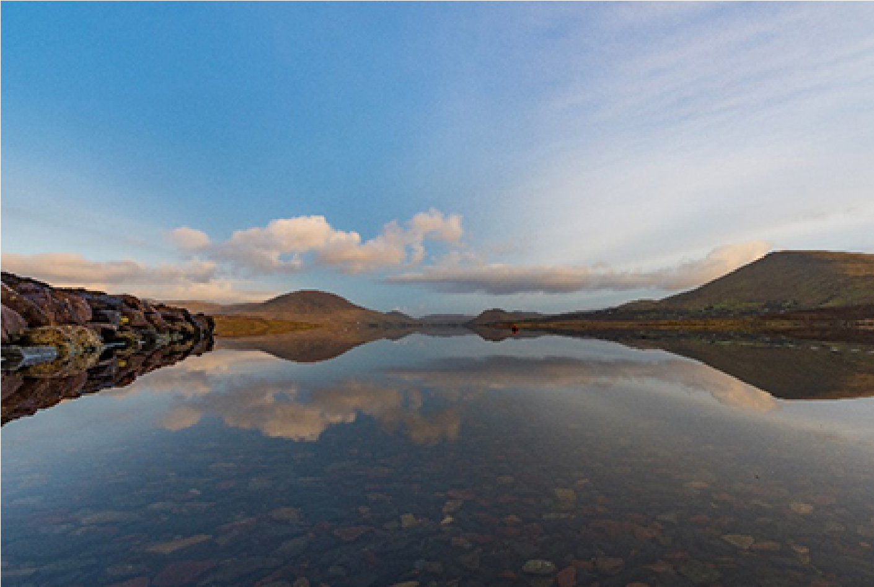

The challenge: To explore how seasonal forecasts can be used to better understand and manage salmon stocks.
The main lake in the catchment, Lough Feeagh (4 km2) has been monitored at high frequency (sub-hourly) for 2 decades. The majority of the catchment is covered in blanket peat, and the main land uses in the area are hillside grazing by sheep and forestry. The Burrishoole catchment is typographically well defined, with high mountains delineating the area which drains into Lough Feeagh. From there, two short channels drop 15 metres into Lough Furnace, a coastal lagoon with a direct tidal connection to the Atlantic Ocean. The structure of these two channels, the natural Salmon Leap, and the man-made Mill Race, lent themselves to the construction of fish traps which can capture the total migration of salmon and trout entering and exiting the catchment, and silver eel returning to the Sargasso Sea to spawn. The catchment has been a site for long term ecological research since the 1950s. The Burrishoole index site is an important source of information on the migration and production of diadromous fish in the North Atlantic region. The Marine Institute seeks to explore how seasonal forecasts can be used to better understand and manage diadromous fish stocks. Project goals are to obtain a user friendly tool which indicates when fish are likely to migrate, but also to increase our knowledge about climate impacts on fish phenology. Our other interest is to include Lough Feeagh in the ISIMIP lake sector.
Co-developer: Marine Institute

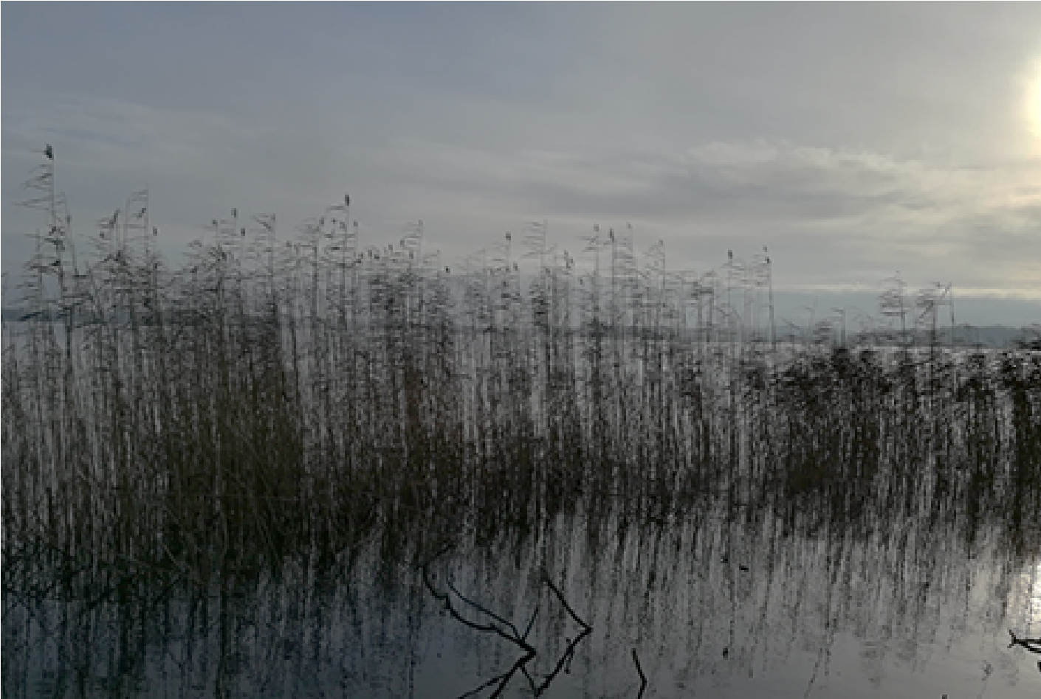
LAKE ARRESKOV, DENMARK

Lake Arreskov is a typical Danish shallow lake (mean depth 2 m, surface area of 3.2 km2).

The challenge: Incorporating seasonal prediction of extreme events as a tool for compliance with the EU Water Framework Directive.
The lake is located in the upper part of the River Odense watershed on the island of Funen. The lake has become eutrophic after decades nutrient enrichment driven by sewage discharges and intensive agriculture. A large water management effort has been made in Denmark during the 80s and 90s, particularly much improved sewage treatment, which has reduced the nutrient load to the lake. Attempts to improve the ecological quality through biomanipulation has also been done, by removal of cyprinid fish, mainly roach and bream, and stocking of piscivore fingerlings. Nevertheless, the lake still remains eutrophic, and do not meet the requirements of the EU Water Framework Directive. Hence, action must be put in place to reduce external nutrient inputs further, and models are being used by the ministry of the environment to estimate required nutrient load reduction.
Co-developer: Ministry of Environment and Food of Denmark

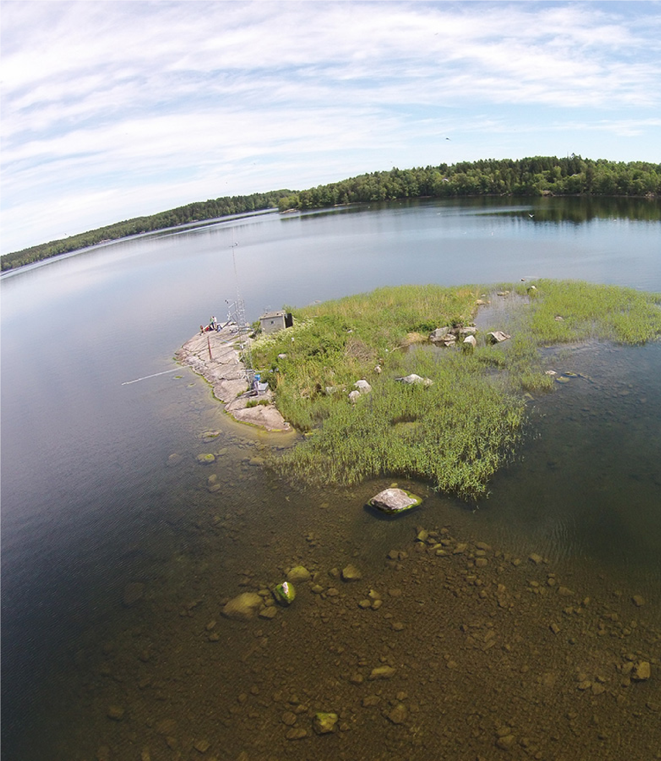
LAKE ERKEN, SWEDEN

Lake Erken is a moderately eutrophic lake located in east-central Sweden, and it is a landmark for lake ecology education.

The challenge: To elaborate educational materials using numerical prediction of the impacts of climate change and extreme events on water quality.

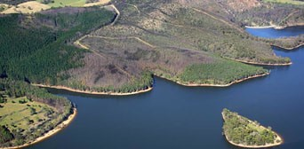
Lake Erken has been the site of a limnological field station for nearly 70 years, one of the most studied lakes in the world, that actively participates in the Swedish Infrastructure for Ecosystem Science, Global Lake Ecological Observatory Network and The Inter-Sectoral Impact Model Intercomparison Project sites. Lake Erken and lakes around the globe have been experiencing significant changes in water temperature and thermal structure due to a warming climate. However, the understanding of the complexities of climate change impacts on environment and humans remains limited. Our goal in WATExR is to prepare hands-on activities for the Summer Science Camp at Erken Laboratory, where 16-19-year-old students will conduct research projects using long-term data and ISIMIP climate change simulations for Lake Erken and >60 globally distributed lakes.
Co-developer: Uppsala University
MOUNT BOLD RESERVOIR, AUSTRALIA

Mount Bold is the largest reservoir in South Australia.

The challenge: Using seasonal prediction to anticipate water level fluctuations and phosphorus levels in the reservoir.
The reservoir is not directly connected to the reticulation system. Water is released as required to maintain an adequate level at the Clarendon Weir and from that point, water is diverted to Happy Valley where it is abstracted and treated for the drinking water supply of Adelaide. Mount Bold’s height above sea level is 795 feet and the water are dammed back to 6.5 miles. It has a capacity of 46,545 ML. Mount Bold has had issues with maintaining the water level within the reservoir as it has a unique setup with water being pumped 48km into the Onkaparinga river which then flows into Mount Bold. The pumping of this water can be quite costly so knowing how much and when the water should be pumped is of key concern to the co-developer. Also the levels of phosphorus in the outflow pipe are of interest to the co-developer due to the fact that downstream in Happy Valley they have had algal blooms attributed to phosphorus in inflow concentrations. Project goals are to develop a forecast system that will forecast the levels of the reservoir and concentrations of phosphorus in the outflow.
Co-developer: SA Water and University of Adelaide

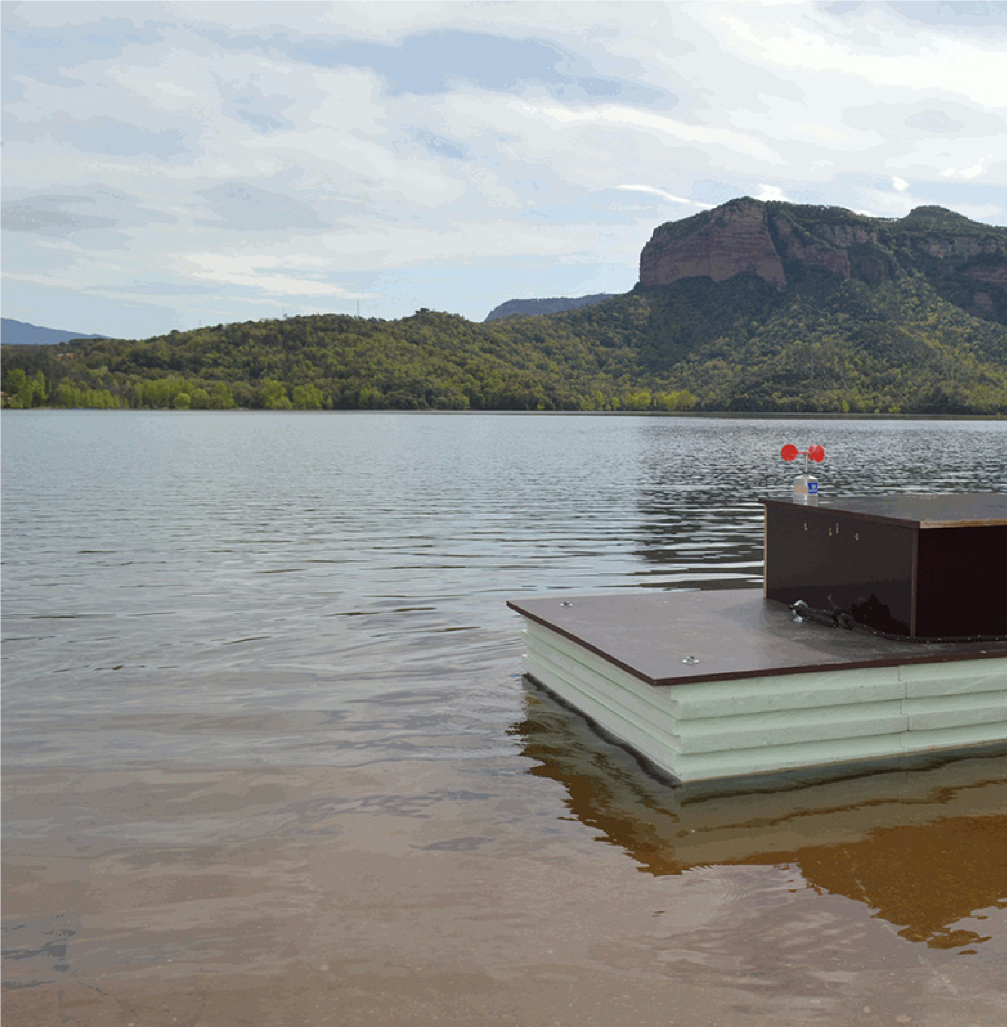

SAU RESERVOIR, SPAIN

Sau Reservoir is the main water supply source for the city of Barcelona

The challenge: Anticipating threats to water supply security (anoxic layers, cyanobacteria, disinfection-by-products formation) using seasonal prediction.
The reservoir is on the middle stretch of the Ter river catchment and is the main water input for the downst thdrawal source for treatment and human consumption for Barcelona metropolitan area . The main purp
ood protection and recreation. The canyon-like reservoir is characterized as eutrophic and monomictic, m receives water from a mix of land cover types including: densely populated areas, productive pastures an rest dominates in the high part of the catchment, for a total area of 1523 km2. The water level su ers wide eptember. Severe drawdowns or increases in Sau Reservoir often induce water quality deteriorations epis ooms or to increase the dissolved organic carbon making the reservoir sensitive to both droughts and o
oncentration of dissolved organic carbon during extreme events, low levels of water under drought condi
active carbon), occurrence of cyanobacterial blooms during hot summers.
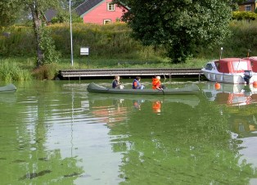
Co-developer: Aigües Ter-Llobregat and the Catalan Water Agency
VANSJØ-HOBØL (MORSA) CATCHMENT, NORWAY

The Vansjø-Hobøl (Morsa) catchment (area = 675 km2) in south-eastern Norway is one of Norway’s catchments most affected by agricultural runoff.

The challenge: Developing an early warning system for water quality deterioration episodes based on seasonal prediction.
The main lake in the catchment, Lake Vansjø (36 km2), is used as the drinking water source for the city of Moss (60,000 people) and is used extensively for bathing, fishing and boating. Vansjø has a long history of eutrophication and algal blooms, including toxin-producing cyanobacterial blooms, and substantial efforts have been made over the last decade to implement measures to improve water quality. Lake Vansjø is an important drinking water source and is used extensively for recreational use. However, algal blooms and browning are problematic for drinking water, bathing and WFD compliance. Project goals are to obtain an early warning system to inform management of the catchment, lake and water treatment works: seasonal predictions of weather and the associated likelihood of toxic algal blooms or influxes of organic matter would allow for a number of measures to be taken to enhance preparedness.
co-developer: MORSA

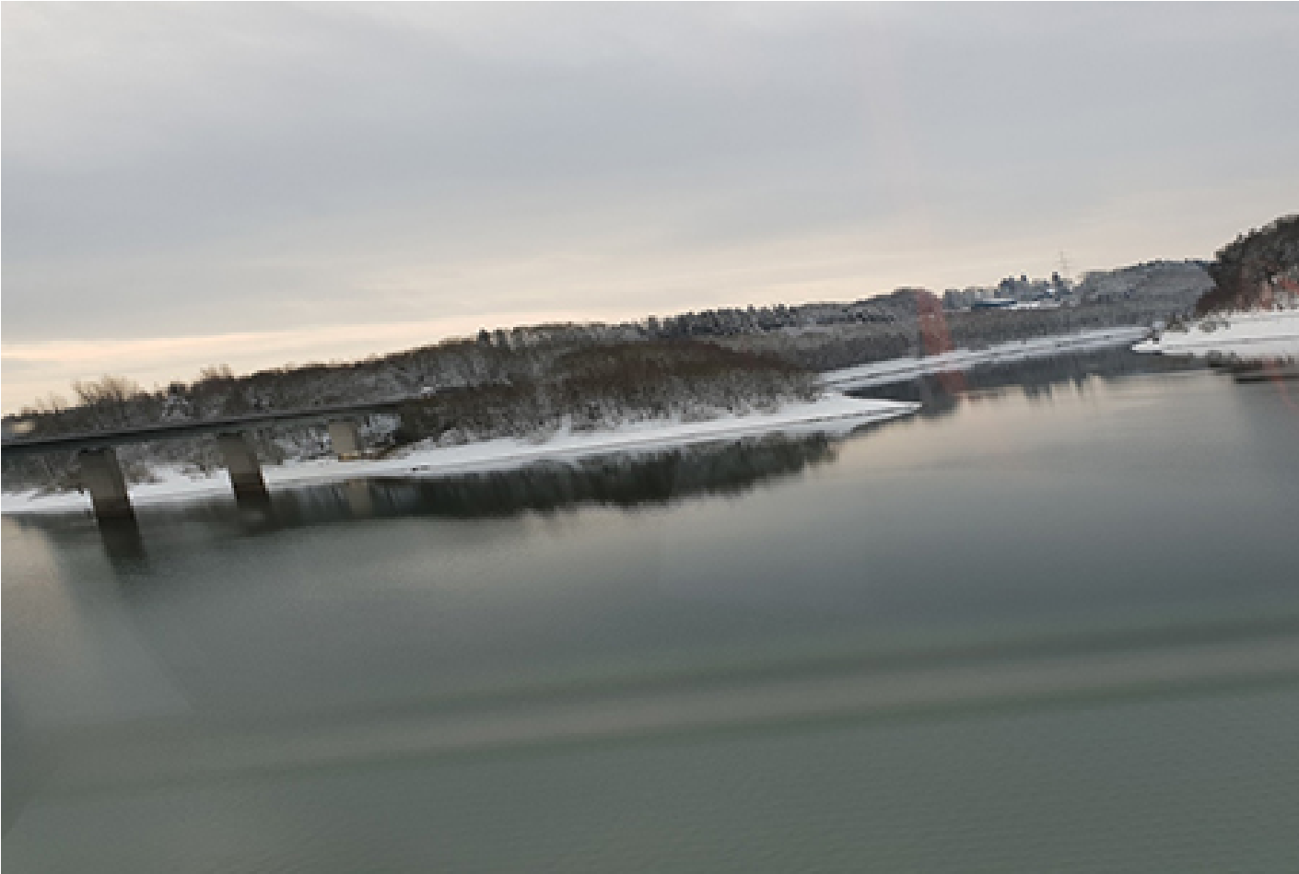
WUPPER RESERVOIR, GERMANY

The Wupper Reservoir is located in West Germany near Cologne. The reservoir is on the river Wupper, whose catchment is a part of the Rhine river catchment.

The challenge: Including seasonal prediction in the water quality forecast system already in place.
The main purposes are the flow controlling, flood protection and recreation. At full capacity, the surface area of the reservoir in is 211 ha and the volume is around 26 million m3. The maximum depth is 31 m and the mean depth is 11 m. The water level suffers wide fluctuations, where the maximum is in April and the minimum is in October. The canyon-like reservoir is also characterized as slightly eutrophic and it is mostly dimictic, mainly stratified from May to September. It receives treated sewage water as well as effluents from combined sewer overflows from the densely populated upstream catchment area of 212 km2.
Co-developer: WUPPERVERBAND

