TEOTIL3 Lillestrøm
Innholdsfortegnelse

TEOTIL3 Lillestrøm
Using monitoring and modelling to assess water quality in catchments draining to Lillestrøm kommune.

Preface
In April 2026, NIVA published a report (Wallhead et al., 2026) describing a range of scenarios for reducing nutrient loading to the Oslofjord. The study evaluated nutrient reductions that could be achieved across different parts of the Oslofjord catchment through various combinations of wastewater treatment and agricultural mitigation measures.
Lillestrøm kommune is currently developing River Basin Management Plans for catchments that discharge within the municipal boundary. Since all these catchments form part of the wider Oslofjord catchment, NIVA’s recent modelling provides a valuable foundation for local planning. The aim of this project is to refine the broad-scale modelling already undertaken by NIVA using local monitoring and Lillestrøm-specific datasets. Results will support development of Lillestrøm’s catchment management plans by documenting present-day water quality, trends over time, and the potential to reduce nutrient loads using combinations of measures.

Authors
James E Sample is a Senior Engineer in the Data Science section at the Norwegian Institute for Water Research (NIVA).

Citation
Sample JE. 2026. Water quality trends in catchments draining to Lillestrøm kommune: analysis of monitoring and model data. NIVA project 260150. Available online.

Final PDF
The final deliverable from this project, a PDF report (in Norwegian), is available here.

Proposal
An overview of tasks defined in the project proposal is here.

Licence
This work is licensed under a Creative Commons Attribution-ShareAlike 4.0 International License.

Abbreviations
Tabell 1.1: Abbreviations used in this document.
Abbreviation | Meaning
API | Application programming interface
AR50 | NIBIO's national land cover dataset with 50 m resolution
BOF5 | Biological oxygen demand over 5 days ("biokjemisk oksygenforbruk")
C | Carbon
DIN | Dissolved inorganic nitrogen
DOC | Dissolved organic carbon
EMEP | European Monitoring and Evaluation Programme
GES | Good Ecological Status
GTS | Grid Time Series (API provided by NVE)
KDE | Estimering av kjernetetthet (Kernel Density Estimation)
KOF | Chemical oxygen demand ("kjemisk oksygenforbruk")
MAD | Median absolute deviation
N | Nitrogen
NIBIO | Norsk institutt for bioøkonomi
NIVA | Norsk institutt for vannforskning
NVE | Norges vassdrags- og energidirektorat
OSPAR | Oslo-Paris agreement to protect the marine environment of the North-eastern Atlantic Ocean
P | Phosphorus
p.e. | Person equivalents
RMP | Regionale miljøprogram
RMSE | Root mean square error
SS | Suspended sediment
SSB | Statistisk Sentralbyrå
TDP | Total dissolved phosphorus
TOC | Total organic carbon
TON | Total organic nitrogen
TOTN | Total nitrogen
TOTP | Total phosphorus
TPP | Total particulate phosphorus
WFD | European Water Framework Directive (Vannforskriften)

Introduction

Scope
This project aims to:
- Summarise available monitoring data for catchments around Lillestrøm kommune.
- Describe present-day water quality status and observed trends over time.
- Use modelling to identify the main sources of nutrients in each catchment.
- Describe the potential for reducing nutrient loads in each catchment using measures targeting wastewater and agriculture (based on recent modelling of the Oslofjord catchment undertaken by NIVA and NIBIO for Miljødirekotratet).

Report structure
This chapter defines the area of interest for this project and provides a high level overview of the study catchments and their properties. Chapter 3 describes the main sources of input data and the models used in the analysis, while Chapter 4 gives details of the workflow and methodology. Chapters 5 to 11 present results for each catchment separately, and Chapter 12 gives a summary of the main results.

Area of interest
Tabell 2.1 and Figur 2.1 show the catchments of interest.
Tabell 2.1: Catchments considered in this study.
Catchment ID | Name | Outlet lon | Outlet lat | Comment
1 | Sagelva | 11.02384 | 59.95745 | Tributary to Nittelva
2 | Nittelva | 11.07092 | 59.93806 | Just upstream of confluence with Leira
3 | Leira | 11.07367 | 59.93905 | Just upstream of confluence with Nittelva
4 | Rømua | 11.20984 | 59.99055 | Single REGINE; no lakes
5 | Jeksla | 11.09281 | 59.99753 | Small sub-catchment of Leira; not resolved by REGINE network
6 | Åa | 11.28279 | 59.99649 | Single REGINE; few lakes
7 | Gansåa | 11.22130 | 59.86080 | Not resolved by REGINE network

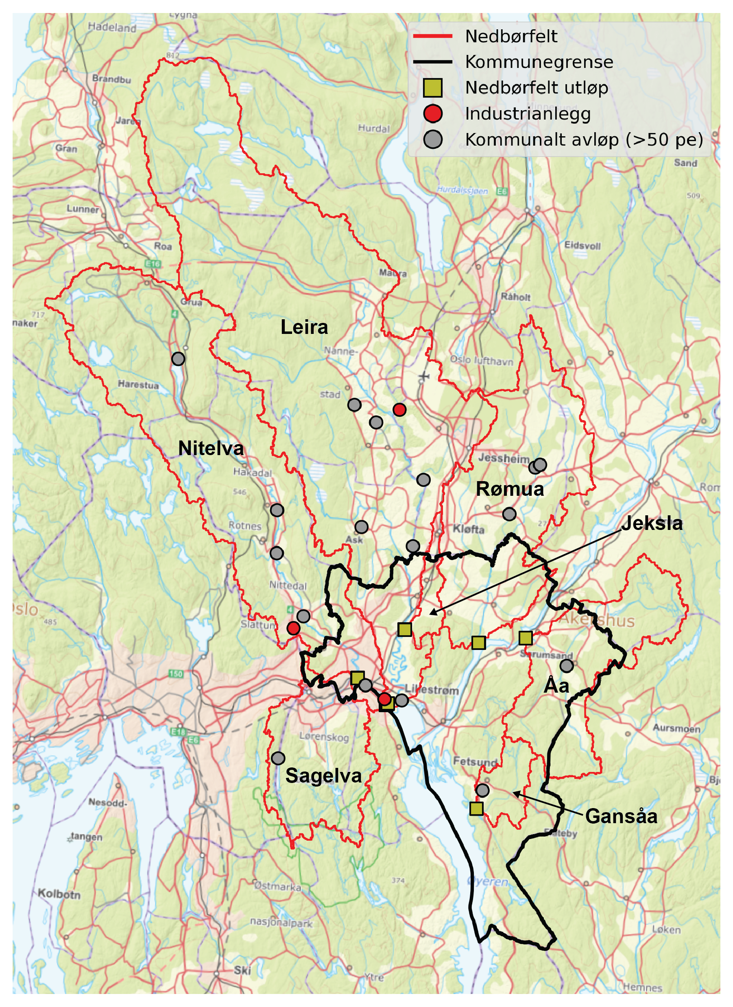
Figur 2.1: Lillestrøm kommune (black outline) and the seven catchments considered in this analysis (red outlines). Yellow squares mark catchment outlets; red circles are point source discharges from industry; grey circles are discharges from municipal wastewater plants (with capacity >50 pe).

Sources of nutrients

Diffuse sources
Tabell 2.2 and Figur 2.2 show land cover proportions for each catchment.
- Forest is the dominant land cover (≥65 %) for Leira, Nittelva, Sagelva, Åa and Gansåa.
- Agriculture is the dominant land cover for Rømua (49 %) and Jeksla (39 %), and also covers significant parts of Leira (20 %) and Åa (23 %).
- Sagelva and Jeksla have significant urban areas (16 % and 23 %, respectively).
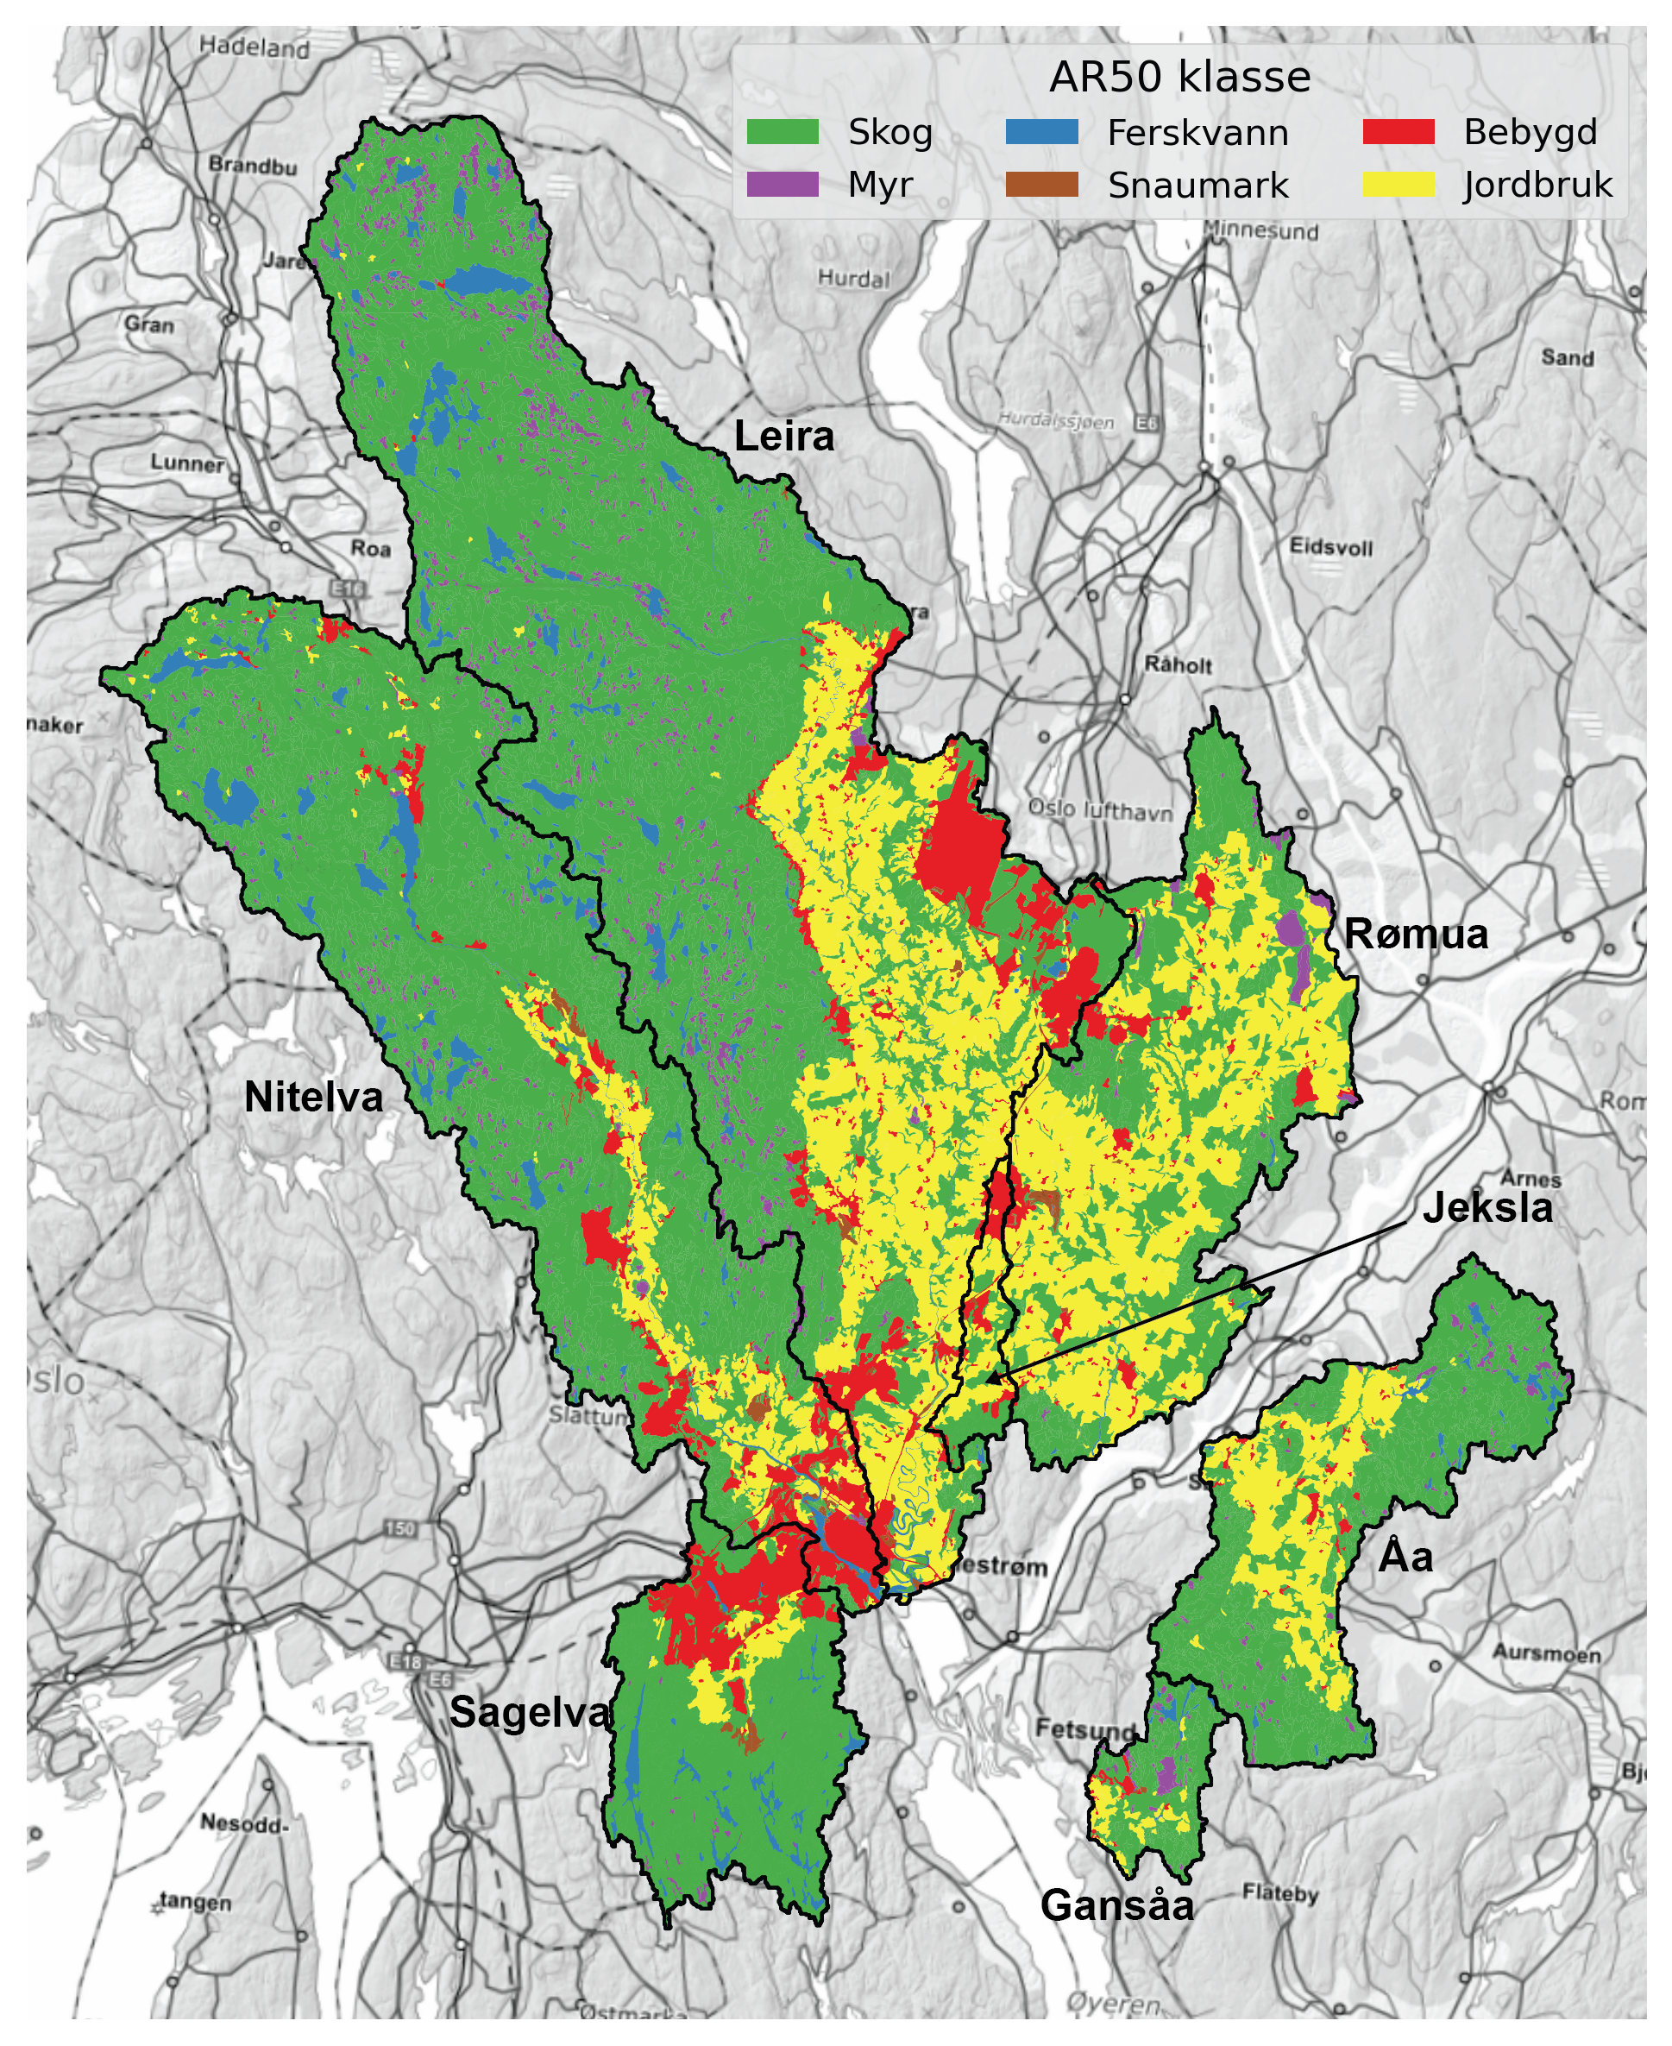
Figur 2.2: Land cover based on the ‘ARTYPE’ classifications from NIBIO’s AR50 dataset

Tabell 2.2: Land cover proportions based on NIBIO’s AR50 dataset.
Nedbørfelt | Sagelva |  | Nitelva |  | Leira |  | Rømua |  | Jeksla |  | Åa |  | Gansåa
AR50 klasse | km² | % | km² | % | km² | % | km² | % | km² | % | km² | % | km² | %
Bebygd | 17.6 | 16 | 45.3 | 9 | 46.5 | 7 | 9.8 | 5 | 3.8 | 22 | 2.0 | 2 | 0.8 | 3
Jordbruk | 6.8 | 6 | 36.1 | 8 | 132.0 | 20 | 103.3 | 49 | 6.6 | 39 | 29.6 | 23 | 3.4 | 13
Skog | 77.0 | 71 | 363.9 | 75 | 436.0 | 65 | 92.9 | 44 | 6.5 | 38 | 93.8 | 72 | 18.6 | 73
Snaumark | 1.2 | 1 | 3.8 | 1 | 2.2 | 0 | 1.2 | 1 | 0.1 | 1 | 0.0 | 0 | 0.1 | 0
Myr | 0.7 | 1 | 9.1 | 2 | 27.6 | 4 | 4.1 | 2 | 0.0 | 0 | 3.0 | 2 | 1.8 | 7
Ferskvann | 5.6 | 5 | 25.7 | 5 | 23.8 | 4 | 0.5 | 0 | 0.0 | 0 | 2.3 | 2 | 0.7 | 3
Totalt | 108.9 | 100 | 483.9 | 100 | 668.1 | 100 | 211.8 | 100 | 17.0 | 100 | 130.7 | 100 | 25.4 | 100

All catchments of interest contain substantial areas of marine deposits (Figur 2.3; Tabell 2.3), and all except Gansåa are classified as leirpåvirket (clay-influenced) under the Water Framework Directive. Marine clays contain apatite, a phosphorus-rich mineral that contributes to naturally elevated phosphorus concentrations. Consequently, background levels of phosphorus - particularly particulate phosphorus - are expected to be high in these rivers. A comparison of Figur 2.3 and Figur 2.2 shows that agricultural land is concentrated predominantly in areas underlain by marine clays.
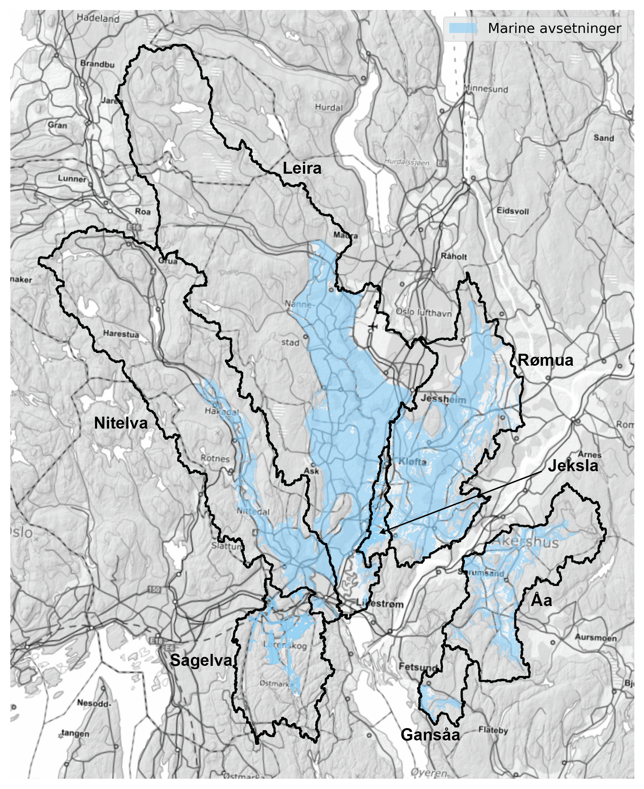
Figur 2.3: Extent of marine deposits based on NGU’s surface geology data (løsmassekart).

Tabell 2.3: Proportions of each catchment that are (i) below the marine limit, and (ii) covered by marine deposits. Based on NGU’s løsmassekart.
 | Totalt areal (km²) | Under marin grense (km²) | Under marin grense (%) | Marine avsetninger (km²) | Marine avsetninger (%)
Nedbørfelt
Sagelva | 109.0 | 40.7 | 37 | 15.3 | 14
Nitelva | 483.9 | 121.3 | 25 | 63.9 | 13
Leira | 668.1 | 242.0 | 36 | 173.3 | 26
Rømua | 211.9 | 178.6 | 84 | 112.1 | 53
Jeksla | 17.1 | 15.5 | 91 | 7.9 | 46
Åa | 130.7 | 76.0 | 58 | 34.2 | 26
Gansåa | 25.3 | 10.0 | 40 | 4.8 | 19

Point sources
Major point sources are shown in Tabell 2.4. Nutrient inputs are the mean of reported discharges during the period from 2013 to 2024 (in tonnes).
- The largest single point source is Nedre Romerike avløpsanlegg (NRA), which discharges to Nittelva just upstream of the confluence with Leira. Other significant wastewater discharges to Nittelva are renseanleggene at Rotnes and Åneby, further upstream. In Leira, significant wastewater discharges include Gardermoen sentralrenseanlegg and Kløfta renseanlegg, both in the lower-central part of the catchment.
- The largest industrial point source is Dynea Lillestrøm, a manufacturer of adhesives and industrial coatings.
Tabell 2.4: Main point sources of nutrients within the study area. Values are mean annual discharges during the period from 2013 to 2024.
Nedbørfelt | Navn | Sektor | Type | TOTN (tonn) | TOTP (tonn) | TOC (tonn) | SS (tonn)
Sagelva | Mariholtet sportsstue, renseanlegg | Kommunalt avløp (>50 pe) | Naturbasert | 0.01 | 0.00 | 0.01 | 0.01
Nitelva | Dynea Lillestrøm | Industrianlegg | Kjemisk industri | 27.13 | 0.11 | 17.86 | 5.79
Nitelva | NRA (Nedre Romerike avløpsanlegg) | Kommunalt avløp (>50 pe) | Kjemisk-biologisk m/N-fjerning | 179.29 | 5.20 | 217.73 | 162.97
Nitelva | Diplom-Is avd Produksjon Gjelleråsen | Industrianlegg | Næringsmiddelindustri, unntatt fiskeforedling | - | - | 0.65 | -
Nitelva | Rotnes renseanlegg | Kommunalt avløp (>50 pe) | Kjemisk | 24.79 | 0.37 | 20.27 | 15.51
Nitelva | Slattum renseanlegg (Nedlagt) | Kommunalt avløp (>50 pe) | Kjemisk | 25.25 | 0.42 | 54.56 | 30.44
Nitelva | Åneby renseanlegg | Kommunalt avløp (>50 pe) | Kjemisk | 18.03 | 0.14 | 12.32 | 6.51
Nitelva | Harestua renseanlegg | Kommunalt avløp (>50 pe) | Kjemisk-biologisk | 11.61 | 0.13 | 6.34 | 12.41
Leira | Tuen renseanlegg (Nedlagt) | Kommunalt avløp (>50 pe) | Kjemisk | 0.01 | 0.00 | 0.01 | 0.01
Leira | Kløfta renseanlegg | Kommunalt avløp (>50 pe) | Kjemisk | 36.97 | 0.18 | 38.30 | 15.70
Leira | Avinor avd. Oslo Lufthavn Gardermoen | Industrianlegg | Flyplass | - | - | 1.29 | -
Leira | Gardermoen sentralrenseanlegg | Kommunalt avløp (>50 pe) | Kjemisk-biologisk m/N-fjerning | 51.98 | 1.07 | 37.39 | 47.37
Leira | Gjerdrum renseanlegg (Nedlagt) | Kommunalt avløp (>50 pe) | Kjemisk | 17.72 | 0.07 | 14.74 | 12.15
Leira | Åsgreina renseanlegg (Nedlagt) | Kommunalt avløp (>50 pe) | Kjemisk | 1.58 | 0.02 | 1.61 | 1.41
Leira | Fagerli renseanlegg | Kommunalt avløp (>50 pe) | Biologisk | 0.37 | 0.04 | 0.27 | 0.38
Rømua | Onsrud leir renseanlegg | Kommunalt avløp (>50 pe) | Kjemisk-biologisk | 0.18 | 0.00 | - | 0.14
Rømua | Onsrud rekkehus | Kommunalt avløp (>50 pe) | Kjemisk-biologisk | 0.13 | 0.00 | 0.06 | 0.10
Rømua | Ingjersmyr avløpsanlegg | Kommunalt avløp (>50 pe) | Kjemisk-biologisk | 0.12 | 0.00 | 0.04 | 0.09
Åa | Hogset renseanlegg (Nedlagt) | Kommunalt avløp (>50 pe) | Kjemisk-biologisk | 3.13 | 0.02 | 1.03 | 1.66
Gansåa | Dalen renseanlegg | Kommunalt avløp (>50 pe) | Kjemisk | 3.07 | 0.03 | 1.61 | 2.48

Data sources and models

Water chemistry
Water chemistry data are available from Vannmiljø, the national water chemistry database maintained by Miljødirektoratet. At the start of this project, Lillestrøm kommune provided a list of monitoring stations with good quality data in each catchment of interest.
Catchments in Norway are also divided into waterbodies according to Vannforskriften, which is Norway’s implementation of the EU Water Framework Directive (WFD). The Vann-nett portal uses data from Vannmiljø to assign each waterbody a status (high, good, moderate, poor or bad) based thresholds defined in Vannforskriften for each parameter or quality element.
Tabell 3.1 lists the main monitoring stations in each catchment and identifies the corresponding WFD waterbody for each station. The WFD status for a waterbody displayed in Vann-nett may combine data from multiple stations, so for this analysis two sets of data were downloaded: (i) monitoring data for the specific stations suggested by Lillestrøm kommune, and (ii) all monitoring data used to assign status for each waterbody in Vann-nett. The first dataset provides the best available time series for individual points, whereas the second offers a more aggregated assessment (often with greater variability) and reflects the data used by water managers to assess water quality status.
All water chemistry data were downloaded programmatically via Python using the Vannmiljø and Vann-nett Application Programming Interfaces (APIs). See notebook 02 for details.
Tabell 3.1: Water chemistry monitoring stations within the catchments of interest.
Nedbørfelt | Vannmiljø-ID | Stasjonsnavn | REGINE-ID | Vannforekomst-ID | Vannforekomstnavn | Lengdegrad | Breddegrad
Sagelva | 002-46599 | Sagelva ved Skjetten bro (F3) | 002.CBA0 | 002-3899-R | Fjellhamarelva - Sagelva | 11.016950 | 59.958500
Sagelva | 002-63540 | Fjellhammarelva (F10) | 002.CBA0 | 002-3899-R | Fjellhamarelva - Sagelva | 10.996170 | 59.944190
Nitelva | 002-30586 | Rud Nitelva (N8) | 002.CB0 | 002-3891-R | Nedre Nitelva | 11.057000 | 59.945530
Nitelva | 002-30578 | Kjellerholen Nitelva (N6) | 002.CC0 | 002-1638-R | Nitelva Slattum-Kjeller | 11.008500 | 59.979250
Leira | 002-29659 | Leira ved Borgen bru (L5) | 002.CAA0 | 002-3384-R | Leira nedstrøms Krokfoss | 11.100320 | 59.950360
Leira | 002-30584 | Leira ved Leirsund (L8) | 002.CAA0 | 002-3384-R | Leira nedstrøms Krokfoss | 11.088490 | 59.997550
Leira | 002-30575 | Frogner Leira | 002.CAA0 | 002-3384-R | Leira nedstrøms Krokfoss | 11.097950 | 60.022850
Rømua | 002-28960 | Rømua ved Lørenfallet - RØM1 | 002.D2Z | 002-3659-R | Rømua | 11.220990 | 60.021630
Jeksla | 002-30593 | Jeksla ved Haugli, J14 | 002.CAA0 | 002-599-R | Jeksla | 11.106370 | 60.001990
Åa | 002-60929 | Fossåa ved Sylta (ÅA1) | 002.D3Z | 002-3685-R | Fossåa | 11.300180 | 59.992090
Åa | 002-60963 | Sloråa ved Bruvollen (ÅA3) | 002.D3Z | 002-3687-R | Sloråa | 11.348070 | 59.985120
Åa | 002-60964 | Kauserudåa før samløp Sloråa (ÅA4) | 002.D3Z | 002-3692-R | Stensrudåa - Korsåa | 11.348230 | 59.983910
Gansåa | 002-60933 | Gansåa nedstrøms Dalen RA (BD) | 002.C5 | 002-3655-R | Gansåa | 11.222750 | 59.861390

Waterbody status classes are missing in Vann-Nett for many of the waterbodies listed in Tabell 3.1. This is because all catchments of interest except Gansåa are classified as leirpåvirket (national waterbody type R111; see Seksjon 2.4.1 and Tabell 2.3), which means they are expected to have naturally high concentrations of particulate and total phosphorus. At present, there is no widely accepted set of class boundaries for TOTP status in catchments of type R111. However, thresholds for the boundary between good and moderate status have been proposed, based on the percentage cover of marine clay deposits in each catchment (e.g. Meland et al., 2023). Following this approach, Tabell 3.2 shows the TOTP concentrations assumed in this report to mark the boundary between good and moderate status for each waterbody of type R111.
Tabell 3.2: Assumed boundary between moderate and good status for TOTP concentrations in catchments classified as leirpåvirket (clay-influenced; national waterbody type R111). After Meland et al. (2023).
Vannforekomst ID | Vannforekomstnavn | Leirdekkningsgrad (%) | God/moderat grense for TOTP (μg/l)
002-3899-R | Fjellhamarelva - Sagelva | 14 | 40
002-3891-R | Nedre Nitelva | 13 | 40
002-1638-R | Nitelva Slattum-Kjeller | 10 | 40
002-3384-R | Leira nedstrøms Krokfoss | 26 | 50
002-3659-R | Rømua | 53 | 80
002-599-R | Jeksla | 46 | 80
002-3685-R | Fossåa | 26 | 50
002-3687-R | Sloråa | 20 | 40

Water discharge
Water discharge is monitored by Norges vassdrags- og energidirektorat (NVE). However, discharge monitoring for the water chemistry stations of interest (Tabell 3.1) is limited. The outflow of Sagelva is monitored by NVE discharge station 2.1185.0, which corresponds directly to Vannmiljø station ID 002-46599. The only other NVE station with data within the catchments of interest is at Kråkfoss (2.279.0) on Leira, but this is much further upstream than any of the chemistry monitoring stations.
In cases where direct monitoring of discharge is not available, NVE publishes modelled estimates of daily discharge via the Grid Time Series (GTS) API. Simulations are based on a spatially distributed version of the HBV model developed by Beldring et al. (2003). For catchments without direct monitoring, the GTS API provides the best available estimates of river flow, but NVE’s model does not include detailed flow-routing or water transfers between catchments (e.g. for drinking water or hydropower). It is therefore necessary to evaluate the GTS API for catchments around Lillestrøm kommune (see Seksjon 4.3).

Nutrient inputs
In addition to monitoring data, source-specific nutrient inputs have been estimated from available national and regional datasets.

Municipal wastewater
Municipal wastewater treatment plants with capacity ≥50 person equivalents (p.e.) are required to monitor and report nutrient discharges to Miljødirektoratet via ALTINN. These data are made available to NIVA as part of national scale modelling projects using TEOTIL3 (Seksjon 3.4.2).
Raw data are cleaned and statistically interpolated using a methodology based on Statistisk Sentralbyrå’s (SSB’s) procedure for national wastewater statistics (e.g. Berge & Hjertaas, 2024). Where wastewater discharges are monitored, these values are used directly. Otherwise, discharges are estimated based on plant capacity (number of people connected, in p.e.) and assumed default treatment efficiencies that vary according to treatment type (provided by Miljødirektoratet; here).

Other wastewater
For small wastewater treatment plants (capacity <50 p.e.) and systems that are not connected to the municipal wastewater network (e.g. septic tanks), SSB compiles aggregated discharge statistics at municipality level. These sources are commonly referred to as “spredt avløp” (scattered wastewater discharges). For this project, Lillestrøm kommune provided a more detailed dataset, including locations of individual septic tanks and small treatment plants (minirenseanlegg), as well as information on stormwater and emergency overflows from the municipal wastewater network within the municipality.
For the modelling in this project, SSB data were used for all municipalities except Lillestrøm, where the more detailed, site-specific dataset was used instead. It should be noted, however, that SSB’s dataset covers a longer time period than the Lillestrøm-specific data. Consequently, the spredt dataset prepared for this project provides higher spatial resolution within Lillestrøm kommune than standard national datasets, but with slightly reduced temporal resolution.
A detailed comparison of the national and Lillestrøm-specific spredt datasets is provided in notebook 05.

Industry
Data describing industrial discharges has been provided by Miljødirektoratet. Data collection is based on self-reporting from industry and reflects the components regulated in the respective discharge permits. Data are consistent with the information made publicly available via the Norske utslipp website.

Agriculture
Annual estimates of nutrient losses from agriculture are made by NIBIO using the AGRITIL models (Kværnø et al., 2024). See Seksjon 3.4.1.

Urban
Estimates of nutrient runoff from urban areas have been made using typical runoff coefficients for Norwegian built-up areas taken from Åstebøl et al. (2012).

Background
Estimates of annual nutrient inputs from runoff in forest and upland areas are made by NIVA using long-term national monitoring data. Key datasets include the Norwegian “1000 Lakes” surveys in 1995 and 2019, and the ongoing “Trend lakes” project. See de Wit et al. (2023) for an overview.

Water quality models

AGRITIL
The AGRITIL models (Kværnø et al., 2024) have been used to estimate nutrient losses from agricultural land to first-order streams. AGRITIL provides source-specific input data for agricultural runoff to TEOTIL3 (Seksjon 3.4.2) and consists of separate empirical models for nitrogen (AGRITIL-N) and for suspended sediment, phosphorus and organic carbon (AGRITIL-SPC). The models are calibrated using data from the Norwegian Agricultural Environmental Monitoring Programme (JOVA) and are designed to quantify gross nutrient and sediment losses from agricultural areas under varying environmental conditions and management practices.
AGRITIL-N simulates losses of total nitrogen (TOTN) and nitrate (NO3) from agricultural land. Predicted nitrogen losses are influenced by factors such as runoff, nitrogen balance, soil type, climatic conditions, and the implementation of mitigation measures including winter vegetation cover, catch crops and reduced tillage.
AGRITIL-SPC simulates losses of suspended sediment (SS), total phosphorus (TOTP), phosphate (PO4) and total organic carbon (TOC). Model estimates are based on relationships between nutrient and sediment losses, hydrological conditions, soil properties, land use, erosion risk, and agricultural management practices.
AGRITIL estimates losses from agricultural land at the edge-of-field or first-order stream scale and does not account for nutrient retention occurring downstream. Downstream transport and retention processes are subsequently represented within TEOTIL3.

TEOTIL3
The TEOTIL3 model (Sample et al., 2024) has been used to simulate source-apportioned nutrient inputs for each catchment of interest. TEOTIL3 was also used to estimate the load reductions required for Good Ecological Status (GES) under the Water Framework Directive, as well as the extent to which reductions might be achieved using combinations of measures (based on Wallhead et al., 2026).
TEOTIL3 is an annual mass balance model that simulates the following nutrients:
- Total nitrogen (TOTN) and the main fractions of nitrogen: dissolved inorganic nitrogen (DIN) and total organic nitrogen (TON).
- Total phosphorus (TOTP) and the main fraction of phosphorus: total dissolved phosphorus (TDP) and total particulate phosphorus (TPP).
- Total organic carbon (TOC).
- Suspended sediment (particles; SS).
TEOTIL3 includes a simple hydrological transport module that simulates nutrient retention in lakes, but not in rivers. The model considers nutrients from the following sources (using datasets described in Seksjon 3.3):
- Inputs from agriculture simulated by NIBIO using the AGRITIL models.
- Discharges from large wastewater treatment plants (≥50 p.e.).
- Direct inputs from industrial plants not connected to the municipal wastewater network.
- Discharges from small wastewater treatment plants (<50 p.e.; referred to as “spredt avløp”).
- Nutrient runoff from urban areas.
- Nutrient losses from aquaculture in seawater (not relevant for Lillestrøm kommune).
- Atmospheric deposition of nitrogen directly to lake surfaces.
- Natural background runoff from forest, upland and glacier areas.
TEOTIL3 does not include temporary sources of nutrients, such as construction sites or road building. The standard version of the model also omits overflows from the municipal wastewater network, but for this project the model has been extended to include overflow data provided by Lillestrøm kommune (see Seksjon 3.3.2).

Methodology

Data preparation and cleaning
Data were downloaded for all stations and waterbodies listed in Tabell 3.1 using the Vannmiljø API. Tabell 4.1 shows how parameter names in Vannmiljø have been converted to standardised names and units consistent with the parameters modelled by TEOTIL3.
Tabell 4.1: Mapping between parameter names used in Vannmiljø and standardised names and units used in this report.
Vannmiljø | Standardised | Description | Standardised unit
N-TOT (ufiltrert) | TOTN | Total nitrogen | µg-N/l
N-NO3 (filtrert) | NO3 | Nitrate | µg-N/l
N-NO3 (ufiltrert) | NO3 | Nitrate | µg-N/l
N-NH4 (ufiltrert) | NH4 | Ammonium | µg-N/l
P-TOT (filtrert) | TDP | Total dissolved phosphorus | µg-P/l
P-TOT (ufiltrert) | TOTP | Total phosphorus | µg-P/l
P-ORTO (filtrert) | SRP | Soluble reactive phosphorus | µg-P/l
P-ORTO (ufiltrert) | TRP | Total reactive phosphorus | µg-P/l
P-PO4 (filtrert) | DIP | Dissolved inorganic phosphorus | µg-P/l
P-PO4 (ufiltrert) | TIP | Total inorganic phosphorus | µg-P/l
STS (ufiltrert) | SS | Suspended sediment | mg/l
TOC (ufiltrert) | TOC | Total organic carbon | mg-C/l

Extreme outliers in the time series for each parameter were identified using the double median absolute deviation (MAD) method with a modified z-score threshold of 20. The method calculates separate MAD values above and below the median, allowing robust outlier detection in skewed distributions without assuming normality. Observations with modified z-scores greater than 20 were flagged as outliers and removed from subsequent analysis. A threshold of 20 is substantially higher than the commonly used value of 3.5 and therefore represents a highly conservative screening criterion. As a result, only the most extreme departures from typical behaviour are identified as outliers, minimising the risk of incorrectly flagging valid observations.
Figur 4.1 shows raw water chemistry data from the lower Leira catchment at station 002-29659 (Leira ved Borgen bru). Measurements identified as outliers are shown in red. Monitoring at this location is representative of the wider dataset for Lillestrøm kommune, with extensive records for TOTN, TOTP, TOC and SS. By contrast, data for ammonium and nitrate are sparse, and monitoring of phosphorus fractions has been inconsistent, comprising varying combinations of SRP, TRP, DIP, TIP, and TDP depending on the site, contractor, and monitoring period.
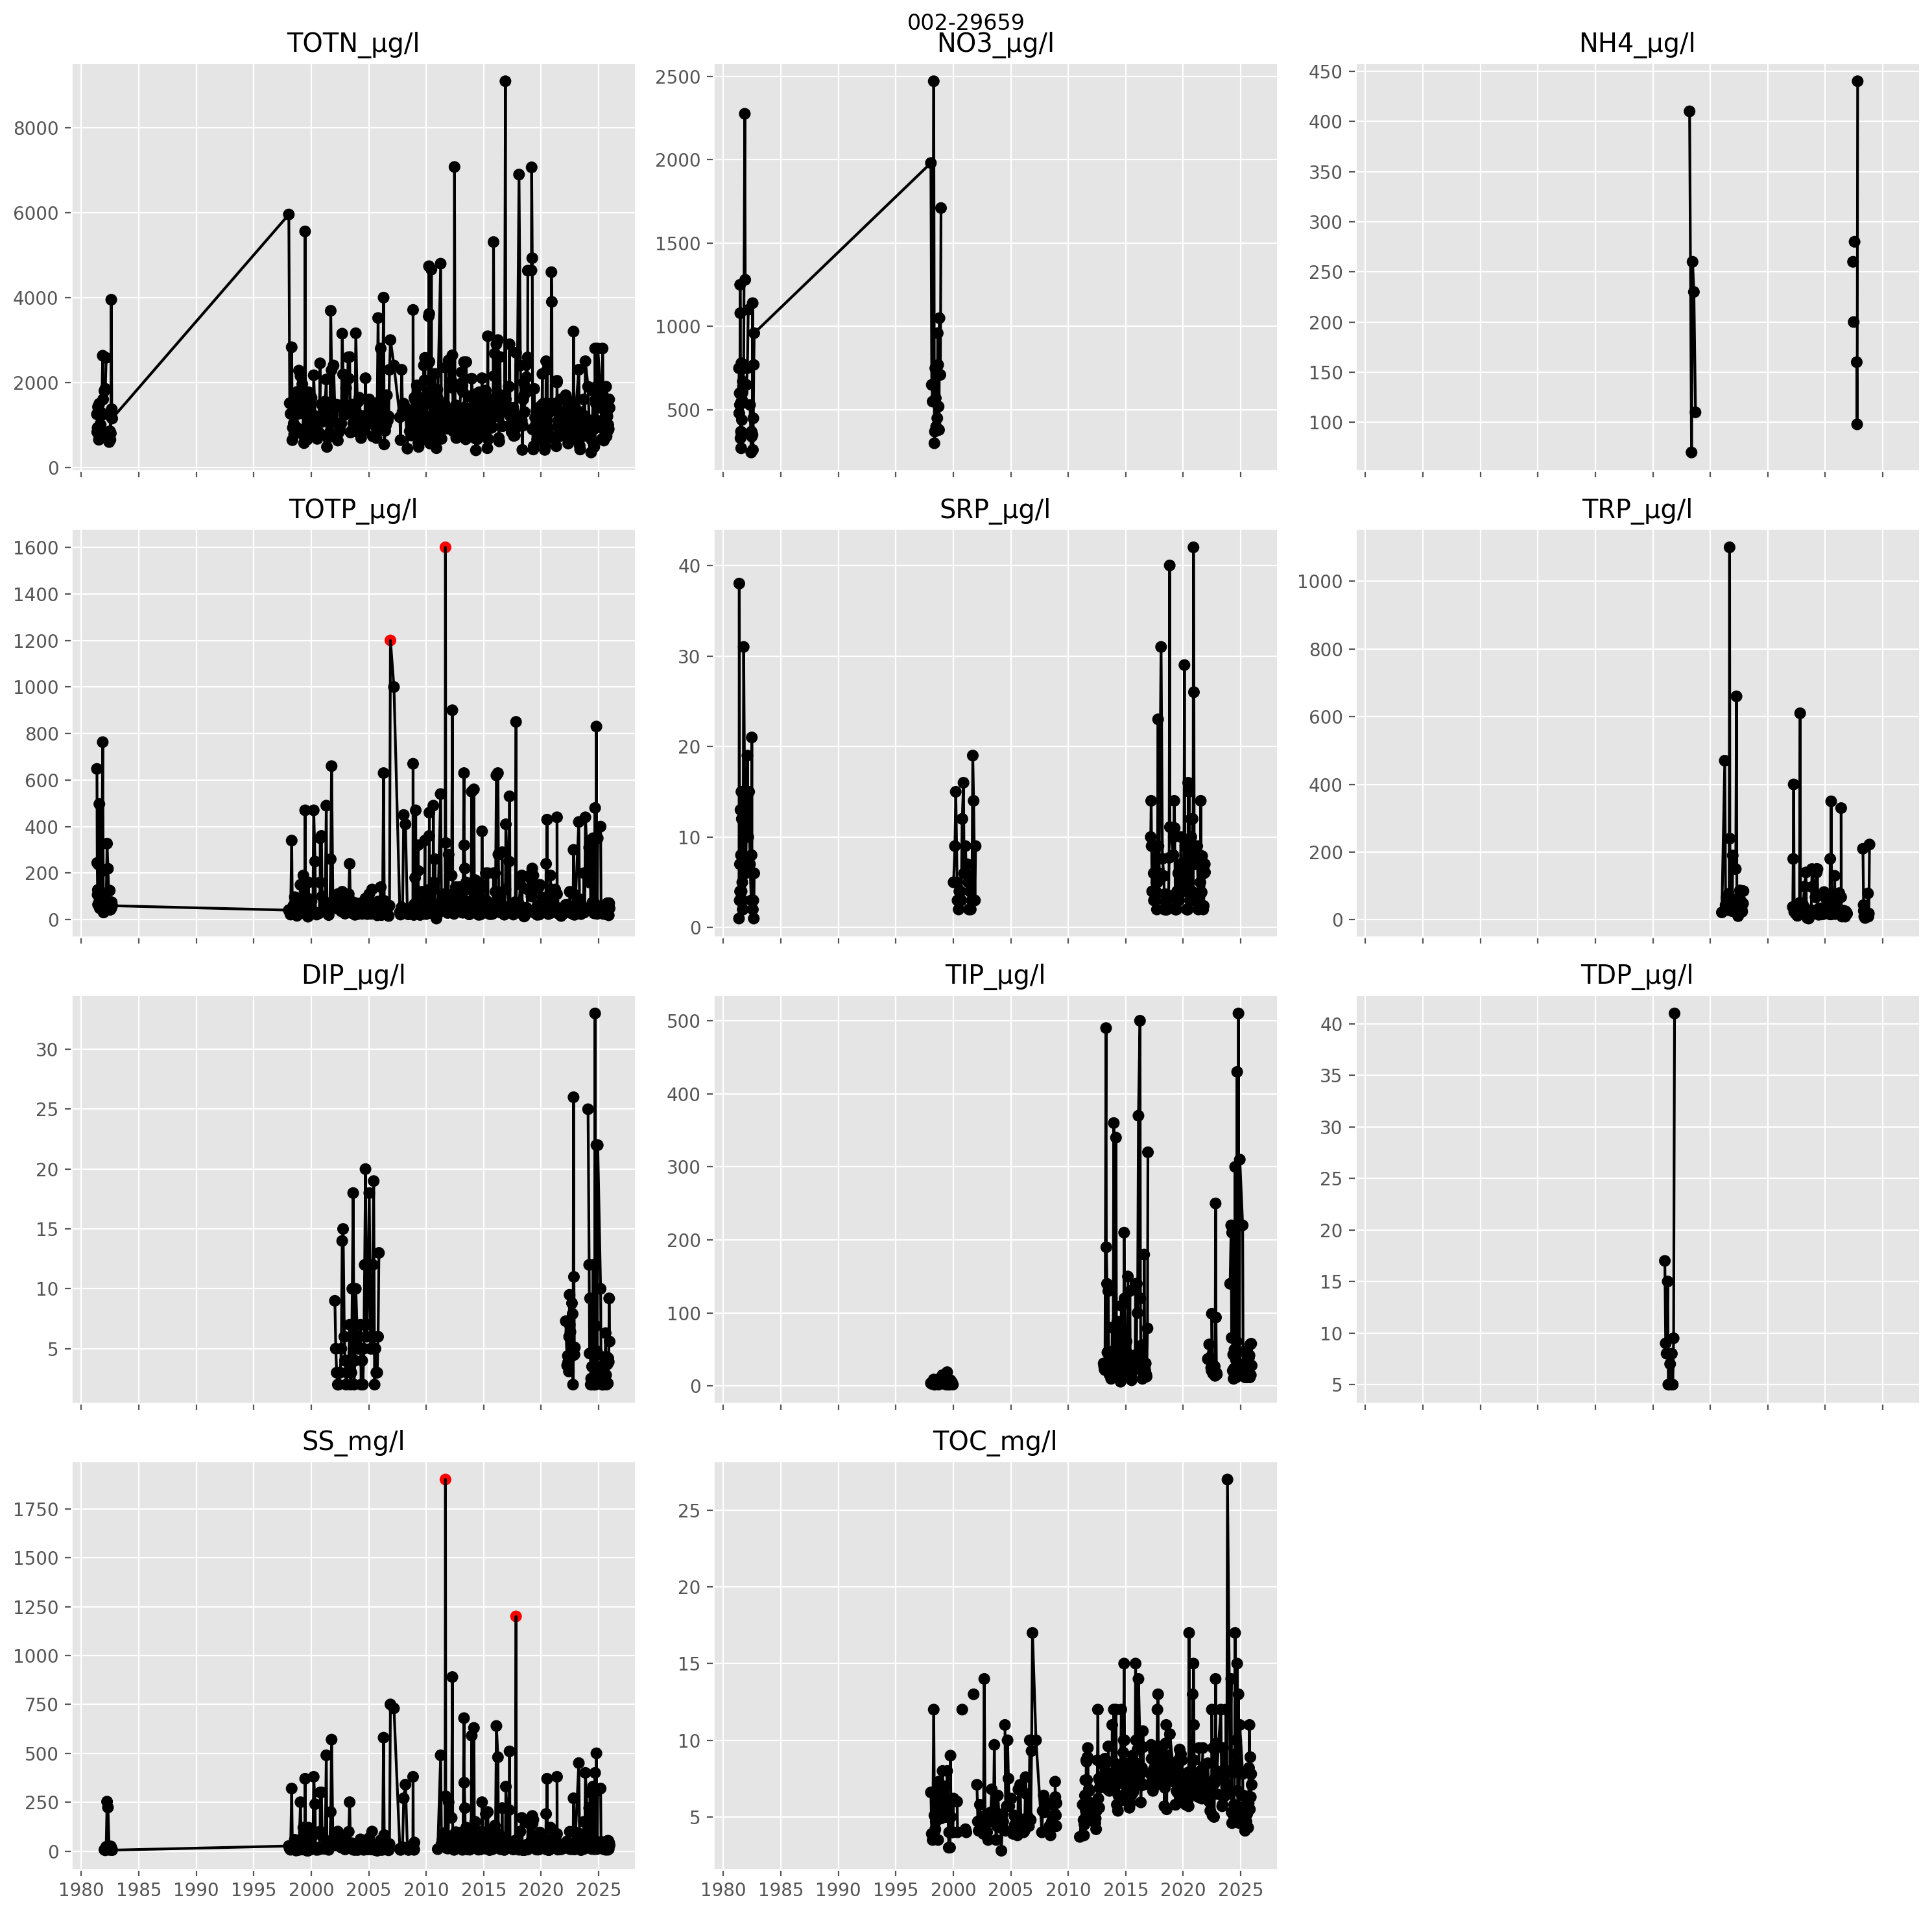
Figur 4.1: Concentrations measured at Vannmiljø station 002-29659 (Leira ved Borgen bru). Measurements identified as outliers using the “double median absolute deviation” method are shown in red.
The absence of consistent long-term monitoring of nitrogen and phosphorus fractions limits the ability to assess annual trends in concentrations and loads for these parameters. Consequently, analysis of the observed data in this project has been restricted to TOTN, TOTP, TOC and SS. A matrix plot of the raw data for these parameters for all stations is available here.
Code to download the raw data is provided in notebook 02, while outliers are flagged in notebooks 03a and 03b.

Annual mean concentrations
To assess trends in concentration, outliers were removed from the dataset and annual mean concentrations calculated for each site and waterbody. To avoid biases due to limited monitoring, annual means were only calculated for years with at least 12 data points (i.e. at least 12 samples per year per station or waterbody).
Annual mean concentrations for stations are calculated in notebook 03a and for waterbodies in notebook 03b.

Water discharge
Figur 4.2 compares simulations from NVE’s model underpinning the GTS API with observed discharge at stations 2.1185.0 (Sagelva) and 2.279.0 (Kråkfoss, Leira). The comparison period extends from 2015 to 2025 for Sagelva and from 1980 to 2025 for Kråkfoss. Overall, NVE’s model performs reasonably well, with Nash-Sutcliffe efficiencies of approximately 0.6 at both sites. However, results indicate a negative systematic bias (y-axis), suggesting that NVE’s model tends to underpredict discharge on average. Furthermore, the model substantially underestimates discharge variability (x-axis), producing a smoother signal with lower standard deviation than the observed series. This latter tendency is common in hydrological models.
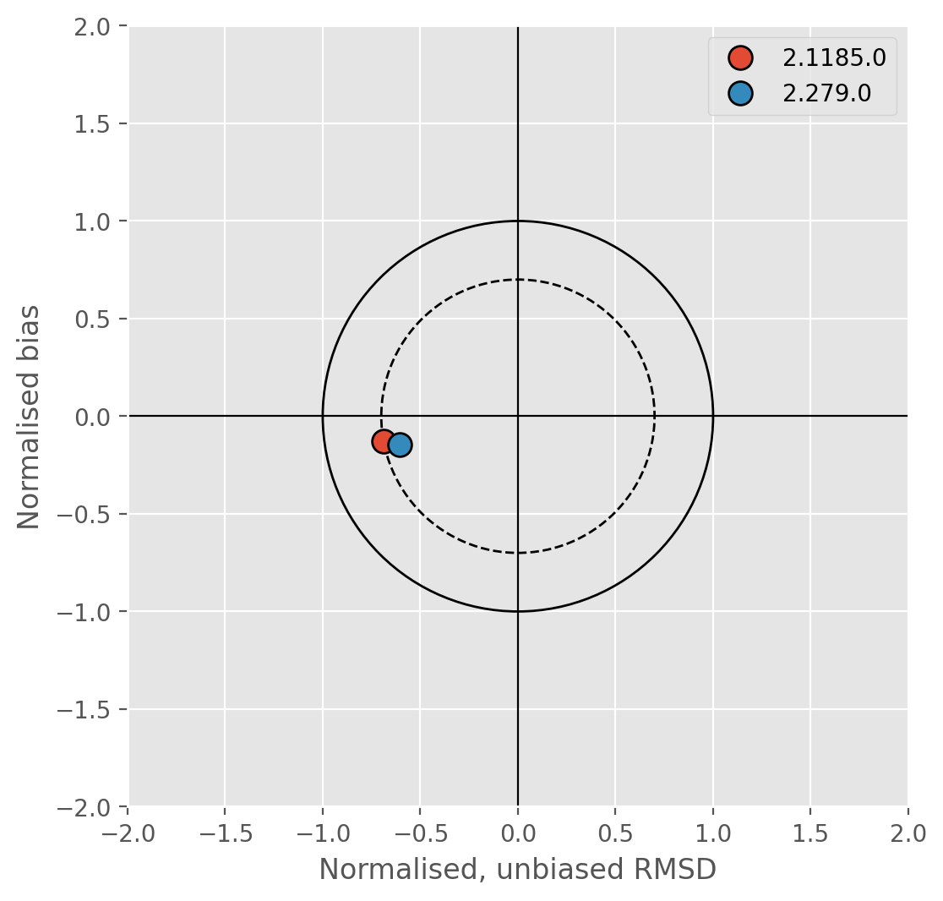
Figur 4.2: Target plot comparing NVE’s discharge simulations to measured discharge at NVE stations 2.1185.0 (Sagelva) and 2.279.0 (Kråkfoss, Leira). The y-axis shows normalised bias between simulated and observed. The x-axis is the unbiased, normalised root mean square difference (RMSD) between simulated and observed data. The distance between a point and the origin is total RMSD. RMSD = 1 is shown by the solid circle (any point within this has positively correlated simulated and observed data and positive Nash-Sutcliffe scores); the dashed circle marks RMSD = 0.7.
Based on this assessment, NVE’s modelled discharge appears to be suitable for estimating nutrient loads at monitoring stations where direct discharge measurements are not available (i.e. all stations listed in Tabell 3.1, except 002-46599). However, to reduce bias in fluxes estimated using the GTS API, a correction factor for NVE’s flow simulations was calculated as:
$$f=\frac{Obs_{avg}}{Mod_{avg}}=\frac{1}{1+bias} (4.1)$$
where $f$ is a dimensionless factor applied to simulations from the GTS API; $Obs_{avg}$ are mean observed flows at stations with discharge monitoring (2.1185.0 and 2.279.0); $Mod_{avg}$ are mean observed flows for the same stations calculated from the GTS API; and $bias$ is the estimated bias from Figur 4.2.
For station 2.1185.0 (Sagelva), the estimated correction factor, $f$, is 1.19 and for station 2.279.0 (Kråkfoss, Leira) it is 1.22. Overall, it appears the GTS API underestimates mean flows in the Lillestrøm region by about 20 %. A bias correction factor of 1.2 was therefore applied to all flows from the GTS API before calculating annual nutrient fluxes.

Annual loads
Annual loads were estimated for each monitoring station and waterbody using the cleaned concentration dataset, after removing outliers and retaining only years with at least 12 samples per site or waterbody. Daily flow data for each site were downloaded from NVE via the GTS API (see Seksjon 3.2) and bias-corrected as described above.
Estimates of annual riverine loads were calculated according to Ligning 4.2 following the recommendations in OSPAR Agreement 2014:04 (§6.13b). This is the same method used by national monitoring programmes such as Elveovervåkingsprogrammet and is designed to account for irregular sampling intervals and the influence of high-flow events.
$$L=Q_{r}\frac{\sum_{i=1}^{n}{C_{i}}Q_{i}t_{i}}{\sum_{i=1}^{n}{Q_{i}}t_{i}} (4.2)$$
where $L$ is the annual load; $Q_{i}$ represents the water discharge on sampling day $i$; $C_{i}$ is the concentration measured on day $i$; $t_{i}$ is the time period from the midpoint between day $(i−1)$ and day $i$ to the midpoint between day $i$ and day $(i+1)$, that is, half the number of days between the previous and subsequent sampling events; and $Q_{r}$ is the annual water volume.
Annual nutrient loads estimated from manual sampling are subject to considerable uncertainty, particularly when sampling frequencies are low. This is especially true for particle-bound parameters such as TPP and SS, for which a substantial proportion of the total annual load may be transported during a small number of high-flow events. The uncertainty associated with load estimates depends primarily on (i) sampling frequency, (ii) the parameter of interest, and (iii) catchment characteristics that influence the speed and magnitude of hydrological responses. In general, more frequent sampling yields more accurate load estimates, and dissolved constituents such as DIN can be estimated with greater accuracy than particulate-bound constituents (TPP and SS), because their concentrations vary less during storm events. Similarly, load estimates are often more reliable for large catchments than for small ones, because larger catchments respond more slowly, reducing the likelihood that major transport events occur between sampling dates (Slabon & Hoffman, 2024). As an example, Skarbøvik et al. (2012) analysed data from the Numedalslågen catchment (5,500 km²) and found that SS loads estimated from manual sampling at frequencies ranging from weekly to monthly typically underestimated true annual loads by 30 to 70 %. The catchments considered in this study are substantially smaller than Numedalslågen (17 to 668 km²; Tabell 2.2), while sampling frequencies vary from approximately weekly to less than monthly. It is therefore likely that annual loads for particulate-bound parameters calculated from the measured data will underestimate true fluxes.
Annual loads for stations are calculated in notebook 04a and for waterbodies in notebook 04b.

Tests for trends
Trends in annual mean concentrations and annual loads were evaluated using the Mann-Kendall test and Sen’s slope estimator (e.g. Helsel et al., 2020). The Mann-Kendall test is a non-parametric method that assesses the statistical significance of monotonic trends without assuming a specific data distribution. Sen’s slope estimator provides a robust estimate of the rate of change over time and is less sensitive to outliers than ordinary least squares regression. Together, these methods are widely applied in water quality studies because environmental monitoring data are often non-normally distributed, contain censored or extreme values, and may violate the assumptions of parametric trend analyses.
In this report, trends are considered statistically “significant” for Mann-Kendall p-values ≤0.05. Results with p-values greater than 0.05 but ≤0.10 are also noted and described as increasing or decreasing “tendencies”.
Trend tests for stations are applied in notebook 04a and for waterbodies in notebook 04b.

TEOTIL3 modelling
TEOTIL3 is applied annually at national scale as part of modelling work funded by Miljødirektoratet. For this project, standard TEOTIL3 input files were modified to include more detailed data for spredt and wastewater overflows provided by Lillestrøm kommune (see Seksjon 3.3.2). TEOTIL3 was then run using the modified input files for the period from 2013 to 2024.

Spatial resolution
TEOTIL3 uses NVE’s REGINE catchment dataset to represent the Norwegian hydrological network. REGINE (REGIster over NEdbørfelt i Norge) provides a nationwide hydrological subdivision of Norway into interconnected catchment units and forms a spatial framework used in many Norwegian water quality assessments. The dataset covers the entire mainland and coastal zone and is organised as a hierarchical network of sub-catchments linked according to surface water flow pathways. Each REGINE unit is assigned a unique watercourse identifier that preserves upstream-downstream relationships within the river network, allowing nutrient transport and retention processes to be modelled consistently from headwaters to coast.
In TEOTIL3, nutrient sources and landscape characteristics are aggregated to individual REGINE units and riverine transport is simulated using the connected catchment network. This approach provides a compromise between computational efficiency and spatial detail, enabling the model to represent local source contributions while maintaining complete coverage of large river basins.
Because the REGINE framework is hierarchical, results can be analysed at multiple spatial scales. However, TEOTIL3 is primarily designed for simulating medium to large river basins (typically 100s to 1000s of square kilometres) comprising many REGINE units. Of the catchments of interest in this study, Sagelva, Nittelva and Leira are well suited to modelling with TEOTIL3. Rømua and Åa are large enough (212 and 131 km², respectively), but each comprises just a single REGINE unit, which makes modelling using TEOTIL3 challenging. The catchments for Jeksla and Gansåa are small (17 and 25 km², respectively) and occupy less than one REGINE unit. Because they are not resolved by the REGINE network, they cannot be modelled explicitly with TEOTIL3. Model results for these catchments must therefore be estimated by area-scaling simulations for the surrounding area. This approach gives reasonable results on average, but adds uncertainty to the model results for Jeksla and Gansåa and, to a lesser extent, for Rømua and Åa.
To improve the resolution of TEOTIL3 in small catchments, this study compiled a more spatially detailed dataset of wastewater discharges than the standard one used in national scale applications of TEOTIL3 (Seksjon 4.6.2). However, nutrient inputs from other sources - especially agriculture - are underpinned by the same datasets used in the national model runs. It is important to keep in mind that these datasets have considerable uncertainty at the scale of individual REGINE units.

Lillestrøm-specific wastewater inputs
The wastewater overflow dataset provided by Lillestrøm kommune includes the location and number of people connected to each overflow, together with the number of hours of operation in each year. Annual discharges from each overflow can therefore be estimated as:
$$D=\frac{C×P×H}{24×1000} (4.3)$$
where $D$ is the nutrient discharge in kg; $C$ is the overflow capacity in p.e.; $P$ is the nutrient discharge per person per day in g; and $H$ is the number of hours of operation per year.
Values for $P$, the nutrient discharge per person per day, are based on data previously compiled by Norsk Vann (Tabell 4.2).
Tabell 4.2: Typical nutrient discharges per person per day. Based on data compiled by Norsk Vann.
Parameter | Discharge (g/pers/døgn)
TOTN | 12.0
TOTP | 1.8
BOF5 | 60.0
KOF | 120.0
SS | 70.0

Equation Ligning 4.3 can be used to estimate annual overflows for TOTN, TOTP, BOF5, KOF and SS. To estimate TOC, and fractions of N and P, we use the factors for Urenset wastewater from the TEOTIL3 database.
Site-specific spredt inputs for Lillestrøm kommune were estimated in a similar way:
$$D=\frac{365.25×C×P×(1−E)}{1000} (4.4)$$
where $D$ is the annual nutrient discharge in kg; $C$ is the capacity in p.e.; $P$ is the nutrient discharge per person per day in g (from Tabell 4.2); and $E$ is the plant treatment efficiency (a dimensionless value between 0 and 1).
The treatment efficiency, $E$, is calculated from data published by NIBIO (Hensel & Mæhlum, 2025):
$$E=E_{ideal}×(1−R) (4.5)$$
where $E_{ideal}$ is the best-case efficiency of a new or well-maintained plant, and $R$ is a reduction factor representing how much the efficiency declines for a plant of typical age and condition.
It is important to note that the site-specific spredt dataset provided by Lillestrøm kommune represents a single point in time, whereas TEOTIL3 requires input data from 2013 to 2024. The Lillestrøm-specific spredt data therefore provides better spatial resolution than the standard TEOTIL3 input files, but with the downside that the model no longer captures changes in spredt inputs over time.
Code to calculate spredt inputs and wastewater overflows using data provided by Lillestrøm kommune is in notebook 05. Notebook 06 updates the standard TEOTIL3 input files using the Lillestrøm data and runs TEOTIL3 for the period from 2013 to 2024.

Avlastningsbehov
The avlastningsbehov for a catchment or waterbody is the amount by which nutrient inputs need to reduce to achieve Good Ecological Status (GES) for the water quality element of interest. For nutrients, the Water Framework Directive defines target concentrations for Good status for TOTN and TOTP based on catchment typologies.
Given measured annual mean concentrations and a target concentration, the simplest way to estimate an avlastningsbehov is to calculate the percentage reduction in concentrations needed to achieve the target. For example, if the measured mean annual concentration of TOTP is 50 μg-P/l and the target for GES is 40 μg-P/l, a simplistic avlastningsbehov can be estimated as 20 %. This assumes a proportional relationship between nutrient inputs and observed concentrations and does not account for variability in hydrological conditions or nutrient retention processes.
To assess whether load reductions for GES are practically achievable, it is usually necessary to convert concentration-based estimates into load reduction targets in tonnes. This requires estimates of annual water volume. For example, given a concentration target for GES, $C_{GES}$, and the annual water volume, $V$, the maximum annual load for GES, $L_{max}$, can be estimated as:
$$L_{max}=C_{GES}×V (4.6)$$
Given present-day load estimates based either on monitoring data or modelling (e.g. with TEOTIL3), the avlastningsbehov in tonnes can be calculated as the difference between the present-day load and $L_{max}$:
$$A_{i}=L_{i}−L_{max}=L_{i}−(C_{GES}×V_{i}) (4.7)$$
where $A_{i}$ is the estimated avlastningsbehov (in e.g. tonnes) to achieve GES in year $i$; $L_{i}$ is load estimate for year $i$ based on either monitoring or modelling; and $V_{i}$ is the annual water volume in year $i$. Note that negative values for $A_{i}$ in this equation indicate years in which estimated loads were already below the GES threshold and therefore no load reduction was required.
In this study, we calculate time series of annual loads using both monitoring data and TEOTIL3. We also have simulations of annual flow volume in each catchment based on data from the GTS API (Seksjon 3.2). For each catchment and parameter, we estimate a time series of annual avlastningsbehov based on monitoring, $A_{i}^{mon}$, and on modelling, $A_{i}^{mod}$.
The typical avlastningsbehov in each catchment is calculated as the median of annual values. This is done separately for monitoring and modelling to give two medians, ${\tilde{A}}^{mon}$ and ${\tilde{A}}^{mod}$. Since the median is the middle value when numbers are placed in ascending order, the median avlastningsbehov can be interpreted as the load reduction that would have achieved GES in half the years considered. Differences between ${\tilde{A}}^{mon}$ and ${\tilde{A}}^{mod}$ reflect methodological uncertainties, such as limitations in the assumptions made by TEOTIL3, or whether the monitoring data are good enough to accurately measure “true” nutrient loads.
As well as calculating a median avlastningsbehov for each catchment, the distribution of annual avlastningsbehov provides useful information about the degree of interannual variation in the estimated reductions. These distributions are calculated for each catchment by applying Kernel Density Estimation (KDE) to the datasets of annual avlastningsbehov expressed as percentages:
$$A_{i}^{pct}=100\frac{L_{i}−L_{max}}{L_{i}} (4.8)$$
As an example, consider Figur 7.5, which shows estimated avlastningsbehov for Leira. Red curves on each plot show distributions of avlastningsbehov based on monitoring data, while blue curves show distributions based on modelling with TEOTIL3. Vertical dashed lines show the median value of each distribution, while the shape of the curves indicates variability. Broad, flat curves suggest the avlastningsbehov is poorly constrained (i.e. in some years it may be significantly higher or lower than the median value), whereas narrow, pointed curves indicate low variation (i.e. the avlastningsbehov remains consistent from year to year).
For TOTN in Leira, both distributions are narrow, indicating the avlastningsbehov is well-constrained. The median avlastningsbehov based on monitoring data is 42 %, compared to 55 % using TEOTIL3. For TOTP, the distributions are broader: TEOTIL3 assigns higher probabilities to avlastningsbehov in the 50 to 60 % range, while estimates based on monitoring are more like 45 to 55 %. Nevertheless, the median estimates are almost identical (54 % and 55 %).

Scenarios
Wallhead et al. (2026) considered two scenarios of wastewater and agricultural measures designed to reduce nutrient loads to the Oslofjord:
- Scenario A is a medium ambition scenario designed to reflect implementation of measures covered by existing legislation.
  - For agriculture, measures are only applied within the five environmental requirement zones (miljøkravsonene): Viken 1 and 2 (Akershus, Østfold, Oslo and Buskerud, Gran municipality in Innlandet); Innlandet 1 (Innlandet); and Vestfold & Telemark 1 and 2 (Grenland, Midtre Telemark and Vestfold). In the rest of the Oslofjord catchment, agricultural measures in scenario A represent those already in place in 2021. See Tabell 4.3 for list of agricultural measures considered in each scenario.
  - For wastewater treatment, scenario A assumes all treatment plants larger than 10 000 p.e. are upgraded to achieve minimum treatment efficiencies of 80 % for TOTN, 95 % for BOF5, 95 % for KOF, and 95 % for SS. Plants with treatment efficiencies exceeding these targets were assumed to retain their existing performance. For example, if a plant already had 85 % efficiency for TOTN in the historic data, it retained this efficiency in this scenario. In addition, annual wastewater overflows equivalent to 2 % of influent volume were assumed for all treatment plants serving more than 1,000 people.
- Scenario B is a more ambitious scenario designed to explore what could be achieved by expanding and intensifying existing measures to the whole Oslofjord catchment. Scenario B includes all measures from scenario A, plus:
  - For agriculture, measures are expanded beyond the environmental requirement zones to cover the whole Oslofjord catchment. In addition, scenario B includes reductions to soil nitrogen and phosphorus excesses for all agricultural land (measures “P-AL-reduksjon” and “N-balansereduksjon”). See Tabell 4.3 for details.
  - For wastewater treatment, plants with capacity >10 000 p.e. discharging directly to the Oslofjord were upgraded to achieve 85 % treatment efficiency for TOTN, while those with capacity between 5000 and 10 000 p.e. were upgraded to achieve 70 % efficiency for TOTN. In addition, wastewater overflows were reduced to 1 % for all plants serving more than 1000 people.
Tabell 4.3: Summary of agricultural measures in scenarios A and B. After Wallhead et al. (2026).
Tiltak | Området |  | Forutsetninger
 | Scenario A | Scenario B
Ingen jordarbeiding rundt kummer innenfor 2 m fra kummen | Alle miljøkravsoner | Hele nedbørfelt | Ytterligere gjennomføring av dette tiltaket påvirker 65% av åpenåkerarealet. Det er i AGRITIL-SPC lagt inn en renseeffekt av 2 m bred grasdekt kantsone rundt kum lik 10 % for SS
Ingen jordarbeiding om høsten i erosjonsrisikoklasse 3-4 på alt areal med dyrka mark | Alle miljøkravsoner | Hele nedbørfelt | Lett høstharving er tillatt ifølge miljøkravene, men det er valgt å beregne med stubb på alt kornareal i disse erosjonsrisikoklassene. Eng i klasse 3-4 kan ikke høstpløyes.
Ingen jordarbeiding om høsten på alt kornareal i erosjonsrisikoklasse 1-2 | - | Hele nedbørfelt | -
Gras i dråg, 6 m bredde | Alle miljøkravsoner | Hele nedbørfelt | Scenario A: I Vestfold er det åpnet for 20 m stubb i dråg, og andre løsninger på potet og grønnsaker. I Innlandet kreves gras i dråg kun dersom det velges 60 m bred kantsone av stubb mot vassdrag i stedet for grasdekt kantsone. Dette forenkles til å regne med gras i dråg i Viken 1 og 2 og Vestfold & Telemark 1 og 2, men ikke i Innlandet.
Grasdekt kantsone langs alle vassdrag, 6 m bredde, på alt åpenåkerareal | Alle miljøkravsoner | Hele nedbørfelt | Krav om 2 m obligatorisk naturlig kantsone allerede er innfridd ved faktisk drift 2021. Forskriftene åpner for at en i stedet kan velge 20 m stubb i Viken og i Vestfold & Telemark, og 60 m stubb i Innlandet, men modellen kan ikke beregne effekter av dette. Derfor forutsetter vi grasdekt kantsone overalt (noe som vil gi noe overvurdert effekt).
60 % plantedekke (inkludert stubb, gras, direktesådd fangvekst og høstkorn, lett høstharving til høstkorn eller høstoljevekster) | Viken 2 og Vestfold & Telemark 2 | - | I Vestfold & Telemark 2 er 20 % fangvekst et alternativ til 60 % plantedekke (forskriften legger opp til valgfrihet mellom disse to), men vi velger for enkelhets skyld samme tilnærming som for Viken 2. Kravet gjelder egentlig på hvert enkelt foretaks areal, men modellene opererer ikke på så liten skala, så kravet gjøres om til å gjelde på REGINE-skala.
Fangvekst på 80% av arealet med tidligkulturer av potet og grønnsaker | Vestfold & Telemark 1 og 2 | Hele nedbørfelt | Tidligkulturer utgjør 32 % av totalt areal med potet og grønnsaker, jf. Kværnø & Bechmann (2024), dvs. at det blir fangvekst på 26 % av totalt areal med potet og grønnsaker.
Fangvekst på 50% av kornarealet | - | Hele nedbørfelt | Ikke der det er høstkorn
P-AL-reduksjon | - | Hele nedbørfelt | Det er beregnet hva gjennomsnittlig P-AL vil bli i hver REGINE-enhet i 2040, gitt at P-balansen holdes på -1,5 kg P/daa fra 2021. Beregningen er basert på tall fra Øgaard et al. (2016).
N-balansereduksjon | - | Hele nedbørfelt | Gjennomsnittlig N-balanse settes til maksimalt +2,5 kg/daa

For full details of the Oslofjord scenarios modelling, see Wallhead et al. (2026). It is important to note that scenario B should not be interpreted as a recommendation for future management: it was originally designed by Miljødirektoratet to explore maximum load reductions that could be achieved using traditional packages of measures. Commonly funded agricultural measures are effective at reducing losses of particulate material (SS and TPP), but are generally less effective for nitrogen. In the Oslofjord modelling work, Wallhead et al. (2026) showed that scenario A generally achieves sufficient reductions for phosphorus and particulate material, but not for nitrogen. Scenario B, meanwhile, achieves larger reductions than necessary for phosphorus and particles, and approaches the reduction required for nitrogen. A more balanced future management scenario would therefore combine the reductions in particulate material and phosphorus achieved by scenario A with the reductions in nitrogen losses achieved by scenario B.
For this project, it was not possible to re-run the scenarios from the Oslofjord modelling work. Instead, more detailed historical simulations have been set up for Lillestrøm by applying TEOTIL3 with Lillestrøm-specific input datasets (Seksjon 4.6.2). This provides a more refined historical baseline for Lillestrøm that can be evaluated alongside the higher-level results from the Oslofjord scenario modelling.
When comparing avlastningsbehovene for Lillestrøm catchments to reductions achieved by the Oslofjord scenarios modelling, it is important to remember that the scenarios themselves are not proposals for future management. For example, for Sagelva, the estimated avlastningsbehov for GES for TOTN is between 8 and 19 % (Tabell 5.3). Scenario A fails to achieve this, but scenario B is sufficient (Figur 5.6). The interpretation is that measures achieving reductions in nitrogen loads comparable to scenario B will be needed to achieve GES for TOTN in Sagelva. However, the necessary reductions may be achievable through more targeted and efficient combinations of measures focused specifically on nitrogen, rather than through the broader suite of interventions represented by Scenario B.

Sagelva

Catchment overview
Sagelva is a small catchment (109 km²) draining to Nittelva in the western part of Lillestrøm kommune. Land cover is dominated by forest (71 %), but with significant urban (16 %) and agricultural (6 %) areas. See Figur 5.1 and Tabell 5.1. The catchment is classified as leirpåvirket (clay-influenced) under the Water Framework Directive and about 14 % of the catchment is underlain by marine sediments and clays (Tabell 3.2).
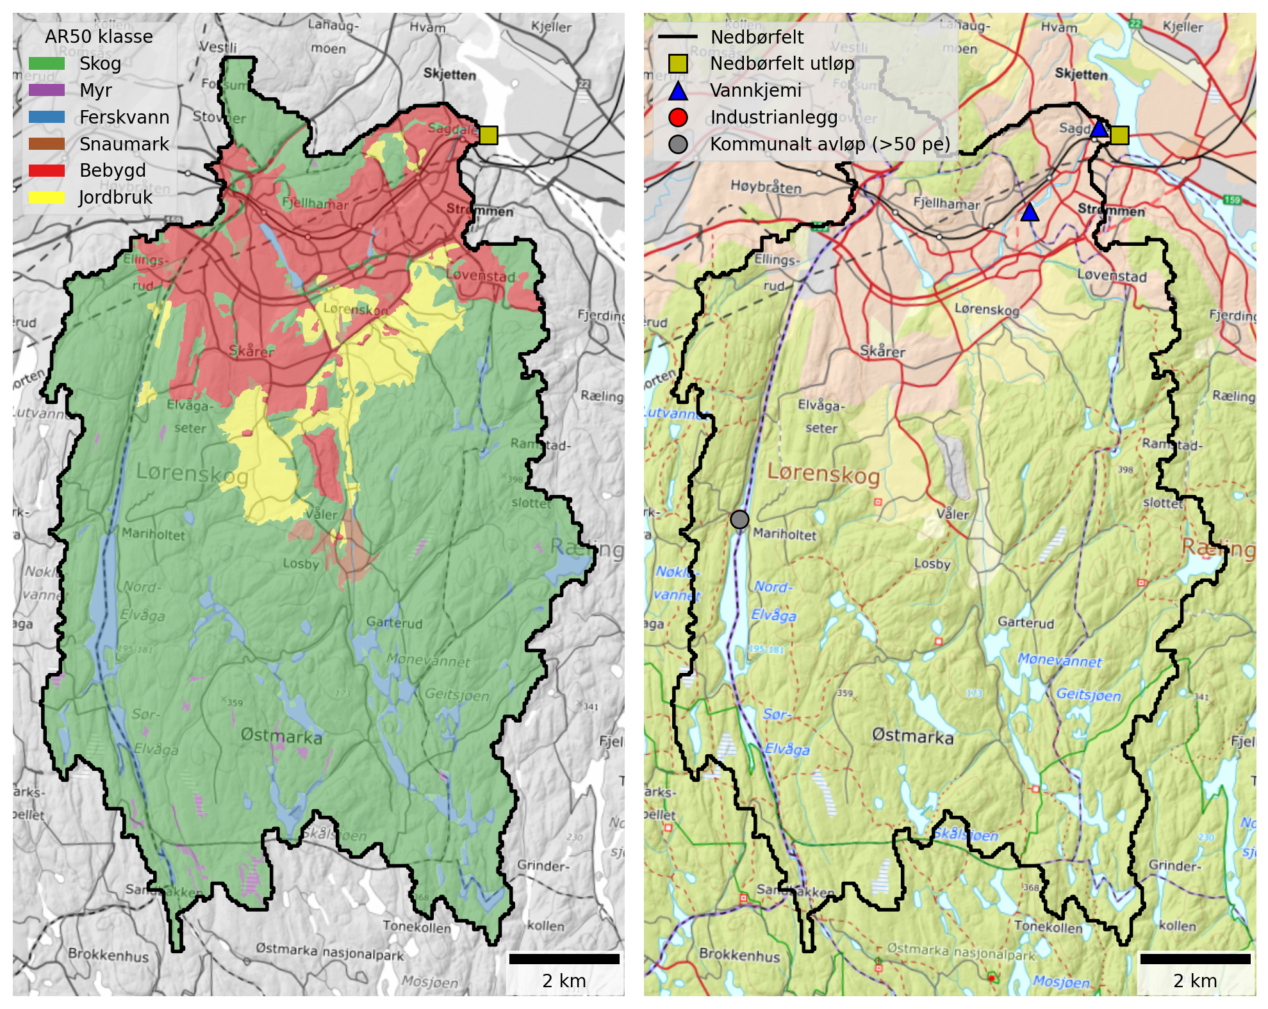
Figur 5.1: Maps of the Sagelva catchment. Left: Land cover based NIBIO’s AR50 dataset. Right: Point source discharges from industry and municipal wastewater plants (≥50 p.e.).

Tabell 5.1: Land cover proportions for Sagelva based on NIBIO’s AR50 dataset.
Nedbørfelt | Sagelva
AR50 klasse | km² | %
Bebygd | 17.6 | 16
Jordbruk | 6.8 | 6
Skog | 77.0 | 71
Snaumark | 1.2 | 1
Myr | 0.7 | 1
Ferskvann | 5.6 | 5
Totalt | 108.9 | 100

There are no major industrial discharges within the Sagelva catchment and the only municipal wastewater plant with design capacity ≥50 p.e. is Mariholtet sportsstue, which reports low discharges of nutrients (Tabell 5.2).
Tabell 5.2: Industrial and municipal wastewater discharges (≥50 p.e.) within the Sagelva catchment. Values are mean annual discharges from 2013 to 2024, excluding overflows.
Navn | Sektor | Type | TOTN (tonn) | TOTP (tonn) | TOC (tonn) | SS (tonn)
Mariholtet sportsstue, renseanlegg | Kommunalt avløp (>50 pe) | Naturbasert | 0.01 | 0.00 | 0.01 | 0.01

Monitoring data
The best monitoring data for Sagelva comes from Vannmiljø stations 002-46599 (Sagelva ved Skjetten bro, F3) and 002-63540 (Fjellhammarelva, F10), both of which are located within waterbody 002-3899-R (Fjellhamarelva - Sagelva) in the lower part of the catchment (blue triangles on Figur 5.1). Skjetten bro is the downstream-most station with the longest monitoring record, beginning in 1995.
Figur 5.2 shows trends in mean annual concentrations estimated from the combined dataset for waterbody 002-3899-R. Concentrations of SS and TOTP have remained broadly stable over the past 30 years, but there has been a significant decline in TOTN concentrations (by about -8 μg-N/l/year) and a significant increase in TOC concentrations (about +0.1 mg-C/l/year).
In terms of water quality status, concentrations of TOTN have improved from the middle of the moderate class in 2010 to close to the boundary between moderate and good in 2023-25. If this trend continues, waterbody 002-3899-R will likely achieve Good Ecological Status (GES) for TOTN in the coming years. For TOTP, concentrations are broadly stable at around 40 μg-P/l. This corresponds to the boundary between moderate and good status for a catchment of this type with around 20 % marine clay cover. For TOC, there appears to be a step-change increase in concentrations between 2012 and 2013. This may be due to changes in water sampling or analysis protocols, although according to Vannmiljø the reporting lab has not changed.
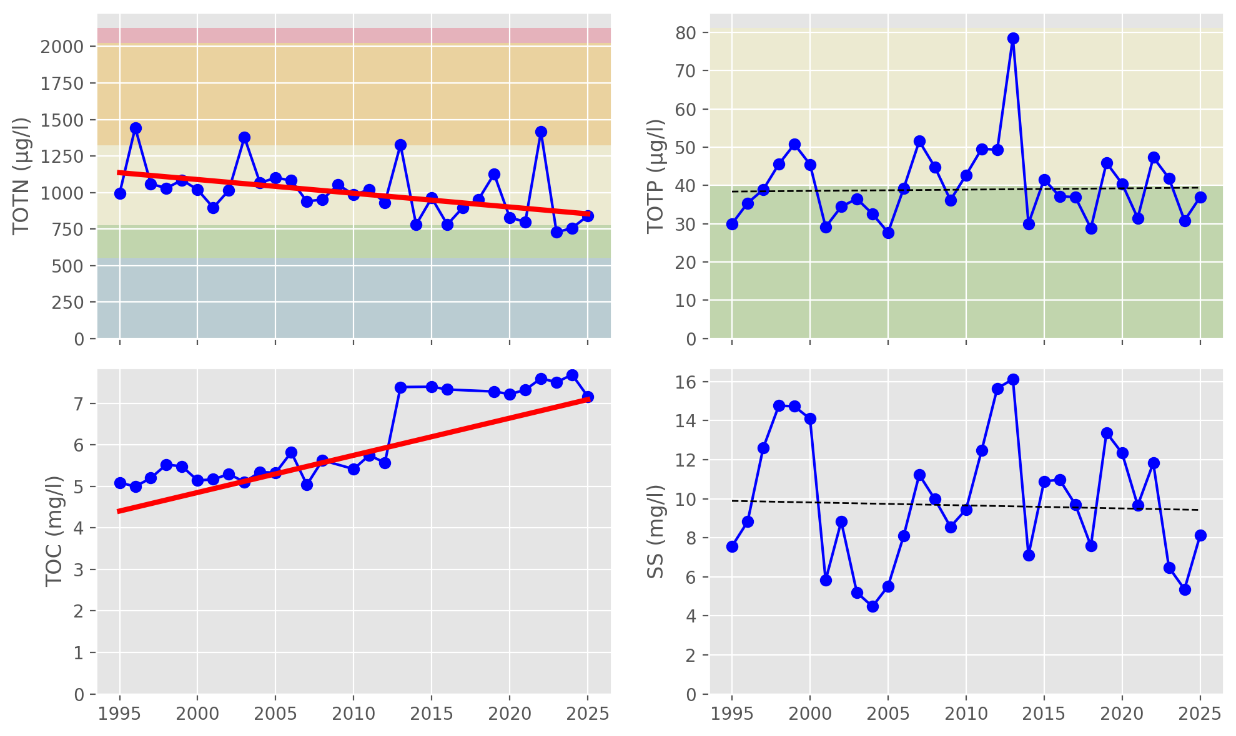
Figur 5.2: Trends in annual mean concentrations for waterbody 002-3899-R (Fjellhamarelva - Sagelva). Solid red lines show statistically significant linear trends ($p≤0.05$); dashed red lines indicate weak evidence of a linear trend ($0.05<p≤0.10$); and dashed black lines indicate no statistically significant trend ($p>0.10$). Background colours show thresholds for water quality status defined under the Water Framework Directive and taken from Vann-Nett, where available (bad, poor, moderate, good and high).

Source apportionment
Figur 5.3 shows nutrient fluxes estimated from observed data (black lines) together with source-apportioned fluxes simulated by TEOTIL3 (stacked bars). TEOTIL3’s simulations for TOTN are broadly in agreement with the monitoring data, and results for TOC are also reasonable. For TOTP and - especially - SS, annual fluxes simulated by TEOTIL3 are higher than the estimates based on monitoring data. It is possible that TEOTIL3 is overestimating losses of particulate material (SS and TPP) in this catchment. However, it is also likely that particulate fluxes (TPP and SS) estimated from infrequent sampling data underestimate the true nutrient load (see Seksjon 4.4).
Given the uncertainties in both monitoring and modelling, it is reasonable to suggest that nutrient fluxes from Sagelva are approximately:
- 40 to 80 tonnes/year for TOTN
- 2 to 4 tonnes/year for TOTP
- 300 to 600 tonnes/year for TOC
- 1000 to 2000 tonnes/year for SS
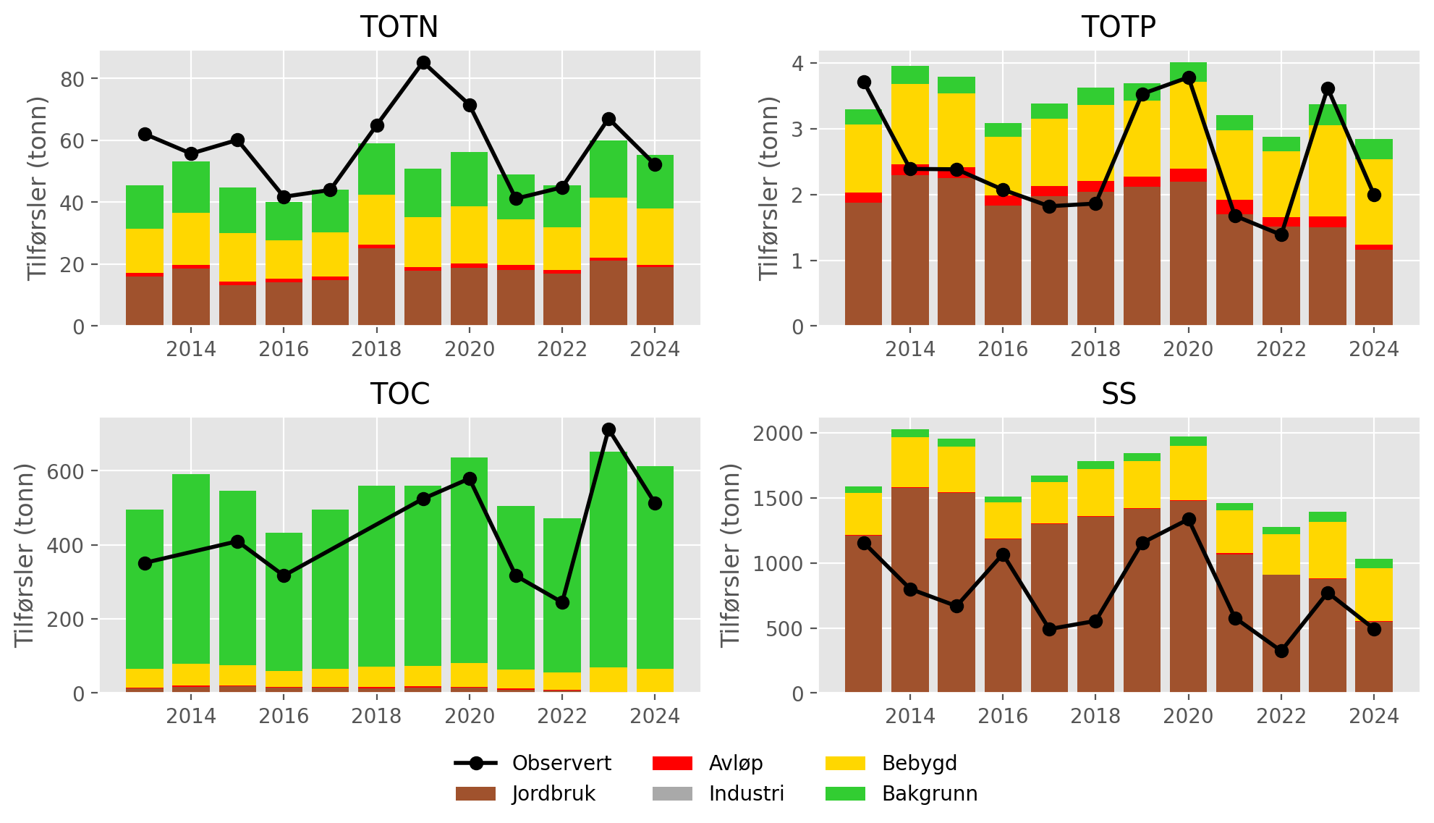
Figur 5.3: Annual nutrient fluxes for waterbody 002-3899-R (Fjellhamarelva - Sagelva). Black lines show fluxes estimated from monitoring data; stacked bars show source-apportioned fluxes simulated by TEOTIL3.
Figur 5.4 shows the mean percentage contribution from each source to annual fluxes for the period from 2020 to 2024. According to TEOTIL3, agriculture is the dominant source of TOTN, TOTP and SS, but there are significant contributions from urban runoff in the lower part of the catchment, which is densely populated. TOC fluxes are dominated by background inputs from forest areas in the south of the catchment (Figur 5.1). The contribution from wastewater discharges in this catchment is small: about 5 % for TOTP and less than 2 % for TOTN, TOC and SS. There are no large municipal wastewater plants in this catchment, so the wastewater contribution comes primarily from rainwater overflows from the municipal wastewater network. On average, rainwater overflows within Lillestrøm kommune account for about 4 % of the annual TOTP load and 2 % of the annual TOTN load (the contribution to SS and TOC is negligible). Spredt avløp also makes a contribution of about 1 % of the TOTP load (and less for the other parameters).
It is important to note that the overflows dataset provided by Lillestrøm kommune only includes discharges within the kommune boundary, which only covers the northern-most part of the Sagelva catchment (Figur 2.1). The true contribution from wastewater overflows would be greater if discharges from neighbouring kommuner, such as Lørenskog, were included.
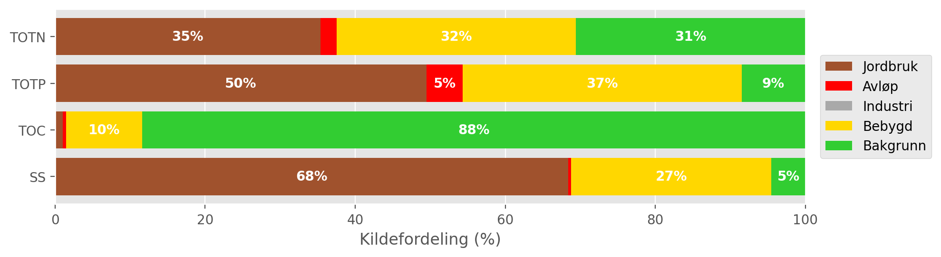
Figur 5.4: Mean source-apportionment for waterbody 002-3899-R (Fjellhamarelva - Sagelva) based on TEOTIL3 simulations from 2020 to 2024. For clarity, labels are omitted for sources contributing less than 3 %.

Load reductions and scenarios
During the decade from 2015 to 2024, the median annual flow volume from Sagelva (station 002-46599) was 52 Mm³/year. Taking the maximum concentrations for GES of 775 μg/l for N and 40 μg/l for P, the maximum annual load for Good status is approximately 40 tonnes for TOTN and 2 tonnes for TOTP. These values are at the lower limit of nutrient loads measured in recent years (Figur 5.3). Combining the same GES thresholds with the annual flow time series from NVE, we calculate an avlastningsbehov for each year from 2015 to 2024, using both observed nutrient loads (black lines on Figur 5.3) and loads modelled using TEOTIL3 (stacked bars on Figur 5.3).
Figur 5.5 shows the distribution of annual avlastningsbehovene for the period from 2015 to 2024. Since TOTN fluxes simulated by TEOTIL3 are slightly lower than fluxes calculated from monitoring data (Figur 5.3), the median avlastningsbehov from TEOTIL3 (8 %) is lower than that based on monitoring data (19 %). The distributions based on both modelled and observed data are broad, suggesting that in some some years reductions of more than 25 % would be required to maintain “good” status. However, overall, reduction targets of 10 to 20 % seem reasonable for TOTN.
For TOTP, the fluxes simulated by TEOTIL3 are generally higher than estimates based on monitoring data (Figur 5.3). Monitored fluxes are usually around 2 tonnes per year, but occasionally up to ~4 tonnes per year. Since 2 tonnes per year is close to the maximum for GES, the median avlastningsbehov based on observed data is small (3 %), although in some years it is a high as 15 %. TEOTIL3 results are typically less variable, with simulated TOTP fluxes usually around 3 tonnes per year. This gives a much higher median avlastningsbehov of 40 % (Tabell 5.3).
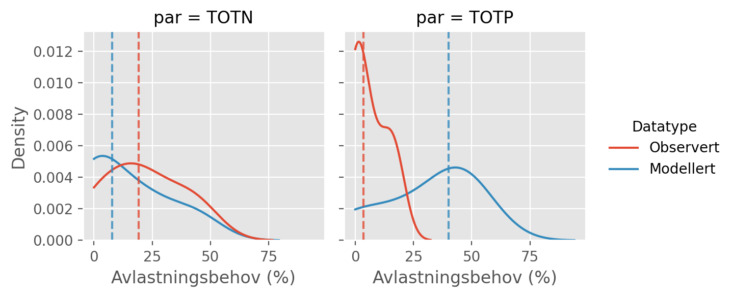
Figur 5.5: Distributions of annual avlastningsbehovene (in percent) for the ten year period from 2015 to 2024, based on observed fluxes (red curves) and fluxes simulated by TEOTIL3 (blue curves). Vertical dashed lines show the median avlastningsbehov based on each dataset i.e. the load reduction that would have achieved GES in roughly half of the ten year period.
Figur 5.6 shows load reductions achieved for the Sagelva catchment by two scenarios modelled by Wallhead et al. (2026). These scenarios considered packages of agricultural measures and upgrades to larger municipal wastewater treatment plants (Seksjon 4.8). Since there are no significant discharges from municipal wastewater plants to the Sagelva catchment, all reductions are achieved by agricultural measures. Furthermore, results from this study suggest that additional reductions of up to 4 % for TOTP and 2 % for TOTN could be achieved if rainwater overflows from Lillestrøm kommune were reduced to zero (Seksjon 5.3).
The required TOTN reductions for GES of 10 to 20 % cannot be achieved by scenario A, but could plausibly be achieved by scenario B. For TOTP, scenarios A and B both comfortably exceed the 3 % reduction target estimated from the monitoring data, and scenario B achieves a TOTP reduction of 36 %, which is approximately equal to the avlastningsbehov for GES based on TEOTIL3 simulations.
A summary of avlastningsbehovene for GES in Sagelva and the reductions achieved by scenarios A and B is shown in Tabell 5.3.
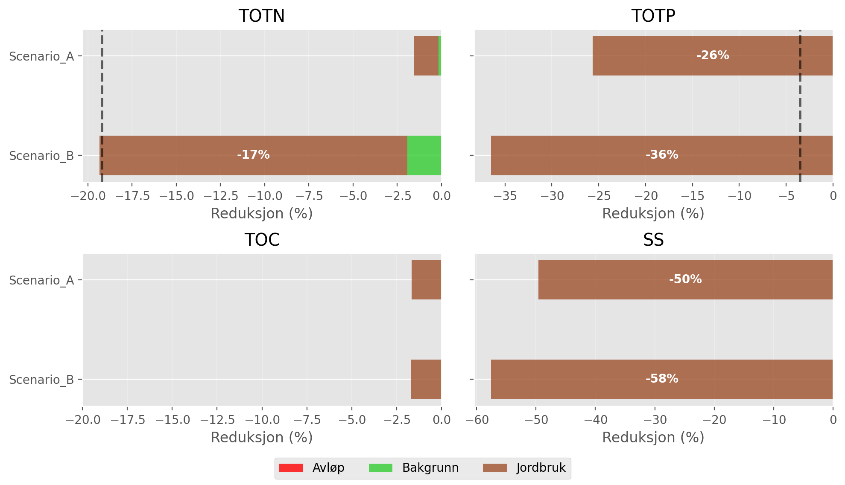
Figur 5.6: Load reductions achieved in the Sagelva catchment by scenarios A and B of Wallhead et al. (2026). Black vertical lines on the plots for TOTN and TOTP show the median avlastningsbehov for GES estimated using observed data (Figur 5.5). For clarity, labels are omitted from bars representing less than 3 %.

Tabell 5.3: Summary of avlastningsbehovene and scenario results for Sagelva.
Nedbørfelt | Vannforekomst ID | Parameter | Vann-Nett tilstand | Avlastningsbehov fra observert data (%) | Avlastningsbehov fra modellert data (%) | Reduksjon ScA (%) | Reduksjon ScB (%)
Sagelva | 002-3899-R | SS | Undefined |  |  | -50 | -58
Sagelva | 002-3899-R | TOC | Undefined |  |  | -2 | -2
Sagelva | 002-3899-R | TOTN | Moderate | -19 | -8 | -2 | -19
Sagelva | 002-3899-R | TOTP | Moderate | -3 | -40 | -26 | -36

Nittelva (including Sagelva)

Catchment overview
Nittelva is a medium sized catchment (484 km²) that includes Sagelva as a tributary. Land cover is dominated by forest (75 %), but there are significant areas of urban and agricultural land located along the river valley and in the lower part of the catchment. See Figur 6.1 and Tabell 6.1. 25 % of the catchment is located below the marine limit and approximately 13 % of the land area - including most agricultural land - is underlain by marine deposits. For this reason, the catchment is classified as leirpåvirket (clay-influenced) under the Water Framework Directive (Tabell 3.2).
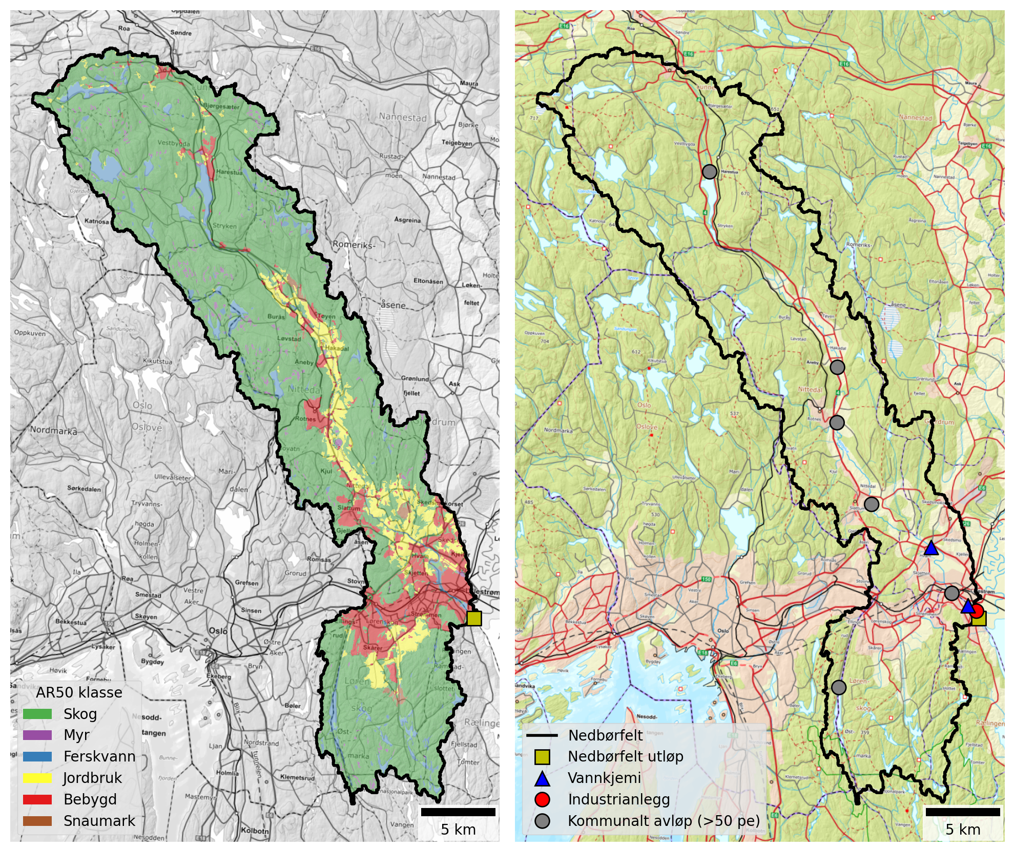
Figur 6.1: Maps of the Nittelva catchment (including Sagelva). Left: Land cover based NIBIO’s AR50 dataset. Right: Point source discharges from industry and municipal wastewater plants (≥50 p.e.).

Tabell 6.1: Land cover proportions for Nittelva (including Sagelva) based on NIBIO’s AR50 dataset.
Nedbørfelt | Nitelva
AR50 klasse | km² | %
Bebygd | 45.3 | 9
Jordbruk | 36.1 | 8
Skog | 363.9 | 75
Snaumark | 3.8 | 1
Myr | 9.1 | 2
Ferskvann | 25.7 | 5
Totalt | 483.9 | 100

Nittelva receives discharges from several municipal wastewater treatment plants, the largest of which is Nedre Romerike avløpsanlegg (NRA), located just upstream of the catchment outflow. A little further upstream there is also a decommissioned treatment plant at Slattum, which was operational until 2019. In the middle part of the catchment there are treatment plants at Rotnes and Åneby, and in the upper catchment is Harestua renseanlegg, which discharges to the northern end of Harestuvatnet. The catchment also receives significant nutrient inputs from Dynea Lillestrøm, a manufacturer of adhesives and industrial coatings that discharges close to the catchment outflow (Figur 6.1 and Tabell 6.2).
Note that, as of 2026, the wastewater treatment plants at Rotnes and Åneby are being decommissioned and effluent diverted to NRA. However, since the modelling in this report uses data up to 2024, both plants are considered “active” in this analysis.
Tabell 6.2: Industrial and municipal wastewater discharges (≥50 p.e.) within the Nittelva catchment. Values are mean annual discharges from 2013 to 2024, excluding overflows.
Navn | Sektor | Type | TOTN (tonn) | TOTP (tonn) | TOC (tonn) | SS (tonn)
Mariholtet sportsstue, renseanlegg | Kommunalt avløp (>50 pe) | Naturbasert | 0.01 | 0.00 | 0.01 | 0.01
Dynea Lillestrøm | Industrianlegg | Kjemisk industri | 27.13 | 0.11 | 17.86 | 5.79
NRA (Nedre Romerike avløpsanlegg) | Kommunalt avløp (>50 pe) | Kjemisk-biologisk m/N-fjerning | 179.29 | 5.20 | 217.73 | 162.97
Diplom-Is avd Produksjon Gjelleråsen | Industrianlegg | Næringsmiddelindustri, unntatt fiskeforedling | - | - | 0.65 | -
Rotnes renseanlegg | Kommunalt avløp (>50 pe) | Kjemisk | 24.79 | 0.37 | 20.27 | 15.51
Slattum renseanlegg (Nedlagt) | Kommunalt avløp (>50 pe) | Kjemisk | 25.25 | 0.42 | 54.56 | 30.44
Åneby renseanlegg | Kommunalt avløp (>50 pe) | Kjemisk | 18.03 | 0.14 | 12.32 | 6.51
Harestua renseanlegg | Kommunalt avløp (>50 pe) | Kjemisk-biologisk | 11.61 | 0.13 | 6.34 | 12.41

Monitoring data
The best monitoring data for the Lower Nittelva (waterbody ID 002-3891-R) come from Vannmiljø station 002-30586 (Rud Nittelva), which has been monitored since the 1980s. Monitoring at this station stopped at the end of 2020, after which the best data come from station 002-79092 (Nittelva, Rud), located about 300 m upstream. The monitoring dataset for this waterbody is generally of good quality, except during 2021 and 2022, when the sampling frequency is low. About 5 km further upstream, Vannmiljø station 002-30578 (Kjellerholen Nittelva) also provides long-term data for waterbody 002-1638-R (Nittelva Slattum-Kjeller), beginning in 1995.
Figur 6.2 shows trends in mean annual concentrations estimated from the combined dataset for waterbody 002-3891-R. Since the 1980s, there have been significant decreases in concentrations of TOTN (-37 μg-N/l/year on average), TOTP (-1 μg-P/l/year) and SS (-0.25 mg/l/year). There is also an increasing trend in concentrations of TOC (by an average of +0.03 mg-C/l/year).
Declining trends in TOTN concentrations and increasing trends in TOC are also observed in Sagelva (Figur 5.2) and for waterbody 002-1638-R (Nittelva Slattum-Kjeller; see here), both of which are only a short distance upstream of Nedre Nittelva (waterbody 002-3891-R). However, decreasing trends in TOTP and SS concentrations are not observed at these locations, which implies reductions in TOTP and SS inputs may have occurred primarily along the Nittelva main stem, between waterbodies 002-1638-R and 002-3891-R (i.e. between the two blue triangles on Figur 6.1).
The increasing trend in TOC concentrations identified in several Nittelva subcatchments is consistent with patterns in TOC observed elsewhere in South-eastern Norway. These changes are partly driven by the increasing solubility of organic matter in forest and upland soils as catchments recover from acidification. This has led to “browning” of surface waters in many rivers and lakes previously affected by acidification, and also to “coastal darkening” in parts of Oslofjord and Skagerrak (e.g. Frigstad et al., 2023).
In terms of water quality status, recent annual concentrations of TOTN in the Lower Nittelva are typically towards the middle of the Moderate status band, which is an improvement compared to consistently Poor status during the decade prior to 2020. For TOTP, concentrations have generally been below 40 μg-P/l (the upper threshold for Good status) since the early 2000s. However, in recent years, measured TOTP concentrations have been close to the Good/Moderate boundary, and in Vann-Nett the waterbody is currently assigned Moderate status for TOTP.
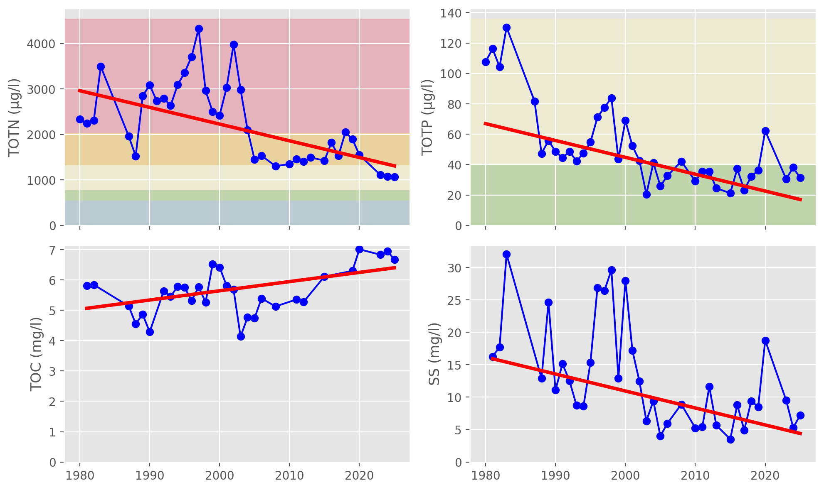
Figur 6.2: Trends in annual mean concentrations for waterbody 002-3891-R (Nedre Nittelva). Solid red lines show statistically significant linear trends ($p≤0.05$); dashed red lines indicate weak evidence of a linear trend ($0.05<p≤0.10$); and dashed black lines indicate no statistically significant trend ($p>0.10$). Background colours show thresholds for water quality status defined under the Water Framework Directive and taken from Vann-Nett, where available (bad, poor, moderate, good and high).

Source apportionment
Figur 6.3 shows nutrient fluxes for Nittelva estimated from observed data (black lines) together with source-apportioned fluxes simulated by TEOTIL3 (stacked bars). TEOTIL3’s simulations for TOTN and TOC are consistent with the monitoring data. For TOTP and SS, TEOTIL3’s simulated fluxes are higher than the monitored fluxes until 2020, when observed fluxes increase sharply. From 2020 onwards, TEOTIL’s simulations are broadly compatible with fluxes estimated from monitoring data.
As noted in Seksjon 6.2, data from 2020 onwards come predominantly from Vannmiljø station station 002-79092 (Nittelva, Rud), whereas before 2020 most data come from a different site (002-30586; Rud Nittelva). Changes to the monitoring programme are therefore one explanation for the sudden increase in measured fluxes, illustrating the large uncertainties in particulate nutrient loads estimated from low frequency sampling (see Seksjon 4.4). Other factors include a landslide that occurred in Nittedal in autumn 2019, which damaged the sewerage network and resulted in increased wastewater discharges, as well as unusually high loads of phosphorus-rich clay particles. In 2023, the catchment was also affected by Storm Hans, an extreme weather event associated with widespread flooding and erosion.
Before 2019, measured fluxes of TOTP based on data from 002-30586 (Rud Nittelva) are typically 8 to 10 tonnes per year (Figur 6.3). This seems surprisingly low given that (i) measured TOTP fluxes from Sagelva are 2 to 4 tonnes per year (Figur 5.3); (ii) recent TOTP fluxes measured at Kjellerholen (Vannmiljø station 002-30578), approximately 5 km upstream, vary between 7 and 20 tonnes/year (see here), and (iii) reported TOTP discharges from NRA, less than a kilometre upstream, are typically around 5 tonnes/year (Tabell 6.2). Based on this, it seems plausible that the measured fluxes for TOTP and SS between 2013 and 2018, shown as a black line on Figur 6.3, are underestimating the true flux.
Combining the available datasets, typical nutrient fluxes for Nedre Nittelva (waterbody 002-3891-R) are approximately:
- 400 to 800 tonnes/year for TOTN
- 10 to 40 tonnes/year for TOTP
- 2500 to 4000 tonnes/year for TOC
- 3000 to 12 000 tonnes/year for SS
As described in Seksjon 4.4, high natural variation (and also high uncertainty) are expected for TOTP and SS.
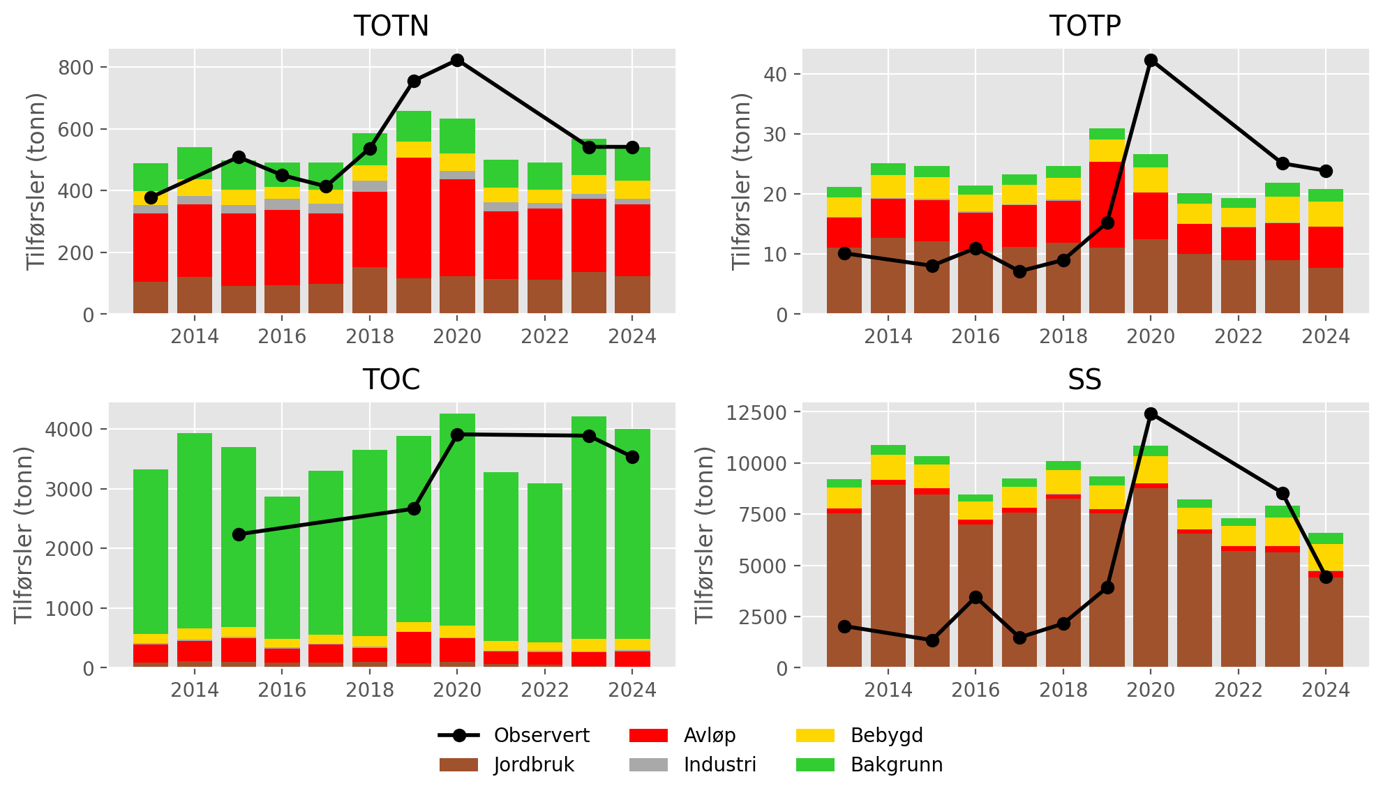
Figur 6.3: Annual nutrient fluxes for waterbody 002-3891-R (Nedre Nittelva). Black lines show fluxes estimated from monitoring data; stacked bars show source-apportioned fluxes simulated by TEOTIL3.
Figur 6.4 shows the mean percentage contribution from each source to annual fluxes for the period from 2020 to 2024. According to TEOTIL3, municipal wastewater discharges are the main source of TOTN, accounting for 45 % of the nitrogen flux to waterbody 002-3891-R. Of this, rainwater and emergency overflows within Lillestrøm kommune account for 1 %, spredt avløp contributes an additional 0.5 %, and the remainder (43.5 %) comes from treated wastewater discharges from major municipal wastewater plants. The largest of these is NRA, which has an average TOTN discharge of 180 tonnes/year between 2013 to 2024 (Tabell 6.2), accounting for approximately one third of the TOTN load reaching waterbody 002-3891-R. After NRA, the second largest point source of nitrogen to Nedre Nittelva is the industrial plant Dynea Lillestrøm, which contributes about 4 % of the TOTN load. Other significant sources of TOTN in the catchment include agriculture (22 %) and background runoff (19 %).
For TOTP, agriculture is the dominant source, contributing 44 % of the TOTP load. Wastewater contributions are also significant, accounting for 29 % of the TOTP load. Of this, 24 % comes from the main outlets of municipal wastewater treatment plants, 1 % comes from spredt avløp, and 4 % is from rainwater and emergency sewerage overflows within Lillestrøm kommune.
In common with many catchments in this area, TOC inputs come primarily from forested areas (included within the “background” class in TEOTIL3), while SS fluxes are dominated by particulate material derived from clay-rich agricultural land.
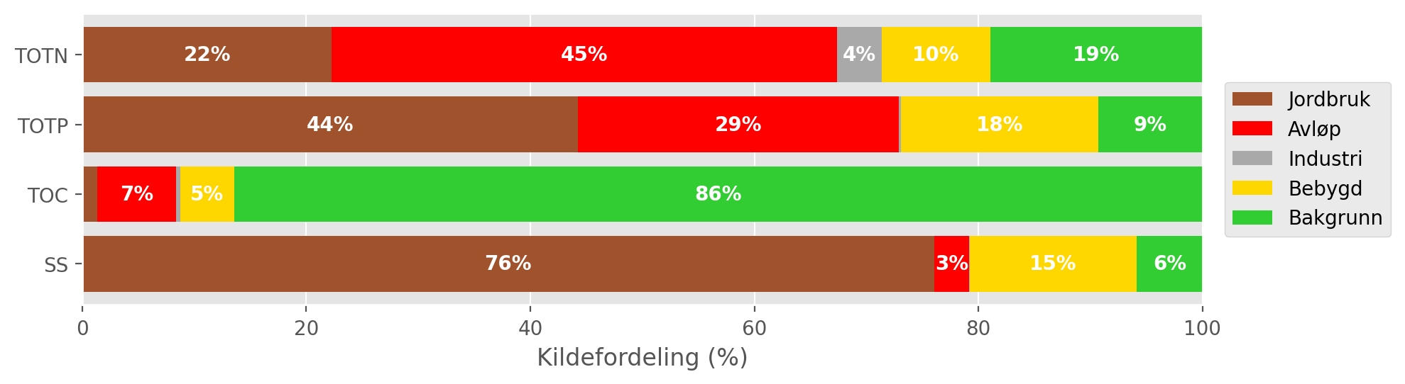
Figur 6.4: Mean source-apportionment for waterbody 002-3891-R (Nedre Nittelva) based on TEOTIL3 simulations from 2020 to 2024. For clarity, labels are omitted for sources contributing less than 3 %.

Load reductions and scenarios
During the decade from 2015 to 2024, the median annual flow volume from Nittelva (station 002-30586) was 376 Mm³/year. Taking the maximum concentrations for GES of 775 μg/l for N and 40 μg/l for P, the maximum annual load for Good status in a typical year is approximately 290 tonnes for TOTN and 15 tonnes for TOTP. Observed loads for TOTN (black lines on Figur 6.3) are consistently higher than this, while TOTP fluxes are generally lower than 15 tonnes before 2020 and higher afterwards. To give a more detailed picture, Figur 6.5 shows the distribution of annual avlastningsbehovene estimated for each year between 2015 and 2024. Red curves show distributions based on measured loads, while blue curves are based on model output from TEOTIL3. For TOTN, the observed and modelled distributions are similar, reflecting the generally good agreement between measured and simulated fluxes (Figur 6.3). The median avlastningsbehov estimated from measured data is 48 %, compared to 45 % from TEOTIL3.
For TOTP, the median avlastningsbehov based on measured data is just 3 %, since between 2015 and 2019 measured loads either already achieve GES or are very close. However, as described above in Seksjon 6.3, from 2020 measured fluxes increase sharply. When this happens, avlastningsbehovene based on measured data also increase, reaching as high as 49 % in 2020. For this reason, the distribution of avlastningsbehov for TOTP based on observed data (red curve on Figur 6.5) has two peaks: one centred around zero, which is influenced primarily by data collected before 2020, and another smaller peak centred around 50 %, which is influenced by data collected from 2020 onwards (at different monitoring stations). Simulated TOTP fluxes from TEOTIL3 broadly match the monitoring data from 2020, but modelled fluxes are consistently high for the entire simulation period (Figur 6.3). Annual avlastningsbehovene based on TEOTIL3 are therefore also consistently high, with a median of 42 %.
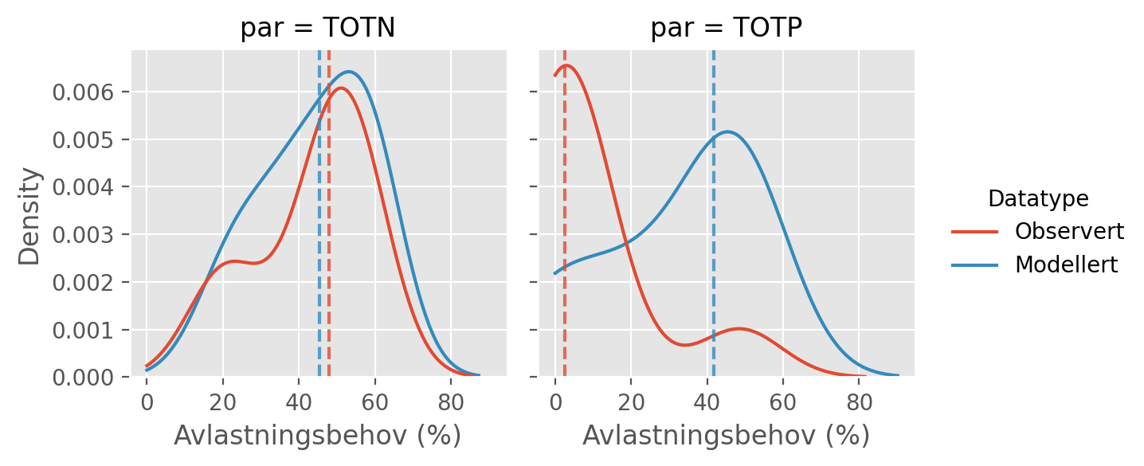
Figur 6.5: Distributions of annual avlastningsbehovene (in percent) for the ten year period from 2015 to 2024 based on observed fluxes (red curves) and fluxes simulated by TEOTIL3 (blue curves). Vertical dashed lines show the median avlastningsbehov based on each dataset i.e. the load reduction that would have achieved GES in roughly half of the ten year period.
Figur 6.6 shows load reductions achieved for the Nittelva catchment by two scenarios modelled by Wallhead et al. (2026). These scenarios considered packages of agricultural measures and upgrades to larger municipal wastewater treatment plants (Seksjon 4.8).
For TOTN, the biggest load reductions are achieved by upgrading municipal wastewater treatment plants. In scenario A, plants with capacity greater than 10 000 p.e. were upgraded to achieve a nitrogen treatment efficiency of 80 %. Within the Nittelva catchment, this applies to the treatment plants at NRA, Rotnes and Slattum. (Note that Slattum closed down in 2019, but it is included in the scenarios of Wallhead et al. because they used data from 2017 to 2019 to define their baseline). NRA is classified as a chemical-biological treatment plant with nitrogen removal. In the years from 2017 to 2019, it reported an average nitrogen removal efficiency of about 70 %. For Rotnes and Slattum, the available data are insufficient for site-specific treatment efficiencies to be calculated, but efficiencies for TOTN are assumed to be about 20 % based on typical values for chemical treatment plants. In scenario A, upgrading these three plants to achieve nitrogen removal efficiencies of 80 % reduces wastewater inputs of TOTN to Nittelva by around 120 tonnes/year, which corresponds to about 20 % of the annual TOTN load reaching waterbody 002-3891-R. In scenario B, further upgrades are applied to wastewater plants with capacity between 5000 and 10 000 p.e. This includes Åneby, which is assumed to achieve a nitrogen removal efficiency of 70 % in scenario B, leading to a further 2 to 3 % reduction in catchment TOTN loads. In addition, the Lillestrøm-specific dataset of wastewater overflows (Seksjon 4.6.2) suggests that a further 1 % reduction in TOTN loads could be achieved if rainwater and emergency overflows within Lillestrøm kommune were reduced to zero (Seksjon 6.3). As of 2026, the wastewater previously treated by Rotnes, Slattum and Åneby is being diverted to NRA, which has reported nitrogen treatment efficiencies of 73 to 75 % since 2020. Assuming that NRA can maintain this efficiency in the future, reductions in wastewater nitrogen loads almost equivalent to scenario B will soon be achieved in the Nittelva catchment.
Reductions to TOTN loads due to agricultural measures are negligible in scenario A and slightly more than 6 % in scenario B. The total load reduction achieved for nitrogen under scenario B is around 30 %, which is not enough to reach the estimated avlastningsbehov for GES of 45 - 48 % (Tabell 6.3).
For TOTP, almost all reductions come from agricultural measures, which achieve a 20 % reduction in TOTP loads in scenario A and 27 % in scenario B. These reductions comfortably exceed the median avlastningsbehov of 3 % estimated from the the monitoring data (black dashed line on Figur 6.6).
Neither scenario makes a large difference to loads of TOC, since most organic carbon comes from background sources (Figur 6.4). Nevertheless, the scenarios assume that upgraded wastewater treatment plants achieve treatment efficiencies of 95 % for BOF5 and KOF, leading to a roughly 5 % decrease in catchment scale TOC loads. Agricultural measures in both scenarios achieve a further TOC reduction of 1 to 2 %.
For SS, NIBIO’s modelling suggests that agricultural measures are capable of substantially reducing losses of particulate material from agricultural land. Since agriculture occupies many of the areas underlain by marine clay deposits (compare Figur 2.2 and Figur 2.3), these measures have the potential to significantly reduce SS fluxes at catchment scale.
A summary of avlastningsbehovene for GES in Nittelva and the reductions achieved by scenarios A and B is shown in Tabell 6.3.
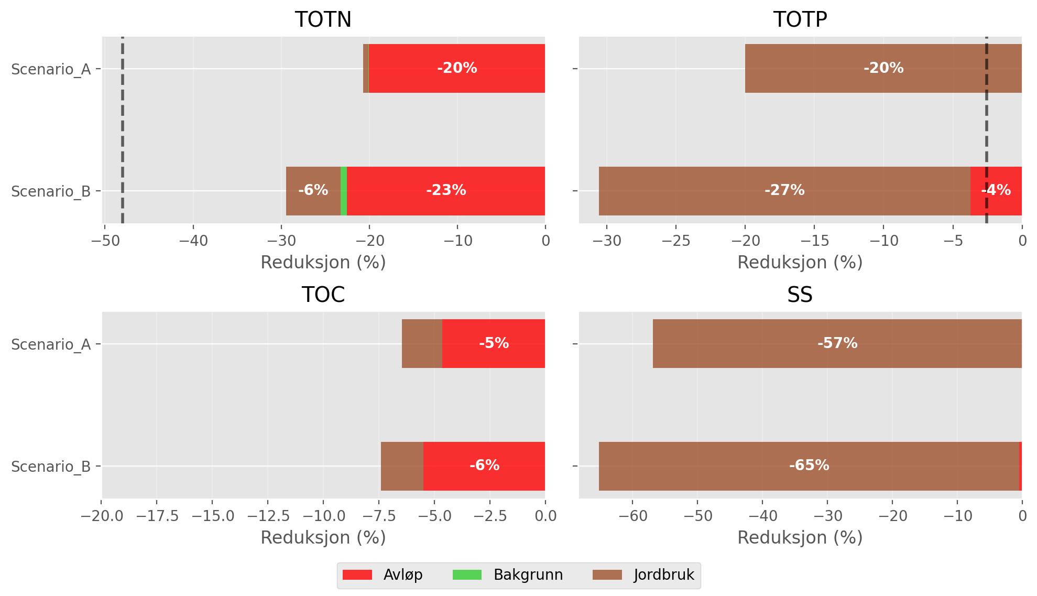
Figur 6.6: Load reductions achieved in the Nittelva catchment by scenarios A and B of Wallhead et al. (2026). Black vertical lines on the plots for TOTN and TOTP show the median avlastningsbehov for GES estimated using observed data (Figur 6.5). For clarity, labels are omitted from bars representing less than 3 %.

Tabell 6.3: Summary of avlastningsbehov and scenario results for Nittelva.
Nedbørfelt | Vannforekomst ID | Parameter | Vann-Nett tilstand | Avlastningsbehov fra observert data (%) | Avlastningsbehov fra modellert data (%) | Reduksjon ScA (%) | Reduksjon ScB (%)
Nitelva | 002-3891-R | SS | Undefined |  |  | -57 | -65
Nitelva | 002-3891-R | TOC | Undefined |  |  | -6 | -7
Nitelva | 002-3891-R | TOTN | Moderate | -48 | -45 | -21 | -29
Nitelva | 002-3891-R | TOTP | Moderate | -3 | -42 | -20 | -31

Leira (including Jeksla)

Catchment overview
Leira is the largest catchment considered in this study (668 km²) and includes Jeksla as a tributary. Land cover is dominated by forest (65 %), but the lower catchment is predominantly agricultural (20 %). See Figur 7.1 and Tabell 7.1. 36 % of the catchment is located below the marine limit and 26 % is underlain by clay-rich marine deposits, including most of the agricultural land. According to the Water Framework Directive, Leira is classified as leirpåvirket (clay-influenced) and the Good/Moderate threshold for TOTP is set to 50 μg-P/l, which is higher than e.g. Nittelva (Figur 2.3 and Tabell 3.2).
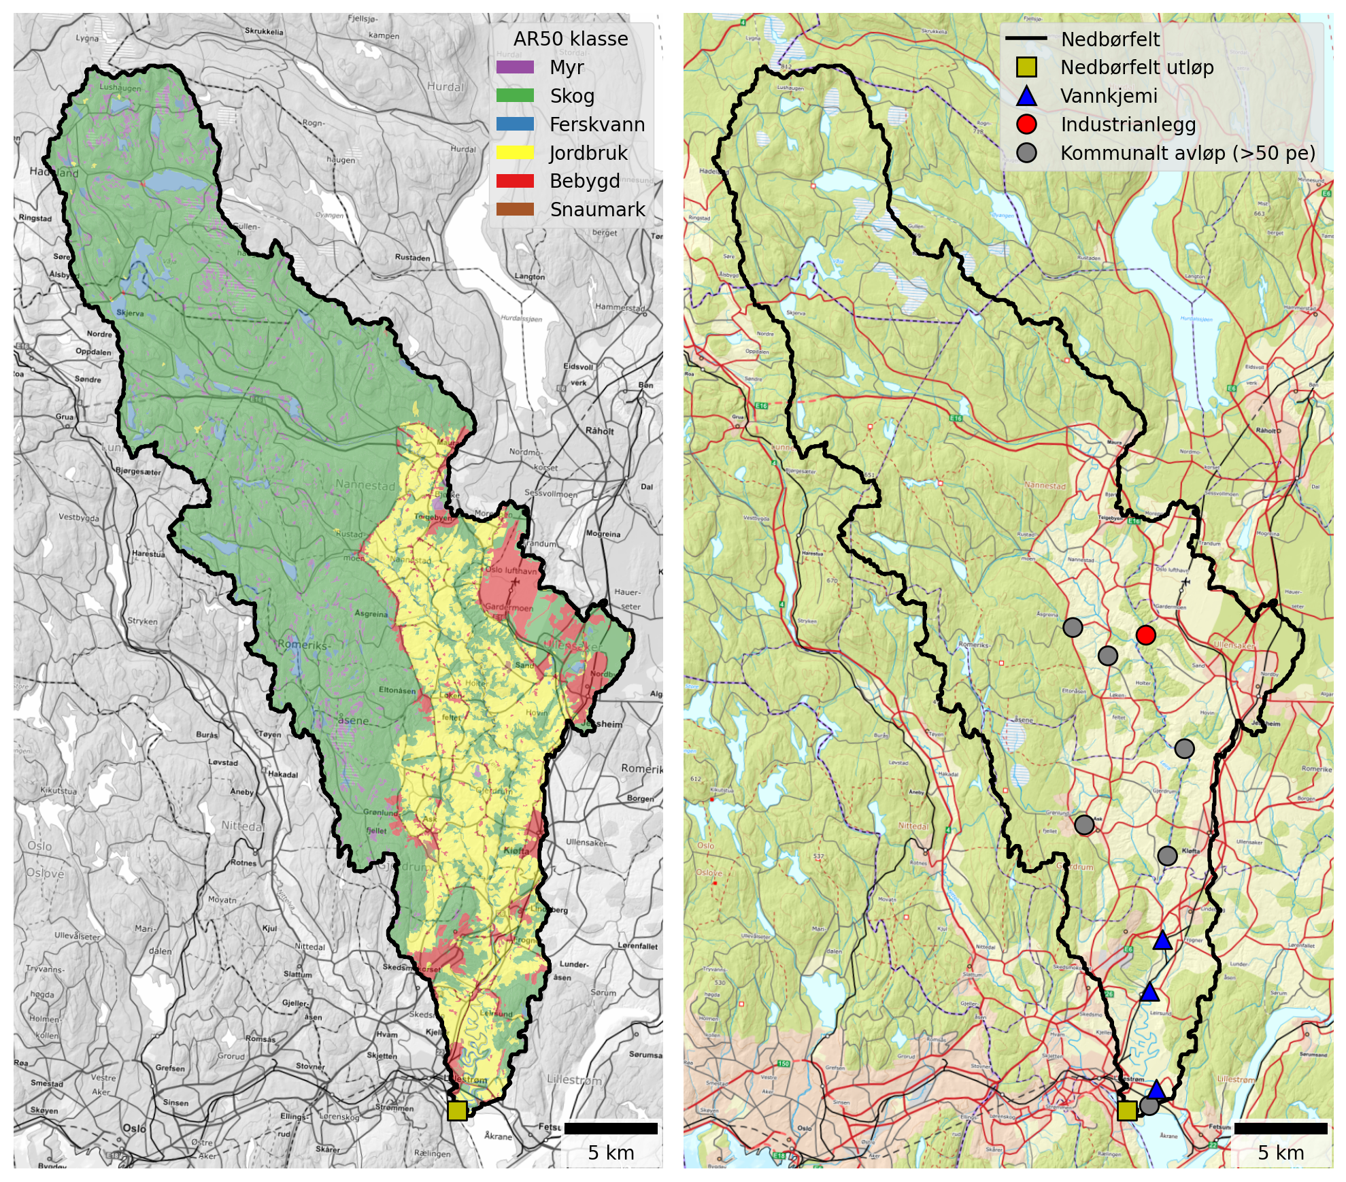
Figur 7.1: Maps of the Leira catchment. Left: Land cover based NIBIO’s AR50 dataset. Right: Point source discharges from industry and municipal wastewater plants (≥50 p.e.).

Tabell 7.1: Land cover proportions for Leira based on NIBIO’s AR50 dataset.
Nedbørfelt | Leira
AR50 klasse | km² | %
Bebygd | 46.5 | 7
Jordbruk | 132.0 | 20
Skog | 436.0 | 65
Snaumark | 2.2 | 0
Myr | 27.6 | 4
Ferskvann | 23.8 | 4
Totalt | 668.1 | 100

The main point source inputs to Leira are Gardermoen sentralrenseanlegg and Kløfta renseanlegg, both of which discharge to the river’s main stem in the lower eastern part of the catchment. Gjerdrum renseanlegg was also a significant source of nutrients until 2017, when it was decommissioned (Tabell 7.2).
Gardermoen sentralrenseanlegg is a chemical-biological treatment plant that includes nitrogen removal. It has been significantly upgraded in recent years and is now one of the country’s most modern and efficient wastewater treatment plants. In this study, we use data reported by the wastewater sector between 2013 and 2024. Since the new plant at Gardermoen did not become operational until March 2025, the latest improvements are not fully reflected in the modelling presented here. However, even before 2025, treatment efficiencies reported by Gardermoen were high: the median TOTN efficiency between 2020 and 2024 was already 85 % (although for 2024 it dips as low as 64 %, perhaps linked to commissioning of the new plant).
Kløfta renseanlegg is an older chemically based treatment facility with relatively low nitrogen removal efficiency. Reported nitrogen removal rates between 2020 and 2024 ranged from 18 % to 24 %. As of 2026, the plant is being decommissioned and replaced by a pumping station that will convey wastewater to the upgraded treatment facility at Gardermoen. Once this work is complete, the vast majority of municipal wastewater discharges to Leira will be handled by a modern, high-performance facility with substantially improved nutrient removal efficiency.
Tabell 7.2: Industrial and municipal wastewater discharges (≥50 p.e.) within the Leira catchment. Values are mean annual discharges from 2013 to 2024, excluding overflows.
Navn | Sektor | Type | TOTN (tonn) | TOTP (tonn) | TOC (tonn) | SS (tonn)
Tuen renseanlegg (Nedlagt) | Kommunalt avløp (>50 pe) | Kjemisk | 0.01 | 0.00 | 0.01 | 0.01
Kløfta renseanlegg | Kommunalt avløp (>50 pe) | Kjemisk | 36.97 | 0.18 | 38.30 | 15.70
Avinor avd. Oslo Lufthavn Gardermoen | Industrianlegg | Flyplass | - | - | 1.29 | -
Gardermoen sentralrenseanlegg | Kommunalt avløp (>50 pe) | Kjemisk-biologisk m/N-fjerning | 51.98 | 1.07 | 37.39 | 47.37
Gjerdrum renseanlegg (Nedlagt) | Kommunalt avløp (>50 pe) | Kjemisk | 17.72 | 0.07 | 14.74 | 12.15
Åsgreina renseanlegg (Nedlagt) | Kommunalt avløp (>50 pe) | Kjemisk | 1.58 | 0.02 | 1.61 | 1.41
Fagerli renseanlegg | Kommunalt avløp (>50 pe) | Biologisk | 0.37 | 0.04 | 0.27 | 0.38

Monitoring data
The best monitoring data for the lower Leira come from Vannmiljø station 002-29659 (Leira ved Borgen bru), located near the catchment outflow, and station 002-30584 (Leira ved Leirsund), which is about 12 km upstream (but only 5 km in a straight line, because the lower Leira meanders). A further 4 km upstream is station 002-30575 (Frogner Leira), which also has excellent long-term monitoring. These stations are marked by blue triangles on Figur 7.1.
The station at Leirsund has data from 1998 to 2008, making it useful for analysis of long-term trends, but not for understanding more recent changes. The stations at Borgen bru and Frogner have data from 1981 to the present. All three stations are assigned to waterbody 002-3384-R (Leira nedstrøms Krokfoss).
Figur 7.2 shows trends in mean annual concentrations estimated from the combined dataset for waterbody 002-3384-R. Concentrations of TOTN have remained consistently high over the past 40 years, close the the boundary between Moderate and Poor status. For TOTP, there is a significant declining trend in annual concentrations of about -1 μg-P/l/year, but values are still above the threshold for GES. TOC concentrations are significantly increasing (by +0.08 mg-C/l/year, on average), and concentrations of SS are broadly stable.
As with other catchments in this region, increasing TOC concentrations are partly driven by the increasing solubility of organic matter in forest and upland soils as catchments recover from acidification. This has led to “browning” of surface waters in many rivers and lakes, and also to “coastal darkening” in parts of Oslofjord and Skagerrak (e.g. Frigstad et al., 2023).
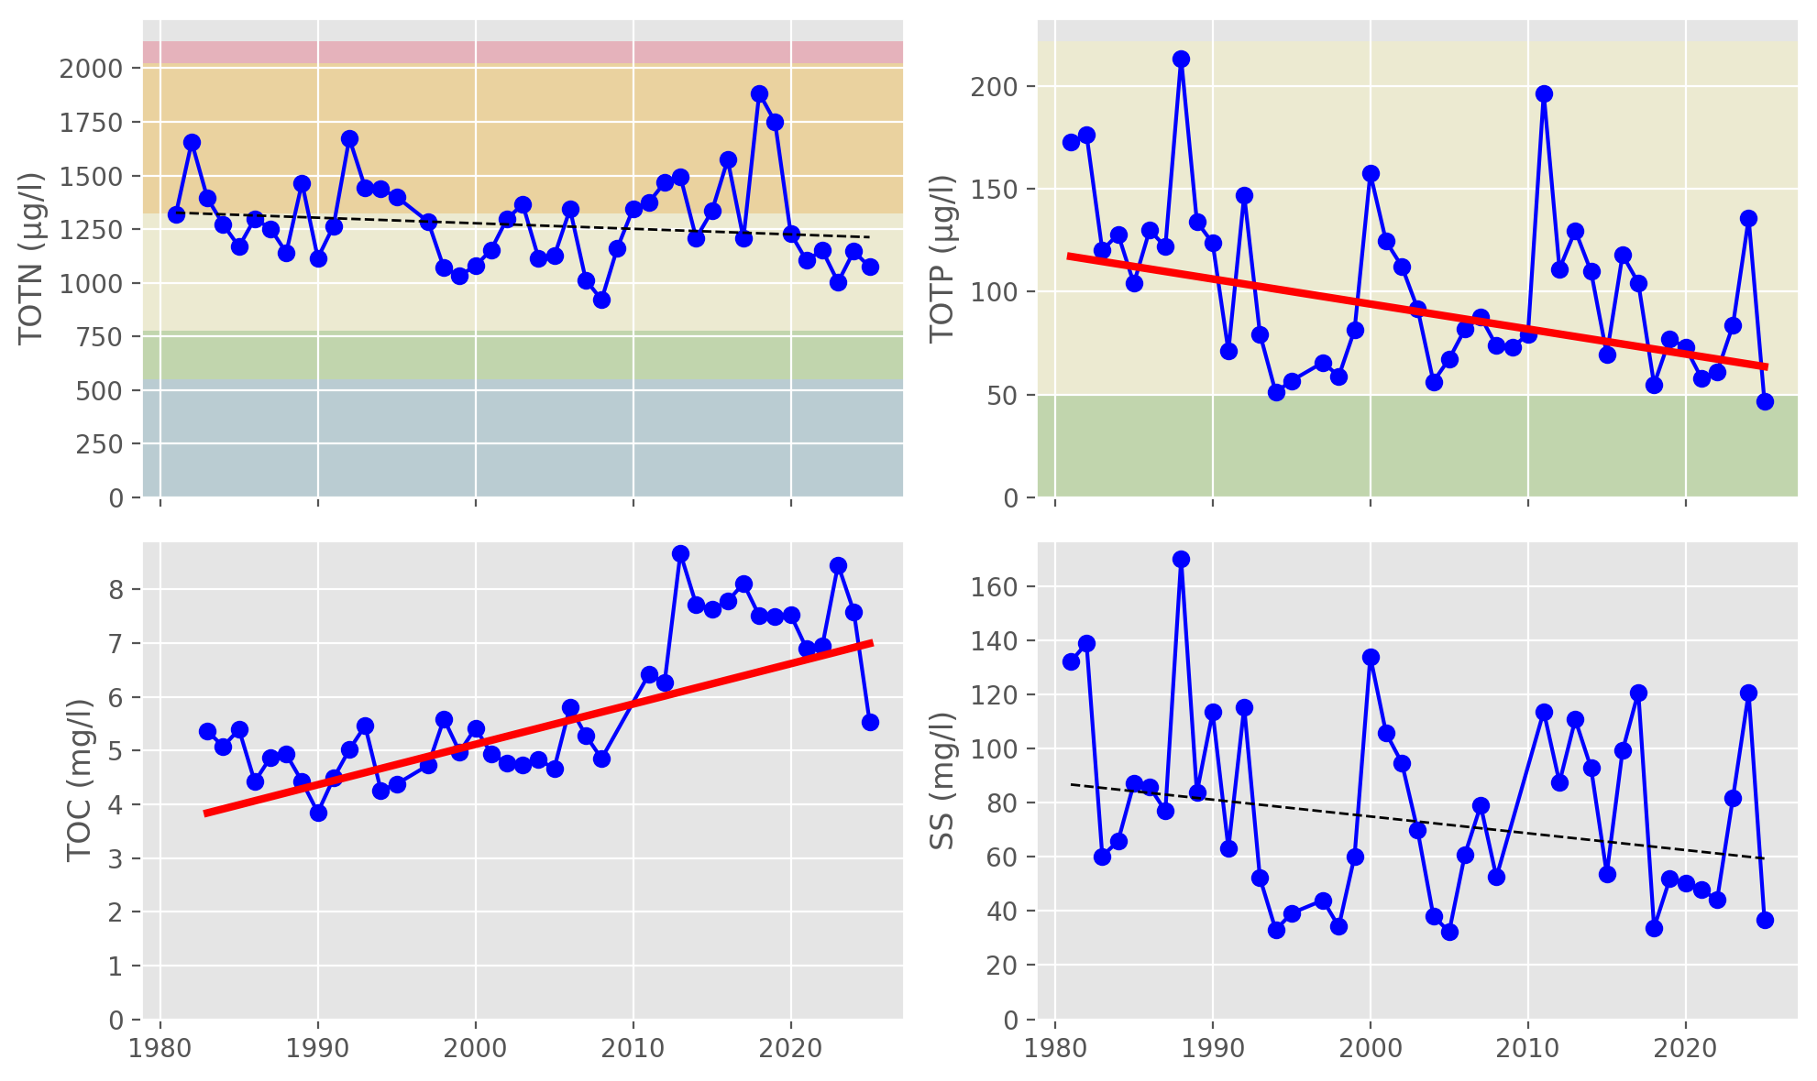
Figur 7.2: Trends in annual mean concentrations for waterbody 002-3384-R (Leira nedstrøms Krokfoss). Solid red lines show statistically significant linear trends ($p≤0.05$); dashed red lines indicate weak evidence of a linear trend ($0.05<p≤0.10$); and dashed black lines indicate no statistically significant trend ($p>0.10$). Background colours show thresholds for water quality status defined under the Water Framework Directive and taken from Vann-Nett, where available (bad, poor, moderate, good and high).

Source apportionment
Figur 7.3 shows nutrient fluxes for Leira estimated from observed data (black lines) together with source-apportioned fluxes simulated by TEOTIL3 (stacked bars). Results from TEOTIL3 are broadly in agreement with the monitoring data for all parameters, although there is evidence that TEOTIL3 slightly overestimates fluxes of TOTN and TOC compared to the monitoring, and slightly underestimates fluxes of TOTP and SS.
The monitoring records for TOTP and SS show high variability. This is expected, since high loads of particulate material and TPP can be transported during a small number of short-duration flow events. Taken together, monitoring and modelling provide a consistent picture of nutrient loads transported by the lower Leira (waterbody 002-3384-R):
- 450 to 900 tonnes/year for TOTN
- 25 to 100 tonnes/year for TOTP
- 2500 to 5000 tonnes/year for TOC
- 30 000 to 90 000 tonnes/year for SS
It is interesting to note that, despite being substantially larger, loads of TOTN and TOC transported by Leira are similar to those measured in Nittelva (Seksjon 6.3). However, loads of TOTP and SS in Leira are significantly higher, probably due to the greater proportion of clay-rich sediments in the lower part of the catchment (Figur 2.3 and Tabell 2.3).
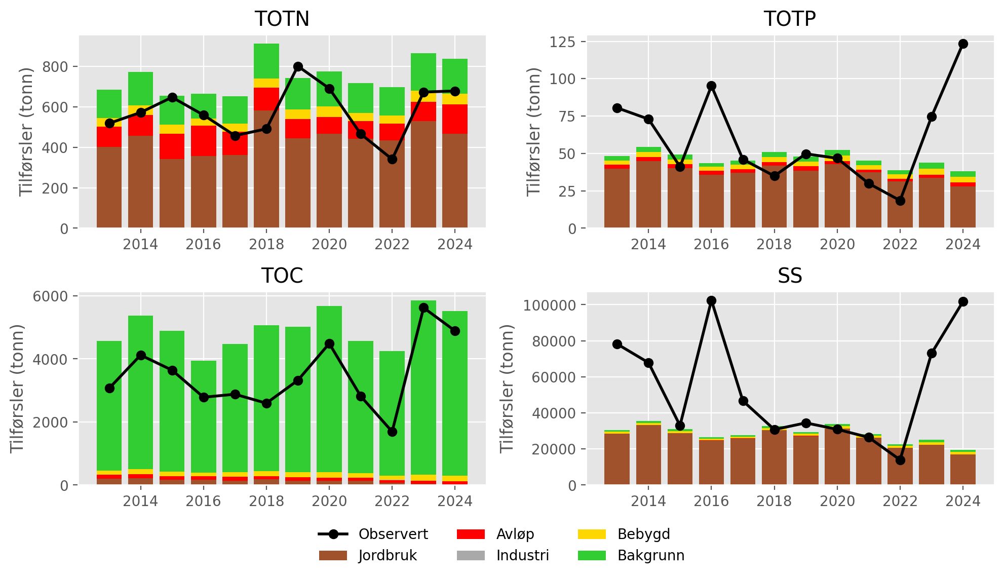
Figur 7.3: Annual nutrient fluxes for waterbody 002-3384-R (Leira nedstrøms Krokfoss). Black lines show fluxes estimated from monitoring data; stacked bars show source-apportioned fluxes simulated by TEOTIL3.
Figur 6.4 shows the mean contribution of each source to annual fluxes during the period 2020 to 2024. According to TEOTIL3, agriculture is the dominant source of nutrients and suspended solids, accounting for 60 % of TOTN, 79 % of TOTP, and 91 % of SS. This reflects both the predominance of agricultural land use in the lower catchment (Figur 7.1) and the fact that most municipal wastewater is treated at the Gardermoen treatment plant, which achieves high nutrient removal efficiencies. As with other catchments in this region, most of the TOC comes from forest soils in the upper catchment, which are included in the “background” category in TEOTIL3.
Wastewater discharges account for 13 % of the TOTN reaching waterbody 002-3384-R: about 1 % from spredt avløp and the rest (12 %) from treated municipal wastewater discharges. Rainwater and emergency wastewater overflows do not make a significant contribution to the catchment scale nitrogen budget, but it is important to note that overflow data are only included for Lilestrøm kommune (Seksjon 4.6.2). It is likely that wastewater overflows would be more significant if data from the neighbouring Ullensaker and Nannestad kommuner were also included. For phosphorous, wastewater discharges account for an average of 5 % of the annual TOTP load: 3 % from municipal wastewater and 2 % from spredt avløp.
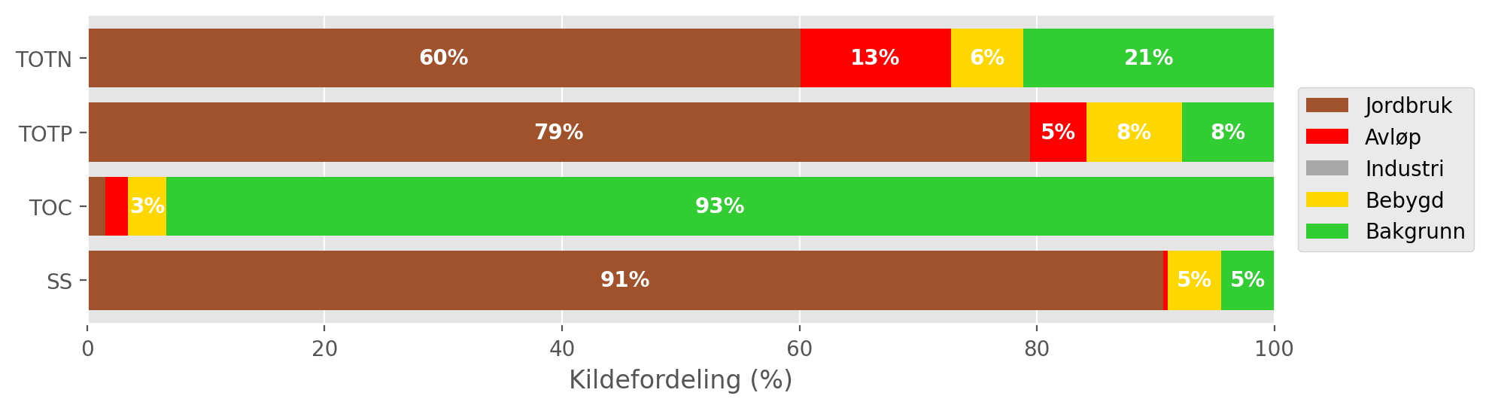
Figur 7.4: Mean source-apportionment for waterbody 002-3384-R (Leira nedstrøms Krokfoss) based on TEOTIL3 simulations from 2020 to 2024. For clarity, labels are omitted for sources contributing less than 3 %.

Load reductions and scenarios
During the decade from 2015 to 2024, the median annual flow volume from Leira at Borgen bru (station 002-29659) was 420 Mm³/year. Taking the maximum concentrations for GES of 775 μg/l for N and 50 μg/l for P, the maximum annual load for Good status in a typical year is approximately 326 tonnes for TOTN and 21 tonnes for TOTP. Monitored and modelled loads of TOTN and TOTP are consistently higher than this, indicating that significant load reductions are needed to achieve GES.
Figur 7.5 shows distributions of annual avlastningsbehov estimated for each year between 2015 and 2024. Red curves show distributions based on measured loads, while blue curves are based on model output from TEOTIL3. Since there is generally good agreement between measured and modelled fluxes, a consistent picture emerges for estimated avlastningsbehovene. For TOTN, the distributions are narrow, with a median avlastningsbehov based on observed data of 42 %, compared to 55 % from TEOTIL3. For TOTP, estimates of avlastningsbehovene based on monitoring and modelling are almost identical (54 % and 55 %, respectively), but the distributions are broader. This reflects greater interannual variability in mobilisation and transport of particulate P, which in turn leads to greater uncertainty in annual avlastningsbehovene.
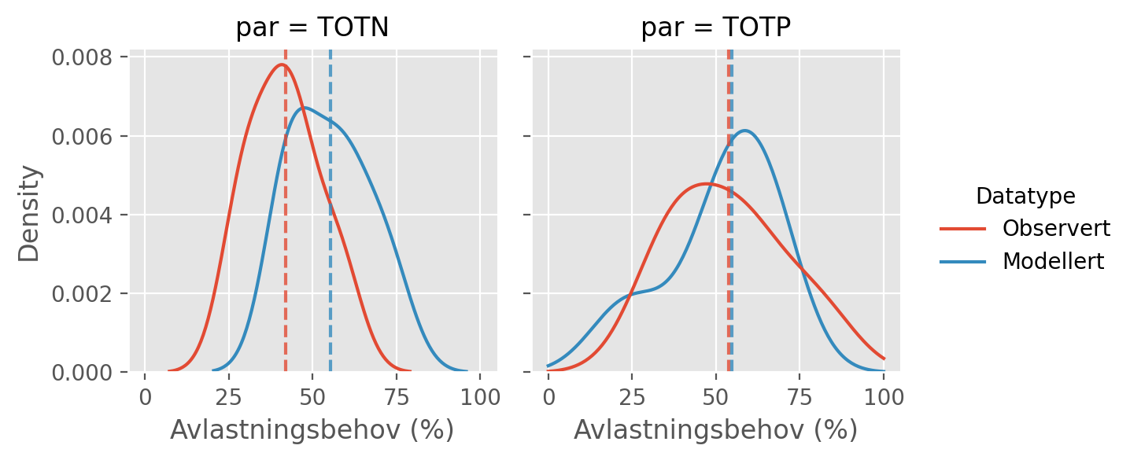
Figur 7.5: Distributions of annual avlastningsbehovene (in percent) for the ten year period from 2015 to 2024 based on observed fluxes (red curves) and fluxes simulated by TEOTIL3 (blue curves). Vertical dashed lines show the median avlastningsbehov based on each dataset i.e. the load reduction that would have achieved GES in roughly half of the ten year period.
Figur 7.6 shows load reductions achieved for the Leira catchment by two scenarios modelled by Wallhead et al. (2026). These scenarios considered packages of agricultural measures and upgrades to larger municipal wastewater treatment plants (Seksjon 4.8).
Under scenario A, plants with capacity greater than 10 000 p.e. were upgraded to achieve a nitrogen treatment efficiency of 80 %. Within the Leira catchment, the only treatment plants large enough to be affected are Gardermoen and Kløfta. Wallhead et al. used a baseline period of 2017 to 2019, during which Gardermoen reported a mean treatment efficiency for TOTN of 78 %, compared to 16 % for Kløfta. Upgrading these to achieve 80 % treatment efficiency reduces nitrogen inputs from municipal wastewater discharges by about 33 tonnes/year in scenario A, which corresponds to a load reduction of about 4 % to the lower Leira (waterbody 002-3384-R). In scenario B, Gjerdum renseanlegg is also upgraded, which achieves an additional 1 % reduction in the annual TOTN load at the catchment outflow.
As of 2026, upgrades to the wastewater system that are broadly consistent with scenario B have already been implemented or surpassed in the Leira catchment. Gjerdum renseanlegg closed down in 2017 and Kløfta is in the process of being decommissioned. Most municipal wastewater discharges within Leira are now directed to the new treatment plant at Gardermoen, which frequently reports nitrogen treatment efficiencies above 85 % (i.e. better than assumed in scenario B). The wastewater reductions to TOTN loads from scenario B shown on Figur 7.6 have therefore already been achieved - or exceeded - in the Leira catchment.
As shown on Figur 7.4, agriculture is the main source of TOTN, TOTP and SS reaching the lower Leira. NIBIO’s modelling suggests that agricultural measures in scenario A have only a small effect on TOTN losses, but a bigger effect on TOTP and SS. In scenario B, agricultural measures reduce the TOTN flux by 18 % and achieve a 52 % reduction in TOTP. Taken together, wastewater and agricultural measures yield a reduction in TOTN loads of approximately 25 % (around 5 % of which is already achieved by Gardermoen renseanlegg). However, this is not enough to reach the estimated avlastningsbehov for GES for nitrogen of 42 % (black dashed line on Figur 7.6). For phosphorous, agricultural measures achieve a TOTP load reduction of 52 %, which is approximately equal to avlastningsbehovene estimated from monitoring and modelling.
A summary of avlastningsbehovene for GES in Leira and the reductions achieved by scenarios A and B is shown in Tabell 7.3.
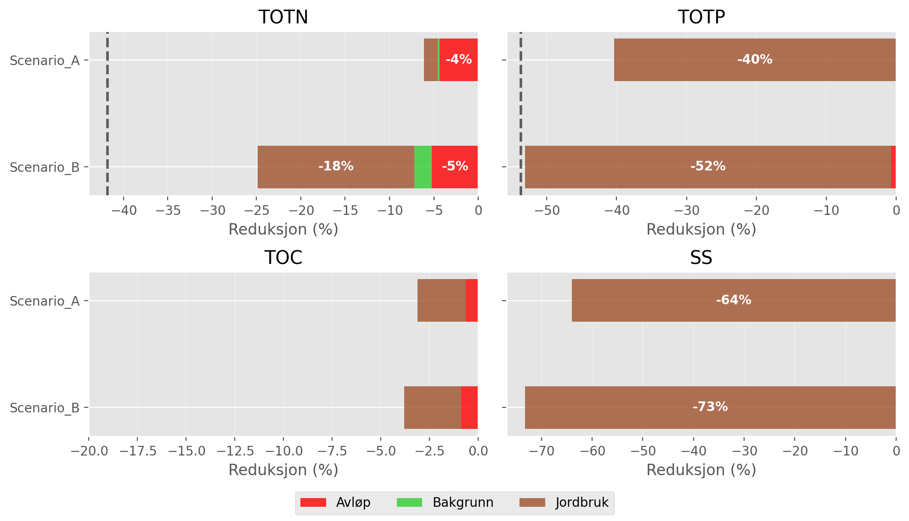
Figur 7.6: Load reductions achieved in the Leira catchment by scenarios A and B of Wallhead et al. (2026). Black vertical lines on the plots for TOTN and TOTP show the median avlastningsbehov for GES estimated using observed data (Figur 7.5). For clarity, labels are omitted from bars representing less than 3 %.

Tabell 7.3: Summary of avlastningsbehov and scenario results for Leira.
Nedbørfelt | Vannforekomst ID | Parameter | Vann-Nett tilstand | Avlastningsbehov fra observert data (%) | Avlastningsbehov fra modellert data (%) | Reduksjon ScA (%) | Reduksjon ScB (%)
Leira | 002-3384-R | SS | Undefined |  |  | -64 | -73
Leira | 002-3384-R | TOC | Undefined |  |  | -3 | -4
Leira | 002-3384-R | TOTN | Moderate | -42 | -55 | -6 | -25
Leira | 002-3384-R | TOTP | Moderate | -54 | -55 | -40 | -53

Jeksla

Catchment overview
Jeksla is a small tributary of Leira with a catchment area of just 17 km². Land cover is dominated by agriculture (39 %), forest (38 %) and urban areas (22 %). See Figur 8.1 and Tabell 8.1. More than 90 % of the catchment is below the marine limit and 46 % of the land area is underlain by marine deposits. The catchment is therefore classified as leirpåvirket (clay-influenced) and the Good/Moderate threshold for TOTP is set to 80 μg-P/l (Figur 2.3 and Tabell 3.2).
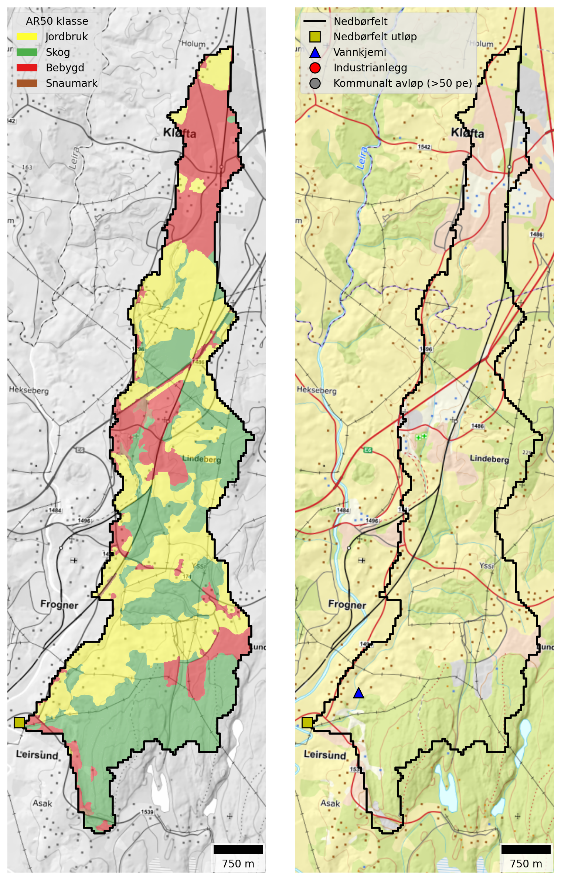
Figur 8.1: Maps of the Jeksla catchment. Left: Land cover based NIBIO’s AR50 dataset. Right: Point source discharges from industry and municipal wastewater plants (≥50 p.e.).

Tabell 8.1: Land cover proportions for Jeksla based on NIBIO’s AR50 dataset.
Nedbørfelt | Jeksla
AR50 klasse | km² | %
Bebygd | 3.8 | 22
Jordbruk | 6.6 | 39
Skog | 6.5 | 38
Snaumark | 0.1 | 1
Myr | 0.0 | 0
Ferskvann | 0.0 | 0
Totalt | 17.0 | 100

There are no municipal wastewater treatment plants or industrial discharges within the Jeksla catchment. However, the catchment does receive wastewater discharges from spredt avløp and from rainwater and emergency overflows. Since most of the catchment lies within Lillestrøm kommune, the Lillestrøm-specific dataset of wastewater overflows (Seksjon 4.6.2) should provide a reasonably complete picture of overflows from the municipal sewerage network.

Monitoring data
The best monitoring data for Jeksla come from Vannmiljø station 002-30593 (Jeksla ved Haugli), which is located approximately 1.5 km upstream of the confluence with Leira (Figur 8.1). The station has been monitored since 1998.
Figur 8.2 shows trends in mean annual concentrations estimated from the combined dataset for waterbody 002-599-R. There are no significant trends for any parameters and nutrient concentrations are generally high. For TOTN, mean annual concentrations are typically 2000 to 4000 μg-N/l, which corresponds to Bad status under the Water Framework Directive. TOTP concentrations in recent years vary between about 60 and 125 μg-P/l and are generally above the Good status threshold of 80 μg-P/l.
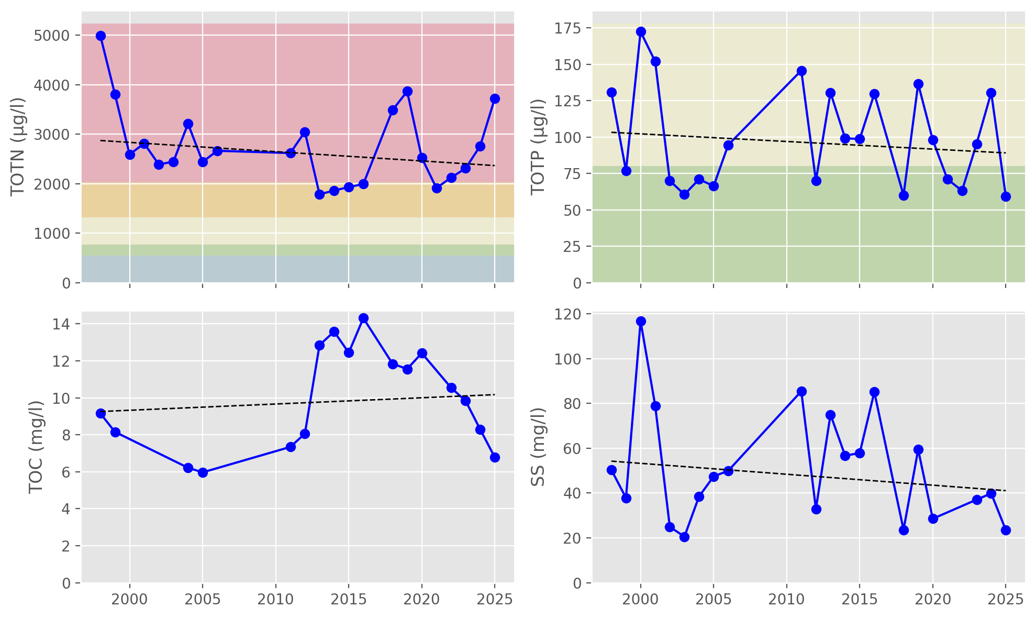
Figur 8.2: Trends in annual mean concentrations for waterbody 002-599-R (Jeksla). Solid red lines show statistically significant linear trends ($p≤0.05$); dashed red lines indicate weak evidence of a linear trend ($0.05<p≤0.10$); and dashed black lines indicate no statistically significant trend ($p>0.10$). Background colours show thresholds for water quality status defined under the Water Framework Directive and taken from Vann-Nett, where available (bad, poor, moderate, good and high).

Source apportionment
Figur 8.3 shows nutrient fluxes for Jeksla estimated from observed data (black lines) together with source-apportioned fluxes simulated by TEOTIL3 (stacked bars). Because the Jeksla catchment is small (17 km²) and occupies only part of a single REGINE unit, it is not possible to simulate nutrient fluxes explicitly using TEOTIL3 (see Seksjon 4.6.1 for details). TEOTIL3’s estimates of diffuse nutrient fluxes for Jeksla are therefore based on simulations from a wider area, scaled to match the size of the Jeksla catchment. TEOTIL3 results for Jeksla are therefore approximate and must be interpreted with caution, since they assume average land management for REGINE 002.CAA0, rather than using Jeksla-specific data. Point inputs to Jeksla are represented explicitly, however, since these can be assigned to specific co-ordinates.
Based on available monitoring data, typical nutrient fluxes for Jeksla (waterbody 002-599-R) are approximately:
- 15 to 30 tonnes/year for TOTN
- 0.5 to 1.5 tonnes/year for TOTP
- 75 to 125 tonnes/year for TOC
- 400 to 1200 tonnes/year for SS
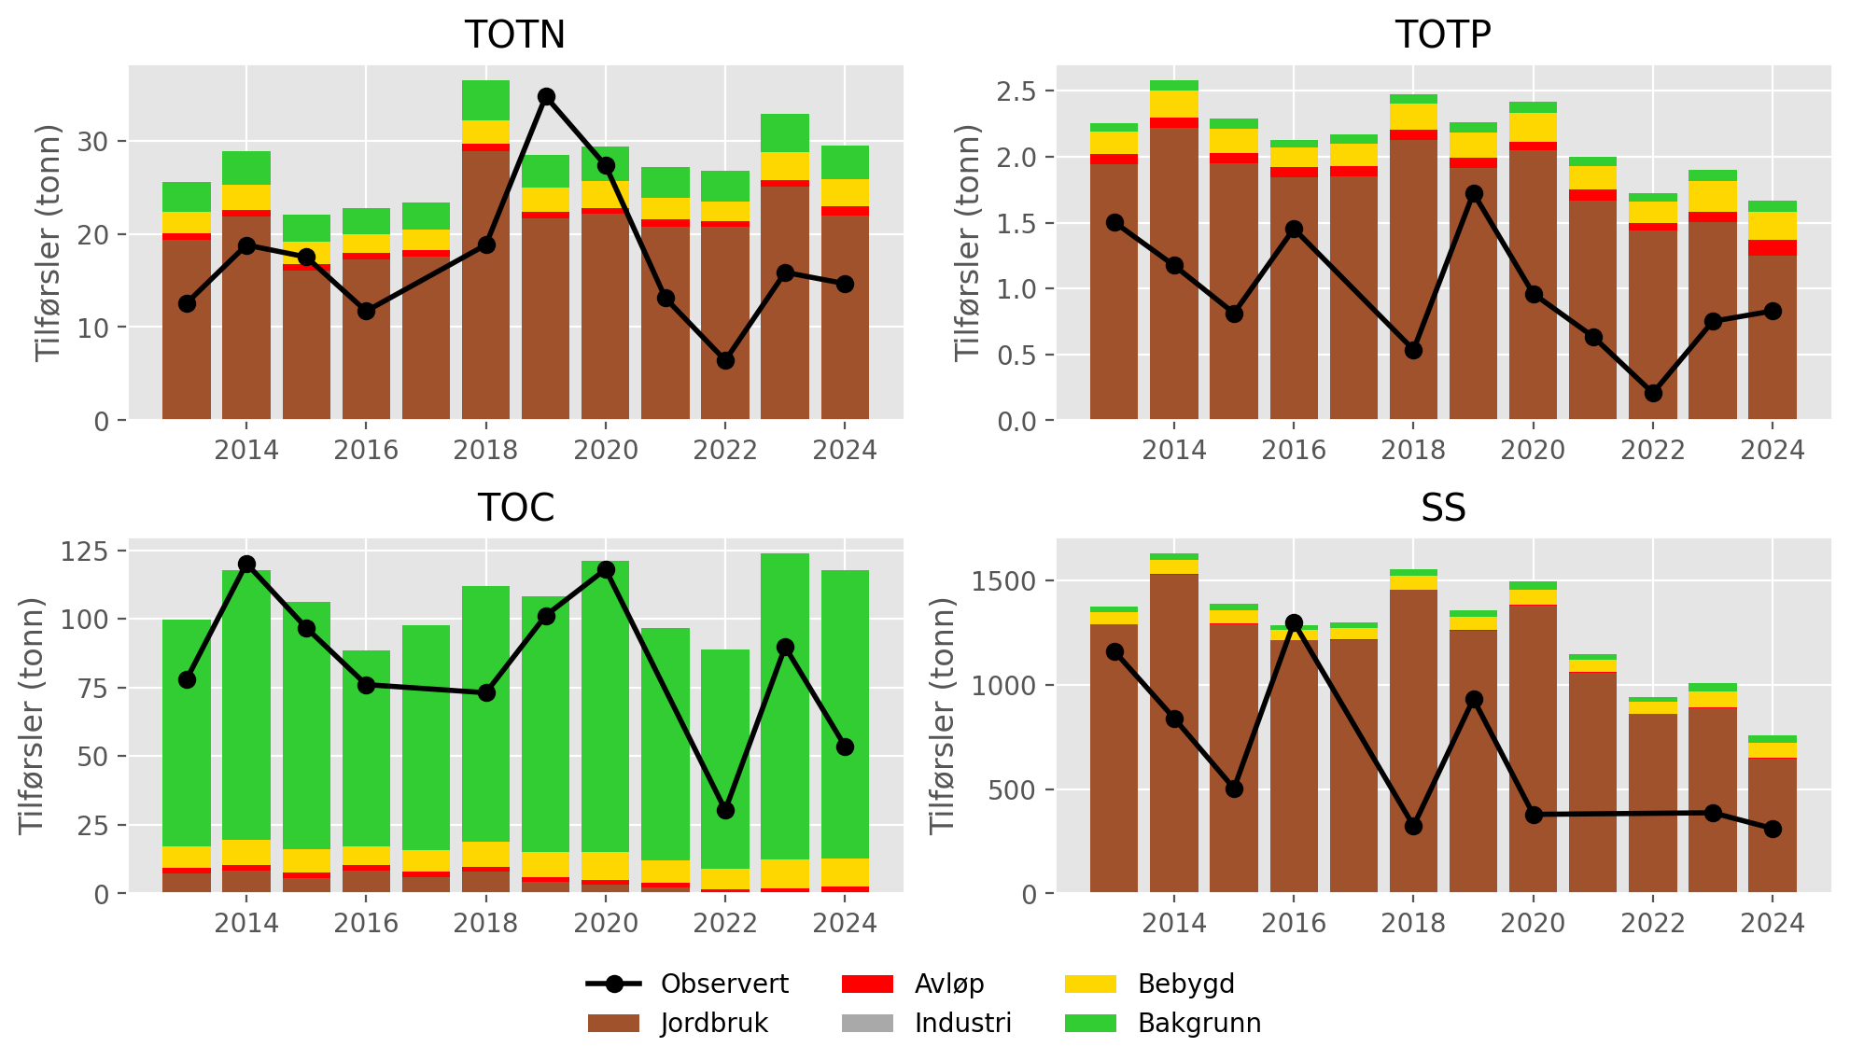
Figur 8.3: Annual nutrient fluxes for waterbody 002-599-R (Jeksla). Black lines show fluxes estimated from monitoring data; stacked bars show source-apportioned fluxes simulated by TEOTIL3. TEOTIL3 results are approximate (see text).
Figur 8.4 shows the mean contribution of each source to annual fluxes during the period 2020 to 2024. As noted above, source apportionment for diffuse sources is based on data from a wider area, so results are approximate. According to TEOTIL3, agriculture is the main source of TOTN, TOTP and SS reaching the catchment outflow, while background areas, such as forest, contribute most of the TOC. These results are plausible based on the land cover map and the fact that the catchment does not include any major outlets from municipal wastewater or industrial plants.
Wastewater discharges are estimated to provide 2.5 % of the TOTN flux, of which 1.5 % comes from spredt avløp and 1 % from rainwater and emergency overflows. For TOTP, spredt avløp contributes 2.5 % and wastewater overflows 1.5 %, making the total wastewater contribution for TOTP about 4 %. Urban areas, most notably the settlements at Kløfta and Lindeberg, also make a significant contribution: roughly 10 % for TOTN, TOTP & TOC, and 6 % for SS.
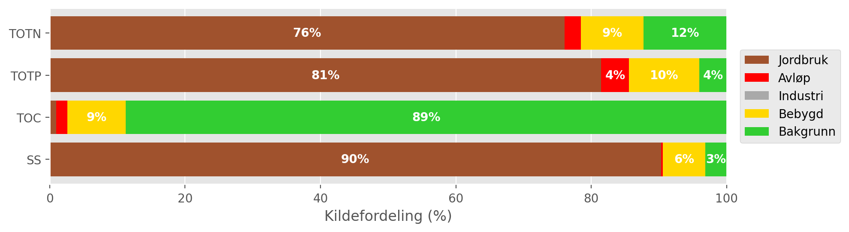
Figur 8.4: Mean source-apportionment for waterbody 002-599-R (Jeksla) based on TEOTIL3 simulations from 2020 to 2024. For clarity, labels are omitted for sources contributing less than 3 %. Results are approximate (see text).

Load reductions and scenarios
During the decade from 2015 to 2024, the median annual flow volume at Jeksla ved Haugli (Vannmiljø station 002-30593) was 6.5 Mm³/year. Taking the maximum concentrations for GES of 775 μg/l for N and 80 μg/l for P, the maximum annual load for Good status in a typical year is approximately 5 tonnes for TOTN and 0.5 tonnes for TOTP. Measured loads are almost always higher than this, and for TOTN measured fluxes are often too large by a factor of three to four (Figur 8.3).
Figur 8.5 shows distributions of annual avlastningsbehov estimated for each year between 2015 and 2024. Red curves show distributions based on measured loads, while blue curves are based on model output from TEOTIL3, which must be interpreted with caution. Distributions for TOTN are sharp and narrow, indicating the avlastningsbehov is well-defined. Based on monitoring data, the median avlastningsbehov for GES for TOTN is 64 %, and almost always between 60 % and 70 %. For TOTP, the distribution based on monitoring is much broader, reflecting greater interannual variability in measured fluxes. The median avlastningsbehov for TOTP using observed data is 20 %, but for some years it is as high as 70 %.
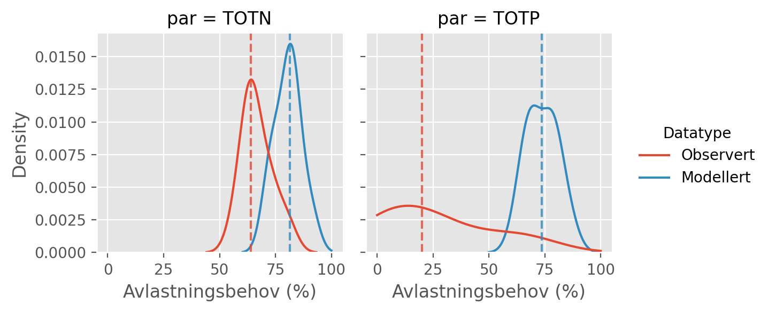
Figur 8.5: Distributions of annual avlastningsbehovene (in percent) for the ten year period from 2015 to 2024 based on observed fluxes (red curves) and fluxes simulated by TEOTIL3 (blue curves). Vertical dashed lines show the median avlastningsbehov based on each dataset i.e. the load reduction that would have achieved GES in roughly half of the ten year period. Modelled results are approximate (see text).
Figur 7.6 shows load reductions achieved in the Jeksla catchment under two management scenarios modelled by Wallhead et al. (2026). As described above, the estimated reductions are derived from modelled changes across a larger area that includes the Jeksla catchment, rather than from measures implemented specifically within the catchment itself. The scenarios comprise packages of agricultural mitigation measures together with upgrades to municipal wastewater treatment plants (Seksjon 4.8).
Since there are no municipal wastewater treatment plants located within the Jeksla catchment, the scenario results do not show any reductions in wastewater discharges. However, the Lillestrøm-specific dataset of rainwater and emergency wastewater overflows suggests that additional reductions of 1 % for TOTN and 1.5 % for TOTP could be achieved if overflows from Lillestrøm kommune were reduced to zero (Seksjon 8.3).
For agriculture, NIBIO’s results for scenario A indicate load reductions of 2 % for TOTN, 43 % for TOTP and 67 % for SS. In scenario B these reductions increase to 28 % for TOTN, 55 % for TOTP and 72 % for SS. Both scenarios comfortably achieve the median load reduction target of 20 % calculated for TOTP (black vertical line on Figur 8.5), but neither scenario comes close to the median avlastningsbehov of 64 % for TOTN. Given the high nitrogen concentrations measured in the catchment, and the limited potential for load reductions at point sources, it seems unlikely that GES for TOTN can be achieved for Jeksla.
A summary of avlastningsbehovene for GES in Jeksla and the reductions achieved by scenarios A and B is shown in Tabell 8.2.
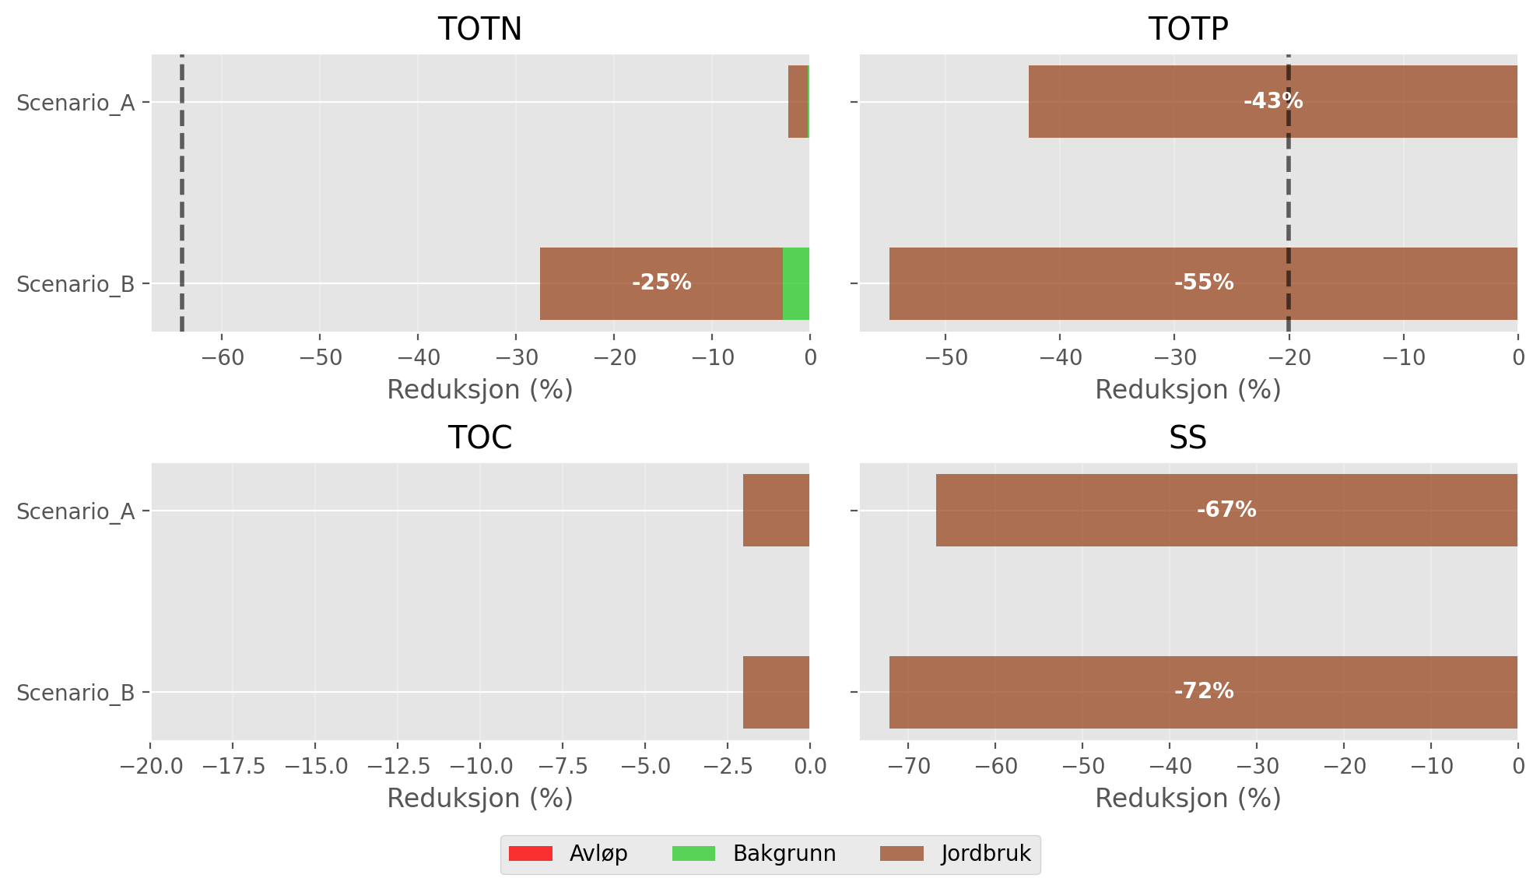
Figur 8.6: Load reductions achieved in the Jeksla catchment by scenarios A and B of Wallhead et al. (2026). Black vertical lines on the plots for TOTN and TOTP show the median avlastningsbehov for GES estimated using observed data (Figur 8.5). For clarity, labels are omitted from bars representing less than 3 %.

Tabell 8.2: Summary of avlastningsbehov and scenario results for Jeksla. Model results are based on a wider area and are approximate at the scale of Jeksla (see text).
Nedbørfelt | Vannforekomst ID | Parameter | Vann-Nett tilstand | Avlastningsbehov fra observert data (%) | Avlastningsbehov fra modellert data (%) | Reduksjon ScA (%) | Reduksjon ScB (%)
Jeksla | 002-599-R | SS | Undefined |  |  | -67 | -72
Jeksla | 002-599-R | TOC | Undefined |  |  | -2 | -2
Jeksla | 002-599-R | TOTN | Bad | -64 | -81 | -2 | -28
Jeksla | 002-599-R | TOTP | Moderate | -20 | -74 | -43 | -55

Rømua

Catchment overview
Rømua is a small catchment (212 km²) draining to Glomma in the northern part of Lillestrøm kommune. Land cover is dominated by agriculture (49 %) and forest (44 %). See Figur 9.1 and Tabell 9.1. 84 % of the catchment is located below the marine limit and 53 % is underlain by marine clay deposits. The catchment is classified as leirpåvirket (clay-influenced) and the Good/Moderate threshold for TOTP is set to 80 μg-P/l (Figur 2.3 and Tabell 3.2).
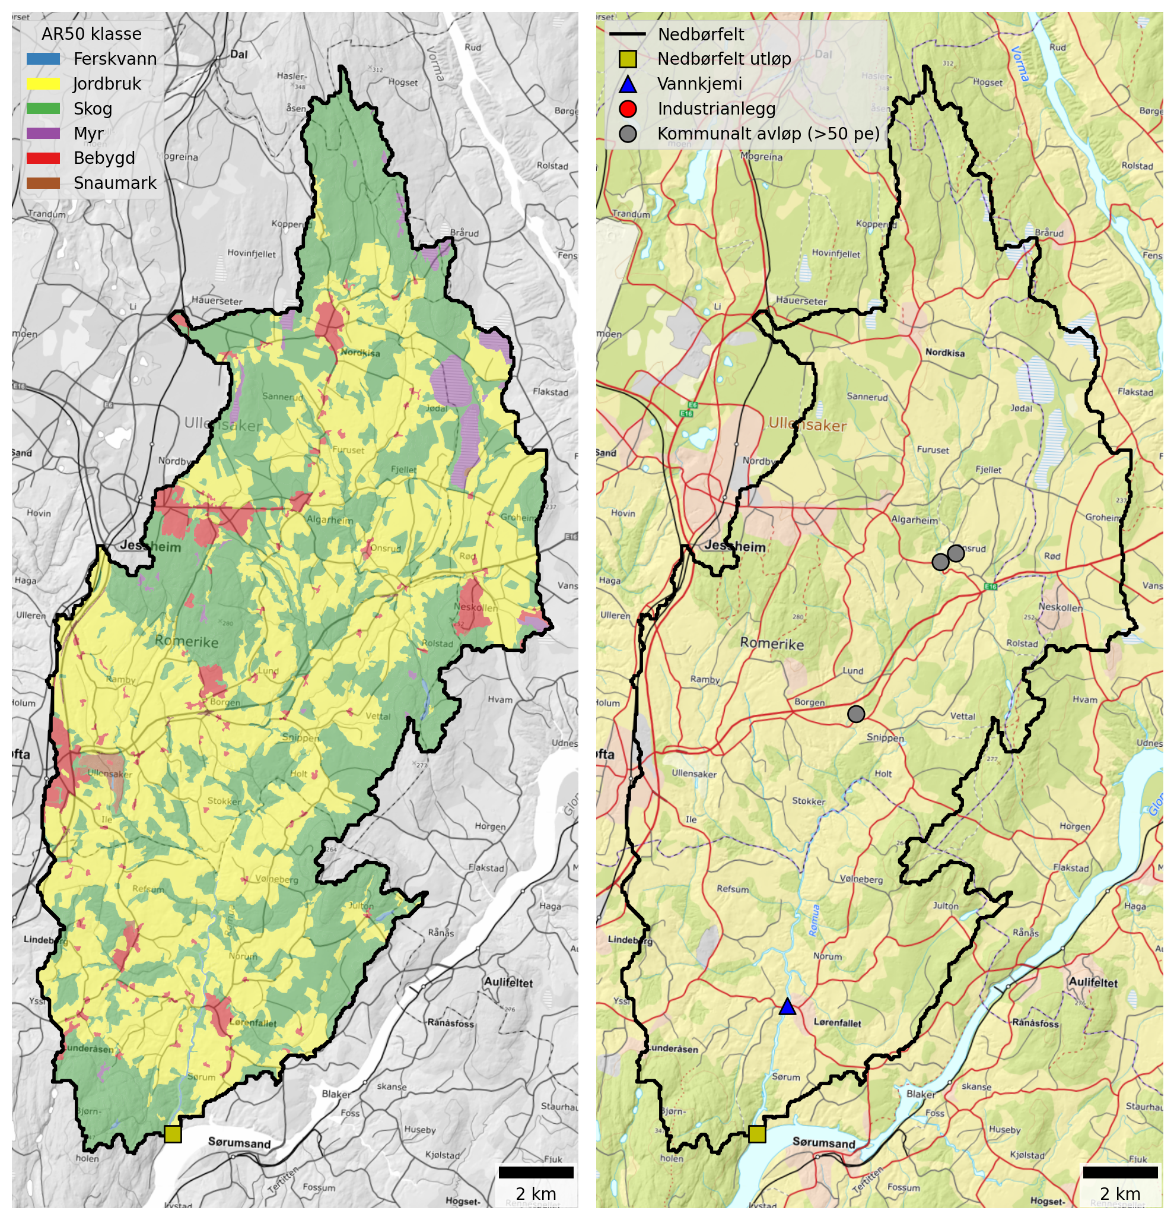
Figur 9.1: Maps of the Rømua catchment. Left: Land cover based NIBIO’s AR50 dataset. Right: Point source discharges from industry and municipal wastewater plants (≥50 p.e.).

Tabell 9.1: Land cover proportions for Rømua based on NIBIO’s AR50 dataset.
Nedbørfelt | Rømua
AR50 klasse | km² | %
Bebygd | 9.8 | 5
Jordbruk | 103.3 | 49
Skog | 92.9 | 44
Snaumark | 1.2 | 1
Myr | 4.1 | 2
Ferskvann | 0.5 | 0
Totalt | 211.8 | 100

Rømua receives discharges from three small wastewater plants connected to the municipal network (Tabell 9.2). All three are located in the central part of the catchment (Figur 9.1) and typical annual nutrient discharges are small. There are no industrial discharges within the catchment and contributions from spredt avløp and wastewater overflows (from within Lillestrøm kommune) are low.
Tabell 9.2: Industrial and municipal wastewater discharges (≥50 p.e.) within the Rømua catchment. Values are mean annual discharges from 2013 to 2024, excluding overflows.
Navn | Sektor | Type | TOTN (tonn) | TOTP (tonn) | TOC (tonn) | SS (tonn)
Onsrud leir renseanlegg | Kommunalt avløp (>50 pe) | Kjemisk-biologisk | 0.18 | 0.00 | - | 0.14
Onsrud rekkehus | Kommunalt avløp (>50 pe) | Kjemisk-biologisk | 0.13 | 0.00 | 0.06 | 0.10
Ingjersmyr avløpsanlegg | Kommunalt avløp (>50 pe) | Kjemisk-biologisk | 0.12 | 0.00 | 0.04 | 0.09

Monitoring data
The best monitoring data for Rømua come from Vannmiljø station 002-28960 (Rømua ved Lørenfallet), which is located approximately 4 km upstream from the confluence with Glomma. The site has been monitored since 1990.
Figur 9.2 shows trends in mean annual concentrations estimated from the combined dataset for waterbody 002-3659-R (Rømua). Concentrations of TOTN have been above 2000 μg-N/l for much of the past 30 years. However, there is a significant declining trend in TOTN (by -19 μg-N/l/year) and, since 2020, typical concentrations have been between 1500 and 2000 μg-N/l, corresponding to Poor status under the WFD. There are no significant trends for TOTP, and mean annual concentrations are typically between 75 and 175 μg-P/l. In Vann-Nett the water quality status for TOTP is classified as Poor (although the threshold between Moderate and Poor is not specified). SS concentrations are broadly stable and there is an increasing trend in TOC (in common with most other catchments in this region).
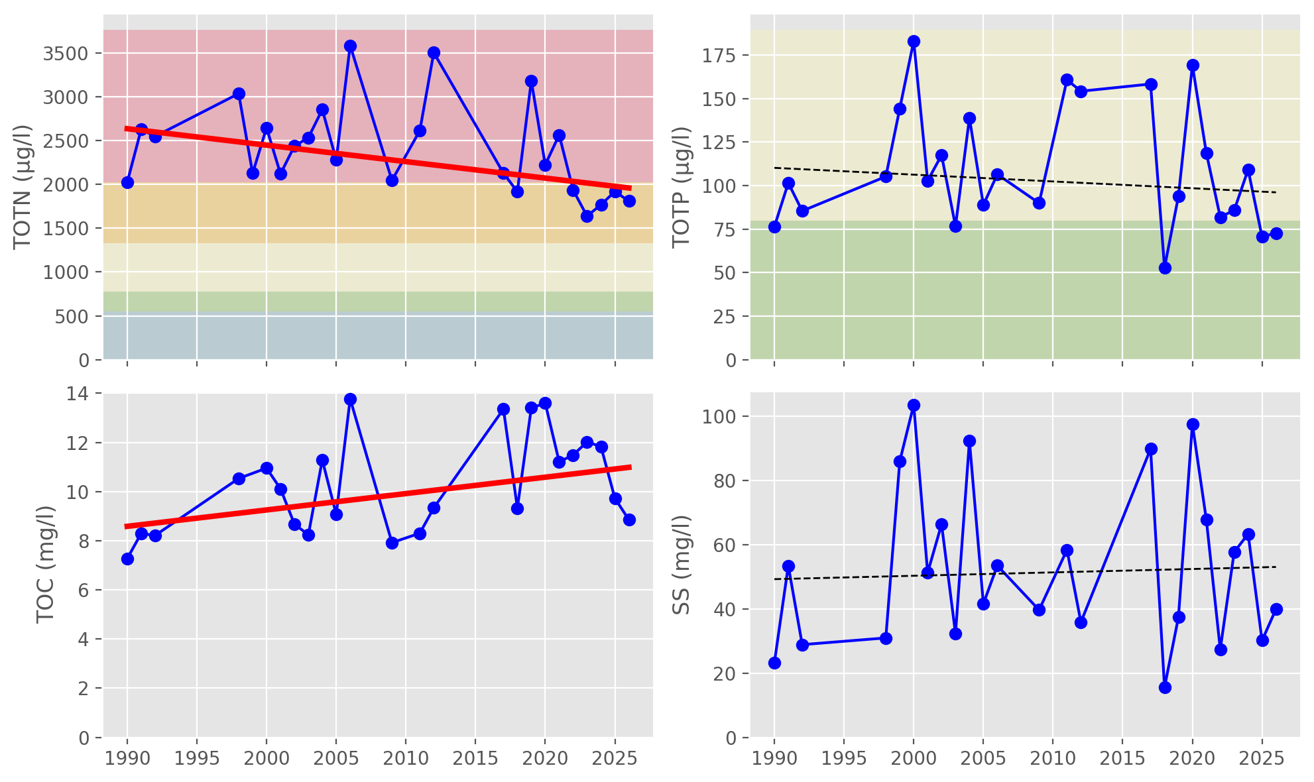
Figur 9.2: Trends in annual mean concentrations for waterbody 002-3659-R (Rømua). Solid red lines show statistically significant linear trends ($p≤0.05$); dashed red lines indicate weak evidence of a linear trend ($0.05<p≤0.10$); and dashed black lines indicate no statistically significant trend ($p>0.10$). Background colours show thresholds for water quality status defined under the Water Framework Directive and taken from Vann-Nett, where available (bad, poor, moderate, good and high).

Source apportionment
Figur 9.3 shows nutrient fluxes for Rømua estimated from observed data (black lines) together with source-apportioned fluxes simulated by TEOTIL3 (stacked bars). Note that even though the Rømua catchment is quite large (212 km²), it is represented by just a single REGINE unit in NVE’s catchment dataset. For this reason, it is not well suited to modelling with TEOTIL3 and results must be interpreted with caution (Seksjon 4.6.1).
Monitored fluxes for Rømua show high variability, especially for TOTP and SS. This is as expected for a catchment dominated by phosphorus-rich clay soils and monitored at relatively low sampling frequency: because these constituents are transported predominantly during high-flow events, estimates derived from monitoring are sensitive to the timing of sample collection relative to floods (Seksjon 4.4). While the TEOTIL3 simulations are also uncertain, modelled fluxes are broadly compatible with those estimated from observed data.
Based on Figur 9.3, typical annual nutrient fluxes for Rømua (waterbody 002-3659-R) are:
- 200 to 500 tonnes/year for TOTN
- 5 to 30 tonnes/year for TOTP
- 1000 to 2000 tonnes/year for TOC
- 5000 to 20 000 tonnes/year for SS
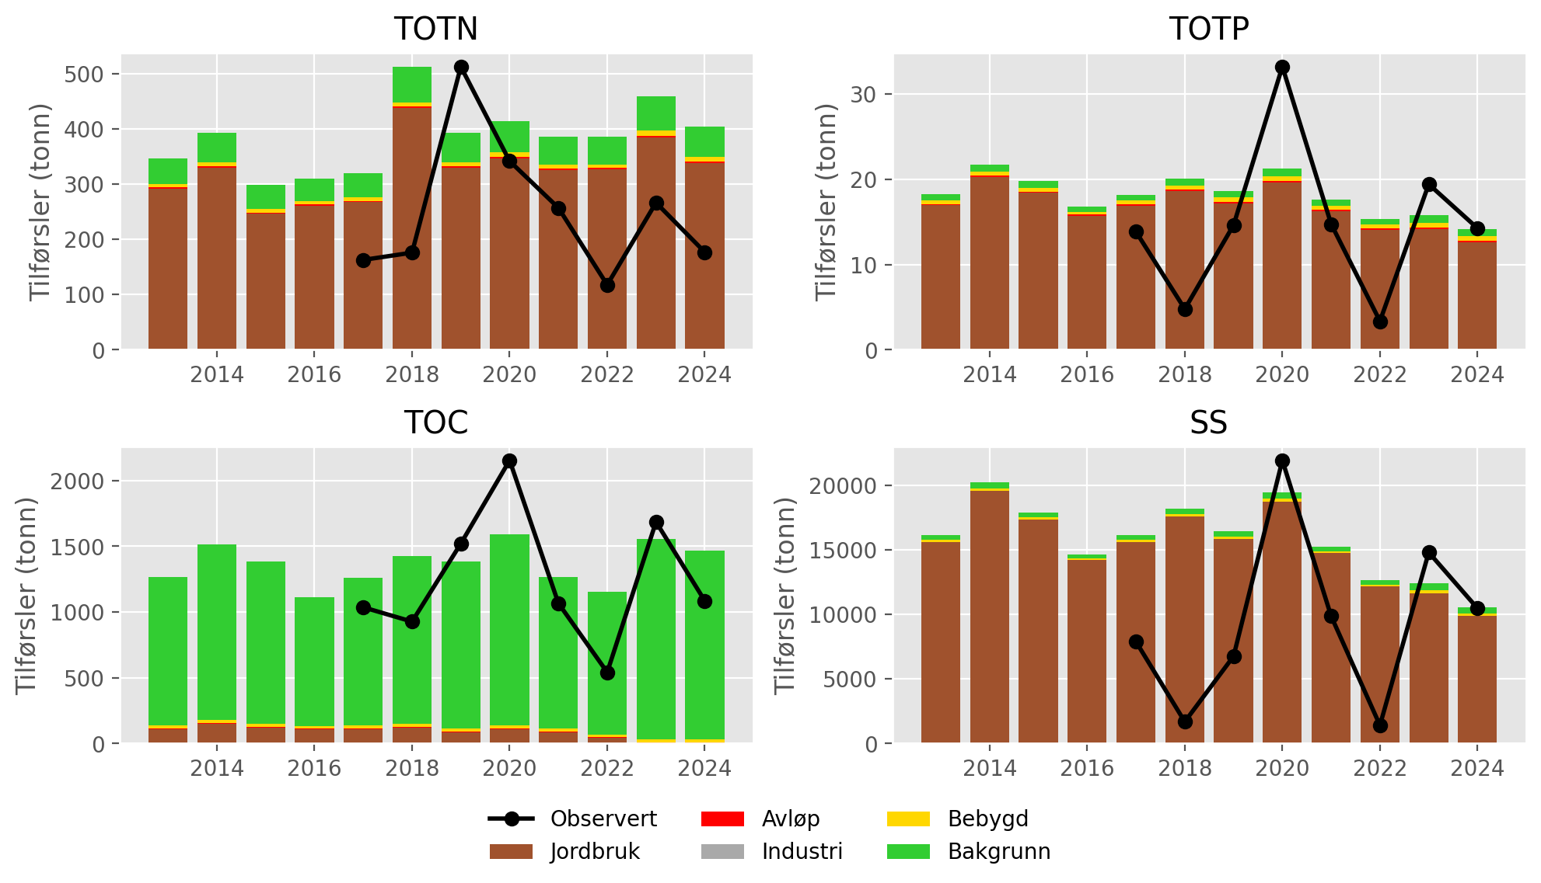
Figur 9.3: Annual nutrient fluxes for waterbody 002-3659-R (Rømua). Black lines show fluxes estimated from monitoring data; stacked bars show source-apportioned fluxes simulated by TEOTIL3.
Figur 9.4 shows the mean contribution of each source to annual fluxes during the period 2020 to 2024. According to TEOTIL3, agriculture contributes 84 % of the TOTN load, 91 % of the TOTP load, and 95 % of the SS load, while forests (background) contribute 95 % of the TOC load. These estimates seem plausible given the lack of significant point sources and the fact that roughly half the catchment comprises agricultural land underlain by phosphorous-rich clays. Wastewater inputs from spredt avløp are estimated to be small, contributing about 1 % of TOTP and 0.5 % of TOTN, while wastewater overflows from within Lillestrøm kommune are negligible.
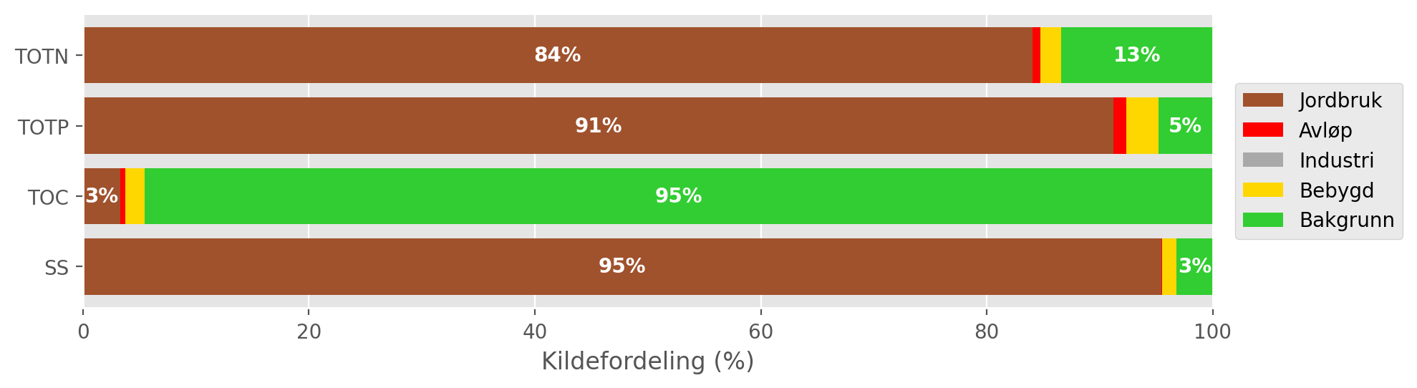
Figur 9.4: Mean source-apportionment for waterbody 002-3659-R (Rømua) based on TEOTIL3 simulations from 2020 to 2024. For clarity, labels are omitted for sources contributing less than 3 %.

Load reductions and scenarios
During the decade from 2015 to 2024, the median annual flow volume at Rømua ved Lørenfallet (Vannmiljø station 002-28960) was 93 Mm³/year. Taking the maximum concentrations for GES of 775 μg/l for N and 80 μg/l for P, the maximum annual load for Good status in a typical year is approximately 72 tonnes for TOTN and 7 tonnes for TOTP. Annual TOTN loads are often higher than this by a factor of 4 to 5, and TOTP loads by a factor of 2 to 3. This indicates that significant reductions will be required to reach GES.
Figur 9.5 shows distributions of annual avlastningsbehov estimated for each year between 2015 and 2024. Red curves show distributions based on measured loads, while blue curves are based on model output from TEOTIL3, which must be interpreted with caution. Distributions for TOTN are generally narrow and pointed, with estimates from both monitoring and modelling in the range from 60 % and 80 %. For TOTP, the distributions are broader, indicating greater uncertainty in the annual estimates due to interannual variability. The median avlastningsbehov for TOTP based on monitoring is 46 %, compared to 58 % from TEOTIL3.
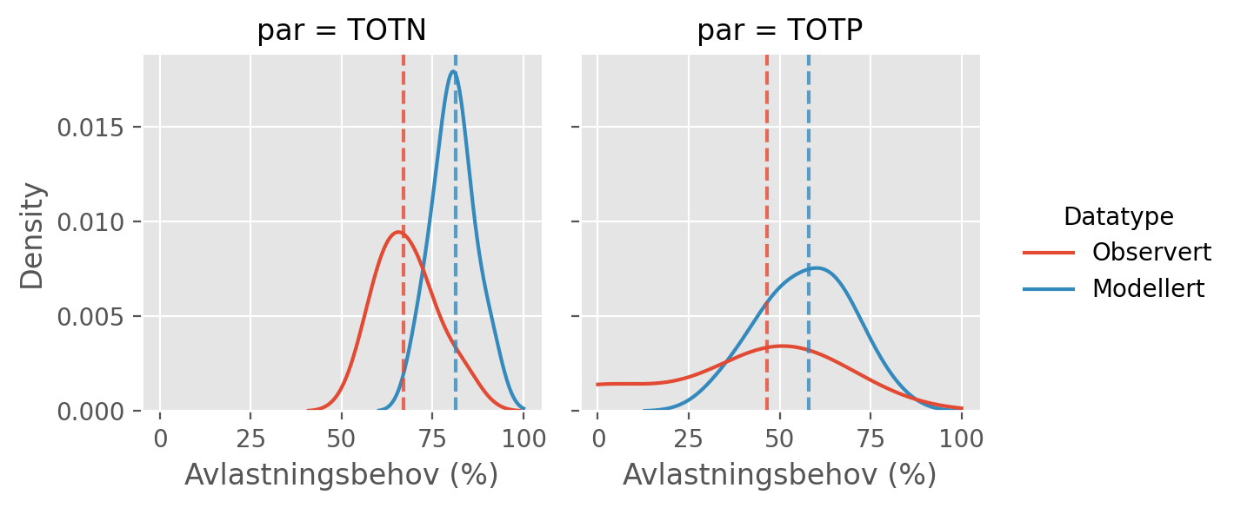
Figur 9.5: Distributions of annual avlastningsbehovene (in percent) for the ten year period from 2015 to 2024 based on observed fluxes (red curves) and fluxes simulated by TEOTIL3 (blue curves). Vertical dashed lines show the median avlastningsbehov based on each dataset i.e. the load reduction that would have achieved GES in roughly half of the ten year period.
Figur 9.6 shows load reductions achieved in the Rømua catchment under two management scenarios modelled by Wallhead et al. (2026). The scenarios comprise packages of agricultural mitigation measures together with upgrades to municipal wastewater treatment plants (Seksjon 4.8).
The three municipal wastewater treatment plants in the Rømua catchment (Tabell 9.2) are not large enough to be affected the scenarios of Wallhead et al., so the simulations do not show any reductions in wastewater inputs in this catchment. Furthermore, historic data from Lillestrøm kommune indicate that wastewater inputs from rainwater and emergency overflows are small. However, reductions of up to 1 % could potentially be achieved by reducing inputs from spredt (Seksjon 9.3).
Since the Rømua catchment is intensively farmed, the biggest potential to reduce nutrient fluxes comes from agricultural measures. Modelling undertaken by NIBIO shows that scenario A achieves only a 2 % reduction in catchment scale TOTN loads, but a 48 % reduction in TOTP. Under scenario B, nitrogen and phosphorous loads are reduced by 30 % and 64 %, respectively.
Scenarios A and B both achieve the estimated avlastningsbehov of 46 % for TOTP (based on observed data). However, neither scenario comes close to the reduction target of 60 to 80 % for TOTN. Despite the significant decreasing trend in TOTN (Figur 9.2), high measured TOTN concentrations and the limited potential for load reductions at point sources make it unlikely that Rømua will achieve GES for TOTN.
A summary of avlastningsbehovene for GES in Rømua and the reductions achieved by scenarios A and B is shown in Tabell 9.3.
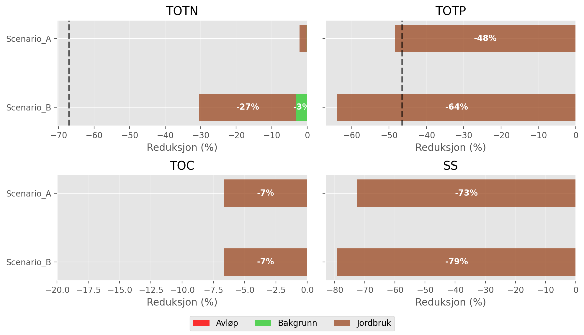
Figur 9.6: Load reductions achieved in the Rømua catchment by scenarios A and B of Wallhead et al. (2026). Black vertical lines on the plots for TOTN and TOTP show the median avlastningsbehov for GES estimated using observed data (Figur 9.5). For clarity, labels are omitted from bars representing less than 3 %.

Tabell 9.3: Summary of avlastningsbehov and scenario results for Rømua.
Nedbørfelt | Vannforekomst ID | Parameter | Vann-Nett tilstand | Avlastningsbehov fra observert data (%) | Avlastningsbehov fra modellert data (%) | Reduksjon ScA (%) | Reduksjon ScB (%)
Rømua | 002-3659-R | SS | Undefined |  |  | -73 | -79
Rømua | 002-3659-R | TOC | Undefined |  |  | -7 | -7
Rømua | 002-3659-R | TOTN | Poor | -67 | -81 | -2 | -30
Rømua | 002-3659-R | TOTP | Poor | -46 | -58 | -48 | -64

Åa

Catchment overview
Åa is a small catchment (131 km²) draining to Glomma in the eastern part of Lillestrøm kommune. Land cover is predominantly forest (72 %) and agriculture (23 %). See Figur 10.1 and Tabell 10.1. 58 % of the catchment is located below the marine limit and 26 % is underlain by marine clay deposits. The catchment is classified as leirpåvirket (clay-influenced) and the Good/Moderate threshold for TOTP is set to 50 μg-P/l (Figur 2.3 and Tabell 3.2).
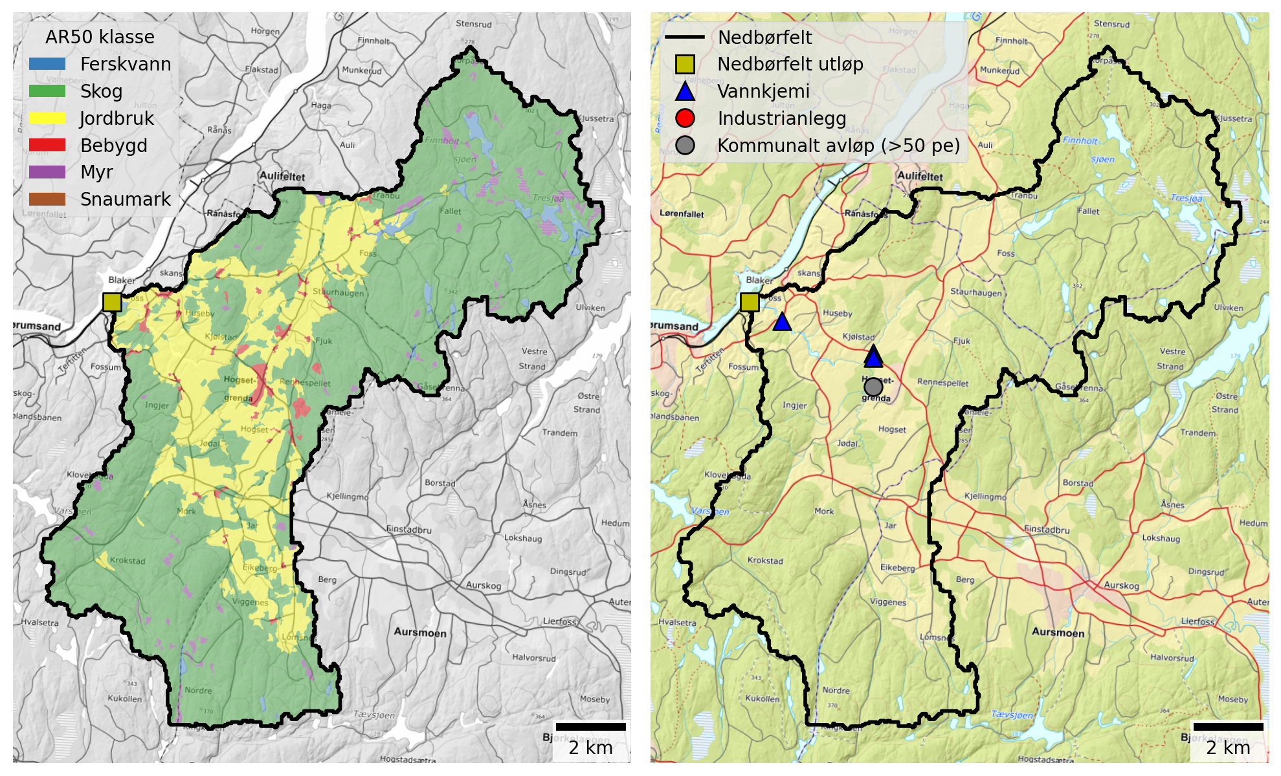
Figur 10.1: Maps of the Åa catchment. Left: Land cover based NIBIO’s AR50 dataset. Right: Point source discharges from industry and municipal wastewater plants (≥50 p.e.).

Tabell 10.1: Land cover proportions for Åa based on NIBIO’s AR50 dataset.
Nedbørfelt | Åa
AR50 klasse | km² | %
Bebygd | 2.0 | 2
Jordbruk | 29.6 | 23
Skog | 93.8 | 72
Snaumark | 0.0 | 0
Myr | 3.0 | 2
Ferskvann | 2.3 | 2
Totalt | 130.7 | 100

There are no industrial discharges to Åa and the only municipal wastewater treatment plant reporting discharges within the modelling period is Hogset renseanlegg (Tabell 10.2). However, this closed down in 2017 and the effluent is now handled by Midtre Romerike avløpsselskap (MIRA), which discharges directly to Glomma at Tangen, west of Sørumsand.
Tabell 10.2: Industrial and municipal wastewater discharges (≥50 p.e.) within the Åa catchment. Values are mean annual discharges from 2013 to 2024, excluding overflows.
Navn | Sektor | Type | TOTN (tonn) | TOTP (tonn) | TOC (tonn) | SS (tonn)
Hogset renseanlegg (Nedlagt) | Kommunalt avløp (>50 pe) | Kjemisk-biologisk | 3.13 | 0.02 | 1.03 | 1.66

Monitoring data
The best monitoring data for Åa come from Vannmiljø station 002-60929 (Fossåa ved Sylta), which is part of waterbody 002-3685-R (Fossåa). The site is located approximately 1 km upstream from the confluence with Glomma and has been monitored since 2003, although the sampling frequency during the early part of the record is low (5 to 10 samples per year). From 2017 onwards, monitoring has improved and the site has been sampled roughly 20 times per year.
Figur 10.2 shows trends in mean annual concentrations estimated from the combined dataset for waterbody 002-3685-R (Fossåa). There are no significant trends for any parameters, although the data quality for this waterbody is not as good as for other sites in this study, making robust trend identification difficult. TOTN concentrations have been broadly stable at around 1300 μg-N/l for much of the past decade, which is close to the boundary between Poor and Moderate status under the WFD. For TOTP, measured annual concentrations vary between 40 and 80 μg-P/l, and the waterbody is assigned Moderate status in Vann-Nett. TOC concentrations are typically around 14 mg-C/l, while SS concentrations vary considerably between 10 and 35 mg/l.
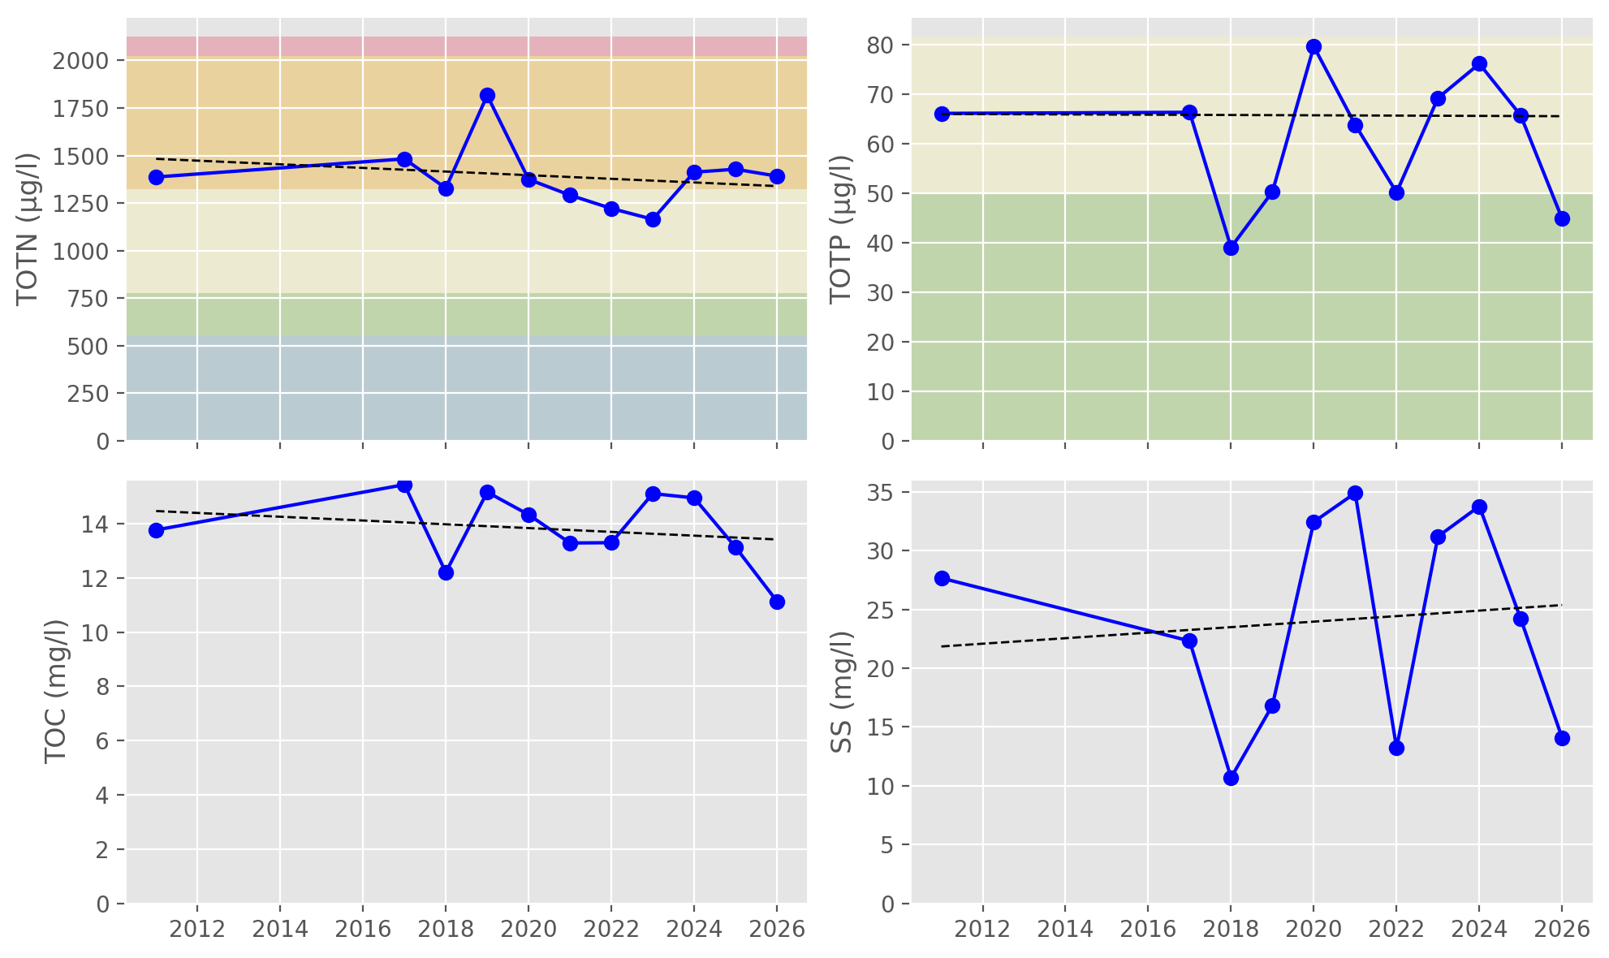
Figur 10.2: Trends in annual mean concentrations for waterbody 002-3685-R (Fossåa). Solid red lines show statistically significant linear trends ($p≤0.05$); dashed red lines indicate weak evidence of a linear trend ($0.05<p≤0.10$); and dashed black lines indicate no statistically significant trend ($p>0.10$). Background colours show thresholds for water quality status defined under the Water Framework Directive and taken from Vann-Nett, where available (bad, poor, moderate, good and high).

Source apportionment
Figur 10.3 shows nutrient fluxes for Åa estimated from observed data (black lines) together with source-apportioned fluxes simulated by TEOTIL3 (stacked bars). Note that the Åa catchment is represented by a single, small REGINE unit in NVE’s catchment dataset. For this reason, it is not well suited to modelling with TEOTIL3 and results must be interpreted with caution (Seksjon 4.6.1).
Fluxes simulated by TEOTIL3 are generally compatible with the highest values from the monitoring. Given the relatively low monitoring frequency, it is likely that load estimates based on monitoring underestimate true values, but it is also possible that TEOTIL3 is underestimating retention in this catchment (because TEOTIL3’s retention calculations are not designed for single REGINEs). In addition, NIBIO’s modelling of agricultural nutrient losses has high uncertainty at the scale of single REGINE units.
As expected from low frequency monitoring, the measured fluxes for Åa have high variability - especially for TOTP and SS. Based on the period from 2017 to 2024, typical annual nutrient fluxes for this catchment are:
- 50 to 150 tonnes/year for TOTN
- 2 to 10 tonnes/year for TOTP
- 500 to 1300 tonnes/year for TOC
- 1000 to 6000 tonnes/year for SS
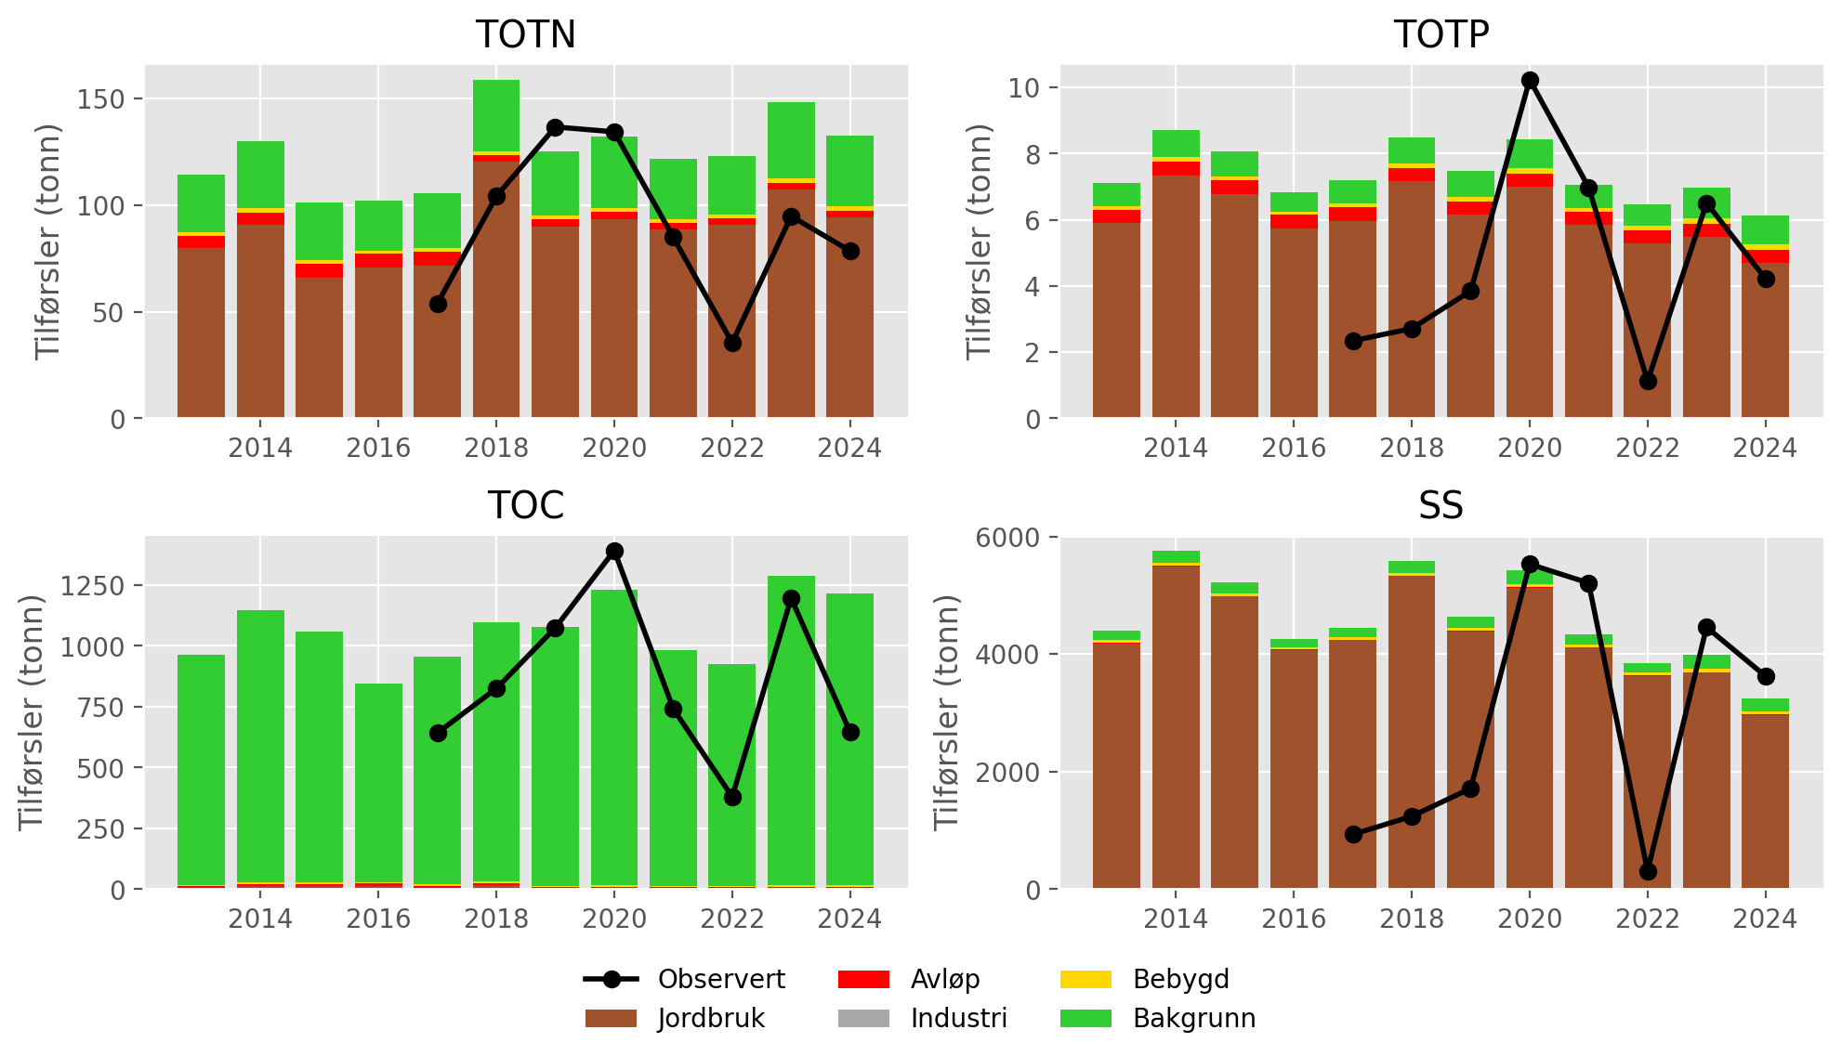
Figur 10.3: Annual nutrient fluxes for waterbody 002-3685-R (Fossåa). Black lines show fluxes estimated from monitoring data; stacked bars show source-apportioned fluxes simulated by TEOTIL3.
Figur 10.4 shows the mean contribution of each source to annual fluxes during the period 2020 to 2024. According to TEOTIL3, agriculture contributes 72 % of the TOTN load, 81 % of the TOTP load, and 94 % of the SS load, while forests (background) contribute 99 % of the TOC load. For all parameters, the dominant nutrient sources in this catchment are agriculture and forests, although wastewater discharges from spredt account for roughly 2 % of TOTN and 6 % of TOTP. Despite roughly half of the Åa catchment being located within Lillestrøm kommune, the rainwater and emergency overflows dataset from Lillestrøm suggests that inputs from overflows are negligible.
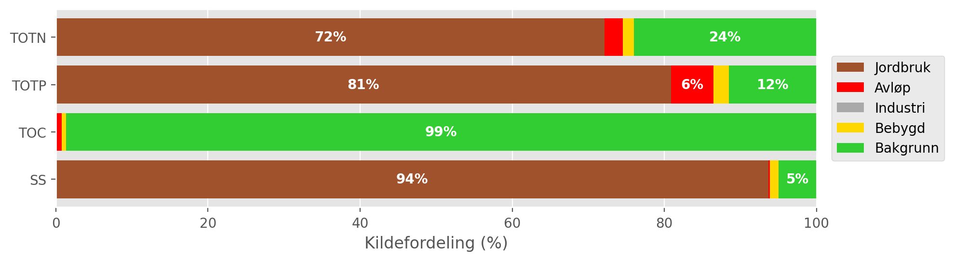
Figur 10.4: Mean source-apportionment for waterbody 002-3685-R (Fossåa) based on TEOTIL3 simulations from 2020 to 2024. For clarity, labels are omitted for sources contributing less than 3 %.

Load reductions and scenarios
During the decade from 2015 to 2024, the median annual flow volume at Fossåa ved Sylta (Vannmiljø station 002-60929) was 60 Mm³/year. Taking the maximum concentrations for GES of 775 μg/l for N and 50 μg/l for P, the maximum annual load for Good status in a typical year is approximately 47 tonnes for TOTN and 3 tonnes for TOTP. These values are roughly equivalent to the lowest values in the observed data, but in most years fluxes are considerably higher.
Figur 10.5 shows distributions of annual avlastningsbehov estimated for each year between 2015 and 2024. Red curves show distributions based on measured loads, while blue curves are based on model output from TEOTIL3, which must be interpreted with caution. Since annual loads simulated by TEOTIL3 are generally higher than those based on monitoring, avlastningsbehovene estimated using TEOTIL3 are also consistently higher. Given the limitations of both monitoring and modelling in this catchment, it is difficult to know which dataset is most representative.
For TOTN, both distributions are narrow and pointed, with a median avlastningsbehov based on observations of 44 %, compared to 63 % using TEOTIL3. For TOTP, the distribution based on observed data is broad: annual estimates of avlastningsbehovene range from 0 % to 58 %, with a median of 19 %. Estimates from TEOTIL3 are consistently higher, with a median of 58 %. Which of these estimates is better depends on whether the low TOTP and SS fluxes measured during 2017-19 and 2022 (Figur 10.3) are accurate, or whether the sampling programme missed flow events that mobilised significant amounts of particulate phosphorus.
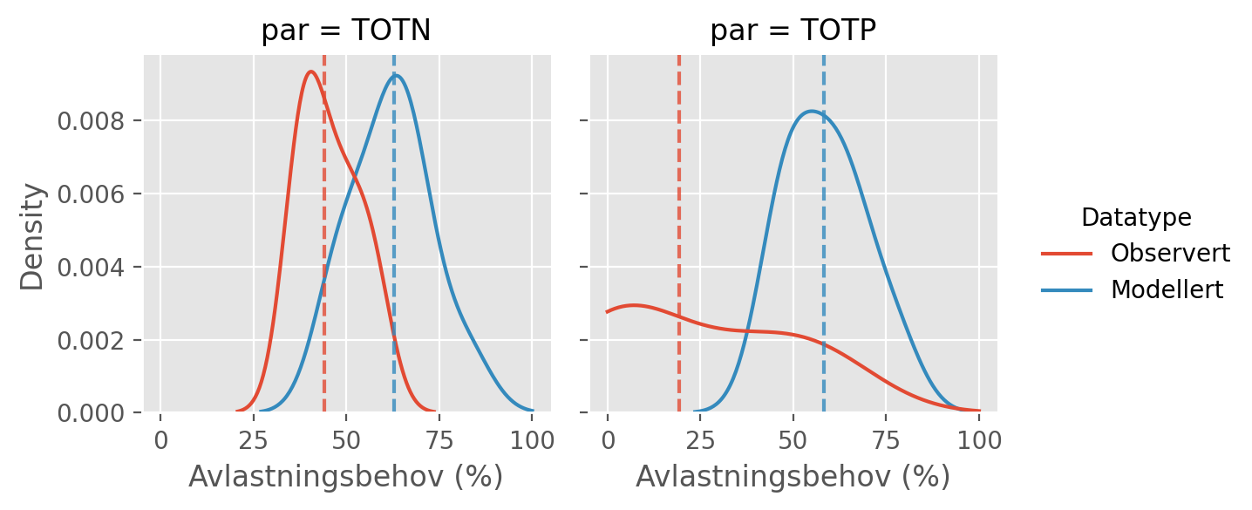
Figur 10.5: Distributions of annual avlastningsbehovene (in percent) for the ten year period from 2015 to 2024 based on observed fluxes (red curves) and fluxes simulated by TEOTIL3 (blue curves). Vertical dashed lines show the median avlastningsbehov based on each dataset i.e. the load reduction that would have achieved GES in roughly half of the ten year period.
Figur 10.6 shows load reductions achieved in the Åa catchment under two management scenarios modelled by Wallhead et al. (2026). The scenarios comprise packages of agricultural mitigation measures together with upgrades to municipal wastewater treatment plants (Seksjon 4.8).
There are no municipal wastewater treatment plants within the Åa catchment large enough to be affected by the scenarios, so simulations do not show any reductions in wastewater inputs. Furthermore, analysis undertaken in this study using overflows data from Lillstrøm kommune indicates that rainwater and emergency overflows from Lillestrøm to this catchment are small. However, load reductions of approximately 2 % for TOTN and 6 % for TOTP could potentially be achieved by reducing inputs from spredt avløp (Seksjon 10.3).
Given the lack of point sources, the main scenario reductions in this catchment are achieved by agricultural measures. Scenario A achieves a roughly 1 % reduction in TOTN loads and a 39 % reduction in TOTP, while scenario B achieves 27 % for TOTN and 53 % for TOTP. Scenario A is therefore sufficient to achieve the estimated avlastningsbehov for TOTP, but even scenario B is insufficient for TOTN. Estimates avlastningsbehovene for TOTN of 44 to 63 % are high, which will make achieving GES for TOTN in this catchment difficult.
A summary of avlastningsbehovene for GES in Åa and the reductions achieved by scenarios A and B is shown in Tabell 10.3.
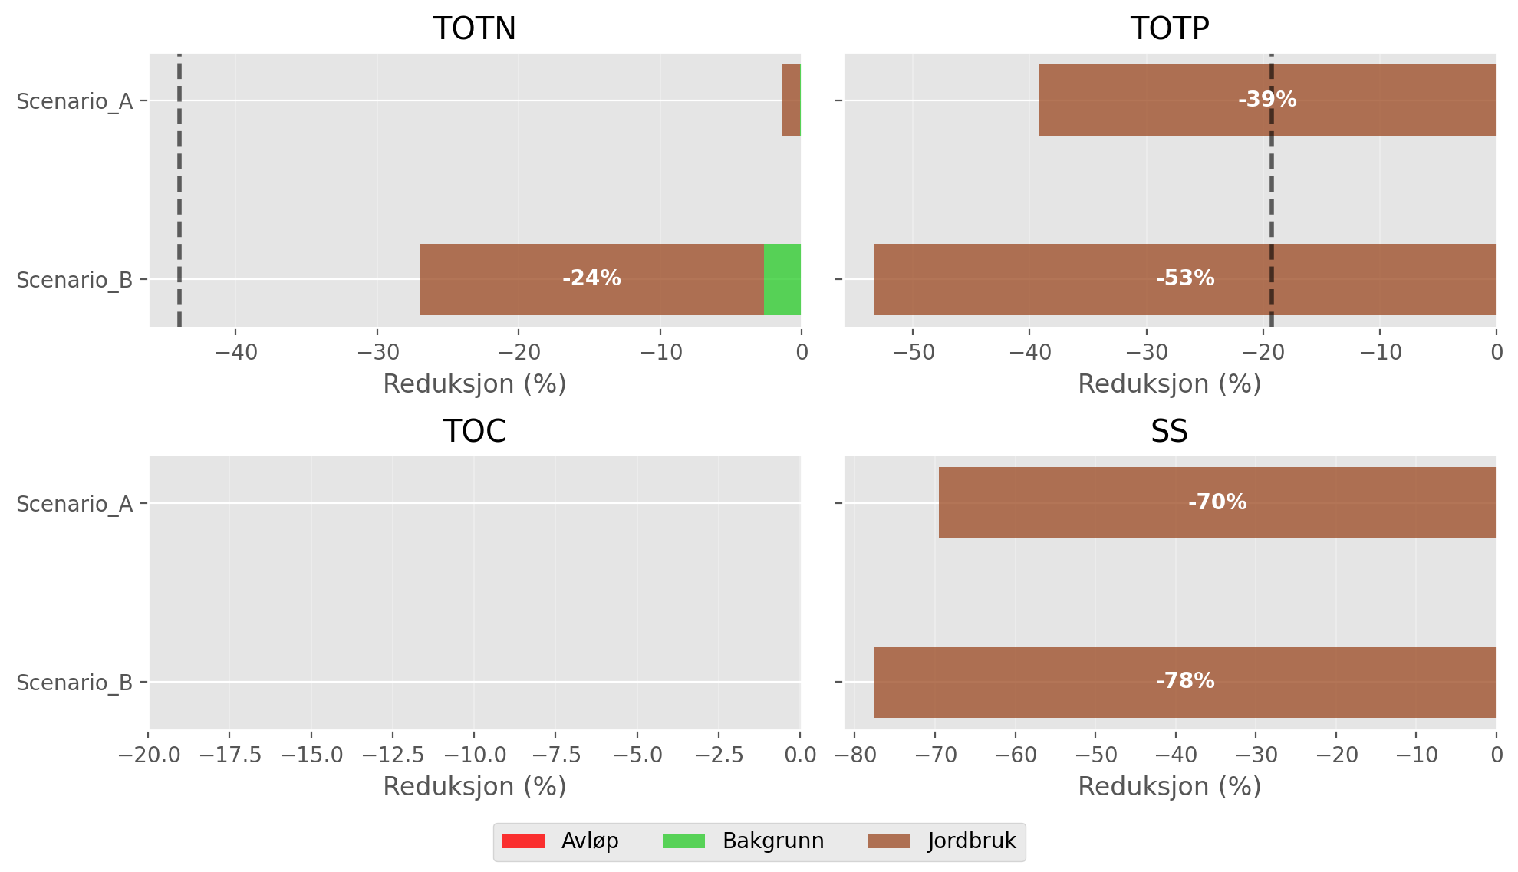
Figur 10.6: Load reductions achieved in the Åa catchment by scenarios A and B of Wallhead et al. (2026). Black vertical lines on the plots for TOTN and TOTP show the median avlastningsbehov for GES estimated using observed data (Figur 10.5). For clarity, labels are omitted from bars representing less than 3 %.

Tabell 10.3: Summary of avlastningsbehov and scenario results for Åa.
Nedbørfelt | Vannforekomst ID | Parameter | Vann-Nett tilstand | Avlastningsbehov fra observert data (%) | Avlastningsbehov fra modellert data (%) | Reduksjon ScA (%) | Reduksjon ScB (%)
Åa | 002-3685-R | SS | Undefined |  |  | -70 | -78
Åa | 002-3685-R | TOC | Undefined |  |  | 0 | 0
Åa | 002-3685-R | TOTN | Moderate | -44 | -63 | -1 | -27
Åa | 002-3685-R | TOTP | Moderate | -19 | -58 | -39 | -53

Gansåa

Catchment overview
Gansåa is a small catchment (25 km²) that drains to Gansvika on the eastern side of Øyeren. It is the only catchment included in this study that lies entirely within Lillestrøm kommune (Figur 2.1). Land cover is dominated by forest (73 %), although agricultural land is also important in the lower catchment (13 %), and extensive wetlands occupy parts of the central area (7 %). See Figur 11.1 and Tabell 11.1. Approximately 40 % of the catchment lies below the marine limit, and 19 % of the land area is underlain by marine deposits (Figur 2.3 and Tabell 3.2). Although this proportion is higher than in several of the other catchments considered here, Gansåa is the only catchment not classified as leirpåvirket (clay-influenced). Instead, it is assigned to waterbody type R108 (Medium, moderately calcareous, humic). For this waterbody type, the Good/Moderate boundary for TOTP is 29 μg-P/l.
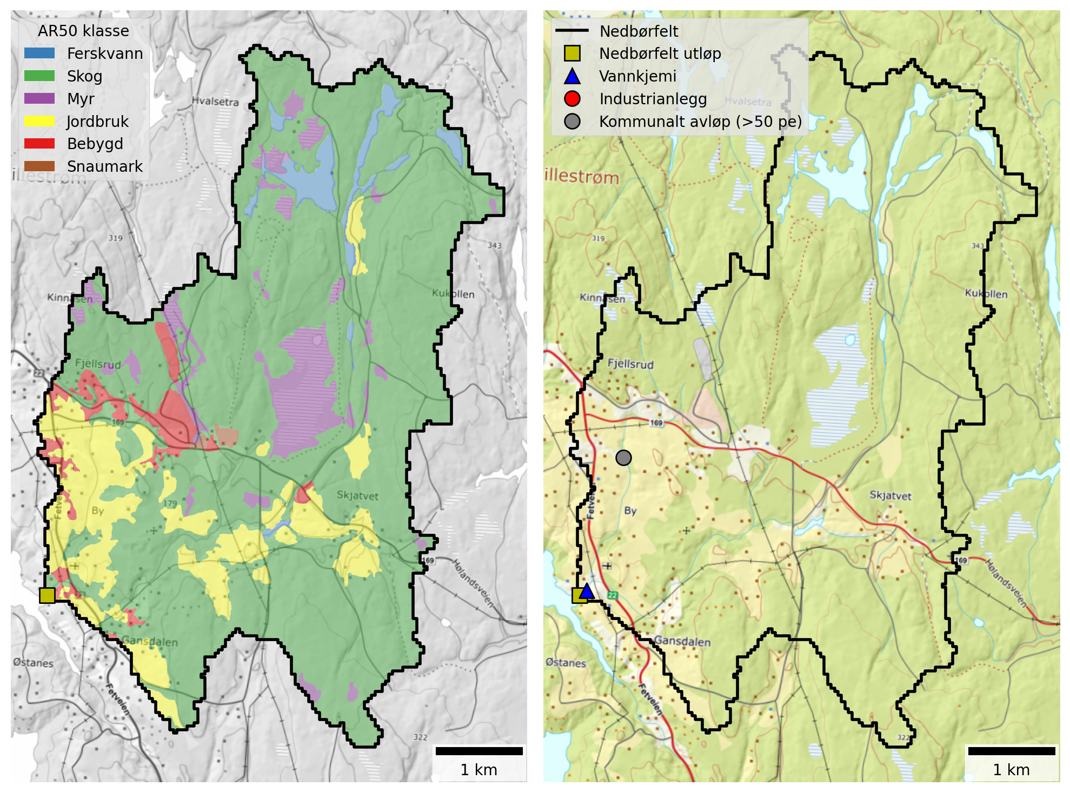
Figur 11.1: Maps of the Gansåa catchment. Left: Land cover based NIBIO’s AR50 dataset. Right: Point source discharges from industry and municipal wastewater plants (≥50 p.e.).

Tabell 11.1: Land cover proportions for Gansåa based on NIBIO’s AR50 dataset.
Nedbørfelt | Gansåa
AR50 klasse | km² | %
Bebygd | 0.8 | 3
Jordbruk | 3.4 | 13
Skog | 18.6 | 73
Snaumark | 0.1 | 0
Myr | 1.8 | 7
Ferskvann | 0.7 | 3
Totalt | 25.4 | 100

Gansåa receives discharges from Dalen renseanlegg, located in the western part of the catchment (Figur 11.1). This is a small facility with chemical treatment type and a design capacity of 1000 p.e. (Tabell 11.2). As of 2026, Dalen is being closed down and the effluent re-directed approximately 5 km westwards to Holtet, which lies outside the catchment boundary. From here, wastewater will be pumped northwards for processing at Midtre Romerike avløpsselskap (MIRA).
There are no industrial discharges within this catchment and wastewater overflows from Lillestrøm kommune are small. However, there are significant inputs from spredt avløp (Seksjon 11.3).
Tabell 11.2: Industrial and municipal wastewater discharges (≥50 p.e.) within the Gansåa catchment. Values are mean annual discharges from 2013 to 2024, excluding overflows.
Navn | Sektor | Type | TOTN (tonn) | TOTP (tonn) | TOC (tonn) | SS (tonn)
Dalen renseanlegg | Kommunalt avløp (>50 pe) | Kjemisk | 3.07 | 0.03 | 1.61 | 2.48

Monitoring data
The best monitoring data for Gansåa come from Vannmiljø station 002-60933 (Gansåa nedstrøms Dalen RA), which is located approximately 200 m upstream of the outflow to Øyeren. The station is part of waterbody 002-3655-R (Gansåa) and has been monitored since 2003, but data before 2017 are limited. Since 2017, data collection has been more frequent - typically 20 to 25 samples per year.
Figur 11.2 shows trends in mean annual concentrations estimated from the combined dataset for waterbody 002-3655-R. There are no significant trends for any parameters, although the data period (10 years) is short for robust trend identification. TOTN concentrations are typically between 800 and 1000 μg-N/l, which corresponds to Moderate status under the Water Framework Directive. TOTP concentrations are also within the Moderate class, usually between 30 and 40 μg-P/l.
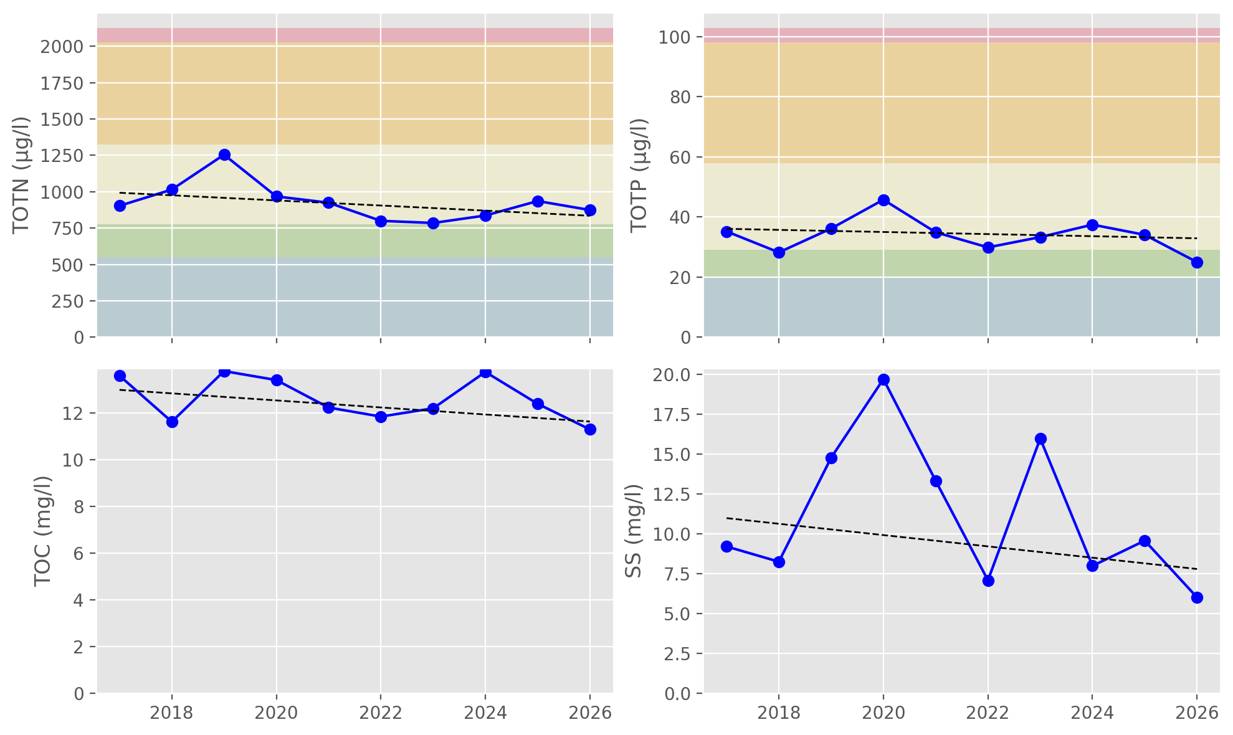
Figur 11.2: Trends in annual mean concentrations for waterbody 002-3655-R (Gansåa). Solid red lines show statistically significant linear trends ($p≤0.05$); dashed red lines indicate weak evidence of a linear trend ($0.05<p≤0.10$); and dashed black lines indicate no statistically significant trend ($p>0.10$). Background colours show thresholds for water quality status defined under the Water Framework Directive and taken from Vann-Nett, where available (bad, poor, moderate, good and high).

Source apportionment
Figur 11.3 shows nutrient fluxes for Gansåa estimated from observed data (black lines) together with source-apportioned fluxes simulated by TEOTIL3 (stacked bars). Because the Gansåa catchment is small (25 km²) and occupies only part of a single REGINE unit, it is not possible to simulate nutrient fluxes explicitly using TEOTIL3 (see Seksjon 4.6.1). TEOTIL3’s estimates of diffuse nutrient fluxes for Gansåa are therefore based on simulations from a wider area, scaled to match the size of the Gansåa catchment. TEOTIL3 results for Gansåa are therefore approximate and must be interpreted with caution, since they assume average land management and point inputs for REGINE 002.C5, rather than using Gansåa-specific data.
Based on available monitoring data, typical nutrient fluxes for Gansåa (waterbody 002-3655-R) are approximately:
- 10 to 20 tonnes/year for TOTN
- 0.3 to 1.3 tonnes/year for TOTP
- 100 to 300 tonnes/year for TOC
- 100 to 700 tonnes/year for SS
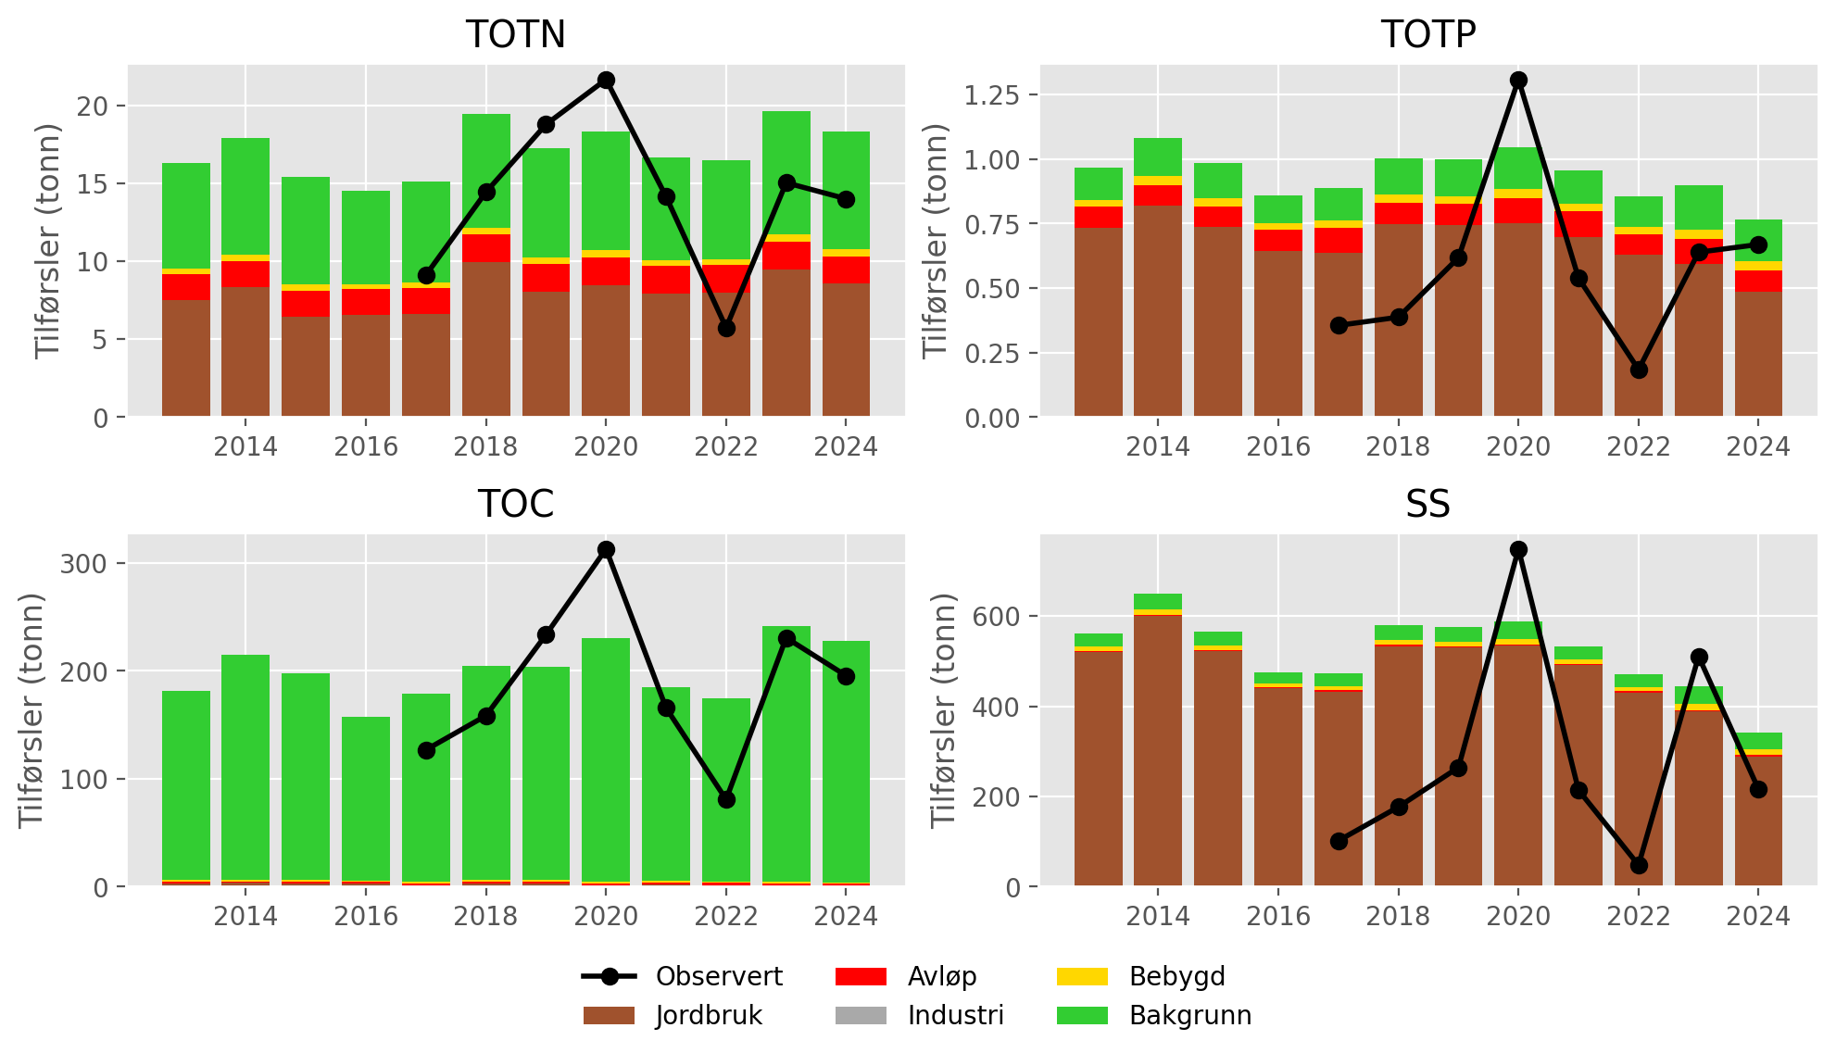
Figur 11.3: Annual nutrient fluxes for waterbody 002-3655-R (Gansåa). Black lines show fluxes estimated from monitoring data; stacked bars show source-apportioned fluxes simulated by TEOTIL3. TEOTIL3 results are approximate (see text).
Figur 11.4 shows the mean contribution of each source to annual fluxes during the period 2020 to 2024. As noted above, source apportionment is based on data from a wider area (REGINE 002.C5), so results are approximate. According to TEOTIL3, agriculture is the main source of TOTN, TOTP and SS inputs to REGINE 002.C5, while background areas, predominantly forests and marshland, contribute most of the TOC. Background sources also make significant contributions to TOTN (40 %), TOTP (16 %) and SS (7 %).
Wastewater inputs contribute approximately 10 % of the TOTN and TOTP to REGINE 002.C5. For TOTN, this can be divided into 6.5 % from municipal wastewater discharges and 3.5 % from spredt avløp. For TOTP, the split is 1.5 % and 8.5 %, respectively. Note, however, that these figures likely underestimate the true contribution from municipal wastewater to the Gansåa catchment. This is because inputs from Dalen renseanlegg to Gansåa are proportionally greater than the average over REGINE 002.C5 as a whole.
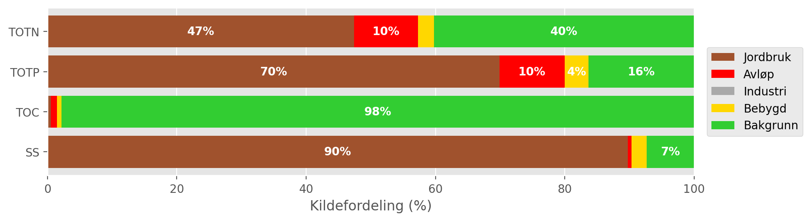
Figur 11.4: Mean source-apportionment for waterbody 002-3655-R (Gansåa) based on TEOTIL3 simulations from 2020 to 2024. For clarity, labels are omitted for sources contributing less than 3 %. Results are approximate (see text).

Load reductions and scenarios
During the decade from 2015 to 2024, the median annual flow volume at the outflow of Gansåa (Vannmiljø station 002-60933) was 14 Mm³/year. Taking the maximum concentrations for GES of 775 μg/l for N and 29 μg/l for P, the maximum annual load for Good status in a typical year is approximately 11 tonnes for TOTN and 0.4 tonnes for TOTP (Figur 11.3). These values are roughly equivalent to the lowest estimates in the observed data, but measured fluxes are usually higher.
Figur 11.5 shows distributions of annual avlastningsbehov estimated for each year between 2015 and 2024. Red curves show distributions based on measured loads, while blue curves are based on model output from TEOTIL3 for REGINE 002.C5, which must be interpreted with caution. Using the observed data, the median avlastningsbehov for TOTN is 24 %, and for TOTP it is 23 %. Estimates using TEOTIL3 are considerably higher (36 % and 58 %, respectively), but these are based on model results from a wider area, which are not considered robust at the scale of Gansåa.
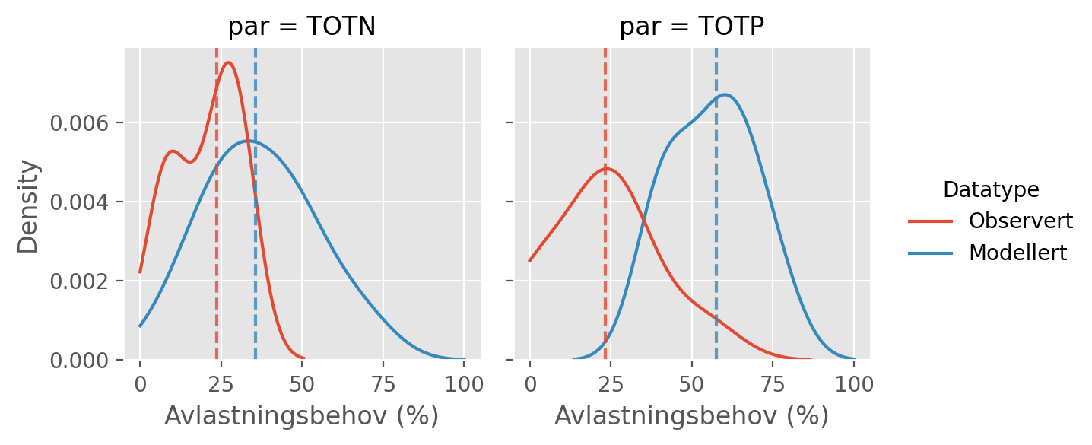
Figur 11.5: Distributions of annual avlastningsbehovene (in percent) for the ten year period from 2015 to 2024 based on observed fluxes (red curves) and fluxes simulated by TEOTIL3 (blue curves). Vertical dashed lines show the median avlastningsbehov based on each dataset i.e. the load reduction that would have achieved GES in roughly half of the ten year period. Modelled results are approximate (see text).
Figur 11.6 shows load reductions achieved in the Gansåa catchment under two management scenarios modelled by Wallhead et al. (2026). As described above, the estimated reductions are derived from modelled changes across a larger area that includes the Gansåa catchment, rather than from measures implemented specifically within the catchment itself. The scenarios comprise packages of agricultural mitigation measures together with upgrades to municipal wastewater treatment plants (Seksjon 4.8).
Dale renseanlegg is too small to be affected by the wastewater upgrades considered by Wallhead et al., so the scenarios do not show any changes in wastewater inputs. However, historically, Dalen renseanlegg discharges around 3 tonnes of TOTN and 30 kg of TOTP per year (Tabell 11.2). From late 2026, these discharges will redirected out of the catchment to MIRA, which could lead to significant reductions in TOTN fluxes (up to 20 %), and more modest reductions in TOTP fluxes (around 3 %), in addition to the changes modelled by Wallhead et al. shown on Figur 11.6.
The agricultural measures modelled by NIBIO achieve load reductions for TOTN of 2 % under scenario A and 16 % in scenario B. For TOTP, the reductions are 45 % and 56 %, respectively. Neither scenario achieves the median avlastningsbehov of 24 % for TOTN, but once the effect of decommissioning Dalen renseanlegg in 2026 is included, it is likely that scenario B would achieve GES for TOTN, and scenario A would come close. For TOTP, the agricultural measures in scenarios A and B both comfortably exceed the median load reduction target of 23 %. Based on these results, it seems feasible that Gansåa will achieve GES for nitrogen and phosphorous in the coming years, as long as agricultural measures broadly equivalent to scenario A are implemented.
A summary of avlastningsbehovene for GES in Gansåa and the reductions achieved by scenarios A and B is shown in Tabell 11.3.
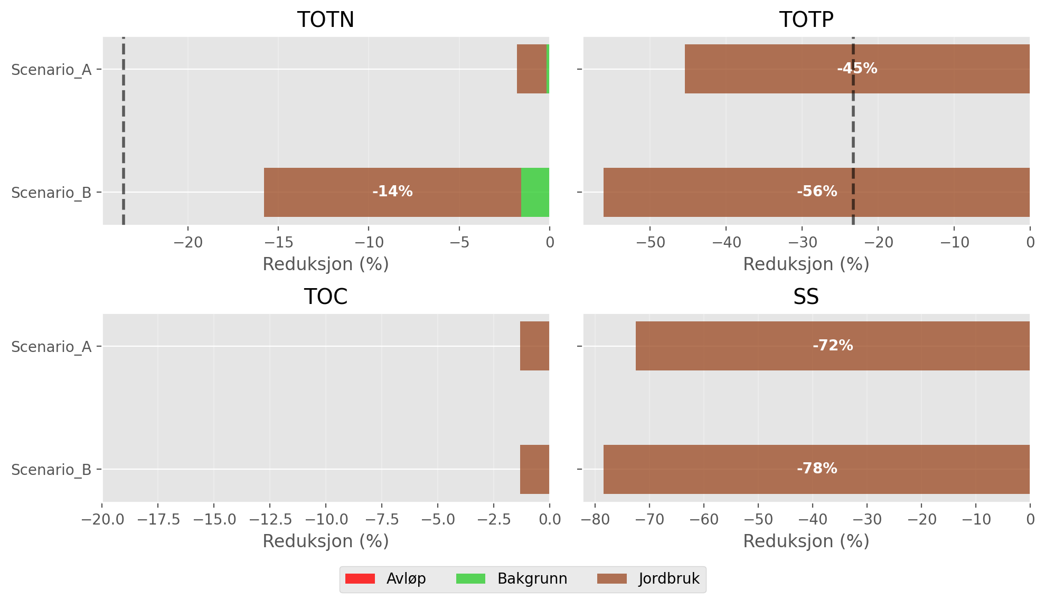
Figur 11.6: Load reductions achieved in the Gansåa catchment by scenarios A and B of Wallhead et al. (2026). Black vertical lines on the plots for TOTN and TOTP show the median avlastningsbehov for GES estimated using observed data (Figur 11.5). For clarity, labels are omitted from bars representing less than 3 %.

Tabell 11.3: Summary of avlastningsbehov and scenario results for Gansåa. Model results are based on a wider area and are approximate at the scale of Gansåa (see text).
Nedbørfelt | Vannforekomst ID | Parameter | Vann-Nett tilstand | Avlastningsbehov fra observert data (%) | Avlastningsbehov fra modellert data (%) | Reduksjon ScA (%) | Reduksjon ScB (%)
Gansåa | 002-3655-R | SS | Undefined |  |  | -72 | -78
Gansåa | 002-3655-R | TOC | Undefined |  |  | -1 | -1
Gansåa | 002-3655-R | TOTN | Moderate | -24 | -36 | -2 | -16
Gansåa | 002-3655-R | TOTP | Moderate | -23 | -58 | -45 | -56

Summary
This study uses monitoring and modelling to assess water quality status, trends in nutrient concentrations, and load reductions to achieve good ecological status (GES) for seven catchments with outflows within Lillestrøm kommune. Tabell 12.1 summarises the main results for each catchment.
Tabell 12.1: Summary of results for all catchments. *Avlastningsbhov based on monitoring only, due to high uncertainty in TEOTIL3. †GES may be achieved by this scenario in combination with decommissioning of Dalen renseanlegg, expected during 2026.
Nedbørfelt | Parameter | Vann-Nett tilstand | Trend | Foreslått avlastningsbehov (%) | Oppnådd Scenario A | Oppnådd Scenario B
Sagelva | TOTN | Moderat | Synkende | 8 to 19 | Nei | Ja
 | TOTP | Moderat | Ingen | 3 to 40 | Ja | Ja
 | TOC | Udefinert | Økende | - | - | -
 | SS | Udefinert | Ingen | - | - | -
Nitelva (ink. Sagelva) | TOTN | Moderat | Synkende | 45 to 48 | Nei | Nei
 | TOTP | Moderat | Synkende | 3 to 42 | Ja | Ja
 | TOC | Udefinert | Økende | - | - | -
 | SS | Udefinert | Synkende | - | - | -
Leira (ink. Jeksla) | TOTN | Moderat | Ingen | 42 to 55 | Nei | Nei
 | TOTP | Moderat | Synkende | 54 to 55 | Nei | Ja
 | TOC | Udefinert | Økende | - | - | -
 | SS | Udefinert | Ingen | - | - | -
Jeksla | TOTN | Svært dårlig | Ingen | 64* | Nei | Nei
 | TOTP | Moderat | Ingen | 20* | Ja | Ja
 | TOC | Udefinert | Ingen | - | - | -
 | SS | Udefinert | Ingen | - | - | -
Rømua | TOTN | Dårlig | Synkende | 67 to 81 | Nei | Nei
 | TOTP | Dårlig | Ingen | 46 to 58 | Ja | Ja
 | TOC | Udefinert | Økende | - | - | -
 | SS | Udefinert | Ingen | - | - | -
Åa | TOTN | Moderat | Ingen | 44 to 63 | Nei | Nei
 | TOTP | Moderat | Ingen | 19 to 58 | Ja | Ja
 | TOC | Udefinert | Ingen | - | - | -
 | SS | Udefinert | Ingen | - | - | -
Gansåa | TOTN | Moderat | Ingen | 24* | Nei† | Nei†
 | TOTP | Moderat | Ingen | 23* | Ja | Ja
 | TOC | Udefinert | Ingen | - | - | -
 | SS | Udefinert | Ingen | - | - | -

Agriculture and wastewater discharges are the dominant human sources of nutrients to catchments in this region. All catchments are affected by eutrophication to some extent, with present-day water quality status for TOTN and TOTP ranging from Moderate to Bad. A positive result is that there are no increasing trends in mean annual concentrations of TOTN or TOTP, and several catchments show significant declining trends over time. However, in most catchments, including the four largest, TOC concentrations are significantly increasing. This is part of a broader regional pattern, which is most likely due to increasing concentrations of dissolved organic matter in forest and upload soils as catchments recover from acidification.
Nittelva and Leira (the two largest catchments) and Sagelva all have good long-term monitoring and are well suited to modelling using TEOTIL3. Monitoring and modelling for these catchments provide a broadly consistent picture of historic nutrient loads, except for TOTP in Nittelva, where there are questions over whether the monitoring data accurately represent fluxes of particulate phosphorous. Several catchments, most notably Jeksla and Gansåa, are too small to be modelled explicitly with TEOTIL3. In these catchments, model results are scaled using average conditions over a wider area, meaning results must be interpreted with caution. Monitoring data for these catchments is also generally of lower quality, making it difficult to estimate load reduction targets robustly.
For most catchments, significant load reductions will be required to reach GES for TOTN and TOTP.
Of the seven catchments considered, only Nittelva and Leira receive significant inputs from large municipal wastewater treatment plants. In the Leira catchment, recent upgrades to Gardermoen renseanlegg during 2025-6 mean that most of the potential improvements to wastewater handling have already been achieved. In Nittelva, the older treatment plants at Rotnes and Åneby are also in the process of being decommissioned, with effluent diverted to Nedre Romerike avløpsanlegg (NRA), which also reports high treatment efficiencies for nitrogen (although not as high as the new facility at Gardermoen). Several important upgrades to reduce wastewater discharges in these catchments are therefore already in progress.
For agriculture, recent modelling undertaken by NIBIO suggests that large reductions in TOTP and SS losses could be achieved in these catchments using traditional packages of agricultural measures, corresponding to scenario A in Wallhead et al. (2026). Scenario A assumes full implementation of measures covered by existing legislation within the five Environmental Requirement Zones (Seksjon 4.8), which should be completed in the coming years. For all catchments except Leira, results suggest that measures equivalent to scenario A would be sufficient to achieve GES for TOTP. For Leira, additional measures for TOTP equivalent to scenario B of Wallhead et al. would probably be required.
For TOTN, GES is likely to be harder to achieve. Measured TOTN concentrations are high in most catchments and reduction targets of more than 40 % are common. In addition, traditional agricultural measures are targeted towards reducing losses of particulate material, making them effective for reducing inputs of TOTP and SS, but less effective for nitrogen. In five out of seven catchments, neither scenario from Wallhead et al. is sufficient to achieve GES for TOTN. In Sagelva, GES for TOTN is achieved by scenario B, but not scenario A. For Gansåa, neither scenario alone achieves GES for TOTN, but when combined with decommissioning of Dalen renseanlegg (underway during 2026), it is likely that scenario B would achieve GES for TOTN, and scenario A would come close.
It is important to emphasise that the scenarios of Wallhead et al. focus on traditional packages of agricultural measures historically funded under the Regionale miljøprogram (RMP). As noted above, these are not efficient for reducing losses of agricultural nitrogen. In the Lillestrøm catchments considered in this study, future management plans should aim to combine the TOTP and SS mitigation of scenario A with additional wastewater and agricultural measures specifically targeting nitrogen. Scenario B itself is not desirable, because it typically achieves larger than necessary reductions in TOTP and SS, without effectively tackling nitrogen losses from agriculture.

References
Beldring S, Engeland K, Roald LA, Sælthun NR, Voksø A. 2003. Estimation of parameters in a distributed precipitation-runoff model for Norway. Hydrology and Earth System Sciences 7 (3) 304-316. Tilgjengelig på nett.
Berge G & Hjertaas HW. 2024. Kommunale avløp 2023. Ressursinnsats, gebyrer, utslipp, rensing og slamdisponering. SSB rapport 2024/45. Tilgjengelig på nett.
Frigstad H, Andersen GS, Trannum HC, McGovern M, Naustvoll L, Kaste Ø, Deininger A, Hjermann DØ. 2023. Three decades of change in the Skagerrak coastal ecosystem, shaped by eutrophication and coastal darkening. Estuarine, Coastal and Shelf Science 283. Tilgjengelig på nett.
Helsel DR, Hirsch RM, Ryberg KR, Archfield SA, Gilroy EJ. 2020. Statistical Methods in Water Resources. U.S. Geological Survey Techniques and Methods, Book 4, Chapter A3. Tilgjengelig på nett.
Hensel GR & Mæhlum T. 2025. Mindre avløpsanlegg i spredt bebyggelse - Renseeffekt og reduksjonsfaktorer NIBIO rapport 11 41. Tilgjengelig på nett.
Kværnø S, Fischer F, Bechmann M. 2024. AGRITIL - Nutrient loss model for agriculture - Modelling soil, organic carbon, nitrogen and phosphorus losses from Norwegian agricultural areas to water. NIBIO rapport 10-43-2024. Tilgjengelig på nett.
Meland A, Fyhn A, Kornstad T, Falk MI, Karlsson T, Vingerhagen R. 2023. Overvåkning og klassifisering 2022: Fysisk-kjemiske kvalitetselementer. Vannområde Leira-Nitelva rapport 02-J03. Tilgjengelig på nett.
Sample JE, Jackson-Blake LA, Vogelsang C, Kaste Ø. 2024. TEOTIL3: En modell for beregning av kildebaserte tilførsler via elver og direktetilførsler til kyst. NIVA rapport 7996-2024. Tilgjengelig på nett.
Skarbøvik E, Stålnacke P, Bogen J, Bønsnes TE. 2012. Impact of sampling frequency on mean concentrations and estimated loads of suspended sediment in a Norwegian river: Implications for water management. Science of The Total Environment 433 462-471. Tilgjengelig på nett.
Slabon A & Hoffmann T. 2024. Uncertainties of annual suspended sediment transport estimates driven by temporal variability. Water Resources Research 60, e2022WR032628. Tilgjengelig på nett.
Wallhead P, Staalstrøm A, Jackson-Blake LA, Kvile K, Frigstad H, Norling M, Rinde E, Murray C, Sample JE, Yakushev E, Ramon P, Christensen KH, Kristensen NM, Simonsen M, Kværnø SH, Fischer F, Bechmann M. 2026. Modellering av Oslofjorden: scenarier med redusert menneskelig belastning for å oppnå god økologisk tilstand. NIVA rapport 8186-2026. Tilgjengelig på nett.
de Wit HA, Garmo ØA, Jackson-Blake LA, Clayer F, Vogt RD, Austnes K, Kaste Ø, Gundersen CB, Guerrerro JL, Hindar A. 2023. Changing water chemistry in one thousand Norwegian lakes during three decades of cleaner air and climate change. Global Biogeochemical Cycles 37. Tilgjengelig på nett.
Åstebøl SO, Kjølholt J, Hvitved-Jacobsen T, Berg G, Saunes H. 2012. Beregning av forurensing fra overvann. COWI rapport A029838/137924. Tilgjengelig på nett.

