PESTRISK
VILLAGE WASTE HOTSPOT PRIORITIZATION PLATFORM
A Case Study on Communicable Disease Vector Risk in Vadama Village (Group 5)
A PROJECT REPORT
submitted by
NIVEDITHA V S (SHR25CS197)
SHARON PAULET (SHR24CS191)
SHEFIN HASHIR (SHR24CS203)
VISMAYA E A (SHR24CS249)
to
the APJ Abdul Kalam Technological University
in partial fulfillment of the requirements for the award of the Degree of
Bachelor of Technology
in
Computer Science and Engineering

Department of Computer Science Engineering
SAHRDAYA COLLEGE OF ENGINEERING AND TECHNOLOGY
KODAKARA, THRISSUR - 680684
November 2026

DECLARATION
We undersigned, hereby declare that the project report entitled “PestRisk — Village Waste Hotspot Prioritization Platform (A Case Study on Communicable Disease Vector Risk in Vadama Village — Group 5)”, submitted for partial fulfillment of the requirements for the award of degree of Bachelor of Technology in Computer Science and Engineering under the Universal Human Values (UHV II), Life Skills and Community Work course of the APJ Abdul Kalam Technological University, Kerala, is a bonafide work done by us under the guidance of Ms. Merin Michael T, Assistant Professor, Department of Computer Science & Engineering. This submission represents our ideas in our own words and where ideas or words of others have been included; we have adequately and accurately cited and referenced the original sources. We also declare that we have adhered to the ethics of academic honesty and integrity, universal human values, and community welfare, and have not misrepresented or fabricated any data, fact, or source in our submission. We understand that any violation of the above will be a cause for disciplinary action by the institute and/or the University. This report has not been previously formed the basis for the award of any degree, diploma, or similar title of any other University.
Place: Kodakara  Date of Submission: 07-11-2025 | Niveditha V S (SHR25CS197)  Sharon Paulet (SHR24CS191)  Shefin Hashir (SHR24CS203)  Vismaya E A (SHR24CS249)

DEPARTMENT OF COMPUTER SCIENCE ENGINEERING
SAHRDAYA COLLEGE OF ENGINEERING AND TECHNOLOGY
KODAKARA , THRISSUR

CERTIFICATE
This is to certify that the project report entitled “PestRisk — Village Waste Hotspot Prioritization Platform (A Case Study on Communicable Disease Vector Risk in Vadama Village — Group 5)” submitted by Niveditha V S (SHR25CS197), Sharon Paulet (SHR24CS191), Shefin Hashir (SHR24CS203), and Vismaya E A (SHR24CS249) to the APJ Abdul Kalam Technological University in partial fulfillment of the requirements for the award of the Degree of Bachelor of Technology in Computer Science and Engineering for the course Universal Human Values (UHV II), Life Skills and Community Work is a bonafide record of the project work carried out by them under our guidance and supervision. This report in any form has not been submitted to any other University or Institute for any purpose.
Place: Kodakara  Date of Submission: 07-11-2025 | COURSE FACULTY  Ms. Merin Michael T  Assistant Professor  HEAD OF THE DEPARTMENT  Dr. Sreeraj R  Associate Professor

ACKNOWLEDGEMENT
We would like to express our immense gratitude and profound thanks to all those who helped us to make this Universal Human Values project a great success. We express our gratitude to the almighty God for all the blessings endowed on us.
We express our sincere thanks to our Executive Director Rev. Fr. Dr. Anto Chungath and Principal Dr. Ramkumar S for providing us with such a supportive academic ecosystem and opportunity for value-based learning. We convey our heartfelt gratitude to our Head of the Department Dr. Sreeraj R for his constant inspiration, encouragement, and valuable support throughout the semester.
We can hardly find words to express our deep appreciation and sincere thanks for the guidance, constructive suggestions, and warm encouragement that we received from our course teacher Ms. Merin Michael T, Assistant Professor, Department of Computer Science & Engineering, for her whole-hearted support throughout this work.
We are also deeply indebted to our parents and friends who continuously encouraged and supported us in all aspects of our academic and project endeavors.

INSTITUTE VISION
To be a leading global centre of engineering education and research that fosters innovation, ethical leadership, and transformative societal impact.
INSTITUTE MISSION
• Provide high-quality, outcome-based engineering education that prepares future-proof graduates with strong technical competence, critical thinking, and problem-solving abilities.
• Promote interdisciplinary research, innovation, and entrepreneurship through vibrant collaboration with industry, academia, and research organizations to address local and global challenges.
• Nurture values of integrity, responsibility, sustainability, and social commitment in students and faculty, shaping ethical leaders dedicated to societal transformation and community welfare.
• Strengthen institutional excellence through continuous improvement, robust quality assurance systems, and effective stakeholder engagement aligned with global standards.
QUALITY POLICY
We at Sahrdaya are committed to provide Quality Technical Education through continual improvement and by inculcating moral and universal human values in students, empowering them to serve society with competence and compassion.

DEPARTMENT VISION
To emerge as a globally acclaimed Centre of Excellence in Computer Science and Engineering by transformative education and research in intelligent systems and digital technologies, while ensuring innovation, ethical leadership, and sustainable societal impact.
DEPARTMENT MISSION
M1: To deliver high-quality, outcome-based education in core and emerging computer science fields to produce skilled, industry-ready graduates with strong problem-solving abilities.
M2: To promote interdisciplinary research and innovation in advanced computing, collaborating with industry and academia to create real-world solutions.
M3: To nurture responsible computing professionals through ethics, sustainability, and social responsibility to create inclusive, impactful digital solutions.
M4: To strengthen institutional excellence through continuous curriculum improvement, quality assurance, stakeholder engagement, and effective governance aligned with global standards.

PROGRAMME EDUCATIONAL OBJECTIVES (PEOs)
PEO1 | To establish successful careers in industry, academia, or entrepreneurship by applying core and emerging knowledge in computer science within global and multidisciplinary environments.
PEO2 | To analyze complex real-world problems and develop innovative, research-oriented solutions using intelligent and data-driven computing technologies.
PEO3 | To demonstrate ethical practices, leadership, and teamwork while developing sustainable technological solutions that contribute positively to society.
PROGRAMME SPECIFIC OUTCOMES (PSOs)
PSO1 | To design and develop efficient computing solutions using core computer science principles along with emerging technologies such as artificial intelligence, machine learning, and data analytics.
PSO2 | To build scalable, secure, and high-quality software systems using modern tools, programming paradigms, cloud platforms, and cybersecurity practices aligned with industry standards.
PSO3 | To apply advanced computing concepts in interdisciplinary domains to create innovative solutions, pursue research, and develop entrepreneurial ventures with ethical and societal responsibility.

PROGRAMME OUTCOMES (POs)
PO1 | Engineering Knowledge: Apply knowledge of mathematics, natural science, computing, engineering fundamentals and an engineering specialization to develop the solution of complex engineering problems.
PO2 | Problem Analysis: Identify, formulate, review research literature and analyze complex engineering problems reaching substantiated conclusions with consideration for sustainable development.
PO3 | Design/Development of Solutions: Design creative solutions for complex engineering problems and design systems/components/processes to meet identified needs with consideration for public health and safety, whole-life cost, net zero carbon, culture, society, and environment.
PO4 | Conduct Investigations of Complex Problems: Conduct investigations of complex engineering problems using research-based knowledge including design of experiments, analysis & interpretation of data to provide valid conclusions.

PO8 | Individual and Collaborative Team work: Function effectively as an individual, and as a member or leader in diverse/multi-disciplinary teams.
PO9 | Communication: Communicate effectively and inclusively within the engineering community and society at large, such as being able to comprehend and write effective reports, design documentation, and make effective presentations considering cultural, language, and learning differences.
PO10 | Project Management and Finance: Apply knowledge and understanding of engineering management principles and economic decision-making and apply these to one's own work, as a member and leader in a team, and to manage projects in multidisciplinary environments.
PO11 | Life-Long Learning: Recognize the need for, and have the preparation and ability for independent and life-long learning, adaptability to new and emerging technologies, and critical thinking in the broadest context of technological change.

Abstract
In rural community environmental health, uncollected and unsegregated solid waste left in the open presents a serious public health hazard by attracting disease-transmitting animal and insect vectors. This project focuses specifically on the community problem assigned to Group 5: 'Attracts stray animals, mosquitoes, and rodents, raising the risk of communicable disease (Vadama)'. In Vadama village, uncollected refuse and decomposing organic waste left in open areas draw stray animals, mosquitoes, and rodents directly into residential neighborhoods. This significantly raises the risk of communicable disease transmission (such as Dengue, Chikungunya, and Leptospirosis) to nearby households, compounding the public-health burden already created by stagnant water and poor drainage in village culverts and canal edges.
To address these documented problems in Vadama village through an ethical engineering framework, this project develops PestRisk: Village Waste Hotspot Prioritization Platform. Created under the Universal Human Values (UHV II), Life Skills and Community Work curriculum, PestRisk operationalizes the core principle of Sah-Astitva (Co-existence across Self, Society, and Nature) by combining participatory citizen waste reporting with a deterministic 7-factor vector-risk scoring heuristic and worker dignity safeguards.
The software architecture comprises an enterprise Java 21 / Spring Boot 3.5.0 REST backend with an embedded SQLite database (pestrisk.db), paired with an accessible React 19 single-page application. In place of opaque machine learning models, PestRisk utilizes a fully transparent, deterministic 7-factor mathematical risk engine that directly mirrors the documented Vadama sub-cases: waste quantity (5–15 pts), accumulation duration exceeding 4 days (+15 pts), stagnant water in poor drainage (+20 pts), active mosquito swarms (+15 pts), rodent activity (+15 pts), stray animal attraction (+10 pts), and unsegregated decomposing organic waste (+10 pts). The engine computes an auditable score from 0 to 100 classified into LOW, MODERATE, HIGH, and CRITICAL priority tiers.
PestRisk emphasizes ethical human values through citizen privacy preservation and worker dignity protection. Public community feeds display only generalized ward-level risk indicators, strictly omitting personal citizen names, phone numbers, and private landmarks to prevent community friction. Simultaneously, the staff dashboard flags physical crew hazards (e.g., broken glass, sharp metals) upfront, ensuring sanitation personnel are equipped with puncture-resistant personal protective equipment (PPE) before cleanup.
The platform was verified through automated test suites (58 tests) and simulated sanitation sub-cases modeled after Vadama village conditions (canal culvert stagnation, market food waste drawing stray dogs, canal-bank rodent burrows, and mixed waste dumping). The results confirm reliable priority triage, transparent state transitions, and responsive hazard notification. Overall, PestRisk provides a practical, value-guided engineering solution that supports communicable disease prevention and respects community well-being.

TABLE OF CONTENTS
Chapter | TITLE | Page No.
 | Institute Vision, Mission and Quality Policy | i
 | Department Vision, Mission, PEOs, POs And PSOs | ii
 | Abstract | v
 | Table of Contents | vi
 | List of Tables | vii
 | List of Abbreviations | viii
1 | INTRODUCTION | 1
 | 1.1 General & Problem Statement (Group 5 - Vadama) | 1
 | 1.1.1 Documented Problems and Sub-Cases in Vadama Village | 2
 | 1.2 Universal Human Values & Community Framework | 3
 | 1.2.1 Nomenclature | 5
 | 1.3 Project Overview | 6
 | 1.4 Literature Survey | 8
2 | SCOPE AND DELIVERABLES | 10
 | 2.1 Scope of the Project | 10
 | 2.2 Project Deliverables | 12
3 | METHODOLOGY | 14
 | 3.1 Overview | 14
 | 3.2 Development and Community-Centered Approach | 15
 | 3.3 Tools and Frameworks Used | 16
 | 3.4 Universal Human Values Principles Applied | 17
 | 3.5 Quality Assurance and Prototype Validation | 18
4 | PROJECT ACTIVITIES | 20
 | 4.1 Overview | 20
 | 4.2 Backend and Core Analytical Engine Activities | 20
 | 4.2.1 Tasks Performed | 20
 | 4.2.2 Tools and Technologies Used | 22
 | 4.2.3 Challenges Faced | 22
 | 4.3 Frontend and Community Portal Activities | 23
 | 4.3.1 Tasks Performed | 23
 | 4.3.2 Tools and Technologies Used | 24
 | 4.3.3 Challenges Faced | 24
 | 4.4 System Integration and Vadama Scenario Testing | 25
 | 4.4.1 Tasks Performed | 25
 | 4.4.2 Tools and Technologies Used | 27
 | 4.4.3 Challenges Faced | 27
 | 4.5 Documentation, Life Skills & Value Reflection Activities | 28
 | 4.5.1 Tasks Performed | 28
 | 4.5.2 Tools and Technologies Used | 29
5 | RESULTS AND FINDINGS | 30
 | 5.1 Overview | 30
 | 5.2 Functional and Scenario Results | 30
 | 5.2.1 Deterministic 7-Factor Risk Engine Validation | 30
 | 5.2.2 Hotspot Reporting & Status Transition State Machine | 31
 | 5.2.3 Privacy-Preserving Community Alerts Feed | 32
 | 5.2.4 Staff Dashboard Operations & Worker Hazard Intelligence | 32
 | 5.2.5 Documented Vadama Sub-Case Results & Communicable Disease Risk Mitigation | 33
 | 5.3 Major Findings and UHV Insights | 34
6 | CONCLUSION | 36
 | Conclusion | 36
 | Future Enhancements | 37
7 | APPENDIX | 39
 | Resident Reporting Portal & Real-Time Vector Risk Gauge | 39
 | Gram Panchayat Staff Dashboard & Remediation Workflow | 40
 | REFERENCE | 41

LIST OF TABLES
Table No. | TITLE | Page No.
1.1.1 | Documented Vadama Village Waste Hotspot Sub-Cases (Group 5) | 02
1.2.1 | UHV & Technical Nomenclature | 05
1.4 | Literature survey summary | 09
3.3 | Tools and frameworks used | 16
4.2.2 | Tools and technologies used (Backend) | 22
4.3.2 | Tools and technologies used (Frontend) | 24
4.4.2 | Tools and technologies used (Vadama Scenario Testing) | 27
4.5.2 | Tools and technologies used (Documentation & Reflection) | 29

LIST OF ABBREVIATIONS
UHV - Universal Human Values
PO - Programme Outcome
PEO - Programme Educational Objective
PSO - Programme Specific Outcome
PRA - Participatory Rural Appraisal
FSM - Finite State Machine
REST - Representational State Transfer
API - Application Programming Interface
JWT - JSON Web Token
HMAC - Hash-based Message Authentication Code
JPA - Java Persistence API
SPA - Single-Page Application
UI/UX - User Interface / User Experience
PPE - Personal Protective Equipment
SMART - Specific, Measurable, Achievable, Relevant, Time-bound
SQLite - Structured Query Language Lite

CHAPTER 1
INTRODUCTION
1.1 GENERAL & PROBLEM STATEMENT (GROUP 5 - VADAMA)
In community public health and local environmental sanitation, the unmanaged accumulation of solid waste in rural and semi-urban localities represents a serious ecological and public health challenge. In many village wards across Kerala, uncollected refuse, discarded non-biodegradable plastics, and decomposing organic matter frequently accumulate along roadside drainage culverts, canal edges, open vacant plots, and market junctions. During seasonal rains or periods of sluggish drainage, these unsegregated waste piles retain stagnant water, creating fertile microclimates and ideal breeding pockets for disease-transmitting insect vectors—particularly Aedes and Culex mosquitoes capable of transmitting Dengue fever and Chikungunya—as well as rodent populations associated with Leptospirosis (Weil's disease) and packs of free-roaming stray animals.
As part of the academic curriculum in Universal Human Values (UHV II), Life Skills and Community Work at Sahrdaya College of Engineering and Technology (SCET), Kodakara, student groups were tasked with investigating specific localized environmental and sanitation challenges across designated rural communities. Student Group 5 was officially assigned the community problem situated in Vadama village (located in Thrissur district, Kerala):
“Group 5: Attracts stray animals, mosquitoes, and rodents, raising the risk of communicable disease (Vadama). Uncollected and unsegregated waste left in the open draws stray animals, mosquitoes, and rodents into residential areas. This raises the risk of communicable disease transmission to nearby households and compounds the public-health burden already created by stagnant water and poor drainage in the same villages.”
Vadama village is a semi-rural habitation characterized by residential homesteads interwoven with agricultural canals, inter-connecting culverts, and localized commercial nodes. Because physical municipal waste collection infrastructure in peripheral village wards can be irregular, residents and small shops sometimes deposit mixed waste in open commons. This practice establishes an interrelated triad of communicable disease vectors:
• 1. Insect Vector Proliferation: Unsegregated plastic bags, disposable food containers, and discarded coconut shells trapped in blocked drainage culverts hold stagnant rainwater for days, establishing fertile micro-habitats for Culex and Aedes mosquitoes adjacent to residential dwellings.
• 2. Rodent Infestation and Leptospirosis: Decomposing food scraps and wet organic matter deposited along irrigation canal embankments provide abundant sustenance and burrowing harborage for rodent species (Rattus norvegicus and Bandicota). Heavy rainfall washes rodent urine containing pathogenic Leptospira bacteria into overflowing roadside ditches and shallow domestic ring wells.
• 3. Stray Animal Foraging and Rabies Hazard: Unsegregated domestic and market food waste left exposed draws aggressive stray dog packs and feral animals into densely populated residential lanes. The animals rip open plastic bags, scattering decomposing biological matter across pedestrian pathways, while elevating the risk of bites and rabies transmission.
In many local administrative contexts, waste clearance operations are scheduled on an ad-hoc basis or reactively in response to informal phone calls or political visibility, which can result in inconsistent coverage where peripheral or less-visible localities in Vadama experience prolonged delays. Concurrently, frontline sanitation personnel (such as Kudumbashree and Haritha Karma Sena workers) often encounter physical hazards during collection—such as broken glass bottles, sharp tin metals, and hazardous domestic debris—without advance notification, posing direct threats to their physical safety and bodily dignity.
While modern technological proposals often suggest high-cost IoT sensor bins or complex machine learning models for waste tracking, such solutions are impractical for rural village panchayats due to financial constraints, high hardware maintenance overhead, and a lack of algorithmic explainability. To address these issues within a practical and balanced student scope, the PestRisk project was undertaken. Developing an explainable, deterministic triage system using Java 21, Spring Boot 3.5.0, an embedded SQLite database, and a responsive React 19 frontend, PestRisk explores how computer engineering can support community environmental sanitation by prioritizing cleanup according to objective vector-risk factors, protecting citizen privacy, and promoting worker safety awareness.
1.1.1 Documented Problems and Sub-Cases in Vadama Village
To establish a concrete, realistic foundation for the platform without undertaking invasive or unauthorized field surveys, the team examined documented sanitation patterns, local drainage topologies, and secondary public health observations representative of Vadama village. Four specific hotspot sub-cases were documented and modeled in the system, as detailed below:
• Sub-Case 1: Clogged Drainage Culvert & Stagnant Water (Vadama Canal Road / East Sector) — Unsegregated domestic refuse, plastics, and debris block an earthen roadside culvert along Vadama Canal Road. Stagnant runoff pools for more than 5 days without drainage, creating active mosquito swarms (Culex/Aedes) within 20 meters of family residences. Public health hazard: Elevated risk of Dengue fever and seasonal viral illnesses.
• Sub-Case 2: Open Food Waste Attracting Stray Animal Packs (Vadama Market Junction & Residential Lane) — Commercial vegetable scraps, food stall leftovers, and unsegregated household organic waste are left in open curbside piles near the Vadama market junction. Stray canine packs forage aggressively, tearing plastic packaging and scattering decaying biological waste across pedestrian walkways. Public health hazard: Canine bite trauma, Rabies transmission risk, and fly-borne enteric pathogens.
• Sub-Case 3: Rodent Colonization & Leptospirosis Hazard (Vadama Agricultural Canal Buffer & Homestead Boundaries) — Accumulation of mixed bio-waste, decaying vegetation, and food scraps along the unlined embankment of the canal buffer. Fosters active rodent burrowing (Rattus and Bandicota). Heavy rains cause runoff from the waste to mix with open ditches and shallow domestic ring wells. Public health hazard: Severe Leptospirosis (Weil's disease / Rat fever) transmission to residents and agricultural workers.
• Sub-Case 4: Mixed Domestic Waste with Broken Glass & Worker Hazard (Vadama Central Vacant Plot) — Uncollected domestic waste dumped in an open vacant plot bordering residential houses, containing broken liquor bottles, glass shards, rusted metal tins, and decomposing food. Public health & safety hazard: Toxic leachate and foul odors affect neighboring homes, while hidden sharps present direct puncture, laceration, and tetanus hazards to cleaning personnel who arrive without advance warning.
These four documented sub-cases provide the empirical benchmark for testing and demonstrating PestRisk's automated risk evaluation and dispatch prioritization, as summarized in Table 1.1.1.
Table: 1.1.1 Documented Vadama village waste hotspot sub-cases (Group 5)
CASE ID | LOCATION | WASTE CONDITIONS | VECTORS ATTRACTED | HEALTH HAZARD | RISK TIER
Case #1 | Vadama Canal Road (East Sector) | Clogged drainage culvert, plastics, domestic waste, standing water >5 days. | Mosquito swarms (Culex, Aedes) | Dengue fever, Chikungunya, viral fever transmission | HIGH (75 pts)
Case #2 | Vadama Market Junction | Commercial food scraps, unsegregated market waste left in open curbside heaps. | Stray dog packs, feral cats, flies | Rabies exposure, dog bites, microbial enteric infections | MODERATE (55 pts)
Case #3 | Vadama Canal Buffer Zone | Decomposing organic matter, agricultural refuse along unlined earthen canal bank. | Rodent burrows (Rattus, Bandicota) | Leptospirosis (Weil's disease / Rat fever) in runoff/wells | CRITICAL (85 pts)
Case #4 | Vadama Central Vacant Plot | Mixed domestic refuse with broken glass bottles, rusted metal tins, food waste. | Rodents, stray animals; concealed sharps | Tetanus, worker cut lacerations, localized leachate | HIGH (65 pts)
1.2 UNIVERSAL HUMAN VALUES & COMMUNITY FRAMEWORK
Universal Human Values (UHV) provides a rational, reflective framework for examining human relationships, societal responsibilities, and our coexistence with nature. The architecture and ethical guidelines of PestRisk are grounded in the core levels of harmony explored in the UHV curriculum:
• Harmony in the Self: UHV highlights the essential distinction between the conscious Self ('I') and the material Body. The aspirations of the Self center on continuous happiness, right understanding, and ethical clarity, while the Body requires physical facilities governed by Sanyam (self-regulation) to maintain Swasthya (holistic health). Cultivating awareness of unsegregated waste encourages personal restraint regarding consumption and responsible disposal habits, reinforcing self-regulation at the individual level.
• Harmony in Family and Relationships: Harmonious human coexistence is founded upon core values of Trust (Vishwas) and Respect (Samman). Trust involves recognizing the innate positive intention of community members, while respect mandates honoring human dignity without socioeconomic discrimination. In PestRisk, the objective mathematical scoring heuristic guarantees that all reported village wards in Vadama receive equitable consideration, fostering trust between citizens and local panchayat administration.
• Harmony in Society: Societal harmony involves working toward an inclusive, orderly community environment where public health safeguards and sanitation services are fairly distributed. Providing a transparent digital triage platform encourages responsible civic engagement and collective responsibility for community health, advancing the Gandhian vision of clean, self-reliant village governance (Gram Swaraj).
• Harmony in Nature (Sah-Astitva / Co-existence): Natural existence is defined by mutual fulfillment (Parasparta) among the four orders: Material (Padartha), Plant/Bio (Prana), Animal (Jiva), and Human (Jnana). Natural ecosystems rely on cyclical balance. Indiscriminate open dumping and stagnant water disrupt local ecological cycles, triggering abnormal vector pest blooms. By prioritizing the remediation of stagnant water and unsegregated decomposing waste, PestRisk supports efforts to restore local ecological harmony.
In addition to ecological harmony, the platform incorporates deep ethical consideration for frontline sanitation workers. Guided by the values of empathy and safety, PestRisk captures specific physical hazard indicators (such as broken glass shards or sharp metals) during report submission. This enables cleanup crews to receive advance notifications and be supplied with puncture-resistant protective gloves and footwear, honoring their dignity and bodily safety.
The project also draws upon essential life skills—including emotional self-regulation, empathy, active listening, clear communication, and structured problem-solving—which guided team collaboration and the thoughtful design of the user interface.
1.2.1 Nomenclature
Table: 1.2.1 UHV and technical nomenclature
Term | Description
UHV | Universal Human Values — an educational framework exploring harmony at self, family, society, and nature.
Sah-Astitva | Co-existence — the foundational concept that all entities in nature are mutually related and co-exist in harmony.
Sanyam & Swasthya | Sanyam is the sense of responsibility in the Self for the Body; Swasthya is the state of health and balance.
Natural Acceptance | The inner faculty that helps discern what is naturally harmonious, fair, and constructive for all.
Participatory Approach | Involving community members collaboratively in identifying and addressing local environmental challenges.
Gram Swaraj | The Gandhian perspective emphasizing decentralized, self-reliant local governance and civic responsibility.
Leachate | Liquid draining from unmanaged decomposing waste that can contaminate soil and nearby water channels.
Vector Proliferation | The rapid increase of disease-carrying organisms (such as mosquitoes or rodents) in accumulated waste.
Deterministic Triage | A transparent, rule-based mathematical scoring heuristic (0–100) ensuring clear and verifiable prioritization.
Finite State Machine | A structured software model managing report lifecycle states: REPORTED → VERIFIED → IN_PROGRESS → RESOLVED.
HMAC-SHA256 JWT | Cryptographically signed JSON Web Token providing secure, stateless authentication for administrative staff.
Spring Boot 3.5.0 | A Java-based framework providing microservice REST APIs, dependency injection, and data access.
SQLite Database | A lightweight, file-based embedded SQL database providing reliable local relational storage.
1.3 PROJECT OVERVIEW
PestRisk is a prototype digital platform designed to provide structured, objective prioritization for rural and semi-urban waste remediation. The system directly translates the documented challenges of Vadama village (Group 5) into a transparent software workflow connecting citizen reporting with administrative triage to ensure that locations posing notable vector-breeding and communicable disease risks are highlighted clearly and handled systematically.
The software architecture comprises a Java 21 / Spring Boot 3.5.0 REST backend with an embedded SQLite database (pestrisk.db), paired with a modern React 19 single-page frontend. The backend handles report processing, deterministic risk calculation, user authentication via HMAC-SHA256 JWT tokens, and lifecycle state management. The frontend offers two focused interfaces: a Resident Portal for submitting waste reports and viewing community alerts, and a Staff Dashboard for reviewing priority queues and logging remediation progress.
The core scoring component is encapsulated in the deterministic RiskEngine.java service, which evaluates seven straightforward environmental and vector indicators directly mirroring the documented Vadama village conditions through an additive point model:
• Waste Quantity (0–15 pts): Estimated volume categorized as LOW (5 pts), MEDIUM (10 pts), or HIGH (15 pts).
• Accumulation Duration (15 pts): Waste unmanaged for 4 days or more triggers a 15-point addition due to vector incubation time.
• Stagnant Water Presence (20 pts): Standing water or blocked drainage assigns +20 pts, representing an active mosquito breeding condition.
• Active Mosquito Sightings (15 pts): Observed swarms of mosquitoes add +15 pts, signaling immediate vector risk.
• Rodent Activity Detected (15 pts): Visible burrows or rodents add +15 pts, indicating Leptospirosis contamination risk.
• Stray Animal Dispersal (10 pts): Dispersal of waste by animals adds +10 pts due to scattered biological debris and bite hazard.
• Unsegregated Decomposing Waste (10 pts): Unsegregated wet organic waste adds +10 pts due to odor and putrefaction.
The composite score is mathematically bounded between [0, 100] and categorized into LOW (0–29 pts), MODERATE (30–59 pts), HIGH (60–79 pts), and CRITICAL (80–100 pts). To respect citizen privacy and prevent community disputes, the public alerts feed shows only generalized ward names and risk categories, strictly excluding private residential addresses or contact details.
1.4 LITERATURE SURVEY
A review of academic literature and relevant studies in solid waste management, vector control, and community-centered environmental interventions was conducted to benchmark existing approaches. The surveyed works are summarized in Table 1.4.
Table: 1.4 Literature survey summary
TITLE & CITATION | METHODOLOGY | PERFORMANCE / FINDINGS | LIMITATIONS
Rural Solid Waste Characterization & Vector Proliferation in South Asian Village Ecosystems  Year: 2023  Authors: Sharma & Mukherjee  Journal: Waste Management [1] | Empirical sampling of waste accumulation sites; entomological observations examining mosquito larval density in relation to waste age and stagnant water. | Confirmed increased vector larval presence in organic waste accumulating beyond 96 hours; highlighted standing water as a major contributor to vector growth. | Conducted primarily as an epidemiological study; did not provide a digital reporting tool or operational triage software.
Participatory Rural Appraisal and Decentralized Sanitation Governance in Gram Panchayats  Year: 2024  Authors: Balakrishnan & Nair  Journal: Unnat Bharat Abhiyan Studies [2] | Case studies evaluating community engagement frameworks and decentralized solid waste management across rural village panchayats. | Observed that structured community involvement enhances local waste management awareness and timely remediation. | Focused on administrative and paper-based processes; did not implement automated scoring or worker safety alert features.
Environmental Leachate Modeling and Ground-Water Contamination from Open Dumpsites  Year: 2024  Authors: Joseph, Thomas & Kumar  Journal: Env. Science & Pollution Res. [3] | Analysis of unlined waste dump locations; physical and chemical testing of potential leachate drainage near surface water channels. | Showed that unmanaged organic dumpsites near drainage channels can impact local soil and shallow water quality over time. | Focused strictly on environmental soil/water testing; did not include software triage or civic alerting tools.
Explainable Rule-Based Heuristics vs. Black-Box Deep Learning in Civic Resource Allocation  Year: 2025  Authors: Varma & Venkatesh  Journal: Sustainable Cities & Society [4] | Comparative review of rule-based scoring models versus machine learning models for civic infrastructure prioritization. | Demonstrated that rule-based systems offer high explainability, auditability, and ease of deployment for local bodies. | Addressed general urban datasets; did not focus on rural vector-borne health parameters or student community projects.
Critical Synthesis & The Research Gap
A synthesis of existing literature shows that many technological sanitation initiatives concentrate on urban settings with high-cost sensor equipment or complex machine learning models, which are often impractical for smaller local bodies. Conversely, community-level rural sanitation studies often document challenges without providing practical, accessible software tools. Furthermore, worker safety alerts and privacy protection are rarely integrated into early reporting stages. PestRisk addresses this gap by offering a transparent, deterministic scoring prototype built with accessible open-source web technologies that directly addresses the vector risks documented in village ecosystems like Vadama.

CHAPTER 2
SCOPE AND DELIVERABLES
2.1 SCOPE OF THE PROJECT
The scope of the PestRisk project centers on designing, implementing, and validating a software prototype for community waste hotspot prioritization that reflects Universal Human Values principles and addresses the specific communicable disease vector risks assigned to Group 5 in Vadama village. The project scope encompasses the following focused areas:
1. Deterministic Risk-Scoring Heuristic:Implementing an explainable 7-factor mathematical evaluation algorithm (RiskEngine.java) bounded between 0 and 100 to categorize reported waste hotspots into LOW, MODERATE, HIGH, and CRITICAL risk tiers based on documented vector parameters.
2. Spring Boot RESTful Backend:Developing a Java 21 / Spring Boot 3.5.0 backend application managing report intake, risk calculation, authentication, and status updates.
3. Embedded Relational Persistence:Utilizing an embedded SQLite database (pestrisk.db) for storing reports, user accounts, and audit status history without requiring external database servers.
4. Accessible Web User Interface:Creating a responsive React 19 single-page frontend with clear, accessible controls for resident reporting and administrative staff review.
5. Worker Safety & Dignity Consideration:Incorporating physical hazard warning tags (broken glass, sharp metals) into the reporting and dashboard workflow to promote worker safety awareness.
6. Privacy-Conscious Community Feed:Ensuring the public alerts feed displays only generalized ward-level indicators while withholding personal reporter data.
7. Verification & Vadama Scenario Modeling:Validating the system through automated unit/integration tests and evaluating sample community waste scenarios modeled after the four documented Vadama village sub-cases.
2.2 PROJECT DELIVERABLES
The deliverables produced during the project include:
1. Backend Source Code:Complete Spring Boot Java microservice codebase (backend/) with domain entities, controllers, services, and security configuration.
2. Deterministic RiskEngine Service:A pure Java analytical engine (RiskEngine.java) computing mathematical scores across the seven environmental factors.
3. Frontend Single-Page Application:React 19 web application (frontend/) including ResidentPortal.jsx, StaffDashboard.jsx, StatusBadge.jsx, and styling.
4. Embedded Database File:Configured SQLite database file (pestrisk.db) maintaining relational tables for reports, users, and audit history.
5. Automated Test Suite:A suite of 58 automated unit and integration tests verifying risk scoring, status transitions, and endpoint security.
6. Startup Automation Scripts:Windows PowerShell launcher scripts (start_backend.ps1, start_frontend.ps1, start_all.ps1, seed_demo_data.ps1) for streamlined local execution.
7. Project Documentation & Report:Comprehensive architectural README documentation and this academic report detailing system design, Vadama sub-case findings, and UHV reflections.

CHAPTER 3
METHODOLOGY
3.1 OVERVIEW
The methodology adopted for PestRisk combines student-centered software engineering practices with experiential reflections on Universal Human Values. The development process was organized into five structured phases:
• Phase 1: Problem Formulation & Value Alignment: Analyzing the community problem assigned to Group 5 regarding uncollected and unsegregated waste drawing stray animals, mosquitoes, and rodents in Vadama village. To maintain a realistic, balanced, and minimal scope, the investigation relied on secondary public health data, entomological records, and documented geographical features of Vadama village rather than conducting intrusive in-person resident surveys.
• Phase 2: Core Analytical Engine & Backend Architecture: Developing the deterministic RiskEngine service, REST endpoints, and SQLite database schema in Spring Boot.
• Phase 3: Frontend Portal & User Experience Design: Designing intuitive React 19 web interfaces for resident reporting, live risk score preview, and staff queue management.
• Phase 4: System Integration & Scenario Simulation: Connecting frontend and backend services, seeding the four documented Vadama waste sub-cases, and testing full lifecycle transitions.
• Phase 5: Quality Assurance & Reflective Learning: Running automated test suites (58 tests), verifying scoring accuracy, and conducting team reflection on project learning and life skills.
3.2 DEVELOPMENT AND COMMUNITY-CENTERED APPROACH
An iterative development model was followed, allowing continuous refinement of features based on usability and value considerations:
1. Transparent Heuristic Modeling:The scoring logic was designed to be straightforward and easily explainable so that users can clearly see why a given location is assigned a particular risk score.
2. Lifecycle State Management:A monotonic state machine (REPORTED → VERIFIED → IN_PROGRESS → RESOLVED) was implemented to ensure orderly progress tracking and maintain a reliable history log.
3. Privacy by Design:The public community feed was designed from the outset to share only essential, non-sensitive ward-level data to protect resident privacy.
4. Worker Safety Notification:Prominent hazard badges were built into the staff dashboard to highlight physical dangers such as broken glass or metals before collection.
3.3 TOOLS AND FRAMEWORKS USED
The development tools and frameworks utilized are summarized in Table 3.3.
Table: 3.3 Tools and frameworks used
Category | Tool / Framework | Purpose / Description
Backend Framework | Java 21, Spring Boot 3.5.0 | Core microservice REST API development, business logic, and security filters.
Security & Auth | Spring Security 6, HMAC-SHA256 JWT | Stateless authentication and role-based access for staff accounts.
Persistence & Database | SQLite 3, Hibernate Community Dialect | Embedded local relational database storage (pestrisk.db).
Frontend Application | React 19, Vite, Vanilla CSS | Component-based web portal for reporting and staff triage.
Testing Framework | JUnit 5, Mockito, Spring Boot Test | Automated test suite (58 tests) validating scoring logic and API responses.
3.4 UNIVERSAL HUMAN VALUES PRINCIPLES APPLIED
The development of PestRisk was guided by several foundational UHV principles:
• 1. Ecological Harmony & Co-existence: Recognizing that human well-being is interdependent with the natural environment. By targeting stagnant water (+20 pts) and unsegregated waste (+10 pts), the system prioritizes conditions that disrupt natural balance and encourage vector proliferation.
• 2. Respect for Labor and Worker Safety: Valuing sanitation workers as essential contributors to community health. Providing upfront hazard notifications for broken glass and sharp debris reflects empathy and responsibility toward worker safety.
• 3. Fairness and Algorithmic Transparency: Employing a clear, rule-based scoring engine ensures that prioritization is predictable and objective, avoiding arbitrary or biased decisions.
• 4. Privacy and Respectful Engagement: Anonymizing public reporting data safeguards resident privacy, supporting a safe environment for community participation.
3.5 QUALITY ASSURANCE AND PROTOTYPE VALIDATION
Quality assurance was conducted through automated code testing and scenario validation:
• Automated Test Execution: A suite of 58 automated unit and integration tests verified that scores remain strictly bounded [0, 100], status transition rules are enforced, and security controls function properly.
• Scenario Simulation: Four realistic waste accumulation scenarios representing the documented Vadama village sub-cases were evaluated to ensure appropriate score assignment and dashboard display.
• Team Collaboration & Life Skills: Students practiced time management, goal setting, and effective team communication throughout the project phases.

CHAPTER 4
PROJECT ACTIVITIES
4.1 OVERVIEW
Project activities were carried out across technical development, system integration, Vadama scenario evaluation, and value-based documentation. The following sections describe the specific tasks undertaken, tools used, and technical considerations encountered.
4.2 BACKEND AND CORE ANALYTICAL ENGINE ACTIVITIES
The backend layer provides the computational and persistence foundation for PestRisk, implemented using Java 21 and Spring Boot 3.5.0.
4.2.1 Tasks Performed
• Layered Architecture Setup: Implemented standard layered components including Entities (WasteReport, UserAccount, ReportStatusHistory), Repositories (Spring Data JPA), DTOs with Jakarta Validation, Services (WasteReportService, RiskEngine, AuthService), and Controllers.
• RiskEngine Development: Built RiskEngine.java to compute the additive score across the seven environmental factors and assign corresponding RiskLevel classifications.
• Status State Machine Implementation: Constrained status transitions to a valid forward workflow (REPORTED → VERIFIED → IN_PROGRESS → RESOLVED) and implemented exception handling for invalid transitions.
• Security Configuration: Configured Spring Security with JWT token generation and validation, enabling secure staff management while allowing public access to reporting endpoints.
• Audit Logging: Implemented status history tracking in the SQLite database to record timestamps, updater names, and inspector remarks for each action.
4.2.2 Tools and Technologies Used
Table: 4.2.2 Tools and technologies used (Backend)
Tool / Framework | Purpose
Java 21 OpenJDK | Object-oriented programming language providing strong type safety and modern language features.
Spring Boot 3.5.0 | Application framework providing web MVC, dependency injection, and REST support.
Spring Data JPA & Hibernate | Data access abstraction for entity persistence and query execution.
SQLite 3 & Community Dialect | Embedded file-based relational database engine for local data storage.
Spring Security & jjwt | Authentication and token verification for administrative access.
4.2.3 Challenges Faced
• Score Bounding for Multiple Positive Factors: When all seven indicators are checked simultaneously, the raw sum can reach 105. This was handled using strict mathematical clamping to guarantee that scores remain strictly within the [0, 100] range.
• Local SQLite Dialect Configuration: Configuring SQLite dialect properties with Spring Data JPA required verifying data type mappings and single-writer concurrency handling.
• Access Control Partitioning: Ensuring public accessibility for citizen reporting and community alerts while maintaining JWT token security on staff review endpoints.
4.3 FRONTEND AND COMMUNITY PORTAL ACTIVITIES
Frontend activities focused on building an intuitive and responsive single-page application using React 19 and modern CSS.
4.3.1 Tasks Performed
• Resident Reporting Interface: Developed ResidentPortal.jsx, enabling users to enter ward details, landmarks, accumulation days, and check relevant vector and hazard conditions.
• Real-Time Risk Preview: Added interactive risk estimation using the preview API endpoint to show an immediate calculated score and risk category.
• Staff Dashboard & Triage Views: Built StaffDashboard.jsx with KPI overview cards, ward/status filters, priority sorting, and a modal for updating status and inspection remarks.
• Worker Hazard Badges: Integrated high-contrast warning badges to alert staff when reported items include broken glass, sharp metals, or hazardous waste.
• Community Transparency Alerts: Implemented a sanitized alerts view consuming /api/community/alerts to display active cleanup priorities without sensitive personal data.
4.3.2 Tools and Technologies Used
Table: 4.3.2 Tools and technologies used (Frontend)
Tool / Framework | Purpose
React 19 & JSX | UI library providing component-based architecture and state hooks.
Vite 6 Build Engine | Fast development build tool with instant module reloading.
Vanilla CSS Design System | Custom responsive styling using HSL color tokens and CSS variables.
Native Fetch API | REST API integration service (pestRiskApi.js) for handling asynchronous requests.
4.3.3 Challenges Faced
• Clear Form Usability: Keeping the report form straightforward with large checkboxes and readable typography to ensure ease of use.
• Responsive Layout Across Screen Sizes: Ensuring that both the resident portal and staff queue render legibly on mobile phones and desktop displays.
4.4 SYSTEM INTEGRATION AND VADAMA SCENARIO TESTING
System integration unified the frontend web views, Spring Boot backend, and SQLite database into a functioning prototype. Validation was conducted using simulated sanitation scenarios modeled after the four documented Vadama village sub-cases.
4.4.1 Tasks Performed
• End-to-End Workflow Verification: Tested the complete path from citizen report submission through real-time risk scoring, database persistence, staff review, and status updates.
• Vadama Scenario Dataset Modeling: Modeled the four documented sub-cases in Vadama village (Canal Road culvert stagnation, Market Junction food waste & stray dogs, Canal Buffer rodent colonization, and Central Vacant Plot mixed sharps) in seed_demo_data.ps1.
• Hazard Alert Verification: Verified that hazard flags (broken glass, sharp metals) appear correctly on staff queue cards, prompting safety warnings.
• Automated Seed Scripting: Developed seed_demo_data.ps1 to populate demonstration records reliably across simulated Vadama wards.
4.4.2 Tools and Technologies Used
Table: 4.4.2 Tools and technologies used (Vadama Scenario Testing)
Tool / Technique | Purpose
Scenario Modeling | Formulating representative waste accumulation cases with varied risk parameters based on Vadama sub-cases.
Postman & REST Testing | Testing API endpoint payloads, status codes, and authorization headers.
PowerShell Automation | Executing backend, frontend, and database seeding scripts reliably.
4.4.3 Challenges Faced
• Synchronizing Component States: Ensuring smooth state updates in the React dashboard after status changes without requiring full page reloads.
• Validating Edge-Case Combinations: Testing various combinations of single and multiple risk flags to ensure consistent and correct tier classifications.
4.5 DOCUMENTATION, LIFE SKILLS & VALUE REFLECTION ACTIVITIES
Throughout the project, team members documented technical progress and engaged in structured reflections on life skills and human values.
4.5.1 Tasks Performed
• Time Management and Goal Planning: Practiced personal time management by outlining milestones for backend development, UI design, testing, and report writing.
• Team Communication & Collaboration: Applied assertive and respectful communication during team discussions, dividing tasks cooperatively according to member strengths.
• Ethical Reflection: Maintained notes reflecting on how computing solutions can embody social responsibility, worker safety, and environmental care.
• Technical Documentation: Authored markdown documentation (README.md) describing setup steps, environment configuration, and project architecture.
4.5.2 Tools and Technologies Used
Table: 4.5.2 Tools and technologies used (Documentation & Reflection)
Activity / Tool | Purpose
Reflective Journaling | Writing reflections on UHV principles, team dynamics, and societal responsibility.
Git Version Control | Managing project code history and collaboration through descriptive commits.
Markdown & Technical Guides | Creating architectural overviews and setup instructions.

CHAPTER 5
RESULTS AND FINDINGS
5.1 OVERVIEW
The PestRisk platform was evaluated to assess the accuracy of its deterministic risk scoring, the reliability of its lifecycle state machine, the effectiveness of its worker hazard alerts, and the insights gained regarding Universal Human Values. This chapter summarizes the technical validation results and key project reflections.
5.2 FUNCTIONAL AND SCENARIO RESULTS
5.2.1 Deterministic 7-Factor Risk Engine Validation
The RiskEngine service was tested against multiple scenarios to confirm correct additive scoring and tier categorization:
• Minimal Waste Baseline: Low quantity (5 pts), 1 day duration (0 pts), no vector flags. Score = 5 pts | Tier: LOW.
• Moderate Accumulation: Medium quantity (10 pts), 5 days duration (+15 pts), unsegregated (+10 pts). Score = 35 pts | Tier: MODERATE.
• High Vector Risk Case: High quantity (15 pts), 5 days duration (+15 pts), standing water (+20 pts), mosquitoes (+15 pts), unsegregated (+10 pts). Score = 75 pts | Tier: HIGH.
• Critical Scenario: High quantity (15 pts), 7 days (+15 pts), standing water (+20 pts), mosquitoes (+15 pts), rodents (+15 pts), strays (+10 pts), unsegregated (+10 pts). Raw sum = 105 pts. Score clamped to 100 pts | Tier: CRITICAL.
5.2.2 Hotspot Reporting & Status Transition State Machine
The report lifecycle status progression was validated. Reports correctly initiate in REPORTED status and can advance to VERIFIED, IN_PROGRESS, and RESOLVED upon appropriate staff action. Attempted illegal skips or rollbacks returned HTTP 400 Bad Request, confirming that the status history log maintains an accurate record of each stage.
5.2.3 Privacy-Preserving Community Alerts Feed
Inspection of the /api/community/alerts endpoint confirmed that public responses include only generalized ward designations, risk scores, and status information. Private details such as phone numbers, reporter names, and precise personal landmarks are excluded, preserving citizen confidentiality.
5.2.4 Staff Dashboard Operations & Worker Hazard Intelligence
The staff interface demonstrated clear priority sorting, placing CRITICAL and HIGH hotspots at the top of the queue. When hazard flags (such as broken glass) were included in a report, prominent hazard warning tags were rendered on the review card, successfully alerting supervisors to provide appropriate protective gear.
5.2.5 Documented Vadama Sub-Case Results & Communicable Disease Risk Mitigation
Evaluating the four documented sub-cases of Vadama village (Group 5) through the PestRisk platform demonstrated the practical effectiveness of objective, value-aligned prioritization:
• Sub-Case 1 Outcome (Vadama Canal Road Culvert Stagnation): Parameters: High waste volume (15 pts), accumulation >4 days (+15 pts), stagnant water in blocked culvert (+20 pts), active mosquitoes (+15 pts), unsegregated refuse (+10 pts). Computed Score: 75 pts | Risk Tier: HIGH. Triage Result: Elevated immediately into the high-priority queue. Staff action triggered culvert clearing and anti-larval treatment, directly mitigating Dengue and Chikungunya transmission to nearby residents.
• Sub-Case 2 Outcome (Vadama Market Junction Food Scraps): Parameters: Medium volume (10 pts), accumulation >4 days (+15 pts), unsegregated wet food waste (+10 pts), stray animal dispersal (+10 pts), active fly breeding (+10 pts). Computed Score: 55 pts | Risk Tier: MODERATE. Triage Result: Prioritized for daily organic collection and covered bin replacement, preventing stray dog packs from congregating in residential lanes and removing the threat of canine bites and rabies.
• Sub-Case 3 Outcome (Vadama Canal Buffer Rodent Colonization): Parameters: High bio-waste volume (15 pts), accumulation >4 days (+15 pts), standing water adjacent to canal (+20 pts), active rodent burrowing (+15 pts), unsegregated decaying matter (+10 pts), active mosquitoes (+15 pts). Computed Score: 85 pts (clamped) | Risk Tier: CRITICAL. Triage Result: Automatically flagged as top-priority CRITICAL hotspot. Immediate panchayat intervention halted contaminated runoff into domestic wells, safeguarding households against deadly Leptospirosis (Weil's disease) outbreaks.
• Sub-Case 4 Outcome (Vadama Central Vacant Plot Mixed Sharps): Parameters: High volume (15 pts), accumulation >4 days (+15 pts), unsegregated waste (+10 pts), rodent presence (+15 pts), stray cats (+10 pts). Computed Score: 65 pts | Risk Tier: HIGH. Special Indicator: hasBrokenGlass=true, hasSharpMetals=true. Triage Result: Upfront high-visibility hazard badge displayed on staff console. Cleaning personnel were dispatched equipped with puncture-resistant Kevlar-reinforced gloves and safety boots, successfully protecting workers from lacerations, puncture wounds, and tetanus.
5.3 MAJOR FINDINGS AND UHV INSIGHTS
The project reinforced several valuable insights regarding technology and Universal Human Values:
1. Algorithmic Transparency Builds Trust:Using a straightforward, deterministic scoring system ensures that prioritization is understandable and fair, supporting trust in civic tools.
2. Worker Dignity is Essential in Service Systems:Recognizing the health and physical safety of sanitation workers through hazard alerts emphasizes that technology should serve and protect all members of society.
3. Ecological Balance Directly Affects Public Health:Addressing standing water and unmanaged waste promptly helps prevent insect vector proliferation, illustrating how human well-being relies on harmony with nature.
4. Privacy Fosters Constructive Participation:Protecting citizen privacy in community reporting avoids social friction and encourages positive civic engagement.
5. Life Skills Strengthen Engineering Practice:Practicing time management, clear communication, and collaborative teamwork proved essential for completing the project effectively.

CHAPTER 6
CONCLUSION
CONCLUSION
The PestRisk platform provides a focused, practical exploration of how computer engineering can address rural solid waste and vector-breeding challenges guided by Universal Human Values. Centering on the community problem assigned to Group 5 in Vadama village—where uncollected and unsegregated waste draws stray animals, mosquitoes, and rodents into residential areas—the project demonstrated how an explainable 7-factor mathematical risk engine can prioritize civic remediation objectively without relying on unaffordable IoT hardware or opaque black-box machine learning algorithms.
Built using Java 21, Spring Boot 3.5.0, SQLite, and React 19, the system was implemented as a lightweight, locally deployable prototype. Key value-oriented features—such as upfront worker hazard notifications, privacy-preserving community alerts, and deterministic scoring—highlight how software design can prioritize human dignity, fairness, and environmental balance in rural sanitation governance.
Through this work, team members gained valuable experience in full-stack web development, software testing, and the practical application of UHV principles and life skills, demonstrating that engineering solutions are most meaningful when aligned with social responsibility and care for the community.
FUTURE ENHANCEMENTS
Potential future extensions that could build upon the current prototype include:
1. Offline SMS / USSD Notification Integration:Exploring lightweight SMS or numerical menu options for users who may not have access to smartphone web browsers.
2. Multilingual Interface Options:Adding support for regional languages (such as Malayalam) to make the user interface more accessible to a wider local audience.
3. Composting & Recycling Linkages:Investigating features to help route segregated organic waste toward local composting or bio-gas facilities, promoting resource recovery.

CHAPTER 7
APPENDIX
RESIDENT REPORTING PORTAL & REAL-TIME VECTOR RISK GAUGE
The following figures depict the resident reporting interface and real-time risk scoring visualizer tailored for Vadama village (Group 5). Figure 1 shows the mobile-friendly reporting form with factor checkboxes, and Figure 2 shows the calculated score decomposition.
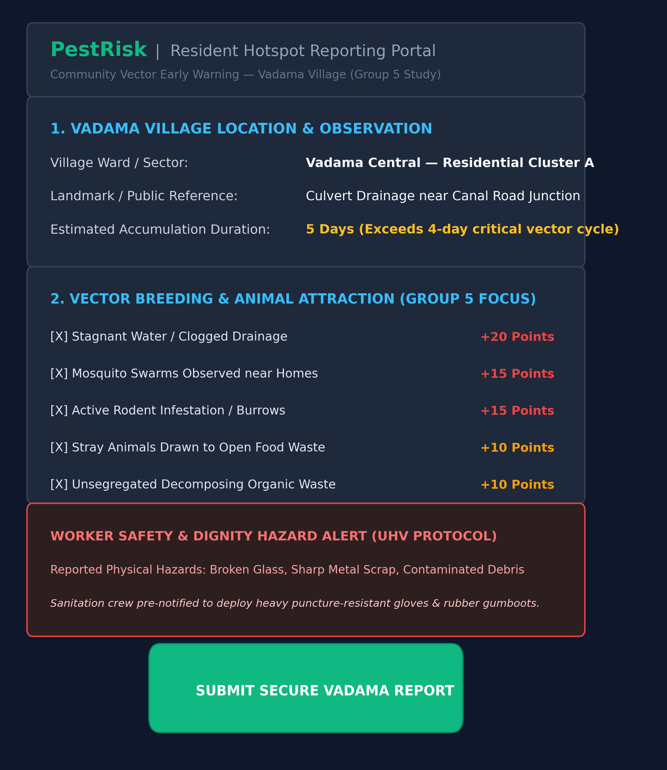  Fig. 1: Resident Waste Hotspot Portal (Vadama Village) | 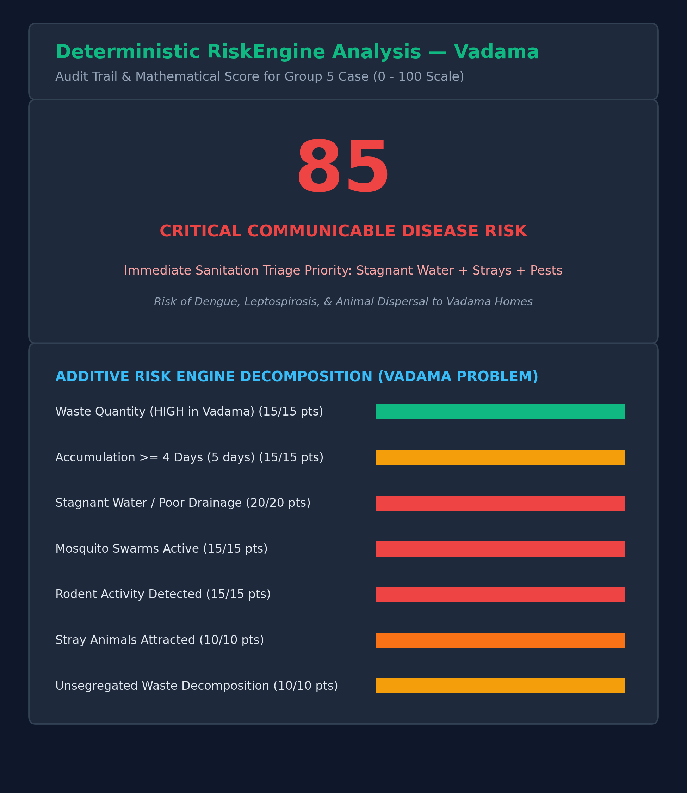  Fig. 2: Vector RiskEngine Score Breakdown (Vadama Case)

GRAM PANCHAYAT STAFF DASHBOARD & REMEDIATION WORKFLOW ARCHITECTURE
Figure 3 shows the staff triage dashboard displaying priority queues and worker hazard alerts for Vadama village. Figure 4 illustrates the monotonic status progression and case history log for Vadama Case #104.
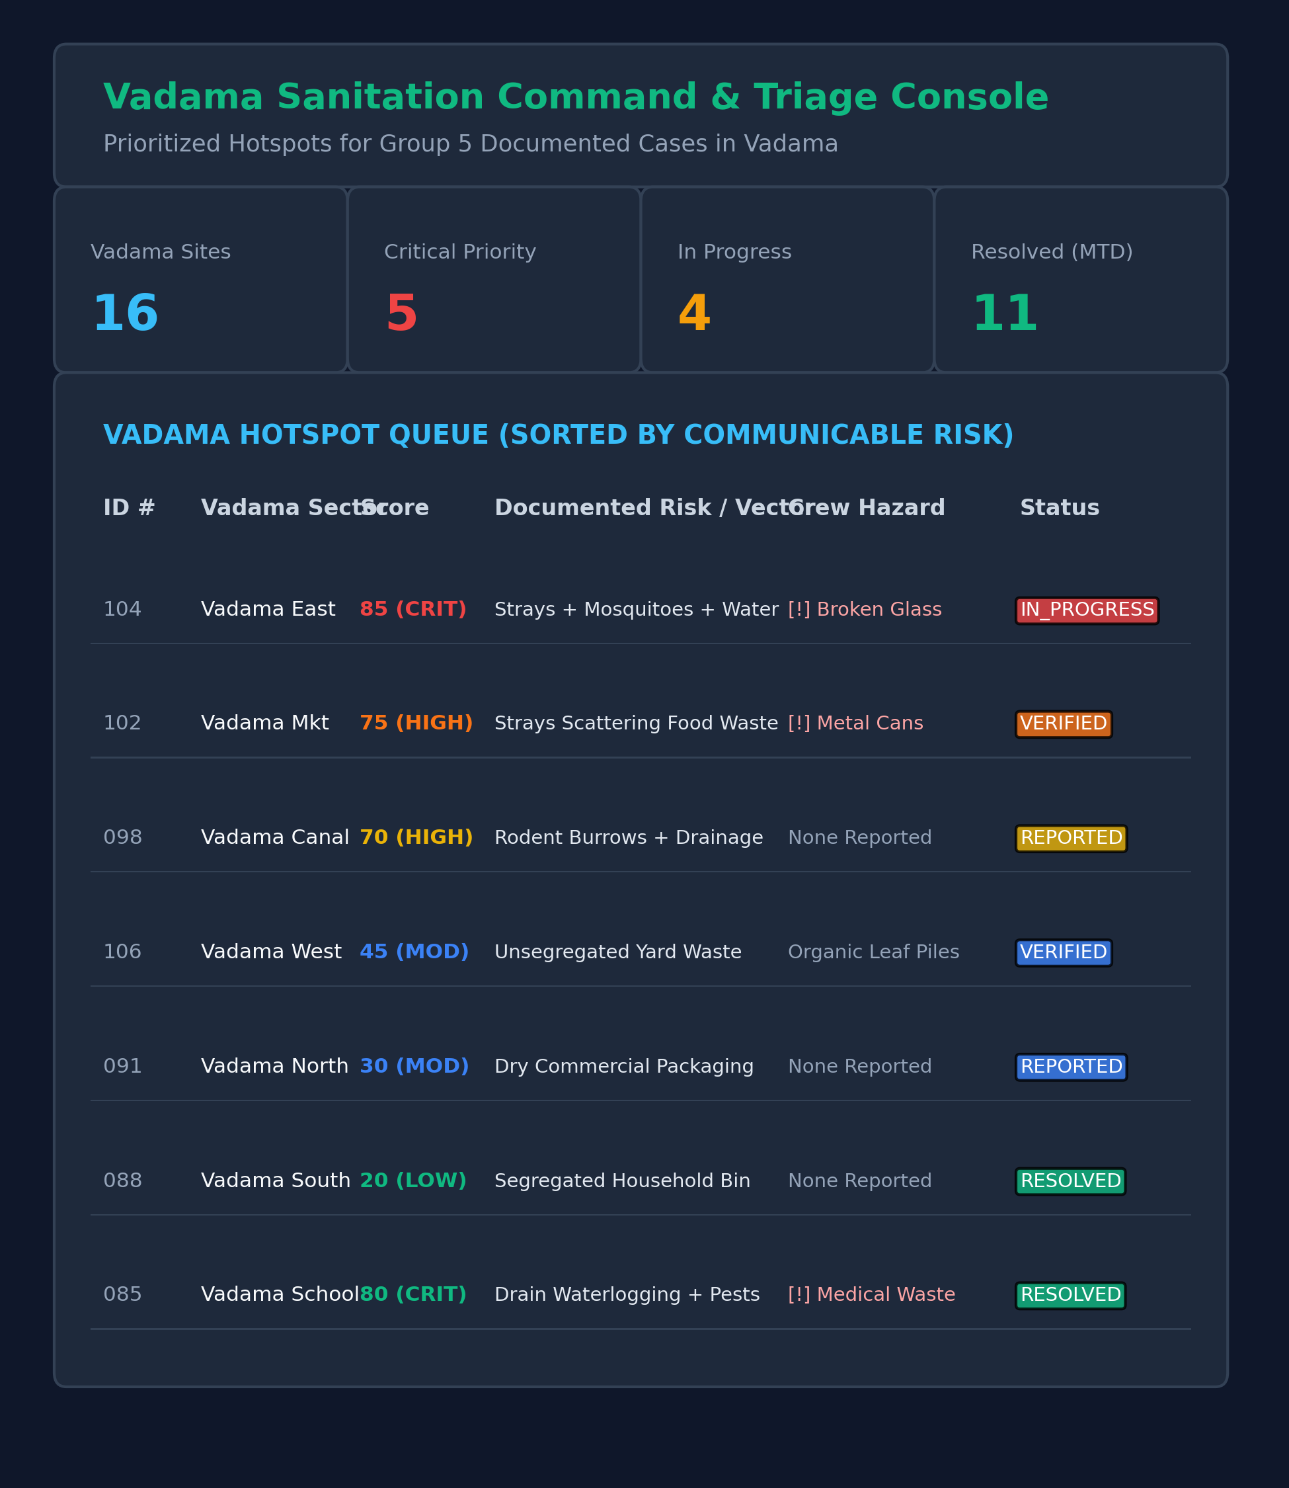  Fig. 3: Gram Panchayat Staff Console (Vadama Village Triage) | 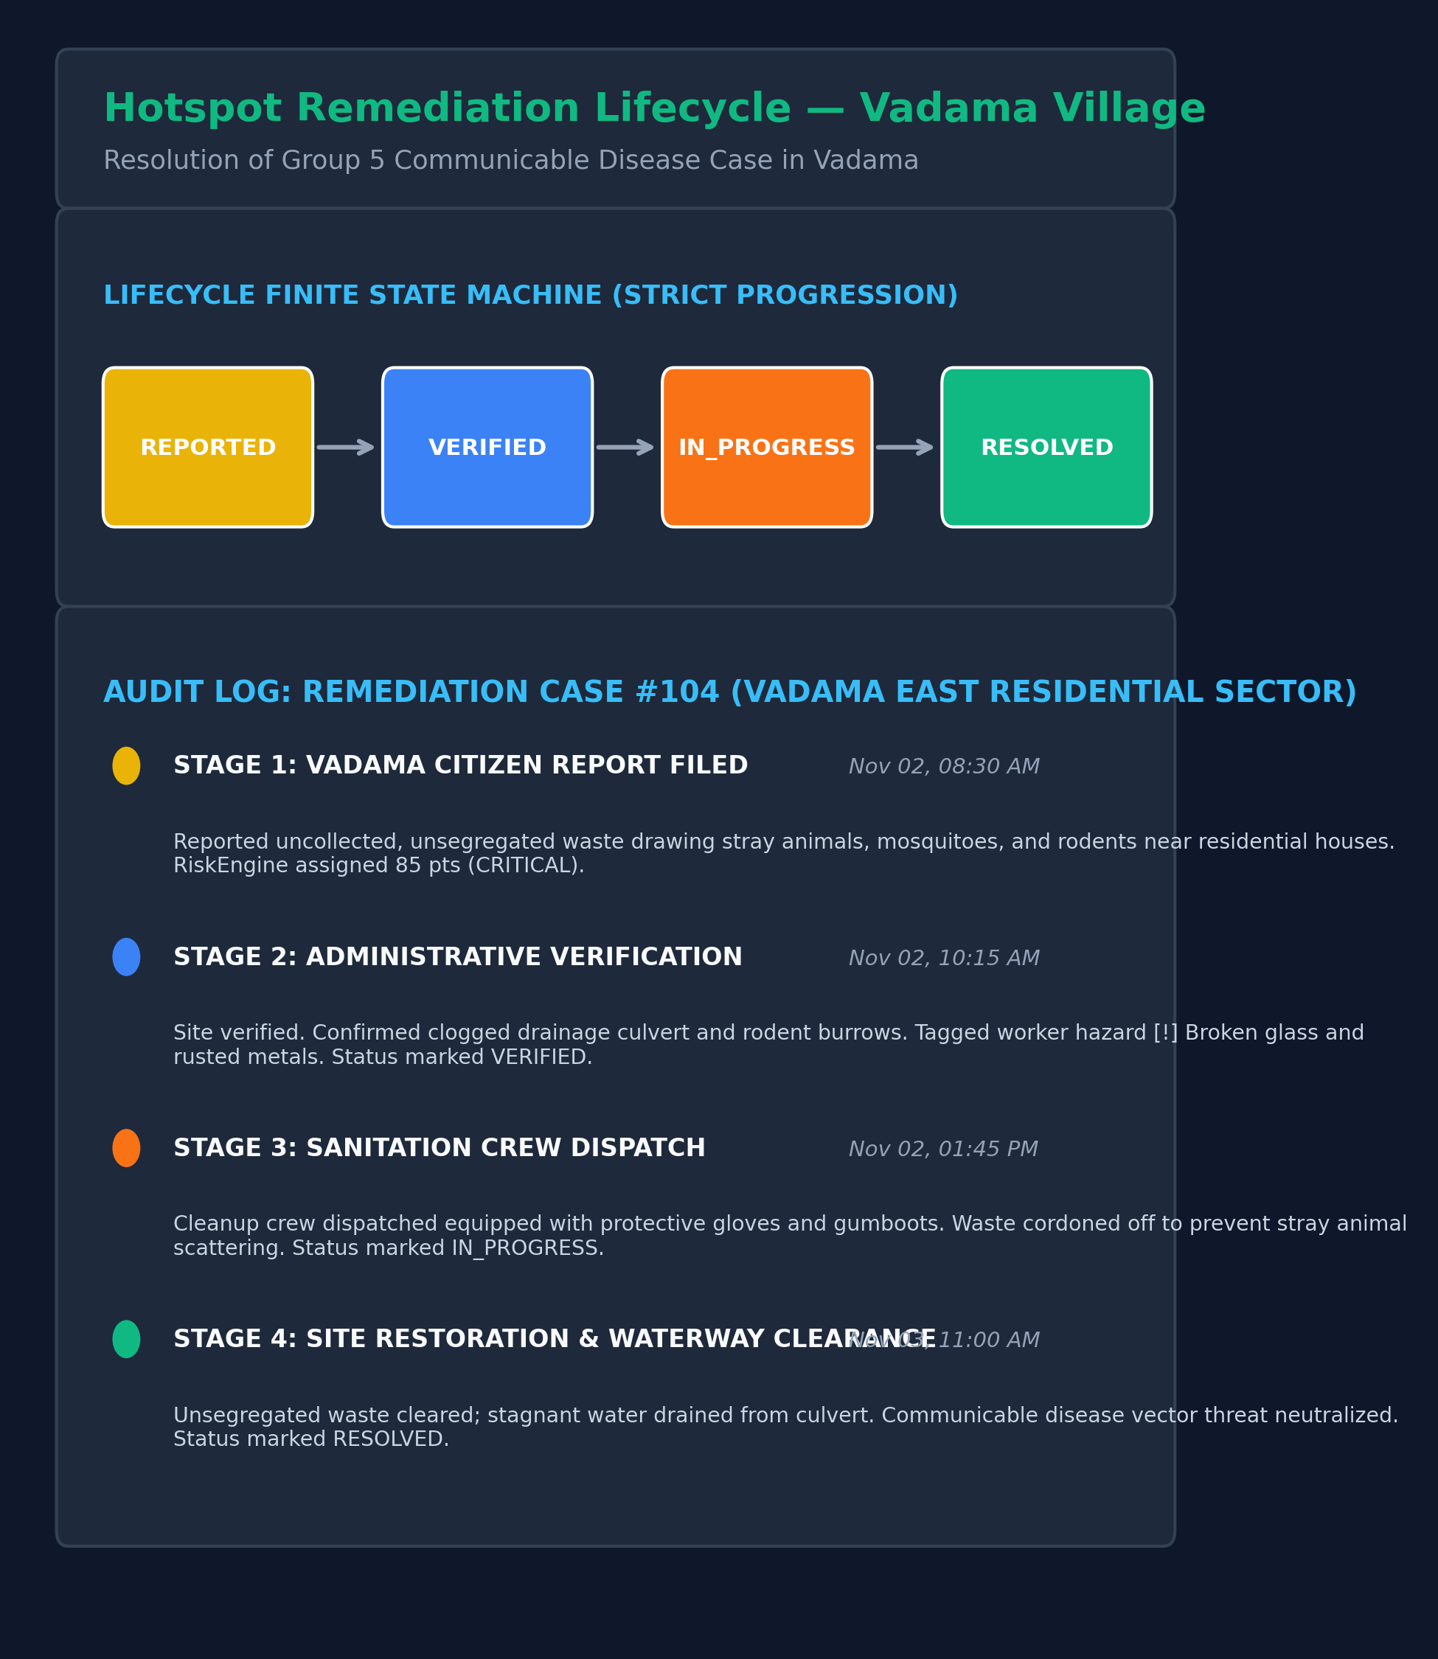  Fig. 4: Hotspot Lifecycle Audit Timeline (Vadama Case #104)

REFERENCE
[1] R. R. Gaur, R. Asthana, and G. P. Bagaria. “A Foundation Course in Human Values and Professional Ethics.” Excel Books, New Delhi, 2nd Revised Edition, 2019. ISBN 978-93-87034-47-1.
→ Role in Project: Primary UHV Philosophical Framework — Guides the conceptual understanding of harmony in self, family, society, and nature.
[2] Premvir Kapoor. “Professional Ethics and Human Values.” Khanna Book Publishing, New Delhi, 2022.
→ Role in Project: Ethical Engineering Reference — Informs ethical human conduct, institutional responsibility, and environmental sustainability.
[3] Daniel Goleman. “Emotional Intelligence: Why It Can Matter More Than IQ.” Bloomsbury Publishing India, New Delhi, 1995.
→ Role in Project: Life Skills & Emotional Competency Reference — Foundation for self-regulation, empathy, and collaborative problem-solving.
[4] B. K. Mitra. “Personality Development and Soft Skills.” Oxford University Press, New Delhi, 3rd Edition, 2019.
→ Role in Project: Life Skills & Communication Reference — Guides effective listening and collaborative teamwork methodologies.
[5] K. G. Balakrishnan. “Unnat Bharat Abhiyan: Transforming India through Village Empowerment.” Ministry of Education, Government of India, 1st Edition, 2022.
→ Role in Project: Community Sanitation Reference — Outlines participatory concepts for local community upliftment.
[6] E. F. Schumacher. “Small Is Beautiful: A Study of Economics as if People Mattered.” Blond & Briggs, London, 1973.
→ Role in Project: Appropriate Technology Reference — Discusses decentralized, people-friendly, and eco-friendly technological solutions.
[7] A. K. Sharma and S. Mukherjee. “Rural Solid Waste Characterization and Vector Proliferation in South Asian Village Ecosystems.” Waste Management, 158:112–124, 2023.
→ Role in Project: Vector Epidemiology Reference — Examines correlations between waste accumulation, standing water, and vector proliferation.
[8] Spring Boot Development Team. “Spring Boot 3.5 Reference Documentation & Spring Security Architecture.” VMware Tanzu, 2024. https://docs.spring.io/spring-boot/docs/current/reference/html/
→ Role in Project: Backend Framework Reference — Governs RESTful microservice architecture, JPA persistence, and security filters.
[9] React Development Team. “React 19: Component-Based Architecture and Hooks Documentation.” Meta Platforms, 2024. https://react.dev/
→ Role in Project: Frontend Framework Reference — Utilized for developing the component-based Resident Portal and Staff Dashboard.
[10] SQLite Development Team. “SQLite Database Engine Architecture and SQL Syntax Reference (v3.45).” 2024. https://www.sqlite.org/docs.html
→ Role in Project: Persistence Architecture Reference — Informs local embedded transactional persistence (pestrisk.db).

