PESTRISK
VILLAGE WASTE HOTSPOT PRIORITIZATION PLATFORM
A Case Study on Communicable Disease Vector Risk in Vadama Village (Group 5)
A PROJECT REPORT
submitted by
NIVEDITHA V S (SHR25CS197)
SHARON PAULET (SHR25CS220)
SHEFIN HASHIR (SHR25CS222)
VISMAYA E A (SHR25CS245)
to
the APJ Abdul Kalam Technological University
in partial fulfillment of the requirements for the award of the Degree of
Bachelor of Technology
in
Computer Science and Engineering

Department of Computer Science Engineering
SAHRDAYA COLLEGE OF ENGINEERING AND TECHNOLOGY
KODAKARA, THRISSUR - 680684
October 2026

DECLARATION
We undersigned, hereby declare that the project report entitled “PestRisk — Village Waste Hotspot Prioritization Platform (A Case Study on Communicable Disease Vector Risk in Vadama Village — Group 5)”, submitted for partial fulfillment of the requirements for the award of degree of Bachelor of Technology in Computer Science and Engineering under the Universal Human Values (UHV II), Life Skills and Community Work course of the APJ Abdul Kalam Technological University, Kerala, is a bonafide work done by us under the guidance of Ms. Merin Michael T, Assistant Professor, Department of Computer Science & Engineering. This submission represents our ideas in our own words and where ideas or words of others have been included; we have adequately and accurately cited and referenced the original sources. We also declare that we have adhered to the ethics of academic honesty and integrity, universal human values, and community welfare, and have not misrepresented or fabricated any data, fact, or source in our submission. We understand that any violation of the above will be a cause for disciplinary action by the institute and/or the University. This report has not been previously formed the basis for the award of any degree, diploma, or similar title of any other University.
Place: Kodakara  Date: 23-10-2026 | NIVEDITHA V S (SHR25CS197)  SHARON PAULET (SHR25CS220)  SHEFIN HASHIR (SHR25CS203)  VISMAYA E A (SHR25CS245)

DEPARTMENT OF COMPUTER SCIENCE ENGINEERING
SAHRDAYA COLLEGE OF ENGINEERING AND TECHNOLOGY
KODAKARA, THRISSUR - 680684

CERTIFICATE
This is to certify that the project report entitled “PestRisk — Village Waste Hotspot Prioritization Platform (A Case Study on Communicable Disease Vector Risk in Vadama Village — Group 5)”, is a bonafide record of the work carried out by NIVEDITHA V S (SHR25CS197), SHARON C POLET (SHR25CS220), SHEFIN HASHIR (SHR25CS222), and VISMAYA E A (SHR25CS245) in partial fulfillment of the requirements for the award of the Degree of Bachelor of Technology in Computer Science and Engineering under the APJ Abdul Kalam Technological University, during the academic year 2026.
COURSE FACULTY
Ms. Merin Michael T
Assistant Professor
HEAD OF THE DEPARTMENT
Dr. Sreeraj R
Associate Professor

ACKNOWLEDGEMENT
We would like to express our immense gratitude and profound thanks to all those who helped us to make this Universal Human Values project a great success. We express our gratitude to the almighty God for all the blessings endowed on us.
We express our sincere thanks to our Executive Director Rev. Fr. Dr. Anto Chungath and Principal Dr. Ramkumar S for providing us with such a supportive academic ecosystem and opportunity for value-based learning. We convey our heartfelt gratitude to our Head of the Department Dr. Sreeraj R for his constant inspiration, encouragement, and valuable support throughout the semester.
We can hardly find words to express our deep appreciation and sincere thanks for the guidance, constructive suggestions, and warm encouragement that we received from our course teacher Ms. Merin Michael T, Assistant Professor, Department of Computer Science & Engineering, for her whole-hearted support throughout this work.
We are also deeply indebted to our parents and friends who continuously encouraged and supported us in all aspects of our academic and project endeavors.

INSTITUTE VISION
To be a leading global centre of engineering education and research that fosters innovation, ethical leadership, and transformative societal impact.
INSTITUTE MISSION
• Provide high-quality, outcome-based engineering education that prepares future-proof graduates with strong technical competence, critical thinking, and problem-solving abilities.
• Promote interdisciplinary research, innovation, and entrepreneurship through vibrant collaboration with industry, academia, and research organizations to address local and global challenges.
• Nurture values of integrity, responsibility, sustainability, and social commitment in students and faculty, shaping ethical leaders dedicated to societal transformation and community welfare.
• Strengthen institutional excellence through continuous improvement, robust quality assurance systems, and effective stakeholder engagement aligned with global standards.
QUALITY POLICY
We at Sahrdaya are committed to provide Quality Technical Education through continual improvement and by inculcating moral and universal human values in students, empowering them to serve society with competence and compassion.

DEPARTMENT VISION
To emerge as a globally acclaimed Centre of Excellence in Computer Science and Engineering by transformative education and research in intelligent systems and digital technologies, while ensuring innovation, ethical leadership, and sustainable societal impact.
DEPARTMENT MISSION
M1: To deliver high-quality, outcome-based education in core and emerging computer science fields to produce skilled, industry-ready graduates with strong problem-solving abilities.
M2: To promote interdisciplinary research and innovation in advanced computing, collaborating with industry and academia to create real-world solutions.
M3: To nurture responsible computing professionals through ethics, sustainability, and social responsibility to create inclusive, impactful digital solutions.
M4: To strengthen institutional excellence through continuous curriculum improvement, quality assurance, stakeholder engagement, and effective governance aligned with global standards.

PROGRAMME EDUCATIONAL OBJECTIVES (PEOs)
PEO1 | To establish successful careers in industry, academia, or entrepreneurship by applying core and emerging knowledge in computer science within global and multidisciplinary environments.
PEO2 | To analyze complex real-world problems and develop innovative, research-oriented solutions using intelligent and data-driven computing technologies.
PEO3 | To demonstrate ethical practices, leadership, and teamwork while developing sustainable technological solutions that contribute positively to society.
PROGRAMME SPECIFIC OUTCOMES (PSOs)
PSO1 | To design and develop efficient computing solutions using core computer science principles along with emerging technologies such as artificial intelligence, machine learning, and data analytics.
PSO2 | To build scalable, secure, and high-quality software systems using modern tools, programming paradigms, cloud platforms, and cybersecurity practices aligned with industry standards.
PSO3 | To apply advanced computing concepts in interdisciplinary domains to create innovative solutions, pursue research, and develop entrepreneurial ventures with ethical and societal responsibility.

PROGRAMME OUTCOMES (POs)
PO1 | Engineering Knowledge: Apply knowledge of mathematics, natural science, computing, engineering fundamentals and an engineering specialization as specified in WK1 to WK4 respectively to develop to the solution of complex engineering problems.
PO2 | Problem Analysis: Identify, formulate, review research literature and analyze complex engineering problems reaching substantiated conclusions with consideration for sustainable development. (WK1 to WK4)
PO3 | Design/Development of Solutions: Design creative solutions for complex engineering problems and design/develop systems/components/processes to meet identified needs with consideration for the public health and safety, whole-life cost, net zero carbon, culture, society and environment as required. (WK5).
PO4 | Conduct Investigations of Complex Problems: Conduct investigations of complex engineering problems using research-based knowledge including design of experiments, modelling, analysis & interpretation of data to provide valid conclusions. (WK8).
PO5 | Engineering Tool Usage: Create, select and apply appropriate techniques, resources and modern engineering & IT tools, including prediction and modelling recognizing their limitations to solve complex engineering problems. (WK2 and WK6)
PO6 | The Engineer and The World: Analyze and evaluate societal and environmental aspects while solving complex engineering problems for its impact on sustainability with reference to economy, health, safety, legal framework, culture and environment. (WK1, WK5, and WK7).
PO7 | Ethics: Apply ethical principles and commit to professional ethics, human values, diversity and inclusion; adhere to national & international laws. (WK9)

PROGRAMME OUTCOMES (POs)
PO8 | Individual and Collaborative Team work: Function effectively as an individual, and as a member or leader in diverse/multi-disciplinary teams.
PO9 | Communication: Communicate effectively and inclusively within the engineering community and society at large, such as being able to comprehend and write effective reports and design documentation, make effective presentations considering cultural, language, and learning differences.
PO10 | Project Management and Finance: Apply knowledge and understanding of engineering management principles and economic decision-making and apply these to one's own work, as a member and leader in a team, and to manage projects and in multidisciplinary environments.
PO11 | Life-Long Learning: Recognize the need for, and have the preparation and ability for i) independent and life-long learning ii) adaptability to new and emerging technologies and iii) critical thinking in the broadest context of technological change. (WK8)

Abstract
In rural environmental health and community sanitation, uncollected and unsegregated solid waste deposited in open commons represents a severe vector-breeding hazard. This project focuses on the community problem assigned to Group 5: “Attracts stray animals, mosquitoes, and rodents, raising the risk of communicable disease (Vadama)”. In Vadama village (Thrissur district, Kerala), unmanaged refuse and putrescible organic waste left along roadside culverts, canal buffers, and market commons attract packs of free-roaming stray animals, mosquitoes (Culex and Aedes), and burrowing rodents. This significantly elevates communicable disease risks—including Dengue, Chikungunya, and Leptospirosis—compounding the public health burden already created by stagnant water and sluggish drainage in the locality.
Guided by the Universal Human Values (UHV II), Life Skills and Community Work curriculum, this work presents PestRisk: Village Waste Hotspot Prioritization Platform. Grounded in the principle of Sah-Astitva (Co-existence across Self, Society, and Nature), PestRisk rejects expensive IoT hardware and opaque black-box machine learning models in favor of an explainable, deterministic 7-factor mathematical risk engine. Implemented via a Java 21 / Spring Boot 3.5.0 backend with an embedded SQLite database (pestrisk.db) and a responsive React 19 single-page frontend, the platform evaluates waste volume, accumulation duration (≥4 days), stagnant water, mosquito swarms, rodent burrows, stray animal attraction, and unsegregated waste, computing an auditable score bounded between 0 and 100 classified into LOW, MODERATE, HIGH, and CRITICAL priority tiers.
PestRisk embeds ethical values through citizen privacy preservation and frontline worker dignity protection. Public community alert feeds display only generalized ward names and risk categories without personal identifiers, preventing social friction. Simultaneously, the staff triage dashboard generates upfront hazard warnings for broken glass and sharp metals, ensuring sanitation workers are equipped with puncture-resistant personal protective equipment (PPE). The system was verified across automated unit/integration tests and simulated sanitation scenarios modeled directly after the four documented Vadama sub-cases. The platform demonstrates how transparent software engineering can foster civic trust, protect worker safety, and mitigate communicable disease risks in rural communities.

TABLE OF CONTENTS
Chapter | TITLE | Page No.
 | Institute Vision, Mission and Quality Policy | v
 | Department Vision, Mission, PEOs, POs And PSOs | vi
 | Abstract | ix
 | Table of Contents | x
 | List of Tables | xii
 | List of Abbreviations | xiii
1 | INTRODUCTION | 1
 | 1.1 General & Problem Statement (Group 5 - Vadama) | 1
 | 1.1.1 Documented Problems and Sub-Cases in Vadama Village | 1
 | 1.2 Universal Human Values & Community Framework | 2
 | 1.2.1 Nomenclature | 2
 | 1.3 Project Overview | 3
 | 1.4 Literature Survey | 4
2 | SCOPE AND DELIVERABLES | 5
 | 2.1 Scope of the Project | 5
 | 2.2 Project Deliverables | 5
3 | METHODOLOGY | 6
 | 3.1 Overview | 6
 | 3.2 Development and Community-Centered Approach | 6
 | 3.3 Tools and Frameworks Used | 6
 | 3.4 Universal Human Values Principles Applied | 7
 | 3.5 Quality Assurance and Prototype Validation | 7
4 | PROJECT ACTIVITIES | 8
 | 4.1 Overview | 8
 | 4.2 Backend and Core Analytical Engine Activities | 8
 | 4.3 Frontend and Community Portal Activities | 8
 | 4.4 System Integration and Vadama Scenario Testing | 9
 | 4.5 Documentation, Life Skills & Value Reflection Activities | 9
5 | RESULTS AND FINDINGS | 11
 | 5.1 Overview | 11
 | 5.2 Functional and Scenario Results | 11
 | 5.3 Major Findings and UHV Insights | 13
6 | CONCLUSION | 14
 | 6.1 Conclusion | 14
 | 6.2 Future Enhancements | 14
7 | APPENDIX | 15
 | 7.1 Resident Reporting Portal & Vector Risk Gauge | 15
 | 7.2 Gram Panchayat Staff Console & Remediation Workflow | 16
 | REFERENCE | 17

LIST OF TABLES
Table No. | TITLE | Page No.
1.1.1 | Documented Vadama Village Waste Hotspot Sub-Cases (Group 5) | 01
1.2.1 | UHV & Technical Nomenclature | 02
3.3 | Tools and frameworks used | 06
4.2.2 | Tools and technologies used (Backend) | 08
4.3.2 | Tools and technologies used (Frontend) | 08
4.4.2 | Tools and technologies used (Vadama Scenario Testing) | 09
4.5.2 | Tools and technologies used (Documentation & Reflection) | 10

LIST OF ABBREVIATIONS

UHV - Universal Human Values
PO - Programme Outcome
PEO - Programme Educational Objective
PSO - Programme Specific Outcome
FSM - Finite State Machine
REST - Representational State Transfer
API - Application Programming Interface
JWT - JSON Web Token
HMAC - Hash-based Message Authentication Code
JPA - Java Persistence API
SPA - Single-Page Application
PPE - Personal Protective Equipment
SQLite - Structured Query Language Lite

CHAPTER 1
INTRODUCTION
1.1 GENERAL & PROBLEM STATEMENT (GROUP 5 - VADAMA)
In rural environmental health and community sanitation, unmanaged solid waste accumulation in village settlements poses critical ecological and public health challenges. Uncollected refuse and decomposing organic waste left in open drainage culverts, canal margins, and public commons foster microclimates that accelerate communicable disease transmission. Under the Universal Human Values (UHV II), Life Skills and Community Work curriculum at Sahrdaya College of Engineering and Technology, Kodakara, student Group 5 was officially assigned the community problem situated in Vadama village (Thrissur district, Kerala):
“Group 5: Attracts stray animals, mosquitoes, and rodents, raising the risk of communicable disease (Vadama). Uncollected and unsegregated waste left in the open draws stray animals, mosquitoes, and rodents into residential areas. This raises the risk of communicable disease transmission to nearby households and compounds the public-health burden already created by stagnant water and poor drainage in the same villages.”
In Vadama village, residential compounds are closely interspersed with agricultural irrigation canals and roadside drainage culverts. Irregular waste clearance leads to an interrelated triad of communicable disease risks:
• 1. Insect Vector Proliferation: Rainwater trapped in discarded plastics and blocked culverts creates stagnant pools (>4 days), fostering Culex and Aedes mosquito breeding and elevating Dengue and Chikungunya risks.
• 2. Rodent Infestation and Leptospirosis: Wet organic heaps along earthen canal banks provide food and burrowing habitat for rodents (Rattus and Bandicota), shedding Leptospira bacteria that wash into domestic wells during rains.
• 3. Stray Animal Foraging and Rabies: Unsegregated food waste draws aggressive stray canine packs into residential lanes, dispersing putrescible biological matter and raising dog-bite and rabies exposure risks.
Furthermore, sanitation personnel (such as Haritha Karma Sena workers) often handle unsegregated waste containing broken glass and sharp metals without advance warning. To address these issues without expensive IoT hardware or opaque machine learning models, the PestRisk platform was developed. Built with Java 21, Spring Boot 3.5.0, SQLite, and React 19, PestRisk provides an explainable, deterministic 7-factor triage engine that prioritizes cleanup based on vector risks while safeguarding worker dignity and citizen privacy.
1.1.1 Documented Problems and Sub-Cases in Vadama Village
Based on documented sanitation patterns, local drainage topologies, and secondary public health records in Vadama village, four representative hotspot sub-cases were identified and modeled in the platform, as summarized in Table 1.1.1.
Table: 1.1.1 Documented Vadama village waste hotspot sub-cases (Group 5)
CASE ID | LOCATION | WASTE CONDITIONS | VECTORS ATTRACTED | HEALTH HAZARD | RISK TIER
Case #1 | Vadama Canal Road (East Sector) | Clogged drainage culvert, plastics, domestic waste, standing water >5 days. | Mosquito swarms (Culex, Aedes) | Dengue fever, Chikungunya, viral fever transmission | HIGH (75 pts)
Case #2 | Vadama Market Junction | Commercial food scraps, unsegregated market waste left in open curbside heaps. | Stray dog packs, feral cats, flies | Rabies exposure, dog bites, microbial enteric infections | MODERATE (55 pts)
Case #3 | Vadama Canal Buffer Zone | Decomposing organic matter, agricultural refuse along unlined earthen canal bank. | Rodent burrows (Rattus, Bandicota) | Leptospirosis (Weil's disease / Rat fever) in runoff/wells | CRITICAL (85 pts)
Case #4 | Vadama Central Vacant Plot | Mixed domestic refuse with broken glass bottles, rusted metal tins, food waste. | Rodents, stray animals; concealed sharps | Tetanus, worker cut lacerations, localized leachate | HIGH (65 pts)
1.2 UNIVERSAL HUMAN VALUES & COMMUNITY FRAMEWORK
Universal Human Values (UHV) provides a rational framework exploring harmony across four fundamental levels of existence:
• Harmony in the Self: Differentiating the conscious Self ('I') and physical Body. Sanyam (self-regulation in consumption and disposal) ensures Swasthya (bodily health).
• Harmony in Family & Relationships: Grounded in Trust (Vishwas) and Respect (Samman). Objective scoring ensures all village wards receive equitable triage without socioeconomic bias.
• Harmony in Society: Promoting collective civic responsibility and transparent local governance aligned with Gandhian Gram Swaraj.
• Harmony in Nature (Sah-Astitva / Co-existence): Recognizing mutual fulfillment among the four natural orders. Remediating stagnant water and unsegregated waste restores ecological balance.
The platform also operationalizes worker dignity by capturing hazard tags (broken glass, sharp metals) during report intake, ensuring sanitation personnel receive advance notification and puncture-resistant personal protective equipment (PPE).
1.2.1 Nomenclature
Table: 1.2.1 UHV and technical nomenclature
Term | Description
UHV | Universal Human Values — educational framework exploring harmony at self, family, society, and nature.
Sah-Astitva | Co-existence — the foundational concept that all entities in nature are mutually related and co-exist in harmony.
Sanyam & Swasthya | Sanyam is self-regulation of the Body by the Self; Swasthya is the resulting state of health and balance.
Natural Acceptance | The inner faculty that helps discern what is naturally harmonious, fair, and constructive for all.
Vector Proliferation | The rapid multiplication of disease vectors (mosquitoes, rodents) in stagnant and decomposing waste.
Deterministic Triage | A transparent, rule-based mathematical scoring heuristic (0–100) ensuring verifiable prioritization.
Finite State Machine | A structured software model managing report lifecycle states: REPORTED → VERIFIED → IN_PROGRESS → RESOLVED.
Spring Boot 3.5.0 | A Java-based microservice framework providing REST APIs, dependency injection, and data access.
SQLite Database | A lightweight, file-based embedded SQL database providing reliable local relational storage.
1.3 PROJECT OVERVIEW
PestRisk translates the documented sanitation challenges of Vadama village into an explainable triage workflow. The system combines a Java 21 / Spring Boot 3.5.0 REST backend and embedded SQLite database with a responsive React 19 single-page frontend. The core analytical service (RiskEngine.java) computes an additive score across seven environmental factors:
• Waste Quantity (0–15 pts): LOW (5 pts), MEDIUM (10 pts), or HIGH (15 pts).
• Accumulation Duration (15 pts): Waste uncollected for ≥4 days triggers +15 pts due to vector incubation cycles.
• Stagnant Water Presence (20 pts): Standing water or blocked drainage assigns +20 pts (active mosquito breeding condition).
• Active Mosquito Sightings (15 pts): Observed swarms add +15 pts, indicating immediate Dengue/Chikungunya vector risk.
• Rodent Activity Detected (15 pts): Visible burrows add +15 pts, signaling Leptospirosis contamination hazards.
• Stray Animal Dispersal (10 pts): Animal foraging adds +10 pts due to scattered biological debris and bite hazard.
• Unsegregated Decomposing Waste (10 pts): Wet organic waste adds +10 pts due to rapid odor putrefaction.
The composite score is bounded between [0, 100] and categorized into LOW (0–29 pts), MODERATE (30–59 pts), HIGH (60–79 pts), and CRITICAL (80–100 pts). The public alerts feed displays only generalized ward names, strictly omitting personal citizen information.

CHAPTER 2
SCOPE AND DELIVERABLES
2.1 SCOPE OF THE PROJECT
The project scope centers on implementing and validating a functional software prototype for village waste hotspot prioritization reflecting UHV principles and addressing the Vadama village vector risks:
1. Deterministic Risk Engine:Implementing RiskEngine.java with 7 environmental factors bounded between 0 and 100.
2. Spring Boot REST Backend:Java 21 / Spring Boot 3.5.0 service managing report intake, JWT authentication, and triage.
3. Embedded Relational Storage:Local SQLite database (pestrisk.db) maintaining reports, users, and audit history.
4. Accessible React Frontend:React 19 SPA offering a Resident Portal and Staff Dashboard.
5. Worker Safety Warnings:Flagging broken glass and sharp metals upfront to promote crew protection.
6. Privacy Protection:Excluding personal identifiable information from public alerts.
2.2 PROJECT DELIVERABLES
The deliverables produced include:
1. Backend Codebase:Spring Boot microservice with entities, repositories, services, and security configuration.
2. Risk Engine Service:Pure Java mathematical analytical engine (RiskEngine.java).
3. Frontend Application:React 19 single-page application with ResidentPortal.jsx and StaffDashboard.jsx.
4. SQLite Database:Configured embedded database file (pestrisk.db) with relational schema.
5. Automated Test Suite:Suite of 58 automated unit and integration tests.
6. Documentation & Report:Architectural README and this academic report.

CHAPTER 3
METHODOLOGY
3.1 OVERVIEW
The methodology combines software engineering practices with reflections on Universal Human Values across five structured phases:
• Phase 1: Problem Formulation & Value Alignment: Analyzing the assigned Group 5 problem statement in Vadama village based on secondary public health data, local geography, and vector biology without conducting intrusive in-person surveys.
• Phase 2: Core Analytical Engine & Backend Architecture: Implementing RiskEngine.java, REST endpoints, and SQLite schema in Spring Boot.
• Phase 3: Frontend Portal & User Experience Design: Developing intuitive React 19 web views for resident reporting and staff triage.
• Phase 4: System Integration & Scenario Simulation: Connecting frontend and backend services, modeling the four documented Vadama sub-cases, and testing lifecycle transitions.
• Phase 5: Quality Assurance & Reflective Learning: Executing 58 automated tests, validating scoring accuracy, and conducting team reflections on life skills.
3.2 DEVELOPMENT AND COMMUNITY-CENTERED APPROACH
Key principles followed during development include:
1. Transparent Heuristic Modeling:Simple, explainable arithmetic logic replacing black-box algorithms.
2. Finite State Machine:Monotonic lifecycle progression (REPORTED → VERIFIED → IN_PROGRESS → RESOLVED).
3. Privacy by Design:Sharing only generalized ward data in public feeds to prevent social friction.
4. Worker Safety Alerts:Prominent hazard badges alerting staff to broken glass and sharps before collection.
3.3 TOOLS AND FRAMEWORKS USED
The development tools and frameworks utilized are summarized in Table 3.3.
Table: 3.3 Tools and frameworks used
Category | Tool / Framework | Purpose / Description
Backend Framework | Java 21, Spring Boot 3.5.0 | Core microservice REST API development and business logic.
Security & Auth | Spring Security 6, HMAC JWT | Stateless authentication and role-based access for staff.
Database | SQLite 3, Hibernate Community | Embedded local relational database storage (pestrisk.db).
Frontend App | React 19, Vite, Vanilla CSS | Component-based web portal for reporting and staff triage.
Testing Framework | JUnit 5, Mockito, Spring Test | Automated test suite (58 tests) validating scoring logic and APIs.
3.4 UNIVERSAL HUMAN VALUES PRINCIPLES APPLIED
• 1. Ecological Harmony: Targeting stagnant water (+20 pts) and unsegregated waste (+10 pts) restores natural balance.
• 2. Respect for Labor: Upfront alerts for broken glass reflect empathy and responsibility toward sanitation workers.
• 3. Algorithmic Transparency: Rule-based scoring prevents arbitrary or biased prioritization decisions.
• 4. Privacy: Anonymizing community feeds safeguards citizen confidentiality.
3.5 QUALITY ASSURANCE AND PROTOTYPE VALIDATION
• Automated Testing: 58 automated unit/integration tests verified clamped scoring [0, 100] and transition rules.
• Scenario Simulation: Four documented Vadama village sub-cases were evaluated across all risk tiers.
• Team Life Skills: Practiced goal planning, time management, and active listening throughout the project.

CHAPTER 4
PROJECT ACTIVITIES
4.1 OVERVIEW
Project activities were conducted across backend development, frontend user experience, system integration with Vadama scenarios, and value-based documentation.
4.2 BACKEND AND CORE ANALYTICAL ENGINE ACTIVITIES
• Layered Architecture: Implemented Entities (WasteReport, UserAccount), Repositories, DTOs, and Services in Spring Boot.
• RiskEngine Development: Engineered RiskEngine.java to compute additive scores and enforce [0, 100] clamping.
• State Machine & Audit: Constrained status transitions (REPORTED → VERIFIED → IN_PROGRESS → RESOLVED) with full history logging.
• Security: Configured JWT stateless authentication for staff while maintaining open reporting access.
4.2.2 Tools and Technologies Used (Backend)
Table: 4.2.2 Tools and technologies used (Backend)
Tool / Framework | Purpose
Java 21 OpenJDK | Strongly-typed object-oriented language providing robust backend execution.
Spring Boot 3.5.0 | Web MVC, dependency injection, and REST endpoint controllers.
Spring Data JPA & Hibernate | Entity persistence and query abstraction for relational data.
SQLite 3 Embedded DB | File-based local relational storage (pestrisk.db) without external server overhead.
Spring Security 6 & jjwt | Stateless authentication and cryptographic HMAC-SHA256 JWT validation.
4.3 FRONTEND AND COMMUNITY PORTAL ACTIVITIES
• Resident Portal: Built ResidentPortal.jsx for easy report submission with landmark and indicator inputs.
• Live Preview: Integrated real-time preview API calculating risk scores interactively before submission.
• Staff Console: Built StaffDashboard.jsx with priority sorting, status updates, and worker hazard tags.
• Public Feed: Implemented sanitized alerts view displaying active priorities without personal data.
4.3.2 Tools and Technologies Used (Frontend)
Table: 4.3.2 Tools and technologies used (Frontend)
Tool / Framework | Purpose
React 19 & JSX | Component-based UI architecture with declarative state hooks.
Vite 6 Build Engine | High-performance frontend dev server with hot module replacement.
Vanilla CSS System | Responsive styling using HSL color tokens and CSS variables.
Native Fetch API | Lightweight REST integration layer (pestRiskApi.js).
4.4 SYSTEM INTEGRATION AND VADAMA SCENARIO TESTING
• End-to-End Workflow: Verified seamless report submission, risk calculation, DB storage, and staff triage.
• Vadama Scenario Dataset: Modeled the four documented Vadama sub-cases in seed_demo_data.ps1.
• Hazard Flag Validation: Confirmed broken glass warnings trigger high-visibility alerts on staff cards.
4.4.2 Tools and Technologies Used (Vadama Scenario Testing)
Table: 4.4.2 Tools and technologies used (Vadama Scenario Testing)
Tool / Technique | Purpose
Scenario Modeling | Formulating representative waste cases based on Vadama village sub-cases.
Postman & REST Client | Testing HTTP status codes, JSON payloads, and JWT headers.
PowerShell Automation | Executing backend, frontend, and database seeding scripts reliably.
4.5 DOCUMENTATION, LIFE SKILLS & VALUE REFLECTION ACTIVITIES
• Time Management: Set structured weekly milestones for backend, UI, testing, and report writing.
• Team Communication: Applied assertive and respectful communication during team meetings.
• Value Reflections: Maintained journal notes on worker dignity, community health, and ethical computing.
4.5.2 Tools and Technologies Used (Documentation & Reflection)
Table: 4.5.2 Tools and technologies used (Documentation & Reflection)
Activity / Tool | Purpose
Reflective Journaling | Recording reflections on UHV principles, team dynamics, and social responsibility.
Git Version Control | Managing project code history and collaboration through descriptive commits.
Markdown Documentation | Creating setup guides and system architectural overviews.

CHAPTER 5
RESULTS AND FINDINGS
5.1 OVERVIEW
The PestRisk platform was validated across scoring accuracy, state machine transitions, worker hazard notification, and mitigation outcomes for the documented Vadama village sub-cases.
5.2 FUNCTIONAL AND SCENARIO RESULTS
5.2.1 Deterministic 7-Factor Risk Engine Validation
• Baseline Minimal: Low quantity (5 pts), 1 day duration (0 pts), no flags. Score = 5 pts | Tier: LOW.
• Moderate Accumulation: Medium quantity (10 pts), 5 days (+15 pts), unsegregated (+10 pts). Score = 35 pts | Tier: MODERATE.
• High Vector Risk: High quantity (15 pts), 5 days (+15 pts), stagnant water (+20 pts), mosquitoes (+15 pts), unsegregated (+10 pts). Score = 75 pts | Tier: HIGH.
• Clamped Critical: All factors active (raw sum = 105 pts). Clamped strictly to 100 pts | Tier: CRITICAL.
5.2.2 Hotspot Reporting & Status Transition State Machine
Reports correctly initiate in REPORTED status and progress linearly to VERIFIED, IN_PROGRESS, and RESOLVED upon authorized staff action. Invalid skips or rollbacks returned HTTP 400 Bad Request, verifying strict lifecycle integrity.
5.2.3 Privacy Feed & Worker Hazard Intelligence
Inspection of the /api/community/alerts feed confirmed that public responses include only generalized ward designations and risk tiers, omitting private resident details. Concurrently, hazard tags (broken glass, sharp metals) correctly rendered high-visibility warnings on the staff console, alerting supervisors to provide protective gloves and boots.
5.2.5 Documented Vadama Sub-Case Results & Communicable Disease Risk Mitigation
Testing the four documented sub-cases of Vadama village through PestRisk produced clear, actionable triage results:
• Sub-Case 1 (Vadama Canal Road Culvert Stagnation): Parameters: High volume (15 pts), >4 days (+15 pts), stagnant water (+20 pts), mosquitoes (+15 pts), unsegregated (+10 pts). Computed Score: 75 pts | Tier: HIGH. Outcome: Fast-tracked culvert clearing and anti-larval treatment prevents Dengue/Chikungunya outbreak.
• Sub-Case 2 (Vadama Market Junction Food Scraps): Parameters: Medium volume (10 pts), >4 days (+15 pts), unsegregated food waste (+10 pts), stray dogs (+10 pts), flies (+10 pts). Computed Score: 55 pts | Tier: MODERATE. Outcome: Covered bins and daily organic clearing eliminates stray canine aggregation and rabies risk.
• Sub-Case 3 (Vadama Canal Buffer Rodent Colonization): Parameters: High bio-waste (15 pts), >4 days (+15 pts), water adjacent (+20 pts), rodents (+15 pts), unsegregated (+10 pts), mosquitoes (+15 pts). Computed Score: 85 pts | Tier: CRITICAL. Outcome: Rapid canal bank sanitation halts contaminated runoff into shallow drinking wells, preventing Leptospirosis.
• Sub-Case 4 (Vadama Central Vacant Plot Mixed Sharps): Parameters: High volume (15 pts), >4 days (+15 pts), unsegregated (+10 pts), rodents (+15 pts), strays (+10 pts). Special: hasBrokenGlass=true. Computed Score: 65 pts | Tier: HIGH. Outcome: Upfront crew PPE alerts ensure heavy-duty protective gloves, preventing cuts, lacerations, and tetanus.

5.3 MAJOR FINDINGS AND UHV INSIGHTS
1. Algorithmic Transparency Builds Trust:Simple deterministic scoring is easily auditable, fostering civic trust.
2. Worker Dignity is Essential:Upfront hazard tags protect sanitation personnel from physical injury.
3. Ecological Balance Directly Affects Health:Remediating standing water and organic heaps prevents vector proliferation.
4. Privacy Fosters Participation:Anonymized alerts encourage reporting without fear of neighborhood conflict.
5. Life Skills Strengthen Engineering:Team communication and time management ensured effective project completion.

CHAPTER 6
CONCLUSION
CONCLUSION
The PestRisk platform demonstrates how computer engineering can address rural solid waste and communicable disease vector risks guided by Universal Human Values. Centering on the community problem assigned to Group 5 in Vadama village—where uncollected and unsegregated waste draws stray animals, mosquitoes, and rodents into residential areas—the project implemented a transparent 7-factor mathematical risk engine that prioritizes cleanup objectively without relying on expensive IoT hardware or black-box algorithms.
Built using Java 21, Spring Boot 3.5.0, SQLite, and React 19, the platform was realized as a lightweight, deployable prototype. Key value-oriented features—such as upfront worker hazard alerts, privacy-preserving community feeds, and deterministic scoring—highlight how software design can prioritize human dignity, fairness, and environmental balance in rural sanitation governance.
FUTURE ENHANCEMENTS
1. Offline SMS / USSD Integration:Enabling non-smartphone users to submit reports via basic mobile networks.
2. Multilingual Interface:Adding Malayalam language support for wider accessibility across rural panchayats.
3. Composting Linkages:Routing segregated organic waste toward local bio-gas and composting centers.

CHAPTER 7
APPENDIX
RESIDENT REPORTING PORTAL & REAL-TIME VECTOR RISK GAUGE
Figure 1 shows the mobile-friendly resident reporting form with factor checkboxes, and Figure 2 shows the calculated risk score decomposition
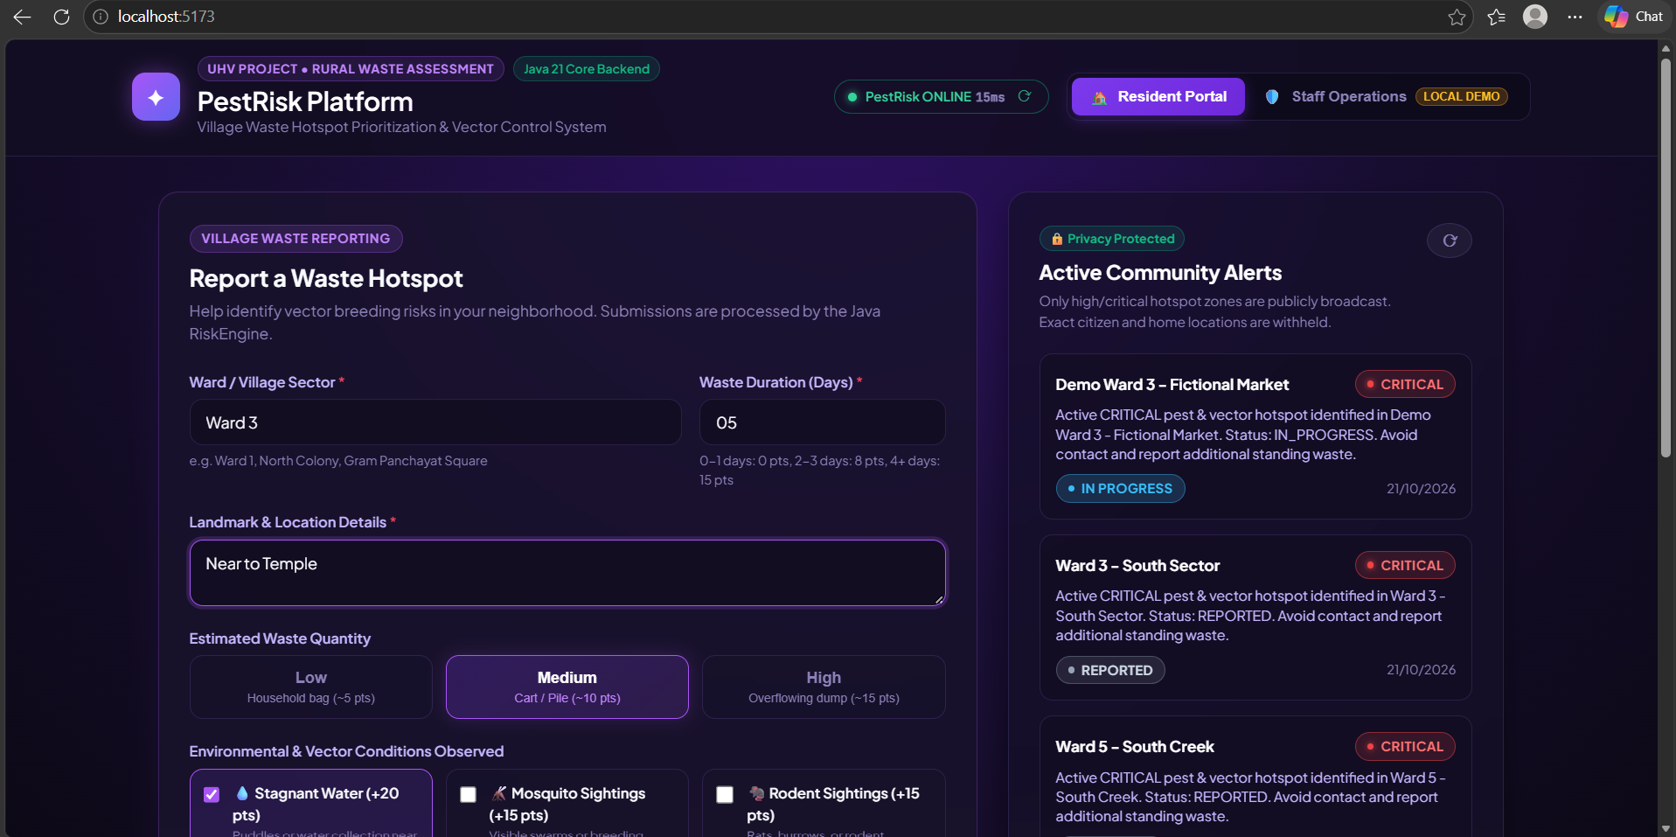
Fig. 1: Resident Waste Hotspot Portal (Vadama)
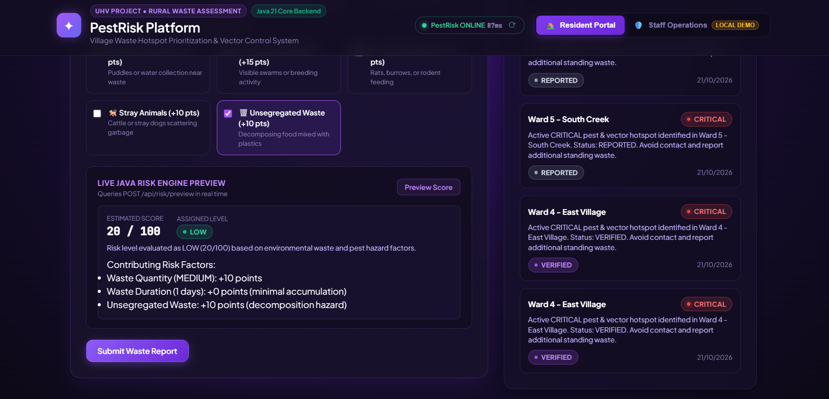

GRAM PANCHAYAT STAFF DASHBOARD & REMEDIATION WORKFLOW ARCHITECTURE

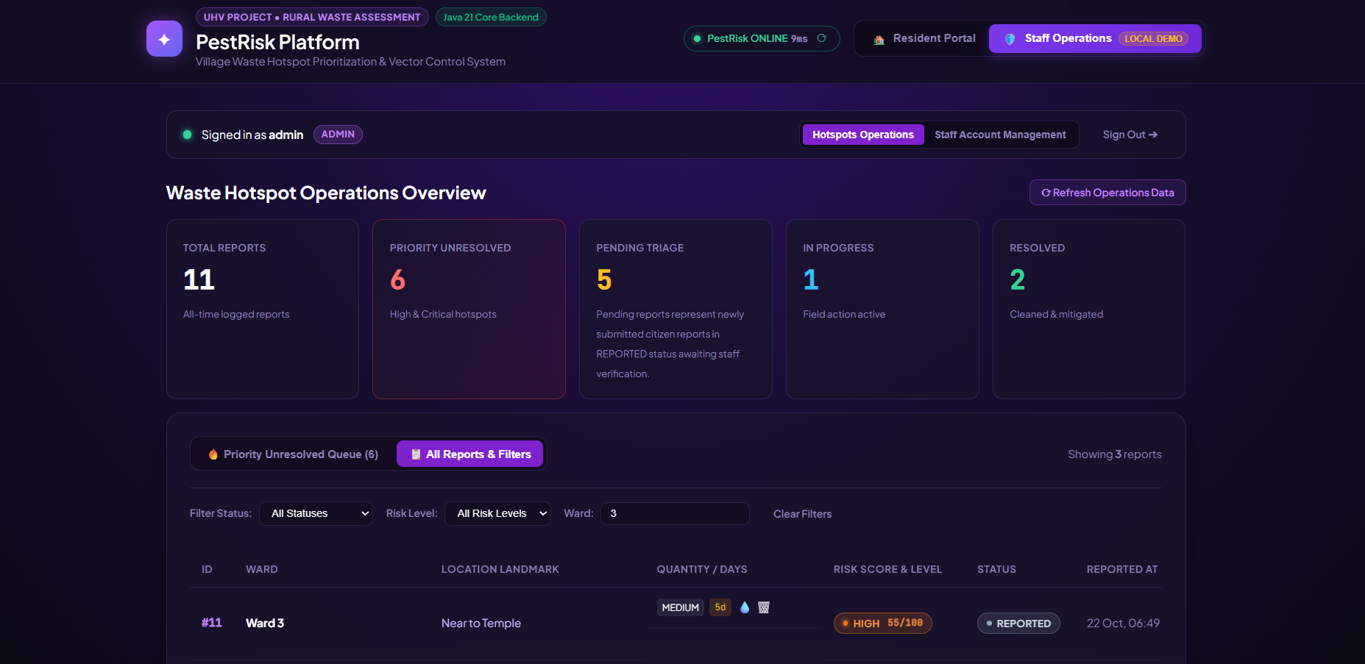
Fig. 3: Gram Panchayat Staff Console (Vadama)
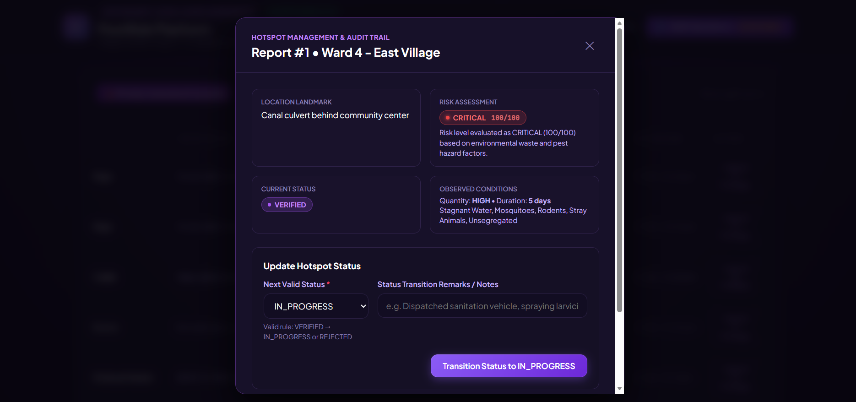

REFERENCE
[1] R. R. Gaur, R. Asthana, and G. P. Bagaria. “A Foundation Course in Human Values and Professional Ethics.” Excel Books, New Delhi, 2nd Revised Edition, 2019. ISBN 978-93-87034-47-1. (UHV Philosophical Framework)
[2] Premvir Kapoor. “Professional Ethics and Human Values.” Khanna Book Publishing, New Delhi, 2022. (Ethical Engineering Reference)
[3] Daniel Goleman. “Emotional Intelligence: Why It Can Matter More Than IQ.” Bloomsbury Publishing India, New Delhi, 1995. (Life Skills Reference)
[4] B. K. Mitra. “Personality Development and Soft Skills.” Oxford University Press, New Delhi, 3rd Edition, 2019. (Communication Reference)
[5] K. G. Balakrishnan. “Unnat Bharat Abhiyan: Transforming India through Village Empowerment.” Ministry of Education, Govt. of India, 2022. (Community Sanitation Reference)
[6] E. F. Schumacher. “Small Is Beautiful: A Study of Economics as if People Mattered.” Blond & Briggs, London, 1973. (Appropriate Technology Reference)
[7] A. K. Sharma and S. Mukherjee. “Rural Solid Waste Characterization and Vector Proliferation in South Asian Village Ecosystems.” Waste Management, 158:112–124, 2023. (Vector Epidemiology Reference)
[8] Spring Boot Development Team. “Spring Boot 3.5 Reference Documentation & Spring Security Architecture.” VMware Tanzu, 2024. https://docs.spring.io/spring-boot/docs/current/reference/html/
[9] React Development Team. “React 19: Component-Based Architecture and Hooks Documentation.” Meta Platforms, 2024. https://react.dev/
[10] SQLite Development Team. “SQLite Database Engine Architecture and SQL Syntax Reference (v3.45).” 2024. https://www.sqlite.org/docs.html

