HOSPITAL MANAGEMENT SYSTEM
A DBMS Capstone Project Report submitted in partial fulfillment
of the requirements for the award of the degree of
BACHELOR OF TECHNOLOGY
in
ARTIFICIAL INTELLIGENCE AND MACHINE LEARNING
Submitted By
P. Nivil Sai Kumar Reddy – 25B11AI896
D. Lakshmi Manikanta – 25B11AI276
J.Y.R.S.S.D. Prasanna Kumar – 25B11AI436
K. Dronam Raju – 25B11AI555
Under the esteemed guidance of
Mr. T. Srinivasulu M.Tech, (Ph.D.)
Assistant Professor
DEPARTMENT OF ARTIFICIAL INTELLIGENCE AND MACHINE LEARNING
ADITYA UNIVERSITY
(Formerly Aditya Engineering College (A))
Aditya Nagar, ADB Road, Surampalem, Andhra Pradesh, India
2026 – 2027

CERTIFICATE
This is to certify that the DBMS Capstone Project report entitled “HOSPITAL MANAGEMENT SYSTEM” is being submitted by P. Nivil Sai Kumar Reddy (25B11AI896), D. Lakshmi Manikanta (25B11AI276), J.Y.R.S.S.D. Prasanna Kumar (25B11AI436) and K. Dronam Raju (25B11AI555) in partial fulfillment of the requirements for the award of the B.Tech. degree in Artificial Intelligence and Machine Learning. The work documented in this report was carried out as part of the Capstone Project for Database Management Systems (2501IT05) during the academic year 2026–2027.

Project Guide | Head of the Department
Mr. T. Srinivasulu, M. Tech, (Ph.D.) | Dr. K. Naga Bhargavi, M. Tech, Ph.D.
Associate Professor | Associate Professor & HOD

DECLARATION
We hereby declare that the DBMS Capstone Project entitled “HOSPITAL MANAGEMENT SYSTEM” is a genuine work carried out by us. The database design and documentation presented in this report are based on the project design supplied for the capstone review and have been prepared under the guidance of Mr. T. Srinivasulu, Department of Artificial Intelligence and Machine Learning, Aditya University, Surampalem. We further declare that this work has not been submitted, in full or in part, for the award of any degree of this or any other educational institution.
Project Associate | Roll Number
P. Nivil Sai Kumar Reddy | 25B11AI896
D. Lakshmi Manikanta | 25B11AI276
J.Y.R.S.S.D. Prasanna Kumar | 25B11AI436
K. Dronam Raju | 25B11AI555

Date: ____________
Place: Surampalem

ACKNOWLEDGEMENT
It is with immense pleasure that we express our indebted gratitude to our project guide, Mr. T. Srinivasulu, Department of Artificial Intelligence and Machine Learning, who guided us throughout the capstone project. We are thankful for the constant encouragement and valuable suggestions received during the review stages.
We are grateful to Dr. K. Naga Bhargavi, Head of the Department, for inspiring us and for arranging the facilities and resources needed for this project. We extend our sincere thanks to the Management and the University for providing an excellent academic environment.
We also thank the Teaching and Non-Teaching Staff, our parents and our friends, who have directly or indirectly supported us in completing this project.

ABSTRACT
The Hospital Management System is a SQL-based relational database designed to organize interconnected hospital information and support reliable storage and retrieval of records. The supplied Project 2 design identifies the patient, doctor, department, ward, appointment, treatment and billing areas, together with Patient_Contact for the multi-valued contact attribute. The database design uses primary keys, foreign keys, UNIQUE, NOT NULL, CHECK and DEFAULT constraints to improve data integrity and reduce redundancy. The ER model represents the major relationships among these records, including department–doctor, department–ward, patient–appointment, doctor–appointment, appointment–treatment, ward–treatment, patient–bill and treatment–bill. The relational schema contains eight tables, with Patient_Contact resolving the multi-valued patient contact information. The design is normalized toward Third Normal Form, with derived values such as age, available beds and total amount treated as computed values. The supplied project material covers DDL, DML, constraints, SELECT/JOIN/GROUP BY, views and reporting-query scope; however, Review-II execution screenshots and a complete query set are not included in the supplied PPT. The report therefore documents the supported design and clearly marks execution evidence that was not supplied.

INDEX
Chapter / Section | Page
Certificate | i
Declaration | ii
Acknowledgement | iii
Abstract | iv
List of Figures | v
List of Tables | vi
1 Introduction | 1
2 System Study and Tools | 4
3 Database Design (Review – I) | 6
4 Database Implementation (Review – II) | 14
5 SQL Operations and Queries | 19
6 Modules and Functionalities | 21
7 Results – Sample Outputs and Screenshots | 22
8 Testing and Data Validation | 23
9 GitHub Repository and Team Contribution | 24
10 Conclusion and Future Enhancements | 25
References | 27
Appendix A – Complete SQL Script | 28

LIST OF FIGURES
Figure No. | Title
Fig. 3.1 | ER Diagram of the Hospital Management System (supplied in Project 2 PPT)
Fig. 3.2 | Relational Schema Diagram (supplied in Project 2 PPT)
Fig. 3.3 | Database Design Summary (supplied in Project 2 PPT)
Fig. 4.1 | Successful Creation of Tables – execution evidence not supplied
Fig. 4.2 | Sample Data Inserted into the Tables – execution evidence not supplied
Fig. 4.3 | Referential Integrity Validation – execution evidence not supplied

LIST OF TABLES
Table No. | Title
Table 2.1 | Tools and Technologies Used
Table 2.2 | Software and Hardware Requirements
Table 3.1 | Entities Identified
Table 3.2 | Attributes of Each Entity
Table 3.3 | Relationships and Cardinality
Table 3.4 | Relational Database Schema
Table 3.5 | Primary Key and Foreign Key Definitions
Table 3.6 | Normalization Steps
Table 4.1 | Sample Data Summary
Table 4.2 | Constraints and Data Integrity Rules
Table 6.1 | Modules and Their Functionalities
Table 8.1 | Test Cases and Results
Table 9.1 | Team Responsibilities
Table 9.2 | Review-wise Progress Record

CHAPTER 1: INTRODUCTION

1.1 Introduction to the Domain
A hospital handles a large amount of interconnected information about patients, doctors, departments, appointments, wards, treatments and billing. The supplied Hospital Management System is intended to organize these records in a centralized relational database so that related information can be stored systematically and retrieved through SQL.
The Project 2 PPT presents the system as a SQL-based database design using ER modeling, normalization, primary and foreign keys, integrity constraints and structured queries. The design focuses on reliable data storage and retrieval rather than a frontend application.

1.2 Problem Statement
Hospitals handle large amounts of interconnected data. Manual or scattered records can cause duplicate patient entries, appointment conflicts, missing medical details and billing errors. The proposed SQL-based system addresses these issues through normalized relational tables, primary and foreign keys, integrity constraints and structured queries.

1.3 Motivation and Need for a Database
A DBMS is required to maintain relationships among hospital records and to enforce rules that are difficult to guarantee in separate files or spreadsheets. Primary keys identify records uniquely, foreign keys maintain relationships, and validation constraints help prevent inconsistent data. Centralized storage also makes hospital information easier to retrieve for authorized users.

1.4 Objectives of the Project
No. | Objective | SQL / DBMS Focus
1 | Store patient and hospital information systematically. | Relational tables + DDL
2 | Manage doctors, departments and appointments. | PK/FK + JOINs
3 | Maintain treatment and patient-contact details. | Normalization + constraints
4 | Track wards and billing records. | Referential integrity
5 | Support accurate reporting and retrieval. | SELECT, aggregates, views

1.5 Scope of the Project
The documented design covers patient identity and contacts, doctors, departments, wards, appointments, treatments and billing. It includes the relationships and constraints represented in the supplied Project 2 ER model and relational schema. A frontend application, live hospital deployment, user authentication and production-level security are outside the documented scope.

1.6 Organization of the Report
This report is organized into ten chapters. Chapter 2 presents the system study and tools used. Chapter 3 covers the database design, ER diagram, relational schema and normalization. Chapter 4 documents the supplied DDL/DML and integrity design. Chapter 5 records the SQL operation scope and identifies execution material not supplied. Chapter 6 explains the major modules. Chapter 7 records result/screenshot requirements. Chapter 8 covers testing and validation. Chapter 9 records team contribution. Chapter 10 concludes the work and lists future enhancements.

CHAPTER 2: SYSTEM STUDY AND TOOLS

2.1 Existing System and Its Limitations
The project identifies the problem as hospital information being handled through manual or scattered records. Such an arrangement can create duplicate patient entries, appointment conflicts, missing medical details and billing errors. Retrieval and cross-checking of connected information also become difficult.

2.2 Proposed Database System
The proposed system is a centralized SQL-based relational database. Hospital information is separated into related tables and linked using primary and foreign keys. The design also uses normalization and integrity constraints so that the same information does not have to be repeatedly stored in unrelated records.

2.3 Tools and Technologies Used
Category | Tool / Technology Used | Version / Remarks
Database Server | SQL / Relational DBMS | Project PPT describes a SQL-based implementation; exact server version is not stated.
Query / Admin Tool | SQL execution environment | Exact tool/version is not stated in the supplied PPT.
ER Diagram Tool | ER modelling / diagram | The PPT contains the ER and relational-schema diagrams; exact drawing tool is not stated.
Version Control | Git / GitHub | Repository link is not provided in the supplied PPT.
Documentation | Microsoft Word | Used for report preparation.

2.4 Software and Hardware Requirements
Requirement Type | Specification
Operating System | Windows / Linux system capable of running the selected SQL environment.
Database Server | SQL-compatible relational DBMS.
Client / Query Tool | SQL client or database administration tool.
Processor | Modern dual-core processor or above.
RAM | 4 GB minimum; more recommended for database tools.
Disk Space | Sufficient space for DBMS, project files and documentation.

Note: Exact software versions and hardware specifications are not stated in the supplied Project 2 PPT; the table therefore records only general requirements rather than claiming a specific configuration.

CHAPTER 3: DATABASE DESIGN
The following design documentation follows the structured ER/schema content shown in Project 2 of the supplied PPT. The PPT visual design slides represent eight relational tables, including Patient_Contact.

3.1 Identified Entities
S.No | Entity Name | Description
1 | Patient | Stores patient identity and medical details.
2 | Patient_Contact | Stores multiple contact numbers per patient.
3 | Doctor | Stores doctor details and specialization.
4 | Department | Represents hospital departments and their head.
5 | Ward | Stores ward name, capacity and department link.
6 | Appointment | Records patient-doctor appointment schedules.
7 | Treatment | Stores diagnosis and treatment per appointment.
8 | Bill | Records charges and payment status.

3.2 Entity Attributes and Attribute Types
Entity | Attribute | Data Type | Key / Constraint | Attribute Type
Patient | patient_id | INT | PK | Simple
Patient | first_name | VARCHAR(50) | — | Simple
Patient | last_name | VARCHAR(50) | — | Simple
Patient | dob | DATE | — | Simple
Patient | blood_group | CHAR(5) | — | Simple
Patient | gender | VARCHAR(10) | — | Simple
Patient | address | TEXT | — | Composite
Patient | age | — | — | Derived
Patient_Contact | id | INT | PK | Simple
Patient_Contact | patient_id | INT | FK | Simple
Patient_Contact | contact | VARCHAR(15) | — | Simple
Doctor | doctor_id | INT | PK | Simple
Doctor | first_name | VARCHAR(50) | — | Simple
Doctor | last_name | VARCHAR(50) | — | Simple
Doctor | specialization | VARCHAR(100) | — | Simple
Doctor | experience_years | INT | — | Simple
Doctor | email | VARCHAR(100) | UNIQUE, NOT NULL | Simple
Doctor | dept_id | INT | FK | Simple
Department | dept_id | INT | PK | Simple
Department | dept_name | VARCHAR(100) | NOT NULL, UNIQUE | Simple
Department | floor_no | INT | — | Simple
Department | hod_doctor_id | INT | FK | Simple
Ward | ward_id | INT | PK | Simple
Ward | ward_name | VARCHAR(50) | — | Simple
Ward | capacity | INT | — | Simple
Ward | available_beds | — | — | Derived
Ward | dept_id | INT | FK | Simple
Appointment | appt_id | INT | PK | Simple
Appointment | patient_id | INT | FK | Simple
Appointment | doctor_id | INT | FK | Simple
Appointment | appt_date | DATE | NOT NULL | Simple
Appointment | appt_time | TIME | NOT NULL | Simple
Appointment | status | VARCHAR(20) | DEFAULT | Simple
Appointment | symptoms | TEXT | — | Simple
Treatment | treatment_id | INT | PK | Simple
Treatment | appt_id | INT | FK, UNIQUE | Simple
Treatment | diagnosis | TEXT | — | Simple
Treatment | treatment_date | DATE | — | Simple
Treatment | ward_id | INT | FK | Simple
Bill | bill_id | INT | PK | Simple
Bill | patient_id | INT | FK | Simple
Bill | treatment_id | INT | FK, UNIQUE | Simple
Bill | consultation_fee | DECIMAL(10,2) | DEFAULT 0 | Simple
Bill | medicine_charges | DECIMAL(10,2) | DEFAULT 0 | Simple
Bill | bed_charges | DECIMAL(10,2) | DEFAULT 0 | Simple
Bill | total_amount | — | — | Derived
Bill | payment_status | VARCHAR(20) | DEFAULT | Simple
Bill | bill_date | DATE | — | Simple

3.3 ER Diagram
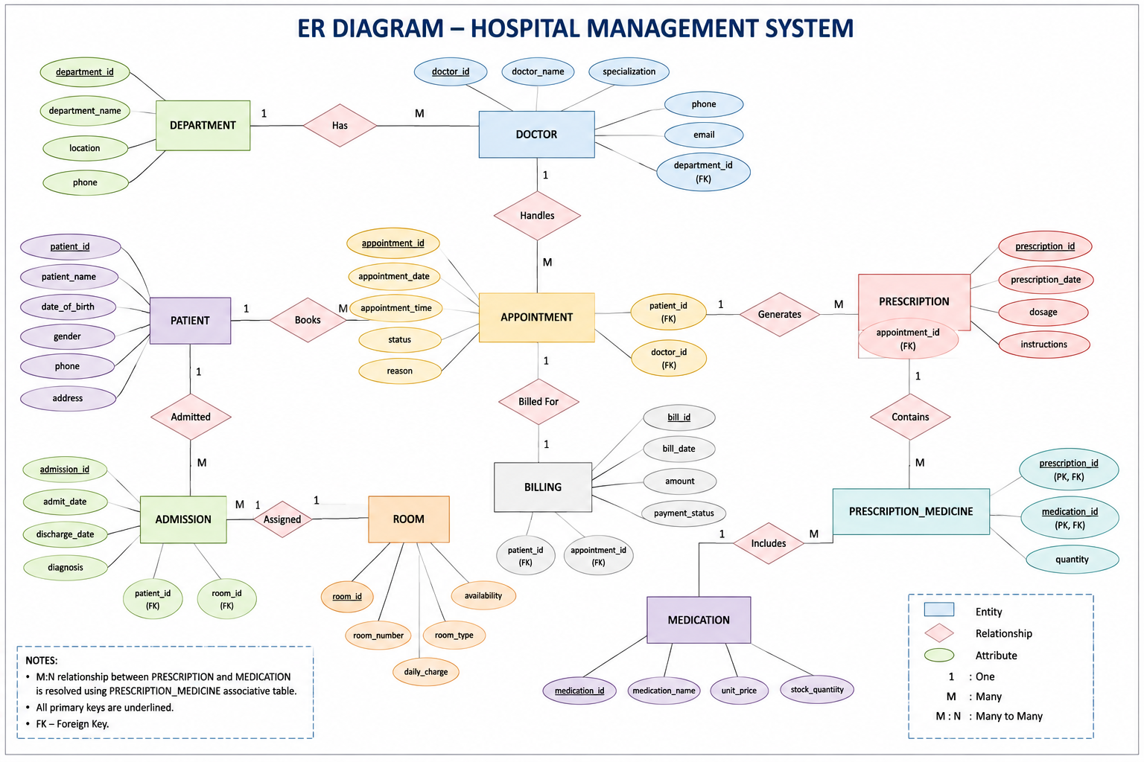
Fig. 3.1: ER Diagram of the Hospital Management System (as supplied in Project 2 PPT)
The ER diagram supplied in the PPT shows Patient, Patient_Contact, Doctor, Department, Ward, Appointment, Treatment and Bill, with the corresponding relationships and cardinalities.

3.4 Relationships and Cardinality
Entity 1 | Relationship | Entity 2 | Cardinality | Meaning
Department | has / contains | Doctor | 1 : M | One department can have many doctors; each doctor belongs to one department.
Department | has / contains | Ward | 1 : M | One department can have many wards; each ward belongs to one department.
Patient | has | Patient_Contact | 1 : M | A patient can have multiple contact numbers.
Patient | has | Appointment | 1 : M | One patient can have many appointments.
Doctor | handles | Appointment | 1 : M | One doctor can handle many appointments.
Appointment | results in | Treatment | 1 : 1 | Each appointment results in a treatment record.
Ward | contains / assigned to | Treatment | 1 : M | A ward can be used for many treatments over time.
Patient | has | Bill | 1 : M | A patient can have multiple bills.
Treatment | has | Bill | 1 : 1 | Each treatment has one associated bill in this design.

3.5 Relational Database Schema
Table Name | Columns | Purpose
PATIENT | patient_id; first_name; last_name; dob; blood_group; gender; address | Patient master
PATIENT_CONTACT | id; contact; patient_id | Multi-valued contact numbers
DEPARTMENT | dept_id; dept_name; floor_no; hod_doctor_id | Department master
DOCTOR | doctor_id; first_name; last_name; specialization; experience_years; email; dept_id | Doctor master
WARD | ward_id; ward_name; capacity; dept_id | Ward master
APPOINTMENT | appt_id; appt_date; appt_time; status; symptoms; patient_id; doctor_id | Scheduling
TREATMENT | treatment_id; diagnosis; treatment_date; appt_id; ward_id | Diagnosis and treatment
BILL | bill_id; consultation_fee; medicine_charges; bed_charges; payment_status; bill_date; patient_id; treatment_id | Billing

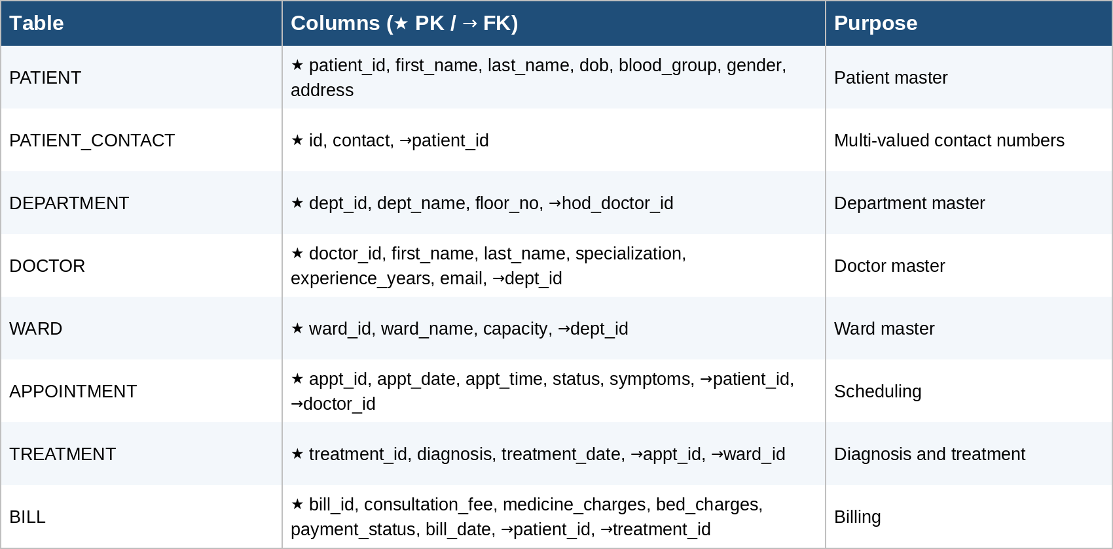
Fig. 3.2: Relational Schema Diagram (as supplied in Project 2 PPT)

3.6 Primary Keys and Foreign Keys
Table | Primary Key | Foreign Key | References
PATIENT | patient_id | — | —
PATIENT_CONTACT | id | patient_id | PATIENT(patient_id)
DEPARTMENT | dept_id | hod_doctor_id | DOCTOR(doctor_id)
DOCTOR | doctor_id | dept_id | DEPARTMENT(dept_id)
WARD | ward_id | dept_id | DEPARTMENT(dept_id)
APPOINTMENT | appt_id | patient_id, doctor_id | PATIENT(patient_id), DOCTOR(doctor_id)
TREATMENT | treatment_id | appt_id, ward_id | APPOINTMENT(appt_id), WARD(ward_id)
BILL | bill_id | patient_id, treatment_id | PATIENT(patient_id), TREATMENT(treatment_id)

3.7 Normalization up to 3NF
Normal Form | Condition Satisfied | Anomaly / Redundancy Addressed | Resulting Design
1NF | Atomic attributes; patient contact numbers separated into Patient_Contact. | Repeating / multi-valued contact data. | PATIENT, PATIENT_CONTACT and other base tables
2NF | Non-key attributes depend on the complete primary key; treatment and billing details are separated by entity. | Partial dependency and repeated descriptive data. | Separate patient, doctor, department, ward, appointment, treatment and bill tables
3NF | Derived values such as age, available_beds and total_amount are treated as computed values. | Transitive / redundant derived data. | Normalized relational tables with computed values

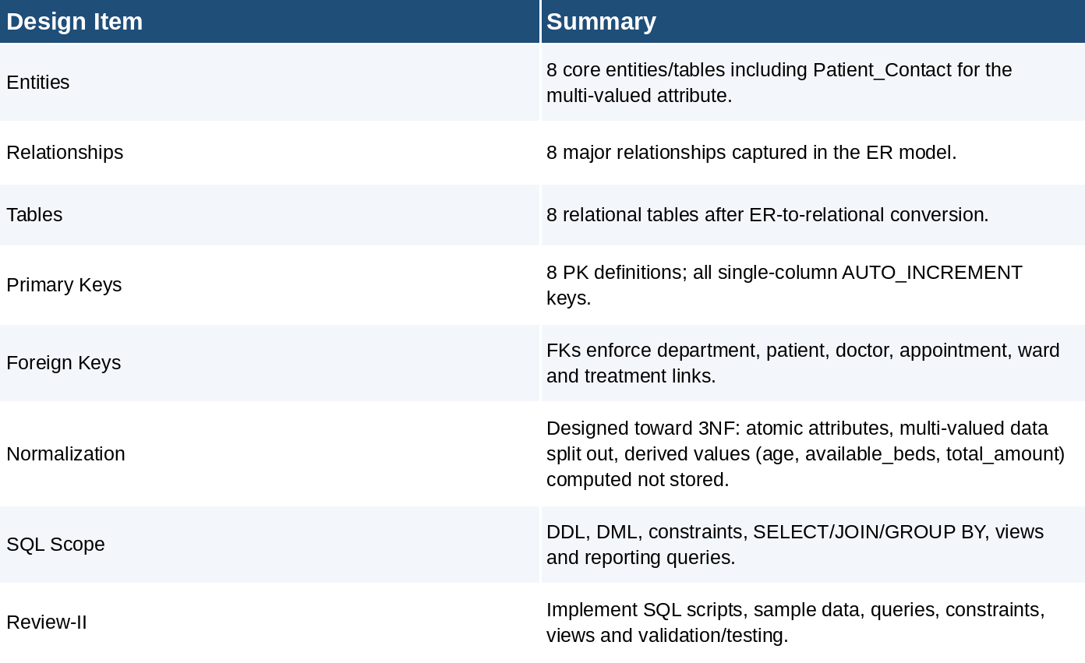
Fig. 3.3: Database Design Summary supplied in Project 2 PPT

CHAPTER 4: DATABASE IMPLEMENTATION
The Project 2 PPT is a Review-I presentation. It states the intended Review-II scope—SQL scripts, sample data, queries, constraints, views and validation/testing—but does not contain Review-II execution screenshots. The following implementation material is therefore limited to SQL and sample-data content available in the supplied Project 2 reference document, while execution evidence is explicitly marked as not supplied.

4.1 Database and Table Creation – DDL
The supplied Project 2 reference material provides CREATE TABLE definitions for Department, Doctor, Patient, Patient_Contact, Ward, Appointment, Treatment and Bill. The complete script is reproduced in Appendix A.
Table | Key Constraints / Integrity Features
Department | PRIMARY KEY, AUTO_INCREMENT, UNIQUE department name
Doctor | PRIMARY KEY, AUTO_INCREMENT, UNIQUE and NOT NULL email, CHECK experience_years >= 0, FOREIGN KEY to Department
Patient | PRIMARY KEY, AUTO_INCREMENT, NOT NULL first and last names
Patient_Contact | PRIMARY KEY, AUTO_INCREMENT, FOREIGN KEY to Patient
Ward | PRIMARY KEY, AUTO_INCREMENT, CHECK capacity > 0, FOREIGN KEY to Department
Appointment | PRIMARY KEY, AUTO_INCREMENT, NOT NULL patient/doctor/date/time, DEFAULT status, FOREIGN KEYs
Treatment | PRIMARY KEY, AUTO_INCREMENT, UNIQUE appointment link, FOREIGN KEYs to Appointment and Ward
Bill | PRIMARY KEY, AUTO_INCREMENT, UNIQUE treatment link, DEFAULT charge/payment values, FOREIGN KEYs

Fig. 4.1: Successful Creation of Tables — execution screenshot not supplied in the PPT.

4.2 Sample Data Insertion – DML
The supplied Project 2 reference material provides sample rows for Patient, Appointment and Bill. It does not provide a complete populated-data listing for every table.
S.No | Table Name | No. of Records Provided | Sample Data / Remarks
1 | Patient | 3 | Suresh Babu, Latha Rao and Kiran Reddy
2 | Appointment | 3 | Three appointment records
3 | Bill | 2 | Two bill records

Fig. 4.2: Sample Data Inserted into the Tables — output screenshot not supplied in the PPT.

4.3 Constraints and Data Integrity
Constraint / Validation | Applied On | Purpose
PRIMARY KEY | All entity tables | Uniquely identifies each row and prevents duplicate primary identifiers.
FOREIGN KEY | Patient_Contact, Doctor, Ward, Appointment, Treatment, Bill | Maintains valid relationships between parent and child tables.
UNIQUE | Department.dept_name; Doctor.email; Treatment.appt_id; Bill.treatment_id | Prevents duplicate values where uniqueness is required.
NOT NULL | Required Doctor, Patient and Appointment fields | Prevents missing mandatory values.
CHECK | Doctor.experience_years; Ward.capacity | Restricts invalid numeric values.
DEFAULT | Appointment.status; Bill charge/payment fields | Supplies default values when not explicitly provided.

4.4 Data Validation Rules
The database design prevents duplicate identifiers through primary keys and prevents orphan child records through foreign keys. CHECK constraints restrict invalid numeric values, while NOT NULL and UNIQUE constraints enforce required and unique data. The supplied PPT does not contain a screenshot of an actual referential-integrity error; therefore no execution error is claimed here.
Fig. 4.3: Referential Integrity Enforced by the Database — execution screenshot not supplied.

CHAPTER 5: SQL OPERATIONS AND QUERIES
The PPT lists DDL, DML, constraints, SELECT/JOIN/GROUP BY, views and reporting queries as the intended SQL scope. It does not provide a numbered set of executed queries or their outputs. To avoid inventing execution evidence, the sections below record the required query categories and the available source status.

5.1 DQL – Basic Retrieval Queries
Q.No | Purpose | SQL Statement | Output Ref.
— | Basic retrieval of hospital records | Not supplied in the PPT. | Not supplied

5.2 Join Operations
Q.No | Type of Join | SQL Statement | Output Ref.
— | JOIN operations between related hospital tables | The PPT states JOINs are in scope, but does not supply the executed statements. | Not supplied

5.3 Aggregate Functions, GROUP BY and HAVING
Q.No | Function Used | SQL Statement | Output Ref.
— | Aggregate/reporting queries | The PPT states GROUP BY/reporting queries are in scope, but no executed query is supplied. | Not supplied

5.4 Nested and Correlated Subqueries
Q.No | Type | SQL Statement | Output Ref.
— | Nested / correlated subqueries | Not supplied in the PPT. | Not supplied

5.5 Views and Relational Set Operations
Q.No | View / Set Operation | SQL Statement | Output Ref.
— | Views and reporting queries | The PPT states views are in scope, but no view definition or output is supplied. | Not supplied

5.6 DCL and TCL Operations
Q.No | Command | Purpose | SQL Statement | Output Ref.
— | DCL/TCL | No DCL/TCL execution statements are supplied in the PPT. | Not supplied | Not supplied

CHAPTER 6: MODULES AND FUNCTIONALITIES
S.No | Module Name | Functionality | Tables Involved
1 | Patient Management | Maintains patient identity and multiple contact numbers. | PATIENT, PATIENT_CONTACT
2 | Doctor & Department Management | Maintains doctor specialization and department association. | DOCTOR, DEPARTMENT
3 | Ward Management | Stores ward information, capacity and department association. | WARD, DEPARTMENT
4 | Appointment Management | Records patient-doctor appointment date, time, status and symptoms. | APPOINTMENT, PATIENT, DOCTOR
5 | Treatment Management | Stores diagnosis and treatment information associated with appointments and wards. | TREATMENT, APPOINTMENT, WARD
6 | Billing Management | Stores consultation, medicine and bed charges together with payment status. | BILL, PATIENT, TREATMENT

Patient Management
The patient module maintains the master patient record. Patient_Contact separates multiple contact numbers from the main patient table, supporting the normalization design.

Doctor and Department Management
Doctor records are connected to departments through a foreign key. Department records include department name, floor and head-doctor reference.

Appointment and Treatment Management
Appointments connect patients and doctors. A treatment record is associated with an appointment and may be linked to a ward.

Ward and Billing Management
Wards maintain capacity and department association, while bills store consultation, medicine and bed charges and payment status.

CHAPTER 7: RESULTS – SAMPLE OUTPUTS AND SCREENSHOTS
The supplied PPT is a Review-I design presentation and does not include SQL execution screenshots. The following figures identify the evidence expected for the final documentation without claiming that those screenshots were supplied.
Fig. 7.1: ER diagram of the Hospital Management System — supplied in the PPT.
Fig. 7.2: Relational schema diagram — supplied in the PPT.
Fig. 7.3: Successful table-creation output — execution screenshot not supplied.
Fig. 7.4: Sample query/output screenshot — execution screenshot not supplied.

CHAPTER 8: TESTING AND DATA VALIDATION
The design supports validation through primary keys, foreign keys, UNIQUE, NOT NULL, CHECK and DEFAULT constraints. Actual execution results are not included in the supplied PPT, so the table below records intended test cases rather than claiming observed execution.
TC No. | Test Case | Input / Action | Expected Result | Actual Result | Status
TC01 | Duplicate primary key | Insert a second row with an existing primary-key value. | Database rejects duplicate key. | Execution result not supplied | Not demonstrated
TC02 | Invalid doctor experience | Insert a negative experience_years value. | CHECK constraint rejects the value. | Execution result not supplied | Not demonstrated
TC03 | Invalid ward capacity | Insert capacity <= 0. | CHECK constraint rejects the value. | Execution result not supplied | Not demonstrated
TC04 | Orphan appointment | Insert appointment referencing a non-existent patient/doctor. | FOREIGN KEY prevents the orphan record. | Execution result not supplied | Not demonstrated
TC05 | Duplicate appointment treatment link | Insert two Treatment rows for the same appointment. | UNIQUE constraint on appt_id prevents duplication. | Execution result not supplied | Not demonstrated
TC06 | Duplicate bill treatment link | Insert two Bill rows for the same treatment. | UNIQUE constraint on treatment_id prevents duplication. | Execution result not supplied | Not demonstrated

CHAPTER 9: GITHUB REPOSITORY AND TEAM CONTRIBUTION

9.1 Repository Details
GitHub Repository Link: Not provided in the supplied Project 2 PPT.

9.2 Team Responsibilities and Contribution
S.No | Student Name | Roll Number | Role / Responsibility | Modules Contributed
1 | P. Nivil Sai Kumar Reddy | 25B11AI896 | Project design / documentation | ER design, schema and report
2 | D. Lakshmi Manikanta | 25B11AI276 | Database design support | Entities, relationships and schema
3 | J.Y.R.S.S.D. Prasanna Kumar | 25B11AI436 | Database design support | Attributes and normalization
4 | K. Dronam Raju | 25B11AI555 | Database design support | Presentation and review material

9.3 Review-wise Progress
Review | Date | Deliverables Presented | Remarks / Source
Zeroth / Initial | Not stated in PPT | Hospital Management System topic and project direction. | PPT
First Review | Not stated in PPT | Abstract, introduction, problem statement, objectives, entities, attributes, ER diagram, relationships, relational schema, design summary and conclusion. | PPT
Review-II | Future / next stage in PPT | SQL scripts, sample records, joins, aggregate queries, views, constraints and validation/testing. | PPT states this as the next stage; execution evidence not supplied.

CHAPTER 10: CONCLUSION AND FUTURE ENHANCEMENTS

10.1 Conclusion
The Hospital Management System establishes a SQL-based relational database structure for managing interconnected hospital information. The design shown in the supplied Project 2 ER and schema diagrams contains eight relational tables: Patient, Patient_Contact, Doctor, Department, Ward, Appointment, Treatment and Bill. The design captures the major relationship patterns, applies primary and foreign keys, and uses normalization to reduce redundancy. The project also identifies SQL operations such as DDL, DML, SELECT/JOIN/GROUP BY, views and reporting queries as part of the intended implementation scope.

10.2 Limitations of the Present Work
The supplied PPT is primarily a first-review design presentation. It does not contain the final Review-II execution screenshots, complete query statements and outputs, GitHub repository link, or complete execution evidence for constraint-validation tests. The report therefore does not claim those items as completed.

10.3 Future Enhancements
- Complete Review-II implementation with full DDL, DML and SQL query execution.
- Add complete sample data for every table and capture successful execution outputs.
- Add stored procedures, functions and triggers for automated hospital workflows.
- Add indexing and query optimization for larger hospital datasets.
- Add authentication, role-based access control, audit logging, backup and recovery.
- Develop a frontend application for hospital staff to interact with the database.
- Add reporting dashboards for appointments, treatments, wards and billing.

REFERENCES
Abraham Silberschatz, Henry F. Korth and S. Sudarshan, “Database System Concepts”, 8th Edition, McGraw-Hill, ISBN: 978-1260230508.
Raghurama Krishnan and Johannes Gehrke, “Database Management Systems”, 4th Edition, McGraw-Hill, ISBN: 978-1260091195.
Ramez Elmasri and Shamkant B. Navathe, “Fundamentals of Database Systems”, 7th Edition, Pearson, ISBN: 978-0137504277.
Project 2 Hospital Management System – supplied DBMS Cornerstone Project PPT.
Project 2 Hospital Management System – supplied Capstone database reference document.

APPENDIX A – COMPLETE SQL SCRIPT
The following script is the Project 2 hospital DDL supplied in the reference database document. It corresponds to the eight-table ER/schema design shown in the PPT.
CREATE TABLE Department (
dept_id INT PRIMARY KEY AUTO_INCREMENT,
dept_name VARCHAR(100) NOT NULL UNIQUE,
floor_no INT,
hod_doctor_id INT
);
CREATE TABLE Doctor (
doctor_id INT PRIMARY KEY AUTO_INCREMENT,
first_name VARCHAR(50) NOT NULL,
last_name VARCHAR(50) NOT NULL,
specialization VARCHAR(100),
experience_years INT CHECK (experience_years >= 0),
email VARCHAR(100) UNIQUE NOT NULL,
dept_id INT,
FOREIGN KEY (dept_id) REFERENCES Department(dept_id)
);
CREATE TABLE Patient (
patient_id INT PRIMARY KEY AUTO_INCREMENT,
first_name VARCHAR(50) NOT NULL,
last_name VARCHAR(50) NOT NULL,
dob DATE,
blood_group CHAR(5),
gender VARCHAR(10),
address TEXT
);
CREATE TABLE Patient_Contact (
id INT PRIMARY KEY AUTO_INCREMENT,
patient_id INT NOT NULL,
contact VARCHAR(15),
FOREIGN KEY (patient_id) REFERENCES Patient(patient_id)
);
CREATE TABLE Ward (
ward_id INT PRIMARY KEY AUTO_INCREMENT,
ward_name VARCHAR(50),
capacity INT CHECK (capacity > 0),
dept_id INT,
FOREIGN KEY (dept_id) REFERENCES Department(dept_id)
);
CREATE TABLE Appointment (
appt_id INT PRIMARY KEY AUTO_INCREMENT,
patient_id INT NOT NULL,
doctor_id INT NOT NULL,
appt_date DATE NOT NULL,
appt_time TIME NOT NULL,
status VARCHAR(20) DEFAULT "Scheduled",
symptoms TEXT,
FOREIGN KEY (patient_id) REFERENCES Patient(patient_id),
FOREIGN KEY (doctor_id) REFERENCES Doctor(doctor_id)
);
CREATE TABLE Treatment (
treatment_id INT PRIMARY KEY AUTO_INCREMENT,
appt_id INT UNIQUE NOT NULL,
diagnosis TEXT,
treatment_date DATE,
ward_id INT,
FOREIGN KEY (appt_id) REFERENCES Appointment(appt_id),
FOREIGN KEY (ward_id) REFERENCES Ward(ward_id)
);
CREATE TABLE Bill (
bill_id INT PRIMARY KEY AUTO_INCREMENT,
patient_id INT NOT NULL,
treatment_id INT UNIQUE,
consultation_fee DECIMAL(10,2) DEFAULT 0,
medicine_charges DECIMAL(10,2) DEFAULT 0,
bed_charges DECIMAL(10,2) DEFAULT 0,
payment_status VARCHAR(20) DEFAULT "Pending",
bill_date DATE,
FOREIGN KEY (patient_id) REFERENCES Patient(patient_id),
FOREIGN KEY (treatment_id) REFERENCES Treatment(treatment_id)
);

Sample Data Supplied for Project 2
Patient
1 | Suresh Babu | 1980-03-15 | O+ | Male
2 | Latha Rao | 1992-07-22 | A+ | Female
3 | Kiran Reddy | 1975-11-05 | B- | Male
Appointment
1 | Patient 1 | Doctor 1 | 2024-08-01 | 10:00:00 | Completed
2 | Patient 2 | Doctor 2 | 2024-08-02 | 11:30:00 | Completed
3 | Patient 3 | Doctor 1 | 2024-08-03 | 09:00:00 | Scheduled
Bill
1 | Patient 1 | 500.00 | 1200.00 | 0.00 | Paid
2 | Patient 2 | 500.00 | 800.00 | 3000.00 | Pending

