CASE 1

File creating after entering integer 1

Give file name ‘newfile’

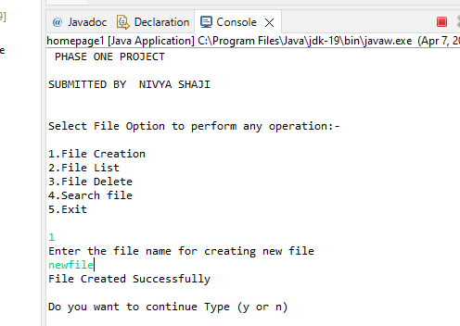

Case2

Select continue by giving character’ y’

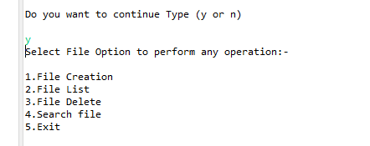

Case3

Select continue by giving character ‘n’

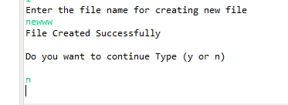

Case4

List of file showing after entering integer 2

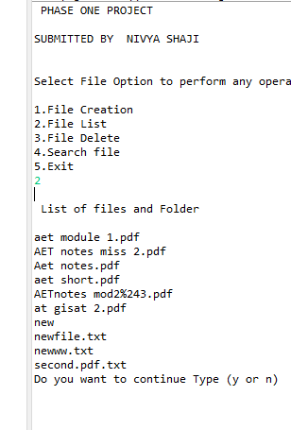

Case5

File is deleted after entering integer 3 value

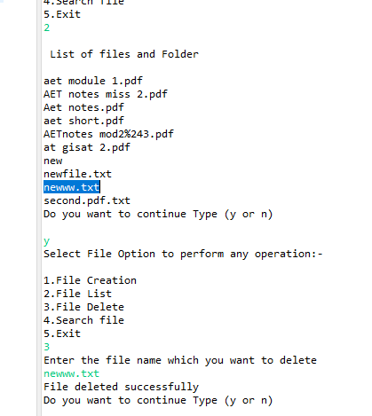

Case 6

File is not deleted by giving invalid name

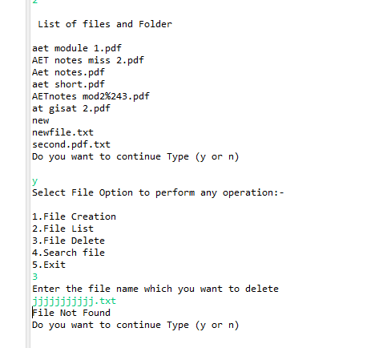

Case7

Searching of file by entering integer 4

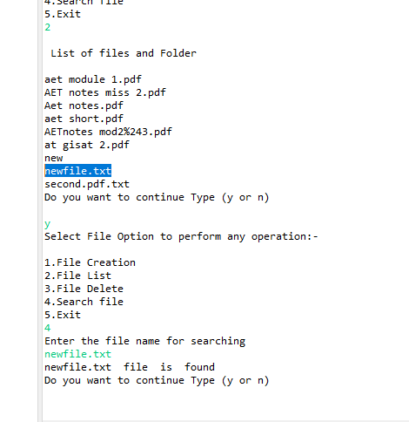

Case8

Wrong search by giving invalid name

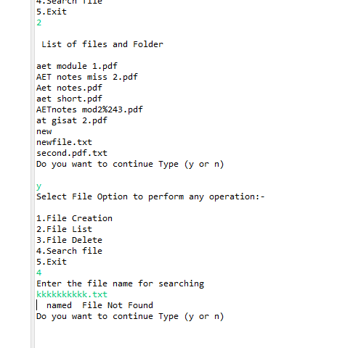

Case9

Exit after entering integer value 5

