**Exercise 1: Implementing the Singleton Pattern**

**CODE**

using System;

namespace SingletonApp

{

public class LogManager

{

private static LogManager? instance;

private LogManager()

{

Console.WriteLine("LogManager instance created.");

}

public static LogManager Get()

{

instance ??= new LogManager();

return instance;

}

public void Write(string msg)

{

Console.WriteLine($"[LOG]: {msg}");

}

}

class App

{

static void Main(string[] args)

{

LogManager logA = LogManager.Get();

logA.Write("First log message");

LogManager logB = LogManager.Get();

logB.Write("Second log message");

Console.WriteLine($"Are both instances the same? {ReferenceEquals(logA, logB)}");

}

}

}

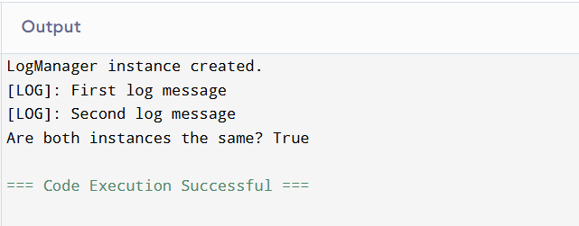

**Exercise 2: Implementing the Factory Method Pattern**

**CODE**

using System;

interface IDocument

{

void Open();

}

class WordDocument : IDocument

{

public void Open()

{

Console.WriteLine("Opening Word Document.");

}

}

class PdfDocument : IDocument

{

public void Open()

{

Console.WriteLine("Opening PDF Document.");

}

}

class ExcelDocument : IDocument

{

public void Open()

{

Console.WriteLine("Opening Excel Document.");

}

}

abstract class DocumentFactory

{

public abstract IDocument CreateDocument();

}

class WordDocumentFactory : DocumentFactory

{

public override IDocument CreateDocument()

{

return new WordDocument();

}

}

class PdfDocumentFactory : DocumentFactory

{

public override IDocument CreateDocument()

{

return new PdfDocument();

}

}

class ExcelDocumentFactory : DocumentFactory

{

public override IDocument CreateDocument()

{

return new ExcelDocument();

}

}

class Program

{

static void Main()

{

Console.WriteLine("Enter the type of document to open (word/pdf/excel):");

string input = Console.ReadLine()?.ToLower();

DocumentFactory factory = input switch

{

"word" => new WordDocumentFactory(),

"pdf" => new PdfDocumentFactory(),

"excel" => new ExcelDocumentFactory(),

_ => null

};

if (factory != null)

{

IDocument document = factory.CreateDocument();

document.Open();

}

else

{

Console.WriteLine("Invalid input. Please enter 'word', 'pdf', or 'excel'.");

}

}

}

