**Project Title: Ambulance Service Provider**

## Introduction

This project focuses on developing a comprehensive backend application for managing ambulance services in a designated area. The application caters to a diverse group of users, including smaller hospitals, individuals, primary healthcare centers, and traffic patrol teams, enabling them to request ambulance services during emergencies. Additionally, the system includes an admin module for managing users, ambulances, and their statuses.

## Technologies Used

### 1. Backend

* **Java Spring Boot:** Provides a robust and scalable framework for building RESTful web services.
* **PostgreSQL:** A powerful, open-source relational database system used for data storage and management.
* **Maven:** A build automation tool used for project management, ensuring efficient dependency management and project setup.

## Features

### Admin Use Cases

1. **Add Ambulance to Database:** Admins can register new ambulances into the system, including details such as ambulance ID, type, and hospital affiliation.
2. **Manage Ambulance Availability:** Admins can update the status of existing ambulances to available or unavailable, providing real-time information on ambulance availability.
3. **Add Users:** The admin has the authority to add new users, including doctors, attendees, and other employees, to the system.
4. **Reset Passwords:** Admin can reset users passwords, ensuring account security and accessibility.

### User Use Cases

1. **Login:** Users can securely log in to the system to access various functionalities.
2. **View All Ambulances:** Users can view a list of all ambulances registered in the system.
3. **View Available Ambulances:** Users can filter and view ambulances that are currently available for dispatch.
4. **Logout:** Users can securely log out of their accounts.
5. **Change Password:** Users can update their account passwords for enhanced security.

## Health Check

To verify that the application is running, users can navigate to the browser or use the following command:

curl localhost:8080/actuator/health

If the app is running correctly, the output will display:

{"status":"UP"}

## Development Process

### Backend Development

The backend of the application was developed using Java Spring Boot, with the following considerations:

* **RESTful API Design:** RESTful principles were applied to design APIs, ensuring a clear and consistent structure for handling requests and responses.
* **Data Persistence:** PostgreSQL was used for reliable data storage, ensuring data integrity and efficient query performance.
* **Security:** Secure authentication and authorization mechanisms were implemented to protect user data and system resources.

**APP Interface and Testing.**

**Folder Structure:**

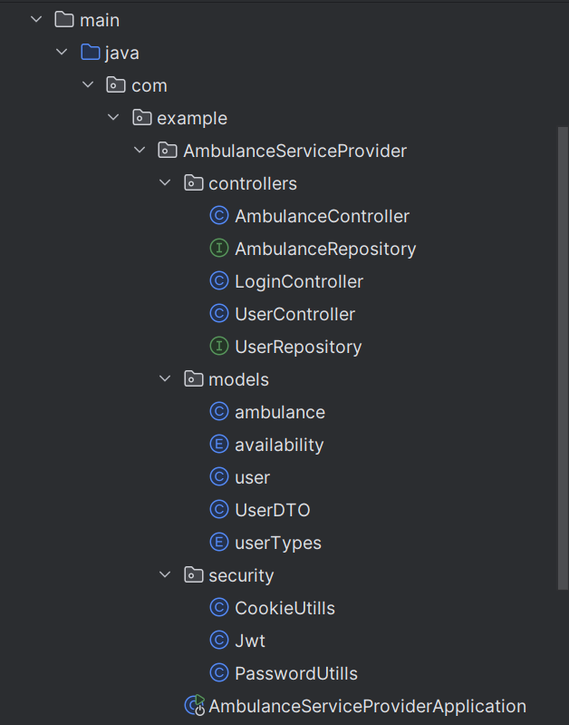

**PostGreSQL Setup:**

**Replace with your credentials   
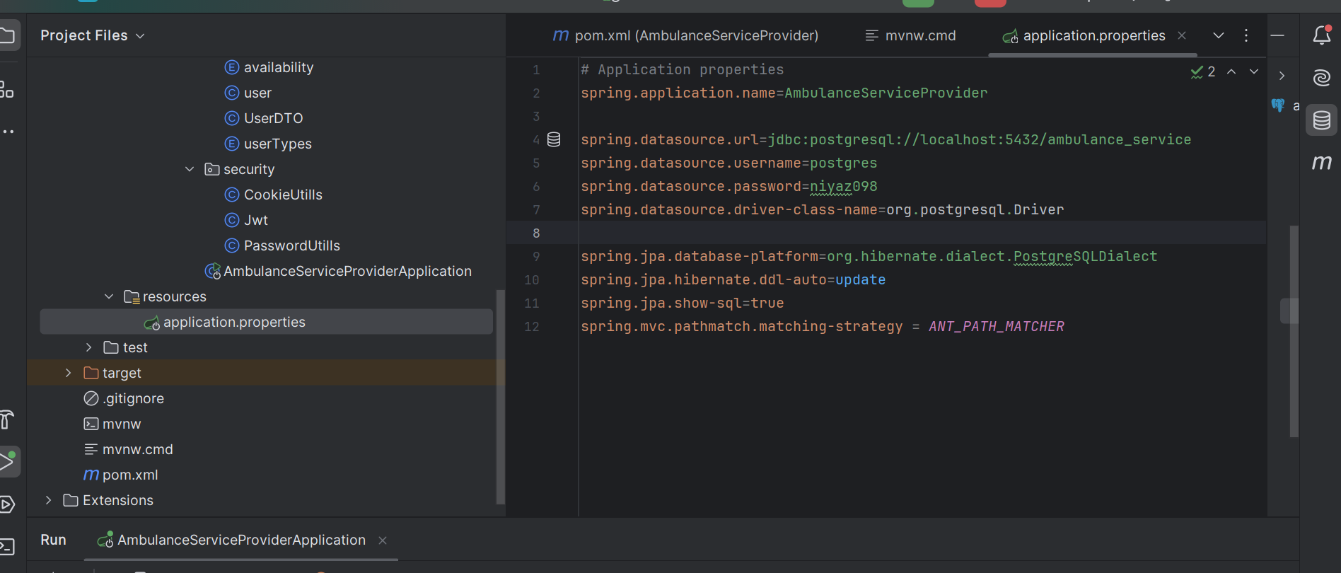**

**Database View:**

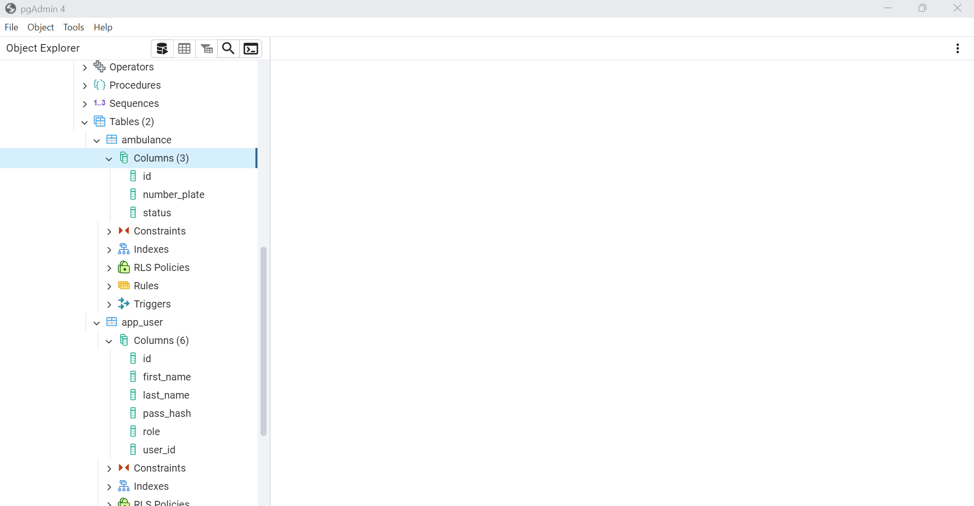

**Test Api:  
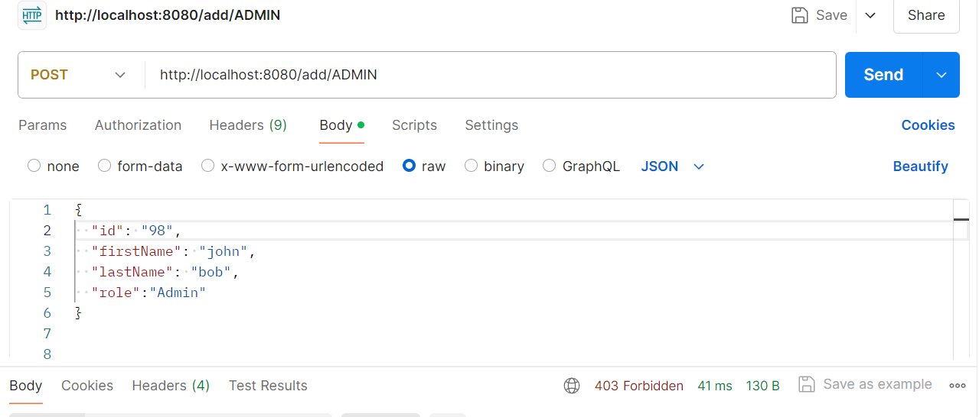**

**After storing data:  
  
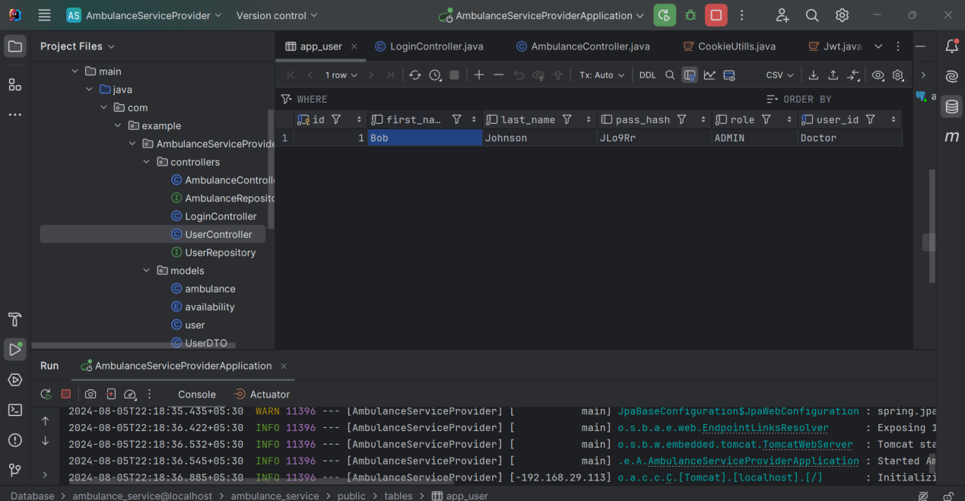**

**App Running Status:**

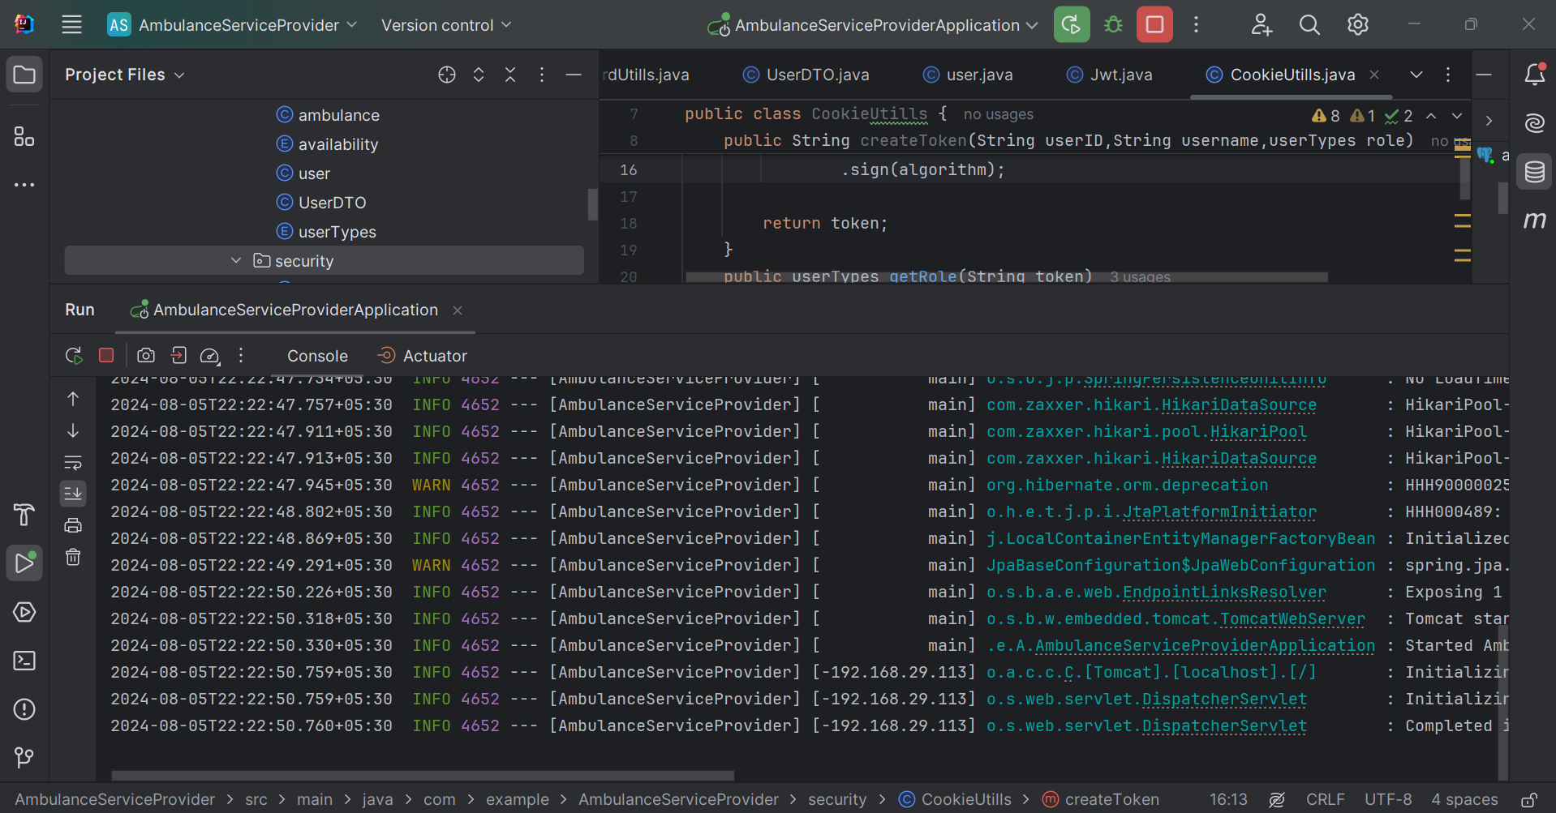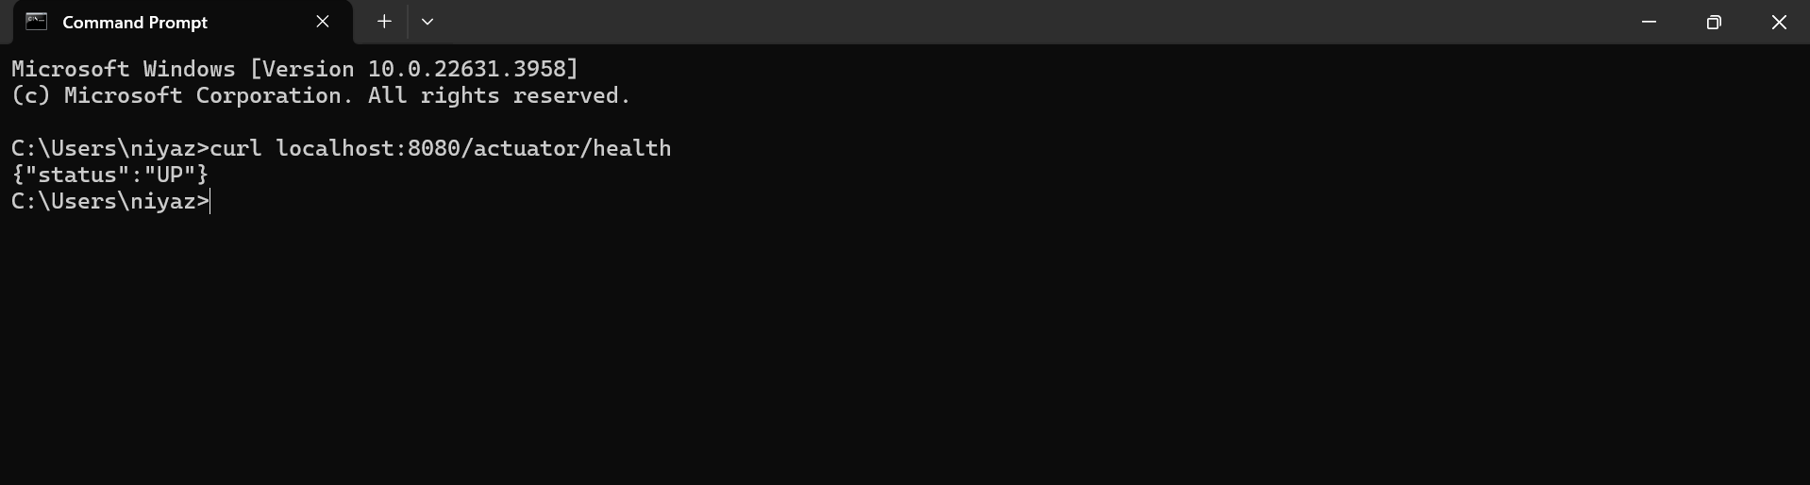

## Conclusion

The Ambulance Service Provider is a vital solution for managing emergency medical services in a region. By leveraging modern technologies like Java Spring Boot and PostgreSQL, the application ensures efficient and secure handling of ambulance dispatch requests. The admin functionalities provide robust management capabilities, while the user functionalities offer a streamlined experience for requesting ambulance services. This project exemplifies the integration of scalable technologies and thoughtful design to address critical healthcare challenges.