Github repository:
NIandHL4life/mlops-pytorch-pipeline: Assignment 3 for MLOPS project by Samuel (DA25M615)
4 merged PRs:
PR1: fix(docker): update requirements with cpu index and pin numpy<2 by NIandHL4life · Pull Request #1 · NIandHL4life/mlops-pytorch-pipeline
PR2: Enhance config schema and updating terminal output by NIandHL4life · Pull Request #2 · NIandHL4life/mlops-pytorch-pipeline
PR3: feat(k8s): configure GPU resource limits and volume mounts for training job by NIandHL4life · Pull Request #3 · NIandHL4life/mlops-pytorch-pipeline
Link to final PR:

Technical Reflection: Challenges in End-to-End MLOps Pipeline Orchestration
Building and orchestrating an end-to-end MLOps pipeline from scratch highlighted the critical pain points where machine learning code intersects with containerization and cloud-native infrastructure. Across the development lifecycle, three core areas presented the most significant technical challenges: virtual environment isolation, hardware-accelerated GPU training, and Kubernetes orchestration with persistent storage.
1. Virtual Environment & Dependency Isolation
The initial hurdle involved managing binary incompatibilities across training and serving environments. PyTorch with CUDA support introduces heavy native C++ binaries, cuDNN bindings, and torchvision dependencies that easily conflict with standard host Python interpreters. Creating separate, pinned dependency files (requirements/train.txt vs. requirements/serve.txt) was essential to keep the serving container lightweight (~300MB) while maintaining full PyTorch capabilities in the training environment. Handling Python path resolution (python -m src.train) across Windows PowerShell and Unix-style containers required strict module structuring to prevent runtime ModuleNotFoundError regressions.
2. Hardware Acceleration & CUDA Memory Management
Enabling laptop GPU training within containerized environments introduced non-trivial hardware virtualization challenges. When running Minikube on Windows, the Docker container VM could not natively interface with NVIDIA NVML drivers, necessitating a dual-mode fallback strategy. Furthermore, training in Docker containers triggered OSError: [Errno 12] Cannot allocate memory during dataset extraction and PyTorch DataLoader operations due to Docker's default 64MB shared memory (/dev/shm) limit. Resolving this required adjusting container memory flags (--shm-size=2g), properly managing CIFAR-10 data decompression on the host filesystem, and verifying tensor placement (cuda:0 vs cpu) across training loops.
3. Kubernetes Orchestration, Storage, & Autoscaling
The most intricate phase was orchestrating Kubernetes workloads with decoupled storage lifecycles. Model serving deployments must treat weights as immutable, requiring /app/checkpoints to be mounted as readOnly: true. However, sharing a single PersistentVolumeClaim (ml-data-pvc) between write-heavy training jobs and read-only serving pods introduced permission barriers when populating checkpoints directly into the cluster. This was resolved by designing helper initialization pods to populate the PVC without compromising serving security. Finally, configuring cluster-wide metrics (metrics-server), defining sensitive liveness/readiness health probes, and tuning Horizontal Pod Autoscaler (HPA) CPU thresholds ensured that the serving replicas could autonomously scale under variable inference load.
In conclusion, these challenges demonstrated that real-world MLOps is as much about robust systems engineering, storage boundaries, and container ergonomics as it is about model performance.

Snapshots:
Preliminary Unit Tests:
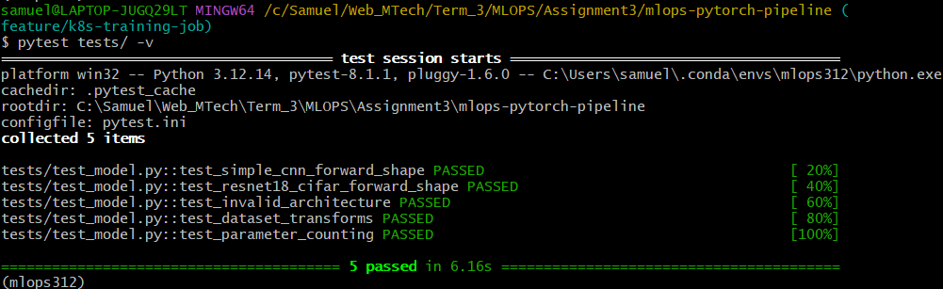
Model Training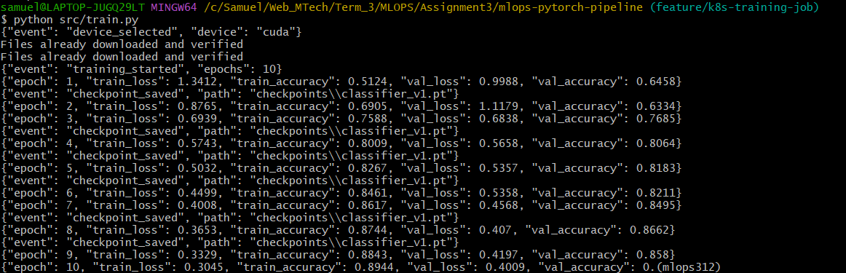
Serving model in Docker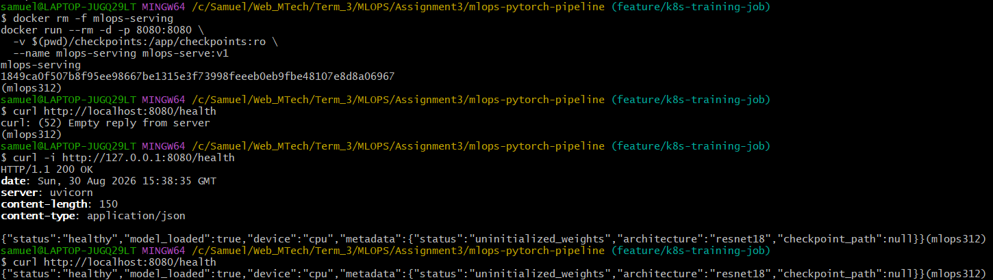
Running a prediction for sample image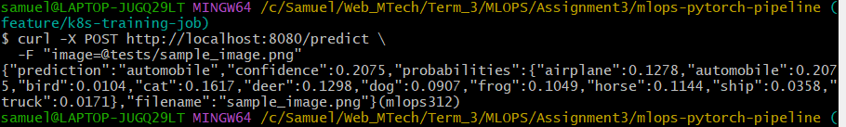

Kubernetes pods running and prediction
Terminal 1
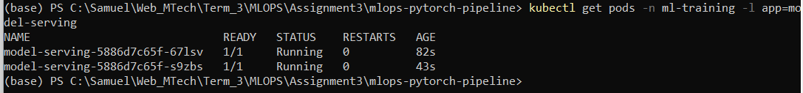
Terminal 2