##This page contains screenshots of my Cloudwatch project##

1.EC2 instance running
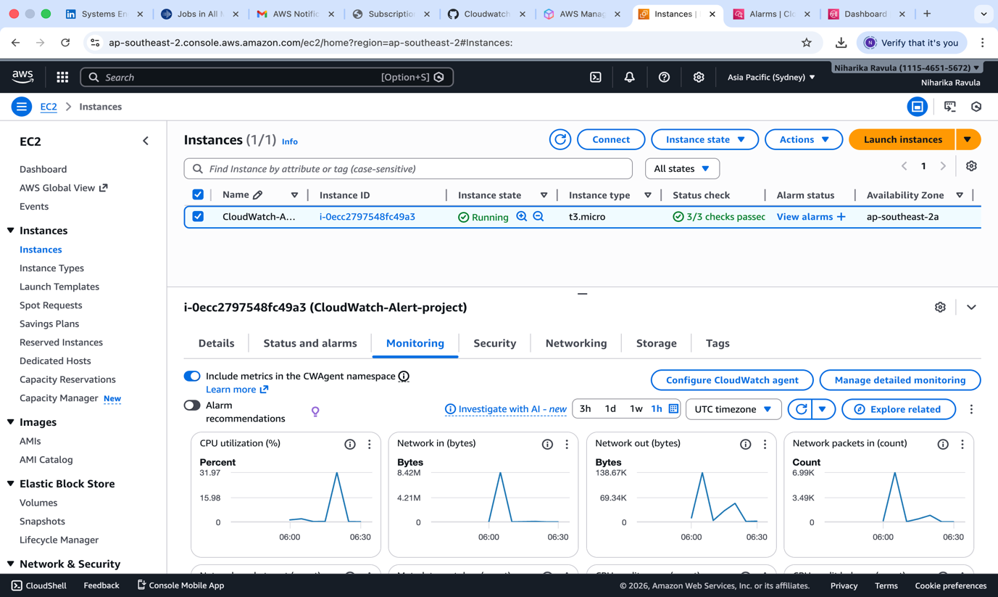

2.Cloudwatch Metric Graph
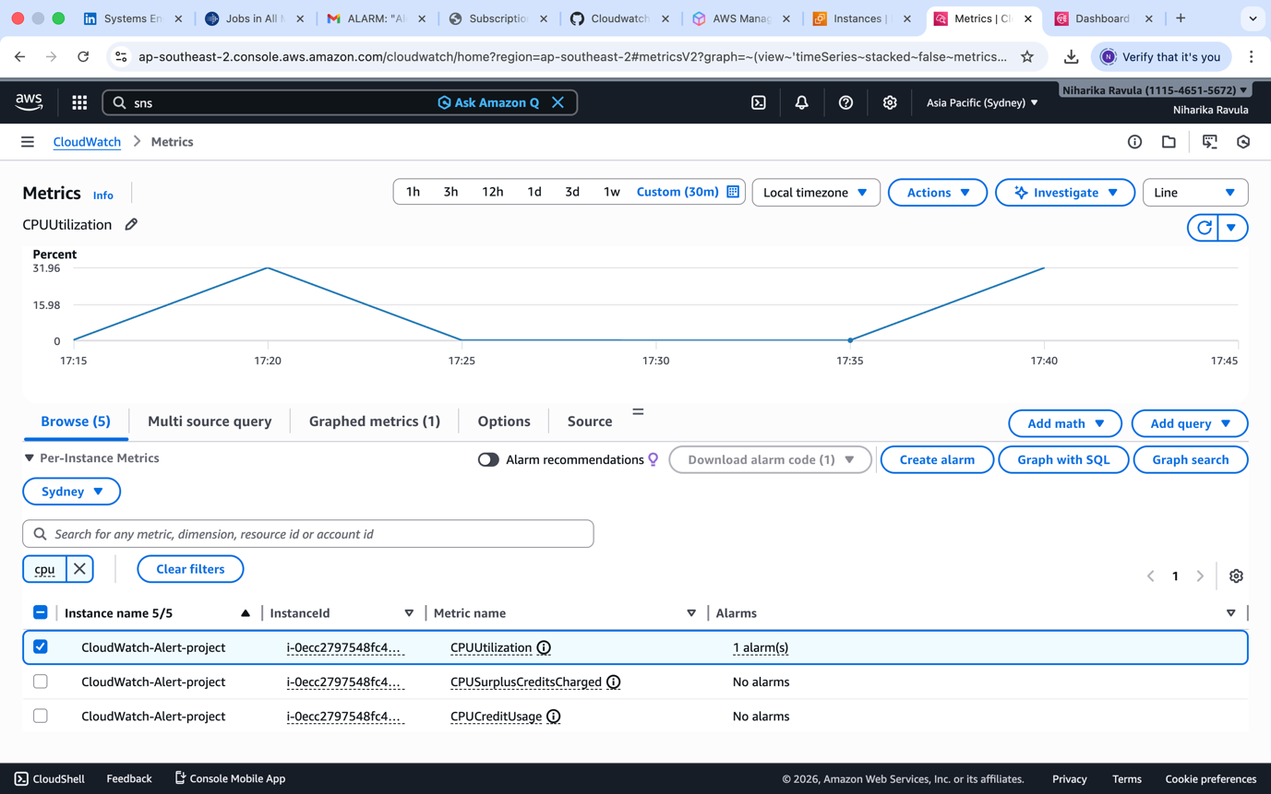

3.Alarm Configuration Page
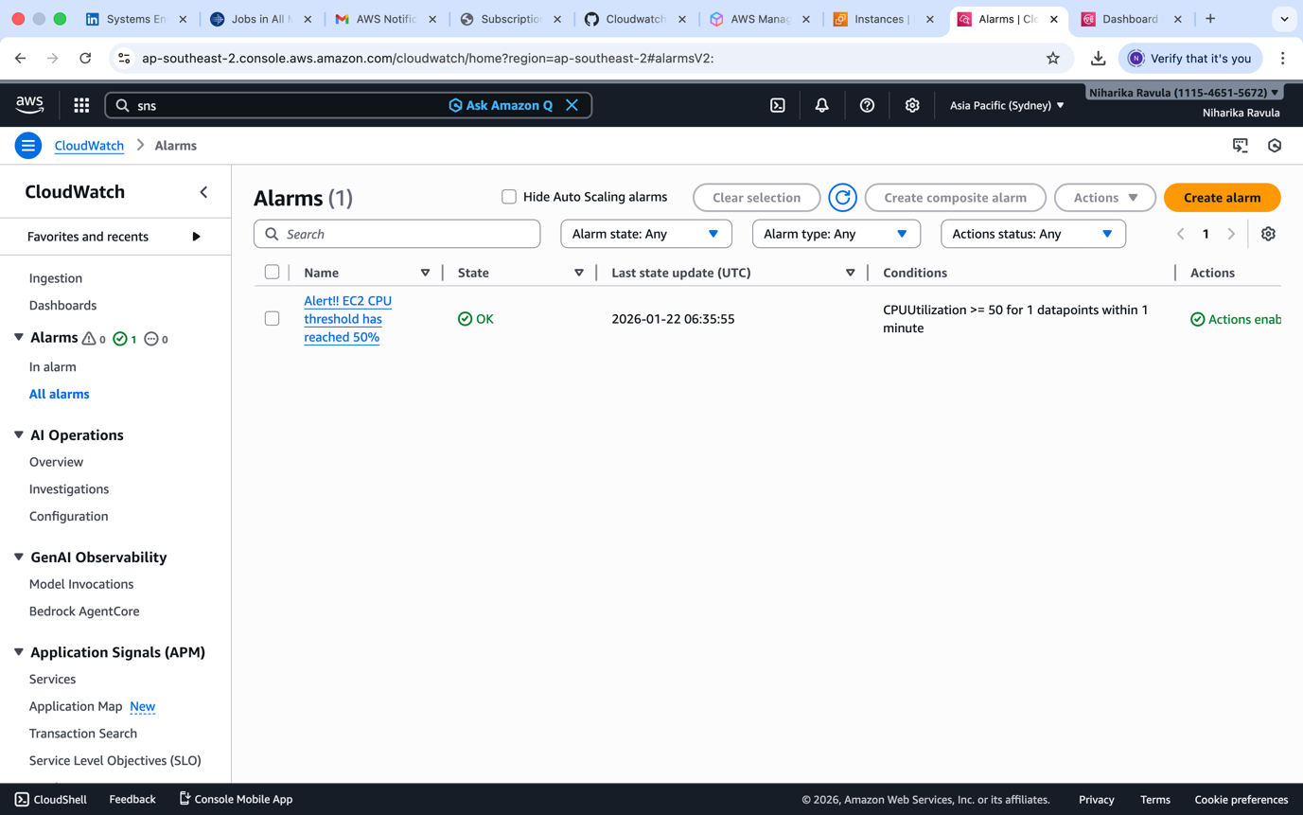

4.Email Confirmation
