Functional Requirements Document

CONTENTS
1 INTRODUCTION 1
1.1 Purpose 1
1.2 Scope 1
1.3 Background 1
1.4 References 1
1.5 Assumptions and Constraints 1
1.6 Document Overview 2
2 METHODOLOGY 3
3 FUNCTIONAL REQUIREMENTS 3
3.1 Context 3
3.2 User Requirements 4
3.3 Functional Requirements 5
4 OTHER REQUIREMENTS 6
4.1 Interface Requirements 6
4.2 Data Conversion Requirements 6
4.3 Hardware/Software Requirements 6
4.4 Operational Requirements 6

INTRODUCTION

Purpose

User Interfaces
Intracive user interfaces which are easy to understand for new users is very import6ent for the success of the application as it makes easier for the user to browse the products.

The applications need a wide variety of icons, from a launcher icon to icons in menus, dialogue, tabs, the status bar, and lists. The Icon Guidelines describe each kind of icon in detail, with specifications for the size, color, shading, and other details for making all your icons fit in the Android system. The Icon Templates Pack is an archive of Photoshop and Illustrator templates and filters that make it much simpler to create conforming icons.

Scope
The project can be used by dog owners and will be used to attain products for their dogs

References
[1] Introduction to Android: Available at http://developer.android.com/guide/index.html
[2] Android Training: Available at http://developer.android.com/training/index.html
[3]Firebase Documentation: Available at https://firebase.google.com/docs/android/setup/
[4] Picasso: Available at http://square.github.io/picasso/
[5] Firebase Authentication: Available at https://firebase.google.com/
[6] GmailBackGround: Available at https://github.com/luongvo/GmailBackground/
[7] Material Drawer: Available at https://github.com/mikepenz/MaterialDrawer/
[8] Payumoney: Available at https://payumoney.com/
[9] Digitalocean Server: Available at https://www.digitalocean.com/

Assumptions and Constraints

Assumptions

They Shop Only On Price
First time business owners often worry if they are not the cheapest option available, but how often do you trawl around for the cheapest products when you shop? Do you think Apple customers buy their products based on price alone? As long as the price isn’t prohibitive there are other factors that matter just as much if not more.

They Know The Product
Another common mistake is forgetting that you are an expert, but your customers may not be. Giving item details is great, but most customers don’t know what DDR2 Ram is, they just want to know that they will be able to check emails and watch TV online (for instance).
They Know What They Want
Some customers know what they want & how much it should cost and if they find you first you’ll make an easy sale. But most customers don’t really know what they want, they have questions and they need reassurance. Your website isn’t just a catalogue, sometimes you need to actually help your customers to make the right buying decision.

Constraints
Constraints are boundary conditions on how the system must be designed and constructed. Examples include: legal requirements, technical standards, strategic decisions.

Throughput. “The rate at which a system generates money through sales.” Most commonly this is considered sales or gross margin, depending on the specifics of the business.

Inventory. “The money the system has invested in purchasing things that it intends to sell.”

Operational Expense. “All the money the system spends in order to turn inventory into throughput.”

METHODOLOGY
The methodology consists of three main phases, starting with conceptual, then logical and the physical database design phase. The conceptual database design is aimed to produce a conceptual representation of the required database. The core activity in this phase involves the use of ER modelling in which the entities,relationship and attributes are defined. For the logical design phase, the aim is to map the conceptual model which is represented by the ER model to the logical structure of the database.In the physical design phase, the emphasis is to translate the logical structure to the physical implementation of the database using the defined database manangement system

FUNCTIONAL REQUIREMENTS

3.1 Context
Information moves through software, it is modified by a series of transformations. Data flow diagram is a graphical representation that depicts information flow and the transforms that are applied as data move from input to output. The basic form of a data flow diagram, also known as a data flow graph or a bubble chart. The data flow diagram may be used to represent a system or software at any level of abstraction. DFDs may be partitioned into levels that represent increasing information flow and functional detail. The DFD provides a mechanism for functional modeling as well as information flow modeling.
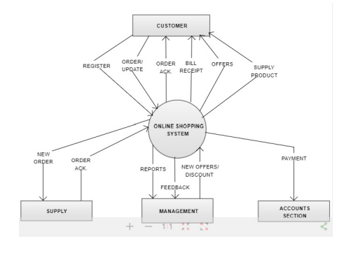

User Requirements

Running an eCommerce application is not always easy. There are sales to make, orders to fill, and payments to receive. This is why it is essential to make sure you have your bases covered when it comes to running a well-rounded website.

We will look at things from a visitor’s point of view. We’ll start at the very beginning, when the user visits an eCommerce website, and work through to the very end, when that user places an order. We’ll go through how a business can excel at every step of the way.

Design
A good design is essential for users since a good design will make it easier for them to make a purchase easily.
Speed
The user should be able to make the purchase with ease and speed in order for a better user experience and a better saving of users time and effort.
Product Selection
- Allow customers to quickly find what they are looking for.
- Keep customers from having “decision paralysis”.
- Increase conversions by naturally limiting the number of clicks to checkout.

OTHER REQUIREMENTS
Other requirements are the non-behavioral requirements of the software that should be taken into account for better overall software.

Interface Requirements
The Interface of the software must have a material view and a navigation bar for the ease of use.

Hardware/Software Requirements
The Mobile phone will require at least 512MB of RAM and Should be able to run android operating system

Recoverability
In case there is a software failure or there is a critical error then our system will know the mistake and will take action within 48 hours.

System Availability
The Application will be available to user’s everyday of the week for 24 hours. While the customer support will be available from Monday through Friday between the hours of 10 AM to 8 PM.

Data Retention
The system shall retain the application information for 3 years this includes database records and access records.

