# E-Commerce Return Analysis Report

## 1. Project Overview

The E-Commerce Return Analysis project aims to uncover insights into product return behavior by customers. By leveraging data visualization and analytics tools, the analysis identifies which categories and price ranges are most affected by returns. This helps in improving customer satisfaction, reducing operational costs, and making informed decisions.

## 2. Objective

The key objective is to analyze product return trends and their impact on business. We explore return rates across various categories, identify return-heavy products, and provide actionable insights.

## 3. Tools Used

- Python (for initial data cleaning and transformation)  
- MySQL Workbench (for storing and querying the dataset)  
- Power BI (for creating interactive dashboards)  
- MS Word (for documentation)

## 4. Dataset Details

The dataset was obtained from an open-source e-commerce platform and includes information on product orders, returns, categories, and price ranges. The main fields are:  
- order_id  
- product_category_name  
- price_range  
- is_returned (0 or 1)  
- order_status

## 5. Data Cleaning & Transformation

Python was used to clean the dataset by handling missing values, encoding return flags, and assigning price ranges. The cleaned data was then imported into MySQL and later connected to Power BI.

## 6. Dashboard Overview (Power BI)

Power BI was used to create a dynamic and interactive dashboard with the following visuals:  
KPIs:  
- Total Orders  
- Total Returns  
- Return Rate %  
  
Visuals:  
- Bar Chart: Returns by Product Category  
- Column Chart: Returns by Price Range  
- Slicers: Product Category, Return Status, Price Range  
  
Features:  
- Color-coded visuals with navy blue tile selection  
- Dynamic measures created with DAX  
- Interactive filtering across visuals

## 

## 7. Visual Insights

* Slicer Filters:

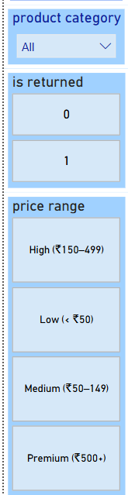

These slicers help users filter the data based on product categories, return status, and price ranges. This improves user interactivity and focused analysis.

* Total Orders:

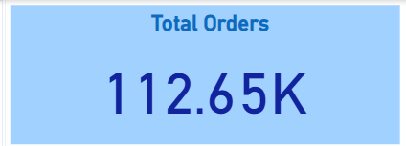

This card displays the total number of orders placed in the dataset. It gives an overview of the dataset volume.

* Total Returns:



This visual highlights the number of returned items. It is essential for calculating return rates and identifying problem areas.

* Return Rate %:



Shows the percentage of returned orders out of total orders. This KPI helps measure return intensity and customer dissatisfaction.

* Clustered Bar Chart: Product Category vs Returns:

These visual displays the number of returned orders across different product categories. It helps identify which categories have higher return volumes.

* Clustered Column Chart: Price Range vs Returns:

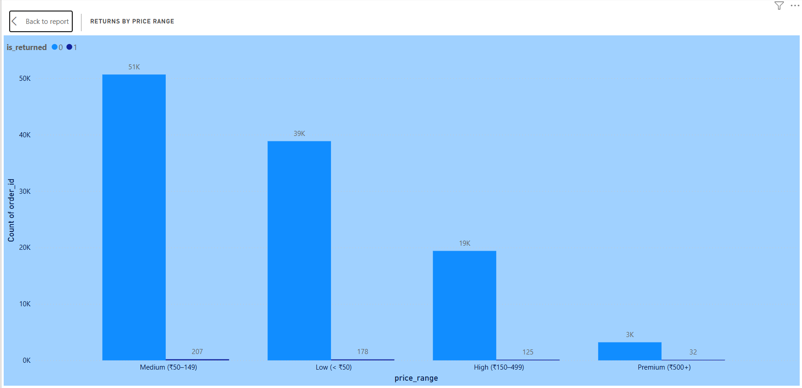

This chart compares return volumes across various price segments. It shows the relation between pricing and returns behavior.

## 8. Conclusion

The analysis revealed key insights such as high return rates in certain categories and price ranges. Power BI provided a dynamic and interactive way to understand these trends, and the data can now be used to make strategic decisions regarding logistics, product quality, and customer communication.