Stock Market Trend Analysis of Top 5 Indian Companies (2023–2025)

By Nisarg Rana

# 1. Introduction

This project explores the stock price trends of five leading Indian companies—Reliance Industries, Tata Consultancy Services (TCS), Infosys, HDFC Bank, and ICICI Bank—over the period from 2023 to 2025. The aim is to analyze historical stock price patterns, understand market behavior, and uncover insights that can aid investors or decision-makers in tracking performance and formulating investment strategies.

# 2. Objective

To perform time-series analysis on historical stock data and visually interpret the trends, volatility, and moving averages of top-performing Indian companies using Python and visualization tools. The end goal is to derive insights useful for traders, analysts, and corporate stakeholders.

# 3. Dataset Description

- Data Source: Yahoo Finance API (via yfinance Python library)  
- Period: January 1, 2023 to May 31, 2025  
- Tickers Analyzed: RELIANCE.NS, TCS.NS, INFY.NS, HDFCBANK.NS, ICICIBANK.NS  
- Features: Date, Open, High, Low, Close, Volume

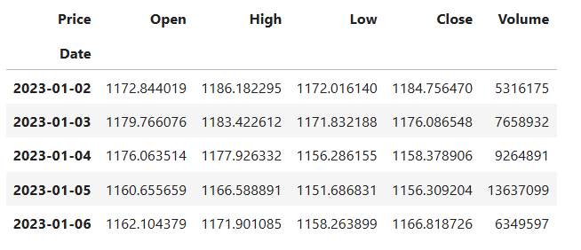

# 4. Data Cleaning

- Removed null values (no missing values were found in this dataset).  
- Standardized date formatting and parsed time columns.  
- Added calculated fields like Daily Return (%), 20-Day Moving Average, and 50-Day Moving Average.  
- Merged individual company datasets into a combined frame for ease of visualization.

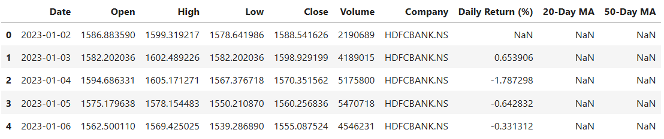

# 5. Visual Analysis

To visualize market behavior, the following charts were created:

1. Daily Stock Prices (Line Chart)

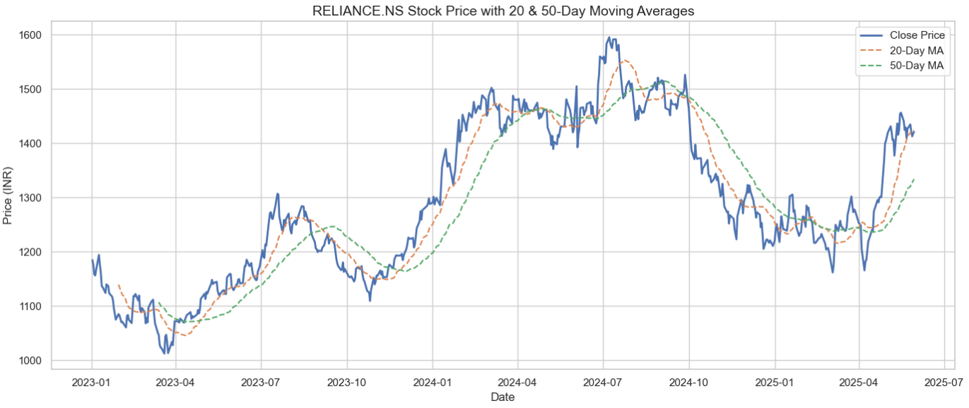

2. Daily Return % (Histogram or Line Chart)

3. Moving Averages (20-Day and 50-Day)

4. Volume Analysis (Bar Chart)

# 6. Key Insights

- Reliance and ICICI Bank showed relatively stable upward trends.  
- Infosys and TCS had more volatile price movement but returned strong recoveries in early 2025.  
- Moving averages indicate short-term dips in early 2024 but strong rallies by 2025.  
- Volume spikes during earnings and financial announcements reflect active trading sentiment.

# 7. Conclusion

The analysis indicates strong long-term performance from the top 5 Indian companies, despite short-term volatility. Moving averages served as effective indicators of support and resistance levels. This project demonstrates how financial data visualization can reveal key investment signals, helping traders and executives monitor stock behavior in a dynamic market.

# 8. References

• Data Source: https://www.kaggle.com/datasets/olistbr/brazilian-ecommerce

• Yahoo Finance (via yfinance library)