Real-Time Weather Trend Analysis of Major Cities in Gujarat (2025)

# 1. Introduction

Weather conditions directly impact daily life, from determining what we wear and how we travel to influencing sectors such as agriculture, logistics, construction, and health. With increasing climate unpredictability, having access to accurate, real-time weather data has become more crucial than ever. This project aims to develop a real-time weather monitoring system tailored for major cities in Gujarat. Using Python and the OpenWeatherMap API, data is collected and updated at regular intervals, stored in a structured MySQL database, and visualized through an interactive Power BI dashboard. This setup provides actionable insights by highlighting current temperatures, humidity levels, and weather conditions across the region.

# 2. Objective

To build an automated pipeline that:

- Fetches real-time weather data from OpenWeatherMap

- Stores it in a structured SQL database

- Visualizes snapshot and comparative insights using Power BI

# 3. Tools & Technologies Used

Component | Tool / Technology

-----------------------------|---------------------------

Data Source | OpenWeatherMap API

Programming | Python

Scheduling | schedule library

Database | MySQL

Visualization | Power BI

Documentation | MS Word

# 4. Data Collection (API Integration)

A Python script was developed to automate:

- API calls for 20+ cities in Gujarat

- Extraction of temperature, humidity, pressure, coordinates, and weather description

- Storage into a MySQL database

- Execution every 2 minutes using the `schedule` module

# 5. Database Design

The database (`weather_project`) stores all weather records in a table `weather_data`:

Column | Type | Description

--------------------|-------------------|-----------------------------------

city | VARCHAR | Name of the city

temperature | FLOAT | Temperature (°C)

humidity | INT | Humidity (%)

pressure | INT | Atmospheric pressure (hPa)

weather_desc | VARCHAR | e.g., Clear, Cloudy, Rain

timestamp | DATETIME | Time of data capture

latitude | FLOAT | City’s latitude

longitude | FLOAT | City’s longitude

# 6. Data Visualization in Power BI

An interactive dashboard was built to present:

- Top 10 cities by latest temperature and humidity

- Pie chart for real-time weather conditions

- Multi-row cards for city summaries

- Card visuals for highest, lowest, and average temperatures

- Slicer to filter by city

- “Clear all filters” button for user convenience

- Custom theme for a clean and modern layout

# 7. Key Insights (Initial Sample)

- Rajkot recorded one of the highest temperatures (e.g., 40.2°C)

- Junagadh and Navsari showed consistently high humidity

- Most cities reported “Clear” or “Cloudy” conditions during observation

- Coastal cities tend to have lower temperature variance

# 8. Challenges & Solutions

Challenge | Solution

-----------------------------------------------------------|------------------------------------------

API rate limit | Used scheduled intervals + city chunking

Initial data too small for trends | Built a snapshot-style dashboard

Power BI map restrictions | Used alternative visuals or signed out

Auto-refresh from local MySQL | Planned setup using Power BI Gateway

# 9. Conclusion & Future Scope

This project demonstrates how real-time API data can be transformed into actionable insights through automation and visualization. It forms a strong base for future enhancements like:

- Trend analysis across weeks/months

- Forecasting temperature or humidity

- Alert systems for extreme weather conditions

# 10. Screenshots

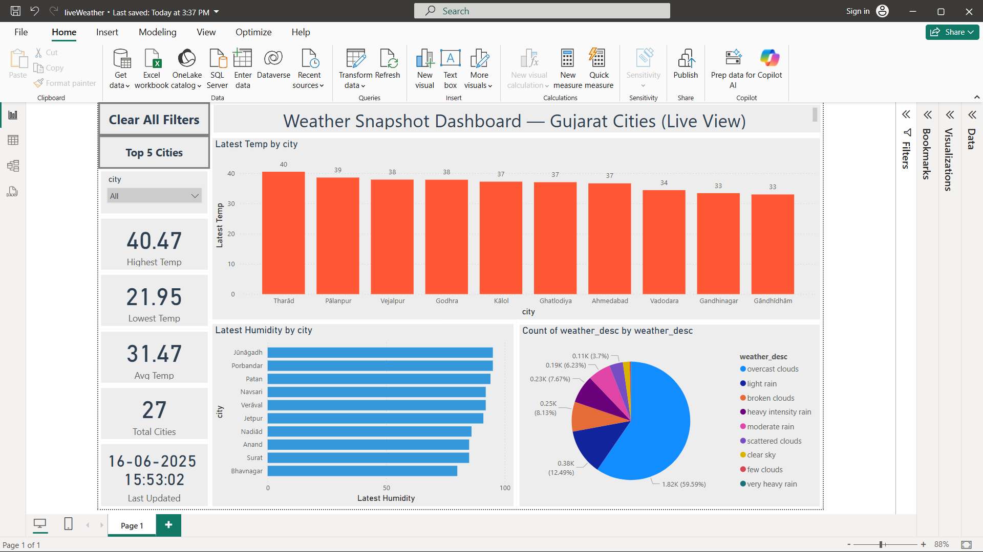

(10.1 Dashboard Overview)

These visual captures the full layout of the Power BI dashboard, combining all key elements — including real-time insights, filters, and comparison visuals — to provide a snapshot of Gujarat’s weather at a glance.

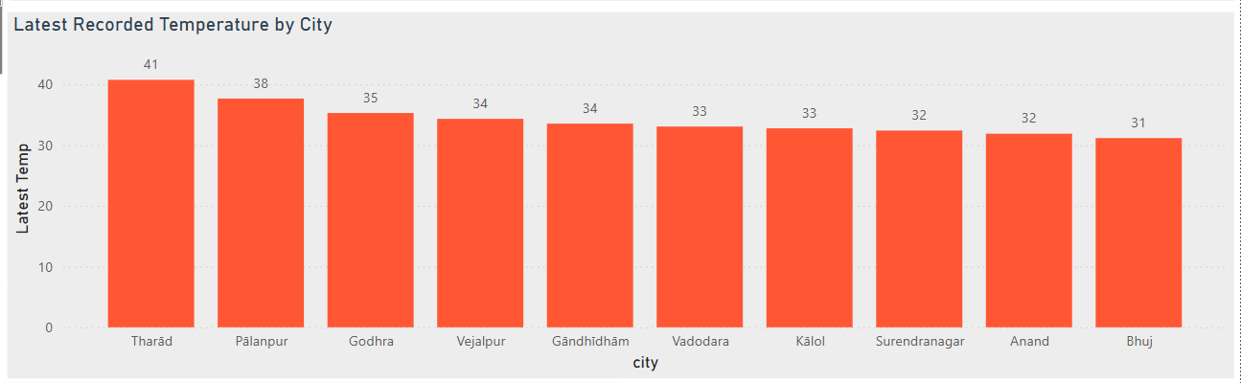

(10.2 Top 10 Hottest Cities (Bar Chart))

This chart highlights the ten cities in Gujarat experiencing the highest temperatures based on the most recent API data. It visually emphasizes regions currently facing the most intense heat conditions.

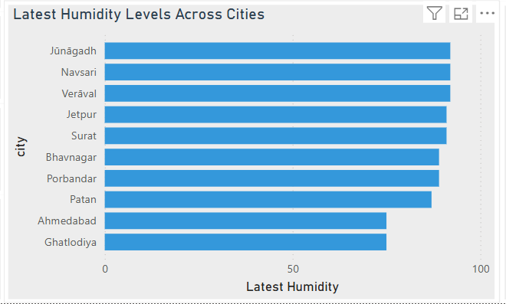

(10.3 Top 10 Most Humid Cities (Bar Chart))

This visual ranks cities by their humidity levels, helping identify areas with thick moisture in the air — useful for monitoring potential discomfort zones or agricultural needs.

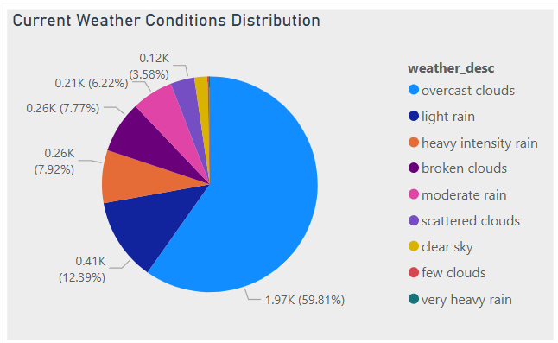

(10.4 Current Weather Condition Distribution (Pie Chart))

This pie chart illustrates the diversity of current weather conditions across Gujarat. It gives a quick view into how many cities are experiencing clear skies, cloudy weather, or rain, helping spot regional patterns instantly.

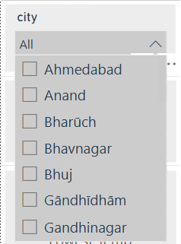

(10.5 City Filter (Slicer))

This slicer allows users to focus the entire dashboard on a specific city or set of cities, enabling personalized and detailed weather exploration across Gujarat’s urban landscape.

(10.6 KPI Cards – Snapshot Metrics)

These card visuals show the highest temperature, lowest temperature, and average humidity among all cities. They offer a quick glance at key metrics to understand the state of the weather across the state.

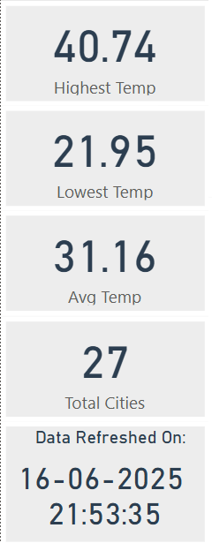

(10.7 Clear All Filters Button)

A smart feature that lets users reset all applied filters with one click, instantly returning the dashboard to its default, full-state view — improving user navigation and interactivity.