Extension Concept

In existing output we have seen LDA were giving topic words and LSA were giving most semantic similar words as output but all those extracted similar words may have multiple similar words which will be unknown to users and by seeing semantic similar words along with a list of all possible different words belongs to that semantic words then it will be very easy for the user to understand sentence meaning correctly.

In existing LSA output we have seen ‘Blockchain’, ‘Technology’, ‘crypto currency’ are the semantic similar words and we know ‘Technology’ may have more different words which are similar and user don’t know about it. So as extension we are extracting list of possible words which are different in reading and have same meaning.

To extract list of all possible words for same semantic words we are employing NLTK deep learning package which will take semantic similar words as input and then output list of possible words which are same in meaning.

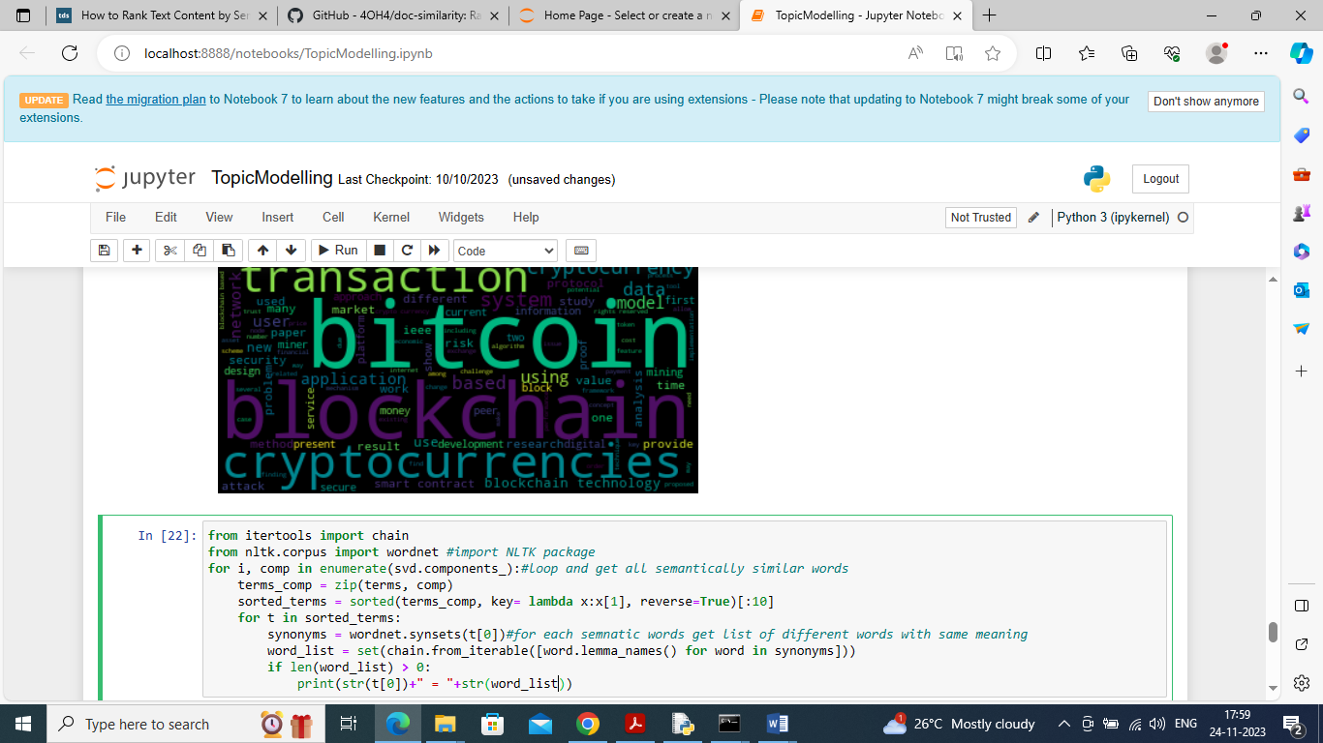

In above screen we are importing NLTK package and then calling deep learning WORDNET module to get list of possible words and after executing above block will get below output

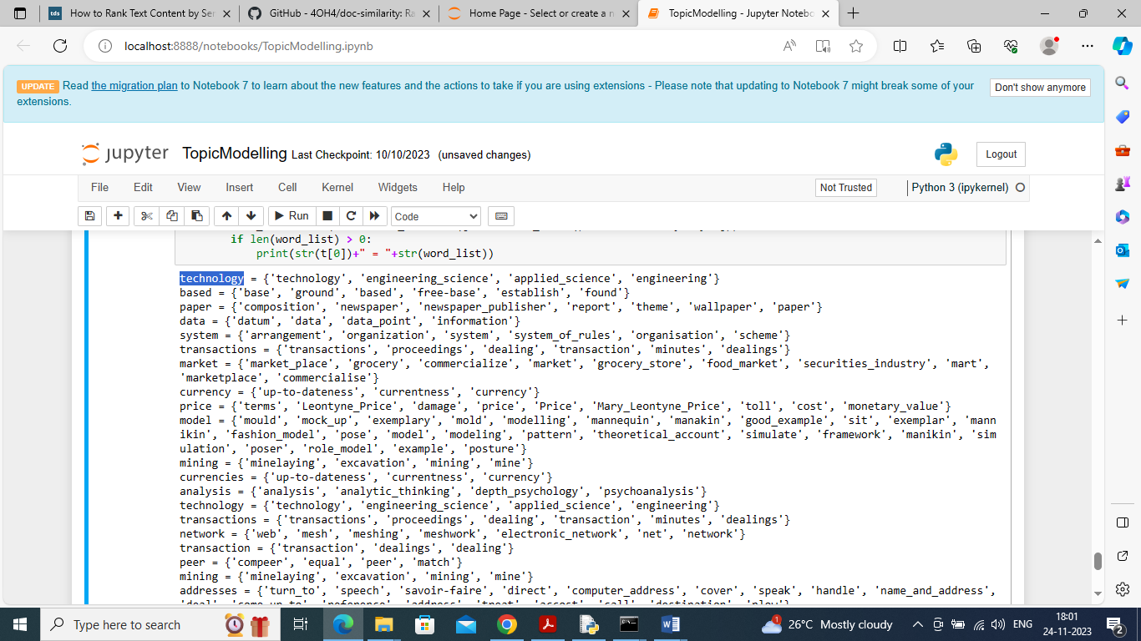

In above output before ‘=’ symbol we are printing semantic similar words and after ‘=’ symbol printing list of possible different words which have same meaning as semantic words. In above output we can see ‘Technology’ and ‘Engineering’ both are different words but will have same sense