**E-COMMERCE WITH**

**BARGAINING SYSTEM**

**A MINI-PROJECT REPORT**

***Submitted by***

**NOVIN JENO S - 220701190**

***in partial fulfilment of the award of the degree***

***of***

# BACHELOR OF ENGINEERING

**IN**

**COMPUTER SCIENCE AND ENGINEERING**



# RAJALAKSHMI ENGINEERING COLLEGE

**AUTONOMOUS, CHENNAI**

NOV/DEC, 2024

### BONAFIDE CERTIFICATE

Certified that this mini project “**E-COMMERCE WITH BARGAINING SYSTEM** is the bonafide work of “ **NOVIN JENO S ( 220701190 ) ”** who

carried out the project work under my supervision.

|  |  |
| --- | --- |
| **SIGNATURE** | **SIGNATURE** |
| **Dr. SABITHA,** | **Mrs. JANANEE V,** |
| Head of the Department, | Assistant Professor, |
| Computer Science & Engineering | ComputerScience&Engineering |
| Rajalakshmi Engineering College | RajalakshmiEngineeringCollege |
| Thandalam, Chennai -602105. | Thandalam, Chennai -602105. |
|  |  |

Submitted for the End semester practical examination to be held on

**INTERNAL EXAMINER EXTERNAL EXAMINER**

### ACKNOWLEDGEMENT

I express my sincere thanks to my beloved and honourable chairman **MR.S.MEGANATHAN** and the chairperson **DR.M.THANGAM MEGANATHAN** for their timely support and encouragement.

I am greatly indebted to my respected and honourable principal **Dr. S.N.MURUGESAN** for his able support and guidance.

No words of gratitude will suffice for the unquestioning support extended to us by my head of the department **Dr. P. KUMAR,** and my Academic Head **Dr.SABITHA,** for being ever supporting force during my project work.

I also extend my sincere and hearty thanks to my internal guide **Mrs. JANANEE V** for her valuable guidance and motivation during the completion of this project.

My sincere thanks to my family members, friends and other staff members of Computer Science and Engineering.

NOVIN JENO S 220701190

## ABSTRACT

### This eCommerce website revolutionizes the online shopping experience by incorporating a dynamic bargaining system that allows buyers and sellers to engage in real-time negotiations. Unlike traditional fixed-price platforms, this innovative approach encourages users to propose offers, counteroffers, and communicate directly, fostering a more interactive marketplace. This feature not only enhances user engagement but also empowers shoppers to secure better deals while offering sellers the flexibility to negotiate prices, ultimately leading to higher satisfaction for both parties.

### The bargaining system is underpinned by sophisticated algorithms that analyze market trends, historical pricing data, and user behavior to provide personalized price suggestions. This ensures that negotiations are grounded in fairness and market realities, making it easier for users to arrive at mutually beneficial agreements. The website’s intuitive interface simplifies the negotiation process, allowing users of all experience levels to participate without feeling overwhelmed. Enhanced by responsive customer support, this platform aims to create a seamless experience that encourages ongoing interaction and builds trust within the community.

### Security and transparency are paramount in this eCommerce model. The platform offers a range of secure payment options and a robust feedback system that allows users to rate their experiences, promoting accountability and encouraging positive interactions. By blending traditional negotiation tactics with cutting-edge technology, this website seeks to transform the eCommerce landscape, creating a vibrant marketplace where consumers and merchants can collaborate to determine fair prices and cultivate lasting relationships.

### TABLE OF CONTENTS

|  |  |  |
| --- | --- | --- |
| S.NO. | TITLE | **PAGE** |
| 1 | ABSTRACT |  |
| 2 | .INTRODUCTION |  |
| 3 | SYSTEM SPECIFICATIONS |  |
| 4 | ARCHITECTURE DIAGRAM |  |
| 5 | MODULE DESCRIPTION |  |
| 6 | SYSTEM DESIGN |  |
| 7 | SAMPLE CODING |  |
| 8 | SCREEN SHOTS |  |
| 9 | CONCLUSION |  |

### // intha page aa delete pananum

### TABLE OF CONTENTS

**CHAPTER NO. TITLE PAGE**

**ABSTRACT4**

**1.INTRODUCTION 6**

1.1.INTRODUCTION 6

1. 2.SCOPE OF THE WORK 6

1.3. AIM AND OBJECTIVES OF THE PROJECT 7

**2.SYSTEM SPECIFICATIONS 8**

1. 1.HARDWARE SPECIFICATIONS 8

2.2.SOFTWARE SPECIFICATIONS 8

**3.ARCHITECTURE DIAGRAM 9**

**4.MODULE DESCRIPTION 10**

1. **SYSTEM DESIGN 12**

5.1.USE CASE DIAGRAM 12

5.2.ER DIAGRAM 13

5.3.DATA FLOW DIAGRAM 14

5.4.ACTIVITY DIAGRAM 15

1. **SAMPLE CODING 16**
2. **SCREEN SHOTS 20**
3. **CONCLUSION 30**

**REFERENCES 3**

### INTRODUCTION

1. **INTRODUCTION**

This eCommerce platform introduces a groundbreaking bargaining system that transforms the online shopping experience by facilitating real-time negotiations between buyers and sellers. By allowing users to propose offers and engage directly in discussions, the platform creates a more interactive and personalized marketplace. This innovative approach empowers consumers to secure better deals while giving sellers the flexibility to negotiate prices based on demand and market trends. With advanced algorithms and a user-friendly interface, the website seamlessly blends traditional negotiation practices with modern eCommerce, enhancing customer satisfaction and fostering lasting relationships within the community.

**1.1 SCOPE OF THE WORK**

The scope of work for the e-commerce platform with a bargaining system involves developing a user-friendly website/app that enables real-time price negotiations between buyers and sellers. Key features will include user registration, a comprehensive product catalog, a dynamic bargaining interface, secure payment integration, and an admin dashboard for management. The project will prioritize an intuitive design to enhance user experience, thorough testing for quality assurance, and a marketing strategy to promote the unique bargaining feature. Additionally, ongoing maintenance and support will ensure the platform remains responsive to user needs and market trends.

### 1.2 Aim of the Project

The primary aim of the e-commerce platform with a bargaining system is to create an innovative online marketplace that enhances the shopping experience by allowing users to negotiate prices directly with sellers. By integrating a real-time bargaining feature, the platform seeks to foster a more interactive and engaging environment, ultimately empowering consumers to feel more in control of their purchasing decisions while driving sales and customer loyalty for sellers.

### 1.3 Objectives of the Project

### The objectives of the project include developing a user-friendly interface that simplifies product browsing and negotiations, implementing a secure and efficient payment system for finalized transactions, and providing an analytics dashboard for sellers to track negotiation outcomes and user behaviour. Additionally, the project aims to facilitate a seamless communication channel between buyers and sellers during the bargaining process, ensuring transparency and trust. Finally, ongoing user feedback will be gathered to continuously improve the platform and its features, ensuring it meets the evolving needs of its users.

**SYSTEM SPECIFICATIONS**

Hardware Requirements

The hardware requirements for the e-commerce platform with a bargaining system include a robust server setup featuring a multi-core processor, such as an Intel Xeon or AMD Ryzen, to efficiently handle multiple simultaneous user requests. A minimum of 16 GB of RAM is recommended to support smooth operation during peak usage, along with a solid-state drive (SSD) of at least 500 GB for fast data access and storage of product images and transaction records. Additionally, a high-speed internet connection with redundancy is crucial to ensure continuous availability and optimal loading times for users across various devices, including desktops, laptops, and mobile devices.

Software Requirements

The software requirements encompass a comprehensive tech stack to ensure seamless functionality of the e-commerce platform. The server will run on a Linux operating system, such as Ubuntu Server 20.04 LTS or CentOS 7, while client devices will support Windows (10 and above), macOS (latest version), and mobile platforms (Android 6.0 and above, iOS 12 and above). The web server will be managed using Node.js with Express.js, and data will be stored in MongoDB for flexible document-based storage. Frontend development will utilize HTML5, CSS3, and React.js to create a dynamic and responsive user interface. Security measures, including SSL certificates and a web application firewall, will be integrated to protect user data and ensure safe transactions.

**ARCHITECTURE DIAGRAM**

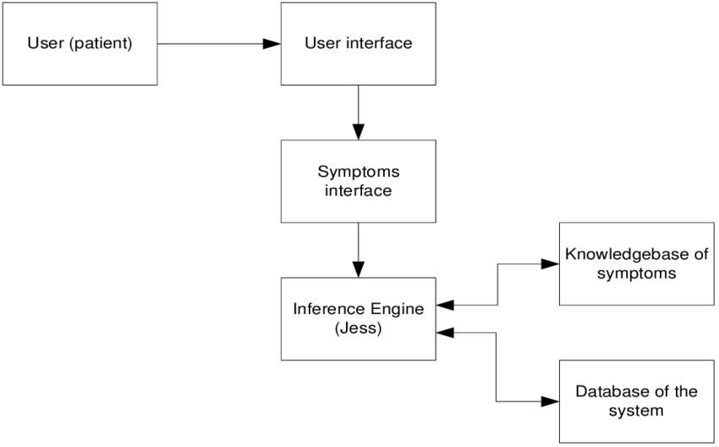

**MODULE DESCRIPTION**

4.1 Login Module

The Login Module serves as the gateway for users to access the e-commerce platform, providing secure authentication and personalized experiences. Users can create accounts, log in with their credentials, and recover passwords if necessary. This module will also include social media login options to streamline the registration process. It ensures that user data is protected through encryption and adheres to privacy regulations, creating a safe environment for online shopping.

4.2. Admin Module

The Admin Module provides a comprehensive dashboard for managing the platform’s operations. Administrators can oversee user accounts, product listings, and order histories, as well as monitor ongoing negotiations. This module allows for the addition, editing, or removal of products, setting base prices, and managing promotional campaigns. It also includes analytics tools to track user engagement and sales performance, enabling data-driven decision-making for enhancing the platform’s effectiveness.

4.3. Product Collection Module

The Product Collection Module showcases the platform's diverse range of products, organized into categories for easy navigation. Each product listing includes detailed descriptions, high-quality images, base prices, and options for users to initiate bargaining. This module also incorporates filters and search functionalities to help users find products quickly. Additionally, it enables sellers to highlight special offers or featured items, fostering an engaging shopping experience that encourages interaction and negotiation.

4.4. Backend Management Module

The Backend Management Module is essential for the overall functionality and maintenance of the e-commerce platform. This module handles server-side operations, ensuring smooth data processing and storage. It includes features for managing the database, handling user data, transaction records, and product inventories. Additionally, this module facilitates the integration of APIs for payment processing, real-time chat functionalities for bargaining, and analytics tracking. It also ensures robust security measures are in place to protect sensitive information, providing admins with tools for monitoring system performance and troubleshooting issues effectively.

**SYSTEM DESIGN**

**5.1 USE CASE DIAGRAM**

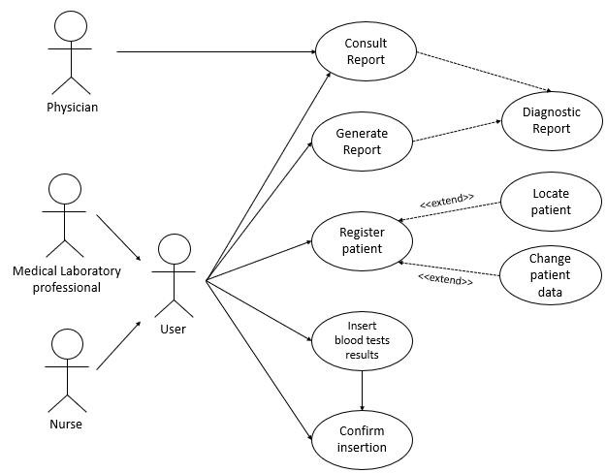

**5.2 ER DIAGRAM**

**5.3**

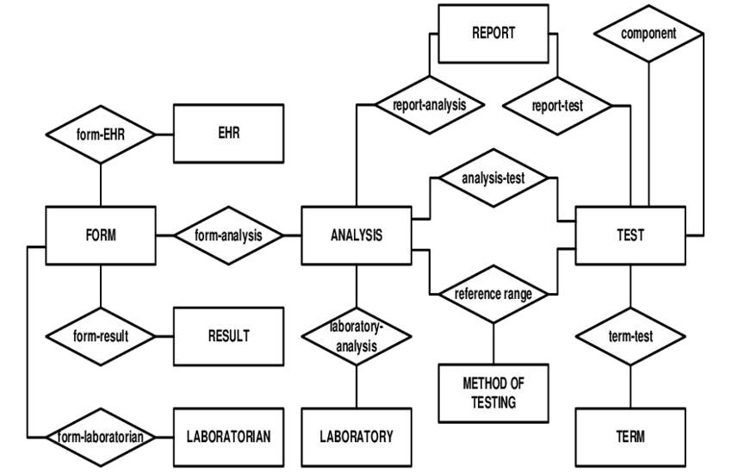

**5.3 DFD DIAGRAM**

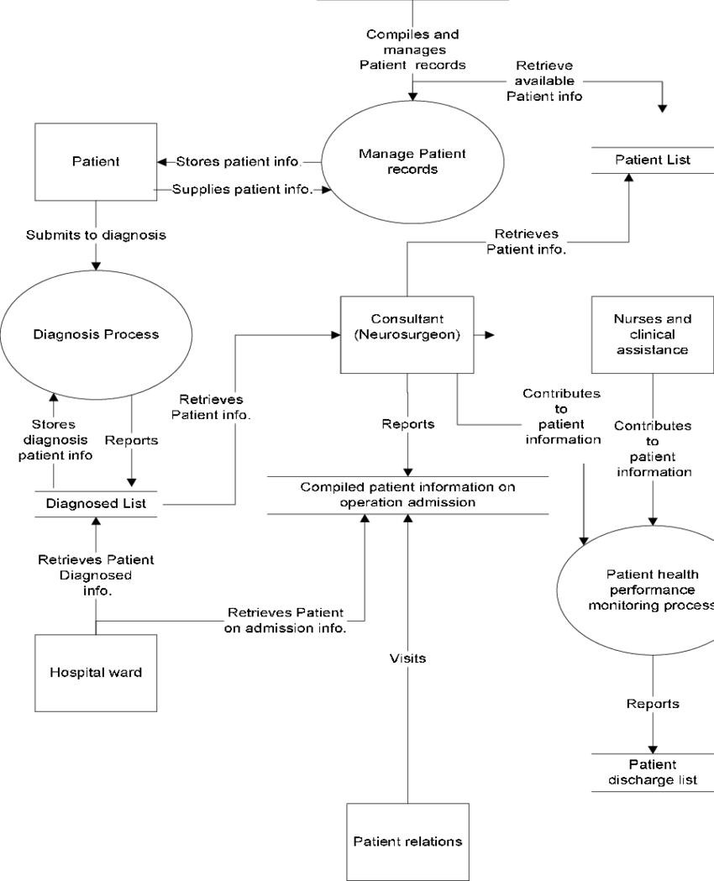

**5.4 ACTIVITY DIAGRAM**

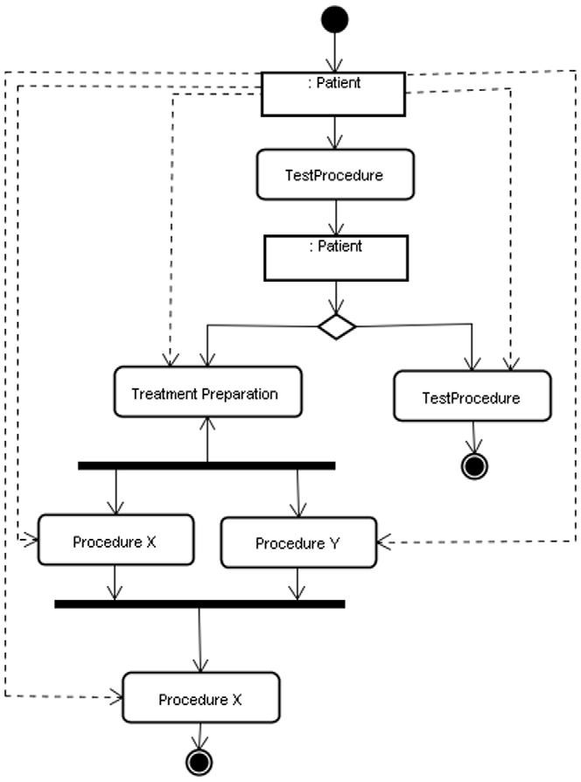

### SAMPLE CODING

<!DOCTYPE *html*>

<html *lang*="en">

<head>

<meta *charset*="utf-8">

<meta *name*="viewport" *content*="width=device-width, initial-scale=1, shrink-to-fit=no">

<meta *name*="description" *content*="">

<meta *name*="author" *content*="">

<title>Nipah virus (NiV) Testing Management System</title>

<!-- Bootstrap core CSS -->

<link *href*="vendor/bootstrap/css/bootstrap.min.css" *rel*="stylesheet">

<!-- Custom styles for this template -->

<link *href*="css/scrolling-nav.css" *rel*="stylesheet">

</head>

<body *id*="page-top">

<!-- Navigation -->

<nav *class*="navbar navbar-expand-lg navbar-dark bg-dark fixed-top" *id*="mainNav"> <div *class*="container">

<a *class*="navbar-brand js-scroll-trigger" *href*="#page-top">Nipah virus (NiV)-TMS</a>

<button *class*="navbar-toggler" *type*="button" *data-toggle*="collapse" *datatarget*="#navbarResponsive" *aria-controls*="navbarResponsive" *aria-expanded*="false" *aria-label*="Toggle navigation">

<span *class*="navbar-toggler-icon"></span>

</button>

<div *class*="collapse navbar-collapse" *id*="navbarResponsive">

<ul *class*="navbar-nav ml-auto">

<li *class*="nav-item">

<a *class*="nav-link js-scroll-trigger" *href*="#about">About Nipah virus (NiV) </a> </li>

<li *class*="nav-item">

<a *class*="nav-link js-scroll-trigger" *href*="#services">Nipah virus (NiV)Symptoms</a>

</li>

<li *class*="nav-item">

<a *class*="nav-link js-scroll-trigger" *href*="#contact">Prevention</a> </li>

<li *class*="nav-item active">

<a *class*="nav-link js-scroll-trigger" *href*="new-user-testing.php">Testing</a>

</li>

<li *class*="nav-item active">

<a *class*="nav-link js-scroll-trigger" *href*="live-test-updates.php">Live Updates</a>

</li>

<li *class*="nav-item active">

<a *class*="nav-link js-scroll-trigger" *href*="login.php">Admin</a> </li>

</ul>

</div>

</div>

</nav>

<header *class*="bg-primary text-white">

<div *class*="container text-center">

<h1>Nipah virus (NiV)-TMS</h1>

<p *class*="lead">Nipah virus (NiV) - Testing Management System</p> </div>

</header>

<section *id*="about">

<div *class*="container">

<div *class*="row">

<div *class*="col-lg-8 mx-auto">

<h2>About this page</h2>

<p *class*="lead">Nipah virus (NiV) was first discovered in 1999 following an outbreak of disease in pigs and people in Malaysia and Singapore. This outbreak resulted in nearly 300 human cases and more than 100 deaths, and caused substantial economic impact as more than 1 million pigs were killed to help control the outbreak.

While there have been no other known outbreaks of NiV in Malaysia and Singapore since 1999, outbreaks have been recorded almost annually in some parts of Asia since then— primarily in Bangladesh and India. The virus has been shown to spread from person-toperson in these outbreaks, raising concerns about the potential for NiV to cause a global pandemic.</p>

<p *class*="lead">Treatment for NiV is limited to supportive care, including rest, hydration, and treatment of symptoms. Immunotherapeutic treatments are currently being developed and evaluated.</p>

</div>

</div>

</div>

</section>

<section *id*="services" *class*="bg-light">

<div *class*="container">

<div *class*="row">

<div *class*="col-lg-8 mx-auto">

<h2>Symptoms may initially include one or several of the following:</h2> <hr />

<p><strong>Fever</strong><br />

<hr />

<p><strong>Headache</strong><br />

<hr />

<p><strong>Cough</strong><br />

<hr />

<p><strong>Difficulty breathing</strong><br />

</div>

</div>

</div>

</section>

<section *id*="contact">

<div *class*="container">

<div *class*="row">

<div *class*="col-lg-8 mx-auto">

<h2>Prevention</h2>

</div>

</section>

<script *src*="vendor/bootstrap/js/bootstrap.bundle.min.js"></script>

<!-- Plugin JavaScript -->

<script *src*="vendor/jquery-easing/jquery.easing.min.js"></script>

<script *src*="js/scrolling-nav.js"></script>

</body>

</html>

**SCREEN SHOTS**

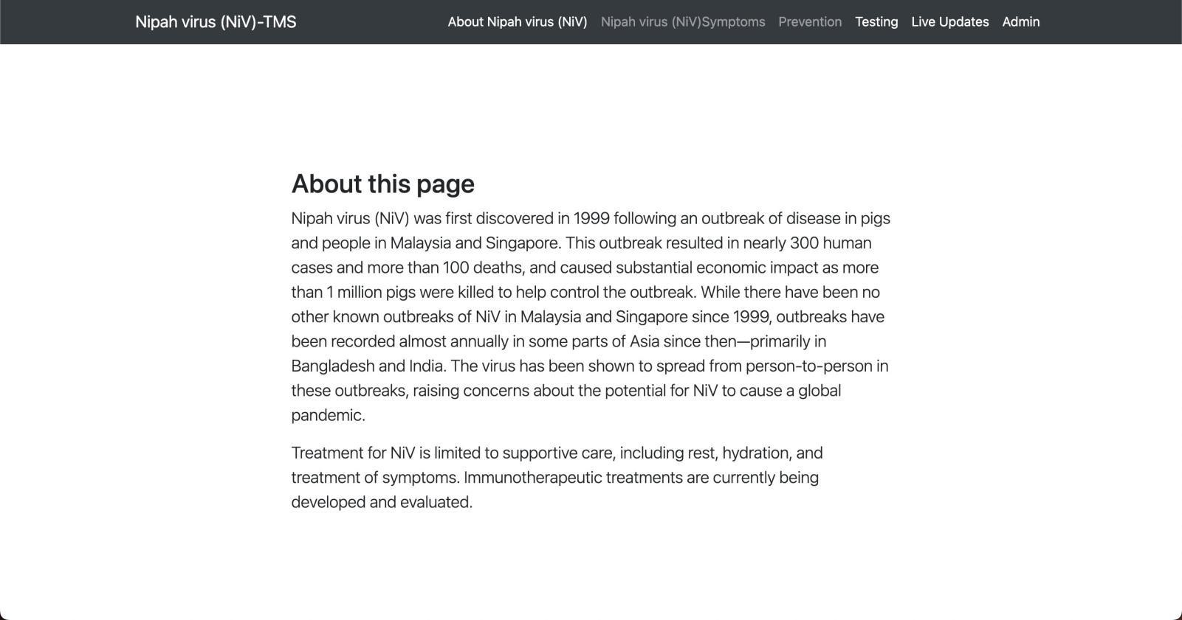

Fig.

7.1

About

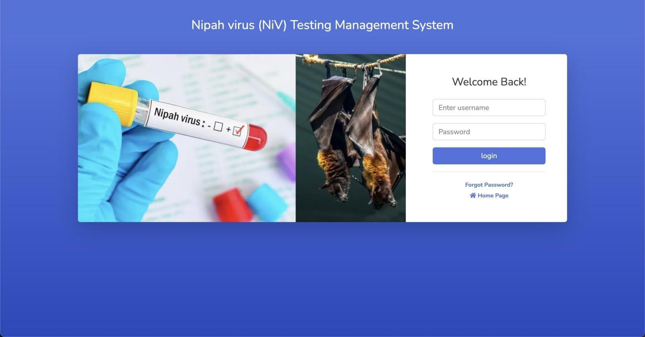

Fig. 7.2 Admin

Login

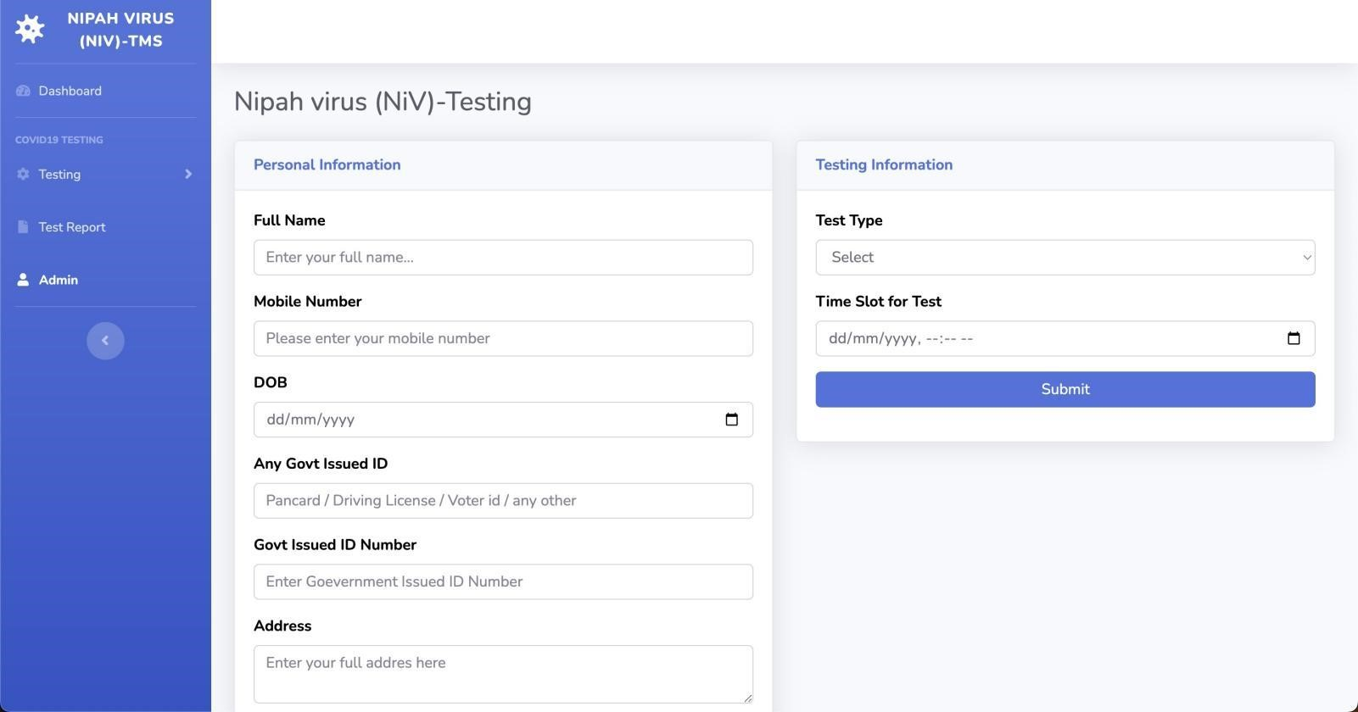

Fig. 7.3 Admin Testing Management

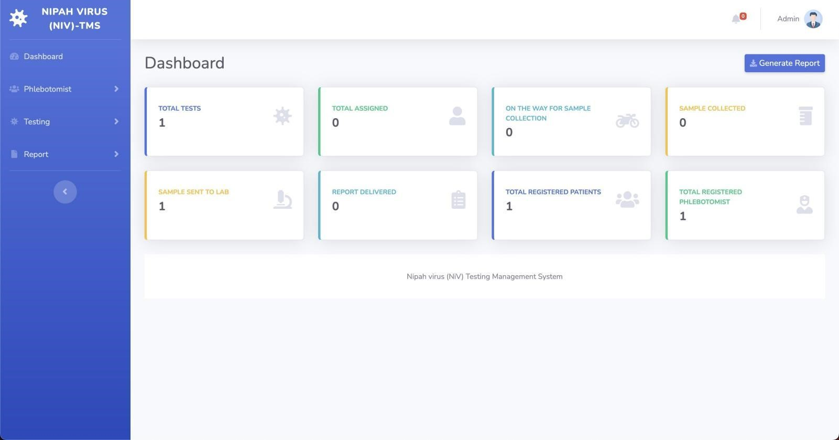

Fig. 7.4 Admin Dashboard

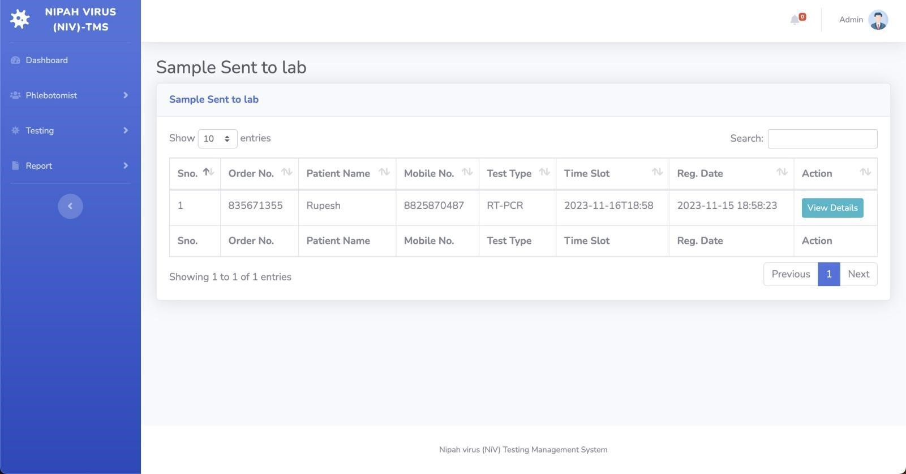

Fig. 7.5 Tracking Lab

#### CONCLUSION

The e-commerce platform with a bargaining system transforms the online shopping experience by allowing consumers to actively negotiate prices. This feature not only empowers buyers but also fosters a more engaging relationship between consumers and sellers. As a result, users feel more in control of their purchasing decisions, leading to higher satisfaction and loyalty.

User-friendly design and robust security measures are central to the platform's success. The login module ensures easy access while maintaining the integrity of user data through secure authentication processes. A streamlined registration system enhances convenience, making it easy for users to start their shopping journey. Trust is further reinforced by the platform’s commitment to protecting sensitive information, encouraging more transactions.

The administrative capabilities provided by the backend management module are crucial for operational efficiency. Administrators can easily manage product listings, monitor user activities, and analyze sales data to optimize the platform. This data-driven approach allows for continual improvements based on user feedback and market trends.

## In summary, the e-commerce platform with a bargaining system is poised to set new standards in online retail. By integrating real-time negotiations and prioritizing user experience, it creates a vibrant marketplace for both buyers and sellers. As the digital landscape evolves, this innovative model will likely attract a diverse audience, enhancing overall market competitiveness. The future of e-commerce lies in such dynamic and interactive solutions that cater to the needs of today’s consumers.

## REFERENCES

HTML , CSS , JS – [www.w3schools.com](http://www.w3schools.com/)

PHP, MYSQL – [www.youtube.com](http://www.youtube.com/)

Product Details– [www.amazon.in](http://www.amazon.in/)

Carousel Slider – [www.glidejs.com](http://www.glidejs.com/)

Font Awesome Icons – [www.fontawesome.com](http://www.fontawesome.com/)

PHP Mailer - <https://github.com/PHPMailer/PHPMailer>

SweetAlert2 - <https://sweetalert2.github.io/v10.html>