**UEME1242 PROGRAMMING GROUP ASSIGNMENT**

**Form a group of 3 to max 5 persons (have to be from the same course and practical group) and write a program based on the requirements below.**

**Problem Statement**

A fitness centre has started operating in Taman Bunga Raya and is well-equipped with good gym facilities. It charges members a reasonable fee of RM60 per month for regular membership and RM20 for each personal training session. Discounts are given for the following situations:

a) Senior citizens discount is 30%,

b) If membership is bought and paid for 12 or more months, the discount is 15%,

c) If More than five personal training sessions are bought and paid for, the discount on each session is 20%.

Besides that, the gym also sells workout cds, gym wear and fitness supplements to members and non-members. Members are given a discount of 10% on all items. The list of items and pricing are as follows:-

|  |  |
| --- | --- |
| **Item** | **Price** |
| Aviva Female Leggings | RM49.90 |
| Aviva Female Sleeveless Top | RM89.90 |
| Reebok Male Sport Fitness T-Shirt | RM69.00 |
| Nike 2-in-1 Male Shorts | RM159.00 |
| Cardio Workout CD | RM20.00 |
| BSN Muscle Stack | RM150.00 |
| Bodybuilding.com Mass Stack | RM200.00 |

Your task is to write a **menu-driven** program, consisting of 4 options:-

1. Calculate membership - to assist the gym staff in calculating the cost of new membership for interested customers

2. Calculate purchase of products

3. Print summary of all transactions (The summary should display: 1. The number of new memberships and total cost, 2. The number of each product purchased and total revenue and 3. Grand total of daily transaction)

4. Exit application

* Your program should have an introductory screen showing details of gym and options listed above.
* Your program should loop until user chooses to terminate the loop. It must be able to keep track of **ALL** transactions until the user decides to stop.
* There should be 2 ways to terminate application, which is either choosing option 4 from menu or after each transaction, ask user if he or she wishes to continue.
* There should also be 2 ways to view daily summary, which is either choosing option 3 from menu or when user chooses to terminate application (as the point above).
* Your program must contain **at least** 5 functions excluding the main function (you can have more than 5).
* Do not use global variables.
* Include necessary input validation and error checking.

Your program should fulfill all the requirements above and the output should be presented in a clear and well-formatted display.

SOME SAMPLE SCREEN SHOTS JUST TO GIVE YOU AN IDEA OF THE OUTPUT:

**(It is just a sample, you are free to design your output in any other manner deemed suitable. NOTE: The sample screen shots do not include error checking! However, your program would score a better grade if you do include necessary error checking ;-))**

**Start Screen – Menu Screen**

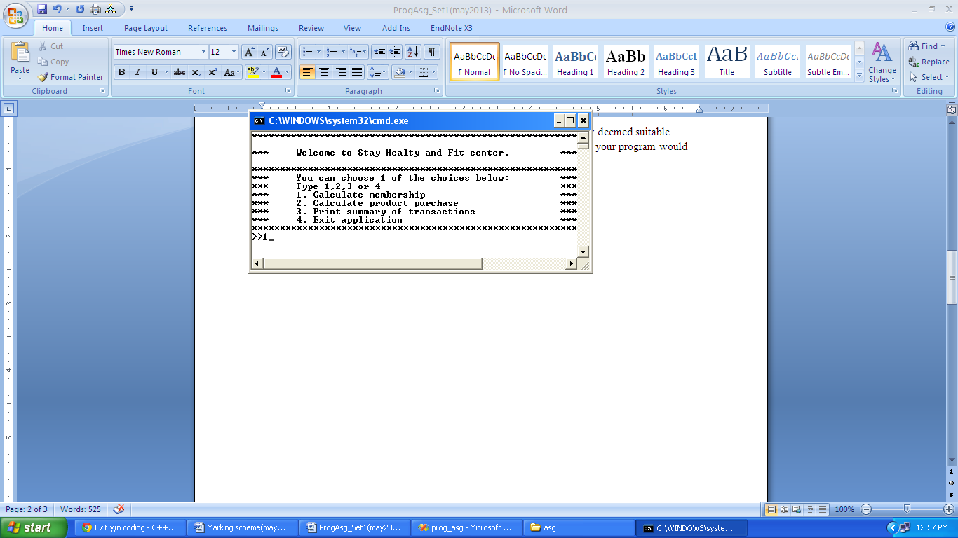

**SAMPLE RUN 1:**

**User chooses option 1:**

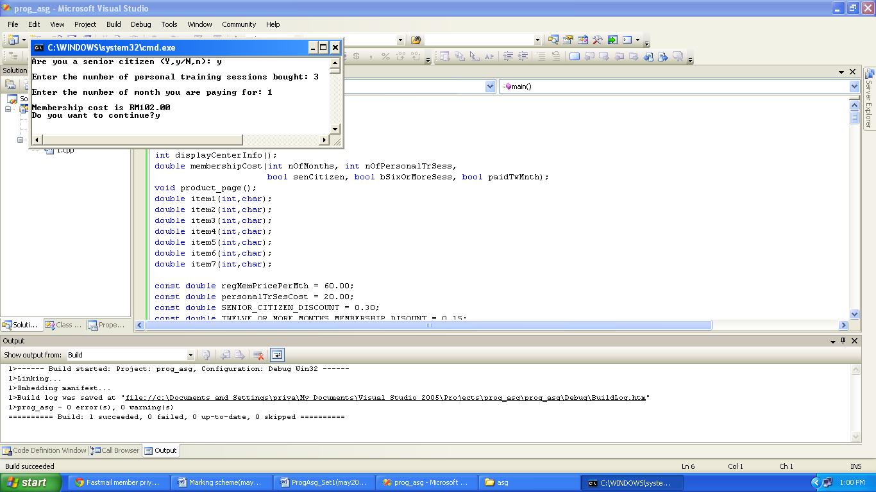

**User wants to continue, the menu screen will be shown again:**

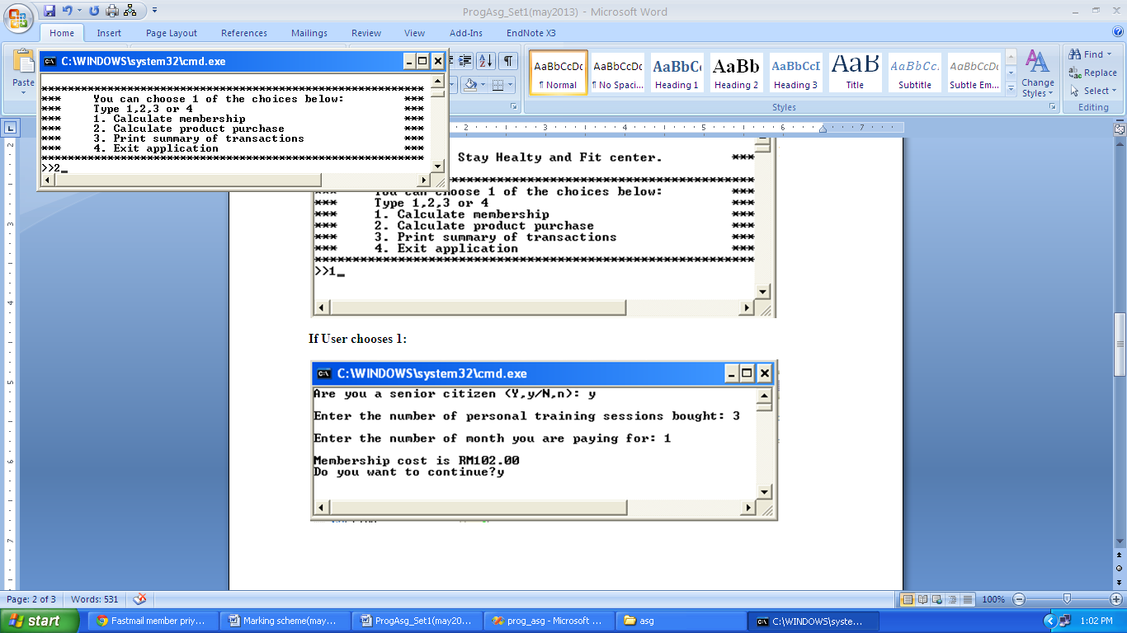

**User chooses option 2:**

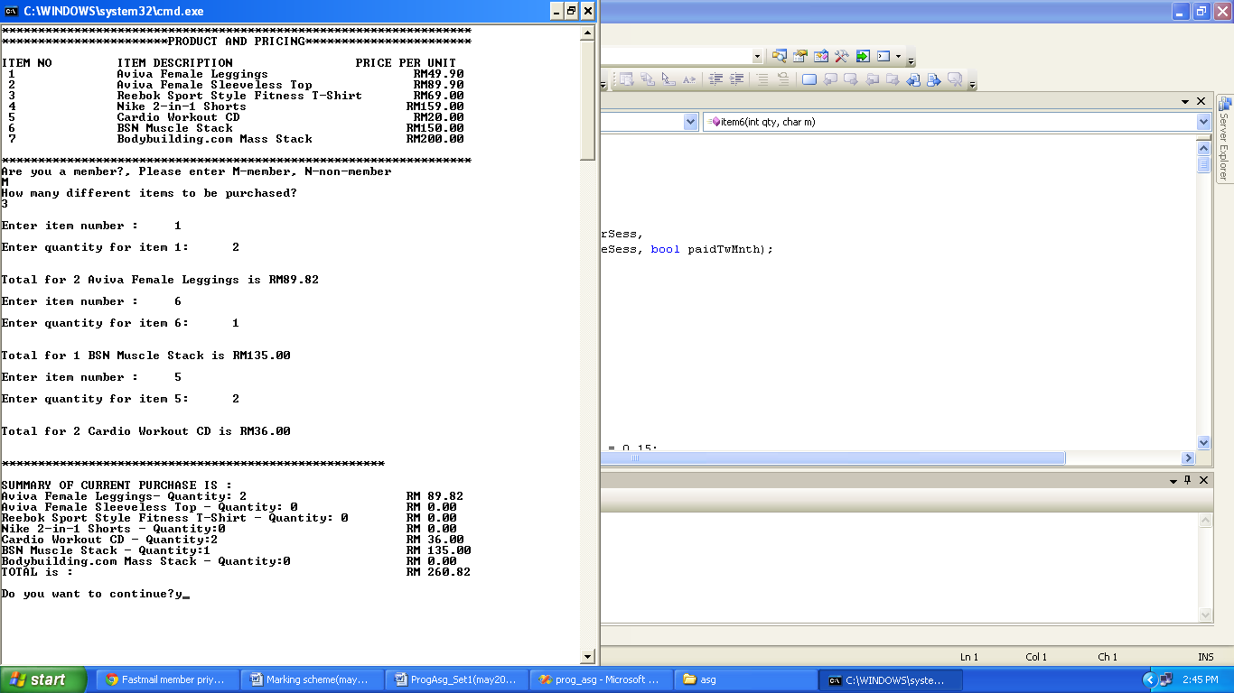

**User chooses to continue and chooses option 3:**

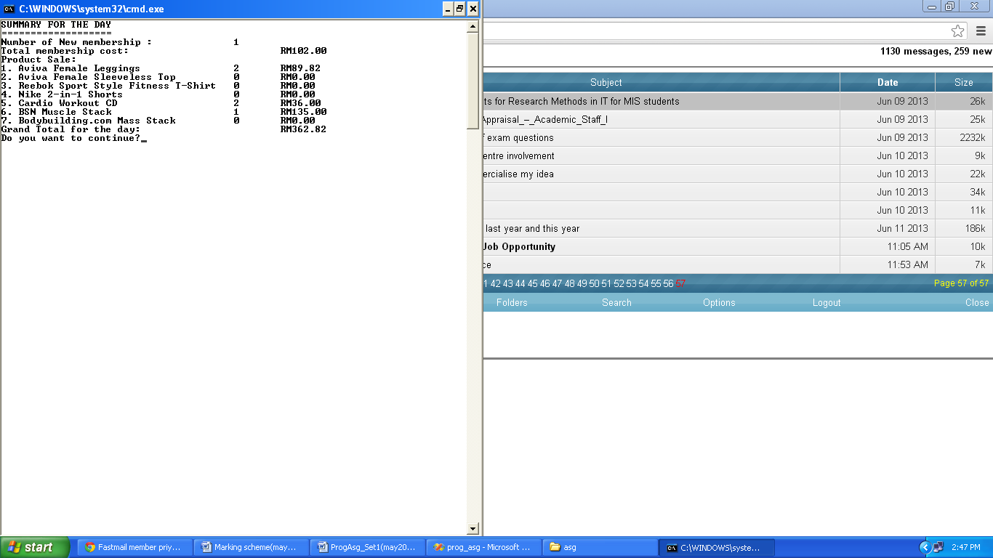

**User chooses to continue and chooses option 4:**

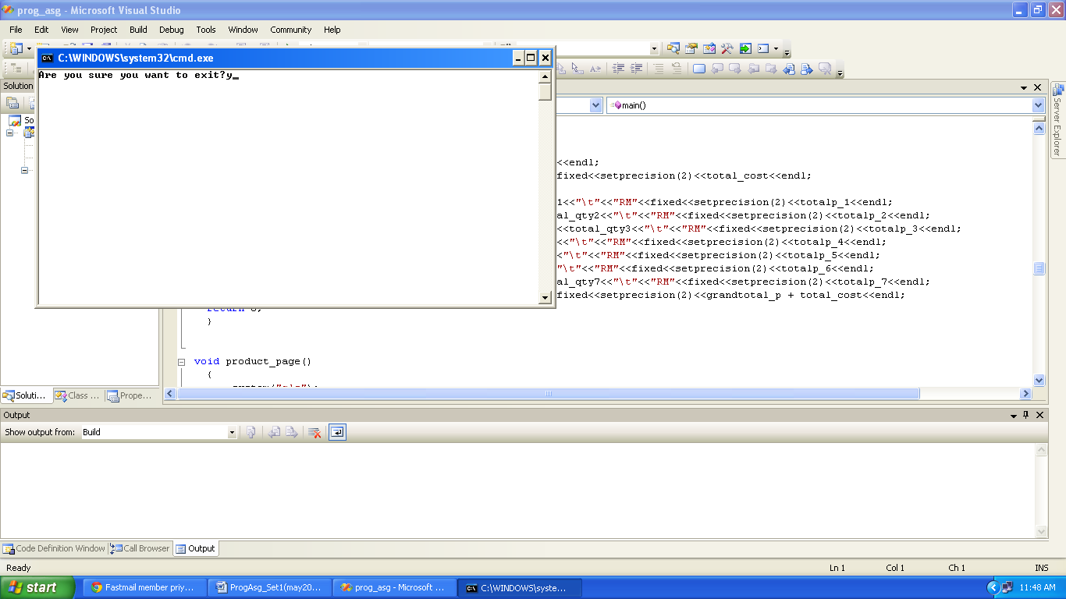

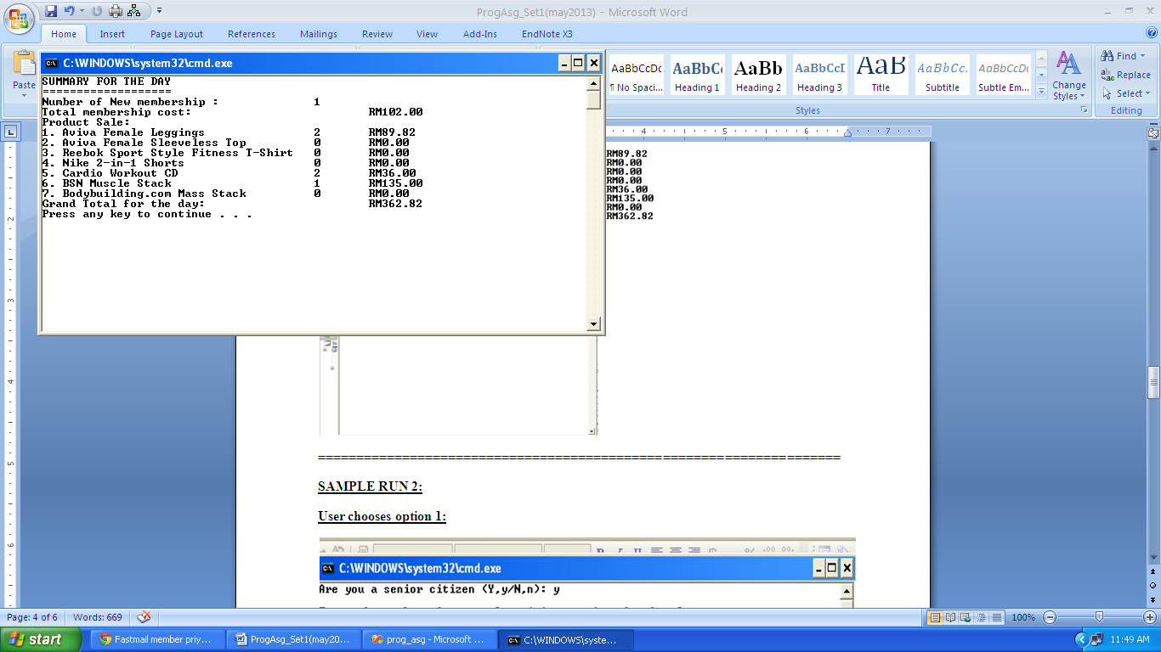

**====================================================================**

**SAMPLE RUN 2:**

**User chooses option 1:**

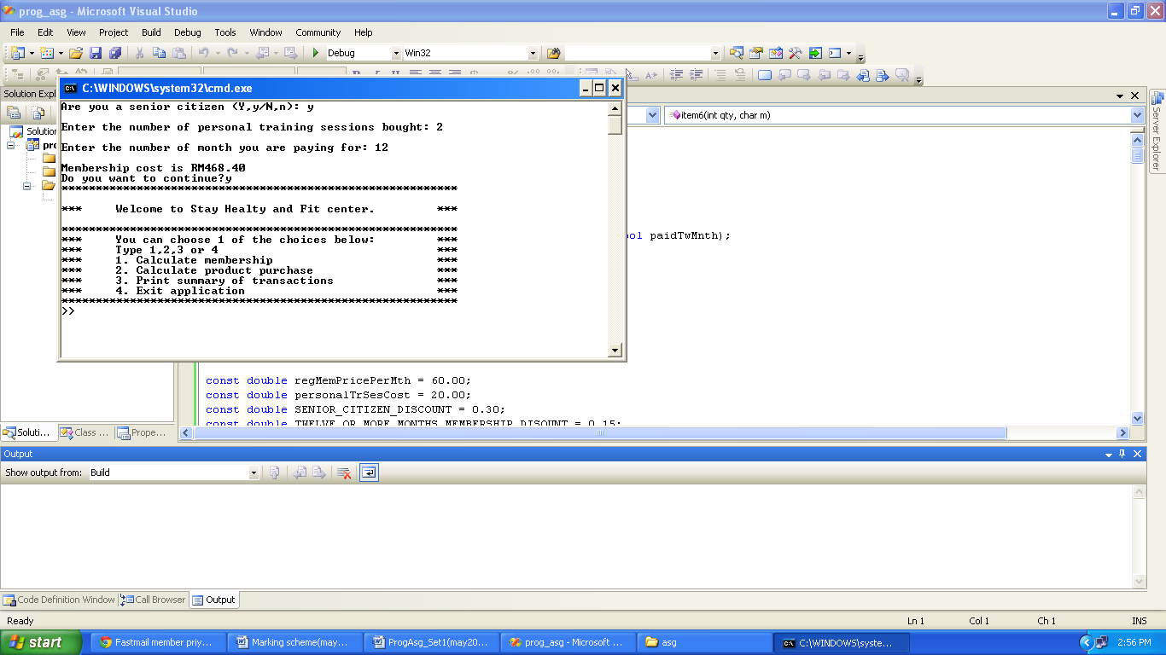

**User wants to continue, the menu screen will be shown again:**



1

**User chooses option 1 again:**

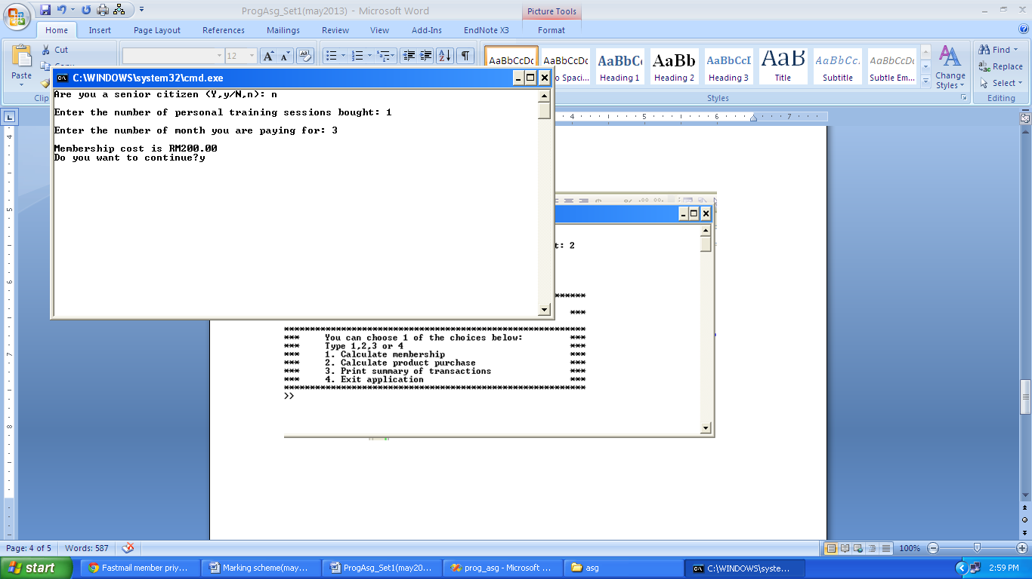**User chooses option 3:**

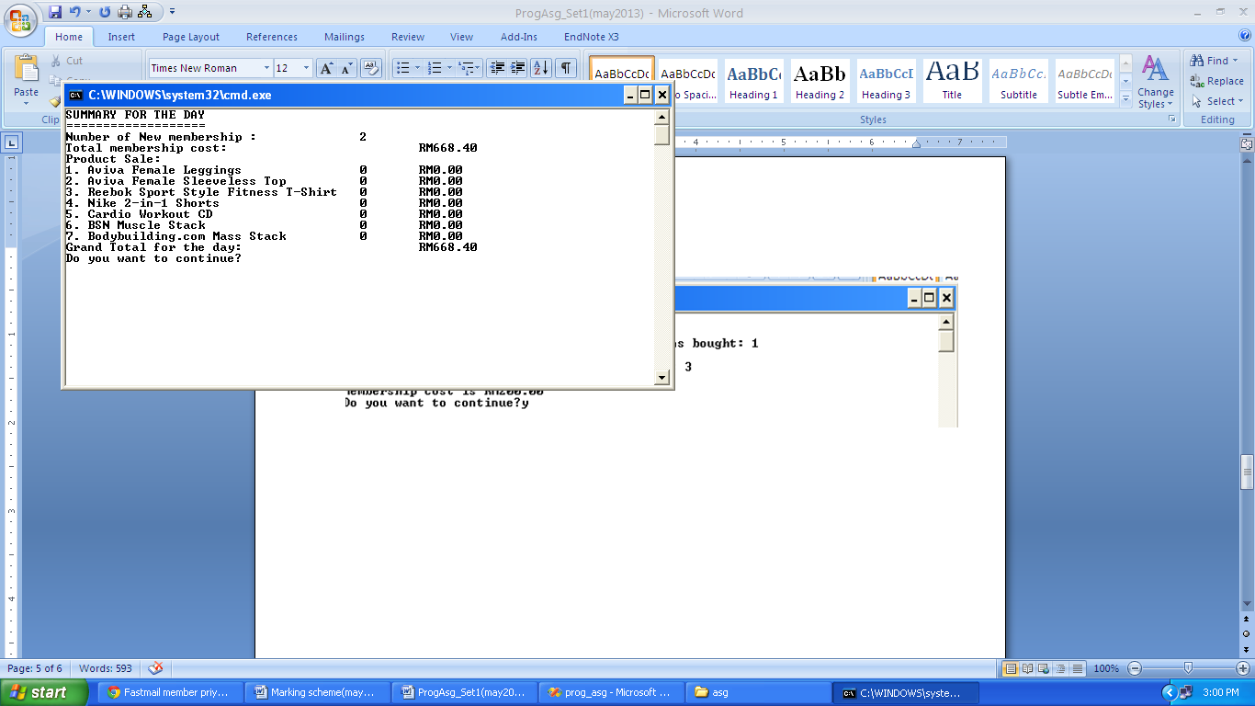

**Due Date: 8 JULY 2013 (Monday during lecture)**

**Submission Requirements**

**A. Hardcopy:**

1. **Cover Page (Name, ID, Practical Group – Day/Time/Practical Lecturer)**
2. **Marking scheme**
3. **Program coding**
4. **Input and Output (screenshot)**
5. **Softcopy of the program (upload to wble.utar.edu.my: e.g. leader_name.cpp)**

**– before 2.00p.m.**

**Marking scheme**

|  |  |  |  |
| --- | --- | --- | --- |
| **No** | **Aspect** | **Marks Allocated** | **Marks Awarded** |
| 1 | Syntactically correct | 5 |  |
| 2 | Has input validations/ error checking | 5 |  |
| 3 | Descriptive variable and function names | 5 |  |
| 4 | Proper use of white space, well formatted output | 5 |  |
| 5 | Proper and consistent indenting | 5 |  |
| 6 | Correct and descriptive output | 5 |  |
| 7 | Proper comments | 5 |  |
| 8 | Complete in terms of question requirement (loop/function/error/input/output) | 5 |  |
| 9 | Original work | 10 |  |

**WARNING: No plagiarism is allowed. Anyone caught will be given zero marks.**