Nicholas Hale
Math – 391
10 - 19 – 2015
Matlab Project II

Tridiagonal Solver

The first aim of this project is to produce a function that solves the matrix equation:

To accomplish this we can create a function that takes four vector parameters (the left diagonal, major diagonal, right diagonal, and right-hand-side vector b), takes the first variable u₁ as b₁ / m₁ (where m is the major diagonal) and performs a decomposition and forward substitution, then does a back-substitution on each point yielding:

function [ u ] = solveTriDiag (a, b, c, r, n)
%solveTriDiag, solves the given tri-diagonal matrix represented by
%diagonals a, b, and c against r
%coefficient variables
u = zeros(n, 1);
gamma = zeros(n, 1);
beta = b(1);
u(1) = r(1) / beta;
%Perform a decomposition and forward substitution
for i = 2 : n
gamma(i) = c(i - 1) / beta;
beta = b(i) - a(i) * gamma(i);

u(i) = (r(i) - a(i) * u(i - 1)) / beta;
end
%Perform a back-substitution
for i = 1 : (n - 1)
j = n - i;
u(j) = u(j) - gamma(j + 1) * u(j + 1);
end
end

Testing against Matlab's built-in back-division solution for 5 x 5 matrices

where the tridiagonal arguments are a_{i, i} = -2, a_{i, i – 1} = 1, a_{i, i + 1} = 1 and b_{i} = 1
yielded relative error (by utilization of the vector norms)

>> testSolveTriDiag
-2 1 0 0 0
1 -2 1 0 0
0 1 -2 1 0
0 0 1 -2 1
0 0 0 1 -2

-2.5000
-4.0000
-4.5000
-4.0000
-2.5000

-2.5000
-4.0000
-4.5000
-4.0000
-2.5000

0

Which leads us to believe that Matlab uses the same approach to finding the solution of tridiagonal matrices as we are. Next, determining the error that both Matlab and our tridiagonal solver produces when tested against the exact solution of the ode:

To do this we needed to create a function that would make use of the properties of the centered difference for the second derivative

to create a solvable linear system of equations its coefficients like so:

Utilizing Matlab's built in solver:

function [ u ] = approxODE(a, b, ua, ub, n )
%approxODE approximates the centered difference of the given second
%derivative f
%Coefficient Matrix for the centered difference
A = tridiagonal(1, -2, 1, n);
f = @(r) -pi^2 * cos(pi * r);
%Discretization difference
h = 1 / n;

A = A .* (1 / h^2);

x = transpose(linspace(a, b, n));
y = zeros(n, 1);
%Make corrections for first and last coefficients
y(1) = f(x(1)) - ua / h^2;
y(n) = f(x(n)) - ub / h^2;

for i = 2 : n - 1
y(i) = f(x(i));
end
%Solve with matlab
u = A \ y;
end

When Matlab's solution to this linear system is plotted against the exact solution u with a discretization parameter n = 50:

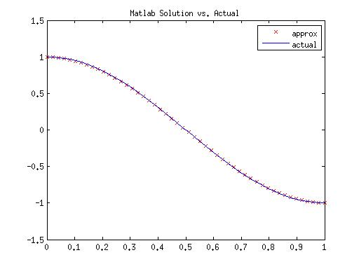

Using our tridiagonal solver with n = 50 we get:

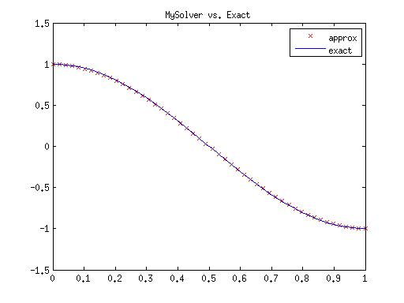

Further more, the relative error from the exact solution of the ODE for both approximations trends as follows (n_{max} = 100):

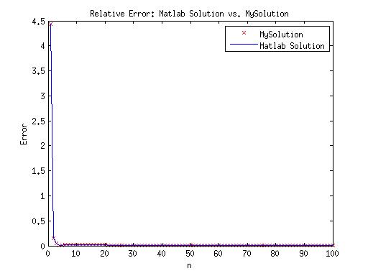

As we can see the relative error of both approximations from the actual solution is nearly identical. This is most likely a result of our methods of solving the tridiagonal matrix being similar or exactly the same. Examining more closely, we can see that as we increase the discretization parameter n, the relative error becomes small, ie. the approximation becomes closer to the actual solution. For our solver, the solution approaches 7.0e-06.

