Homework Cover Sheet

CMPEN 472 SPRING 2021 Homework 11

Section 1 NAME: Nicholas Total score:

HOMEWORK 11 Report

1. Objective:

To learn timer module interrupt based Analog Signal Acquisition programming.

2. Tasks:
- Write a program to aquire analog signal through the HCS12 board (simulation) and display the analog signal values on a Terminal window.
- The program is outlined as follows:
  - Initialize.
  - Your program starts from memory location $3100, data at $3000.
  - The SCI port Terminal baud rate set to 2M baud (assuming 24MHz BUS CLOCK).
  - Wait for the first Enter key hit on the Terminal
  - Print the user guiding messages:
(1) saving Terminal output to file,
(2) run analog signal command - connect an analog signal to ADC pin 7,
(3) when ready, hit SW0 to start the 1024 point ADC data capture.
  - Wait for the Switch SW0 pressing (PORTB bit 0).
  - Start the Timer Module Channel 2 Output Compare interrupt generation at every 125usec (8KHz rate).
Each time the Output Compare interrupt occurs, carry out the following tasks:
    - Service the Output Compare (OC) register (update the counter-compare number) for the next interrupt.
Also clear the OC interrupt flag.
    - Pick up the ADC result (from previous conversion) from the ADC result register.
And set the flag 'happened'. Only the lower 8-bit of the ADC result should be picked
up as the ADC result data. The picked up result data will be converted to the
ASCII characters which represents the decimal number representation of the result data.
The binary result data to ASCII character change must be done in the main program,
not in the interrupt service routine.
    - Start another single Analog-to-Digital conversion of the signal on the AN7 pin.
  - In the main program, if the Timer OC2 interrupt 'happened', then convert the most recently acquired ADC result data
to ASCII characters representing a decimal number. Then send the ASCII characters to Terminal.
  - Repeat for 1024 ADC result data - until the ADC conversion count to be 1024
  - Print the completion of the 1024 data transmission.
  - Then repeat the last 5 steps when Switch SW0 press happens again.
- Additional comments on the Homework 11 (HW11) program are as follows:
  - The Homework 11 program must send the 8-bit number in decimal (with ASCII conversion) to Terminal (SCI port).
  - The sample program uses busy ADC wait for ADC completion. But your Homework 11 program
must use the Timer Module Channel 2 Output Compare interrupt. Set 125usec (8KHz) interrupt rate for each ADC operation.
  - Your Homework 11 program must do one ADC conversion at the rate of exactly 8KHz, 125usec a part.
  - The sample program converts ADC input channel 7 signal. Also your Homework 11 program must convert ADC input channel 7 signal.
  - The sample program does one conversion per Enter key hit, your Homework 11 program must do 1024 conversions per each Push Button SW0 press.
- Check the plot and verify the signal frequency. Use magnify feature to see the signal wave details. Identify one cycle of signal wave, check how many points are plotted. (for plotting, one may also use MS Excel)
- Program Homework 11 such that the program allows you to aquire another set of 1024 point ADC data as follows:
  - Open Terminal output file.
  - Attache analog signal to AN7 pin
  - Press the switch SW0.
  - New set of data will be recorded into the 'RxData3.txt' file.
- Once your Homework 11 program is finished, run it many times to test that it works. Change the analog signal wave frequency as well as the wave type as you test your Homework 11 program. Repeat the data acquisition and plotting.
- Make your program user friendly by giving directions as to how to correctly use your program. Once your program is running, everything must be self explanatory to user at the Terminal.
- Also, make your program 'fool-proof', never crash or stop based on wrong user response.
- Be sure to put much comments so that grader and others can clearly and quickly understand your program. Comments are very important in assembly language programs.
3. Parameters:

s125us: #$0400 ($0400 is 1024 in hex, we are capturing 1024 values)
#3000 (125usec for OC2 interrupt timing)

4. Captured data plot, explain:
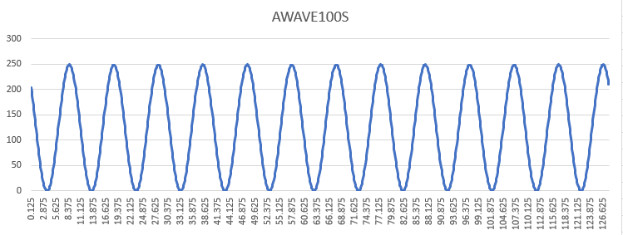

Sine wave graph, data from AWAVE100S file. Generates a graph with a period of 9.8125ms. Its peak is approx. 250.

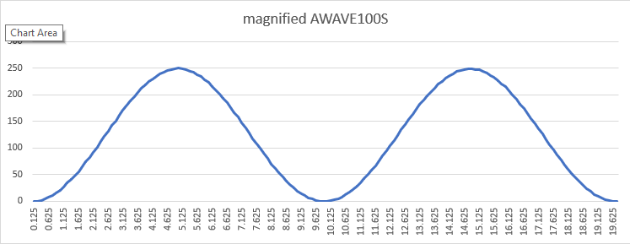
Magnified 2 cycle plot of Sine graph.

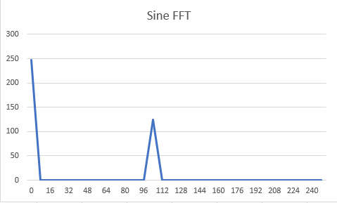
FFT of SINE data, first 33 values. X axis is the FFT Frequency and Y-Axis is the FFT Magnitude. Peak at Freq=104.

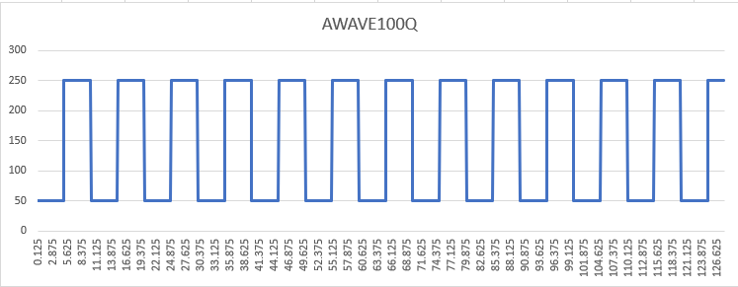
Square wave graph, data from AWAVE100Q file. Generates a graph with a period of 9.9375ms. Its peak is 250, and its minimum is 50.

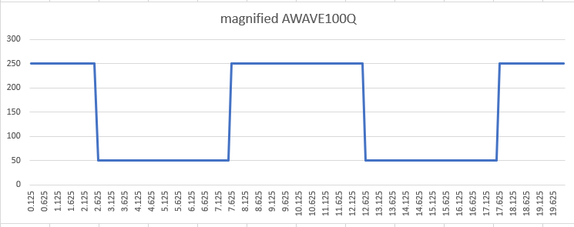
Magnified 2 cycle plot of Square wave graph.

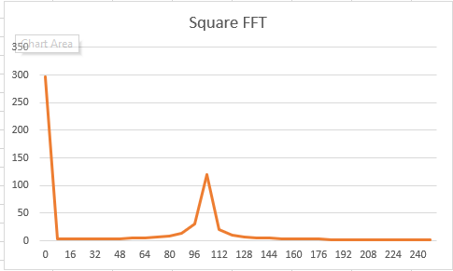
FFT of SQUARE data, first 33 vals. Peak at Freq=104.

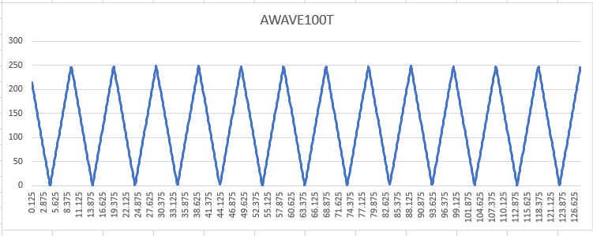
Triangle (Sawtooth) Wave graph, data from AWAVE100T file. Generates a graph with a period of 9.875ms. Its peak is approx. 250.

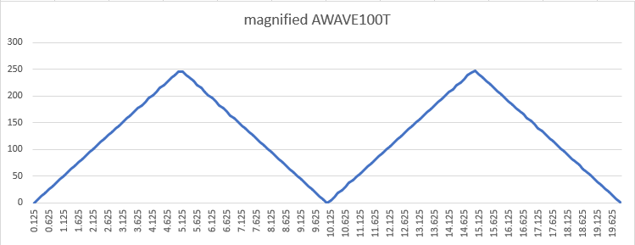
Magnified 2 cycle plot of triangle wave graph.
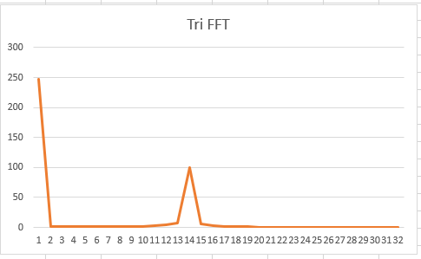
Info same as others.

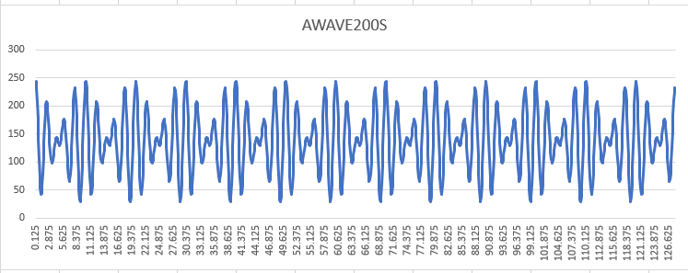
Mixed freq. sine wave graph, data from AWAVE200S file. Generates a graph with a period of 10ms. Its peak is approx. 245. Its minimum is approx. 42.
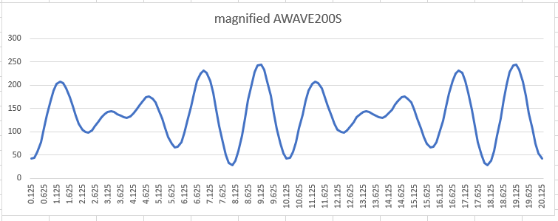
Magnified 2 cycle plot of mixed freq. sine graph.
No time for FFT.

5. Conclusion:

Using mostly code from last week’s assignment, I wrote a program to make use of OC2 interrupts and the chip’s built in ADC to convert data from given files into digital values and then collected those values into txt files, then plotted that data and did FFTs on it.

http://online.sfsu.edu/jtai/downloads/ENGR%20302/Excel.FFT.pdf < Source for doing FFTS in Excel.

