Homework Cover Sheet

CMPEN 472 SPRING 2021 Homework 10

Section 1 NAME: Nicholas Hutton Total score:

Check list:

1. Homework 10 program - Record the Timer Counter, value of TCNT, once every interrupt.

2. Print the record of the Timer Counter to the Terminal, in decimal number.
Printing should be done outside of the interrupt service routine because
each number printing may take long time and you do not want to miss the
subsequent interrupt(s). Keep the interrupt service routine short, always.

3. Homework 10 program simulation/debugging - Capture the text printed on the Terminal into a file.

4. Plot the data using Excel or MatLab (or SciLab).

5. Homework 10 Report -
Explain what Homework 10 is about and what you did, show plots and their explanations.

6. Use this cover-sheet for the report (title, date, purpose, your information, etc.)

7. Submit both your Homework 10 program and the report (not zipped)

8. Other items: Homework report file name and homework program file name,
use this Homework report cover page and follow the sample format below.

HOMEWORK 10 Report

1. Objective:

To learn the general-purpose timer module and the timer interrupt, to learn real-time Rapid Data Transmission programming. Do this by writing a program that collects the data from the Timer Module’s internal counter and print it to the screen.

2. Tasks:

- Initialize
- Your program starts from address $3100, and data section at $3000
- Your program starts with serial SCI port baud rate set to
2M baud (at 24MHz, same baud rate and clock frequency as Homework 8 and 9)
and SCI port is connected to a Terminal in the CodeWarrior Simulator
- Program execution starts - Print the Welcome message on the Terminal
- Wait for the first RETURN key hit on the terminal while running a 'typewriter' function
- Print a short instruction - guiding the user
- Wait for the Switch SW0 pressing - Assume that Switch SW0 is at PORTB bit 0.
- Start the Timer Module Channel 2 Output Compare interrupt generation at every 125 usec interval (8KHz rate).
Each time the Output Compare interrupt occurs, carry out the following tasks:
  - Service the Output Compare (OC) register (update the counter compare number) for the next interrupt.
Also clear the OC interrupt flag (if you selected the Fast Flag Clear option, updating the timer OC register
for the next interrupt will also clear the interrupt flag).
  - Read the Timer Counter value and print the value in decimal number to the Terminal.
Print the 16-bit number in decimal.
  - Increment the data transmit counter
- Wait for the data transmit count to be 1024, to complete the data transmit session
- Repeat the last 3 steps, beginning with Switch SW0 press waiting, indefinitely
- Print data from the terminal to a file on hard drive.

3. Parameters:

Show parameters (numbers) and explanations for each specification:
* Export Symbols
XDEF Entry ; export 'Entry' symbol
ABSENTRY Entry ; for assembly entry point

; include derivative specific macros
PORTB EQU $0001
DDRB EQU $0003

SCIBDH EQU $00C8 ; Serial port (SCI) Baud Register H
SCIBDL EQU $00C9 ; Serial port (SCI) Baud Register L
SCICR2 EQU $00CB ; Serial port (SCI) Control Register 2
SCISR1 EQU $00CC ; Serial port (SCI) Status Register 1
SCIDRL EQU $00CF ; Serial port (SCI) Data Register

TIOS EQU $0040 ; Timer Input Capture (IC) or Output Compare (OC) select
TIE EQU $004C ; Timer interrupt enable register
TCNTH EQU $0044 ; Timer free runing main counter
TSCR1 EQU $0046 ; Timer system control 1
TSCR2 EQU $004D ; Timer system control 2
TFLG1 EQU $004E ; Timer interrupt flag 1
TC2H EQU $0054 ; Timer channel 2 register

CR equ $0d ; carriage return, ASCII 'Return' key
LF equ $0a ; line feed, ASCII 'next line' character

intct equ 79 ; my PC simulation works, 79 => 1 sec approximately

4. Captured data plot, explain:

Plot full 1024pts and plot magnified 2 signal cycles.

Identify one cycle of signal wave, and verify correct signal frequency
by counting how many points are plotted in one cycle.

Detailed explanation of each plot and operation verification.

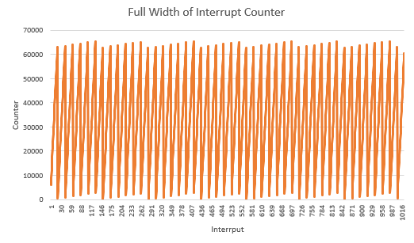
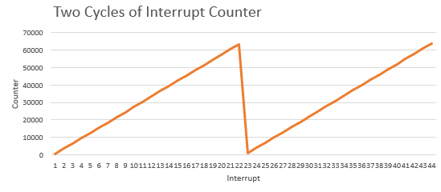

5. Conclusion:

Write the summary of what was done and its key parameters.
Explain what I learned. List any comments.

This program runs the Timer Interrupt and in the main program portion it collects 1024 numbers pulled from the Timer module’s counter and prints them to the display. I learned about another kind of interrupt and also how to handle file output from the serial terminal.

