Question 1: Advanced Power Query Data Preparation — 60 Marks
Use Power Query to clean, transform, and prepare the dataset.
A. Basic Data Cleaning — 15 Marks
- Rename unclear columns. (2 Marks)
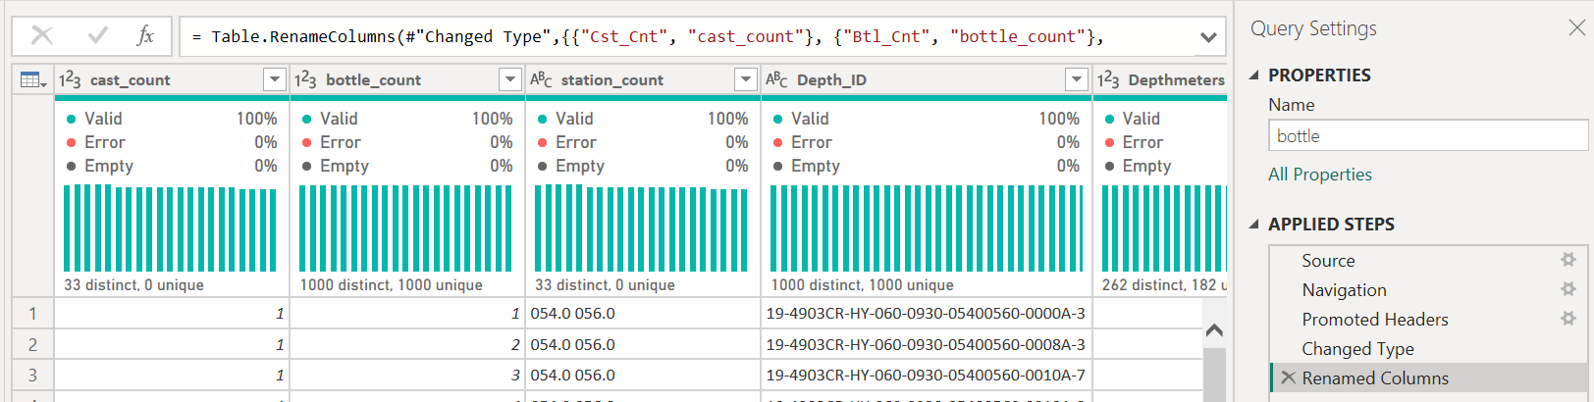
- Change data types correctly. (2 Marks)
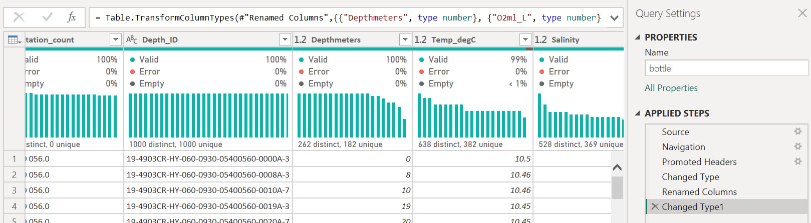
- Remove duplicate records. (2 Marks)
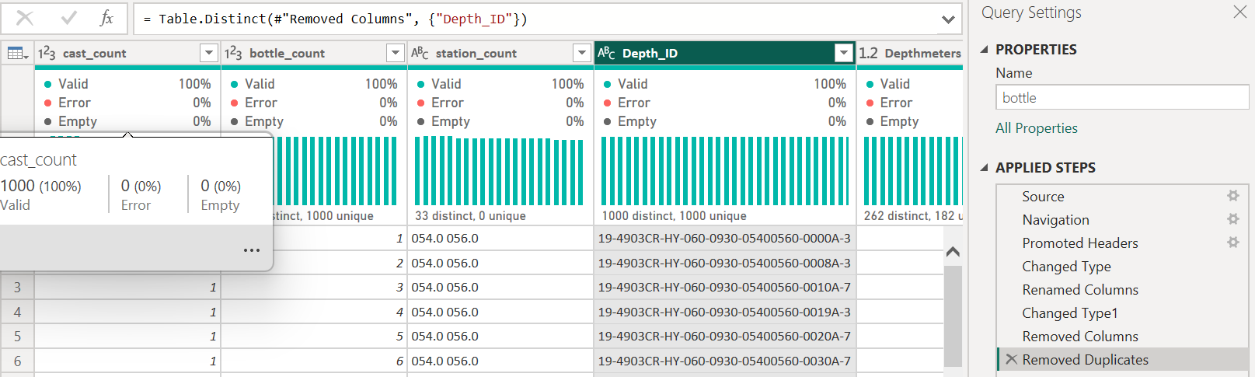
- Remove blank rows. (2 Marks)
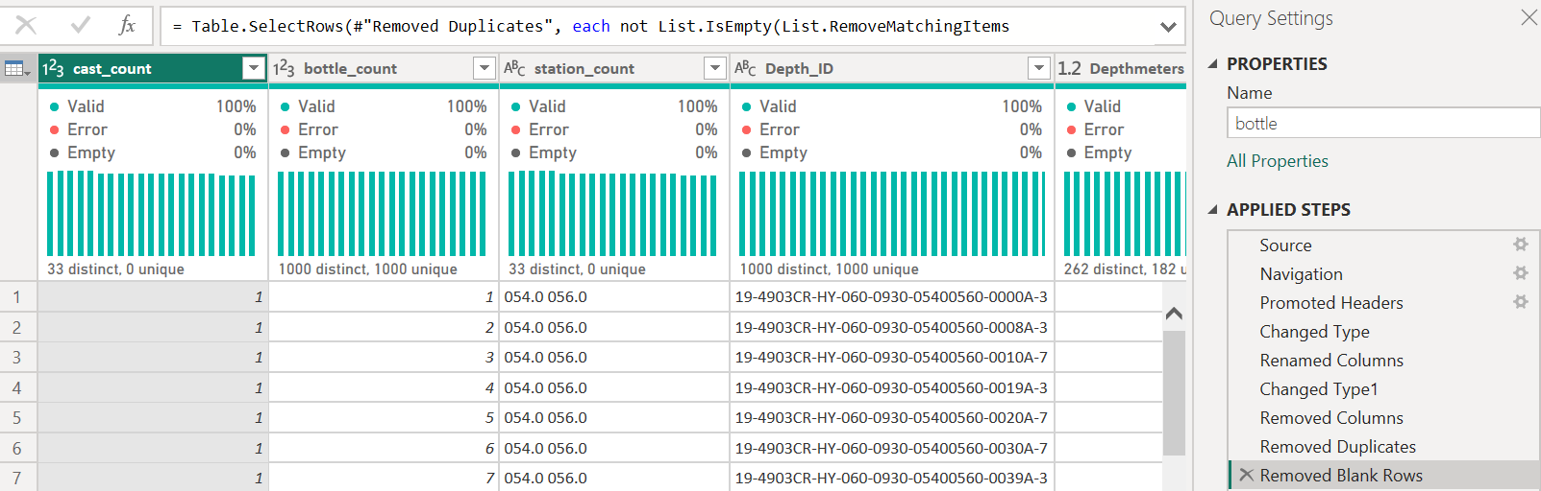
- Trim and clean text columns. (2 Marks)
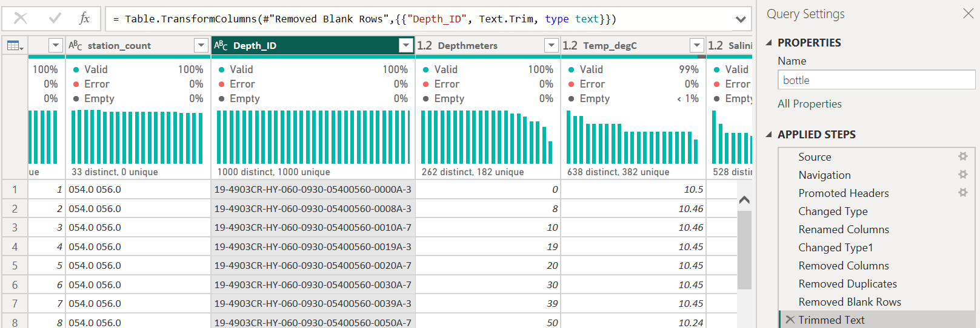
- Replace inconsistent values. (2 Marks)
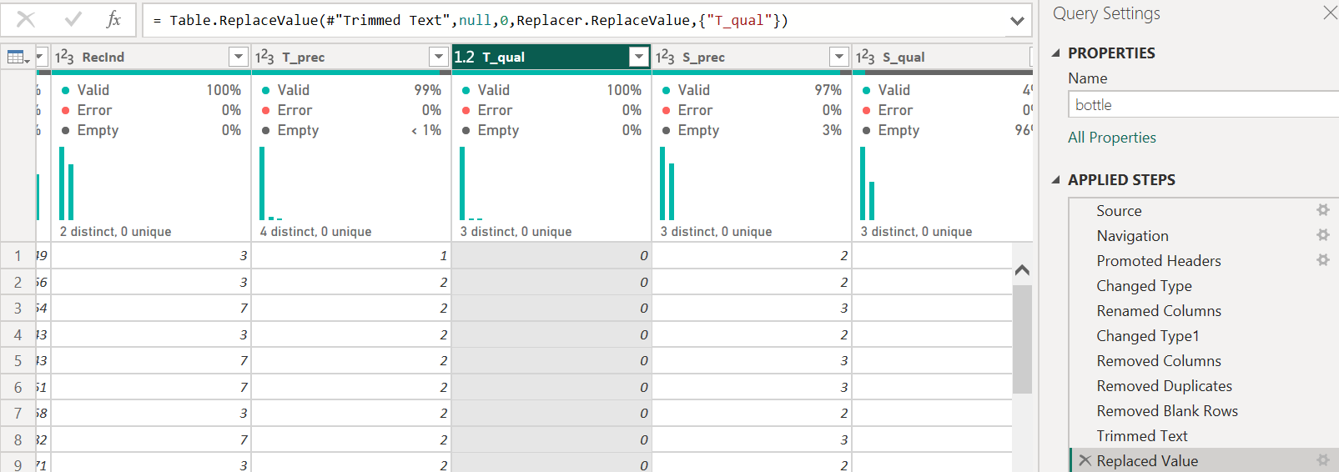
- Remove unnecessary columns. (3 Marks)
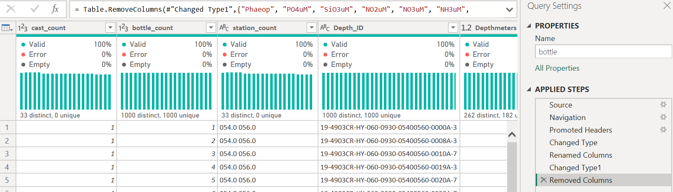
B. Intermediate Transformations — 20 Marks
- Split one column into multiple columns. (2 Marks)
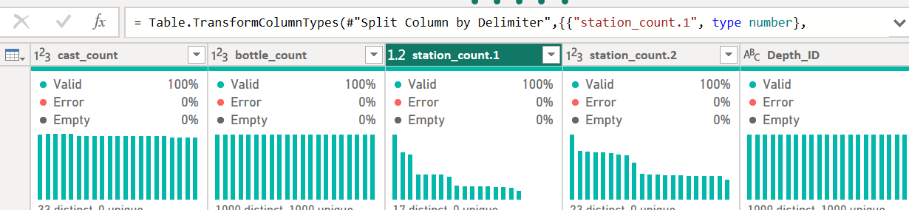
- Merge two or more columns. (2 Marks)
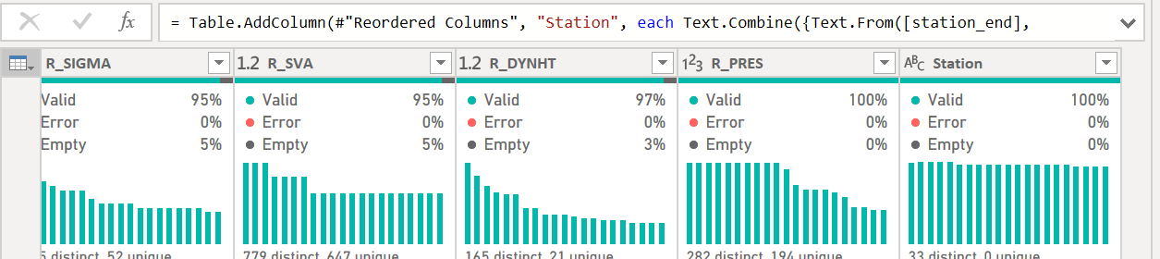
- Create a custom column. (3 Marks)
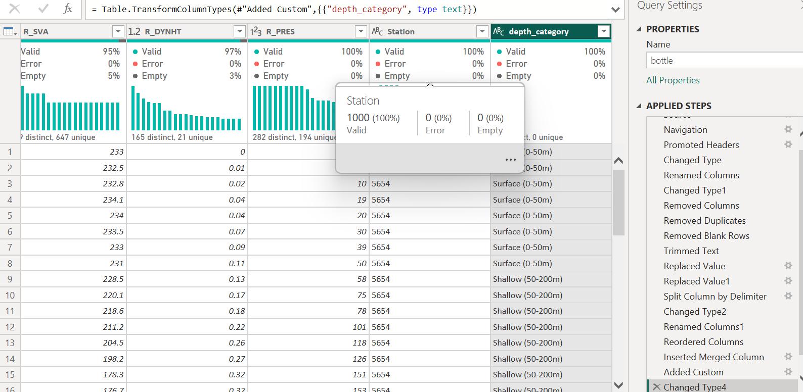
- Create a conditional column. (3 Marks)
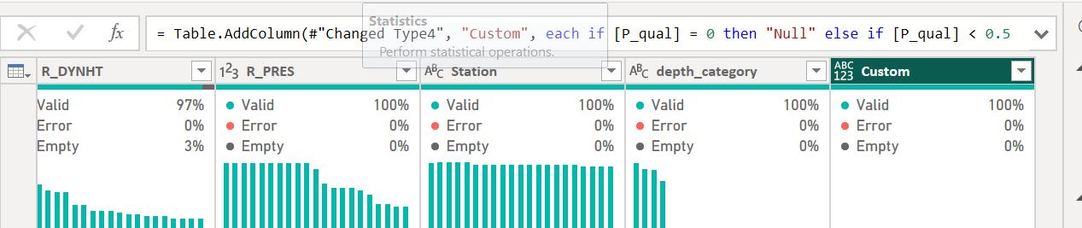
- Extract year, month, quarter, and day from a date column. (4 Marks)
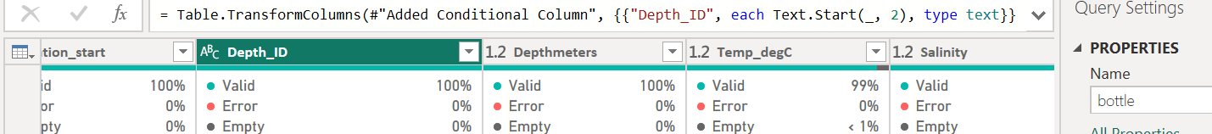
- Filter rows using at least two conditions. (2 Marks)
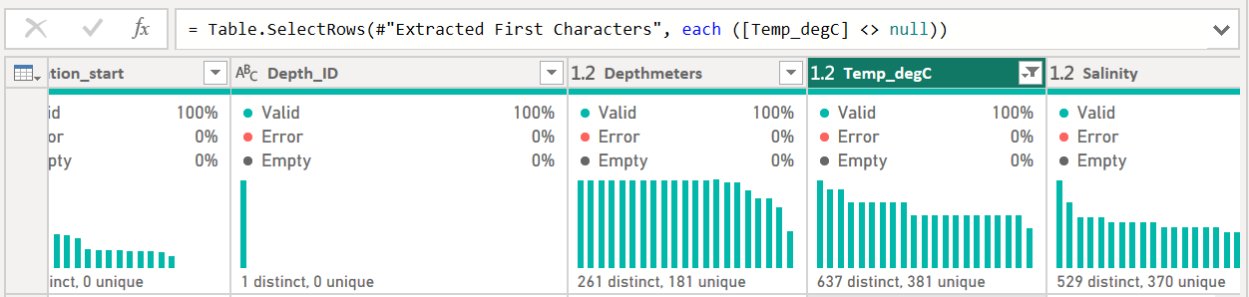
- Sort data meaningfully. (2 Marks)
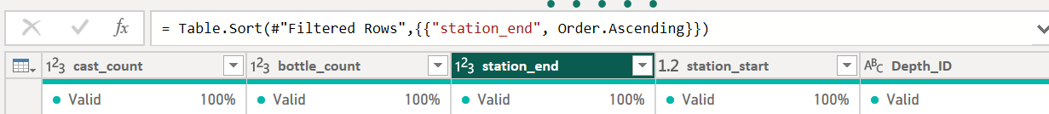
- Add an index column. (2 Marks)
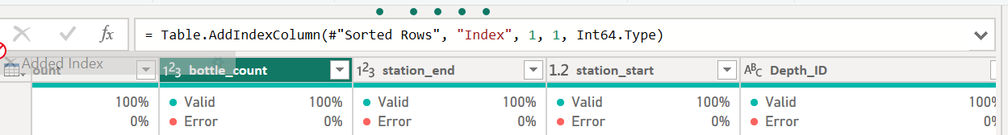
C. Advanced Power Query Tasks — 25 Marks
Complete any five of the following tasks.
Each task carries 5 marks.
- Merge queries using a common key.
- Append two related datasets.
- Pivot a column.
- Unpivot columns.
- Create a parameter and use it to filter data.
- Create a date table in Power Query.
- Use Group By with multiple aggregations.
- Extract text before or after a delimiter.
- Remove or handle errors in a column.
- Create business categories using nested conditional logic.
- Create a summarized query using Reference Query.
- Use Column Profiling to identify data quality issues.
Power Query Evidence Required
Students must include screenshots of:
- Raw imported dataset
- Power Query Editor
- Applied Steps pane
- Column profiling results
- Final cleaned dataset
- Any merge, append, pivot, unpivot, or parameter task attempted
Question 2: Power BI Dashboard Development — 30 Marks
Create a professional Power BI dashboard using the cleaned dataset.
Required Visuals
- Minimum 3 KPI cards. (3 Marks)
- Bar chart. (3 Marks)
- Column chart. (3 Marks)
- Line chart showing a trend. (3 Marks)
- Pie or donut chart. (3 Marks)
- Table visual. (3 Marks)
- Matrix visual. (3 Marks)
- Map or filled map, where applicable. (3 Marks)
- Any two additional meaningful visuals. (4 Marks)
- Professional layout, titles, formatting, and readability. (2 Marks)
Question 3: Dashboard Interactivity and Insights — 10 Marks
- Add at least three slicers. (3 Marks)
- Enable drill-down on one visual. (2 Marks)
- Demonstrate cross-filtering between visuals. (2 Marks)
- Write three business insights based on the dashboard. (3 Marks)

