**INTERNATIONAL ORGANISATION FOR STANDARDISATION**

**ORGANISATION INTERNATIONALE DE NORMALISATION**

**ISO/IEC JTC 1/SC 29/WG 7**

**CODING OF MOVING PICTURES AND AUDIO**

**ISO/IEC JTC 1/SC 29/WG 7 m70061**

**Antalya, TR – November 2024**

**Title: AI-PCC CfP Response Proposal from Nanjing University and OPPO (Track1)**

**Authors: Tong Chen, Ruixiang Xue, Junteng Zhang, Jianqian Wang, Zhan Ma (Nanjing University), Shuting Xia, Ruixiang Xue, Zexing Sun, Chuang Ma, Yue Yu, Haoping Yu, Dong Wang (OPPO)**

**Abstract**

This document presents Nanjing University and OPPO’s joint proposal in response to the Call for Proposals (CfP) for AI-based Point Cloud Coding. The method proposed in this document is a learning-based solution that is capable of compressing the geometry of the input point cloud. It supports static as well as dynamic point cloud input of diverse characteristics in lossy or lossless modes. This response proposal corresponds to the geometry-only coding to address track 1 of the CfP.

# Information form

Title of the proposal:

AI-PCC CfP Response Proposal from Nanjing University and OPPO (Track1).

Organization: Nanjing University, OPPO

Tong Chen chentong@nju.edu.cn

Test conditions covered by the proposal:

Table Check the appropriate box that applies to the submission.

|  |  |  |
| --- | --- | --- |
| Competition track | Use Case | |
| Dense | Sparse |
| Track 1: Geometry-only | P | P |
| Track 2: Geometry + Attribute | X | X |

Table Fulfillment of requirements for AI-based graphics coding of dynamic point clouds

|  |  |  |  |  |  |  |
| --- | --- | --- | --- | --- | --- | --- |
| Technology | Category 1  (Dense Static PCs for Immersive Applications) | | Category 2  (Dense Dynamic PCs for Immersive Applications) | | Category 3. A  (Sparse Dynamic PCs for LiDAR) | |
| **Req.** | **Fulfilled?** | **Req.** | **Fulfilled?** | **Req.** | **Fulfilled?** |
| a) Lossy compression | P | P | P | P | P | P |
| b) Lossless geometry compression | P | P | P | P | P | P |
| c) Lossless attribute compression | P | - | P | - | P | - |
| d) Near-lossless geometry compression | *o* | P | *o* | P | P | P |
| e) Near-lossless attribute compression | *o* | *-* | *o* | *-* | *o* | *-* |
| f) Temporal variations | - | - | P | P | P | P |
| g) Low latency | P | P | P | P | P | P |
| h) Low complexity | P | P | P | P | P | P |
| i) Temporal scalability | - | - | P | P | P | P |
| j) Spatial scalability | *o* | P | *O* | P | *o* | P |
| k) Region-based scalability | *o* | *-* | *O* | *-* | *o* | *-* |
| l) Quality scalability | *o* | P | *O* | P | *o* | P |
| m) Spatial random access | *o* | *-* | *o* | *-* | *o* | *-* |
| n) Temporal random access | - | - | P | P | P | P |
| o) Error resilience | *o* | P | P | P | *o* | P |
| p) Parallel encoding and decoding | *o* | P | *o* | P | *o* | P |
| q) Separable attribute and geometry coding | *o* | - | *o* | - | *o* | - |
| q-1) Geometry only coding | P | P | P | P | P | P |
| q-2) Multiple attribute coding | P | - | P | - | P | - |
| r) Geometry precision | At least Up to 20 | P | At least Up to 12 | P | At least Up to 18 | P |
| s) Model architecture | P | P | P | P | P | P |
| t-1) On the fly Model Update | P | P | P | P | P | P |
| t-2) On-demand Model Update & download | P | P | P | P | P | P |
| u) Inference Reproducibility | P | P | P | P | P | P |

(‘P’ = Required ‘*o*’ = Optional ‘-’ = Not applicable)

Explanations of the requirement items above can be found in the requirement document [1].

# Architecture description

# General

Nanjing University and OPPO’s joint response proposal is a learning-based method that is based on the universal conditional coding framework named *Unicorn* to compress the geometry of a point cloud.

# Terminology

To help readers understand *Unicorn*, the frequently used abbreviations are provided in Table 3 for the geometry codec of *Unicorn*

Table Frequently used abbreviations

|  |  |  |
| --- | --- | --- |
| **Codec** | **Abbreviation** | **Description** |
|  | OPU | Occupancy Processing Unit |
|  | CPA | Conditional Probability Approximation |
|  | CPR | Content-aware Predictive Reconstruction |
| Geometry | MP-POV | Most Probable Positively Occupied Voxel |
|  | PR | Predicting Residual |
|  | PM | Probability Modeling |
|  | OC | Occupancy Classification |
|  | AT | Analysis Transform |
|  | DDS | Dyadic Down-scaling |

# *Unicorn* general architecture

*Unicorn* first progressively downsamples the input point cloud to generate the multiscale sparse tensor representation. Upon this representation, the compression of geometry starts from its spatially lowest-scale tensor and finally arrives at the highest-scale tensor. The cross-scale occupancy processing unit (OPU) is used for geometry compression.

Figure 1 and Figure 2 show high-level block diagrams of the proposed encoding and decoding processes, respectively.

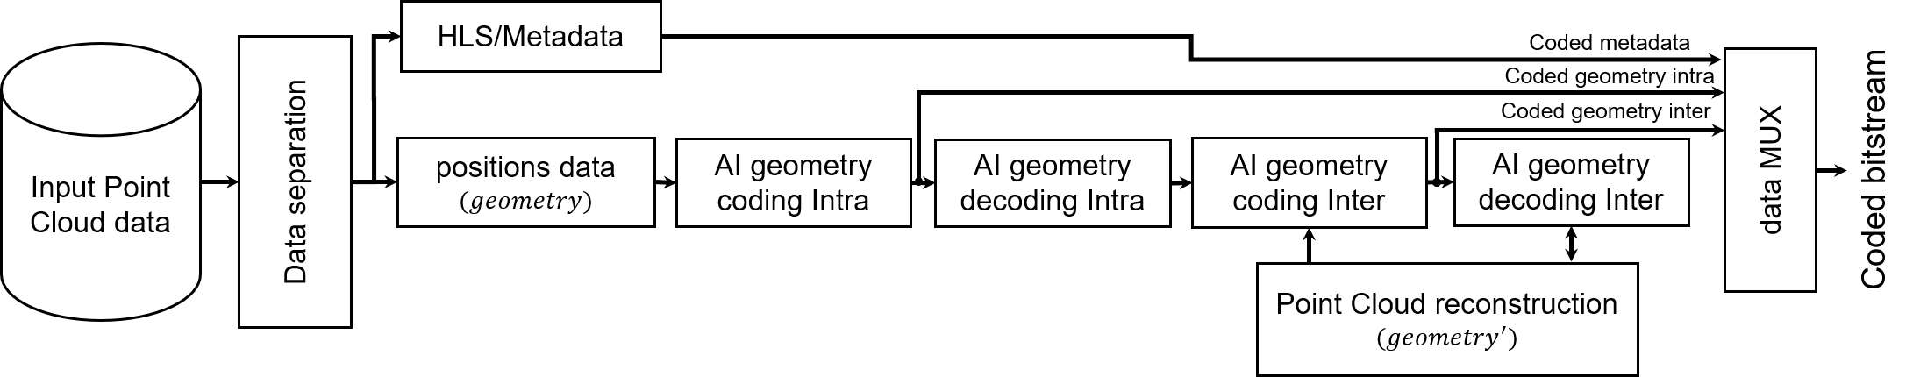

Figure Unicorn encoder architecture

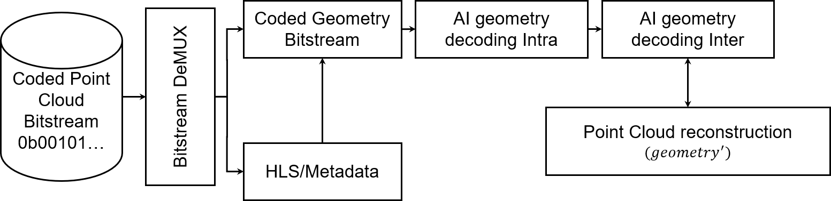

Figure Unicorn decoder architecture

# Geometry codec module

# General

This section provides a description of the geometry coding process of *Unicorn*. A dynamic point cloud , where is a collection of static point cloud frames over time, as illustrated in the left of Figure 3. The geometry and attribute components of are shown in the right of Figure 3. The geometry component is compressed.

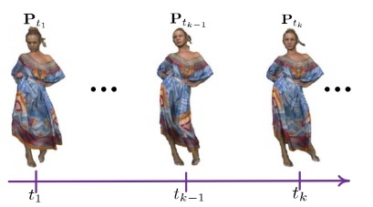 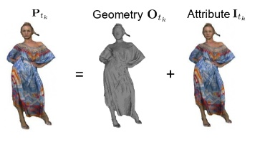

Figure Data processing in Unicorn

*Unicorn* first progressively downsamples the input to generate multiscale sparse tensors , where .The dyadic down-scaling (DDS) is applied to for squeezing every eight inter-connected voxels into a single merged one when decreasing the ：

As shown in Figure 4, as long as there is at least one occupied voxel in each group of eight inter-connected voxels, the merged voxel is an occupied one.

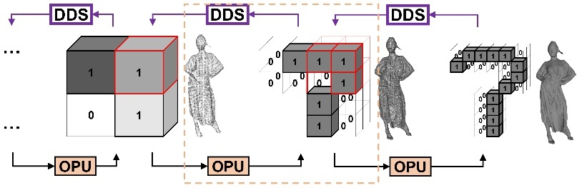

Figure Unicorn's geometry multiscale sparse representation, 1 - Occupied voxel, 0 - Unoccupied voxel. OPU is the occupancy processing unit.

Upon multiscale sparse tensors being generated, the compression of geometry component starts from its spatially lowest-scale tensor and finally arrives at the highest scale to process . The cross-scale occupancy processing unit is termed as OPU.

# Framework of geometry codec

The geometry coding of *Unicorn* is based on a two-stage coding and consists of lossless and lossy components. The architecture of *Unicorn* is based on multiscale sparse tensor representation, and at each scale it receives previous scale priors and performs a set of corresponding computations (lossless OPU or lossy OPU). The lossless geometry coding is based on estimating the occupancy probability of the most probable positively occupied voxel (MP-POV) in each decomposition scale, and it is referred as lossless OPU. The lossy geometry coding is based on the content-aware predictive reconstruction, and it is referred as lossy OPU.

Figure 5 and Figure 6 illustrate the lossless and lossy modes of *Unicorn*'s static geometry coding, and Figure 8 reveals the meaning of each component.

* In the lossless mode, a lossless OPU process runs at each scale from to to estimate the occupancy probability of every relevant voxel, i.e., MP-POV.
* The lossy mode comprises lossless and lossy coding phases consecutively. First, a lossless OPU process is employed from to . Then, a lossy OPU process is applied through the remaining scales from to . Adapting can provide multiple discrete rate points with a single model.

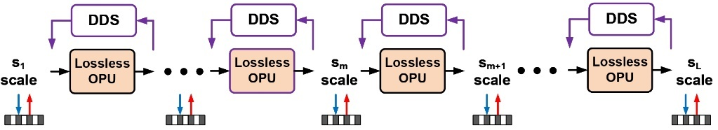

Figure Lossless geometry coding of Unicorn

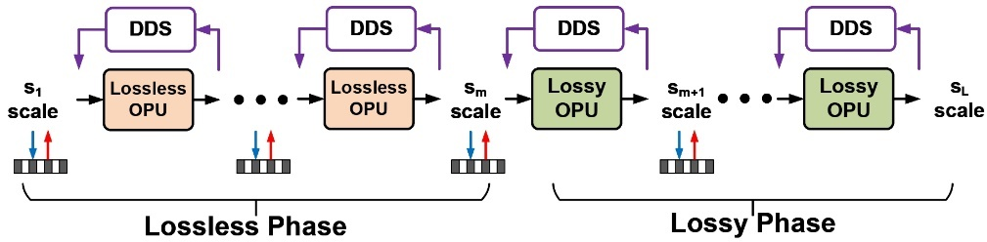

Figure Lossy geometry coding of Unicorn

Figure 7 further depicts the dynamic geometry coding, which can be simply facilitated in *Unicorn* by aggregating and warping priors from the temporal reference frame at to enhance OPU when encoding the frame at . Figure 8 reveals the meaning of each component.

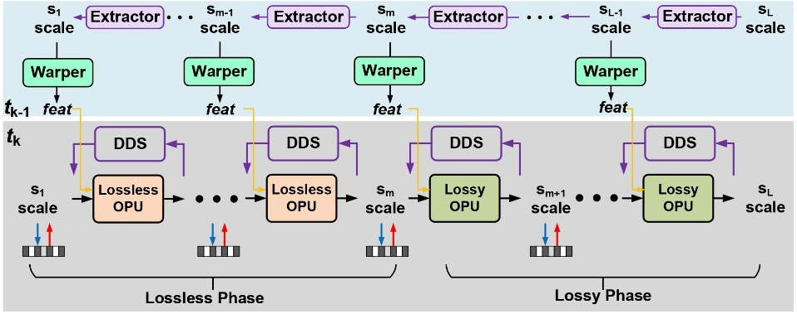

Figure Lossy dynamic geometry coding of Unicorn

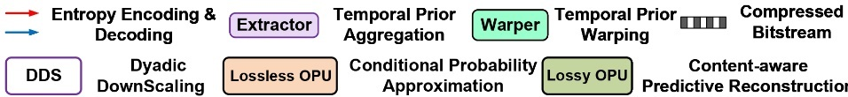

Figure Legends of each component

# Model description for static geometry coding

# General

This section contains the description of two geometry coding methods with occupancy processing units (OPU), i.e., lossless OPU and lossy OPU. First, the details of lossless OPU are provided, which is followed by the operation description of the lossy OPU.

# Lossless OPU

For a given geometry tensor , a lossless OPU process takes inputs from the lower-scale prior and executes the conditional probability approximation (CPA) of each relevant element in the superset of , i.e., MP-POV for arithmetic coding, e.g.,

Each POV in is dyadically upscaled to a 2x2x2 3D patch whereas each input is MP-POVs. These patches are geometrically aligned to a corresponding 2x2x2 voxel cuboid that consists of POVs and inter-connected non-POVs in . Each MP-POV represents a probability that is subsequently used to support lossless compression of the corresponding voxel element (POV or non-POV).

Following the extensive studies in SparsePCGC [2], multistage CPA is applied in lossless OPU for its justified performance-complexity trade-off. Such a multistage procedure partitions voxels into groups to appreciate cross-group correlations. For instance, elements are partitioned into eight groups according to their geometric positions in each cube, i.e., , . Raster scanning is used to order the geometric position for grouping. The geometric position of the voxel in the -th group is highlighted in one local patch as illustrated in the upper part of Figure 9. All these voxels belong to the same -th group form the . Parallel processing is inherently supported for all voxel elements in the same group.

The POVs in the previously reconstructed groups are used to improve the probability estimation of voxels in the latter groups.

is used to collect all POVs reconstructed before -th group, denotes concatenation process. in is upscaled to the resolution of after passing through the first CPA for subsequent computation.

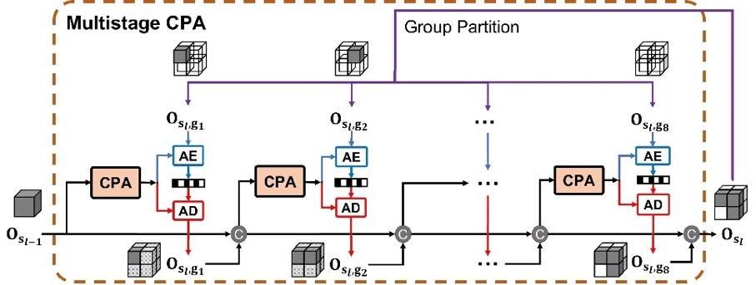

Figure Lossless OPU

# Lossy OPU

Different from lossless OPU, each MP-POV in lossy OPU is used to conduct the probabilistic occupancy classification of POV or non-POV. The lossless OPU minimizes the bitrate consumption by improving the efficiency of CPA to obtain more accurate contextual probability for entropy coding. In contrast, lossy OPU jointly optimize the bits consumption and distortion measures to improve overall R-D performance [3].

The fixed reconstruction process usually involves point vanishing and displacement, producing a visually unpleasant appearance. Point vanishing or displacement is mainly attributed to the resolution downsampling involved in the proposed multiscale representation and other octree-based approaches, and they are highly correlated with content sparsity. For instance, point vanishing dominates when downsampling a solid object point cloud, while point displacement is more visible when downscaling a scant scene sample.

Thus, the scale-dependent fractal dimension is used to quantify a point cloud’s sparsity in [4], i.e., . Here and  are the total number of occupied voxels at scale and , which are carried in the bitstream as the metadata.

Figure 10 illustrates fractal dimension indices for representative point clouds at different bit precisions. As seen, such a scale-wise fractal dimension index reflects the geometric sparsity discussed above.

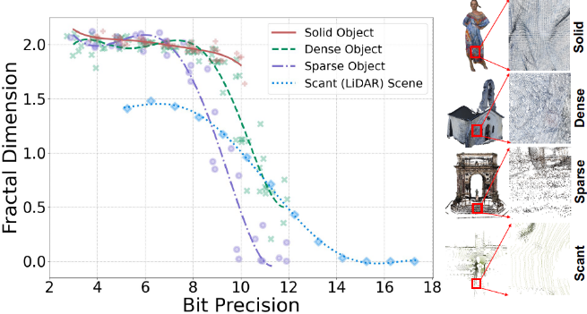

Figure Fractal dimension vs. bit precision for solid/dense/sparse objects and scant scene samples

The content-aware predictive reconstruction (CPR) is proposed to mitigate impairments and reduce distortion. Such a CPR process consists of CPR-V (see Section 2.4.3.3.2) and CPR-D (see Section 2.4.3.3.1) components. Having scale-wise metadata  encapsulated in the compressed bitstream, the can be derived on the fly to adapt CPR-V and CPR-D intelligently. Next, the two basic components of CPR, i.e., CPR-D and CPR-V are explained in detail, which are also illustrated in Figure 11.

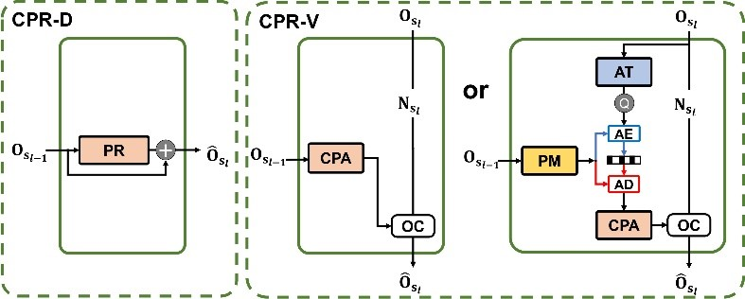

Figure Lossy OPU

# Coordinate refinement of displaced points via CPR-D

The left subplot in Figure 11 depicts the proposed CPR-D. It takes inputs (decoded) from lower-scale prior for predicting residual (PR) so that coordinates can be properly refined as follows:

It is noted that if the occupancy tensor is losslessly compressed at scale ; and if lossy compression is used with quantization noises. Resolution scaling is enforced in this function implicitly.

# Restoring vanished points via CPR-V

The right subplot of Figure 11 visualizes the CPR-V. Similarly, an occupied voxel in is upscaled to eight possibly-occupied voxels at first. As a result, restoring vanished points is equivalent to the occupancy classification (OC) of the possibly-occupied voxel. Assuming a possibly-occupied voxel with a higher probability will have a higher possibility of being an occupied voxel, the core issue again becomes its probability approximation, which is the same as that in lossless OPU.

**Feature augmented CPA.** It turns out that multistage CPA used in lossless OPU is unsuitable in lossy OPU as lossy compression-induced incorrect classification of voxel's occupancy in earlier stages would propagate to the latter ones, and such an error accumulation is very difficult to be characterized and resolved. The naive CPA shown in Equation (1), is a solution, but its probability estimation efficiency is usually limited due to simple one-stage processing.

Recalling that multistage CPA exploits fine-grained correlation from same-scale reconstructed neighbors i.e., through sub-scale grouping for more accurate probability approximation, an alternative solution is to aggregate and embed neighborhood correlation as an auxiliary feature payload to enhance the capacity of CPA. It is called feature augmented CPA for short.

In feature augmented CPA, neural network layers form an analysis transform (AT) to generate feature-space neighborhood embedding which is then quantized and compressed with a neural probability modeling (PM) module that generates the conditional context using (decoded) lower-scale prior. Decoded neighborhood embedding is accordingly attached to the lower-scale prior's coordinates to form for probability estimation, i.e.,

As seen, it can be deduced to if neighborhood embedding is not used, e.g., .

**OC.** Given possibly-occupied voxels and their associated probabilities, a two-step OC decision is then applied. Possibly-occupied voxels at scale can be clustered accordingly so that each patch consisting of eight inter-connected elements, a.k.a a cube, is from the same occupied voxel in . As a result, at least one sub-voxel in each cube patch is occupied. At the first step, a possibly-occupied voxel with the highest probability in each patch is marked as the occupied voxel.

The remaining possibly-occupied voxels are sorted in probability descending order and transform the first elements into occupied voxels accordingly. Here . It is noted that occupied voxels are already determined at the first step. Finally, the same number of occupied voxels are restored as the ground truth at each scale.

# Model description for dynamic geometry coding

This section contains a description of the proposed dynamic geometry coding. The proposed framework enables dynamic coding by warping temporal priors into the lossless and lossy OPUs to exploit spatiotemporal correlations jointly.

As shown in Figure 7, multiscale temporal priors are generated from a (decoded) temporal point cloud reference . Formulating is similar to the generation of multiscale sparse tenors of the current frame discussed in Section 2.4.1. Instead of simply reusing the DDS, the Extractor is proposed to progressively aggregate and embed neighborhood correlations when performing the geometry downsampling dyadically. Thus, temporal prior at scale comprises the geometry coordinates and associated features of all occupied voxels, i.e., .

As temporal motion is inevitable across consecutive frames, the scale-wise temporal priors must be properly warped to the current frame for conditional coding. Here, the Warper is proposed in which it applies a target convolution to transfer the reference's features to the current frame so that spatiotemporal prior is aggregated for lossless or lossy compression in Equation (2) and Equation (4), i.e.,

Figure 12 details the modular unit to exploit spatiotemporal correlations for dynamic coding. Extractor and Warper are implemented by stacking neural network layers (see Figure 13). A target convolutional layer with a fixed kernel size of is utilized in the Warper model to aggregate spatiotemporal prior for dynamic coding.

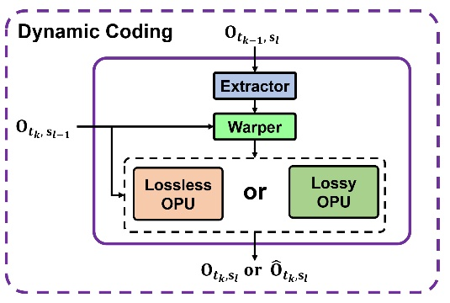

Figure Models in dynamic coding

# 2.4.5. Functional model and neural network

# 2.4.5.1. Functional model

The main functional models of *Unicorn*, i.e., the multistage CPA, the feature augmented CPA and the one-stage CPA, as well as the PR model, are powered with neural networks.

Other neural network modules including AT, PM, Extractor, Warper, etc., are integrated with these functional models to enable desired functionalities.

For example, PM and AT are used in feature augmented CPA, while Extractor and Warper enable dynamic coding.

Figure 13 sketches the neural network blocks used to implement these functional models:

* A DNN block can be fulfilled by simply stacking three Inception ResNet (IRN) blocks in [2] or three NPFormer blocks, as shown in Figure 17. IRN comprises sparse convolutions, while NPFormer relies on neighborhood point attention (NPA).
* Down is a sparse convolution layer (), and is integrated with DNN blocks to build up the AT or Extractor units for neighborhood correlation characterization and embedding.
* Up is a transposed sparse convolution layer () applied to expand an occupied voxel at scale to a corresponding possibly-occupied voxel patch at scale as in the CPA model.

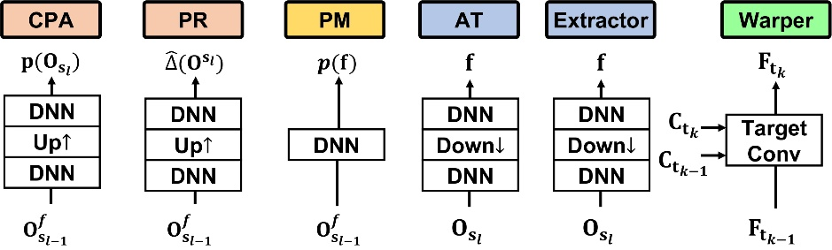

Figure Functional models implemented using neural networks

It is noted that the structure of the Warper module can be different from the current implementation, and it is referred as the new Warper (see Figure 14).

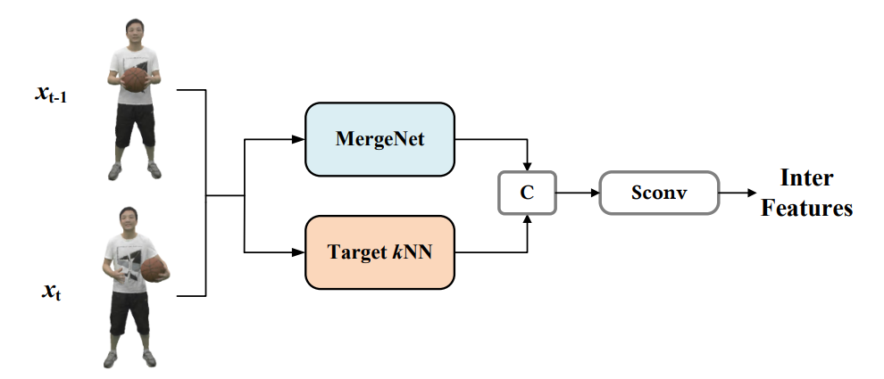

Figure Structure of new Warper

This new Warper mainly consists of MergeNet and Target KNN. The MergeNet is used to substitute the target convolution layer, whose core idea, i.e., Merge operation is to jointly convolve the two reference frames and the current frame according to the following formula. The specific formula and module structure are shown in Figure 15 below:



Figure Structure of MergeNet

The structure of TargetKNN is shown in Figure 16.

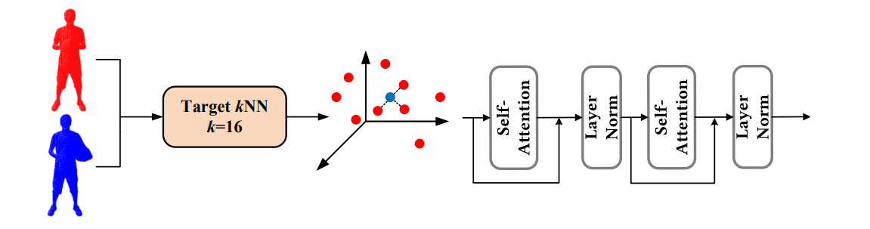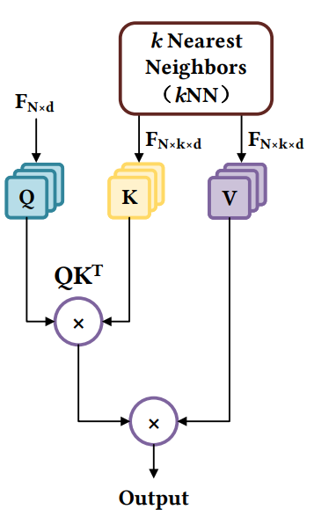

Figure Structure of TargetKNN

This new Warper decreases the storage size of modules (from 9.1MB to 7.0MB) and greatly improves the compression performance on the test sequences of the dynamic dense category. But its compression gain on the test sequences of the dynamic sparse category is not obvious, and it is only used on the test sequences of the dynamic dense category. It also proves the great scalability of our proposed framework.

# 2.4.5.2. Sparse convolution

A sparse tensor, e.g., an occupancy tensor , comprises a set of coordinates and associated features , i.e., . Thus, the sparse convolution is formulated as:

where and are the input and output coordinates, respectively. if the resolution is remains unchanged.

and are the input and output feature vectors at coordinate = (, , ).

defines a 3D local patch with a size of or and the center at in for information aggregation.

**Target convolution** can be supported by setting and in Equation (5) in different frames (at different time stamps), such as the temporal reference and the current frame used in dynamic coding. Therefore, the convolution aggregates related latent features in the reference and transfers them to in the current frame.

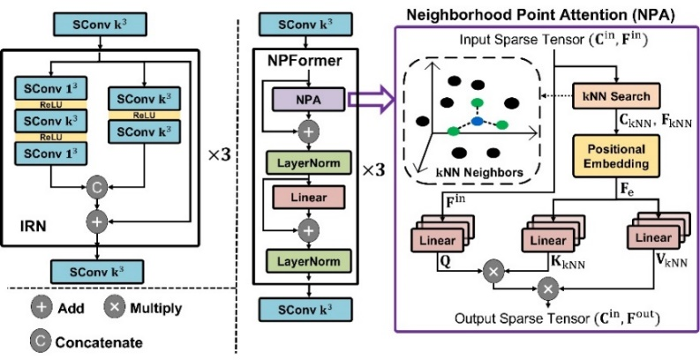

Figure IRN (Left) and NPFormer (Right) used to form the DNN block

# 2.4.5.3. Neighborhood point attention

The architecture of NPA is shown on the right of Figure 17. Assuming the input of a NPA layer is the sparse tensor consisting of coordinates and features , the NN search is conducted for each element in , forming tensors , which is then extended using relative positions, i.e.,

This process is referred to as the positional embedding.

Let , and be the , , and vectors respectively. is linearly transformed from ; and are computed by another two separate linear transformations of . The weights of these three linear transformations are , , and , respectively. Then, the NPA is

The output of NPA is . assumes the same resolution involved in NPA.

The NN neighborhood and the attention mechanism in NPA facilitate the network to adaptively exploit local correlations regardless of the varying density of the underlying content. In contrast, the fixed receptive field setting in sparse convolutions may not be able to include sufficient (and valid) neighbors, especially for sparse contents.

# Training

Functional models, e.g., multistage CPA, feature augmented CPA, one-stage CPA, and PR model, are trained independently, assuming the static coding first. The training is limited to using the data from two consecutive (spatial) scales, and the trained models are applied to any scale without limitations. They are later fine-tuned with the inclusion of Extractor and Warper to support dynamic coding, where two consecutive point cloud frames (from a dynamic sequence) are used.

For a given application scenario, e.g., lossy or lossless compression, static or dynamic coding, solid or scant content, etc., these functional models are properly composited to fulfill the purpose.

All CPA models, i.e., multistage CPA, feature augmented CPA and one-stage CPA try to predict possibly-occupied voxel's occupancy probability. Thus, they first employ binary-cross-entropy (BCE) loss in training:

where is the ground-truth occupancy status: 1 for occupied or 0 for unoccupied and is predicted probability. is the number of original input points used for normalization.

Since feature augmented CPA includes an auxiliary embedding process to characterize neighborhood correlation, an additional cross entropy (CE) loss is augmented:

where the context probability of coding latent feature is conditioned on generated by the probability model using lower-scale prior.

Thus, the total loss used to train feature augmented CPA is , where adjusts the rate-distortion trade-off in lossy coding and is typically set to 1 by default. The adjustment of can control the rate-distortion trade-off to provide more rate points.

The PR model for refining coordinates in CPR-D directly predicts residuals to approach the ground truth. It is optimized using mean square error (MSE) loss:

where , , are the ground-truth residuals, and , , are the predicted residuals.

Further training details, e.g., epoch, learning rate, and device can be found in the attached sheet file.

# Geometry quality scalability

In the geometry codec of *Unicorn*, the compression quality can be adjusted through two separate approaches, which makes the compressed geometry quality scalable possible:

* As described in Section 2.4.2, the geometry coding model consists of two parts, i.e., lossless and lossy phase, which are achieved by lossless OPU and lossy OPU respectively. Adjusting the number of scales allocated to these two phases through adapting the can provide multiple discrete rate points with a single model.
* Apart from controlling the scale factor , *Unicorn* can further realize finer-grained rate control by adjusting the weight of rate-distortion optimization in the feature augmented CPA module during training, i.e., in its loss function . The details can be found in Section 2.4.6. The feature augmented CPA can also be substituted as a one-stage CPA directly.

# Coded bitstream description

# General

This section describes the coded bitstream structure for compressed point clouds.

# Bitstream structure description

The bitstream format of the proposed solution contains two components:

* A V3C container header;
* A geometry component;

The V3C header defines the specifics of the point cloud such as module selection, number of frames in the sequence, etc.

# Geometry component bitstream

The geometry bitstream is represented as a series of OPU outputs, which is comprised of a combination of lossless and lossy OPU coded representations. The decoding process requires sequential reconstruction.

For the lossless phase, the bitstream representing a specific scale can be subdivided into 8 units (stages) corresponding to an octree structure, each corresponding to the occupancy information of the position in the point cloud. It is illustrated in Figure 18.

Figure Geometry bitstream (lossless phase)

As for the lossy phase, the highest scale of the lossless phase is first transformed into the latent feature, then quantized, and finally encoded into bitstream via arithmetic coding. The bitstream is comprised of a header that carries the information about a number of points in each scale and arithmetic coded latent feature payload. It is illustrated in Figure 19.

Figure Geometry bitstream (lossy phase)

# Bitstream parsing process

Below (see Figure 20) exemplify the bitstream structure of geometry component, and whole sequence.

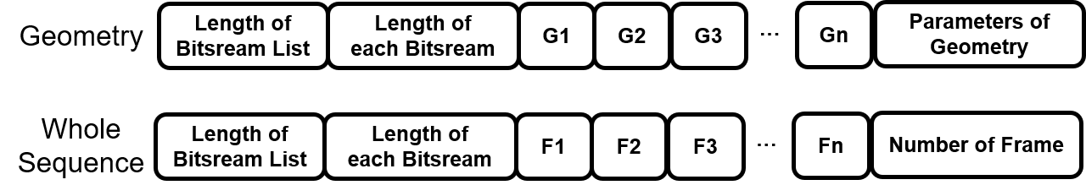

Figure 0 Bitstream structure

The bitstream packaging and reading method is demonstrated in the form of pseudo code below.

Table Bitstream packaging and reading

|  |  |
| --- | --- |
| **Algorithm:** write_bitstream | **Algorithm:** read_bitstream |
| **Input:** bitstream_list, bin_dir, dtype=’uint32’  **Output:** bin_size | **Input:** bin_dir, dtype=’uint32’  **Output:** bitstream_list |
| **1.** bitstream_all = np.array(len(bitstream_list), dtype=dtype).tobytes()  **2.** bitstream_all += np.array([len(bitstream) for bitstream in bitstream_list], dtype=dtype).tobytes()  **3.** for bitstream in bitstream_list:  **4.** assert len(bitstream)<2**32-1  **5.**  bitstream_all += bitstream  **6.** bitstream_all += bitstream  **7.** with open(bin_dir, 'wb') as f:  **8.** f.write(bitstream_all)  **9.** return os.path.getsize(bin_dir)*8 | **1.** with open(bin_dir, 'rb') as fin:  **2.** bitstream_all = fin.read()  **3.** s = 0  **4.** num = np.frombuffer(bitstream_all[s:s+1*4], dtype=dtype)[0]  **5.** s += 1*4  **7.** lengths = np.frombuffer(bitstream_all[s:s+num*4], dtype=dtype)  **8.** s += num*4  **9.** bitstream_list = []  **10.** for l in lengths:  **11.** bitstream = bitstream_all[s:s+l]  **12.**  bitstream_list.append(bitstream)  **13.** s += l  **14.** return bitstream_list |

# Requirements

# Requirements fulfillment

The justification of the requirements fulfillment:

1. Lossy compression  
   The proposed solution supports lossy compression (see Section 2.4.2) through a combination of lossless and lossy coding phases for geometry component.
2. Lossless geometry compression  
   Lossless geometry coding (see Section 2.4.2) is supported by the lossless coding phase, which mainly comprises AI-based probability approximation for geometric occupancy by the lossless occupancy processing units (Lossless OPU, see Section 2.4.3.2), and arithmetic coding units.
3. Lossless attribute compression  
   Not supported
4. Near-lossless geometry compression  
   Adjusting encoder parameters (see Section 2.4.7) can achieve error deviation no more than required by the near-lossless threshold.
5. Near-lossless attribute compression  
   Not supported
6. Temporal variations  
   The geometry codec module of *Unicorn* supports temporal variations coding (see Section 2.4.4).
7. Low latency  
   By adjusting the encoder parameter (see Section 2.4.7), the proposed solution supports latency with a granularity of a single frame.

The average encoder inference speed is 2330 ms for dynamic sparse content, and 970 ms for dynamic dense content.  
The average decoder inference speed is 1430 ms for dynamic sparse content, and 1910 ms for dynamic dense content.

1. Low complexity  
   The AI-based model's complexity is 38% compared to the anchor in dynamic dense category, 55% to the anchor in static dense category, and 90% to the anchor in Cat dynamic sparse category. The maximum inference memory requirement is 10834 MB.
2. Temporal scalability  
   The temporal scalability is achieved by dropping specific P frames, which can be easily accomplished considering the bitstream structure described in Section 3.
3. Spatial scalability  
   The spatial scalability is achieved by early termination and adaptive transmission of the bottleneck layer. For example, spatial scalability can be achieved by partial reconstruction and early decoding termination in the lower scale rather than the highest scale, whereas the scale corresponds to the spatial resolution of the point cloud.
4. Region-based scalability  
   It is not supported in the current implementation; It is supported in principle by specifically setting encoder parameter on regions of interests. However, with the current implementation some blocking artifacts may appear on the ROI boundary.
5. Quality scalability  
   Supported in the current implementation by indicating a certain spatial resolution with subsequent processing by geometry codec that applies feature augmented up-sample block with corresponding lambda parameter or by dropping features, etc. (see Section 2.4.7).
6. Spatial random access  
   It is not supported in the current implementation; However, it is supported in principle by spatially partitioning the input point cloud and coding them respectively.
7. Temporal random access  
   Supported on frame level granularity for dynamic sparse and dynamic dense content.
8. Error resilience  
   Error concealment is supported on a frame level by dropping specific bitstreams (P frames), which can be easily accomplished considering the bitstream structure described in Section 3.2.
9. Parallel encoding and decoding  
   The various scales can be compressed independently by this encoder, however the decoder is a sequential process.
10. Separable attribute and geometry coding  
    The bitstream of geometry can be containerized in v3c elementary bitstream.
    1. Geometry only coding  
       Supported
    2. Multiple attribute coding  
       Not supported
11. Geometry precision  
    The supported geometry coding precision range is up to 22 bits. The range may be extended by applying spatial subdivision to avoid memory overflow caused by the excessive number of points. There is no bit depth limit technology wise.
12. Model architecture  
    The model description for geometry coding can be found in Section 2.4;  
    The architecture of geometry models is stable.
13. Model update
    1. On the fly Model Update  
       Not supported. The model parameters are unified across data types and rate points. The model update can improve the compression performance according to the application seniors, but it is not necessary for such a model update, not to mention a sequence-specific update.
    2. On-demand Model Update & download  
       Model parameters update can be updated on demand by distributing updated model parameters. The decoder can download the model demanded prior to operation.
14. Inference Reproducibility  
    A proponent confirmed the inference reproducibility on several platforms and that it is available for x-check upon request.

# Coding results objective quality

The objective results can be found in the attached spreadsheet file.

# Reference

1. **WG2, MPEG Technical requirements.** Requirements for AI-based Point Cloud Coding. *ISO/IEC JTC 1/SC 29/WG2.* 2024.

2. **Jianqiang Wang, Dandan Ding, Zhu Li, Xiaoxing Feng, Chuntong Cao, Zhan Ma.** Sparse Tensor-based Multiscale Representation for Point Cloud Geometry Compression. *IEEE Trans. Pattern Analysis and Machine Intelligence.* July 2023, pp. 9055-9071.

3. **Sullivan, G.J. and Wiegand, T.** Rate-distortion optimization for video compression. *IEEE signal processing magazine.* 1998, pp. 74--90.

4. **Hausdorff, Felix.** Dimension und äußerem Maß. *Mathematische Annalen.* 1918, Vol. 79.