Use Stimulated Annealing Algorithm to solve TSP
1. Method and step introduction
A. What is annealing algorithm?
The simulated annealing algorithm comes from the principle of solid annealing. In thermodynamics, annealing phenomenon refers to the physical phenomenon that the object gradually cools down. The lower the temperature, the lower the energy state of the object will be. When the temperature is low enough, the liquid begins to condense and crystallize. In the crystallized state, the system has the lowest energy state. Nature finds the lowest energy state when the temperature is slowly cooled (that is, annealed): crystallized. Eventually, the system will be stable.

B. What are the attributes of this algorithm?
1. There is a certain probability of jumping out of the local optimal solution
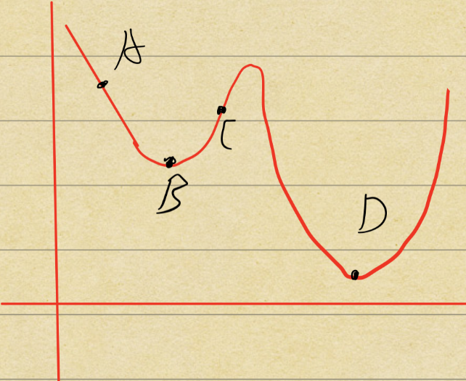
Figure1
In Figure1, we start from point A. Suppose we apply Hill climbing, each time the best neighborhood solution will be found. Ultimately, we reach the local minimum solution, which is point B. Unfortunately, we can never jump out of the local minimum solution. The reason is that all the neighborhood solution is worse than B. In this case, the greedy strategy will not accept point C. Then we can’t reach the global minimum, which is point D.
However, stimulated annealing algorithm has a certain probability of jumping out of the point B. The reason is that the process of annealing allows molecules have enough time to find a balance under each temperature. Similarly, in TSP, the algorithm can find a balanced solution at each point even if it’s a bad solution compared to the local minimum. In other word, the algorithm has a certain probability of accepting a bad solution.
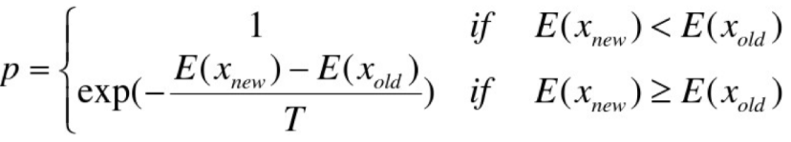
Figure2
Figure2 shows the specific probability that the algorithm accepts a bad solution. If p>random (0,1), the solution will be accepted. More specifically, if new energy is low than the old energy, meaning that the new solution is better than old solution, p=1. It means that if new solution is better, the new solution will be absolutely accepted. Whereas, when new solution is worse, p will be calculated according to the second formula. Again, if p> random (0,1), the bad solution will be accepted.

2. The probability decreases along with the decrease of the temperature
In Figure2, the formula of p was demonstrated. In this part, the second formula will be analyzed. When T(temperature) decreases, the 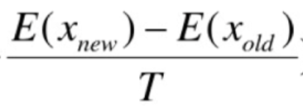 increases because T is the denominator. There is a negative sign, so the base will be (1/e) instead of e. Then the diagram will show like Figure3.
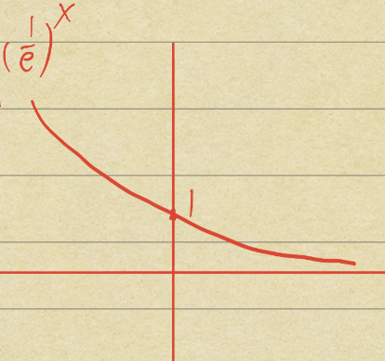
Figure3
With the increasement of 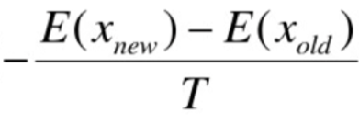, p will decrease as Figure3 shows.
2. Method flow chart
1. Set an initial temperature.
2. Judge whether the current temperature is higher than minimum temperature. (if not go to step 7)
3. if the algorithm reaches the maximum of internal loop, jump out of the internal loop (go to step 5). Else, calculated each neighborhood solution’s possibility to determine whether accept the neighborhood solution or not.
4. Update the best solution in the history.
5. Cool down
6. Go to step 2
7. return best solution
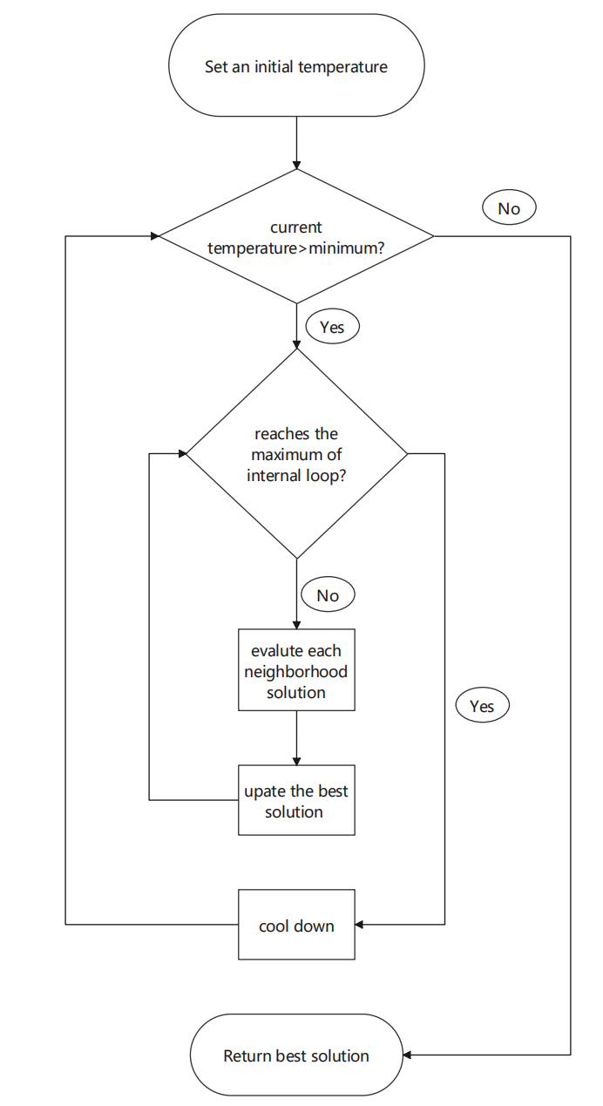
Figure4
3. Design details

4. Experimental procedure

5. Assessment:
A. Quality of obtained solutions
B. Convergence time
C. Stability

6. Discussion and Conclusion

