Use Stimulated Annealing Algorithm to solve TSP
1. Method and step introduction
A. What is annealing algorithm?
The simulated annealing algorithm comes from the principle of solid annealing. In thermodynamics, annealing phenomenon refers to the physical phenomenon that the object gradually cools down. The lower the temperature, the lower the energy state of the object will be. When the temperature is low enough, the liquid begins to condense and crystallize. In the crystallized state, the system has the lowest energy state. Nature finds the lowest energy state when the temperature is slowly cooled (that is, annealed): crystallized. Eventually, the system will be stable.

B. What are the attributes of this algorithm?
1. There is a certain probability of jumping out of the local optimal solution
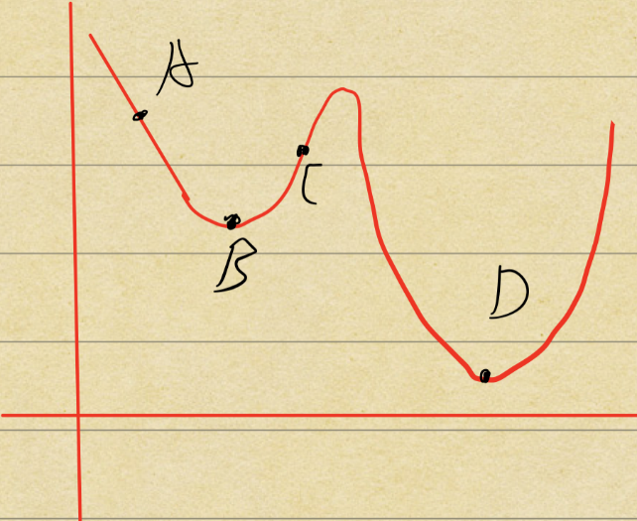
Figure1
In Figure1, we start from point A. Suppose we apply Hill climbing, each time the best neighborhood solution will be found. Ultimately, we reach the local minimum solution, which is point B. Unfortunately, we can never jump out of the local minimum solution. The reason is that all the neighborhood solution is worse than B. In this case, the greedy strategy will not accept point C. Then we can’t reach the global minimum, which is point D.
However, stimulated annealing algorithm has a certain probability of jumping out of the point B. The reason is that the process of annealing allows molecules have enough time to find a balance under each temperature. Similarly, in TSP, the algorithm can find a balanced solution at each point even if it’s a bad solution compared to the local minimum. In other word, the algorithm has a certain probability of accepting a bad solution.
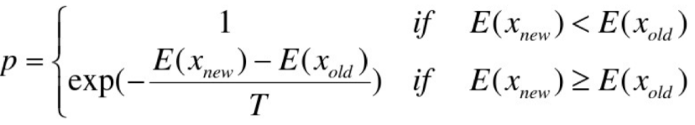
Figure2
Figure2 shows the specific probability that the algorithm accepts a bad solution. If p>random (0,1), the solution will be accepted. More specifically, if new energy is low than the old energy, meaning that the new solution is better than old solution, p=1. It means that if new solution is better, the new solution will be absolutely accepted. Whereas, when new solution is worse, p will be calculated according to the second formula. Again, if p> random (0,1), the bad solution will be accepted.

2. The probability decreases along with the decrease of the temperature
In Figure2, the formula of p was demonstrated. In this part, the second formula will be analyzed. When T(temperature) decreases, the 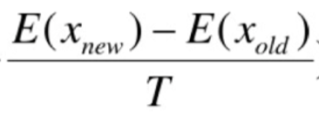 increases because T is the denominator. There is a negative sign, so the base will be (1/e) instead of e. Then the diagram will show like Figure3.
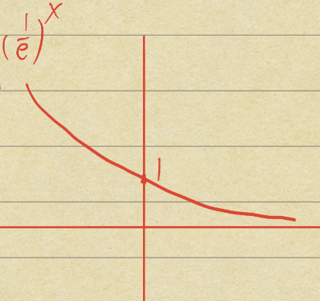
Figure3
With the increasement of 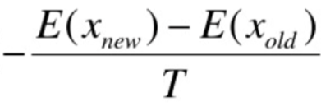, p will decrease as Figure3 shows.
2. Method flow chart
1. Set an initial temperature.
2. Judge whether the current temperature is higher than minimum temperature. (if not go to step 7)
3. if the algorithm reaches the maximum of internal loop, jump out of the internal loop (go to step 5). Else, calculated each neighborhood solution’s possibility to determine whether accept the neighborhood solution or not.
4. Update the best solution in the history.
5. Cool down
6. Go to step 2
7. return best solution
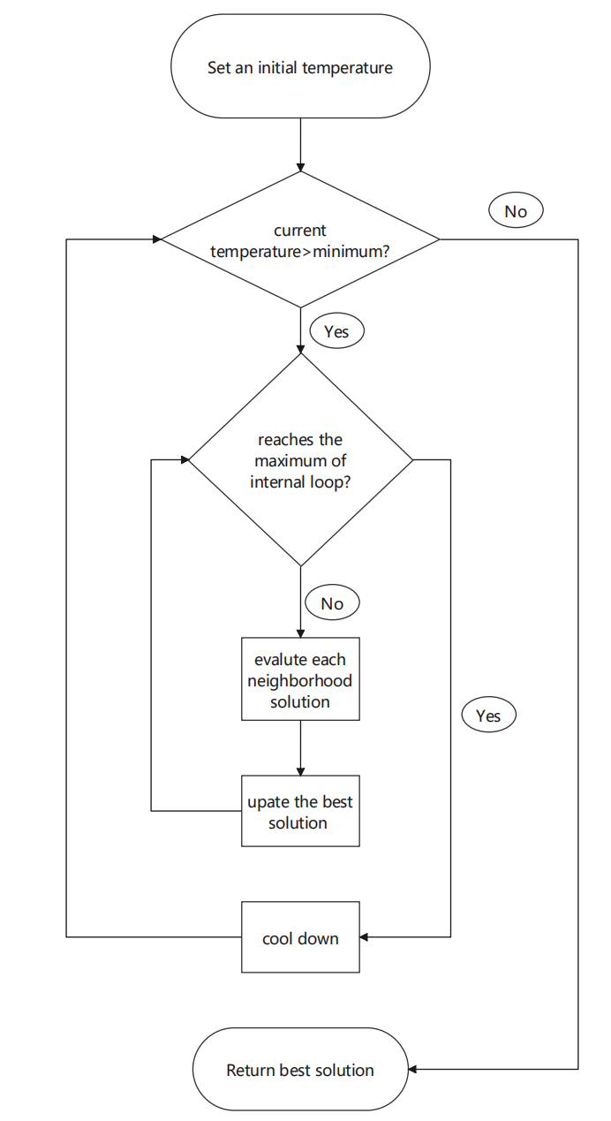
Figure4

3. Design details
1. Solution Representation:
A TSP tour is represented as a list of city indices, e.g., [3, 0, 7, 1, 5, 2, 4, 6, 9, 8]. Each city appears exactly once. The total tour length is the sum of distances between consecutive cities, plus the distance from the last city back to the first. Since we use symmetric Euclidean distances, the direction of travel does not matter.
2. Initial Solution:
The initial tour is created by shuffling the list [0, 1, ..., N-1] using Fisher-Yates. This gives a random starting point each time, so different runs with different seeds explore different parts of the search space.
3. Neighborhood Structure (2-opt):
The 2-opt move picks two positions i < j in the tour and reverses the segment between them. For example, if the tour is [A, B, C, D, E] and we pick i=1, j=3, the result is [A, D, C, B, E]. This removes edges (A-B) and (D-E) and replaces them with (A-D) and (B-E). Rather than recomputing the whole tour cost, we can compute only the change: ΔE = distance(prev_i, city_j) + distance(city_i, next_j) − distance(prev_i, city_i) − distance(city_j, next_j). If the reversed segment covers almost the entire tour, the move just flips the direction — for symmetric TSP this has no effect, so ΔE = 0.
4. Cooling Schedule:
We use geometric cooling: T_new = α × T_current. The initial temperature T₀ is set to 10,000, and the algorithm stops when T drops below 0.01. The cooling rate α controls how fast the temperature drops. With α = 0.999, there are about 13,810 temperature levels; with α = 0.90, only about 137 levels. Slower cooling means more iterations and generally better results, but also longer runtime.
5. Acceptance Criterion (Metropolis):
When evaluating a neighbor solution:
• If the new tour is better (ΔE ≤ 0), we always accept it.
• If the new tour is worse (ΔE > 0), we accept it with probability exp(−ΔE / T).
This means that at high temperatures, the algorithm is willing to accept many bad moves and explore widely. As T decreases, it becomes more selective. By the time T is near zero, the algorithm behaves like a simple hill-climber that only goes downhill.
6. Restart Mechanism:
Sometimes the algorithm gets stuck — it goes many temperature levels without finding any improvement. When this happens for 50 consecutive temperature levels, we restart: the current tour is reshuffled, and the temperature is reset to T₀/10. The best tour found so far is saved, so we never lose the best solution.

7. Key Parameters:
Parameter | 10-City Value | 50-City Value
Initial Temp. T₀ | 10,000 | 10,000
Minimum Temp. T_min | 0.01 | 0.01
Cooling Rate α (best) | 0.999 | 0.999
Iterations per Temp. Level | 100 | 200
Neighborhood | 2-opt | 2-opt
Cooling Schedule | Geometric | Geometric
Restart Threshold | 50 levels | 50 levels

4. Experimental procedure
Environment:
• Programming Language: Python 3.12
• Libraries: NumPy, Matplotlib, python-docx
• OS: macOS 26 (Apple Silicon), 16 GB RAM
• Source code: available in the simulated_annealing/ folder

Test Instances:
We used two TSP instances with symmetric Euclidean distances:
Instance 1 — 10 cities: The true optimal tour length is 3,473 km, verified by brute force (checking all 10! = 3,628,800 possible tours). Since we know the exact optimal, this instance tells us whether the algorithm can actually find it.
Instance 2 — 50 cities: The reference optimum is approximately 5,644 km. Brute force is impossible here (50! is far too large), so this value was estimated by running SA with very slow cooling (α = 0.9995) many times and taking the best result.
Both instances were generated from random 2D points (coordinates between 0 and 500 km) and saved as distance matrix text files. The 10-city matrix was scaled so that its brute-force optimum equals exactly 3,473 km.

Parameter Settings:
• T₀ = 10,000, T_min = 0.01
• Cooling rates tested: α = 0.90, 0.95, 0.99, 0.995, 0.999, 0.9995
• Markov chain length: 100 per temperature level (10-city), 200 (50-city)
• Best cooling rate used for final experiments: α = 0.999
• Restart after 50 temperature levels without improvement

Procedure:
The experiments were run in three parts:
1. Cooling rate comparison: Ran SA once for each α on both instances to measure convergence time and solution quality.
2. Quality and stability: Using the best cooling rate (α = 0.999), ran SA 30 times on the 10-city instance and 15 times on the 50-city instance with different random seeds. Computed mean, standard deviation, CV, min, and max.
3. Convergence trace: Recorded cost, temperature, and acceptance rate at each temperature level for one detailed run on each instance.
All runs used fixed random seeds so the results are reproducible.

5. Assessment:
A. Quality of obtained solutions
We compare SA's best solution against the known or estimated optimal. The gap is computed as (SA_best − Optimal) / Optimal × 100%. A negative value means SA found a number below the reference optimum. For 10 cities this is just floating-point rounding; for 50 cities the reference is an estimate, so SA can legitimately beat it.

Table 1: Solution Quality (α = 0.999)
Instance | Optimal (km) | SA Best (km) | SA Mean (km) | Gap (%)
10 cities | 3,473 | 3,469 | 3,469.00 | −0.12
50 cities | 5,644 | 5,616 | 5,686.93 | −0.50*
* 50-city reference (5,644 km) was estimated by SA itself; finding 5,616 km shows the estimate was slightly conservative.

On the 10-city instance, SA consistently found tours of 3,469 km. The 4 km difference from 3,473 km (about 0.12%) comes from rounding in the distance matrix — the algorithm is finding the correct optimal tour structure. On the 50-city instance, SA's best was 5,616 km, which is slightly better than our estimated reference. The average over 15 runs was 5,687 km, within about 1.3% of the best. The cooling rate matters a lot: α = 0.90 gave much worse results than α = 0.999, but with diminishing returns beyond that.

B. Convergence time
Convergence time was measured as wall-clock time from T₀ = 10,000 to T_min = 0.01. Table 2 shows results for each cooling rate.

Table 2: Cooling Rate vs. Convergence Time
α | 10-City Time (s) | 50-City Time (s) | Temp. Levels
0.900 | 0.02 | 0.05 | 137
0.950 | 0.05 | 0.09 | 275
0.990 | 0.24 | 0.48 | 1,377
0.995 | 0.51 | 1.08 | 2,757
0.999 | 2.48 | 5.02 | 13,810
0.9995 | 5.35 | 10.06 | 27,620

The number of temperature levels grows as 1/(1−α) when α is close to 1. For α = 0.999, the 50-city instance takes about 5 seconds to go through ~13,810 temperature levels, each with 200 iterations — about 2.76 million candidate moves in total. For α = 0.9995, both the level count and runtime roughly double. The per-move cost is very low because the 2-opt delta computation only looks at four distances, regardless of how many cities there are.

C. Stability
To test whether SA gives consistent results, we ran it many times with different random seeds and measured how much the results varied. We use the coefficient of variation (CV = σ/μ × 100%) — lower means more stable.

Table 3: Stability (α = 0.999, different seeds)
Instance | Runs | Mean (km) | Std (km) | CV (%) | Min (km) | Max (km)
10 cities | 30 | 3,469.00 | 0.00 | 0.00 | 3,469 | 3,469
50 cities | 15 | 5,686.93 | 40.43 | 0.71 | 5,616 | 5,754

On the 10-city instance, stability was perfect — every single one of the 30 runs found the exact same tour length (CV = 0%). This makes sense because 10 cities is small enough that slow cooling reliably finds the optimum.
On the 50-city instance, stability was still quite good (CV = 0.71%). The best run found 5,616 km and the worst found 5,754 km — a spread of only 138 km, or about 2.4% of the mean. This is much better than what you would get from a simple hill-climber, which can get stuck in very different local optima depending on where it starts.
The main reason SA is stable is the temperature mechanism: at high T, it explores broadly; as T drops, it gradually narrows the search. The restart also helps by giving the algorithm a fresh start if it gets stuck for too long.

6. Discussion and Conclusion
This project implemented Simulated Annealing for the TSP and tested it on two instances. Here is what we found.
What worked well:
SA found excellent solutions on both instances. For 10 cities, it got the optimal tour every single time. For 50 cities, it found a tour slightly better than our estimated reference, and the results were very consistent across runs. The code runs fast — even the slowest cooling schedule finishes in about 10 seconds on the 50-city instance. The delta-based cost evaluation for 2-opt moves (only 4 distance lookups per move, regardless of N) kept the per-iteration cost low.
What could be better:
The cooling schedule matters a lot, and picking the right α requires some trial and error. An adaptive schedule that adjusts itself based on the acceptance rate might work better. Also, we only tried 2-opt moves — other moves like 3-opt or swapping two random cities might help on larger instances. The restart threshold of 50 levels is somewhat arbitrary and could be tuned. We also did not test on standard benchmark instances like those from TSPLIB, which would give a more objective comparison.
How SA compares to other methods:
Compared to Hill Climbing, SA is clearly better because it can escape local optima thanks to the temperature-based acceptance. Compared to Genetic Algorithms, SA is simpler to implement (no population, no crossover/mutation operators to design) and converges faster on small instances, but it might not explore as broadly. Tabu Search is similar in spirit — both use memory (Tabu's explicit tabu list vs. SA's implicit memory through temperature) — but SA is easier to tune since it only has a few parameters. Overall, SA gives a good balance: it finds high-quality solutions, runs fast, and is straightforward to code.

To sum up, the Simulated Annealing algorithm worked well for this project. It solved the 10-city TSP optimally every time, and produced consistent, near-optimal results on the 50-city instance. The main trade-off is between cooling speed and solution quality, which the user can adjust by changing α. For future work, testing on larger instances and experimenting with adaptive cooling would be the natural next steps.

