单元测试

I. 单项选择（每小题1分，共15分）

( ) 1. —Jack, do you know _______ girl in red over there?

—Yes. She is _______ old friend of mine.

A. a; the B. the; a C. a; an D. the; an

( ) 2. —Do you and Lily live in the same building?

—Yes. I live two floors ________ her. She lives on the fifth floor and I live on the third floor.

A. above B. under C. below D. over

( ) 3. My grandfather’s birthday is on June ______ and my father plans to give him two _____ *yuan*, a big cake and some flowers as his presents.

A. the eight; thousand B. the eighth; thousand

C. the eighth; thousands D. eight; thousands

( ) 4. —Is this your classroom, Jack and Daniel?

—No, it’s _______. ________ is just next to it.

A. Sandy’s and Lily’s; Mine B. Sandy and Lily’s; Mine

C. Sandy’s and Lily’s; Ours D. Sandy and Lily’s; Ours

( ) 5. —Where shall we go for the weekend?

—Let’s go to the _______. We can enjoy Beijing opera together.

A. post office B. police station C. theatreD. bank

( ) 6. —There is a(n) _______ in front of the school hall. What’s it about?

—It’s about the celebration of New Year’s Day.

A. notice B. information C. news D. message

( ) 7. —Is there _______ to eat? I’m quite hungry.

—Sorry, there is ________. Let me take you to the nearest restaurant for a meal.

A. anything; something B. something; something

C. anything; nothing D. everything; anything

( ) 8. —Look out! The big dog is _______. Keep away from it.

—OK. Thank you for telling me about that.

A. funny B. dangerous C. helpful D. lucky

( ) 9. —Jack, I’m sorry. I can’t find my money for the film *ticket* (票). I must go back home to get some.

—You _______ go back. I have enough money for two tickets.

A. don’t have toB. have to C. shouldn’t D. may

( ) 10. —What do you think of the music?

—It _______ very sweet. I like it very much.

A. looks B. smells C. tastes D. sounds

( ) 11. —You don’t look happy. What’s wrong?

—I’m _______ the English *test* (测试) tomorrow. I’m not good at it at all.

A. learning about B. talking about C. worrying about D. thinking about

( ) 12. —Don’t feed the monkeys any food. That may make them ill.

—OK, I ________.

A. will B. won’t C. do D. don’t

( ) 13. —I often go to the forest and hear the birds _______ at the weekend. What about you?

—I work as a volunteer at the community centre and I’m ready _______ others.

A. sing; to help B. to sing; to help C. singing; helping D. sing; helping

( ) 14. —________ is Nanjing from Xuzhou?

—It’s about four hours by car.

A. How far B. How long C. How soon D. How often

( ) 15. —Hello! May I speak to Mr Wang?

—Sorry, he is out. ________

A. Who are you? B. What’s wrong with you?

C. Will you tell him anything? D. Can I take a message for you?

II. 完形填空（每小题1分，共10分）

My grandparents live far away from us. It’s about 1.5 hours’ drive from our house. The road to my grandparents’ home is not very 16 . There are not many cars.

17 a rainy Saturday, Dad and I go to visit my grandparents. But our car breaks down (坏) on the way. Dad tries to find out what the 18 is. But he knows 19 about cars. We are in the middle of nowhere. Then we have to 20 in the rain and hope that someone can help us.

We wait for about half an hour and then a truck driver offers (提出) to drive us there. It 21 us twenty minutes to get there. We 22 the driver and get off the truck.

When we get to my grandparents’ home, we find the 23 is locked (锁着的). I can’t believe how 24 we are. Then Dad calls my grandmother to find that they are at the door of our house.

That is an important lesson for us. We’ll never forget to make a 25 first before we visit someone’s home.

( ) 16. A. quiet B. straight C. busy D. fresh

( ) 17. A. At B. On C. In D. Of

( ) 18. A. problem B. sign C. treasure D. notice

( ) 19. A. anything B. something C. everything D. nothing

( ) 20. A. sit B. stand C. lie D. drive

( ) 21. A. costs B. takes C. needs D. spends

( ) 22. A. thank B. follow C. remember D. check

( ) 23. A. car B. window C. door D. truck

( ) 24. A. funny B. dangerous C. helpful D. unlucky

( ) 25. A. call B. plan C. wish D. video

. 阅读理解（每小题2分，共20分）

**A**

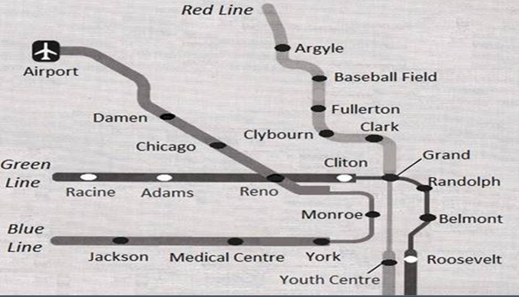

( )26. In the map, the airport is ___________ of Reno.

A. north-west B. south-west C. south-east D. north-east

( )27. ___________ meet at Grand.

A. Red Line and Green Line B. Green Line and Blue Line

C. Blue Line and Red Line D. Red Line, Green Line and Blue Line

( )28. There are ___________ stops from Youth Centre to Argyle.

A. three B. four C. five D. six

( )29. To go to Adams from Randolph, Kitty should get off at the _______ stop.

A. seventh B. sixth C. fifth D. fourth

( )30. Amy is going to Damen from Roosevelt. She should change lines at _______.

A. Cliton B. Reno C. Grand D. Adams

**B**

Sarah wants to keep a pet (宠物), so she goes to Mr Lee’s pet shop in the morning. Sarah looks around and she finds many cute dogs, cats and other animals. They are waiting for their new owners in the shop.

Sarah: Let me see. They are all so cute! But I really don’t know which one can be a good pet. Mr Lee, can you give me some advice (意见)?

Mr Lee: Sure. Kangaroo rats (囊鼠) are popular these days. They look like a mini kangaroo (小袋鼠) and they can jump like a kangaroo. Look! Here is one.

Mr Lee shows a kangaroo rat to Sarah. She reads the information about the kangaroo rat.

|  |
| --- |
| Name: Delmont  Kind: Kangaroo rat  Place: North America  Body height: 13 cm  Tail length (尾巴长度): 17 cm |

Sarah: Its name is Delmont. Wow, its tail is longer than its body.

Mr Lee: Yes, its tail is very long.

Sarah: It’s very funny. Wait a minute, Mr Lee. Is Delmont sick? Look at his bowl. It’s full of water.

Mr Lee: No! Don’t worry about it. Kangaroo rats don’t drink water as much as other animals.

Sarah: OK. Then, I’ll choose Delmont. I can’t wait to take it home.

( ) 31. Sarah comes to Mr Lee’s pet shop to _______.

A. say hello to Mr Lee B. buy a pet

C. help Mr Lee with his work D. wait for a friend

( ) 32. Sarah asks Mr Lee for some advice on ________.

A. how to look after a pet B. when to give water to a pet

C. how to work with animals D. what to keep as a pet

( ) 33. Delmont ________.

A. is the name of a kangaroo B. is really tall

C. has a long tail D. enjoys jumping

( ) 34. Which of the following is TRUE?

A. Kangaroo rats drink more water than other animals.

B. Kangaroo rats are as tall as a baby kangaroo.

C. Kangaroo rats can jump like kangaroos.

D. Kangaroo rats eat less food than other animals.

( ) 35. We can learn from the passage that ________.

A. Sarah likes her new pet very much B. Sarah hopes to find another pet

C. Sarah enjoys playing with animals D. Sarah is afraid of kangaroo rats

IV. 填空（每小题1分，共15分）

A. 根据所给的首字母或汉语提示完成句子。

36. —Look, what are the children doing over there?

—They are p________ for the coming English party.

37. —Shall we buy some food and drinks for the school trip?

—No. We have p________ of food and drinks now.

38. Those (邮递员) are all from Suzhou, right?

39. Tomorrow, my father will celebrate his _________ (四十) birthday.

40. There is a ________(双人的) bed in the room.

B. 根据句意，用括号内所给单词的适当形式填空。

41. —Where is Mrs Yang?

—She is chatting with a friend of _________ (her) under the tree.

42. The boy is very naughty (顽皮的). There are lots of ______ (break) toys in his bedroom.

43. Hou Jue is a good writer and you can find lots of _______(work) of his in the bookshop.

44. The children in the poor areas are looking forward to _________ (live) a happy life like those in big cities.

45. — Do you like the coffee?

— Yes. It tastes very nice. But it will be much _______(good) with some milk in it.

C. 从方框里选择合适的词或词组，并用其正确形式填空。

|  |
| --- |
| art, smell the flowers, dining room, nine, do some shopping |

Amy: Can you tell me something about yourself?

Lisa: No problem. What do you want to know?

Amy: Do you live in a flat or a house?

Lisa: In a flat. It’s on the (46) _____ floor, so I have to take the lift (乘电梯) every day.

Amy: Which is your favourite room?

Lisa: The (47) _______. I can enjoy different kinds of nice food there.

Amy: What’s your hobby?

Lisa: I enjoy (48)_______, and I like drawing.

Amy: Do you want to be an (49)_______ in the future?

Lisa: Yes. I’m interested in different works of art.

Amy: How do you usually spend your weekend?

Lisa: On Saturday, I do my homework at home. On Sunday, I often meet my friends and have fun with them. Sometimes, I go to the park (50)_______.

. 阅读下面的材料，根据首字母提示，用合适的单词填空。（每小题1分，共10分）

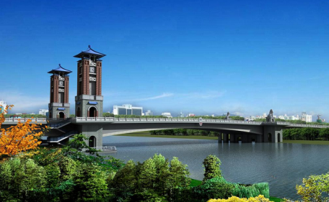

My hometown is in the north of Jiangsu Province. It’s a small and quiet town. There are not many *factories* (工厂), so the air is always very (51) f________. People (52) r________ pigs and hens and live a happy life. Local people are all very (53) f________ and they always give their helping hands to people in need. There is a community centre in my neighbourhood. People with different (54) s________ often help others with different problems at the weekend. Some of them are (55) e________ and they can help check and fix computers.

There is a small park in my town. Inside the park there is a round lake. At the weekend, I like (56) r________ a boat on the lake. The park is usually (57) f________ of happy children on Sunday.

Liu Qiangdong comes from my hometown. Now, he is (58) f_________ all over China. He is my hero. I have a dream. I hope to go to a (59) c________ after I finish the middle school. When I grow up, I wish to have a big company of my (60) o_______ like Liu Qiangdong.

VI. 根据要求完成句子。每空一词。（每小题3分，共15分）

61. There is an interesting show on TV now. (用tomorrow改写句子)

There ________ ________ an interesting show on TV____________.

62. There is something wrong with my new watch. (改为否定句)

There ________ ________ ________ with my new watch.

63. What about watching the Great Wall at the cinema this evening? (改为同义句)

_______ _______ _______ the Great Wall at the cinema this evening?

64. 他计划本周末去美术馆看国画。(完成句子)

He plans to go to the art museum to ________ _______ _______ this weekend.

65. 将来我想当个社会工作者。(完成句子)

I would like to be a social ________ ________ the ________.

VII.书面表达（15分）

假如你是Jenny，你的美国朋友Tom来到你们城市，想去学校找你，他此时在图片中的Police Station位置，请你写一篇短文，向Tom描述到School的路线。

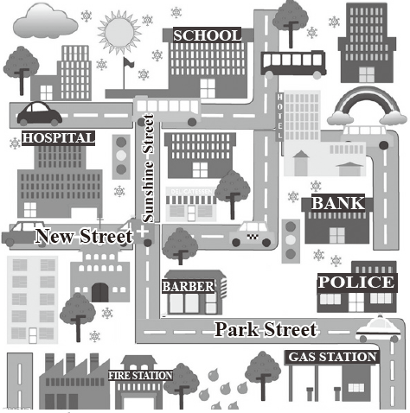

**要求：**1. 条理清楚、意思连贯、语句通顺、标点正确；

2. 70词左右。

**提示词：**Barber’s shop 理发店

_________________________________________________________________________

____________________________________________________________________________

参考答案：

1-5 DCBDC 6-10 ACBAD 11-15 CBAAD

16-20 CBADB 21-25 BACDA

26-30 AADDB 31-35 BDCCA

36. preparing 37. plenty 38. postmen 39. fortieth 40. double

41. hers 42. broken 43. works 44. living 45. better

46. ninth 47. dining room 48. doing some shopping 49. artist 50. to smell the flowers

51. fresh 52. raise 53. friendly 54. skills 55. engineers

56. rowing 57. full 58. famous 59. college 60. own

61. will be; tomorrow 62. isn’t anything wrong / is nothing wrong

63. Why not watch/ Shall we watch

64. see Chinese paintings 65. worker in; future

**One possible version:**

Tom, it’s not difficult for you to get to my school. Now you are at the police station on Park Street. Walk along the street and you’ll see a Barber’s shop. Then turn right into Sunshine Street. Go up the street and turn right at the second crossing. Then you are on New Street. Walk for about two hundred metres and then you will see the school on the left. The classroom building is white and green. You won’t miss it.