单元测试

I. 单项选择（每小题1分，共15分）

( ) 1. My aunt is office worker. She works in a big company near Xinjiekou.

A. a B. an C. the D. /

( ) 2. — Usually, the biggest city of a country is its capital, but the capital of isn’t its biggest city.

— That’s true. Toronto isn’t a capital city.

A. France B. Russia C. Japan D. Canada

( ) 3. Mr and Mrs Green want a car of own, and then they can drive to work.

A. they B. them C. their D. theirs

( ) 4. Wu Li lives in our building. She is really a good because she is always ready to help people around her.

A. visitor B. waiter C. neighbour D. teacher

( ) 5. With few cars and people, the town is very at night.

A. beautiful B. modern C. fresh D. quiet

( ) 6. The window is about 30 cm that boy’s head, so he must stand on a chair to close it.

A. above B. under C. below D. behind

( ) 7. — How much do you know about James?

— Not much. He never says about his life.

A. something B. anything C. nothing D. everything

( )8. — Is there a No. 2 bus stop near here?

— Yes, there is. left at the traffic lights, and you will find it.

A. Turn B. Turns C. To turn D. Turning

( ) 9. — How do you like your grandpa’s pet bird?

— Very much. I enjoy listening to her every morning.

A. sing B. sings C. to sing D. to singing

( ) 10. — Jim, never cross the road here. There are too many cars.

— OK. I . Thank you.

A. can’t B. don’t C. am not D. won’t

( ) 11. — Can you come to my party this Sunday evening?

— Sorry, I’m not sure. I will go I’m free.

A. and B. if C. but D. so

( ) 12. — is it from your school to the biggest Western restaurant in the town?

— About fifteen minutes on foot.

A. How long B. How far C. How much D. How often

( ) 13. There is some fish in the fridge. Mum it for dinner.

A. is cooking B. will cook C. to cook D. cooked

( ) 14. — your new classmate like?

— He is very kind and friendly.

A. How is B. What does C. What is D. How does

( ) 15. — What is your plan for tomorrow, Simon?

— .

A. I am doing some washing B. I am going to visit my uncle

C. I had a good time there D. I often do my homework at home

II. 完形填空（每小题1分，共10分）

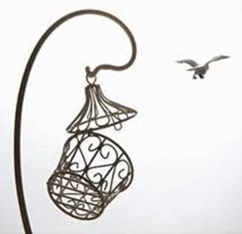Lucky is a bird who grows up in a *cage* (笼子). For Lucky, the life in the cage isn’t like what you think. It is 16 good. In the cage, Lucky has a big “house” to live in and 17 of food to enjoy. And he never needs to 18 the dangerous cat outside the cage. Lucky stays in the cage all day long. He thinks all birds live a life 19 his.

One day, Lucky finds the door of his cage is 20 . “Why don’t I go and see the outside world?” Lucky thinks. “It 21 like a good idea.” He walks out of the cage, flies out of the window and then flies into the sky.

Lucky flies very high. He looks at the buildings 22 him and feels nice. He sees other 23 walking in the square freely, looking for food by themselves and playing together happily. “The outside world is great. I 24 never go back to the cage,” Lucky says.

Lucky is really a lucky bird. He 25 the cage and starts a new life that a bird should have.

( ) 16. A. quite B. only C. soon D. also

( ) 17. A. many B. much C. lot D. plenty

( ) 18. A. look at B. worry about C. prepare for D. take down

( ) 19. A. like B. with C. to D. for

( ) 20. A. dirty B. dark C. open D. double

( ) 21. A. checks B. seems C. knows D. stays

( ) 22. A. before B. above C. below D. after

( ) 23. A. students B. birds C. children D. people

( ) 24. A. will B. can C. am D. does

( ) 25. A. fixes B. closes C. rows D. leaves

III. 阅读理解（每小题2分，共20分）

A

|  |
| --- |
| **Cherry Community Wants Volunteers!**  ★ We want about twenty people to help plant trees in the park on May 21st & 22nd. Families are welcome. You need to bring *tools* (工具) of your own.  ★ We need six young boys to help *mow* (割草) in the garden for the old people at the weekend.  ★ We need ten people to clean the streets. You can get a hat and a pair of gloves.  ★ We want two women in the community office. You need to work from 8:30 a.m. to 6:30 p.m. on Tuesday and Friday. You can get 15 dollars each day.  ★ We also want six men to help *repair* (修缮) the old theatre. You will work from May 24th to May 30th. And you can get 30 dollars each day.  For more information, please call Mrs White at 588-2668. |

( ) 26. The Browns are free on May 21st & 22nd, they can help .

A. plant trees B. repair the theatre C. mow in the garden D. clean the streets

( ) 27. Cherry Community wants to help the old people.

A. girls B. boys C. women D. men

( ) 28. If people help clean the streets, they can get .

A. hats and gloves B. some tools

C. a bottle of water D. 15 dollars each day

( ) 29. It will take days to repair the theatre.

A. five B. six C. seven D. eight

( ) 30. What can we learn from the passage?

A. There is a new theatre in Cherry Community.

B. Volunteers in the community office can get 45 dollars a week.

C. Only people living in Cherry Community can volunteer here.

D. Mrs White may work in the community office.

B

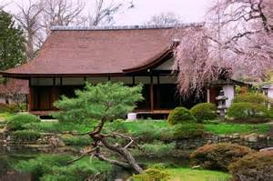

Takei is an exchange student in a college in Philadelphia, America. She comes from Japan. This weekend she is going to have a picnic with her friends in the West [Fairmount Park](https://en.wikipedia.org/wiki/Fairmount_Park). Why does she want to go to this park? Because there is a Japanese house named Shofuso in the park. Takei wants to have a look at it. She **misses** her family and country so much.

Shofuso is also called Japanese House and Garden. It is famous in North America. With a history of 63 years, it’s a gift from Japan to America. People made it in the year of 1953 and then they *sent* (送) it to America by ship. Shofuso has thousands of visitors every year. It welcomes people to learn about Japan. People can try Japanese food and watch Japanese shows here. There are many trees and flowers in the garden. It’s a quiet place to enjoy the blue sky and beautiful park.

Takei is looking forward to her picnic trip. Wish her a good time!

( ) 31. What is Takei doing in America?

A. She is taking a trip. B. She is studying.

C. She is building a house. D. She is visiting her friends.

( ) 32. What does the underlined word “miss” mean in Chinese?

A. 错过 B. 思念 C. 离开 D. 拜访

( ) 33. What does Takei want to visit?

A. A famous restaurant. B. A popular college.

C. A Japanese house. D. A great museum.

( ) 34. What can visitors do in Shofuso?

A. Learn about Japan. B. Listen to nice songs.

C. Row a boat. D. Do some shopping.

( ) 35. Which of the following is TRUE about Shofuso?

A. It is a noisy place. B. It’s a gift from America to Japan.

C. It sells Japanese clothes. D. People sent it to America by ship.

IV. 填空（每小题1分，共15分）

A. 根据句意及括号内所给的汉语提示完成句子。

36. Can you take a (消息) for me, please?

37. Lucy’s brother often (修理) bikes for his classmates.

38. The nurses in this hospital are very kind to the (生病的) people.

39. Sandy is good at drawing, and she is going to be an (艺术家).

40. The little girl (穿过) two roads to go to school every day.

B. 用括号内所给单词的适当形式填空。

41. All the (visit) like to watch the bird show in the zoo.

42. My iPad is (break). I can’t watch films on it.

43. It is about twenty (minute) walk from my home to the cinema.

44. The restaurants are all on the (five) floor of the shopping mall.

45. The monkey on the boy’s T-shirt looks so (fun).

C. 从方框里选择合适的单词并用其正确形式填空。

follow, remember, call, invite, row

46. Sorry, I am busy now, and I you back in ten minutes.

47. Thank you for us to your birthday party.

48. We are looking forward to a boat on Dongping Lake.

49. You should your father when you are in the busy market.

50. Few of us our parents’ birthdays.

V. 阅读材料，根据所给的首字母提示，用合适的单词填空。（每小题1分，共10分）

Mr Brown and his son Kim are on a trip in a small *village* (村庄) (51) h_______ of miles away from the city. The father wants his son to (52) l_______ that life in the city is great by the trip. They (53) s_______ in a local family for some days. In the evening, they go for a walk (54) a_______ the river near the village after dinner.

“How is the trip, Kim?” Mr Brown asks.

“It’s great, Dad.”

“So what do you learn from the trip?” asks the father.

After thinking for a while, Kim answers, “I think life in the village is really great. The city is (55) f_______ of cars and buildings; while there is blue sky and (56) f_______ air in the village. We have parks and swimming pools in the city, but people here (57) o_______ a forest and a river. We have supermarkets to buy food, but people here have (58) f_______ to grow food. We don’t know (59) a_______ in our community, but people here know each other well and help each other. Dad, let’s live here and not go back to the city, (60) s_______ we? ”

VI. 根据汉语意思完成下列英语句子。每空一词。（每小题3分，共15分）

61. 如果明天天气晴朗，我们就会去野餐。

If it is sunny tomorrow, we will .

62. 谁的钥匙扣在我的书桌上？

are on my desk?

63. 我们有大量时间为下周的演出做准备。

We have to prepare for next week’s show.

64. 他们经常围坐在餐桌旁与他们的家人分享食物。

They often sit around the table to their families.

65. 校长想带领他们参观我们的足球场。

The headmaster would like to our football field.

VII.书面表达（15分）

假如你是Peter，你的朋友Sam向你求助：他想去图书馆，但不知道怎么去。请根据下面所给的地图，写一篇短文告诉他正确的路线。

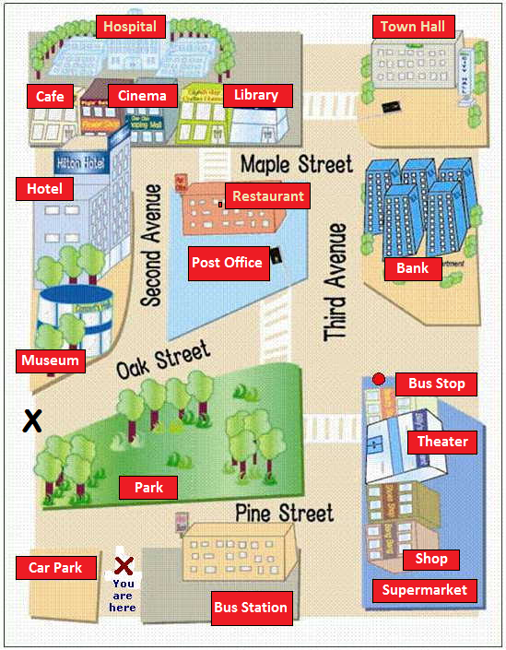

美编修图：You are here 改为Sam is here

图片右上角标注向北↑

**要求：**1. 条理清楚、意思连贯、语句通顺、标点正确；

2. 不少于60词。

____________________________________________________________________________________________________________________________________________________________________________________________________________________________________

参考答案：

1-5 BDCCD 6-10 ABAAD 11-15 BBBCB 16-20 ADBAC

21-25 BCBAD 26-30 ABACD 31-35 BBCAD

36. message 37. fixes 38. sick 39. artist

40. crosses 41. visitors 42. broken 43. minutes’

44. fifth 45. funny 46. will call 47. inviting

48. rowing 49. follow 50. remember 51. hundreds

52. learn 53. stay 54. along 55. full

56. fresh 57. own 58. fields 59. anyone

60. shall 61. have a picnic 62. Whose key rings 63. plenty of time

64. share food with 65. show them around

**One possible version:**

Sam, it’s not difficult for you to get to the library. Turn right into Pine Street first. And then go along Pine Street and turn left into Third Avenue at the first turning. Go past the theatre and the bank, and then turn left into Maple Street. You can see a restaurant on your left. The library is just across from the restaurant. You won’t miss it.