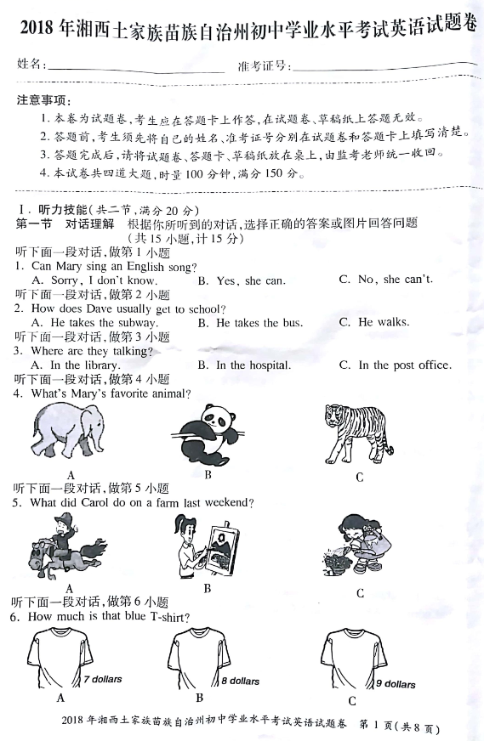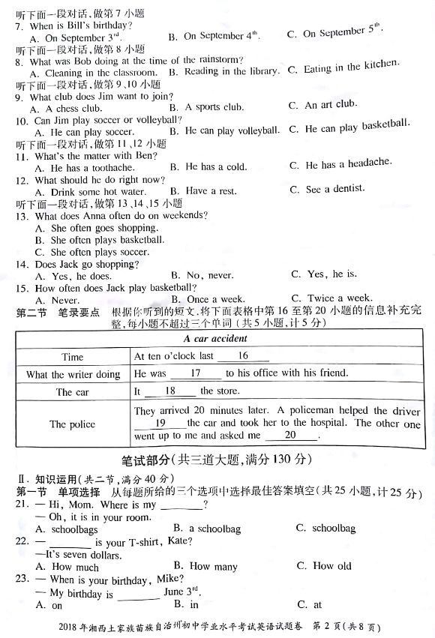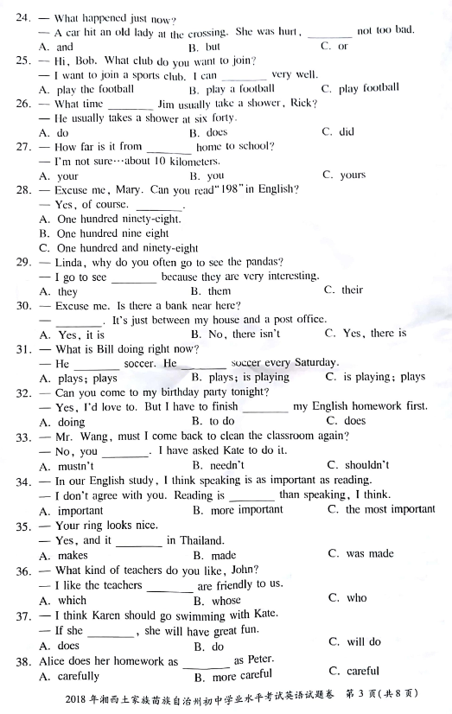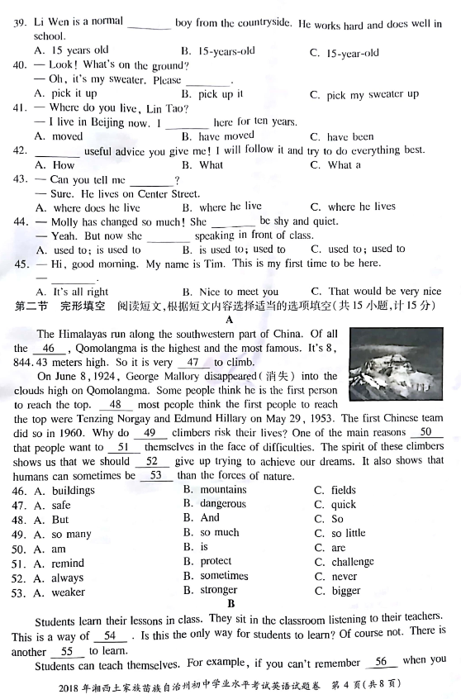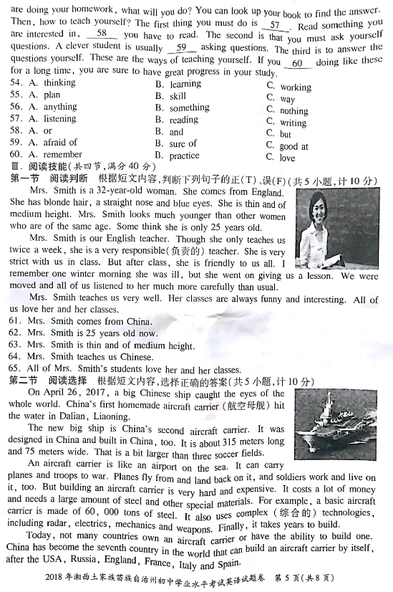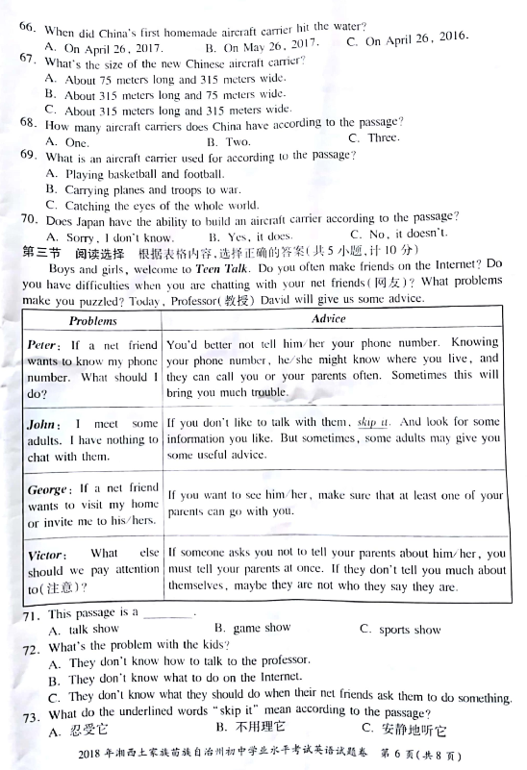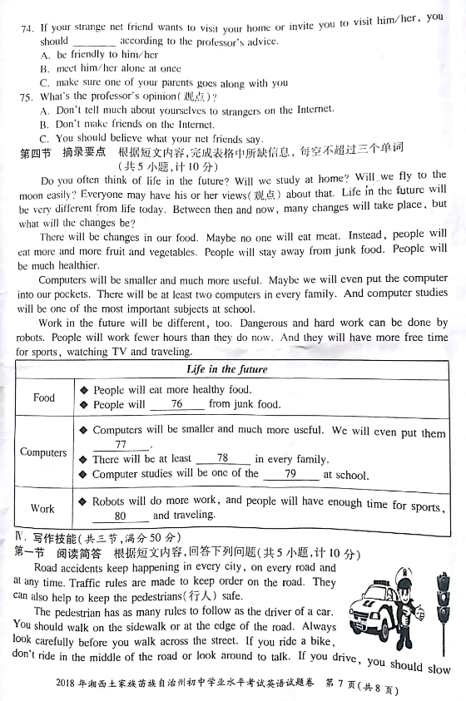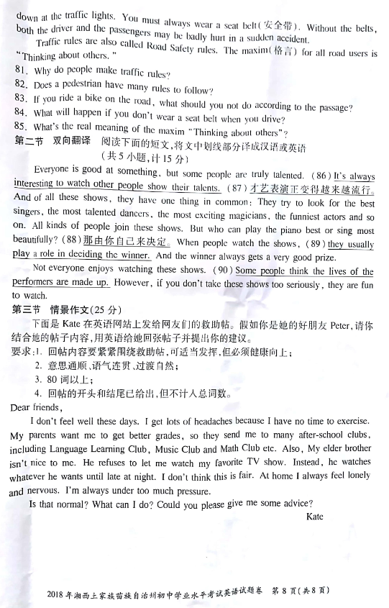

参考答案
1-20.听力答案略
21-30.CAABC BACBC 31-40.CABBC CAACA 41-45.CBAAB
46-53.BBAAB CCB
54-60.BCABB CB
61-65.FFTFT
66-70.ABBBC
71-75.ACBCA
76-80. stay away into our pockets two computers
most important subjects watching TV
81．Because traffic rules can keep order on the road and also help to keep the pedestrians safe．
82．Yes
83．Don't ride in the middle of the road or look around to talk．
84．Both the driver and the passengers may be badly hurt in a sudden accident
85．"为他人着想"
86.看着别人展示自己的才能总是很有趣的．
87.Talent shows are becoming more and more popular．
88.It's up to you．
89.他们通常在决定获胜者的时候起作用．
90.有些人认为表演者的生活是虚构的．
91.
Dear Kate，
I used to have the same problem as you．Therefore，I'd like to offer some advice（点题，引出下文）
First of all，I think you should talk to your parents and tell them how you feel． You tell them not to put too much pressure on you． Second，Be confident and believe yourself，for confidence can make you study easier．Not only does it help you become organized，but also it can reduce pressure，help you get a good rest．【高分句型一】（和父母的关系）
As for your brother，You tell him to learn to share good things and respect each other． If you are kind to him， he will be kind to you．【高分句型二】（和弟弟的关系）
I hope these suggestions can be of great help．（给予鼓励）
Best regards！
Peter

