山西省2016年中考英语试题
第Ⅰ卷 （共70分）
Ⅰ. 第一题 情景反应（每小题1分，共5分）
本题共5个小题，每小题你将听到一组对话。请你从每小题所给的A、B、C三幅图片中，选出与你所听到的信息相关联的一项，并在答题卡上将该项涂黑。
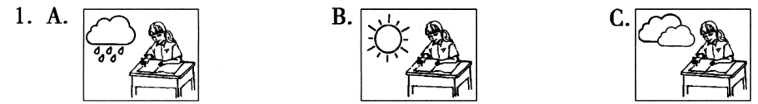
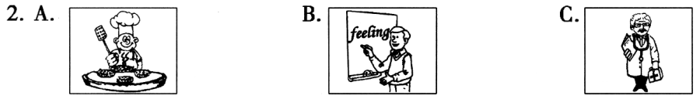
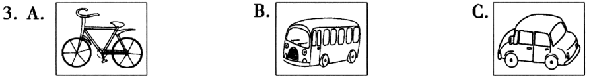
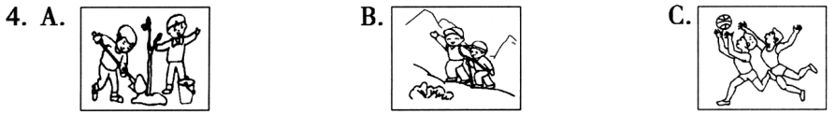
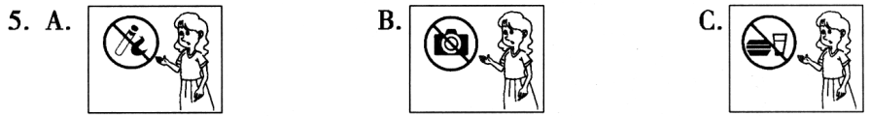

Ⅱ. 对话理解（每小题1分，共5分）
本题共5个小题，每小题你将听到一组对话和一个问题。请你从每小题所给的A、B、C三个选项中，选出一个最佳选项，并在答题卡上将该项涂黑。
A. Sally. B. Linda. C. Nobody.
A. Lovely. B. Colorful. C. expensive
A. Watching TV. B. Writing a report. C. Reading a newapaper.
A. In the restaurant. B.On the bus. C. At the market.
A. Singing is more important.
B. Cool singers must sing better.
C. She doesn’t mind the singers’ looks at all.
Ⅲ. 语篇理解（每小题1分，共5分）
这一大题你将听到一篇短文。请你根据短文内容和所提出的5个问题，从每小题所给的A、B、C三个选项中，选出一个最佳选项，并在答题卡上将该项涂黑。
11. Why did Susie want to learn to play the piano?
A. Because she liked to do something difficult.
B. Because she wanted to play it with her sister.
C. Because she thought the piano music was beautiful.
How did Susie show her mom that she was ready for piano lessons?
A. By helping her mom do housework.
B. By reading a piano book every day.
C. By hearing her sister play the piano.
How did Susie feel in her first piano lesson?
A. Excited and tired.
B. Happy and nervous.
C. Surprised and sad.
What was Susie going to do after school the next day?
A. To do her homework.
B. To play balls outside.
C. To practice the piano.
What did Susie’s mom want to tell Susie?
She should keep her promise.
She must learn from her elder sister.
C. She could have fun before doing her work.

Ⅳ. 单项选择 （每小题1分，共10分）
请你从每小题所给的A、B、C三个选项中，选出可以填入空白处的最佳选项，并在答题卡上将该项涂黑。
During the next few days, I decide to have a good _______ by taking a walk or seeing a movie. I really need to relax.
A. meal B. sleep C. rest
17. Confucius （孔子） is also very famous in many Western countries because he taught people to be _______ to others first.
A. similar B. kind C. important
18. In our life, we need to _______ those people who help us, such as our parents, teachers and friends.
A. thank B. remind C. teach
19. I am really proud of my group _______ we’re always discussing and sharing study secrets together. How important the group work is!
A. because B. though C. unless
20. —Many people play with mobile phones all day instead of reading books.
—That’s too bad. Everyone _______ be a book lover. Reading is more enjoyable.
A. may B. should C. would
21. The earth is the planet _______ provides us with everything we need, fresh air, clean water and so on. It’s our duty to protect it.
A. who B. that C. where
22. Pandas are much-loved around the world. Unluckily, there aren’t many pandas left and they’re _______ now. So we must save them.
A. in order B. in danger C. in need
23. —Song Joong-ki is a movie star in Asia now.
—That’s true. He was once an excellent skater but had to _______ skating because of an accident.
A. give up B. go on C. take up
24. —How was your life in England?
—Quite different from here. _______, people there drink tea with milk.
A. In my opinion B. To my surprise C. At the beginning
25. —I just came back from Shanghai Disneyland. Can you guess _______?
—I’ve no idea. But it can’t be cheap. I’ve heard everything is very expensive.
how I came back home
B. how many days I stayed there
C. how much I paid for the Micky Mouse toy
Ⅴ. 补全对话 （每小题1分，共5分）
根据对话内容，从方框内所给的选项中选出能填入空白处的最佳选项，并在答题卡上将该项涂黑。选项中有两项为多余项。
（Jack and Tom are talking at break.）
Jack: Hi, Tom
Tom: Hi, Jack. 26
Jack: I’m reading an article about Kobe Bryant. You know he has left NBA because of age and injuries.
Tom: 27 His leaving made all his fans sad, including me. He is one of the greatest players in NBA.
Jack: That’s true. He has won first NBA championships and two Olympic gold medals.
Tom: He is a real basketball hero. 28
Jack: Yes. He often started to practice as early as 5 a.m.
Tom: He has a real love for basketball. We should do things like him.
Jack: 29 Nobody can succeed easily unless he works hard.
Tom: Bryant can have some time to relax now.
Jack: You’re right. Oh, it’s time for class. 30 Bye.
Tom: Me too. Bye.
What a pity!
I quite agree.
It’s a pleasure.
Nice talking with you.
What are you reading?
How long did he practice every day?[来源:学科网ZXXK]
Do you know how hard he was working?

Ⅵ. 完形填空 （每小题1分，共10分）
阅读下面短文，掌握其大意，然后从每小题所给的A、B、C三个选项中，选出一个最佳选项，并在答题卡上将该项涂黑。
The world needs love and many people need our help. Several years ago, my teachers asked me to take part in a program that helps those who are 31 . Each week, I spend an hour in the classroom helping with schoolwork, art project, games and other 32 , including eating. My mother is a teacher, so I am used to helping children; however, I found that working with children with special needs would 33 my life forever.
At first, I thought it would be 34 to be with the children who are so different, but gradually I found there’s something special about these students. So there was no need to worry about it. Each Thursday I was welcomed by the smiling faces of Thomas, Joey and Missy. Thomas has to sit on the wheelchair. He communicates with simple words 35 yes or no. Joey, a deaf girl, always welcomed me with a big smile. Missy was born with a kind of 36 and it makes her really small for her age. In a normal classroom, it would be common to hear a teacher comfort a child who is tapping his pencil, speaking 37 , or making unnecessary noises. However, here, shouts, cries, and other noises are 38 . They’re signs of excitement and different ways of communicating.
Working with children with special needs has changed my life. It has made me 39 others’ needs. One of my teachers believes that we should be part of something bigger than 40 . I never realized how true this was until I worked with these children. I believe everyone should get out and do something that makes a difference.
31. A. uneducated B. homeless C. disabled
32. A. courses B. competitions C. activities
33. A. change B. waste C. save
34. A. nervous B. relaxing C. lively
35. A. except B. like C. against
36. A. ability B. illness C. habit
37. A. clearly B. politely C. loudly
38. A. mentioned B. stopped C. encouraged
39. A. refuse B. notice C. influence
40. A. ourselves B. yourselves C. themselves

Ⅶ.阅读理解（一） （每小题2分，共30分）
阅读下列短文，从每小题所给的A、B、C三个选项中，选出一个最佳选项，并在答题卡上将该项涂黑。
（A）
Emma has just finished travelling alone in Europe. Are you interested in her journey? Let’s read some of her travel diaries.

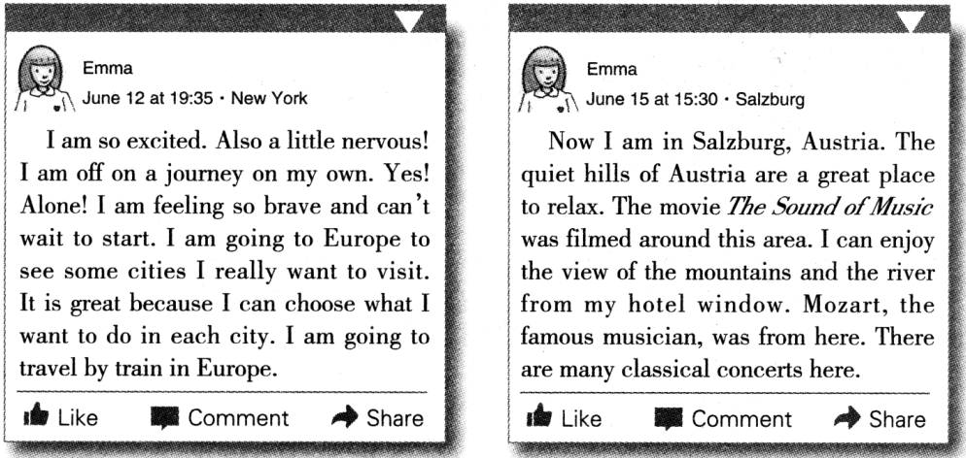
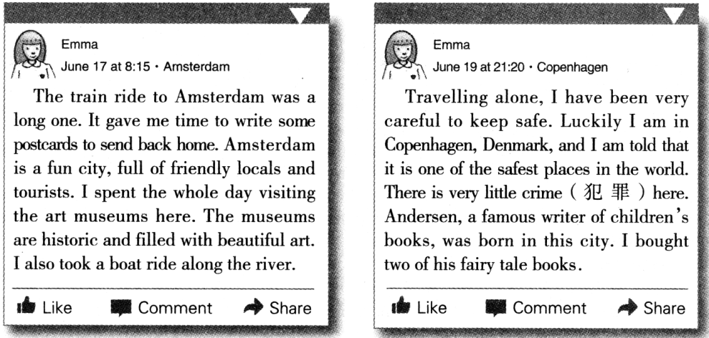
41. Emma was looking forward to this travel because .
A. she had never taken a train ride before
B. she could do anything she liked on the journey
C. she hoped to keep herself away from the busy life
42. From the passage, we can know Salzburg is a great place for .
A. enjoying classical music
B. buying children’s books
C. visiting history museums
43. In Amsterdam, she .
A. climbed the beautiful mountains
B. traveled along the river in a boat
C. wrote some postcards in her hotel
44. She didn’t need to worry about her safety in Copenhagen because .
A. there was very little crime there
B. the city was full of friendly people[来源:学科网ZXXK]
C. she thought she was careful enough
（B）
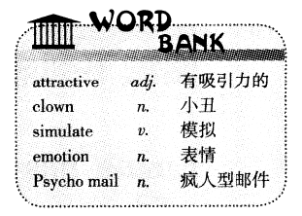
When I opened my e-mail the other day, Rachel, a pretty woman, appeared on my computer screen. She greeted me by name and started talking happily. Sometimes she stopped to smile at me or blow a kiss. It was cool, right? In fact, she was reading to me an e-mail from my brother John.
Rachel could be there because of a new technology called Facemail lets you send in a funny way. By using it, your e-mails can be read to the receiver by an attractive person or by a clown. You can download the software at www.Facemail.com without paying. Facemail faces are lively and they can simulate the emotions that you put in you text. For example, type in , and Rachel blows a kiss.
LifeFX, the company that developed the Facemail, is sure there are wide business uses. Why is e-business not so popular now? One of the reasons is that buying online has no human touch. But if you go to the Nike website, and the famous basketball star Michael Jordan greets you by name, serves you, and personally closes the sale, won’t you be happy? Also, if mom can’t be home when kids get back from school, she can leave a note with a voice and picture on the screen to tell them what there is to eat.
It’s true that Facemail makes life easy and fun, but it should be used with care. The clown looks lively and funny at first. But if you choose the clown, put a few rude words in an e-mail and add some angry emotions, you’re got a Psycho mail.
In fact, who is Rachel?
She is a pretty actress.
She is John’s girlfriend.
She is not a real person.
What is the main advantage of Facemail?
You don’t need to pay for it.
B. E-mail can be attractive in a more lovely way.
C. You can ask a beautiful woman to read the e-mail to you.
What does the underlined expression “closes the sale” probably mean?
A. 停止营业
B. 达成交易
C. 取消折扣
Which of the following is TRUE according to the passage?
You should’t choose a clown.
Facemail can be widely used in business.
Mom can show her kids how to cook by Facemail.
What is the writer’s attitude（态度）towards Facemail?
A. He thinks it’s a danger to the Internet.
B. He thinks it needs further improvement.
C. He thinks it’s a cool and funny technology.[来源:学*科*网Z*X*X*K]
（C）
Let children learn to judge（判断） their own work. A child doesn’t learn to talk by being corrected all the time. If he is corrected too much, he will stop talking. He notices a thousand times a day the differences between the language he uses and the language others use. Little by little, he makes the necessary changes to make his language like other people’s.
In the same way, children learn to do all the other things without being taught — to walk, run, climb or ride a bicycle. They compare their performances with those of more skilled people, and slowly make the changes. But in school we never give a child a chance to find out his mistakes and correct them himself. We do it all for him. We thought that he would never notice a mistake unless it was pointed out to him, to correct it unless he has made to. Soon he becomes dependent on the teacher. Let him work out with the help of other children if he wants it.
If it is a matter in math or science, give him the answer book. Let him correct his own papers. Why should we teachers waste time on such daily work? Our job should be to help the children when they tell us that he can’t find the way to get the right answer. Let the children learn what all educated persons must learn, how to measure（估量） their own understanding, how to know what they know or do not know.
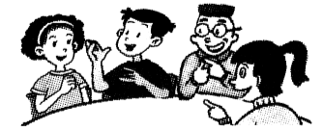
Let them get on with this job in their ways. School teachers can offer help if they ask for it. Some parents and teachers are worried that the children might fail to learn something that they will need to get in the world. Don’t worry! If it is important, they will go out into the world and learn it.

51. According to the passage, the best way for children to learn things is by .
A. being always corrected
B. following adult’s advice
C. doing as other people do
52. The writer thinks teachers in school should .
A. encourage students to learn from each other
B. teach students how to get the answers directly
C. tell students what is wrong as often as possible
53. The underlined sentence in the third paragraph means .
A. teachers can’t correct students’ papers
B. teachers needn’t waste time teaching students in class
C. teachers should help students improve their learning ability
54. We can infer（推断） that from the passage.
A. students can face any challenge easily
B. students can learn a lot in the real life
C. students can grow up without others’ help
55. The best title of the passage may be .
A. Let Us Teachers Stop Working
B. Let Children Learn by Themselves
C. Let Parents Understand Their Kids

第Ⅱ卷 （共50分）
Ⅵ. 听力填空 （每小题1分，共5分）
本题你将听到一篇短文。请你根据所听内容，完成下面的表格，并将获取的信息填到答题卡相应的位置上。每空一词。
The Youngest Headmaster in the World－Ali
Personal information: | ●He is 56. years old.  ●He is from India.
Reasons: | ●To start with, he taught 57. for fun.  ●Later, he realized these kids would never learn to read or write without 58. lessons.
Achievements: | ●Many kids have got education in his school.  ●He has got lots of 59. from the government and other people.
Dreams: | ●He will try his best to keep people’s hopes alive.  ●He expects to help his country 60. a better future.

Ⅶ. 阅读理解（二） （每小题2分，共20分）
A
根据短文内容，从方框内的选项中选出能填入空白处的最佳选项，并在答题卡上将该项涂黑。
Recently, a very simple question became widely spread online: what China should be proud of? 61
Lanlan, whose real name is Negar Kordi, is from Canada. She came to China five years ago and is a student at Ningbo University. Now she has 120,000 fans on the Internet and the number is still growing.
Lanlan loves China and Chinese. 62 And that’s why she is so well received among Chinese net friends. The following is china in her eyes.
“It is the easiest country in which to find a job. If you are not too lazy, it is really very simple to find a job in China. I believe there’re more job chances here than in any other country in the wold.”
“ 63 About 400 million Chinese are studying English. If they can speak good English in the future, China will have the greatest number of English speakers of any non-English speaking country.”
“The speed of Chinese trains is fast. From Ningbo to Beijing, the train runs 1, 365 kilometers for seven hours and the ticket fare is only 595 yuan. ”
“Its public security is great. 64 I have travelled in many countries, and I think China really is very safe.”
“There are much more things China should be proud of. Many Chinese people often criticize（批评）China. At first, I believed that they didn’t like china or that they loved western countries. But later, I realized that they just set a very high standard for China. 65 China must be much better than other countries. ”

A. The foreign language level is surprising.
B. This country of 1.4 billion people makes me feel safe.[来源:学科网ZXXK]
C. A foreign girl living in china gave a very touching answer.
D. They believe that it’
E. She believes china will be the strongest country in the world in future.

B
阅读下面图文，简要回答所给问题，并将答案写在答题卡相应的位置上。
According to new research，recently, some terrible events that teachers were abused(辱骂) on some websites by students happened in the UK. It had a bad influence on schools and the society. The British Teaching Union did a survey of 7,500 teachers. We can get some information from the following data(数据) and know how the teachers who were abused dealt with the problem.
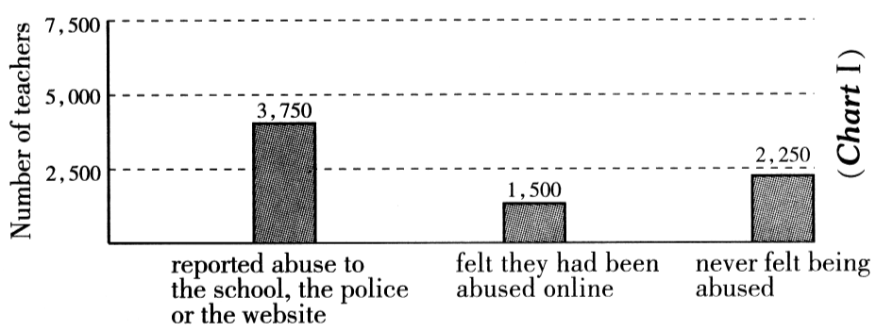
You know teachers are often destroyed by the terrible abuse. Some have lost their confidence to teach and have left school. The survey showed many of the bad comments related to teachers’ looks, abilities and behaviors. We’ve got another data from it. It SHOWS the bad comments were made by not only students but their parents. Please look at the following chart.
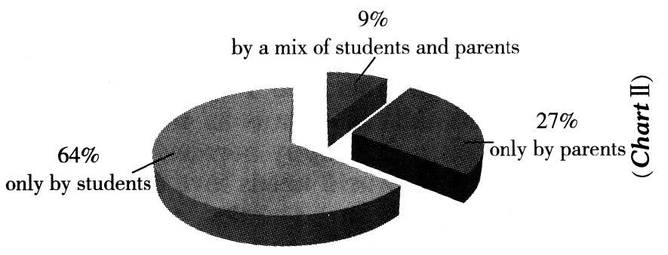
It is clear that we should take some methods to protect teachers from the abuse. We think that the way to solve the problem is the better understanding among teachers, students and parents. Besides good communication, respecting(尊敬) each other is very important. If so, they can get on well with each other.
66. What result did these terrible events lead to according to the passage?
67. From Chart One, how did 50% of the teachers deal with the abuse?
68. What percent of the bad comments were made by parents in total?
69. What is the way to solve the abuse problem according to the passage?
70. After reading the passage, what do you think of this kind of social phenomenon(现象)？

Ⅷ. 词语运用 （每小题1分，共10分）
请根据语篇内容，用方框中所给词的正确形式填空，使短文意思通顺、正确、连贯，并将答案填写到答题卡相应的位置上。方框中有两个词是多余项。
I make teach after large control
try leaf small quiet before without
I make teach after large control
try leaf small quiet before without
As a child, I got angry quite easily and was not good at communicating with others.
I still remember it was an early autumn. Some 71. started to turn yellow and weather became cool. One day, as I was getting ready for school, my mother carelessly handed me my father’s vest（背心）instead of 72. . At that time, I was getting to have a 73. size than my father, so when I put on the vest, I felt as if I wasn’t able to breathe! I realized that it was a small mistake which 74. by my mother, but somehow the breathless feeling was so strong that it made me very angry. My mother said sorry with a smile, but I shouted at her 75. thinking much, I got it off my body so wildly that I made a hole in it. I put on my own vest and rushed out of the house 76. my mother could stop me.
Later, my mother shared her bad feelings with my father, “See what your son has done.” Instead of scold（责备）or beat me , my father 77. asked my mother to mend the vest.
Later when my mother told me about my father’s response, I felt ashamed（惭愧的）of my bad behavior. My father’s gentle kindness 78. me a lesson which I would never forget.
On that day, I decided not to let anger 79. me any longer. Of course, there are times when I am angry. However, whenever that happens, I 80. to remember my father’s vest. It always reminds me to think about others’ feelings when I get angry.
Ⅸ. 书面表达 （共15分）
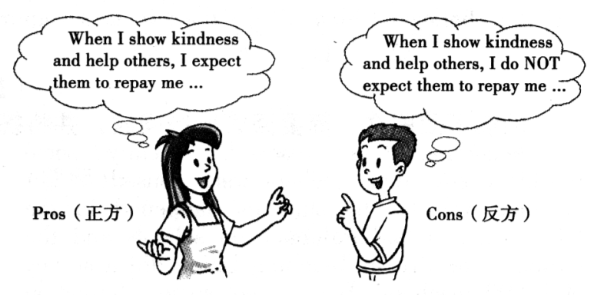
向他人表达善意并帮助他人体现了一个人良好的品格。当你向被人表达善意并给他人提供帮助时，你希望得到回报（repay）吗？针对这一话题，九年级六班的同学们展开了辩论。
假设你是正方或反方的一员，请围绕你的观点，结合自己的亲身经历，说出2至3条理由来说服同学们（只需选择一方观点表达即可）。
要求：1.词数不少于80词；
- 文章的开头已给出，不计入总词数；
- 文中不得出现真实的人名、校名。
When I show kindness and help others, I

答案：
1-5 BCCAB 6-10 BCBCA 11-15CACBA
16-20CBAAB 21-25BBABC 26-30EAGBD
31-35CCAAB 35-40BCCBA 41-45BABAC
46-50CBBBC 51-55CACBB
56. sixteen/16 57. mostly 58. proper 59. attention 60. Build
61-65 CEABD
66. It had a bad influence on schools and the society./ Teachers were often destroyed by the terrible abuse./ Some teachers have lost their confidence to teach and have left school.
67. They reported the abuse to the school, the police or the website.
68. 36%.
69. The better understanding among teachers, students and parents.
70. I think we should try to avoid it. It can hurt both teachers and students.
71. leaves 72. mine 73. larger 74. was made 75. without
76. before 77.quietly 78.taught 79.control 80.wil try
写作：
One possible version:
When I show kindness and help others, I never expect them to repay me. In my view, helping others gives a strong feeling of being needed and brings me happiness. On the other hand, everyone may get into trouble and need help, too.
Several days ago, while I was having a walk in the park, I found a little boy crying. Then I asked him what was the matter, and he told me he couldn’t find his mom. Luckily, he remembered his mother’s phone number. So I called her immediately. Ten minutes later, the boy saw his mom and became excited. His mom was so thankful that she wanted to buy me a gift, but I refused. At that time, I felt quiet happy because I did something really good.
All in all, the world needs love and we should be ready to help others without expecting any repay. If you wanted repay, a “thanks” would be enough.

