中考动词及句式总复习

【同步教育信息】
一. 本周教学内容：
寒假专题——动词及句式

动词种类：
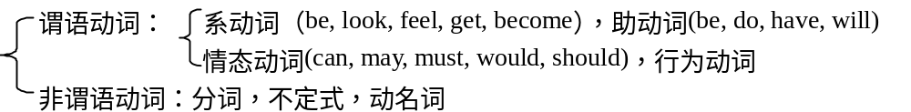
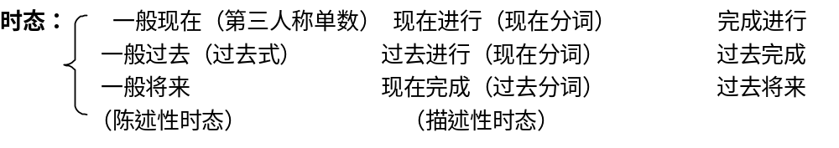
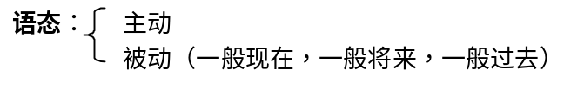
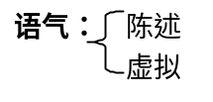
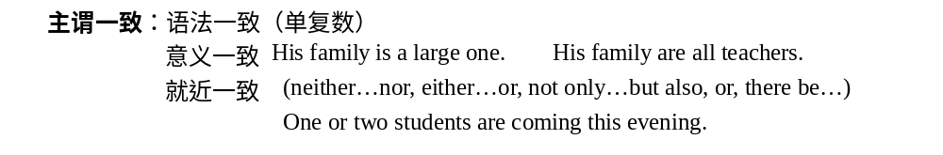句法：
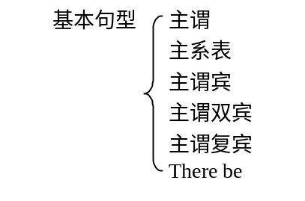
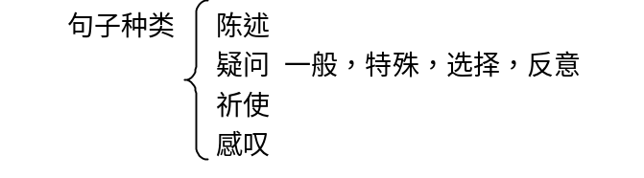
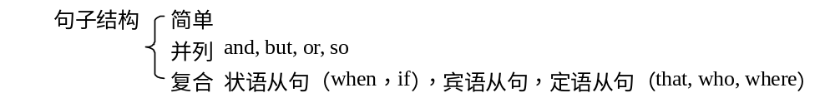

谓语动词：
1. 行为动词
（1）vt. 必须跟宾语，语法意义才完整
有主被动语态，但在下列特殊句型中vt. 后不能跟宾语
have… to do 有……要干
give… to do 给……干
It’s + adj. + to do
（2）vi. 不能直接跟宾语，只有主动语态，若要及物必须跟上相应prep.
（3）vt. & vi.
open, close, burn, sing, study, sell, read, write, clean, keep, act, wash, feel
2. 系动词
系＋ adj. adv. n. prep. 从句，不定式，分词
（1）常见系动词：be, become, seem, look, feel, smell, sound, taste, turn, keep, get, look like,
（2）固定搭配：keep silent, keep quiet, go bad, fall in/asleep, get+adj.，turn＋adj.
（3）系动词通常没被动，少数有进行时 be feeling, be getting
3. 延续性v. 与终止性v.
（1）终止性v. 表延续的转换
换时态： v. + ago
换词 ： arrive / get to / reach----be here / there
end----be over
get back / return----be back
borrow----keep
buy---have
go----be there
come----be here
（2）终止性动词的进行时表将要或反复不断的动作
He is jumping over there. 他在那边反复跳。
（3）延续性动词与具体时刻的状语连用时用进行时
We were waiting for you at 3 yesterday afternoon.
（4）while 引出的时间状语从句中的v. 必须用延续性动词，多为进行时。
（5）终止性动词否定＋until 直到……才
延续性动词肯定＋until 一直干到……为止

英语基本句式：
英语句子有五个基本句式。这五个基本句式可以演变出多种复杂的英语句子。绝大多数英语句子都是由这五个基本句式生成的。
S＋V主谓结构
S＋V＋F主系表结构
S＋V＋O主谓宾结构
S＋V＋O1＋O2 主谓双宾结构
S＋V＋O＋C 主谓宾补结构
说明：S＝主语；F＝谓语；P＝表语；O＝宾语；O1＝间接宾语；O2＝直接宾语；C＝宾语补足语
五个基本句式详细解释如下：
1. S＋V句式: 在此句式中，V是不及物动词，又叫自动词(vi. )。例如：
He runs quickly. 他跑得快。
They listened carefully. 他们听得很仔细。
He suffered from cold and hunger. 他挨冻受饿。
My ink has run out. 我的钢笔水用完了。
2. S＋V＋F句式: 在此句式中，V是系动词(link v. )，常见的系动词有：look，seem，appear，sound，feel，taste，smell，grow，get，fall ill/asleep，stand/sit still，become，turn等。例如：
He seen interested in the book. 他似乎对这本书感兴趣。
The story sounds interesting. 这个故事听起来有趣。
The desk feels hard. 书桌摸起来很硬。
The cake tastes nice. 饼尝起来很香。
The flowers smell sweet and nice. 花闻起来香甜。
You have grown taller than before. 你长得比以前高了。
He has suddenly fallen ill. 他突然病倒了。
He becomes a teacher when he grew up. 他长大后当了教师。
注意：有些动词同时也是及物动词，可构成SVO句式，例如：
He looked me up and down. 他上下打量我。
They are tasting the fish. 他们在品尝鱼。
Please turn the sentence into English. 请把这个句子译成英语。
3. S十V十O句式: 在此句式中，V是及物动词(vt.)，因此有宾语。例如：
I saw a film yesterday. 我昨天看了一部电影。
Have you read the story? 你读过这个故事吗?
They found their home easily. 他们很容易找到他们的家。
They built a house last year. 他们去年建了一所房子。
They've put up a factory in the village. 他们在村里建了一座工厂。
They have taken good care of the children. 这些孩子他们照看得很好。
4. S＋V＋O1＋O2句式: 在此句式中，V是带有双宾语的及物动词。常见的须带双宾语的动词有give，ask，bring，offer，send，pay，lend，show，tell，buy，get，rob，warn等。例如：
He gave me a book/a book to me. 他给我一本书。
He brought me a pen/a pen to me. 他带给我一枝钢笔。
He offered me his seat/his seat to me. 他把座位让给我。
注意下边动词改写后介词的变化：
Mother bought me a book/a book for me. 妈妈给我买了一本书。
He got me a chair/a chair for me. 他给我弄了一把椅子。
Please do me a favor/a favor for me. 请帮我一下。
5. S＋V＋O＋C句式: 在此句式中，V是有宾语补足语的及物动词。常带宾语补足语的词有形容词、副词、介词短语、名词、不定式、现在分词、过去分词。
常见的可接宾语补足语的动词很多，哪些动词可接哪几种形式作宾补，须根据动词的惯用法而定，不能统而概论。请看下面的例子。
They made the girl angry. 他们使这个女孩生气了。
They found her happy that day. 他们发现那天她很高兴。
They named the boy Charlie. 他们给这个男孩起名为查理。
I saw him come in and go out. 我见他进来又出去。
They felt the car moving fast. 他们感到汽车行驶得很快。
I heard the glass broken just now. 我刚才听到玻璃碎了。

【模拟试题】（答题时间：45分钟）
一. 选择填空：
1. She came here _____.
A. since a month ago B. for a month
C. a month ago D. next month
2. They got here ____.
A. a moment ago B. for a moment
C. since a moment ago D. sometimes
3. My father has lived here ______ .
A. for three years B. since three years
C. for three years ago D. three years ago
4. Lucy and Lily ______ in Beijing for nearly two years.
A. are B. were C. will be D. have been
5. My uncle ___ since he left school.
A. smoked B. was smoking C. has smoked D. had smoked
6. They ____ 100,000 trees by the end of 1994.
A. planted B. has planted C. have planted D. had planted
7. By the time Dave got up , his mother _______ breakfast.
A. has cooked B. had cooked C. cooked D. have cooked
8. He said that he _____ never _____ such a beautiful picture before.
A. has…seen B. had ….seen C. have …seen D. was …seeing
9. My sister ____ for three years before she went to college.
A. had worked B. worked C. has worked D. have worked
10. Look! They ___________ their classroom.
A. clean B. are cleaning C. cleaned D. was cleaning

二. 根据对话，用所给动词的适当形式填空：
A: Where’s Kate?
B: She____1____ (go) to London.
A: When __2____ she ___3____(leave)?
B: She ___4____(leave)early this morning.
A: How __5____ she ____6____ (go) there?
B: She ___7___ (go) there by plane .
A: When __8__she ___9____ (come) back ?
B: Sorry, I don’t know. Perhaps she ____10____(get) back in a month.

三. 阅读短文并用所给动词的适当形式填空：
Captain Ben Fawcett has bought an unusual taxi and _______(begin) a new service. The “taxi” is a small Swiss aero phane called a “Pilatus Porter”. This wonderful plane can carry seven passengers. Captain Fawcett’s first passenger____(be) a doctor who ___ (fly) from Birmingham to a lonely village in the Welsh mountains. Since then, Captain Fawcett _____ (fly) passengers to many unusual places. Once he ___ (land) on the roof of a block of flats and on another occasion, he ____(land) in a deserted car park. Captain Fawcett _____just ______(refuse) a strange request from a business man. The man _____ (want) to fly to Rockall, but Captain Fawcett _____ (not take) him because the trip _____ (be) too dangerous.

四. 阅读理解:
(A) Can You Make Short Phone Calls？
Phones are very useful to us, and we can’t work without them. But phones also bring troubles. For example, a friend wants to tell you his or her latest health problem on the phone. You are very busy, so you have to cut your friend off. What will you say?
When you answer a call, don’t ask questions like “How are things?” because these questions will make them think that you have time to talk longer. After “hello,” get right to the heart of the matter you want to say.
When you make a call, you should call at the right time. If you call right before lunch or dinner, or at the end of the work day, people will not talk too much.
When you call someone and do not want to talk longer, you may start with, “Hi, I’ve only got a few minutes, but I want to talk to you about …” or, “I’d like to talk more, but I only have a few minutes before I have to go.”
If you don’t want to spend time talking to someone, you must say, “I’d like to talk to you longer, but I must say Goodbye.” Don’t wait for the answer.
If someone does not stop talking and you have to leave, you can ask someone in your home to help you. For example, you signal to your father, and your father says loudly, “Mary, I think the bread is burning!”
( ) 1. When you want to make a short phone call, you should say: ______ and then go right to the matter.
A. How are things?
B. What’s new?
C. How are you doing?
D. I only have three minutes before I have to leave.
( ) 2. When you want to stop talking, you can say: ____________
A. I have to go now. Goodbye.
B. I’m glad to talk to you. What can I do for you?
C. So, what else is new?
D. Hi. How are things?
( ) 3. If someone does not stop talking and you have to leave, you can ____________
A. ask someone in your home to help you.
B. shout to him loudly.
C. cry loudly.
D. Throw the phone to the floor.

(B) How to Use an ATM
Pat Brown went to her bank to ask for an ATM card. It looks like a credit card. A few weeks later, the bank posted her a card and a four-number personal identification number (PIN). Her PIN is 1234.
As Pat was getting ready for bed one night, she remembered that she had $2 in her bag. The next day she had to give $10 for a lunch for a co-worker. She didn’t want to get up early to go to the bank. So she had to go to the bank at night. She used her ATM card to withdraw (take out) $50 from her checking account (现金帐户).
These are the steps she followed to withdraw money. First, she put her card in the lower slot (狭孔) on the right side of the machine. She made sure her card was facing the right way. Second, the computer screen said, “Please enter (put in) your PIN.” Pat pressed (按) the number 1,2,3, and 4. next, the screen said, “Please select type of transaction (交易) you want by press other keys.” Pat pressed the bottom key for withdrawing money.
Then the screen said, “From which account?” The choices it gave were Checking, Savings, and Money Market. Pat pressed the key for checking. Next, the screen said, “Please choose amount of transaction.” Pat pushed the number 5 and then 0 three times, until the screen read, “50.00”. The screen then read, “Please wait”. In less than a minute, it read, “Please put up the lid and take your money.”
Pat lifts the lid marked Withdraw. She counted her $50 to make sure the ATM hadn’t made a mistake. Then she waited for her withdraw slip to come out of the slot at the upper right corner of the machine. Pat checked the slip to make sure it was correct. Then her ATM card was returned through the card slot. She put it in her bag and walked away. If Pat had made a mistake at any point by pressing the wrong button, she could have pressed Cancel and started over again.
What you should do | What computer should say
Put her card in the lower slot. | Enter (put in) your PIN
1. _______________ | 2. _______________
Press the bottom key for withdrawing money | Select type of account
3. _______________ | Choose amount of transaction
Push the number you want | Put up the lid and take your money
Lift the lid marked Withdraw
4. _______________
Wait for her withdraw slip to come out of the slot
Check the slip to make sure it was correct | Return through the card slot
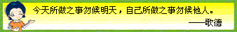
【试题答案】
一. CAADC, CBBAB
二. 1. has gone 2. did 3. leave 4. left 5. did 6. go 7. went 8. will
9. come 10. will get
三. begun, was, flew, has flown, landed, landed, has, refused, wanted, didn’t take, was
四. (A) D A A
(B) 1. Press the PIN numbers 2. Select type of transaction you want
3. Press the key for checking 4. Count her money

【励志故事】
当机不断的教训
华裔电脑名人王安博士，声称影响他一生的最大的教训，发生在他六岁之时。
有一天，王安外出玩耍。路经一棵大树的时候，突然有什么东西掉在他的头上。他伸手一抓，原来是个鸟巢。他怕鸟粪弄脏了衣服，于是赶紧用手拨开。鸟巢掉在了地上，从里面滚出了一只嗷嗷待哺的小麻雀。他很喜欢它，决定把它带回去喂养，于是连鸟巢一起带回了家。
王安回到家，走到门口，忽然想起妈妈不允许他在家里养小动物。所以，他轻轻地把小麻雀放在门后，匆忙走进室内，请求妈妈的允许。在他的苦苦哀求下，妈妈破例答应了儿子的请求。王安兴奋地跑到门后，不料，小麻雀已经不见了。一只黑猫正在那里意犹未尽地擦试着嘴巴。王安为此伤心了好久。
这件事给了王安终身有益的教训，他由此得出一个结论：只要是自己认为对的事情，绝不可优柔寡断，必须马上付诸行动。不能做决定的人，固然没有做错事的机会，但也失去了成功的机运。

