AASHRAY: An AI-Based Framework for Cyclone Disaster Response and Impact-Driven Resource Allocation
AASHRAY: Hypothesis Testing Report —
Impact-Driven Resource Allocation
Final pre-registered experiment · 12,000 held-out synthetic scenarios · official run 7 October 2026

1. Hypothesis

Research question
Does severity–urgency-based priority allocation improve critical-demand coverage compared with arrival-time-based FCFS under constrained resource availability?

Primary hypothesis (critical-demand coverage)
The primary metric is Critical Demand Coverage (CDC): the share of the demand of GT-critical (reference-critical) emergencies that a policy fulfils, summed over water, food and medical kits. The GT-critical label comes from the fixed reference criticality rule defined later in this section. Both policies are run on every scenario, so the comparison is paired: Δ_{i} is the CDC difference in scenario i and μ_{Δ} is its mean over scenarios.
$$CDC = \frac{\text{GT-critical demand fulfilled}}{\text{total GT-critical demand}}, Δ_{i} = {CDC}_{AASHRAY,i} − {CDC}_{FCFS,i}$$
H0 | Under constrained resource availability, the severity–urgency-based AASHRAY allocation policy does not improve critical-demand coverage compared with arrival-time-based FCFS allocation. The mean paired difference in Critical Demand Coverage (CDC) across the 12,000 held-out scenarios is non-positive.  $$μ_{Δ} ≤ 0$$

H1 | Under constrained resource availability, the severity–urgency-based AASHRAY allocation policy improves critical-demand coverage compared with arrival-time-based FCFS allocation. The mean paired difference in Critical Demand Coverage (CDC) across the 12,000 held-out scenarios is positive.  $$μ_{Δ} > 0$$
H0 and H1 form the single primary inferential hypothesis. It is tested with a one-sided paired sign-flip permutation test at α = 0.05 (Section 4).

Secondary evaluation objectives (descriptive; not significance-tested)
H2 and H3 are secondary evaluation objectives, not primary inferential hypotheses.
H2  secondary  objective | Optimality  AASHRAY achieves high critical-demand coverage relative to the MILP optimization benchmark.  Measures: optimality gap; exact-optimum and within-1%, 5% and 10% rates (Section 5). Descriptive: the MILP is the benchmark, so no AASHRAY-vs-MILP significance test is run.

H3  secondary  objective | Computational efficiency  AASHRAY requires substantially less computation than solving the MILP benchmark.  Measures: mean, median, P95 and total runtime; conservative speedup (Section 7). Descriptive; hardware and implementation dependent.

Methods compared
Each emergency has a severity S, an urgency U, a resource demand and an arrival time; warehouses hold limited water, food and medical kits, so order matters only when supply cannot meet all demand. Two allocation policies and one optimization benchmark were run on identical inputs:
Method | Decision rule | Role
FCFS | Arrival order (timestamp, then emergency id); uses no severity or urgency information. | Allocation policy (baseline)
AASHRAY | Descending P = 0.5S + 0.5U from the experiment's ranking code (frozen C045; ties in FCFS order). The application's allocation service, whose own score is 0.4S + 0.4U + 0.2 × categorical priority level, got identical inputs (S = 0.5, U = 0.5, MODERATE) for every emergency, so it allocated in exactly this order (verified on every call). | Allocation policy under test
MILP | Integer program maximizing the GT-critical demand units fulfilled (Section 5); not a competing heuristic. | Optimization benchmark / verification oracle

AASHRAY priority score and reference criticality
The development parameter search allowed a generalized priority formulation with normalized weights:
$$P_{n} = S^{α}U^{1−α}, P_{o} = kS + mU + nP_{n}$$
It selected configuration C045 (α = 0, k = 0.5, m = 0, n = 0.5). With α = 0 the geometric term reduces to P_{n} = U, so the frozen AASHRAY priority score is
$$P_{i} = 0.5S_{i} + 0.5U_{i}$$
The parameter search selected a policy mathematically equivalent to a balanced linear severity–urgency score, P = 0.5S + 0.5U. The geometric component therefore does not contribute to the final experimental policy.
The AASHRAY priority score and the reference criticality rule are separate scoring mechanisms. The reference criticality rule is fixed independently of the AASHRAY configuration and allocation method, but it is derived from the same severity (S) and urgency (U) variables used by the priority score. It uses no AASHRAY parameter (α, k, m, n) and no allocation output. An emergency is GT-critical (reference-critical) when GT_{i} = 1:
$${GT}_{i} = \left\{\begin{matrix}1, & if \left(S_{i} ≥ 0.8 ∧ U_{i} ≥ 0.8\right) ∨ S_{i} ≥ 0.95 ∨ U_{i} ≥ 0.95 \\ 0, & otherwise\end{matrix}\right.$$
This is a predefined simulation reference criterion for evaluating allocation priority; it is not an externally validated operational or clinical definition of real-world criticality. Throughout this report, “critical” refers only to this GT-critical label; the AASHRAY priority score P is a separate quantity and is never used to define CDC.

Test design
Item | Specification
Design | Paired, within-scenario comparison; FCFS, AASHRAY and the MILP benchmark get identical inputs.
Dataset | 12,000 independently generated held-out synthetic disaster scenarios; seed 20261209; namespace aashray-resource-allocation-final.
Scarcity strata (pre-registered) | LOW 1,200 (supply/demand ratio 1.15–1.60) · MODERATE 4,800 (0.90–1.10) · HIGH 6,000 (0.30–0.70) · total 12,000.
Scenario composition | 3–30 emergencies per scenario (size classes 3–6, 8–14, 18–30; mean 13.16; 157,889 emergencies, 28,393 GT-critical) and 2–5 warehouses; water, food and medical kits; 5 severity–urgency profiles, each scarcity level spread evenly over 15 size × profile cells; arrivals within a 3,600 s window; demand drawn independently of S, U and arrival.
Primary metric and test | CDC. One-sided paired sign-flip permutation test of mean Δ; 100,000 permutations; seed 20261210; α = 0.05.
Secondary statistics | Paired percentile bootstrap 95% CI (10,000 resamples, seed 20261211); one-sided Wilcoxon signed-rank test; Cohen's d_{z}; win/tie/loss; probability of superiority. Tie rule |Δ| ≤ 10⁻⁹. Descriptive: optimality gap (H2), runtime (H3), Total Demand Coverage (TDC).

Experimental integrity and reproducibility
Check | Result
Completion | 12,000/12,000 scenarios completed by every method; none dropped or rerun (single official run).
Frozen dataset | Frozen 2026-10-07 20:28:30 UTC, before execution started (20:28:39 UTC); read-only and unchanged afterwards. SHA-256 39912ec07be7cc7e3bde609a65d9019322a014dfde7a15bf769f18f087db7bab.
Generator equivalence | Copied generator reproduced the development dataset byte for byte (development settings).
No contamination | 0 scenarios shared with the development data and 0 with the pilot data.
GT-critical coverage | Every scenario has at least one GT-critical emergency (S/U rejection sampling; 3,437 scenarios redrawn; other streams unaffected).
Identical inputs | FCFS, AASHRAY and MILP received identical scenario inputs (0 mismatches).
Frozen configuration | One AASHRAY configuration (C045); scripts and configuration frozen before the run; no parameter tuning on the final test set.
Checks | 35/35 gate checks passed; 37/37 final validation checks passed (0 failures).
MILP | 12,000/12,000 proven optimal; 12,000/12,000 matched the analytical optimum; 0 failures.
Unchanged files | No application (94), development (23), pilot (14) or MILP (15) files modified; application tests pass (93 passed).

2. Results at a Glance
Metric | FCFS | AASHRAY | MILP | Statistical / interpretation | Conclusion
Mean CDC (primary) | 0.7363 | 0.9477 | 0.9817 | Δ = +0.2114 (+21.14 pp; +28.7% relative); 95% CI [0.2053, 0.2177]; permutation p = 9.9999 × 10⁻⁶ | H0 rejected; primary H1 supported
Effect size | — | — | — | Cohen's d_{z} = 0.603; probability of superiority = 0.721 (ties weighted ½) | Consistent with H1
Median CDC; median Δ | 0.9946 | 1.0000 | 1.0000 | Median Δ = 0 because 49.97% of scenarios are exact ties | Expected given ties (see text)
Paired outcome | 348 wins (2.90%) | 5,656 wins (47.13%) | — | 5,996 ties (49.97%); AASHRAY ≥ FCFS in 97.10% | Better or equal in most scenarios; not always better
HIGH-scarcity CDC | 0.4958 | 0.8968 | 0.9637 | +0.4009 absolute over FCFS (n = 6,000; descriptive 95% CI [0.3906, 0.4112]) | Largest benefit under scarcity
Optimality vs MILP (H2) | — | exact 86.66%; within 10% 91.50% | benchmark | Mean relative gap 0.0350; median 0; P95 0.2441; no significance test | Near-optimal in most scenarios; not optimal
Runtime per scenario (H3) | — | 0.440 ms (conservative mean) | 2.472 ms | Conservative 5.6× by total, 4.8× by median; raw 9.99× is order-affected | Supported (descriptive only)
TDC (descriptive) | 0.7394 | 0.7394 | — | Identical for FCFS and AASHRAY in every scenario (order-invariant) | Descriptive only
Bottom line: Under the fixed reference criticality rule used in this experiment, AASHRAY substantially improves critical-demand coverage compared with FCFS. Mean CDC rose from 0.7363 to 0.9477 (+0.2114; permutation p = 9.9999 × 10⁻⁶), so H0 is rejected. The gain is largest under HIGH scarcity. AASHRAY reaches the MILP optimum in 86.66% of scenarios and needs far less computation, but it is not optimal in every scenario and not better than FCFS in every scenario.

Win / tie / loss
Scope | n | AASHRAY wins (Δ > 0) | Ties (|Δ| ≤ 10⁻⁹) | FCFS wins (Δ < 0)
All scenarios | 12,000 | 5,656 (47.13%) | 5,996 (49.97%) | 348 (2.90%)
LOW | 1,200 | 0 (0.00%) | 1,200 (100.00%) | 0 (0.00%)
MODERATE | 4,800 | 1,180 (24.58%) | 3,579 (74.56%) | 41 (0.85%)
HIGH | 6,000 | 4,476 (74.60%) | 1,217 (20.28%) | 307 (5.12%)

Reading the paired outcome
Why the median paired difference is 0. The median paired difference is 0 because the distribution contains 5,996 exact ties; this does not imply that AASHRAY has no effect. The mean difference is +0.2114. Together with the 348 FCFS wins, the ties make up 6,344 of the 12,000 differences (52.87%), so both middle values of the sorted differences (the 6,000th and 6,001th) are exactly 0. Ties occur at every scarcity level, not only where supply is ample: all 1,200 LOW scenarios, 3,579 of 4,800 MODERATE scenarios and 1,217 of 6,000 HIGH scenarios (table above).
Win rate versus probability of superiority. The win rate (47.13%) counts only scenarios in which AASHRAY is strictly better. The probability of superiority counts each tie as half a win: PS = (5,656 + 0.5 × 5,996) / 12,000 = 0.721. The two numbers measure different things and do not conflict. Among the 6,004 non-tied scenarios, AASHRAY is better in 5,656 (94.20%).

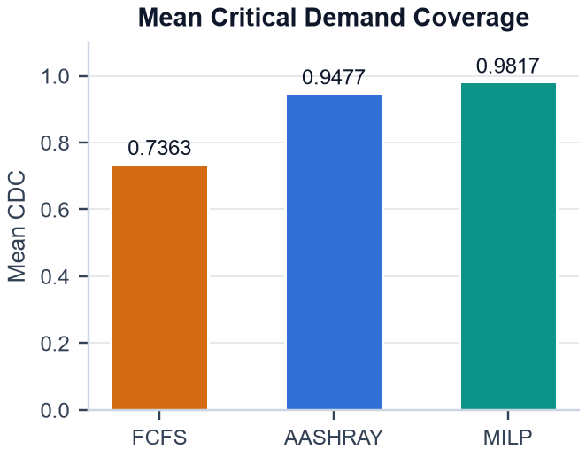  Figure 1. Mean critical-demand coverage across 12,000 held-out disaster scenarios. | 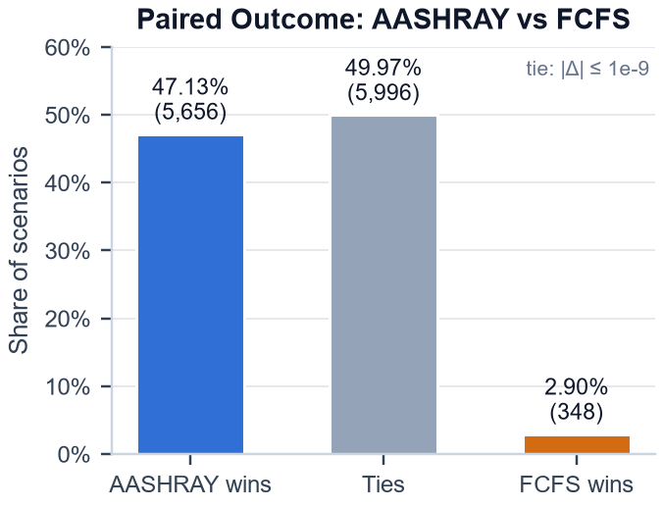  Figure 2. Scenario-level paired outcome between AASHRAY and FCFS.

3. Scarcity-Stratified Results
Scarcity is the pre-registered stratification factor: it sets the ratio of total supply to total demand in each scenario. The HIGH-scarcity stratum gives the strongest practical result. Stratum-level intervals are descriptive; the only inferential test is the overall primary test.
Scarcity | n | FCFS CDC | AASHRAY CDC | MILP CDC | AASHRAY − FCFS | Mean optimality gap ‡
LOW | 1,200 | 1.0000 | 1.0000 | 1.0000 | 0.0000 | 0.0000
MODERATE | 4,800 | 0.9709 | 0.9983 | 0.9995 | +0.0274 | 0.0012
HIGH | 6,000 | 0.4958 | 0.8968 | 0.9637 | +0.4009 | 0.0691
‡ Mean relative gap (CDC_{MILP} − CDC_{AASHRAY}) / CDC_{MILP} (Section 5). The report brief labelled this column 'AASHRAY−MILP' with the values 0.0012 and 0.0691; those are mean relative gaps. The difference of means AASHRAY − MILP is −0.0012 (MODERATE) and −0.0669 (HIGH).
HIGH scarcity (n = 6,000): CDC 0.4958 (FCFS) → 0.8968 (AASHRAY), an improvement of +0.4009 absolute.
Descriptive 95% CI [0.3906, 0.4112]. AASHRAY is better in 4,476 HIGH scenarios (74.60%), tied in 1,217 (20.28%) and worse in 307 (5.12%); the MILP benchmark reaches 0.9637.
Under MODERATE scarcity the gain is small (+0.0274; AASHRAY better in 24.58%, tied in 74.56%). Under LOW scarcity all three methods reach full GT-critical coverage (CDC = 1.0000), so no improvement is possible and none is claimed. The benefit of priority-based allocation becomes most pronounced when resources are scarce.
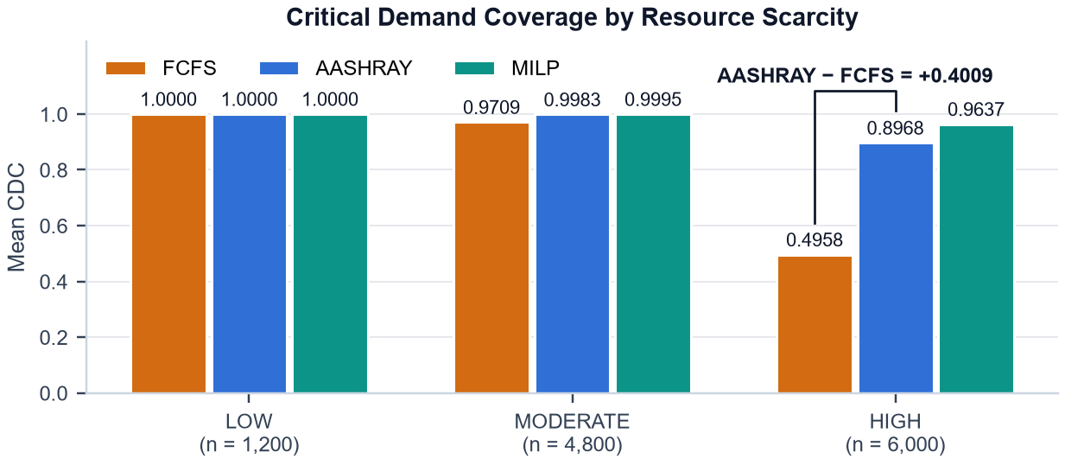
Figure 3. Critical-demand coverage by resource-scarcity level.

Total Demand Coverage (descriptive only)
TDC is the share of all demand units fulfilled, GT-critical or not. Overall TDC is 0.7394 for both FCFS and AASHRAY (LOW 1.0000, MODERATE 0.9747, HIGH 0.4991), and the two values are identical in every one of the 12,000 scenarios. Under the current fungible-resource allocation model, with no vehicle, route or time limits, the serving order changes who receives resources rather than the total quantity eventually delivered. AASHRAY therefore does not improve total resource utilization, and TDC is reported descriptively, not as evidence for AASHRAY. CDC is the primary metric because the hypothesis concerns the prioritization of GT-critical demand. MILP TDC is not reported: the MILP objective counts only GT-critical demand, so its allocation of other demand is solver-dependent.

4. Statistical Testing
Each method is evaluated on exactly the same scenario, so inference uses the per-scenario paired differences Δ_{i} = CDC_{AASHRAY,i} − CDC_{FCFS,i} (n = 12,000; no scenario had undefined CDC). The test statistic is the mean difference, +0.2114 (+21.14 percentage points; +28.7% relative to the FCFS mean). Under H0 the sign of each paired difference is exchangeable, so the permutation test re-evaluates the mean after independent random sign flips:
$$p = \frac{1 + \#\left\{b : {\overline{Δ}}^{\left(b\right)} ≥ \overline{Δ}\right\}}{B + 1} = \frac{1}{100,001} ≈ 9.9999 × {10}^{−6}$$
Test | Settings | Result | Decision
Sign-flip permutation (primary) | One-sided; statistic mean Δ; 100,000 random sign flips; seed 20261210; α = 0.05 | Observed mean Δ = 0.2114; 0 of 100,000 permuted means ≥ observed; p = 9.9999 × 10⁻⁶ | Reject H0
Paired percentile bootstrap | 10,000 resamples of scenarios; seed 20261211; 2.5th / 97.5th percentiles | 95% CI [0.2053, 0.2177]; bootstrap SE 0.0032 | CI excludes 0
Wilcoxon signed-rank (secondary) | One-sided (AASHRAY > FCFS); 5,996 zero differences dropped, n = 6,004; normal approximation | W⁺ = 17,244,745.5; z = 61.31; p < 10⁻³⁰⁰ (below double precision; normal approximation log₁₀ p ≈ −818) | Consistent with primary
Effect size | Cohen's d_{z} = mean Δ / SD(Δ), ddof = 1; PS = (wins + 0.5 × ties) / n | d_{z} = 0.603 (SD 0.3507); probability of superiority = 0.721 | Descriptive
None of the B = 100,000 sign-flipped means reached the observed value, so p equals the smallest value attainable with the +1 correction; resolving a smaller p-value would need more permutations. The Wilcoxon signed-rank test is secondary (the pre-registered primary inference is the permutation test). Its p-value underflows double-precision floating point (the library returns zero), so it is reported as a bound rather than as an exact value.
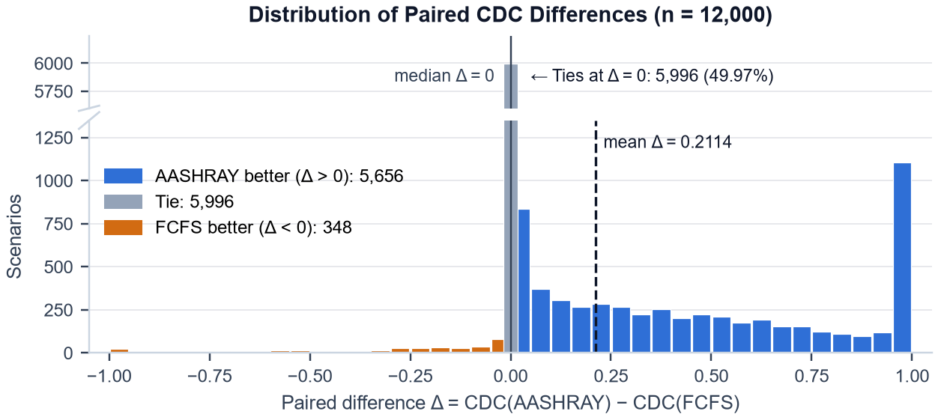
Figure 4. Distribution of paired CDC improvements produced by AASHRAY relative to FCFS.
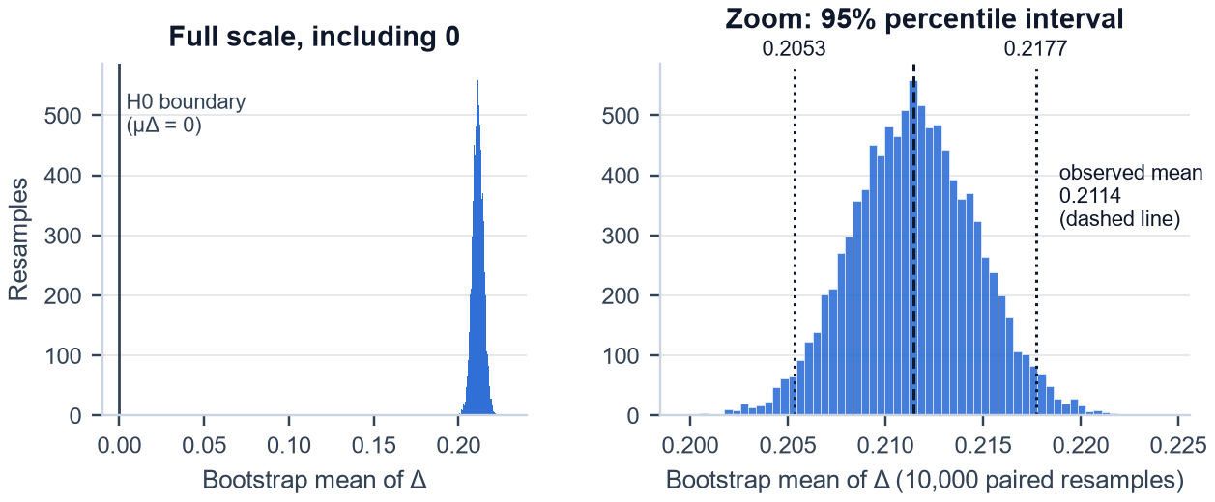
Figure 5. Paired bootstrap distribution of the mean CDC improvement (left: full scale including 0; right: zoom with the 95% percentile interval).

5. Optimization Benchmark
The MILP is used as an optimization benchmark and correctness oracle for the current allocation formulation. It is not treated as a competing heuristic. Its integer decision variable x_{e,r,w} is the number of units of resource type r allocated from warehouse w to emergency e; a_{w,r} is the supply and d_{e,r} the demand:
$$\max{\sum_{e}{\sum_{r}{\sum_{w}{{GT}_{e}x_{e,r,w}}}}}$$
$$\begin{matrix}subject to & \sum_{e}{x_{e,r,w}} ≤ a_{w,r} & ∀ w, r & (warehouse supply) \\ & \sum_{w}{x_{e,r,w}} ≤ d_{e,r} & ∀ e, r & (emergency demand) \\ & x_{e,r,w} ∈ ℤ_{≥0} & ∀ e, r, w & (integral, nonnegative)\end{matrix}$$
Solved with HiGHS 1.12.0 via scipy.optimize.milp (SciPy 1.18.0), relative MIP gap 0 and a 60 s time limit. 12,000 / 12,000 solutions were proven optimal, 12,000 / 12,000 matched an independently computed analytical optimum, and there were 0 failures.
Methodological caveat. The current allocation model has no vehicle-capacity, travel-time, route, resource-compatibility or time-window constraints. Units of one resource type are interchangeable across warehouses, so the MILP optimum reduces to a closed-form bound on GT-critical demand fulfilment, where D_{r}^{crit} is the GT-critical demand and A_{r} the total supply of type r:
$${CDC}^{*} = \frac{\sum_{r}{\min\left(D_{r}^{crit}, A_{r}\right)}}{\sum_{r}{D_{r}^{crit}}}$$
The MILP therefore serves as an optimization benchmark / verification oracle for this formulation; it is not presented as a hard combinatorial problem or a difficult real-world optimization baseline.
AASHRAY's optimality gap is normalized by the MILP optimum:
$${gap}_{i} = \frac{{CDC}_{MILP,i} − {CDC}_{AASHRAY,i}}{{CDC}_{MILP,i}}, with {gap}_{i} = 0 if {CDC}_{MILP,i} = 0$$
The edge case CDC_{MILP} = 0 did not occur (0 scenarios): every scenario contains a GT-critical emergency and the lowest MILP CDC was 0.3008. A scenario counts as an exact optimum when the two CDC values differ by at most 10⁻⁹. No significance test is run between AASHRAY and MILP, because the MILP is the benchmark.
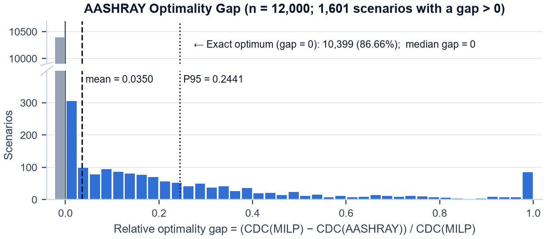
Figure 6. Distribution of AASHRAY's optimality gap relative to the MILP benchmark.
Gap statistic | Value | Rate (n = 12,000) | Share (count)
Mean relative gap | 0.0350 | Exact optimum | 86.66% (10,399)
Median gap | 0.0000 | Within 1% | 88.41% (10,609)
P95 gap | 0.2441 | Within 5% | 90.05% (10,806)
P99 gap | 0.8426 | Within 10% | 91.50% (10,980)
Maximum gap | 1.0000 | Gap > 0 | 13.34% (1,601)
AASHRAY reaches the exact MILP optimum in 10,399 scenarios (86.66%) and is within 10% in 10,980 (91.50%). The gap distribution is strongly skewed: the median is 0 and the mean 0.0350, but the P95 is 0.2441 and 1,601 scenarios have a positive gap. The gap grows with scarcity: the exact-optimum rate is 100.00% (LOW), 98.27% (MODERATE) and 74.70% (HIGH), and the mean gap 0.0000, 0.0012 and 0.0691.
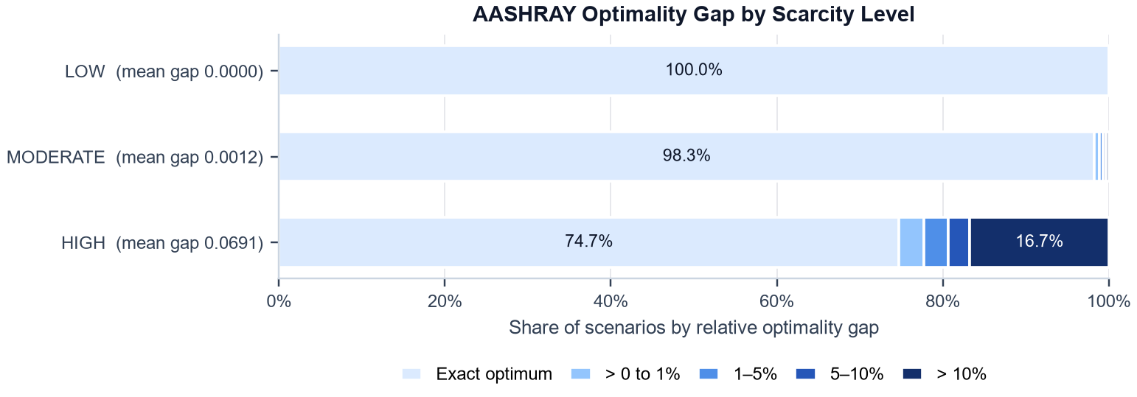
Figure 7. AASHRAY's optimality gap to the MILP benchmark by scarcity level (share of scenarios in each gap band); the gap grows under HIGH scarcity.
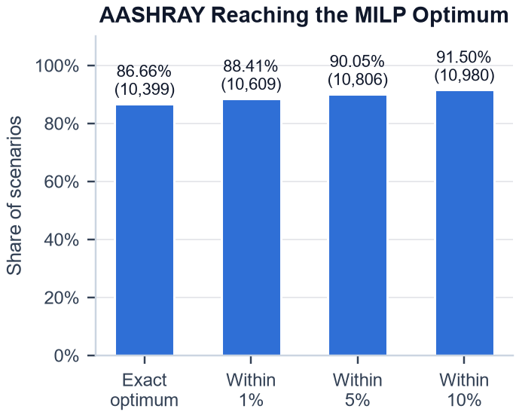  Figure 8. Fraction of scenarios in which AASHRAY reaches or approaches the MILP optimum. | 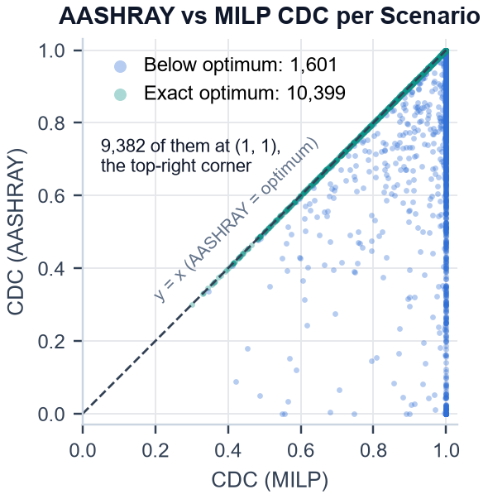  Figure 9. Scenario-level AASHRAY CDC relative to the MILP optimum (points on y = x are exact optima; points below it fall short).

6. Failure / Worst-Case Analysis
In 59 of the 12,000 scenarios AASHRAY covered zero GT-critical demand (CDC = 0) while the MILP covered a positive amount. All 59 are HIGH-scarcity scenarios (0 LOW, 0 MODERATE). In these scenarios the mean MILP CDC was 0.9770 and the mean FCFS CDC 0.3578.
Observed mechanism. AASHRAY ranks by the continuous priority score 0.5S + 0.5U, whereas GT-criticality is a threshold rule. An emergency can be GT-critical through a single extreme value (S ≥ 0.95 or U ≥ 0.95) while its other value is low, which gives it only a moderate balanced score; an emergency that is not GT-critical but has two mid-range values can then score higher and consume the scarce supply first. In all 59 scenarios the highest-scoring emergency was not GT-critical, and in all 59 every GT-critical emergency (64 in total) qualified only through the single-extreme part of the rule (none had both S ≥ 0.8 and U ≥ 0.8).
This is a diagnostic result, not evidence that the experiment failed. This identifies a limitation of the balanced continuous priority score when the reference criticality rule allows an emergency to become critical because of a single extreme severity or urgency value. The AASHRAY score was not modified for this report; a score term that preserves single extreme values is a possible future direction and would need new development tuning and a new held-out evaluation.

Example: FIN-00065 (HIGH scarcity, 3 emergencies)
AASHRAY serves the emergencies in the rank order below. Supply: 634 water, 204 food, 1 medical kit (839 units). CDC: FCFS 0.0000, AASHRAY 0.0000, MILP 1.0000.
Rank | Emergency | S | U | P = 0.5S + 0.5U | GT-critical | Demand (units) | Allocated (units)
1 | E02 | 0.4993 | 0.5746 | 0.53695 | No | 1,605 | 838
2 | E01 | 0.0655 | 0.9774 | 0.52145 | Yes (U ≥ 0.95) | 168 | 0
3 | E03 | 0.0239 | 0.7620 | 0.39295 | No | 311 | 1
Emergency E02 is not GT-critical but has the highest balanced score, so it is served first and absorbs 838 of the 839 available units; the GT-critical E01 (U = 0.9774, S = 0.0655) receives nothing. FCFS also covers no GT-critical demand in this scenario.

7. Computational Efficiency
Runtime was measured per scenario in a single process and a single official run (warm-up on 3 scenarios) on an AMD Ryzen 9 8940HX with Radeon Graphics (Windows 11, Python 3.12.10). AASHRAY time is ranking decision plus allocation; MILP time is model build plus HiGHS solve. Runtime results are descriptive and hardware/implementation dependent; they are not a formal hypothesis test.
Metric | AASHRAY raw (order-affected) | AASHRAY conservative | MILP (build + solve) | MILP ÷ AASHRAY (conservative)
Mean (ms) | 0.247 | 0.440 | 2.472 | 5.6×
Median (ms) | 0.213 | 0.289 | 1.385 | 4.8×
P95 (ms) | 0.488 | 0.786 | 7.087 | —
Total, 12,000 scenarios (s) | 2.97 | 5.28 | 29.67 | 5.6×

Execution-order caveat. For every scenario the methods ran in the order FCFS → AASHRAY → MILP. FCFS and AASHRAY call the same allocation service, and the first call in a scenario was slower than AASHRAY's second call in 11,645 of 12,000 scenarios, so AASHRAY's raw allocation time benefits from a warm-cache/order effect. The raw ratios (9.99× by total, 6.49× by median) are therefore not the main result, and AASHRAY-vs-FCFS timing is not a controlled head-to-head comparison. The conservative estimate charges AASHRAY its own ranking time plus the first-position (FCFS) allocation time of the same scenario.
Even under the conservative estimate, the MILP takes about 5.6× longer in total and 4.8× longer at the median, and it is slower than conservative AASHRAY in 11,995 of 12,000 scenarios. AASHRAY's mean ranking decision takes 0.020 ms; the MILP spends 0.243 ms building the model and 2.230 ms in the solver on average. No significance test was performed on runtime.
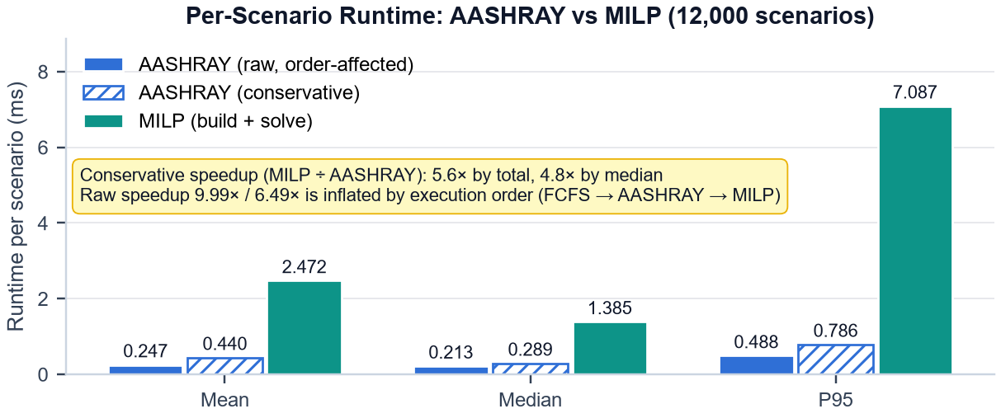
Figure 10. Per-scenario runtime of AASHRAY (raw and conservative) and the MILP benchmark; raw AASHRAY timing is affected by execution order.

8. Conclusion: What Has Been Shown
The results demonstrate that severity–urgency-based priority allocation substantially improves critical-demand coverage over arrival-order FCFS under the simulated resource constraints used in this experiment.
• Primary hypothesis: under the fixed reference criticality rule, AASHRAY mean CDC = 0.9477 vs FCFS = 0.7363; H0 is rejected and the primary H1 is supported.
• Improvement: +0.2114 absolute / +21.14 percentage points (+28.7% relative).
• Statistical significance: paired sign-flip permutation p = 9.9999 × 10⁻⁶ (the minimum attainable with 100,000 permutations); the secondary Wilcoxon test agrees.
• 95% CI: [0.2053, 0.2177] (paired bootstrap, 10,000 resamples).
• Scarcity effect: HIGH scarcity shows the largest benefit: 0.8968 vs 0.4958 CDC (+0.4009); at LOW scarcity all methods reach full GT-critical coverage.
• Optimization: AASHRAY reaches the exact MILP optimum in 86.66% of scenarios and is within 10% in 91.50%; it is not optimal in every scenario (74.70% exact under HIGH scarcity, and 59 HIGH-scarcity scenarios with CDC = 0).
• Computational efficiency: AASHRAY remains substantially cheaper computationally than MILP under the conservative runtime comparison (≈5.6× by total, ≈4.8× by median; descriptive and hardware/implementation dependent).
• Important qualification: AASHRAY's final policy is exactly 0.5S + 0.5U; the geometric component was not part of the selected final ranking.
• Limitation: the current optimization model does not include routing, vehicles, temporal constraints or compatibility.

Limitations
1. The scenarios are synthetic rather than real operational disaster events.
2. GT-criticality is a fixed simulation reference rule derived from the same S and U variables as the priority score, not an externally validated clinical or operational standard.
3. The current allocator has no vehicle, routing, temporal, compatibility or geographic constraints.
4. Therefore the MILP benchmark represents an allocation-only optimization problem, whose optimum has a closed form.
5. The selected AASHRAY policy is linear: P = 0.5S + 0.5U.
6. The experiment does not establish that the geometric priority formulation is superior.
7. The runtime comparison has an execution-order/warm-cache limitation; only the conservative estimate is used for the main runtime conclusion.
8. AASHRAY is not optimal in every scenario, particularly under HIGH scarcity (74.70% exact; 59 scenarios with CDC = 0).
9. The result demonstrates resource-allocation performance, not the performance of the entire end-to-end AASHRAY pipeline.
Overall: Under the fixed reference criticality rule used in this experiment, AASHRAY substantially improves critical-demand coverage over arrival-order FCFS. Mean CDC increased from 0.7363 to 0.9477, an absolute improvement of 0.2114. The improvement is especially pronounced under HIGH resource scarcity, where CDC increased from 0.4958 to 0.8968. AASHRAY also reaches the MILP optimum in 86.66% of scenarios and remains within 10% of the optimum in 91.50% of scenarios.
These results support the effectiveness of the AASHRAY resource-allocation component under the simulated allocation model and reference criticality criterion. They should not be interpreted as validation of real-world disaster-response performance, since the scenarios and reference criticality rule are synthetic and the current allocation model does not include routing, vehicle, temporal, geographic, or resource-compatibility constraints.

Appendix: Provenance and Notes on Reported Values
Source of truth. experiments/resource_allocation_final/ — results/final_scenario_results.csv, final_summary.json, final_statistical_tests.json, final_win_tie_loss.csv, validation_report.json, gate_report.json, run_metadata.json, environment.json, dataset_freeze.json, generator_equivalence.json, file_hash_manifest.json; config/final_config.json; data/final_12000_scenarios.json. Official run 12e24320131d4603b1b2cd875ee4ad93, started 2026-10-07 20:28:39 UTC; repository commit 8b90223 (the experiment folders are untracked; file_hash_manifest.json identifies them).
Report artefacts. reports/resource_allocation_hypothesis_report/scripts/ (prepare_report_data.py, make_charts.py, build_report.py). Charts are drawn from final_scenario_results.csv or from the bootstrap regenerated with seed 20261211 (reproduces the stored interval exactly).
Values that differ from the report brief (the validated result files were used):
• Scarcity table, 'AASHRAY−MILP' column: the brief's 0.0012 / 0.0691 are mean relative optimality gaps; the difference of means is −0.0012 / −0.0669. The column is labelled as the mean optimality gap.
• Within-5% rate: the brief's 90.1% is 90.05% exactly (10,806 / 12,000); rates are reported to two decimals (86.7%, 88.4% and 91.5% in the brief appear as 86.66%, 88.41% and 91.50%).
• Runtime means: the brief's 0.248 ms (AASHRAY) and 2.473 ms (MILP) are double-rounded; exact values 0.247476 and 2.472461 ms, i.e. 0.247 and 2.472 ms (the experiment README, left unchanged, has the same rounding). That AASHRAY value is the raw, order-affected mean; the conservative mean is 0.440 ms. Both are shown and labelled.

