|  |  |
| --- | --- |
| **Project – External Documentation** |  |
| <COMP6115 | COMP6115001>  <Object Oriented Analysis & Design> |
| <Odd> Semester Year <2023/2024> |

* Project Title

Mystic Grills

* Introduction

An application where customer can order food / beverages and then chef can prepare the order. After that, waiter can serve the order to the customer. After the customer has finished the food, they can go to the cashier and pay for the order. Cashier will then make the receipt of the order. There is also an admin that can overlook the application.

* Report / Documentation

1. Register Page

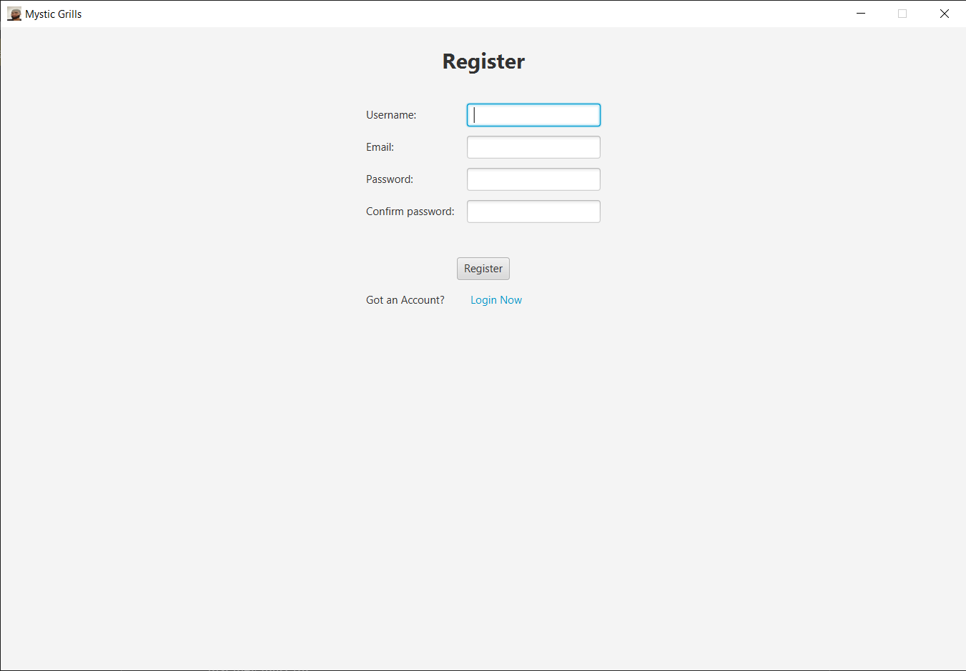

This is the register page where users can create a new account. If they want to login, they can direct themselves by clicking the “Login Now” text. There is some validation within the text fields and after validating, clicking the button will direct the user to the login page.

1. Login Page

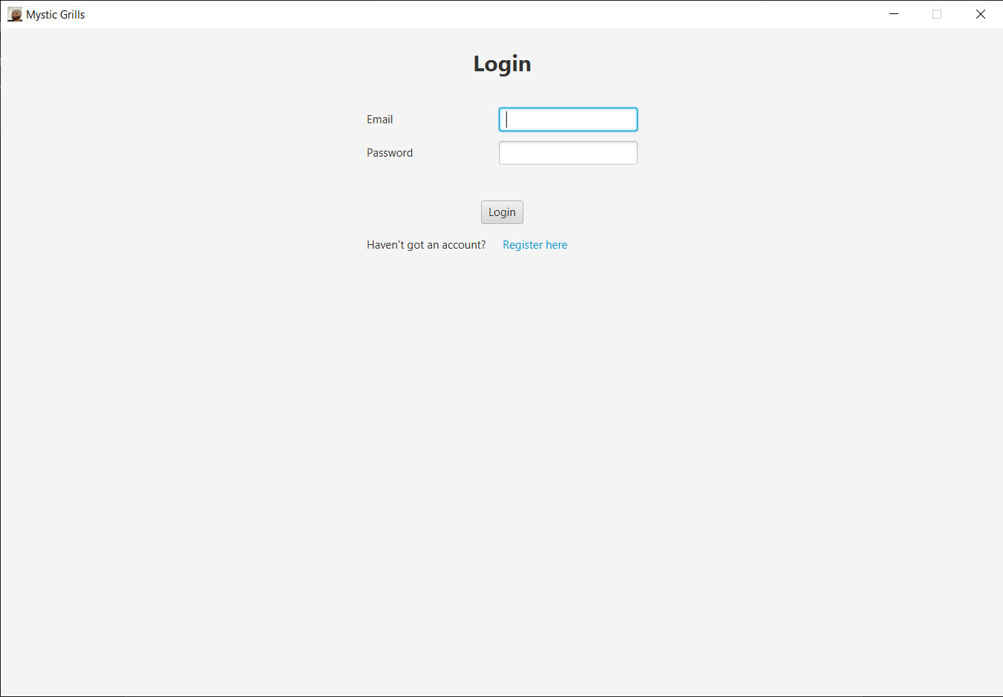

This is the login page where users can login into the application. If they want to register themselves, they can direct themselves by clicking the “Register Here” text. There is some validation within the text fields and after validating, clicking the button will direct the user to the menu page.

1. Navbar

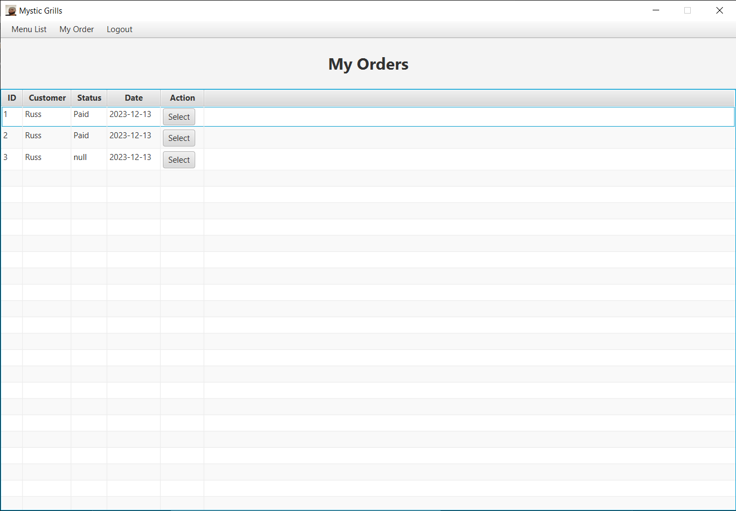

This is the customer’s navbar. The Menu List button will redirect customer to the Menu Page and the My Order Button will redirect customer to the Order page.

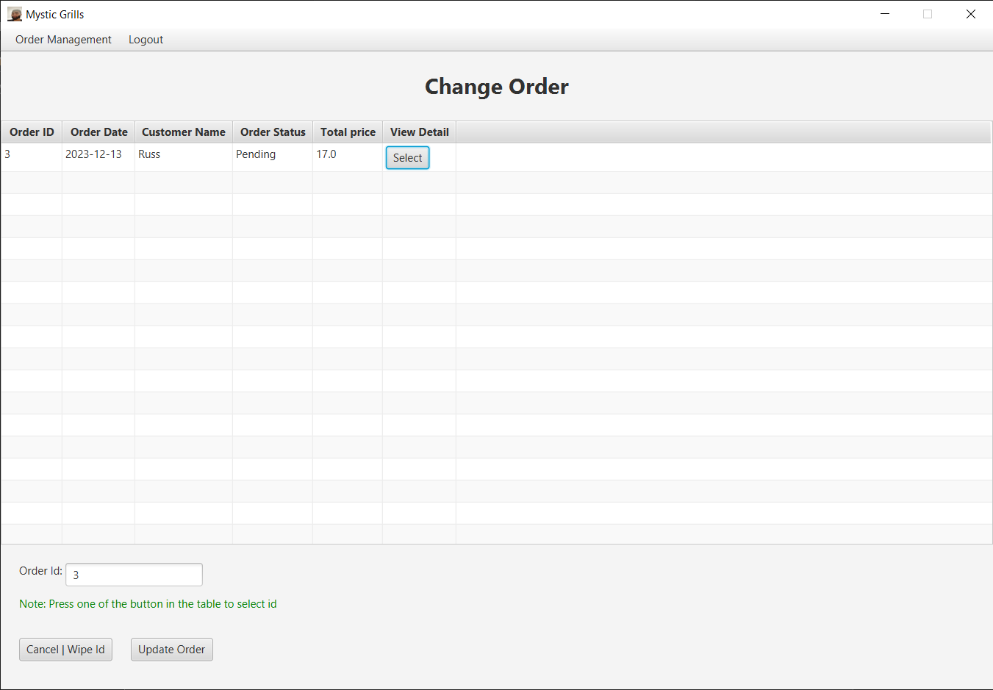

This is the chef’s, waiter’s, and cashier’s navbar. The Order Management button will redirect chefs, waiters, and cashiers to the Order Management Page.

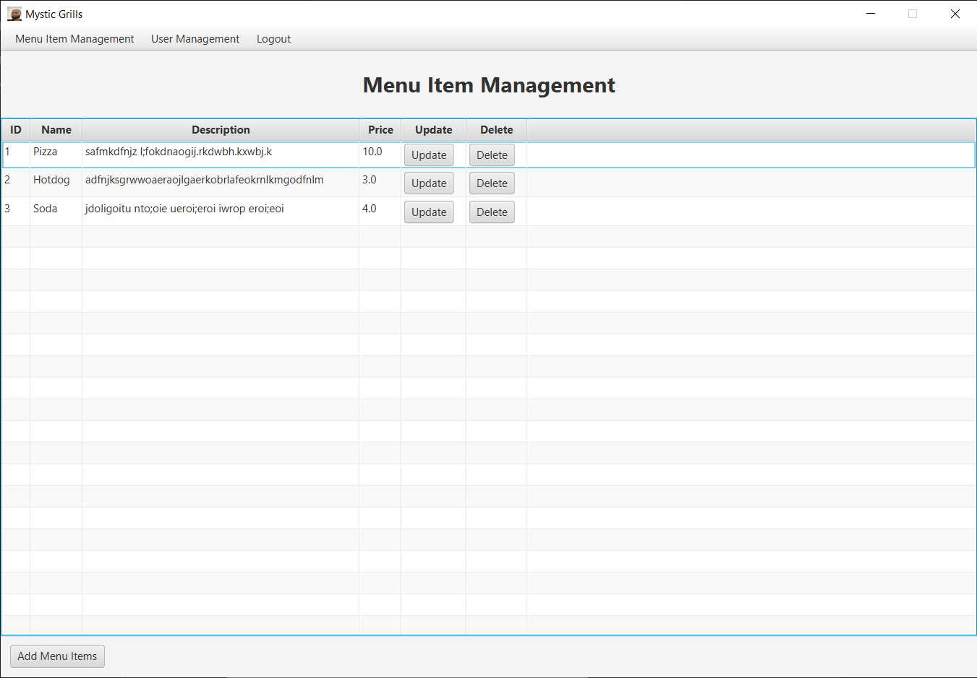

This is the admin’s navbar. The Menu Item Management button will redirect admins to the Menu Item Management Page. The User Management button will redirect admins to the User Management Page.

1. Menu Page

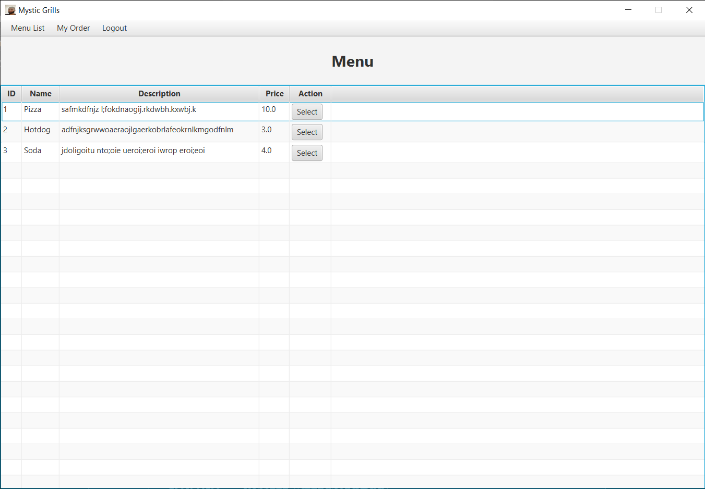

This is the menu page where all the inserted food and beverages are displayed. Clicking the Select button will redirect the user to the menu detail page. Clicking the My Order button at the navbar

1. Menu Detail Page

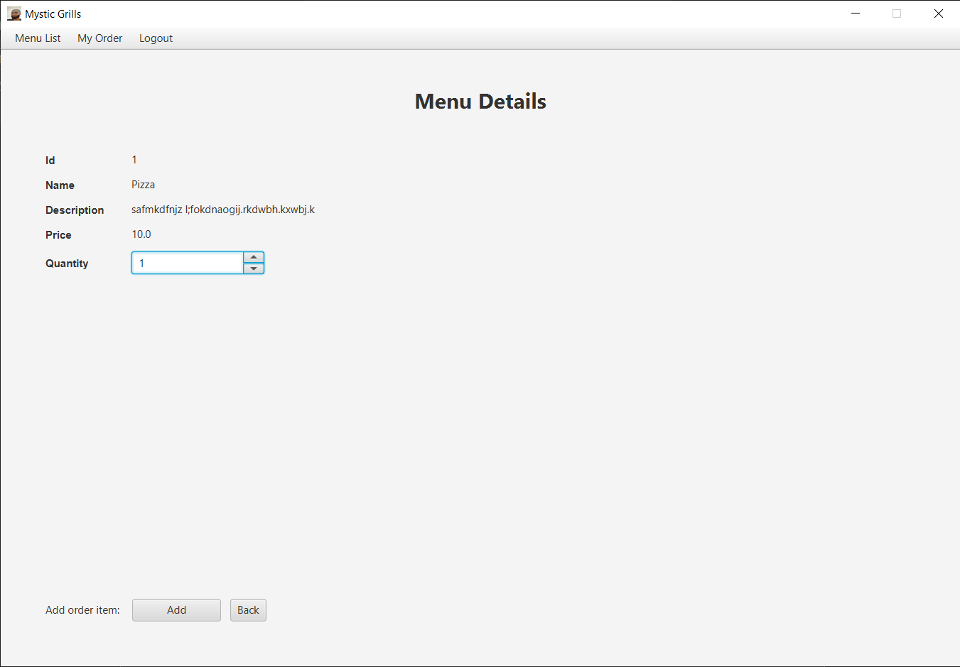

This is the menu page where all the chosen food’s or beverages’ details are displayed. Customer can change the quantity by inserting a number or clicking the up and down buttons. Clicking the Add button will put the current food or beverages and the quantity to the Order. Clicking the back button will redirect the user to the menu detail page.

1. Order Page

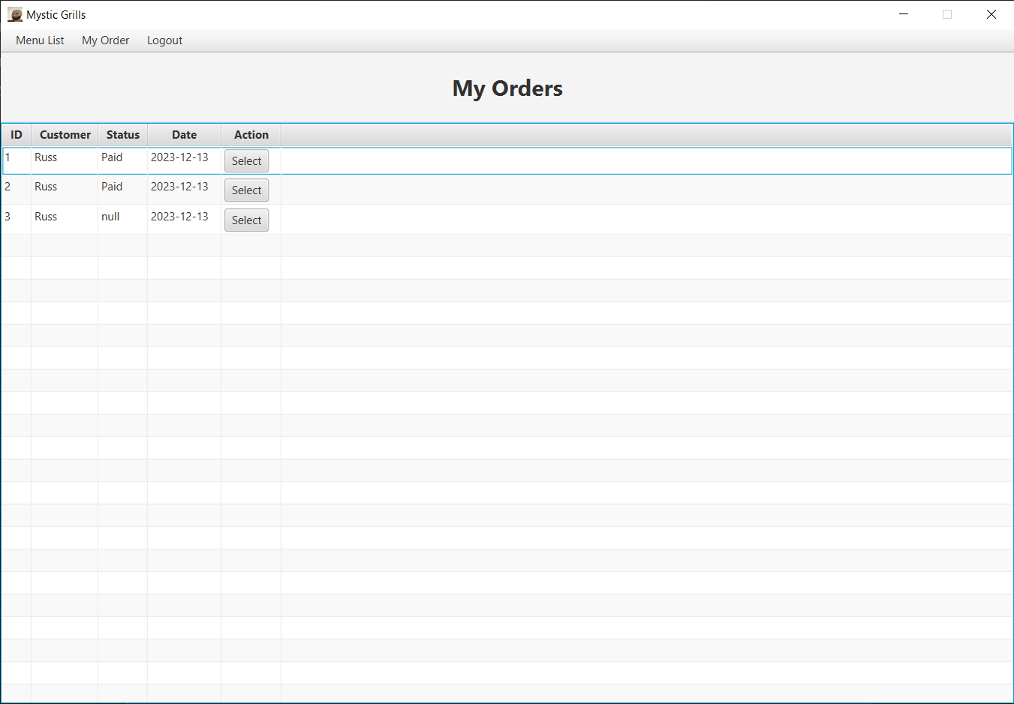

This is the menu page where all the customer’s Order are displayed. Customer can click the Select button to see the Order details. The null status means that the order is made but not submitted yet by the customer. The status will change overtime.

1. Customer Order Detail Page

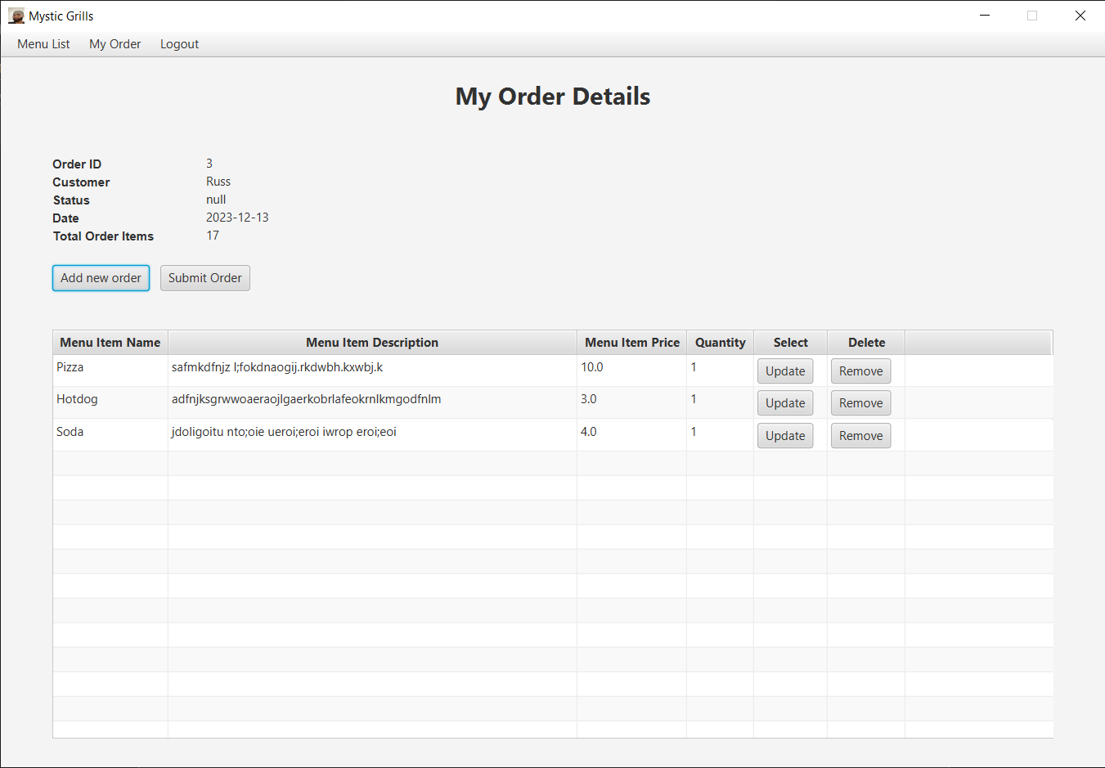

This is the order detail page where all the customer’s order items are displayed. Customers can update the quantity of the item by clicking the update button. Customers can also delete the item from the order by clicking the remove button. Customer can add another item by clicking the Add new Order button. If customer wants to submit the Order, they can click the Submit Order button then the Order Status will be changed to Pending.

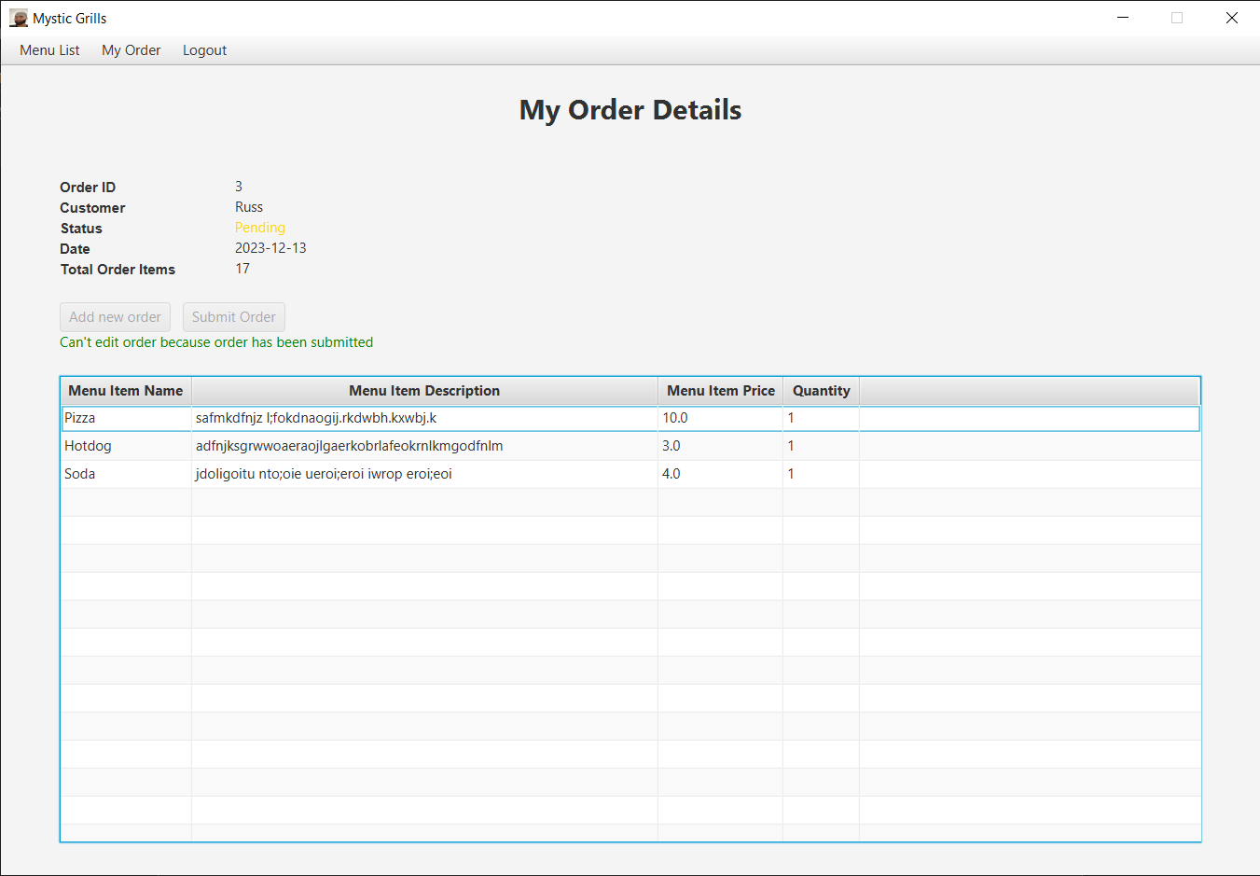

1. Update Order Item Page

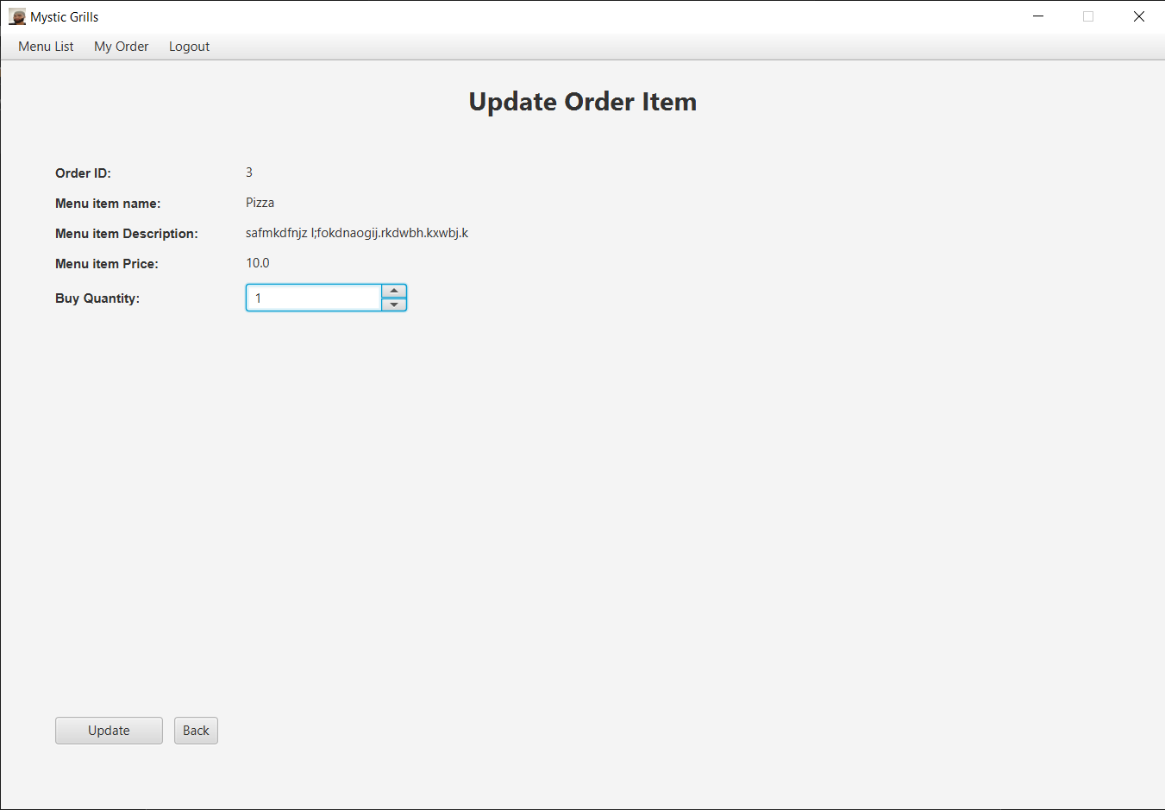

This is the update order item page where the chosen food’s or beverages’ details are displayed. Customer can change the quantity by inserting a number or clicking the up and down buttons. Clicking the Update button will update the current food’s or beverages’ quantity. Clicking the back button will redirect the user to the order detail page.

1. Order Item Delete Confirmation Page

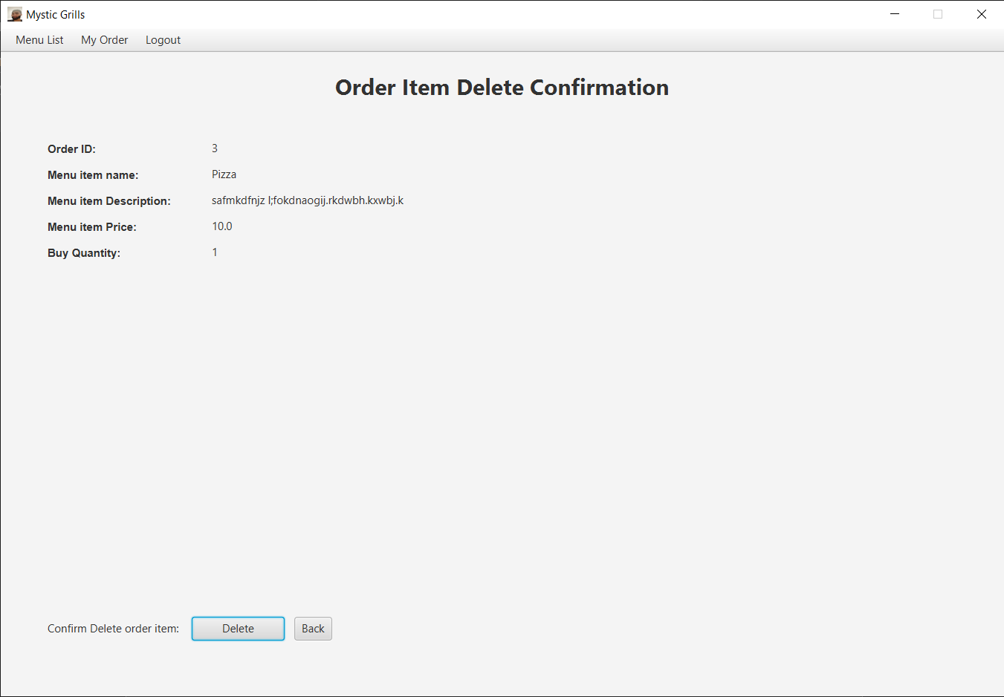

1. This is the order item delete confirmation page where the chosen food’s or beverages’ details are displayed to be confirmed to be deleted. Clicking the Delete button will delete the chosen order item from the Order. Clicking the back button will redirect the user to the order detail page.
2. Change Order



This is the change order page where submitted orders are displayed. Clicking the Select button will select the chosen order and display the Order Id in the text field. After that, the Update Order can be clicked to redirect to the order detail page. The Cancel | Wipe Id button is to deselect the chosen Order. This page can only be accessed by Chef and Waiter role.

1. Order Management Page

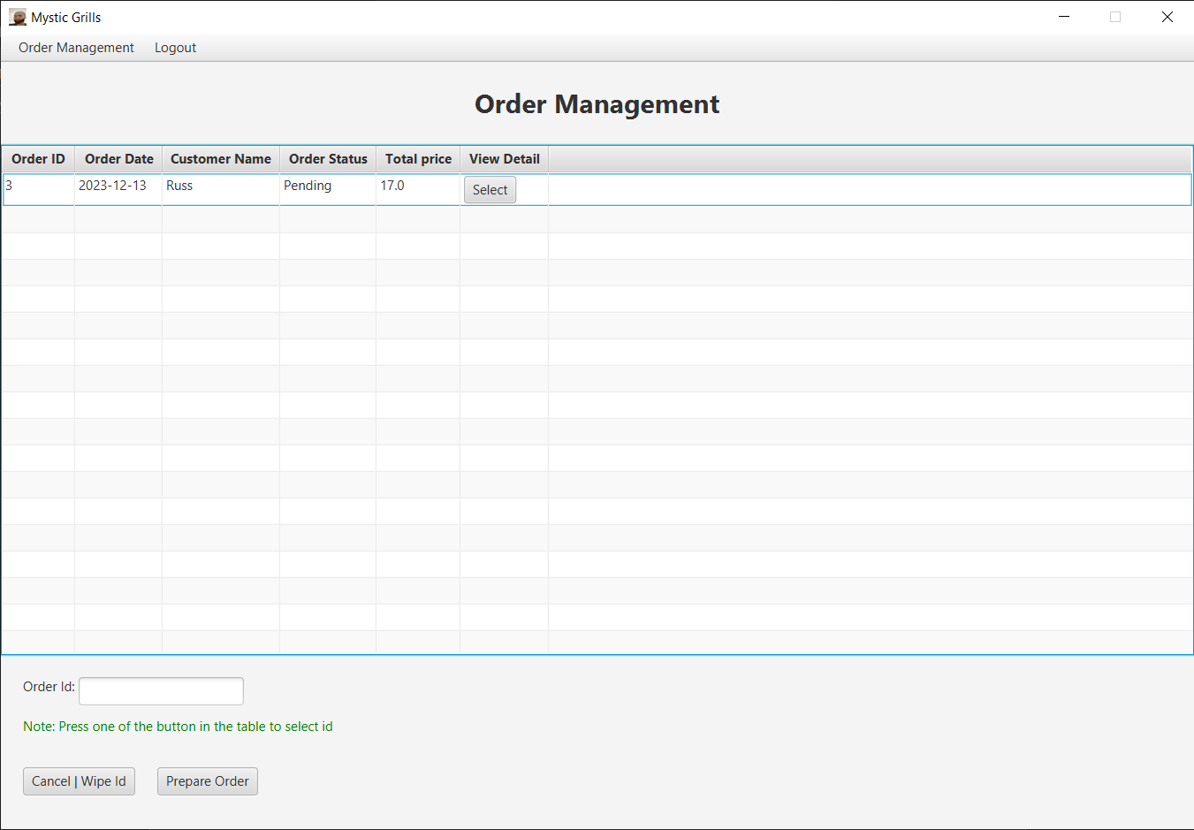

This is the order management page where all the orders are displayed. Chefs can only see Submitted Order or Pending status. Chefs can click the Select button to select the order and then they can click the Prepare Order button to prepare the order.

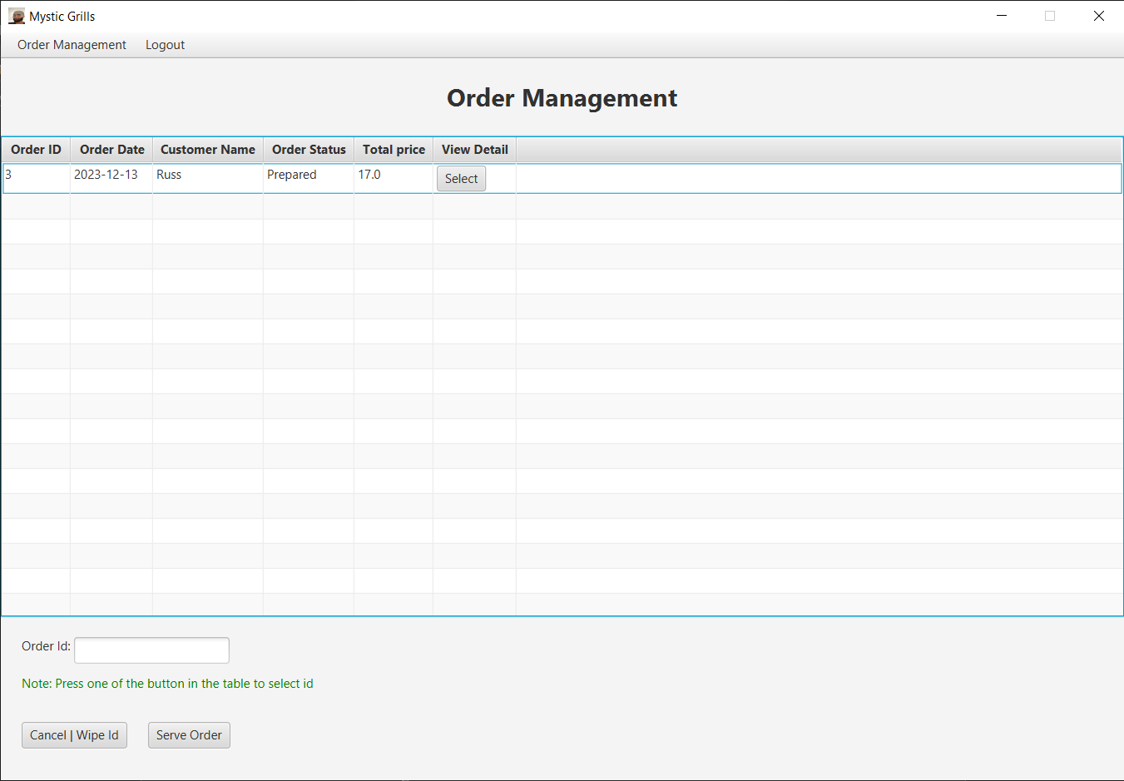

Waiters can only see Prepared Orders or Prepared status. Waiters can click the Select button to select the order and then they can click the Serve Order button to serve the order.

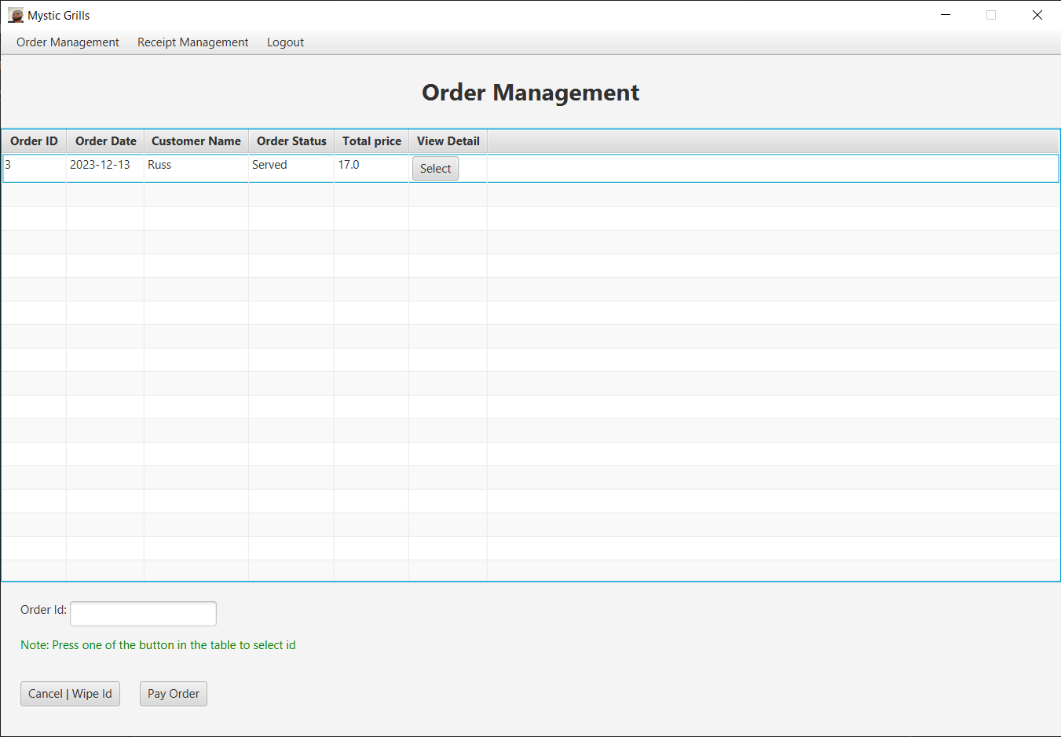

Cashiers can only see Served Orders or Served status. Cashiers can click the Select button to select the order and then they can click the Pay Order button so that customers can pay for their order.

1. Order Detail Page

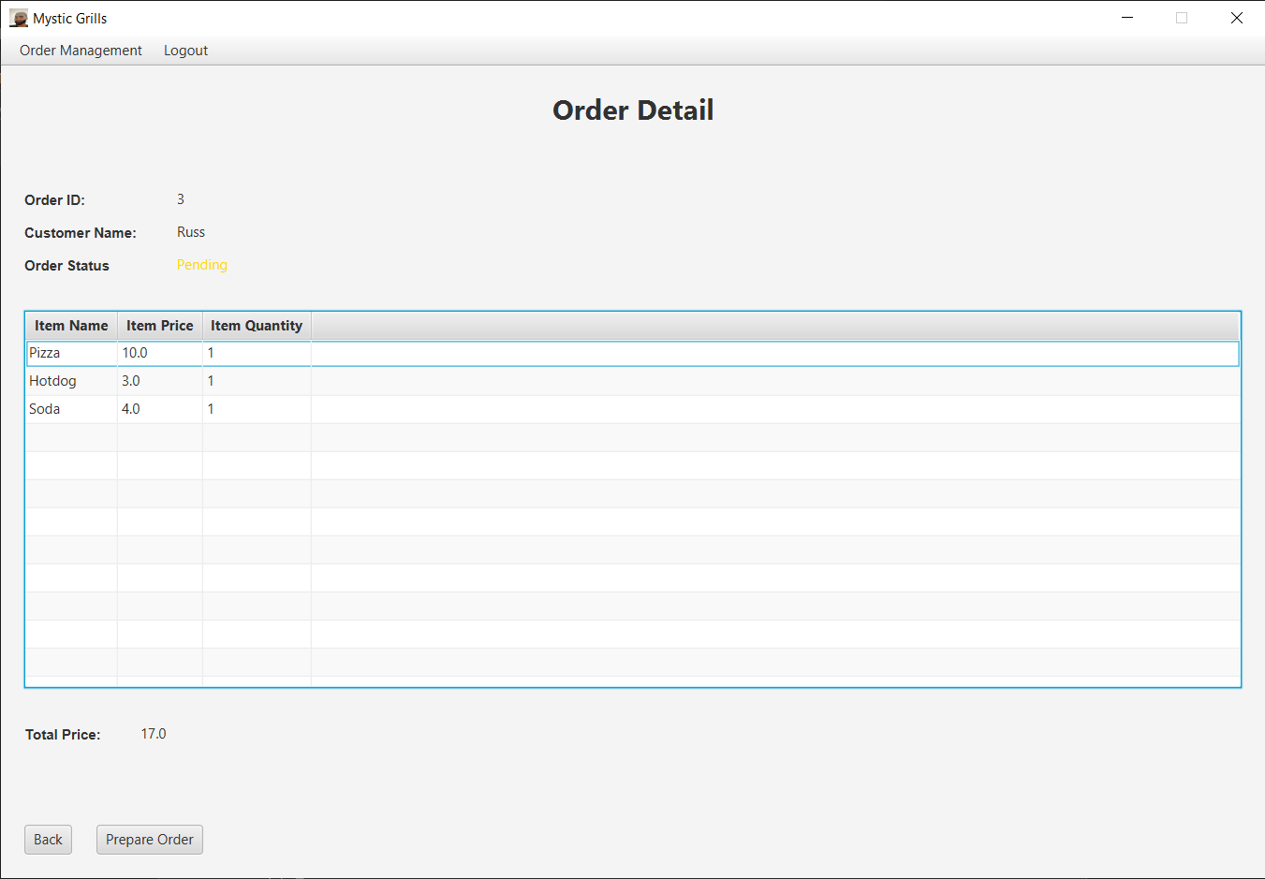

This is the chef’s order detail page where all the Order Item details are displayed. Chefs can click the Prepare Order button to prepare the order and change the Order Status to Prepared. The Back Button will redirect the chef back to the order management page.

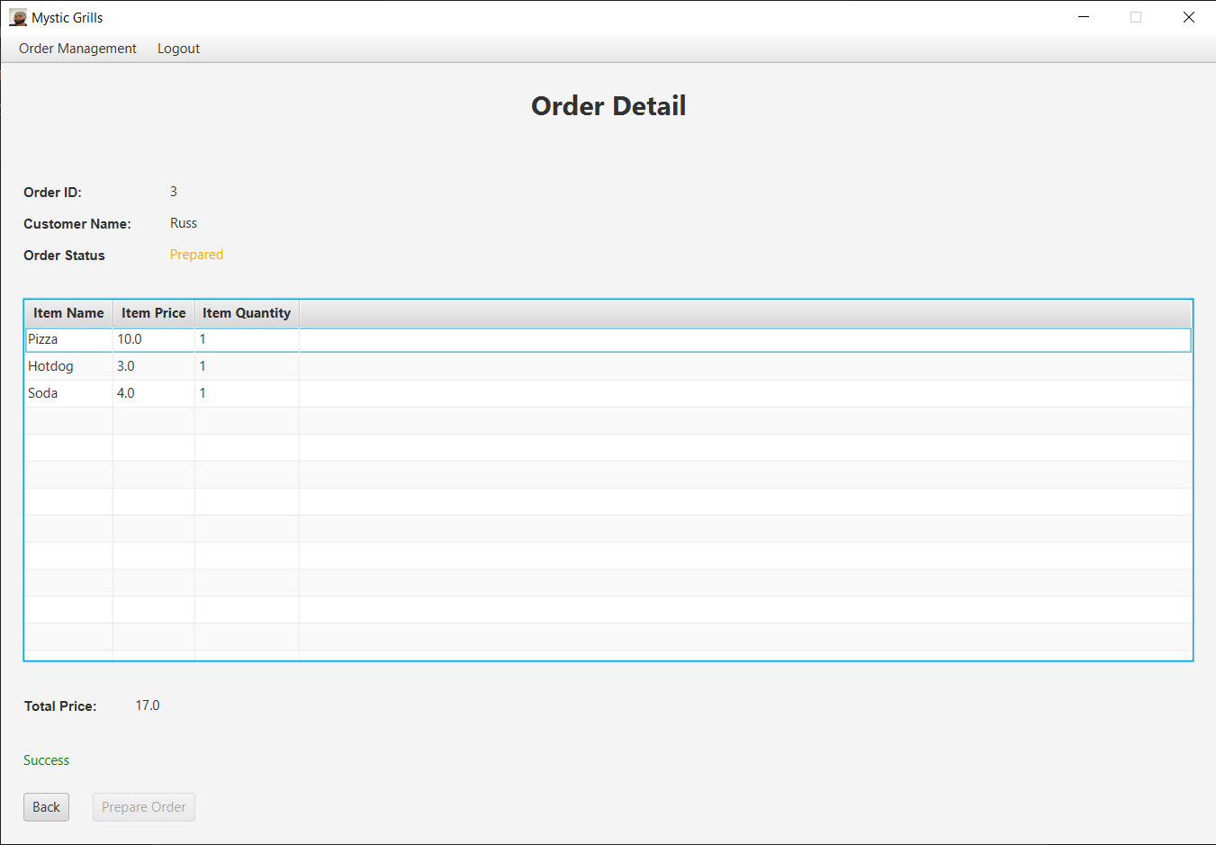

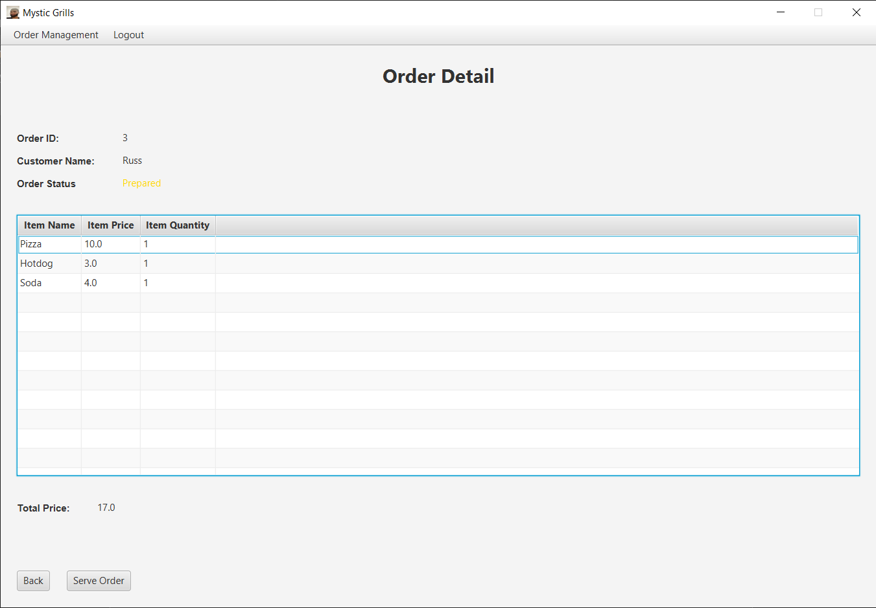

This is the waiter’s order detail page where all the Order Item details are displayed. Waiters can click the Serve Order button to serve the order and change the Order Status to Served. The Back Button will redirect the waiter back to the order management page.

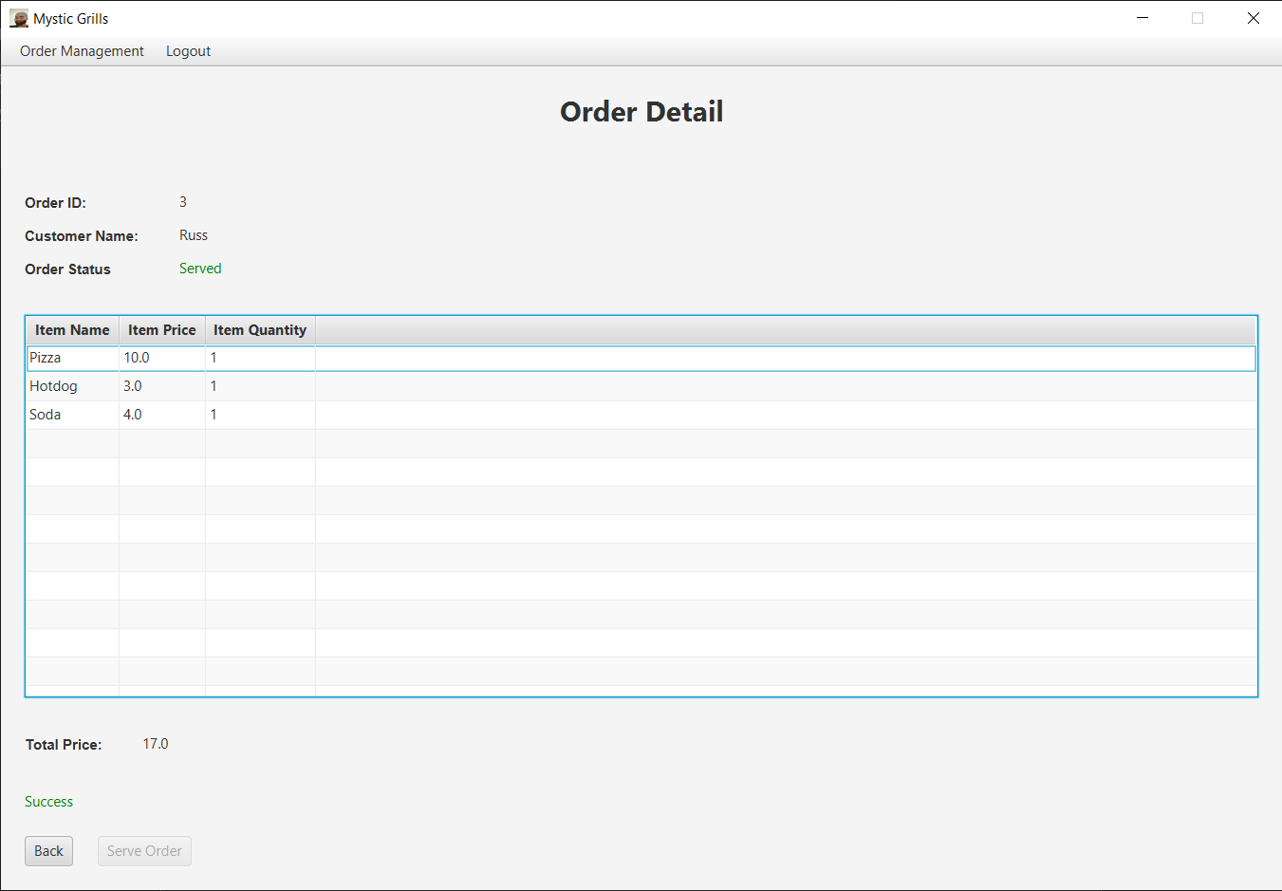

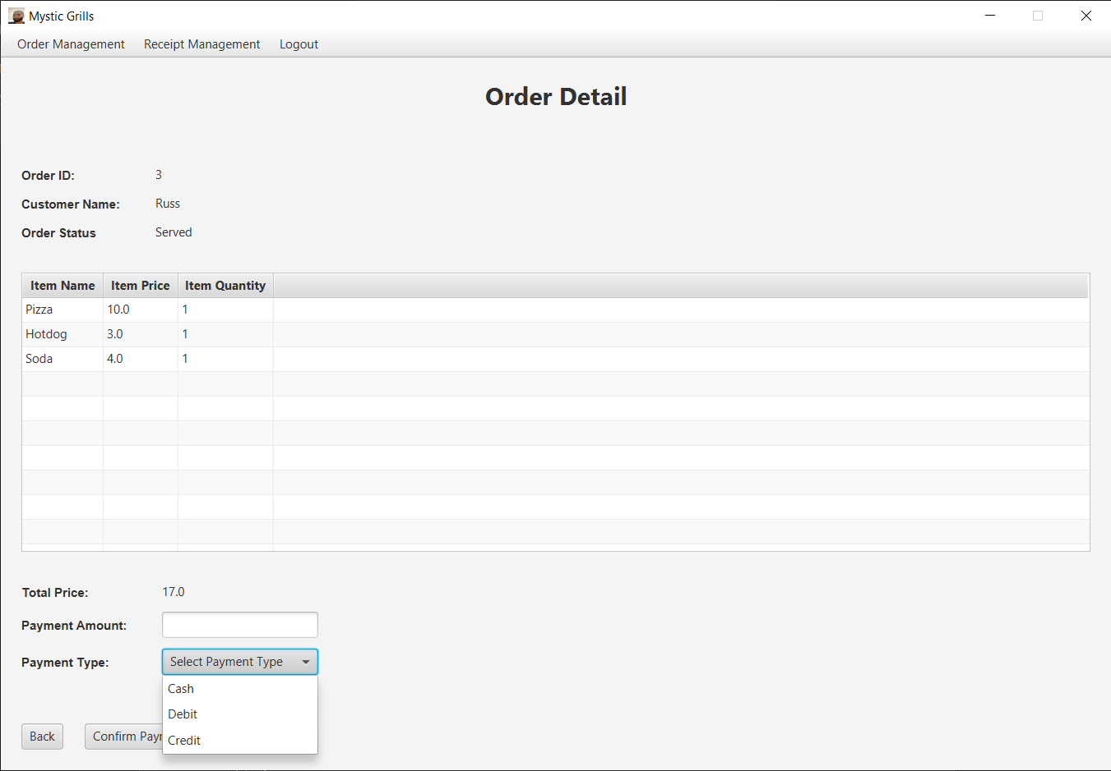

This is the cashier’s order detail page where all the Order Item details are displayed. Waiters can fill in the text field (Payment Amount) and the drop down (Payment Type). If the inputs are valid, they can click the Confirm Payment button to serve the order and change the Order Status to Paid. The Back Button will redirect the waiter back to the order management page.

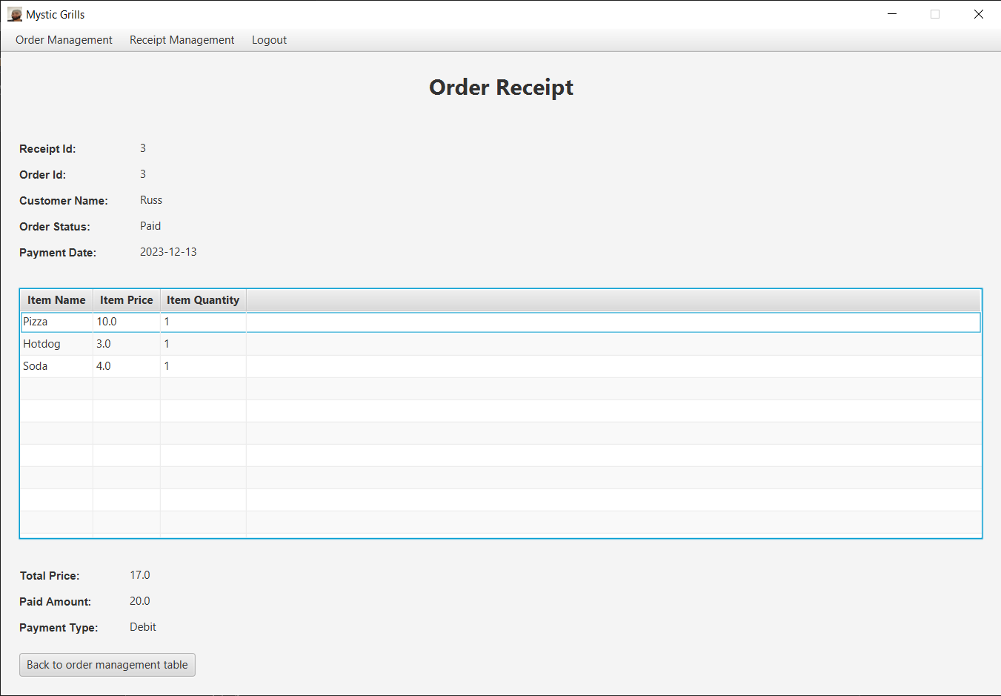

1. Menu Item Management Page

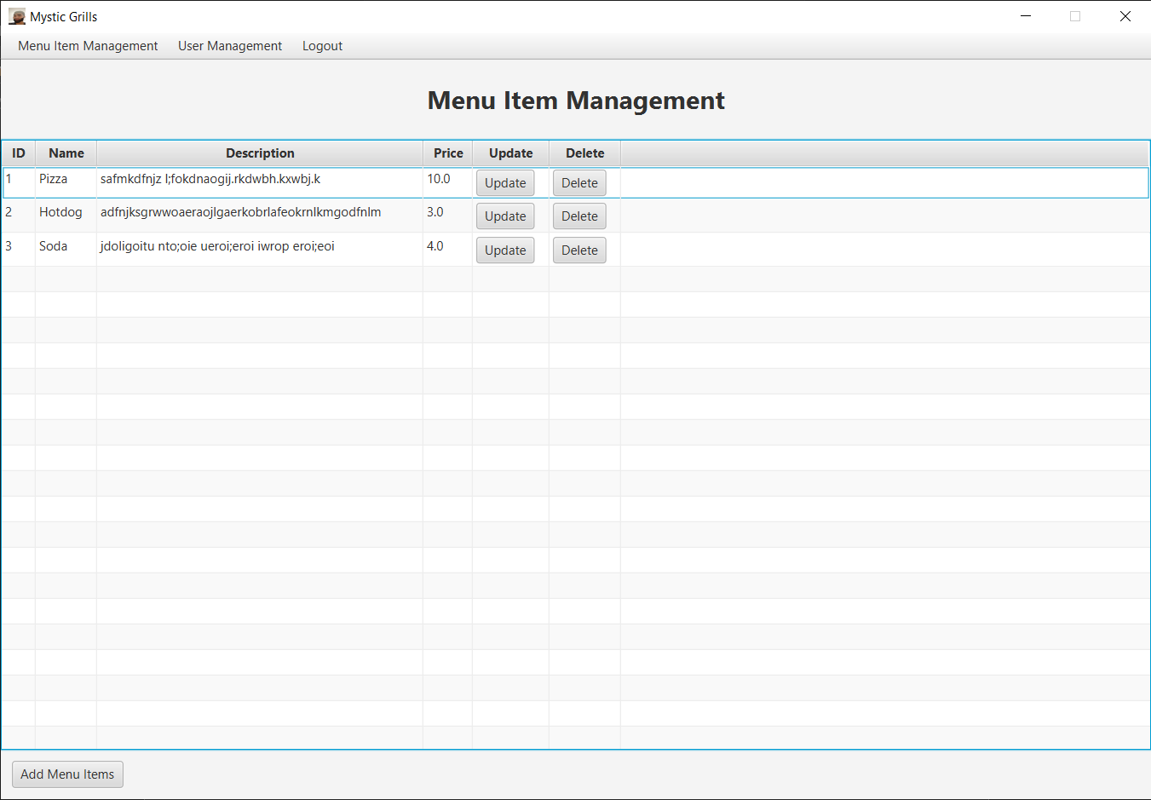

This is the menu item management page where all the items are displayed. Admins can add new menu items by clicking the Add Menu Item Button. Admins can also update the items by clicking the Update Button and admins can delete an item by clicking the Delete Button.

1. Add Menu Item Page

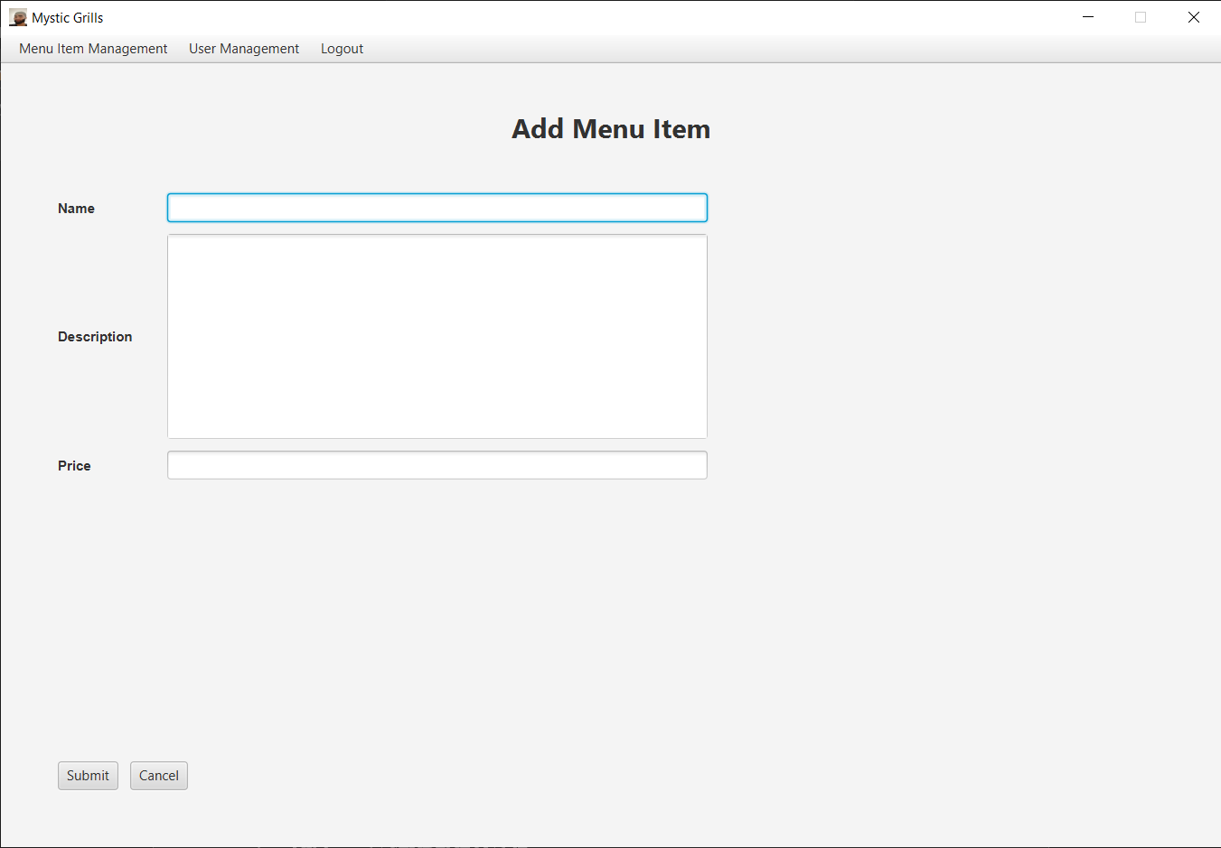

This is the add menu item page where admins can fill in the text fields to add a menu item. All text fields are validated. Clicking the Submit button will insert the new menu item and redirect the admin to the menu item management page. Clicking the cancel button will also redirect the admin to the menu item management page.

1. Delete Menu Item Page

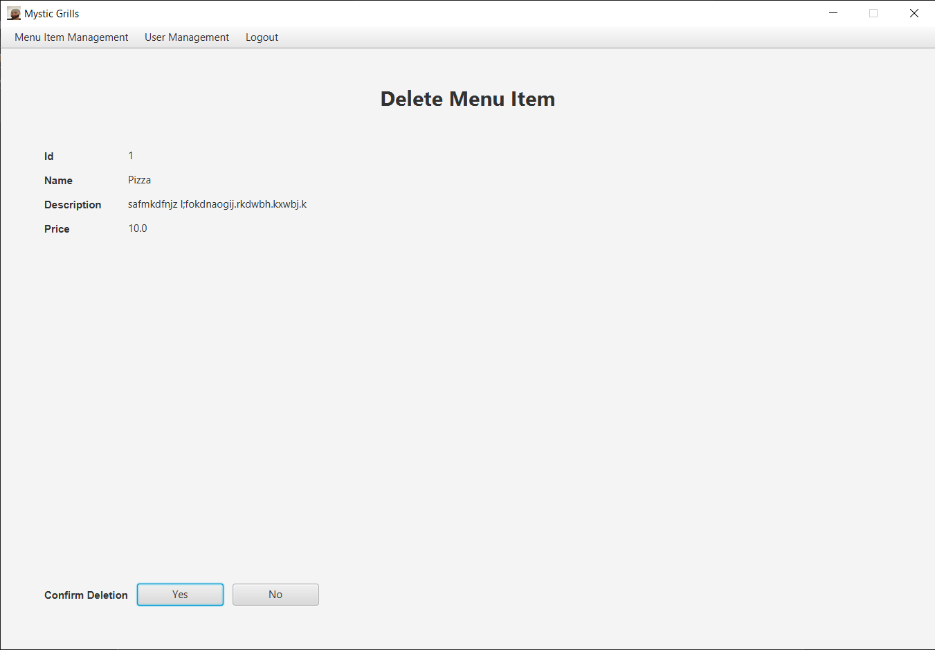

This is the delete menu item page where item details are displayed. Admins can delete the menu item by clicking the Yes Button. Admins can click the No Button to cancel the deletion and redirect the admin to the user management page.

1. Update Menu Item Page

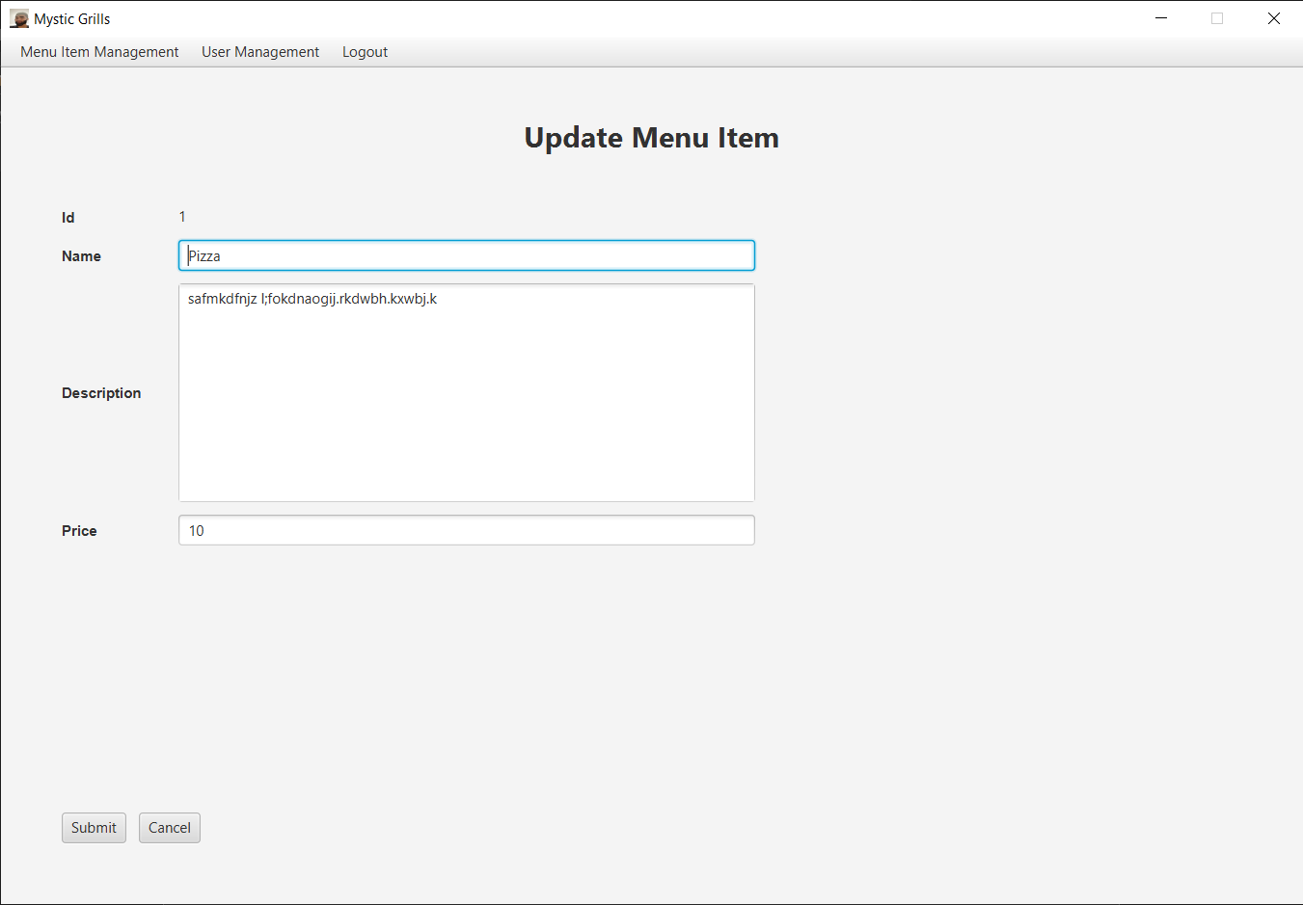

This is the update menu item page where admins can fill in the text fields to update the chosen menu item. All text fields are validated. Clicking the Submit button will update the chosen menu item and redirect the admin to the menu item management page. Clicking the cancel button will also redirect the admin to the menu item management page.

1. User Management Page

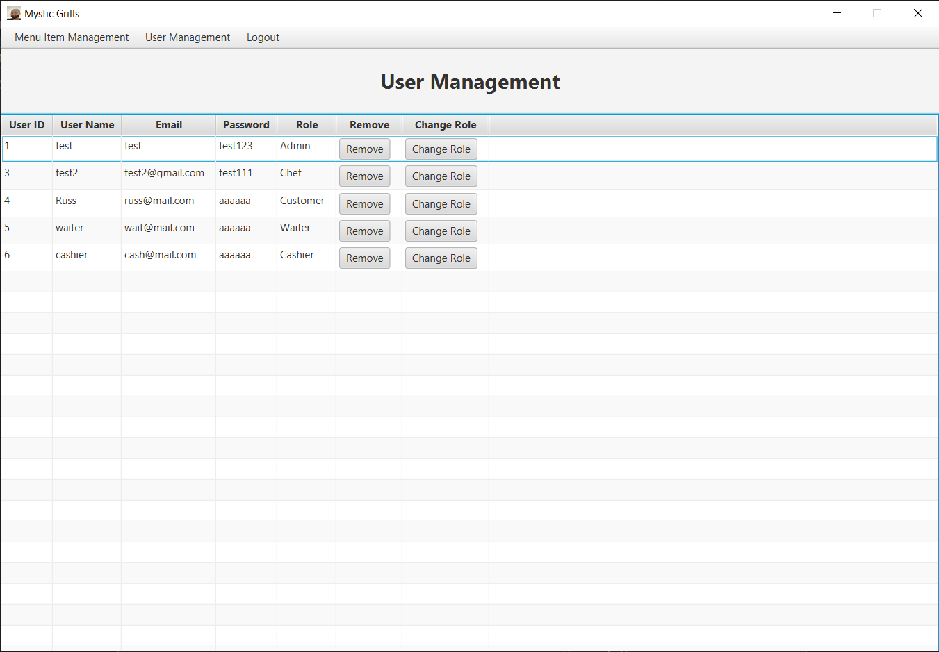

This is the user management page where admins manage all registered users. Admins can remove a user by clicking the Remove Button. Admins can also change users’ roles by clicking the Change Role Button which will redirect them to the change role page.

1. Change Role Page

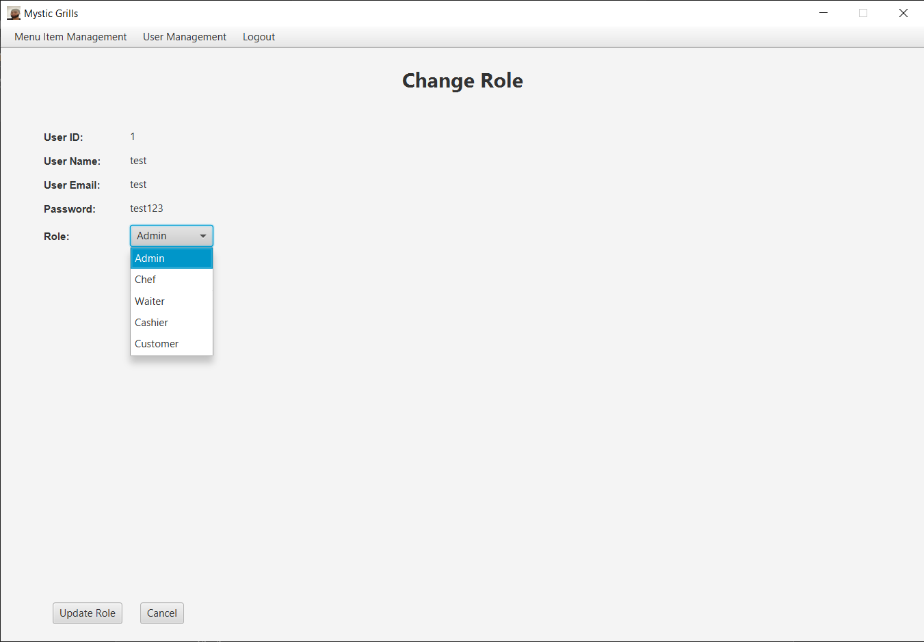

This is the change role page where admins can change the user’s role. Admins can change between Admin, Chef, Waiter, Cashier, and Customer role to the chosen user. Clicking the Update Role Button will change the user’s role and redirect the admin to the user management page. Clicking the cancel button will also redirect the admin to the user management page.

1. Delete User Page

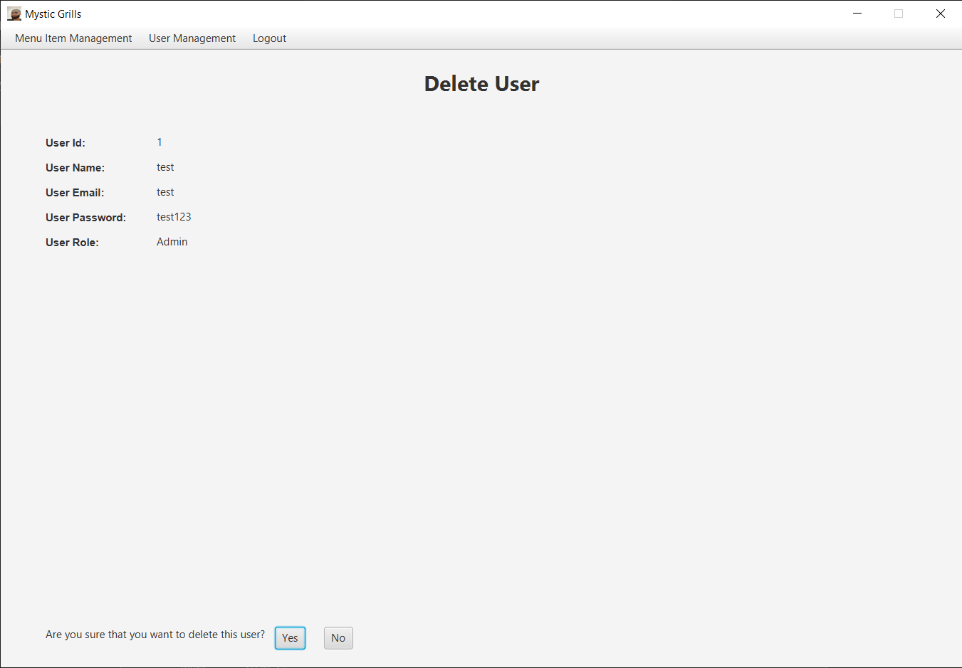

This is the delete user page where the user’s detail are displayed. Admins can click the Yes Button to delete the user. Admins can click the No Button to cancel the deletion and redirect the admin to the user management page.

* Group Member
* <2501967732> – <HANS ARTHUR CUPITERSON >
* <2501967253> – <NATHANAEL JUAN GAUTHAMA>
* <2501966295> – <RUSSELL WILLIAM ARDIAN>