**15B17CI371 – Data Structures Lab**

**ODD 2024**

**Week 1-LAB A**

**Practice Lab**

[CO: C270.1]

**Q1. You are given an empty singly linked list. Assume that this list can contain whole numbers only. Write functions to**

**a. Insert ‘n’ number of data in the singly linked list. Insert from the head.**

**b. Find the total number of nodes in the linked list, and give their average.**

**c. Print first ‘m’ data from the linked list. Assume that ‘m’ is less than ‘n’. Example:**

**Input:**

**Linked list: {1, 3, -9, 45, 2, 3, 56, 100, -67}**

**m=4**

**Output: {1, 3, -9, 45, 2}**

**Example:**

**Input:**

**Linked list: {1, 3, -9, 45, 2, 3, 56, 100, -67}**

**m=10**

**Output: Incorrect value of m**

**d. Find the middle element of the linked list and check if it’s odd or even. Print an appropriate output.**

**Example:**

**Input:**

**Linked list: {1, 3, -9, 45, 2, 3, 56, 100, -67}**

**Output: 3 is odd**

**e. Find the ‘l’ number from the end of the list.**

**Example:**

**Input:**

**Linked list: {1, 3, -9, 45, 2, 3, 56, 100, -67}**

**l=3**

**Output: {56, 100, -67}**

**f. Find if a given number exists in the list. If it does, write function to delete it. Example:**

**Input:**

**Linked list: {1, 3,-9, 45, 2, 3, 56, 100, -67}**

**Number to be found: 45**

**Output: 45 exists in the original list**

**Final list: {1, 3, -9, 2, 3, 56, 100, -67}**

**If the value exists multiple times, delete only the first instance.**

**g. Interchange a pair of values with another given pair in the linked list. Example:**

**Input:**

**Linked list: {1, 3,-9, 45, 2, 3, 56, 100, -67}**

**Pairs to be exchanged: {1,3} with {56,100}**

**Output: {56, 100, -9, 45, 2, 3, 1, 3, -67}**

**Hint: first check if the pair exists and then apply interchange function. If multiple or duplicate pairs are found, consider the first instance of the pair.**

**h. Check whether a given sub-list exists in the given linked list. If it exists, give its position (i.e., the staring position of the sub-list in the master linked list). Example:**

**Input:**

**Linked list: {1, 3,-9, 45, 2, 3, 56, 100, -67}**

**Sub-list to be: {3, -9, 45}**

**Output: Exists at position 2.**

**{1, 3,-9, 45, 2, 3, 56, 100, -67}**

**Assumption: consider only the first occurrence of the sub-list.**

**i. Reverse a sub-list in the given linked list.**

**Example:**

**Input:**

**Linked list: {1, 3,-9, 45, 2, 3, 56, 100, -67}**

**Sub-list to be reversed: {3, -9, 45}**

**Output: {1, 45,-9, 3, 2, 3, 56, 100, -67}**

**Assume that the user inputs the sub-list is found in the master linked list.**

#include <iostream>

#include <vector>

using namespace std;

struct Node

{

int data;

Node* next;

Node(int val):data(val),next(nullptr){}

};

class LinkedList

{

Node* head;

Node* findValue(int value) const

{

Node* temp=head;

while(temp)

{

if(temp->data==value)

return temp;

temp=temp->next;

}

return nullptr;

}

public:

LinkedList():head(nullptr){}

void insertHead(int data)

{

Node* newNode=new Node(data);

newNode->next=head;

head=newNode;

}

pair<int,double> totalAndAverage() const

{

int count=0;

double sum=0;

Node* temp=head;

while(temp)

{

sum+=temp->data;

count++;

temp=temp->next;

}

double average=sum/(count*1.0);

return {count,average};

}

void printFirstM(int m) const

{

if(m<=0)

{

cout<<"Incorrect value of m"<<endl;

return;

}

Node* temp=head;

for(int i=0;i<m;i++)

{

if(temp)

{

cout<<temp->data<<" ";

temp=temp->next;

}

else

{

cout<<"Incorrect value of m"<<endl;

return;

}

}

cout<<endl;

}

void middleElement() const

{

if(!head)

return;

Node* slow=head;

Node* fast=head;

while(fast&&fast->next)

{

slow=slow->next;

fast=fast->next->next;

}

cout<<"Middle element is "<<slow->data<<" which is "<<(slow->data%2==0?"even":"odd")<<endl;

}

void findLFromEnd(int l) const

{

if(l<=0)

{

cout<<"Incorrect value of l"<<endl;

return;

}

Node* fast=head;

Node* slow=head;

for(int i=0;i<l;++i)

{

if(fast)

fast=fast->next;

else

{

cout<<"Incorrect value of l"<<endl;

return;

}

}

while(fast)

{

slow=slow->next;

fast=fast->next;

}

cout<<slow->data<<" ";

while(slow->next)

{

slow=slow->next;

cout<<slow->data<<" ";

}

cout<<endl;

}

void deleteValue(int value)

{

Node* temp=head;

Node* prev=nullptr;

while(temp)

{

if(temp->data==value)

{

if(prev)

prev->next=temp->next;

else

head=temp->next;

delete temp;

cout<<value<<" exists in the original list."<<endl;

return;

}

prev=temp;

temp=temp->next;

}

cout<<value<<" does not exist in the list."<<endl;

}

void interchangePairs(int val1,int val2,int val3,int val4)

{

Node* temp=head;

Node* temp1=nullptr;

Node* temp2=nullptr;

Node* temp3=nullptr;

Node* temp4=nullptr;

while(temp)

{

if(temp->data==val1)

{

if((temp->next)->data==val2)

{

temp1=temp;

temp2=temp->next;

}

}

if(temp->data==val3)

{

if((temp->next)->data==val4)

{

temp3=temp;

temp4=temp->next;

}

}

if(temp1&&temp2&&temp3&&temp4)

{

swap(temp1->data,temp3->data);

swap(temp2->data,temp4->data);

return;

}

temp=temp->next;

}

cout<<"One or both pairs do not exist"<<endl;

}

int findSubList(const vector<int>& subList) const

{

if(subList.empty())

return -1;

Node* temp=head;

int index=0;

while(temp)

{

Node* subTemp=temp;

bool found=true;

for(int val:subList)

{

if(!subTemp || subTemp->data!=val)

{

found=false;

break;

}

subTemp=subTemp->next;

}

if(found)

return index;

temp=temp->next;

index++;

}

return -1;

}

void reverseSubList(const vector<int>& subList)

{

int pos=findSubList(subList);

if(pos==-1)

{

cout<<"Sub-list not found"<<endl;

return;

}

Node* startPrev=nullptr;

Node* start=head;

for(int i=0;i<pos;i++)

{

startPrev=start;

start=start->next;

}

Node* end=start;

for(size_t i=0;i<subList.size();i++)

end=end->next;

Node* prev=end;

Node* curr=start;

while(curr!=end)

{

Node* next=curr->next;

curr->next=prev;

prev=curr;

curr=next;

}

if(startPrev)

startPrev->next=prev;

else

head=prev;

}

void printList() const

{

Node* temp=head;

while(temp)

{

cout<<temp->data<<" ";

temp=temp->next;

}

cout<<endl;

}

};

int main()

{

int l,n,m,val,p1,p2,q1,q2;

LinkedList list;

cout<<"Enter the number of values to be entered in the linked list : ";

cin>>n;

for(int i=0;i<n;i++)

{

cin>>val;

list.insertHead(val);

}

list.printList();

auto [total,average]=list.totalAndAverage();

cout<<"Total nodes : "<<total<<", Average : "<<average<<endl;

cout<<"Input the value of m to print first 'm' values from the linked list : ";

cin>>m;

list.printFirstM(m);

list.middleElement();

cout<<"Input the value of l to print the 'l' values from the end of the list : ";

cin>>l;

list.findLFromEnd(l);

cout<<"Input the value to be deleted : ";

cin>>val;

list.deleteValue(val);

list.printList();

cout<<"Input the vales of pair 1 : ";

cin>>p1>>p2;

cout<<"Input the vales of pair 2 : ";

cin>>q1>>q2;

list.interchangePairs(p1,p2,q1,q2);

cout<<"Pairs interchanged list : \n";

list.printList();

vector<int> subList;

cout<<"Input the size of the sublist : ";

cin>>n;

cout<<"Input the values of the sublist : ";

for(int i=0;i<n;i++)

{

cin>>val;

subList.push_back(val);

}

int pos=list.findSubList(subList);

if(pos!=-1)

cout<<"Sub-list exists at position "<<pos<<endl;

else

cout<<"Sub-list not found"<<endl;

cout<<"\nReversed Sub-list : "<<endl;

list.reverseSubList(subList);

list.printList();

return 0;

}

**Output :**

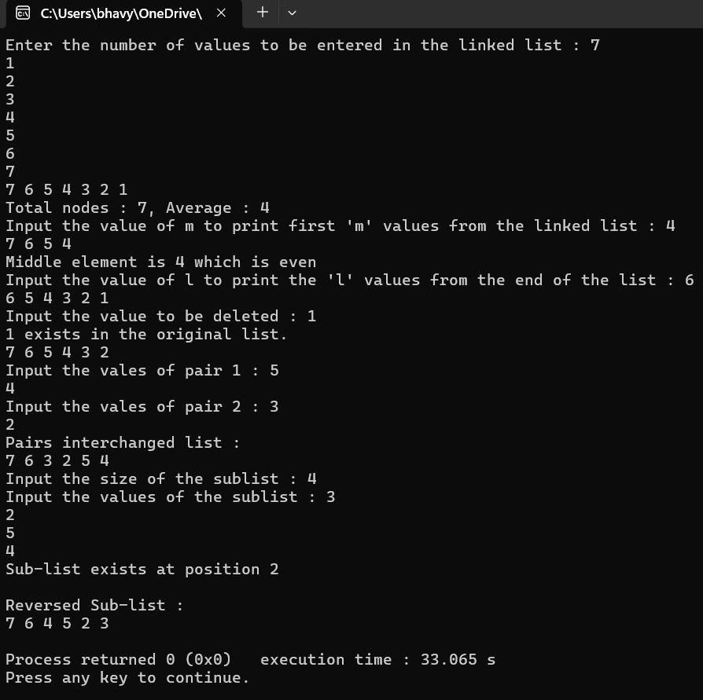

**Q2. Assume that you have a linked list that can contain strings, i.e., each node can contain a string. Write a function to:**

**a. Print all the nodes in the linked list**

**b. Print all the strings (node values) that start with a particular alphabet.**

**c. Find if a given string exists in the linked list or not. Give appropriate output message.**

**d. Find the string with maximum length.**

**e. Find if a node contains “xyz” as a sub-string or not. Give appropriate output message.**

**f. Interchange the strings given in the positions p1, p2. These positions are user input. Check conditions that both p1 and p2 position exist in the given linked list, eg: suppose that your linked list consists of 4 strings only, and if user given p1=7, p2 = 10, then error message must be generated.**

**g. Delete a given node (either by value or by position).**

#include <iostream>

#include <string>

using namespace std;

class Node

{

public:

string data;

Node* next;

Node(string val):data(val),next(nullptr){}

};

class LinkedList

{

Node* head;

public:

LinkedList():head(nullptr){}

void addNode(string val)

{

Node* newNode=new Node(val);

newNode->next=head;

head=newNode;

}

void printAllNodes()

{

cout<<"List :\n";

Node* temp=head;

while(temp!=nullptr)

{

cout<<temp->data<<" ";

temp=temp->next;

}

cout<<endl;

}

void printNodesStartingWith(char ch)

{

Node* temp=head;

cout<<"Nodes starting with '"<<ch<<"' : ";

while(temp!=nullptr)

{

if(temp->data[0]==ch)

cout<<temp->data<<" ";

temp=temp->next;

}

cout<<endl;

}

void findString(string s)

{

Node* temp=head;

int c=0;

while(temp!=nullptr)

{

if(temp->data==s)

{

cout<<"String found in the list at position "<<c+1<<endl;

return;

}

temp=temp->next;

c++;

}

cout<<"String not found in the list."<<endl;

}

string findMaxLengthString()

{

Node* temp=head;

if(!temp)

return "";

string max=temp->data;

while(temp!=nullptr)

{

if(temp->data.length()>max.length())

max=temp->data;

temp=temp->next;

}

return max;

}

void containsSubstring(string s)

{

Node* temp=head;

int c=0;

while(temp!=nullptr)

{

if(temp->data.find(s)!=string::npos)

{

cout<<"Node "<<c+1<<" contains '"<<s<<"' as a substring."<<endl;

return;

}

temp=temp->next;

c++;

}

cout<<"'"<<s<<"' not found as a substring in any node."<<endl;

}

void interchangeNodes(int p1,int p2)

{

if(p1==p2)

return;

Node* temp=head,*temp1=nullptr,*temp2=nullptr;

int c=1;

while(temp&&!(temp1&&temp2))

{

if(c==p1)

temp1=temp;

if(c==p2)

temp2=temp;

c++;

temp=temp->next;

}

if(temp1&&temp2)

{

string t=temp1->data;

temp1->data=temp2->data;

temp2->data=t;

cout<<"Strings are interchanged at the given positions."<<endl;

}

else

cout<<"There is no node in the given position."<<endl;

}

void deleteNodeByValue(string val)

{

Node* temp=head;

Node* prev=nullptr;

if(temp->data==val)

{

head=temp->next;

delete temp;

return;

}

while(temp&&temp->data!=val)

{

prev=temp;

temp=temp->next;

}

if(temp==nullptr)

{

cout<<"'"<<val<<"' not found in the list."<<endl;

return;

}

prev->next=temp->next;

delete temp;

cout<<"'"<<val<<"' deleted from the list."<<endl;

}

void deleteNodeByPosition(int p)

{

if(head==nullptr)

return;

Node* temp=head;

if(p==1)

{

head=temp->next;

delete temp;

cout<<"Node on the given position is deleted."<<endl;

return;

}

int c=1;

while(temp&&c<p-1)

{

temp=temp->next;

c++;

}

if(temp==nullptr||temp->next==nullptr)

{

cout<<"Given position not found in the linked list."<<endl;

return;

}

Node* next=temp->next->next;

delete temp->next;

temp->next=next;

cout<<"Node on the given position is deleted."<<endl;

}

};

int main()

{

LinkedList list;

string s;

int n,p,p1,p2;

char ch;

cout<<"Input the number of string to be entered in the list : ";

cin>>n;

cout<<"Input the strings :\n";

for(int i=0;i<n;i++)

{

cin>>s;

list.addNode(s);

}

list.printAllNodes();

cout<<"Input a character : ";

cin>>ch;

list.printNodesStartingWith(ch);

cout<<"Input a string to be searched : ";

cin>>s;

list.findString(s);

cout<<"String with maximum length: "<<list.findMaxLengthString()<<endl;

cout<<"Input a string to find if a node contains it as a sub-string or not : ";

cin>>s;

list.containsSubstring(s);

cout<<"Input two positions for interchanging the strings : ";

cin>>p1>>p2;

list.interchangeNodes(p1,p2);

list.printAllNodes();

cout<<"Input a string to be deleted from the list : ";

cin>>s;

list.deleteNodeByValue(s);

list.printAllNodes();

cout<<"Input a node position to be deleted from the list : ";

cin>>p;

list.deleteNodeByPosition(p);

list.printAllNodes();

}

**Output :**

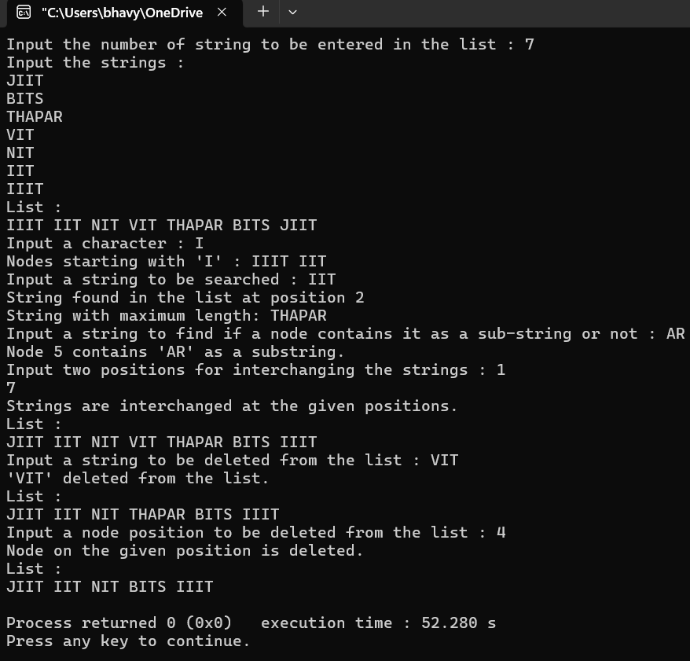

**Q3. Implement a circular linked list that can contain integer elements. Add functions to:**

**a. Insert elements.**

**b. Print elements**

**c. Count the number of elements**

**d. Find if any element has a negative value.**

**e. Find the number of nodes having a value greater than 15.**

**f. Delete a particular element from the list.**

**g. Update the value of a particular element.**

**h. Insert a value at a given position.**

**i. Delete all nodes that have a prime number as their value.**

**j. Remove all the nodes from the list which contains Fibonacci data values.**

#include <iostream>

#include <cmath>

using namespace std;

struct Node

{

int data;

Node* next;

};

class CircularLinkedList

{

Node* head;

bool isPrime(int num)

{

if(num<=1)

return false;

for(int i=2;i<=sqrt(num);i++)

if(num%i==0)

return false;

return true;

}

bool isFibonacci(int num)

{

int a=0,b=1;

if(num==a||num==b) return true;

int c=a+b;

while(c<=num)

{

if(c==num) return true;

a=b;

b=c;

c=a+b;

}

return false;

}

public:

CircularLinkedList():head(nullptr){}

void insert(int value)

{

Node* newNode=new Node{value,nullptr};

if(!head)

{

head=newNode;

head->next=head;

}

else

{

Node* temp=head;

while(temp->next!=head) temp=temp->next;

temp->next=newNode;

newNode->next=head;

}

}

void print()

{

cout<<"Circular Linked List :"<<endl;

if(!head)

return;

Node* temp=head;

do

{

cout<<temp->data<<" ";

temp=temp->next;

}

while(temp!=head);

cout<<endl;

}

int count()

{

if(!head)

return 0;

int cnt=0;

Node* temp=head;

do

{

cnt++;

temp=temp->next;

}

while(temp!=head);

return cnt;

}

void Negative()

{

if(!head)

return;

Node* temp=head;

do

{

if(temp->data<0)

cout<<temp->data<<" ";

temp=temp->next;

}

while(temp!=head);

}

int countGreaterThan15()

{

if(!head)

return 0;

int cnt=0;

Node* temp=head;

do

{

if(temp->data>15) cnt++;

temp=temp->next;

}

while(temp!=head);

return cnt;

}

void deleteValue(int value)

{

if(!head)

return;

Node* temp=head;

Node* prev=nullptr;

do

{

if(temp->data==value)

{

if(prev)

prev->next=temp->next;

else

{

Node* tail=head;

while(tail->next!=head)

tail=tail->next;

head=temp->next;

tail->next=head;

}

Node* toDelete=temp;

temp=temp->next;

delete toDelete;

if(temp==head) break;

cout<<value<<" deleted from the list."<<endl;

return;

}

else

{

prev=temp;

temp=temp->next;

}

}

while(temp!=head);

cout<<value<<" not found in the list."<<endl;

}

void updateValue(int oldValue,int newValue)

{

if(!head)

return;

Node* temp=head;

do

{

if(temp->data==oldValue)

{

temp->data=newValue;

cout<<"Value updated."<<endl;

}

temp=temp->next;

}

while(temp!=head);

}

void insertAtPosition(int value,int position)

{

Node* newNode=new Node{value,nullptr};

if(position==0)

{

if(!head)

{

head=newNode;

head->next=head;

}

else

{

Node* tail=head;

while(tail->next!=head) tail=tail->next;

newNode->next=head;

head=newNode;

tail->next=head;

}

}

else

{

Node* temp=head;

for(int i=0;i<position-1&&temp->next!=head;i++)

temp=temp->next;

newNode->next=temp->next;

temp->next=newNode;

}

}

void deletePrimes() {

if(!head) return;

Node* temp=head;

Node* prev=nullptr;

do

{

if(isPrime(temp->data))

{

if(prev)

prev->next=temp->next;

else

{

Node* tail=head;

while(tail->next!=head) tail=tail->next;

head=temp->next;

tail->next=head;

}

Node* toDelete=temp;

temp=temp->next;

delete toDelete;

if(temp==head)

break;

}

else

{

prev=temp;

temp=temp->next;

}

}

while(temp!=head);

}

void deleteFibonacci()

{

if(!head)

return;

Node* temp=head;

Node* prev=nullptr;

do

{

if(isFibonacci(temp->data))

{

if(prev) prev->next=temp->next;

else

{

Node* tail=head;

while(tail->next!=head) tail=tail->next;

head=temp->next;

tail->next=head;

}

Node* toDelete=temp;

temp=temp->next;

delete toDelete;

if(temp==head) break;

}

else

{

prev=temp;

temp=temp->next;

}

}

while(temp!=head);

}

};

int main()

{

int val,n,oldval,newval,p;

CircularLinkedList cll;

cout<<"Input the number of elements to be inserted in the list : ";

cin>>n;

for(int i=0;i<n;i++)

{

cin>>val;

cll.insert(val);

}

cll.print();

cout<<"Count of the elements: "<<cll.count()<<endl;

cout<<"Elements with negative value : ";

cll.Negative();

cout<<"\nNo. of nodes having value greater than 15 : "<<cll.countGreaterThan15()<<endl;

cout<<"Input a value to be deleted from the list : ";

cin>>val;

cll.deleteValue(val);

cll.print();

cout<<"Input the value to be updated in the list : ";

cin>>oldval;

cout<<"Input the new value : ";

cin>>newval;

cll.updateValue(oldval,newval);

cll.print();

cout<<"Input the value to be inserted in the list : ";

cin>>val;

cout<<"Input the position : ";

cin>>p;

cll.insertAtPosition(val,p);

cll.print();

cout<<"Deleting the nodes having prime number values from the list : ";

cll.deletePrimes();

cll.print();

cout<<"Deleting the nodes having Fibonacci data values from the list : ";

cll.deleteFibonacci();

cll.print();

return 0;

}

**Output :**

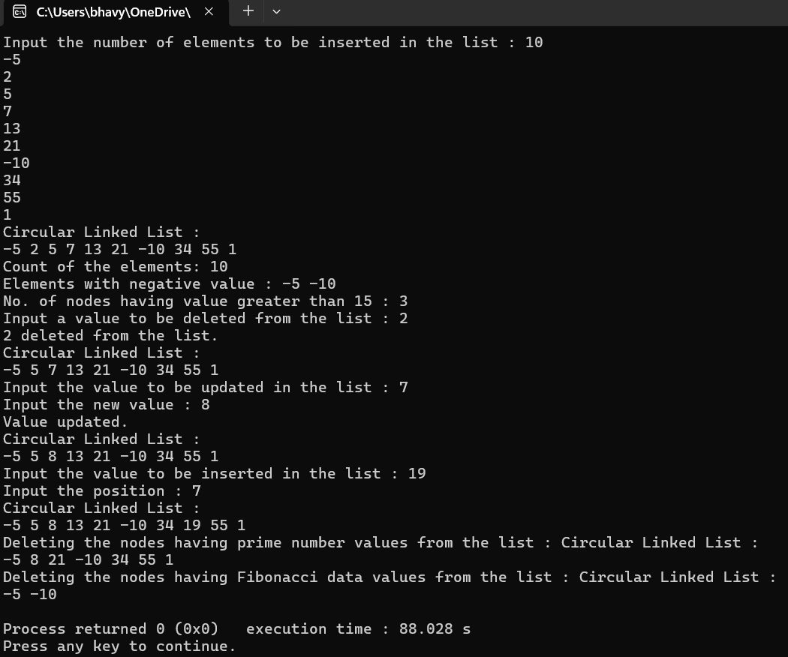

**Q4. Create an empty doubly linked list to store integers. Perform the following by writing appropriate functions to:**

**a. Insert and print elements of the list.**

**b. Traverse all nodes and check if the value is divisible by a number ‘m’.**

**c. Delete all the nodes from the list that are greater than the given value ‘x’.**

**d. Find the number of elements between two duplicate values.**

**Example:**

**Input:**

**Doubly Linked list: {1, 3, -9, 45, 2, -56, 3, 56, 100, -67, 3, 3}**

**Duplicate element: 3**

**Output: No. of elements between a pair of ‘3’ = 4.**

**Assumption: You are considering only the first instance of duplicity, i.e., between {3, -9, 45, 2, -56, 3} and not for instances like {3, 56, 100, -67, 3} nor for {3, 3} or any others.**

#include <iostream>

using namespace std;

struct Node

{

int data;

Node* prev;

Node* next;

Node(int val):data(val),prev(nullptr),next(nullptr){}

};

class DoublyLinkedList

{

Node* head;

Node* tail;

public:

DoublyLinkedList():head(nullptr),tail(nullptr){}

void insert(int val)

{

Node* newNode=new Node(val);

if(tail==nullptr)

head=tail=newNode;

else

{

tail->next=newNode;

newNode->prev=tail;

tail=newNode;

}

}

void print()

{

Node* temp=head;

while(temp!=nullptr)

{

cout<<temp->data<<" ";

temp=temp->next;

}

cout<<endl;

}

void checkDivisibility(int m)

{

Node* temp=head;

while(temp!=nullptr)

{

if(temp->data%m==0)

cout<<temp->data<<" ";

temp=temp->next;

}

cout<<endl;

}

void deleteGreater(int x)

{

Node* temp=head;

while(temp!=nullptr)

{

if(temp->data>x)

{

Node* toDelete=temp;

if(temp->prev)

temp->prev->next=temp->next;

else

head=temp->next;

if(temp->next)

temp->next->prev=temp->prev;

else

tail=temp->prev;

temp=temp->next;

delete toDelete;

}

else

temp=temp->next;

}

}

int elementsBetweenDuplicates(int val)

{

Node* first=nullptr;

Node* second=nullptr;

Node* temp=head;

while(temp!=nullptr)

{

if(temp->data==val)

{

if(first==nullptr)

first=temp;

else

{

second=temp;

break;

}

}

temp=temp->next;

}

if(first==nullptr||second==nullptr)

return -1;

int count=0;

temp=first->next;

while(temp!=second)

{

count++;

temp=temp->next;

}

return count;

}

~DoublyLinkedList()

{

Node* temp=head;

while(temp!=nullptr)

{

Node* next=temp->next;

delete temp;

temp=next;

}

}

};

int main()

{

DoublyLinkedList dll;

int n,val,m,x,duplicate;

cout<<"Input the number of elements to be inserted in the list : ";

cin>>n;

for(int i=0;i<n;i++)

{

cin>>val;

dll.insert(val);

}

cout<<"Doubly Linked List: ";

dll.print();

cout<<"Input a number 'm' to find the values divisible by 'm' : ";

cin>>m;

cout<<"Values divisible by '"<<m<<"' : ";

dll.checkDivisibility(m);

cout<<"Input a number 'x' to delete all the nodes from the list that are greater than the given value 'x' : ";

cin>>x;

cout<<"Deleting elements greater than "<<x<<" :"<<endl;

dll.deleteGreater(x);

dll.print();

cout<<"Input a duplicate element from the list to find the number of elements between the duplicate elements : ";

cin>>duplicate;

int elementsBetween=dll.elementsBetweenDuplicates(duplicate);

if(elementsBetween!=-1)

cout<<"Number of elements between the first pair of '"<<duplicate<<"' : "<<elementsBetween<<endl;

else

cout<<"No duplicates found for value "<<duplicate<<endl;

return 0;

}

**Output :**

