**Q1. Find the first pair of repeating elements in a given array by either returning its position(index) or a suitable statement if the set is not found or not repeated.**

**Assumption 1: indexing starts with value 1.**

**Assumption 2: There are ‘n’ number of elements in the array and you should allow for it to be dynamically decided .**

**Example:**

**Input: A= {3,6,12,-10,3,3,6,34,0, -109,98,1}**

**Find the pair: 3,6**

**Output:6**

#include <iostream> #include <bits/stdc++.h> using namespace std;

int pairfind(int n,int arr[])

{ for (int i = 1; i < n; ++i) { for (int j = 1; j < i; ++j) { if (arr[i - 1] == arr[j - 1] && arr[i] == arr[j]) { return i;

}

}

}

return -1;

}

int main()

{ int n;

cout<<"Enter total array elements: "; cin>>n; int* arr=new int[n]; cout<<"Enter array elements: "; for(int i=0;i<n;i++)

{

cout<<"Enter the "<<i+1<<" element: ";

cin>>arr[i];

}

int ans=pairfind(n,arr); if(ans!=-1)

{

cout<<"The position of pair is: "<<ans<<endl;

}

else

{

cout<<"The pair does not repeat"<<endl;

}

}

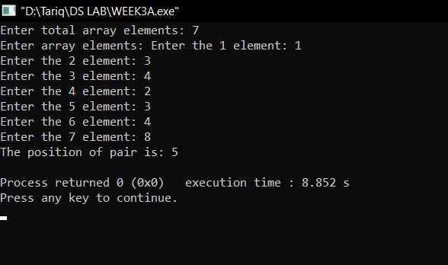

**Q2.Given an integer array of ‘N’ elements. You need to find the maximum sum of two elements such that the sum is closest to a given value, say zero (try with visualizing the number line).**

**Example:**

**Input: N = 3, arr[] = {-5, -50, 56}**

**Output: -68**

**Explanation: Sum of two elements closest to zero is 56.**

**-55 + (-5) = - 55 -5+56 = 51 -50 +56 =6**

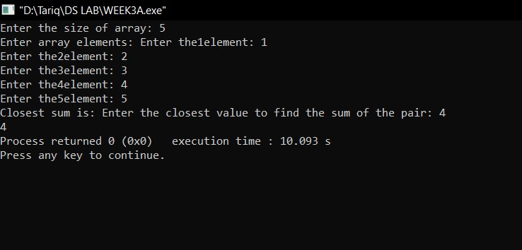

int closestsum(int n,vector<int> &arr)

{

int low=0; int high=n-1; sort(arr.begin(),arr.end()); int closest,sum; cout<<"Enter the closest value to find the sum of the pair: "; cin>>closest; while(low<high)

{

int sum=arr[low]+arr[high]; if(sum<closest)

{

low++;

}

else if(sum>closest)

{

high--; } else

{

return sum;

}

}

return sum;

}

int main()

{ int n; cout<<"Enter the size of array: "; cin>>n; vector<int> arr; int ele;

cout<<"Enter array elements: "; for(int i=0;i<n;i++)

{

cout<<"Enter the"<<i+1<<"element: ";

cin>>ele; arr.push_back(ele);

}

cout<<"Closest sum is: "<<closestsum(n,arr);

}

**Q3. You are given an array ‘A’, which contains elements arranged in an Arithmetic Progression. Within this pre-sorted set of elements (A.P.) one of the elements is missing. Write a program by making a user-defined function called ‘findMissingAPval’ to find this missing element.**

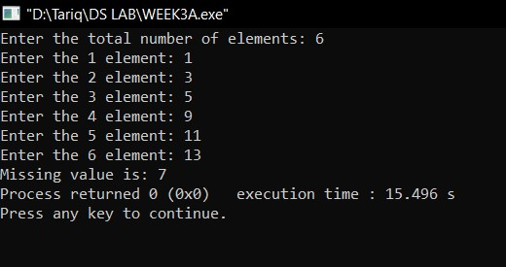

int findMissingAPval(const vector<int>& arr) {

int n = arr.size();

int diff = (arr[n - 1] - arr[0]) / n;

for (int i = 1; i < n; ++i) { if (arr[i] - arr[i - 1] != diff) { return arr[i - 1] + diff;

}

}

}

int main()

{

cout<<"Enter the total number of elements: ";

int n,ele; cin>>n; vector<int> arr; for(int i=0;i<n;i++)

{

cout<<"Enter the "<<i+1<<" element: ";

cin>>ele; arr.push_back(ele);

}

cout<<"Missing value is: "; cout<<findMissingAPval(arr);

}

**Q4. You are given a sorted array ‘A’ with possibly duplicate elements. The task is to find indexes(positions) of the first and last occurrences of an element ‘x’ in the given array. Write an efficient program to perform the above requirement.**

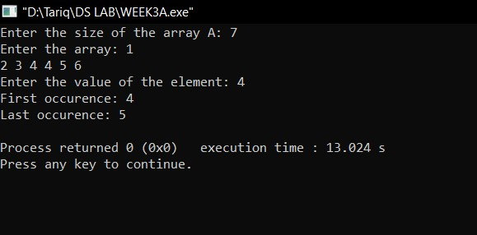

void occurence(int arr[],int n)

{ int x;

cout<<"Enter the value of the element: ";

cin>>x;

int first=0,c=0; for(int i=0;i<n;i++)

{ if(arr[i]==x)

{ first=i; while(arr[i]==arr[i+c])

{ c++;

}

}

}

cout<<"First occurence: "<<first<<endl<<"Last occurence: "<<first+c-1<<endl;

}

int main()

{

cout<<"Enter the size of the array A: ";

int n; cin>>n; int * arr=new int[n]; cout<<"Enter the array: "; for(int i=0;i<n; i++)

{

cin>>arr[i];

}

occurence(arr,n);

}

**Q5. Given a sorted array of size N and an integer K, find the position at which K is present in the array using interpolation search.**

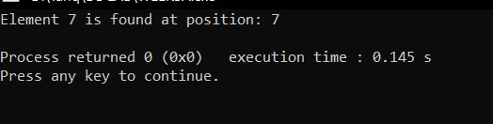

int interpolationSearch(const vector<int>& arr, int K) { int low = 0; int high = arr.size() - 1;

while (low <= high && K >= arr[low] && K <= arr[high]) { int pos = low + ((K - arr[low]) * (high - low)) / (arr[high] - arr[low]);

if (arr[pos] == K) { return pos + 1;

}

if (arr[pos] < K) { low = pos + 1;

} else { high = pos - 1;

}

}

return -1;

}

int main() { vector<int> arr = {1,2,3,4,5,6,7,5,3,32,22}; int K = 7;

int position = interpolationSearch(arr, K);

if (position != -1) { cout << "Element " << K << " is found at position: " << position << endl;

} else {

cout << "Element " << K << " is not found in the array." << endl;

}

return 0;

}

**Q6. Use Binary search to find the maximum length subarray such that its first element is greater than or equal to the last element of the subarray in a given array arr[0..n-1] of length ‘n’.**

**Example:**

**Input : arr[] = {-5, -1, 7, 5, 1, -2}**

**Output : 5**

**Hint: Subarray {-1, 7, 5, 1, -2} forms a maximum length subarray with its first element greater than last.**

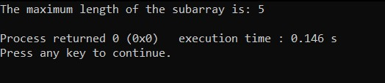

bool isValidSubarray(const vector<int>& arr, int length) {

int n = arr.size();

// Iterate over all possible starting points of the subarray of the given length for (int i = 0; i <= n - length; ++i) { if (arr[i] >= arr[i + length - 1]) { return true;

}

}

return false;

}

int findMaxLengthSubarray(const vector<int>& arr) {

int n = arr.size(); int left = 1, right = n; int maxLength = 0;

while (left <= right) { int mid = left + (right - left) / 2;

if (isValidSubarray(arr, mid)) { maxLength = mid; left = mid + 1; } else { right = mid - 1;

}

}

return maxLength;

}

int main() { vector<int> arr = {-5, -1, 7, 5, 1, -2}; int result = findMaxLengthSubarray(arr); cout << "The maximum length of the subarray is: " << result << endl; return 0;

}

**Q7. Given an array of Strings and a String x, find an index of x if it is present in the array.**

**Examples:**

**Input: arr[] = {”Hi”, ”Folks”, ”ide”, ”for”,”practice”}, x = ”ide” Output: 2, The String x is present at index 2.**

**Input : arr[ ] = {”Hi”, ”Folks”, ”ide”, ”for”, ”practic”}, x = ”zz”**

**Output: 0 (Hint: substring not present.)**

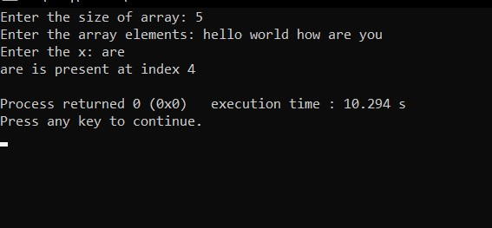

int main()

**{** int n; cout<<"Enter the size of array: ";

cin>>n;

string * arr=new string[n]; cout<<"Enter the array elements: "; for(int i=0;i<n;i++)

{

cin>>arr[i];

}

cout<<"Enter the x: "; string x; cin>>x; for(int i=0;i<n;i++)

{ if(x==arr[i])

{

cout<<x<<" is present at index "<<i+1<<endl;

}

}

}

**Q8. Write a program using linear search to check whether the inputted element belongs to it or not.**

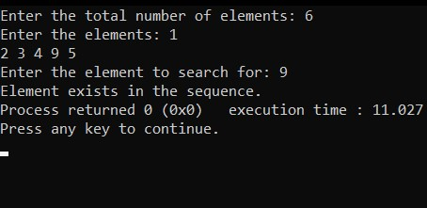 bool check(int val,vector<int> &arr)

{ for(int i=0;i<arr.size();i++)

{

if(val==arr[i]) return true;

}

return false;

}

int main()

{ int n;

cout<<"Enter the total number of elements: "; cin>>n; vector<int> arr; int ele;

cout<<"Enter the elements: "; for(int i=0;i<n;i++)

{

cin>>ele; arr.push_back(ele);

} int val;

cout<<"Enter the element to search for: "; cin>>val; if(check(val,arr))

{

cout<<"Element exists in the sequence.";

}

else{

cout<<"Element does not exist in the sequence.";

}

}