**15B17CI371 – Data Structures Lab**

**ODD 2024**

**Week 4-LAB A**

**Practice Lab**

1. **Write a program to find all occurrence of a key within a given array using sequential search algorithm.**

#include <iostream>

using namespace std;

int main()

{

int n;

cout<<"Input the number of elements: ";

cin>>n;

int *arr=new int[n];

cout<<"Input the elements: ";

for(int i=0;i<n;i++)

cin>>arr[i];

int key;

cout<<"Input the number to be searched : ";

cin>>key;

for(int i=0;i<n;i++)

if(arr[i]==key)

cout<<"Element found at index "<<i<<endl;

}

**Output :**

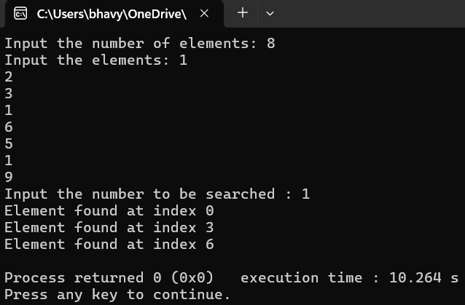

**2. Given an unsorted array and a number n,find if there exists a pair of elements in the array whose product is given number n.**

#include <iostream>

using namespace std;

int main()

{

int n;

cout<<"Input the number of elements: ";

cin>>n;

int *arr=new int[n];

cout<<"Input the elements: ";

for(int i=0;i<n;i++)

cin>>arr[i];

int prod;

cout<<"Input the product : ";

cin>>prod;

bool pairFound=false;

for(int i=0;i<n;i++)

for(int j=i+1;j<n;j++)

if(arr[i]*arr[j]==prod)

{

cout<<"Pair Found:("<<arr[i]<<", "<<arr[j]<<")"<<endl;

pairFound=true;

break;

}

if(!pairFound)

cout<<"No pair found"<<endl;

}

**Output :**

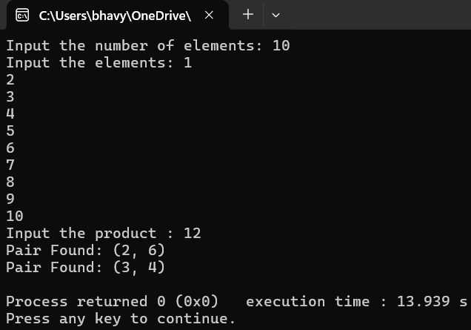

**3. Given an unsorted array of integers,sort the array into a wave-like array. An array arr[] is in wave form if arr[0] >= arr[1] <= arr[2] >= arr[3] <= arr[4] >=…**

#include <iostream>

using namespace std;

int main()

{

int n;

cout<<"Input the number of elements: ";

cin>>n;

int *arr=new int[n];

cout<<"Input the elements: ";

for(int i=0;i<n;i++)

cin>>arr[i];

for(int i=0;i<n-1;i+=2)

{

if(i!=0&&arr[i-1]>arr[i])

{

int temp=arr[i-1];

arr[i-1]=arr[i];

arr[i]=temp;

}

if(i!=n-1&&arr[i]<arr[i+1])

{

int temp=arr[i+1];

arr[i+1]=arr[i];

arr[i]=temp;

}

}

cout<<"Wave Form Array: ";

for(int i=0;i<n;i++)

cout<<arr[i]<<" ";

}

**Output :**

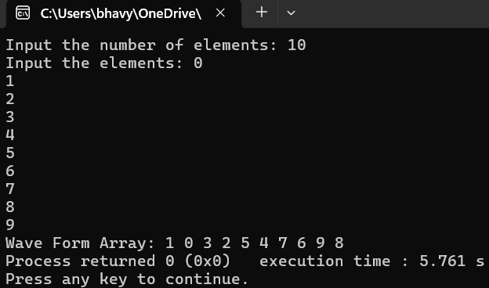

**Virtual Labs**

