**15B17CI371 – Data Structures Lab**

**ODD 2024**

**Week 6-LAB A**

**Practice Lab - STL**

**1. Use vectors to apply sorting to any array.**

#include <iostream>

#include <vector>

using namespace std;

int main()

{

int n,num;

cout<<"Input the size of the array : ";

cin>>n;

vector<int>arr;

cout<<"Input the elements : ";

for(int i=0;i<n;i++)

{

cin>>num;

arr.push_back(num);

}

for(int i=0;i<n;i++)

for(int j=0;j<n-i-1;j++)

if(arr[j]>arr[j+1])

{

int temp=arr[j];

arr[j]=arr[j+1];

arr[j+1]=temp;

}

cout<<"Sorted Array : ";

for (int i:arr)

cout<<i<< " ";

}

**Output :**

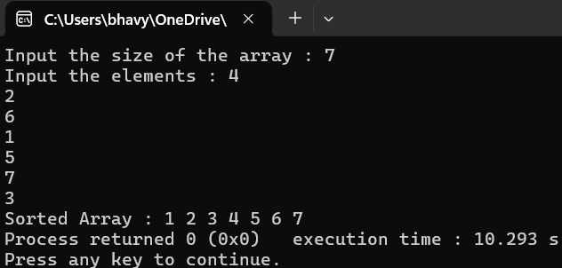

**2. Use STL to :-**

**a. count the frequency of a particular value in a given array.**

#include <iostream>

#include <vector>

#include <algorithm>

using namespace std;

int main()

{

int n,num,val;

cout<<"Input the size of the array : ";

cin>>n;

vector<int>arr;

cout<<"Input the elements : ";

for(int i=0;i<n;i++)

{

cin>>num;

arr.push_back(num);

}

cout<<"Input the element to find out its frequency : ";

cin>>val;

int frequency=count(arr.begin(),arr.end(),val);

cout<< "Frequency of " <<val<< ": "<<frequency;

}

**Output :**

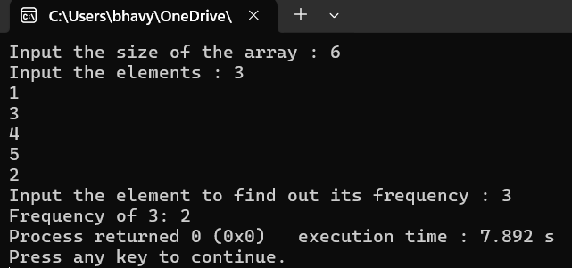

**b. erase a selected element in vector,shift and resizes the vector elements accordingly (after deletion of the selected element).**

#include <iostream>

#include <vector>

#include <algorithm>

using namespace std;

int main()

{

int n,num,ind;

cout<<"Input the size of the array : ";

cin>>n;

vector<int>arr;

cout<<"Input the elements : ";

for(int i=0;i<n;i++)

{

cin>>num;

arr.push_back(num);

}

cout<<"Input the index whose element is to be deleted : ";

cin>>ind;

arr.erase(arr.begin() + ind);

cout<<"New array : ";

for (int i:arr)

cout<<i<< " ";

}

**Output :**

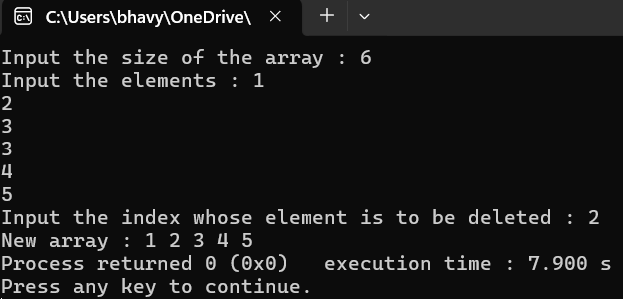

**c. erase duplicates in a given vector.**

#include <iostream>

#include <vector>

#include <algorithm>

using namespace std;

int main()

{

int n,num,ind;

cout<<"Input the size of the array : ";

cin>>n;

vector<int>arr;

cout<<"Input the elements : ";

for(int i=0;i<n;i++)

{

cin>>num;

arr.push_back(num);

}

sort(arr.begin(),arr.end());

arr.erase(unique(arr.begin(),arr.end()),arr.end());

cout<<"Array without duplicates : ";

for (int i:arr)

cout<<i<< " ";

}

**Output :**

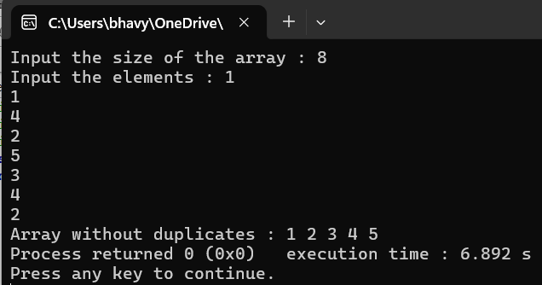

**d. find the distance between the first element and the maximum value within an array**

#include <iostream>

#include <vector>

#include <algorithm>

using namespace std;

int main()

{

int n,num,ind;

cout<<"Input the size of the array : ";

cin>>n;

vector<int>arr;

cout<<"Input the elements : ";

for(int i=0;i<n;i++)

{

cin>>num;

arr.push_back(num);

}

int dis=distance(arr.begin(),max_element(arr.begin(),arr.end()));

cout<< "Distance between first element and max element: "<<dis;

}

**Output :**

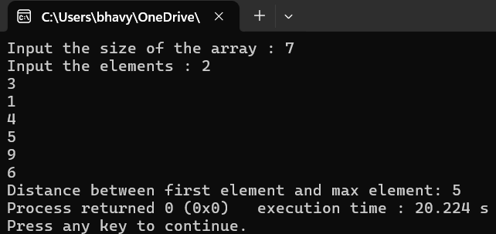

**3. Use std::list (class of the List container) to perform the following:**

**a. Finds the value of the first element in the list.**

**b. Finds the value of the last element in the list.**

**c. Adds a new element at the end of the list.**

**d. Removes the first element of the list,and reduces the size of the listby1.**

**e. Inserts new elements in the list before the element at a specifiedposition.**

**f. Returns the size of the list.**

**g. Removes all the elements from the list,which are equal to a givenelement.**

**h. Reverses the list.**

**i. Removes all duplicate consecutive elements from the list.**

**j. swap the contents of one list with another list.**

#include <iostream>

#include <list>

using namespace std;

int main()

{

int n,num,pos;

list<int> l;

cout<<"Input the number of elements : ";

cin>>n;

cout<<"Input the elements : ";

for(int i=0;i<n;i++)

{

cin>>num;

l.push_front(num);

}

cout<<"List : ";

for(int i:l)

cout<<i<<" ";

cout<<endl<<"First element of the list : "<<l.front() <<endl;

cout<<"Last element of the list : "<<l.back() <<endl;

cout<<"Input the element to add at the end of the list : ";

cin>>num;

l.push_back(num);

cout<<"Updated List : ";

for(int i:l)

cout<<i<<" ";

cout<<endl<<"Removing first element of the list :"<<endl;

l.pop_front();

cout<<"Updated List : ";

for(int i:l)

cout<<i<<" ";

cout<<endl<<"Input the element to add at the specified index of the list : ";

cin>>num;

cout<<"Input the index : ";

cin>>pos;

auto it=l.begin();

advance(it,pos);

l.insert(it,num);

cout<<"Updated List : ";

for(int i:l)

cout<<i<<" ";

size_t listSize=l.size();

cout<<endl<<"Size of the list : "<<listSize<<endl;

cout<<"Input the element to be removed from the list : ";

cin>>num;

l.remove(num);

cout<<"Updated List : ";

for(int i:l)

cout<<i<<" ";

cout<<endl<<"Reversing the list :"<<endl;

l.reverse();

cout<<"Updated List : ";

for(int i:l)

cout<<i<<" ";

cout<<endl<<"Removing consecutive duplicate elements :"<<endl;

l.unique();

cout<<"Updated List : ";

for(int i:l)

cout<<i<<" ";

cout<<"Another List :"<<endl;

list<int> l2;

cout<<"Input the number of elements : ";

cin>>n;

cout<<"Input the elements : ";

for(int i=0;i<n;i++)

{

cin>>num;

l.push_front(num);

}

cout<<"Before Swapping :\nList 1: ";

for(int i:l)

cout<<i<<" ";

cout<<"List 2: ";

for(int i:l2)

cout<<i<<" ";

l.swap(l2);

cout<<"After Swapping :\nList 1: ";

for(int i:l)

cout<<i<<" ";

cout<<"List 2: ";

for(int i:l2)

cout<<i<<" ";

}

**Output :**

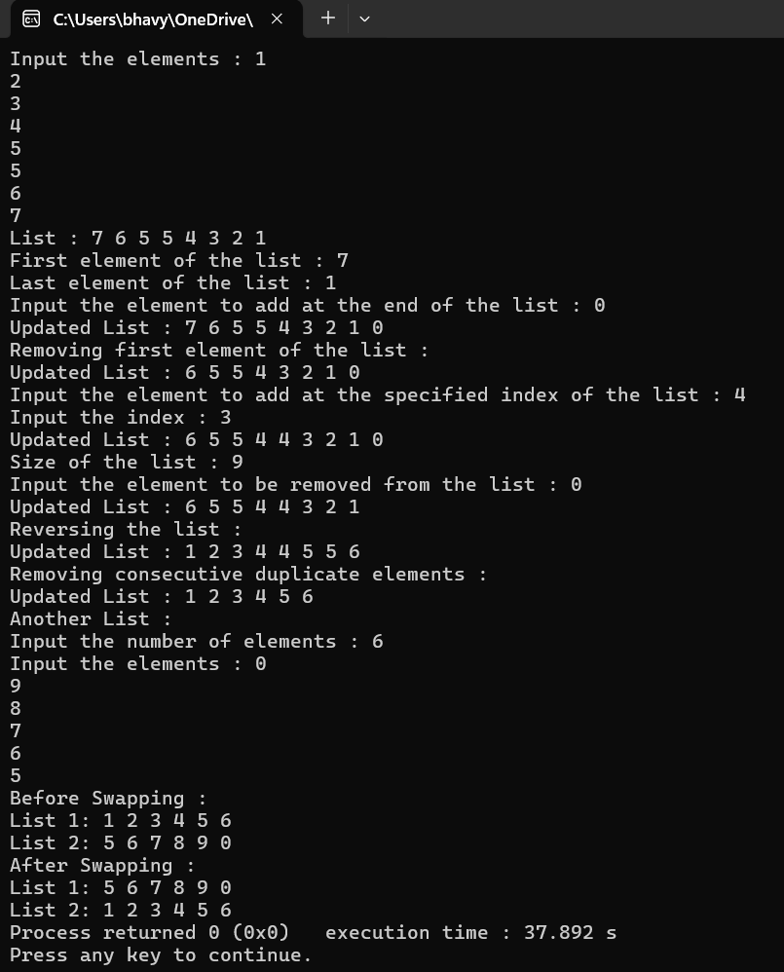

**4. Use std::map Member Functions to**

**a. Find the number of elements in the map.**

**b. Add a new element to the map.**

**c. Removes the key-value ‘g’ from the map.**

#include <iostream>

#include <map>

using namespace std;

int main()

{

map<char,int> M;

M['a']=1;

M['b']=2;

M['c']=3;

M['g']=7;

cout<<"Contents of the map :"<<endl;

for(auto it:M)

cout<<it.first<<"=>"<<it.second<<endl;

cout<<"Number of elements: "<<M.size()<<endl<<endl;

M['d']=4;

cout<<"Added element 'd'."<<endl;

cout<<"Contents of the map :"<<endl;

for(auto it:M)

cout<<it.first<<"=>"<<it.second<<endl;

cout<<"Number of elements: "<<M.size()<<endl<<endl;

M.erase('g');

cout<<"Removing key 'g'."<<endl;

cout<<"Contents of the map :"<<endl;

for(auto it:M)

cout<<it.first<<"=>"<<it.second<<endl;

cout<<"Number of elements: "<<M.size();

}

**Output :**

