NAME : MAKVANA NEEL

ROLL NO : CE064

ID : 20CEUOS086

BATCH : A4

**Lab 10**

**Tutorial-1**

**Stateful Widget**:

When a Flutter builds a Stateful Widget, it creates a State object. This object is where all the mutable state for that widget is held.

The concept of state is defined by two things:

1. The data used by the widget might change.
2. The data can't be read synchronously when the widget is built. (All state must be established by the time the build method is called).

**The lifecycle of stateful widget has the following simplified steps:**

* createState()
* mounted == true
* initState()
* didChangeDependencies()
* build()
* didUpdateWidget()
* setState()
* deactivate()
* dispose()
* mounted == false

In main.dart:

void main() => runApp(MaterialApp(  
// home: Home(),  
// instead of making home: property to make any page to initialize a beginning...  
// we can use following code ....  
 initialRoute: '/home',  
 routes: {  
 '/': (context) => Loading(),  
 '/home': (context) => Home(),  
 '/location': (context) => ChooseLocation(),  
 }  
));

In loading.dart:

import 'package:flutter/material.dart';  
class Loading extends StatefulWidget {  
// const Loading({Key? key}) : super(key: key);  
 @override  
 State<Loading> createState() => _LoadingState();  
}  
class _LoadingState extends State<Loading> {  
 @override  
 Widget build(BuildContext context) {  
 return Scaffold(  
 body: Text('LOADING SCREEN'),  
 );  
 }  
}

In home.dart:

import 'package:flutter/material.dart';  
class Home extends StatefulWidget {  
 @override  
 State<Home> createState() => _HomeState();  
}  
class _HomeState extends State<Home> {  
 @override  
 Widget build(BuildContext context) {  
 return Scaffold(  
 body: SafeArea(  
 child:Column(  
 children: [  
 TextButton.icon(  
 onPressed: (){  
 Navigator.*pushNamed*(context, '/location');  
 },  
 icon: Icon(Icons.*edit_location*),  
 label:Text('EDIT LOCATION'),  
 )  
 ],  
 )  
 ),  
 );  
 }  
}

In choose_location.dart:

import 'package:flutter/material.dart';  
class ChooseLocation extends StatefulWidget {  
// const ChooseLocation({Key? key}) : super(key: key);  
 @override  
 State<ChooseLocation> createState() => _ChooseLocationState();  
}  
  
class _ChooseLocationState extends State<ChooseLocation> {  
 late int counter;  
 @override  
 void initState(){  
 super.initState();  
 counter=0;  
  
 print("INIT STATE FUNCTION RUN IN CHOOSE LOCATION");  
 }  
 @override  
 Widget build(BuildContext context) {  
 return Scaffold(  
 backgroundColor: Colors.*cyan*[100],  
 appBar: AppBar(  
 backgroundColor: Colors.*deepPurpleAccent*,  
 title: Text('Choose Location'),  
 centerTitle: true,  
 elevation: 0,  
 ),  
  
 body: ElevatedButton(  
 onPressed: (){  
 setState((){  
 counter +=1;  
 });  
 },  
 child: Text('COUNTER IS: $counter'),  
 )  
 );  
 }

}

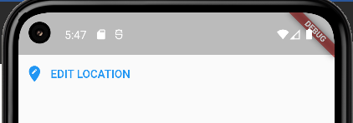

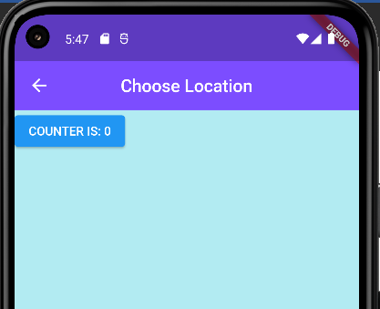

After pressing button twice:

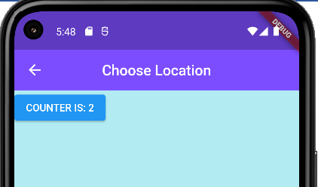

In choose_location.dart:

void getData(){  
 Future.delayed(Duration(seconds:4),(){  
 print("Hello DDU");  
 });  
 print('In getData ...after future call...');  
}  
  
@override  
void initState(){  
 super.initState();  
 counter=0;  
  
 // print("INIT STATE FUNCTION RUN IN CHOOSE LOCATION");  
 print('before getData call');  
 getData();  
 print('after getData call');  
}

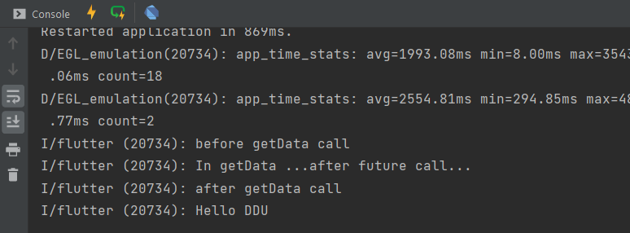

If we don’t use async , await then…

void getData() {  
 Future<String> username = Future.delayed(Duration(seconds: 4), () {  
 return 'UNIVERSITY NAME : DDU';  
 });  
 Future<String> bio = Future.delayed(Duration(seconds: 2), () {  
 return 'DDU IS ONE OF THE BEST UNIVERSITY OF GUJARAT FOR COMPUTER ENGINEERING STUDY';  
 });  
 print('$username -> $bio');  
}

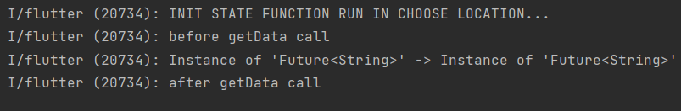

After adding async and await print can’t execute so we get desired output:

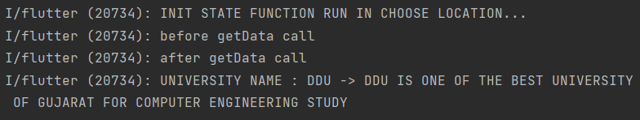

void getData() async {   
 String username = await Future.delayed(Duration(seconds: 4), () {  
 return 'UNIVERSITY NAME : DDU';  
 });  
 String bio = await Future.delayed(Duration(seconds: 2), () {  
 return 'DDU IS ONE OF THE BEST UNIVERSITY OF GUJARAT FOR COMPUTER ENGINEERING STUDY';  
 });  
 print('$username -> $bio');

}

async, await, Future, delayed, Duration,

**async (Asynchronous function):**

* When an async function is called, a Future is immediately returned and the body of the function is executed later.
* As the body of the async function is executed, the Future returned by the function call will be completed along with its result.

**Await:**

* In async function we can use await keyword which will wait for the result.

**future:**

* Dart is a single-threaded programming language.
* Future<T> object represents the result of an asynchronous operation which produces a result of type T.
* If the result is not usable value, then the future’s type is Future<void>.
* A Future represents a single value either a data or an error asynchronously

There are 2 ways to handle Futures:

* Using the Future API
* Using the async and await operation.

In loading.dart:

import 'package:flutter/material.dart';  
import 'package:http/http.dart';  
import 'dart:convert';  
class Loading extends StatefulWidget {  
 @override  
 State<Loading> createState() => _LoadingState();  
}  
class _LoadingState extends State<Loading> {  
 void getData() async {  
 final response = await  
 get(Uri.*parse*('https://jsonplaceholder.typicode.com/albums/1'));  
 print(response.body); // it response in JSON form out put ...we need MAP format..  
 // print(response.body.userId); // this will not work. because its not MAP format..  
 // TO CONVERT JSON TO MAP..WE NEED TO IMPORT convert package....  
 Map data = jsonDecode(response.body);  
 print(data);  
 print(data['title']);  
 }  
 @override  
 void initState() {  
 super.initState();  
 getData();  
 }  
  
 @override  
 Widget build(BuildContext context) {  
 return Scaffold(  
 body: Text('LOADING SCREEN'),  
 );  
 }  
}

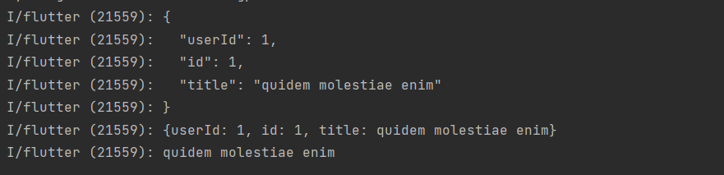

**Tutorial-2**

import 'package:flutter/material.dart';  
import './pages/loading.dart';   
  
void main() => runApp(MaterialApp(  
 initialRoute: '/',  
 routes: {  
 '/': (context) => Loading(),  
 }  
));

In loading.dart:

import 'package:flutter/material.dart';  
import 'package:http/http.dart';  
import 'dart:convert';  
class Loading extends StatefulWidget {  
 @override  
 State<Loading> createState() => _LoadingState();  
}  
class _LoadingState extends State<Loading> {  
 void getTime() async {  
 // Make Request for time and receive response  
 Response response = await  
 get(Uri.*parse*('http://worldtimeapi.org/api/timezone/Asia/Kolkata'));  
 Map timeData = jsonDecode(response.body);  
 print(timeData);  
 // Get particular property form timeData...  
 String dateTime = timeData['datetime'];  
 String offset = timeData['utc_offset']; //not dst_offset  
 print(dateTime);  
 print(offset);  
 DateTime currentTime = DateTime.*parse*(dateTime);  
 print(currentTime);  
 /*  
 DateTime currentOffset = DateTime.parse(offset);  
 print(currentOffset);  
 */  
 String offsetHours = offset.substring(1,3);  
 print(offsetHours);  
 String offsetMinutes = offset.substring(4,6);  
 print(offsetMinutes);  
 currentTime = currentTime.add(Duration(minutes: int.*parse*(offsetMinutes),hours:int.*parse*(offsetHours)));  
 print(currentTime);  
 }  
  
 @override  
 void initState() {  
 super.initState();  
 getTime();  
 }  
  
 @override  
 Widget build(BuildContext context) {  
 return Scaffold(  
 body: Text('LOADING SCREEN'),  
 );  
 }  
}

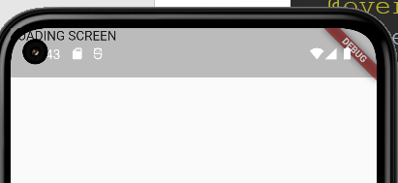

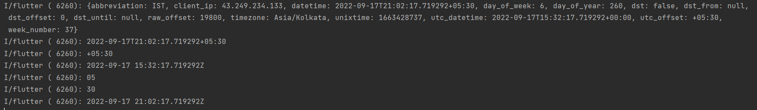

In loading.dart:

import 'package:flutter/material.dart';  
import 'package:http/http.dart';  
import 'dart:convert';  
import 'package:lab10_2/services/world_time.dart';  
  
class Loading extends StatefulWidget {  
 @override  
 State<Loading> createState() => _LoadingState();  
}  
class _LoadingState extends State<Loading> {  
 String? time = 'LOADING..........';  
  
 void setWorldTime() async {  
 WordTime timeinstance =  
 WordTime(location: 'kolkata', flag: 'india.png', url: 'Asia/Kolkata');  
 await timeinstance.getTime();  
 // print(timeinstance.time);  
 setState(() {  
 time = timeinstance.time;  
 });  
 }  
  
 @override  
 void initState() {  
 super.initState();  
 setWorldTime();  
 }  
  
 @override  
 Widget build(BuildContext context) {  
 return Scaffold(  
 body: Padding(  
 padding: EdgeInsets.all(60.0),  
 child: Text(time.toString()),  
 )  
 );  
 }  
}

