NAME : MAKVANA NEEL

ROLL NO : CE064

ID : 20CEUOS086

BATCH : A4

Lab 9

Tutorial 1:

Here we have created special stateless widget called QuoteCard for printing our quotes in special pattern.

Earlier we have done this using widget in _EchoListState class.

import 'package:flutter/material.dart';

import 'quote.dart';

void main() => runApp(MaterialApp(

home: EchoList(),

));

class EchoList extends StatefulWidget {

const EchoList({Key? key}) : super(key: key);

@override

State<EchoList> createState() => _EchoListState();

}

class _EchoListState extends State<EchoList> {

List<Quote> quotes = [

Quote(author: 'author1', text: 'I see humans but no humanity'),

Quote(text: 'The truth is realy pure and never simple', author: 'author2'),

Quote(

text: 'The time is always right to do what is right',

author: 'author3'),

];

Widget quoteTemplate(quote) {

return QuoteCard(quote:quote);

}

@override

Widget build(BuildContext context) {

return Scaffold(

backgroundColor: Colors.lightBlueAccent[100],

appBar: AppBar(

title: Text('Quotes'),

centerTitle: true,

backgroundColor: Colors.orangeAccent,

),

body: Column(

// children: quotes.map((quote) => quoteTemplate(quote)).toList(),

children: quotes.map((quote) => QuoteCard(quote: quote)).toList(),

),

);

}

}

class QuoteCard extends StatelessWidget {

final Quote quote;

QuoteCard({required this.quote});

@override

Widget build(BuildContext context) {

return Card(

margin: EdgeInsets.fromLTRB(20.0, 30.0, 40.0, 10.0),

child: Padding(

padding: const EdgeInsets.all(12.0),

child: Column(

crossAxisAlignment: CrossAxisAlignment.stretch,

children: [

Text(

quote.text,

style: TextStyle(

fontSize: 20,

color: Colors.deepPurple,

),

),

SizedBox(height: 10),

Text(

quote.author,

style: TextStyle(

fontSize: 26,

color: Colors.deepPurple,

),

),

],

),

),

);

}

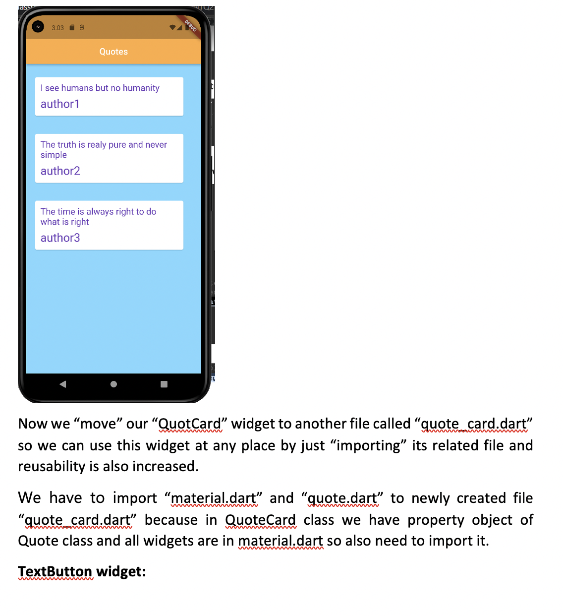

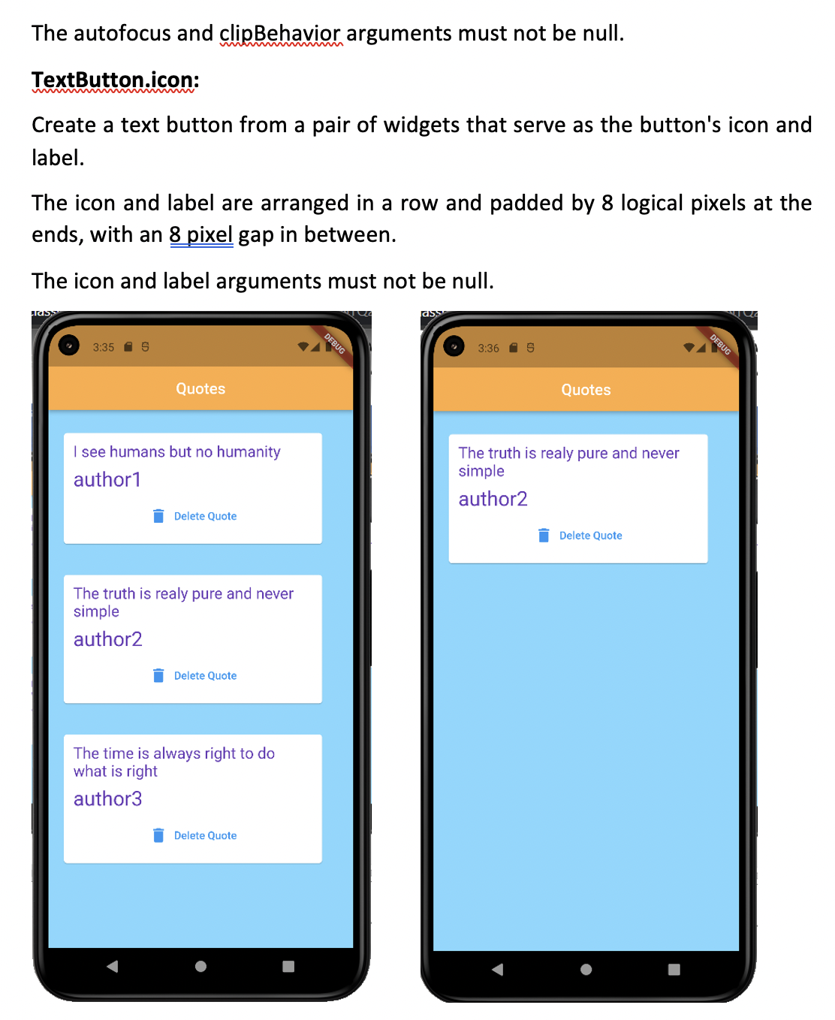

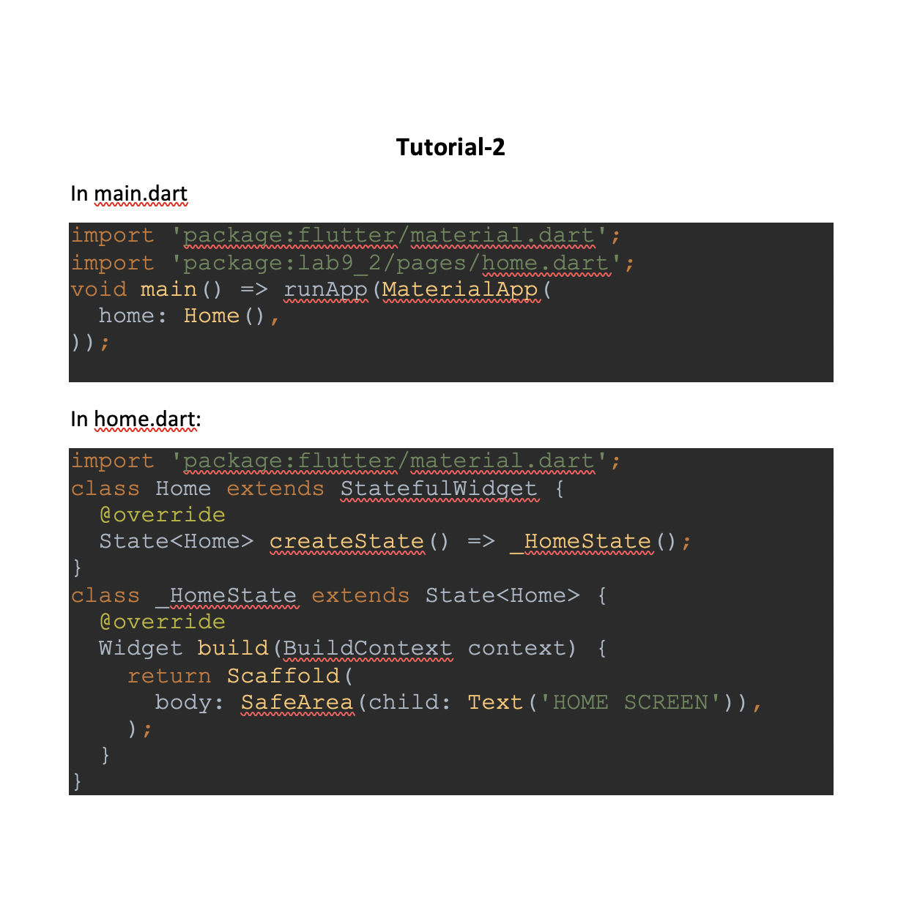

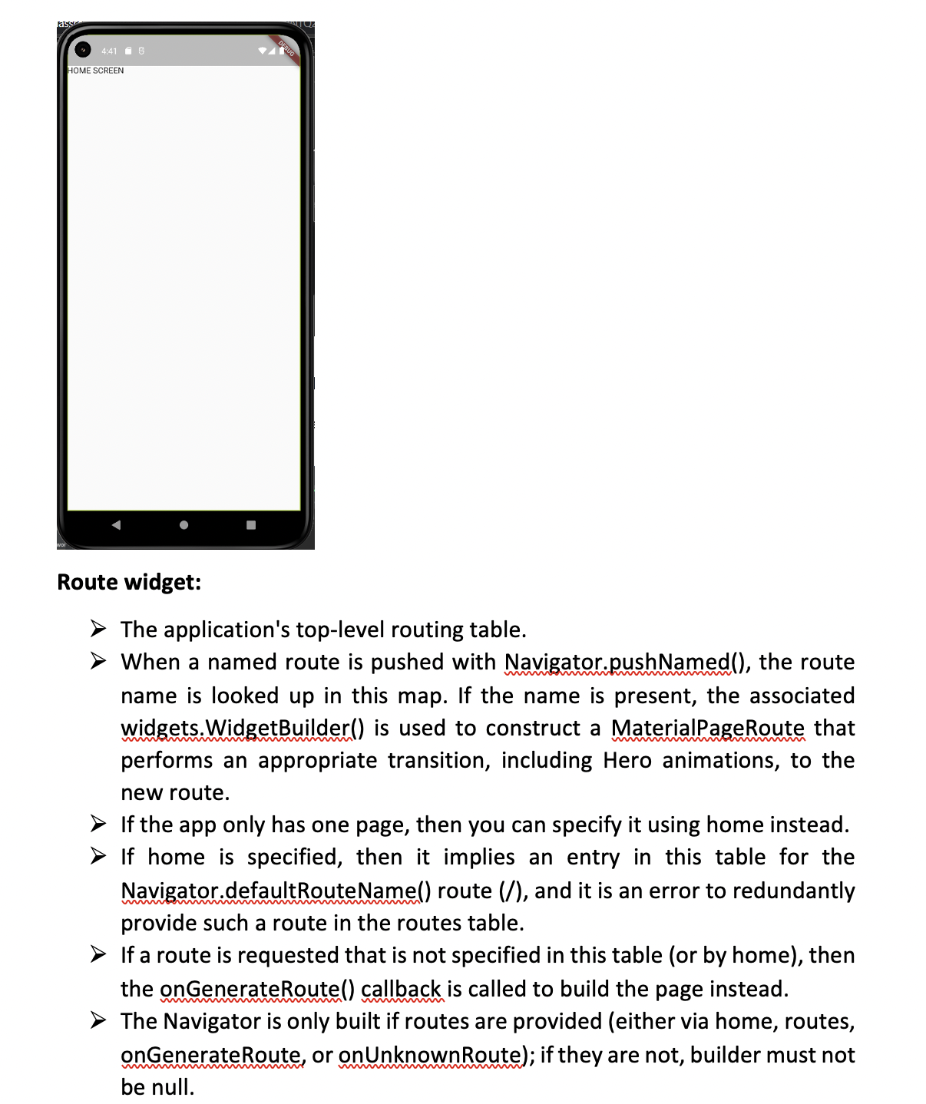

Main.dart:

import 'package:flutter/material.dart';

// import 'package:lab9_2/pages/home.dart';

import './pages/choose_location.dart';

import './pages/home.dart';

import './pages/loading.dart';

// void main() => runApp(MaterialApp(

// home: Home(),

// ));

/*

void main() => runApp(MaterialApp(

// home: Home(),

routes: { // routes is Map variable with 'key:value' pairs

// '/about' ....eg.....routes the screen through 'about' widgets

// '/contact'....

'/': (context) => Loading(), // base routes....base widget file...main

file of project

// above statement will creates error...because it conflict with 'home:

Home(),

// because both statements tell flutter to initialize the app from their

given location

'/home': (context) => Home(),

'/location': (context) => ChooseLocation(),

}

));

*/

void main() => runApp(MaterialApp(

// home: Home(),

// instead of making home: property to make any page to initialize a beginning...

// we can use following code ....

initialRoute: '/home',

routes: {

'/': (context) => Loading(),

'/home': (context) => Home(),

'/location': (context) => ChooseLocation(),

}

));

Home.dart:

import 'package:flutter/material.dart';

class Home extends StatefulWidget {

@override

State<Home> createState() => _HomeState();

}

class _HomeState extends State<Home> {

@override

Widget build(BuildContext context) {

return Scaffold(

body: SafeArea(

child:Column(

children: [

TextButton.icon(

onPressed: (){

Navigator.pushNamed(context, '/location');

},

icon: Icon(Icons.edit_location),

label:Text('EDIT LOCATION'),

)

],

)

),

);

}

}

choose_location.dart:

import 'package:flutter/material.dart';  
class ChooseLocation extends StatefulWidget {  
// const ChooseLocation({Key? key}) : super(key: key);  
 @override  
 State<ChooseLocation> createState() => _ChooseLocationState();  
}  
class _ChooseLocationState extends State<ChooseLocation> {  
 @override  
 Widget build(BuildContext context) {  
 return Scaffold(  
 backgroundColor: Colors.*cyan*[100],  
 appBar: AppBar(  
 backgroundColor: Colors.*deepPurpleAccent*,  
 title: Text('Choose Location'),  
 centerTitle: true,  
 elevation: 0,  
 ),  
 body: Text('Choose location screen'),  
 );  
 }  
}

