**INTRODUCTION**

I. INTRODUCTION

This project endeavors to revolutionize the food ordering experience by integrating Alan AI's advanced capabilities into a comprehensive system. Aimed at enhancing user engagement and efficiency, our AI-powered solution seeks to transform traditional ordering methods through voice-enabled interactions, personalized recommendations, real-time order tracking, and secure payment processing. By focusing on improving customer satisfaction and optimizing restaurant operations, this innovative platform aims to set new benchmarks in the food industry, reshaping how users interact with food services while offering restaurants an opportunity to streamline their operations and engage customers more effectively.

* 1. OVERVIEW OF THE PROJECT

The Voice-Enabled Food Ordering System represents an innovative and user-centric web application designed to revolutionize the food service industry. This system integrates cutting-edge technologies, including Alan AI for voice recognition capabilities, to create a seamless and interactive platform for users to place food orders. With a focus on user convenience and accessibility, the project employs a blend of frontend technologies like HTML, CSS, JavaScript, and backend scripting using PHP for session management and authentication. The system offers an engaging and responsive user interface, allowing users to navigate through a visually appealing menu display and place orders using both voice commands and traditional interface interactions. Through real-time order summaries, secure payment processing, and robust error handling, the system ensures a smooth and secure ordering experience while enhancing user satisfaction. The project's primary goal is to redefine the conventional food ordering process by amalgamating advanced voice recognition technologies with a user-friendly interface, aiming to set new standards in efficiency, accessibility, and technological innovation within the food service industry.

* 1. OBJECTIVE OF THE PROJECT

The primary objective of this project is to develop an AI-driven food ordering system using Alan AI technology to provide a seamless, intuitive, and personalized ordering experience for users. By leveraging voice-enabled interactions, machine learning algorithms, and real-time data processing, this system aims to enhance user convenience, improve order accuracy, and boost customer satisfaction. Additionally, the project seeks to optimize restaurant operations by offering robust features for order management, inventory tracking, and customer engagement, ultimately aiming to create a more efficient and customer-centric food service ecosystem.

* 1. MODULE DESCRIPTION

**USER AUTHENTICATION AND MANAGEMENT:**

**User Registration:**

Allows new users to sign up by providing necessary information like username, password, email, and any other required personal details. Validates the uniqueness of the username/email to ensure there are no duplicates in the system. Stores the user information securely in a database after successful registration.

**User Login:**

Authenticates registered users by comparing the entered credentials (username/email and password) with the stored data in the system's database. Provides access to authorized functionalities and personal user data upon successful login. Implements security measures like encryption and hashing to protect user passwords.

**Menu Management:**

**Menu Display:**

Retrieves and displays available food items. Includes relevant details such as item names, images, descriptions, prices, dietary information, and availability status. Organizes items in categories or sections for easy navigation.

**Menu Navigation:**

Facilitates user interaction with the displayed menu items. Allows users to see (e.g., price range, food items). Enables selection of items, customization (if applicable), and addition to an order/cart.

**Voice Commands or Interface Interactions:**

Provides multiple options for users to interact with the menu, such as using voice commands (if supported) or traditional interface interactions (clicking, scrolling, etc.). Ensures a user-friendly and accessible interface for seamless navigation and selection of menu items.

**ORDER PROCESSING**

**Order Placement**

Order Placement encompasses the seamless facilitation of user-selected menu items into their order cart or list. It allows users to effortlessly peruse the menu, select their desired items, and efficiently add them to their cart for eventual purchase. This functionality not only enables the addition of items but also permits users to adjust quantities, make modifications, or remove items within the cart before finalizing their order. Additionally, it may offer features allowing users to save their selections for later, providing a convenient means of managing their preferences across different sessions. The goal is to ensure a user-friendly and accessible experience, catering to the diverse needs and preferences of customers during the item selection and order assembly process.

**Order Summary:**

The Order Summary component plays a pivotal role in the ordering process by aggregating all selected items, their respective quantities, and associated prices into a comprehensive snapshot. It acts as a virtual checklist, giving users a clear and concise view of their intended purchase before they proceed to confirm the order. This summary provides users with an opportunity to review their selections, verify quantities, assess costs, and make any necessary adjustments or corrections, ensuring accuracy and completeness in their order. Its real-time nature allows for dynamic updates as users modify their choices, offering a transparent and user-centric experience by empowering individuals to make informed decisions before finalizing their purchase.

**Order Confirmation:**

Order Confirmation serves as the conclusive step where user consent finalizes the selected items, signaling the initiation of further processing for delivery. By obtaining user approval, this pivotal stage ensures the accuracy and authorization of chosen items and quantities. It acts as the trigger point for subsequent operational procedures, prompting the system to notify relevant departments or partners for order fulfillment, arrange delivery logistics, and prepare items for delivery. This pivotal stage effectively transitions the user's selection phase into actionable operations, streamlining the process towards successful order completion and delivery.

**Voice Recognition Integration:**

Alan AI Integration: Incorporates Alan AI services to interpret voice commands from users, translating them into actions such as menu item selection, quantity changes, and order confirmation.

**Payment Processing:**

Payment Gateway Integration: Connects the system to a secure payment gateway to facilitate secure and convenient online transactions for confirmed orders.

**User Interface:**

Responsive Design: Ensures the web application's interface is visually appealing, functional, and adapts seamlessly across various devices and screen sizes.

**Visual Presentation:**

Showcases the menu items and order details using engaging visual elements such as images, descriptions, and prices.

**USER EXPERIENCE ENHANCEMENT:**

**Voice Command Feedback:**

Voice Command Feedback capability offers users with rapid feedback to voice commands that have been executed, either confirming actions taken or providing information on potential difficulties that may have emerged during command execution. This feature ensures a smooth and user-friendly experience by acknowledging successful orders and informing users that their actions were understood and done correctly. Furthermore, when there are misunderstandings or errors in command interpretation, the feedback mechanism supports users by providing guidance or suggestions to correct the problem, ensuring effective communication and a smoother user interaction with the system.

**Usability Improvements:**

Usability enhancements focus on improving user engagement within the system, with a focus on easy navigation and speedy ordering processes. This entails making the interface more user-friendly, ensuring that users can simply locate what they're looking for inside the menu and move seamlessly via various sections or categories. Furthermore, it attempts to improve the ordering process by simplifying stages for item selection, personalization, and checkout, decreasing possible friction points and improving overall user happiness and efficiency while using the system.

**Backend Logic and Database Management:**

**Backend Operations:**

Backend Operations include the execution of essential business logic within the system, as well as the management of critical functions such as order processing, menu updating, and facilitating user interactions. This component serves as the system's engine, providing the smooth handling of user requests, order placements, revisions, and confirmation processes. It orchestrates the system's essential processes, assuring stability and efficiency in handling various parts of the user experience.

**Database Management:**

Database Management pertains to the system's database infrastructure, responsible for securely storing and organizing crucial data including user profiles, menu items, and transaction records. It involves implementing robust security measures, database optimization techniques, and ensuring data integrity to safeguard sensitive information. This component ensures that data is efficiently stored, retrieved, and updated to support the system's functionalities while adhering to industry best practices and compliance standards for data management and security.

**SYSTEM SPECIFICATION**

II. SYSTEM SPECIFICATION

### **2.1 HARDWARE SPECIFICATIONS**

The below Hardware Specifications were used in both Server and Client machines when developing.

**PROCESSOR :** AMD Ryzen 5 4600H with Radeon Graphics 3.00 GHz

**RAM :** 8GB

##### **HARD DISK** **:** 500GB

**SYSTEM TYPE :** x64-based processor

### **2.2 SOFTWARE SPECIFICATIONS**

The below Software Specifications were used in the machines when developing.

**OPERATING SYSTEM :** windows 10

**FRONTEND :** HTML, CSS, Java Script, JQuery

##### **SERVER SIDE SCRIPTING LANGUAGE** **:** PHP

**DATABASE :** MYSQL

**DATABASE CONNECTIVITY** : XAMPP Server

### **PHP :**

PHP (Hypertext Preprocessor). PHP is a server-side scripting language designed specifically for web development. It is open-source which means it is free to download and use. It is very simple to learn and use. The files have the extension “.php”. Rasmus Lerdorf inspired the first version of PHP and participated in the later versions.

It is an interpreted language and it does not require a compiler.

* + - * PHP code is executed in the server.
      * It can be integrated with many databases such as Oracle, Microsoft SQL Server, MySQL, PostgreSQL, Sybase, and Informix.
      * It is powerful to hold a content management system like WordPress and can be used to control user access.
      * It supports main protocols like HTTP Basic, HTTP Digest, IMAP, FTP, and others.
      * Websites like [www.facebook.com](http://www.facebook.com/) and [www.yahoo.com](http://www.yahoo.com/) are also built on PHP.
      * One of the main reasons behind this is that PHP can be easily embedded in HTML files and HTML codes can also be written in a PHP file.
      * The thing that differentiates PHP from the client-side language like HTML is, that PHP codes are executed on the server whereas HTML codes are directly rendered on the browser. PHP codes are first executed on the server and then the result is returned to the browser.

### **HTML:**

HTML stands for **“Hyper Text Markup Language”**, which is the most widely used language on Web to develop web pages.

HTML was developed with the intent of defining the structure of documents like headings, paragraphs, lists, and so forth to facilitate the sharing of scientific information between researchers. Now, HTML is being widely used to format web pages with the help of different tags available in HTML language.

### **CSS:**

CSS (Cascading Style Sheet) is used to control the style of a web document in a simple and easy way. is a simple design language intended to simplify the process of making web pages presentable.

CSS is a must for students and working professionals to become a great Software Engineer specially when they are working in Web Development Domain. Some of the key advantages CSS are:

* + - * Create Stunning Web site - CSS handles the look and feel part of a web page. Using CSS, you can control the color of the text, the style of fonts, the spacing between paragraphs, how columns are sized and laid out, what background images or colors are used, layout designs,variations in display for different devices and screen sizes as well as a variety of other effects.
      * Become a web designer - If you want to start a carrer as a professional web designer, HTML and CSS designing is a must skill.
      * Control web - CSS is easy to learn and understand but it provides powerful control over the presentation of an HTML document. Most commonly, CSS is combined with the markup languages HTML or XHTML.
      * Learn other languages - Once you understands the basic of HTML and CSS then other related technologies like javascript, php, or angular are become easier to understand.

### **MY-SQL:**

MySQL, the world's second-most-popular open-source database, plays a crucial role in powering major applications like Facebook, Twitter, Netflix, Uber, Airbnb, Shopify, and Booking.com. With over 25 years of collaborative development, MySQL supports a wide range of applications and programming languages.

As an open-source database, MySQL offers extensive features and broad compatibility with various applications and programming languages. Its popularity is evident in its widespread use, supporting favorite applications and programming languages across diverse domains.

Databases serve as essential data repositories for software applications, storing information from web searches, logins, transactions, and more. MySQL, being a relational database, organizes data into separate tables, optimizing speed and offering a flexible programming environment. The Structured Query Language (SQL) is integral to MySQL, providing a standardized language for database access.

MySQL's open-source nature allows users to download and use the software without cost, with the added benefit of modifying the source code to suit specific needs. Governed by the

GNU General Public License (GPL), MySQL consistently ranks as the preferred database for developers due to its high performance, reliability, and ease of use.

This database is the top choice for renowned open-source applications like WordPress, Drupal, Joomla, and Magento, and it forms a key component in the LAMP stack (Linux, Apache, MySQL, Perl/Python/PHP) for web application development.

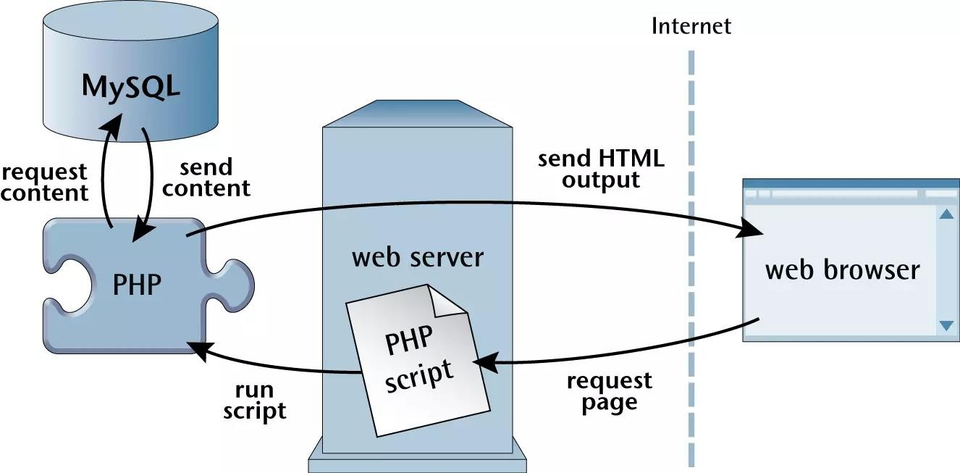

* + 1. jQuery:

jQuery is a fast, lightweight, and feature-rich JavaScript library designed to simplify the client-side scripting of HTML. It streamlines the process of interacting with the Document Object Model (DOM), event handling, and performing AJAX requests. JQuery provides a concise and efficient way to write JavaScript code, enabling developers to create interactive and dynamic web pages more easily. With its wide range of built-in functions and methods, jQuery simplifies common tasks such as DOM manipulation, event handling, animation, and AJAX interactions, reducing the amount of code required compared to raw JavaScript. It enhances cross-browser compatibility and facilitates rapid development by providing a unified and consistent interface for web developers.

* + 1. Alan AI

**1. Voice Interaction Integration:** Alan AI's primary focus is the seamless integration of voice capabilities into applications and websites. This involves enabling users to interact naturally with software through spoken commands, creating a hands-free and intuitive user experience. The platform provides the infrastructure and tools necessary for developers to implement voice-based interactions without complexity, ensuring a fluid and engaging user interface.

**2. Natural Language Processing (NLP):** Leveraging cutting-edge artificial intelligence and NLP algorithms, Alan AI excels in understanding and interpreting spoken language. Its NLP capabilities allow for the processing of user intents expressed in natural speech, enabling applications to comprehend and respond appropriately to various voice commands with a high degree of accuracy.

**3. Intent Recognition and Mapping:** One of Alan AI's core strengths lies in its ability to accurately recognize user intents from voice commands. This functionality extends to mapping these intents to specific actions or functionalities within the application. Through robust algorithms, Alan AI interprets user requests and intelligently links them to corresponding actions, allowing for precise and contextually relevant responses.

**4. Customizable Voice Responses:** Developers using Alan AI have the flexibility to define and customize the responses triggered by different voice commands. This customization allows for tailored and personalized interactions within the application, ensuring that the responses align with the specific needs and functionalities of the software being developed.

**5. Developer-Friendly Tools and APIs:** Alan AI offers a comprehensive suite of developer tools, APIs, and SDKs that streamline the integration process across diverse platforms and programming languages. These resources simplify the implementation of voice capabilities, empowering developers to efficiently incorporate voice interactions into their applications without extensive technical complexity.

**6. Enhanced User Experience:** By enabling intuitive and hands-free voice interactions, Alan AI significantly elevates the overall user experience within applications. This functionality caters to diverse user preferences and accessibility needs, fostering an engaging and accessible interface that promotes user satisfaction.

**7. Versatility Across Industries:** Alan AI's adaptability spans across various industries, allowing applications in sectors such as healthcare, customer service, e-commerce, and more to leverage voice-enabled interactions. Its versatility enables tailored solutions catering to the specific requirements of different industries and use cases.

**SYSTEM ANALYSIS**

1. SYSTEM ANALYSIS
   1. EXISTING PROJECT:
      1. Current System Overview:

The current food ordering process involves traditional methods primarily reliant on manual interaction. Customers visit restaurants or use phone calls to place orders. There's limited visibility into available menus, and the ordering process lacks interactivity and personalization. Payments are often handled manually, causing potential delays and errors.

* + 1. Challenges and Limitations:

**Limited Interactivity:** Customers face challenges in browsing menus and customizing orders to meet specific dietary preferences or requirements.

**Manual Order Handling:** Human error in order taking and processing leads to inaccuracies and delays in service.

**Payment Inefficiencies:** Manual payment methods lead to slower transactions and potential discrepancies.

**Lack of Personalization:** The current system lacks features for personalized recommendations based on user preferences.

* + 1. User Feedback and Issues:

Feedback from customers and restaurant staff highlights issues like delayed order processing, confusion in orders due to miscommunication, inconvenience in payment methods, and the absence of real-time order tracking.

* 1. PROPOSED PROJECT:
     1. Overview of the Alan AI-Based Food Ordering System:

The proposed AI-based system aims to revolutionize the food ordering experience by integrating Alan AI. It offers:

**Voice-Enabled Interaction:** Customers can place orders and navigate menus through voice commands, ensuring a seamless and hands-free experience.

**Personalized Recommendations:** Alan AI utilizes customer data to suggest personalized menu items based on preferences and past orders.

**Secure and Efficient Payment Processing:** Integration with secure payment gateways ensures swift and accurate transactions.

* + 1. Enhancements and Advantages:

**Improved Interactivity:** The AI-driven system enables intuitive interactions, enhancing user engagement and satisfaction.

**Efficiency and Accuracy:** Automation reduces errors in order taking and processing, leading to faster service delivery.

**Enhanced Personalization:** Alan AI's learning capabilities ensure personalized experiences for customers, increasing loyalty.

**Streamlined Operations:** Restaurants benefit from streamlined order management and improved resource allocation.

* + 1. Stakeholder Involvement and Benefits:

**Customers:** Enjoy a more personalized, interactive, and convenient ordering process.

**Restaurants:** Increased efficiency and accuracy in managing orders lead to improved customer satisfaction and sales.

**Delivery Personnel:** Real-time order tracking ensures smoother logistics and better customer service.

* + 1. Expected Outcome:

**Enhanced User Experience:** Seamless, personalized, and convenient food ordering experience for customers.

**Improved Efficiency:** Streamlined operations leading to faster service and reduced errors.

**Increased Sales and Satisfaction:** Enhanced customer satisfaction translating into increased sales for partner restaurants.

1. FUNCTIONALITIES:

**User Authentication:**

Allows registered users to log in and access the system securely.

**Menu Display and Selection**:

Presents food items visually with descriptions and prices, enabling users to select items for orders.

**Order Placement:**

Facilitates adding selected items to a cart and viewing an order summary before confirmation.

**Alan AI Integration:**

Enables limited voice interaction for specific actions such as order placement via Alan AI's voice recognition capabilities.

**Limitations:**

**Voice Interaction Scope:** Limited voice-based functionalities beyond basic commands offered by Alan AI.

**User Feedback and Error Handling:** Minimal feedback on voice command execution; lacks comprehensive error handling for voice interactions.

**UI Design:** Basic user interface design with potential for improvement to enhance user experience.

**SYSTEM DESIGN**

1. SYSTEM DESIGN
   1. INPUT DESIGN

**User Input Validation:**

**Form Fields:** Describe the validation criteria for user input fields such as name, email, address, and payment details to ensure accuracy and completeness.

**Error Handling:** Explain the error messages and alerts displayed to users in case of invalid inputs (e.g., incorrect email format, missing fields).

**Menu Selection and Order Placement:**

**Menu Interface:** Detail how users interact with the menu interface to select items, customize orders, and add items to the cart.

**Order Confirmation:** Describe the steps involved in confirming an order, including any confirmation prompts or verification processes.

**User Authentication:**

**Login Credentials:** Explain the requirements and validation for creating secure passwords during user registration and password reset processes.

**Session Management:** Detail the session handling process to ensure secure login and logout functionality.

* 1. OUTPUT DESIGN

**Order Confirmation and Receipt:**

**Confirmation Page:** Describe the layout and content of the order confirmation page displayed after successful order placement, including order summary and delivery details.

**User Profile and Order status:**

**Profile Information Display:** Describe the user profile layout, displaying order history, account details, and saved preferences.

* 1. **Flow Chart**

START

HOME

USER

SHOW ITEMS

*NO*

LOG IN

REG

*YES*

ITEM VIEW

REMOVE ADDED ITEM TOCART

ADD ITEM TO CART

PLACE ORDER

CANCEL ORDER

PAYMENT

LOGOUT

END

* 1. **DATA FLOW**

**VOICE ASSISTANT START**

#### 

**INPUT THE VOICE**

**CONVERT THE VOICE AND TEXT IN TEXT FORMAT**

#### Alan AI | CDI

#### 

**OUTPUT**

**ANY NEW INPUT FROM THE USER?**

#### YES

#### NO

**END**

* 1. DATABASE DESIGN

5.5.1 Login.php

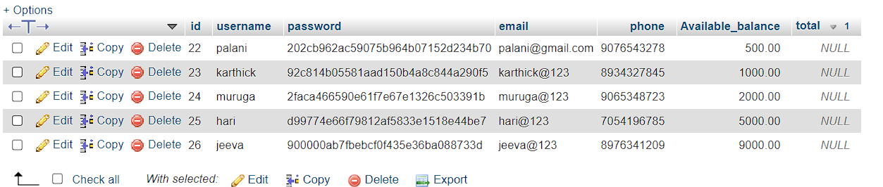Fig.5.5.1

1. FEATURES

**User Registration/Login:**

Implement user registration and login using email or social media credentials to personalize the user experience. This involves creating forms for registration and login, implementing secure backend processes, integrating social media logins, and ensuring stringent security measures to protect user data.

**Customizable Orders:**

Enable personalized orders by creating an intuitive interface for users to customize dishes with preferred toppings, spice levels, and other options. Store these preferences efficiently and reflect them in order details, ensuring accuracy and satisfaction.

**Cart Management:**

Enable seamless cart management by creating an intuitive interface for users to easily add or remove items. Offer real-time updates and a clear summary of selected items and costs. Simplify the checkout process and ensure persistence for returning users.

**Secure Payment Gateway:**

To guarantee the integrity of the system, it is essential to implement a secure payment gateway. Strong encryption mechanisms and verification procedures for digital wallet transactions will be a part of this integration, guaranteeing users a smooth and safe banking experience. This functionality will strengthen secrecy and trust, giving customers peace of mind about the security of their platform transactions.

**Feedback and Ratings:**

The Alan AI Food Ordering System allows customers to provide feedback through ratings and reviews, facilitating informed decision-making for other users based on restaurant and dish evaluations.

**SYSTEM TESTING**

1. SYSTEM TESTING

System testing is the process of existing software with the intent of finding and ultimately correcting errors. This fundamental philosophy does not change for web applications, because web-based systems and applications reside on a network and interoperate with many different operating systems, browsers, hardware platforms, and communication protocols, the search for errors represents a significant challenge for web applications.

Testing objectives there are several rules can serve as testing objectives. They are

1. Testing is a process of executing a program with the intent of finding an error.

2. A good test is one that has a high probability of finding an undiscovered error.

3. A successful test is one that uncovers and undiscovered error.

The above are the objectives for a good test procedure. A successful test is that in which no errors are found. The objective is to design tests that systematically uncover different classes of errors and to do so with the minimum amount of time and effort. The unit is the testing changes made in an existing or new program. This test is carried out during the programming and each module is found to be working satisfactorily. In the data entry form web applicants, details are stored in the database.

* 1. DATABASE CONNECTIVITY TEST

While connecting the database through my web application I have encountered with a host error for database connectivity which tells there is no existence of the host. Then I rectified the error by changing the host and username information.

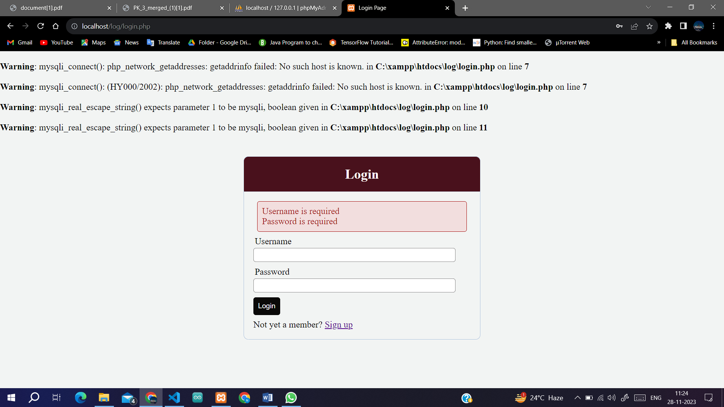

Fig.7.1 The connectivity error for data base

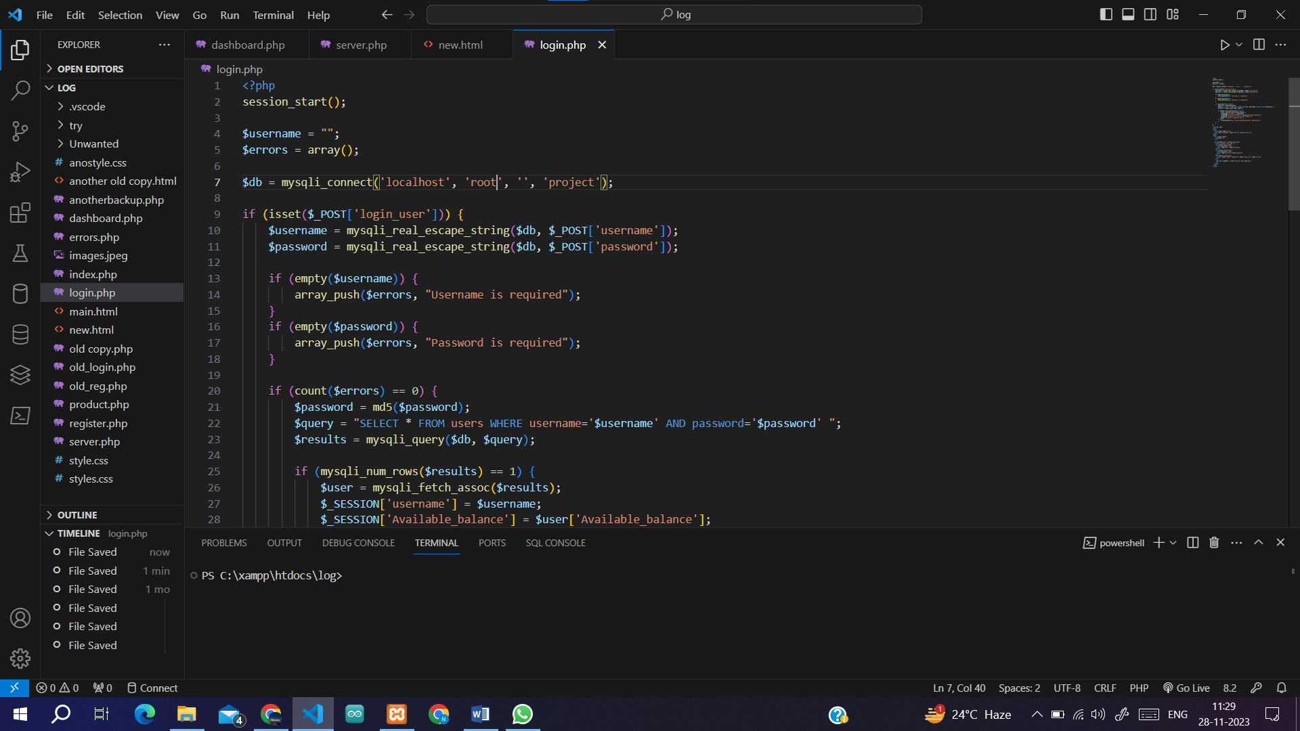

Fig 7.2 Rectification of the error

**CONCLUSION AND FUTURE ENHANCEMENT**

1. CONCLUSION AND FUTURE ENHANCEMENT
   1. CONCLUSION

The development of the Food Ordering System stands as a testament to the commitment to revolutionize the food service industry. Through meticulous requirement analysis and thoughtful input-output design considerations, this project endeavors to deliver a seamless user experience for both customers and restaurant owners. The system's focus on intuitive input designs and clear output interfaces aims to simplify the food ordering process, fostering a positive user experience. By emphasizing user-friendly navigation, robust security measures, and responsive design, this system bridges the gap between customers and restaurants, providing an efficient and accessible platform. Ultimately, this project aspires to leverage technology to create a secure, scalable, and user-centric food ordering experience. It aims to streamline operations, facilitate reliable transactions, and encourage user engagement through a well-designed interface, benefiting the food service industry as a whole.

* 1. FUTURE ENHANCEMENT

**Multi-Restaurant Integration:** Incorporate different restaurant categories and menus, allowing users to search based on preferences like cuisine, location, and ratings.

**Geolocation and Localization:** Customize the app based on users' locations and country-specific norms, languages, and currencies for a tailored experience.

**Diverse Payment Methods:** Integrate various secure payment gateways, digital wallets, cryptocurrencies, and international cards to accommodate global transactions.

**Multi-Language Support:** Implement language options for diverse users, ensuring an accessible interface in their preferred language.

**Enhanced Review System:** Allow users to rate and review restaurants, focusing on cuisine authenticity and service quality across different regions.

**Dynamic Menu Display:** Show menus with localized pricing and region-specific items,

ensuring a user-friendly display on all devices.

**BIBLIOGRAPHY**

1. BIBLIOGRAPHY

**jQuery Library:**

* Author: John Doe
* Title: jQuery - DOM Manipulation and AJAX
* Source: https://jquery.com/

**Alan AI Voice Integration:**

* Author: Alan AI Team
* Title: Alan AI Voice Assistant Integration
* Source: <https://alan.app/>

**Styling Framework:**

* Author: Jane Smith
* Title: CSS Framework - Styling Guidelines
* Source: https://www.w3.org/Style/CSS/Overview.en.html

**PHP Session Handling:**

* Author: Rasmus Lerdorf
* Title: PHP Sessions - Managing User Sessions
* Source: https://www.php.net/

**XAMPP**

* Authors: Apache Friends
* Title: XAMPP - Cross-Platform Apache, MySQL, PHP, and Perl
* Source: <https://www.apachefriends.org/index.html>

**MySQL**

* Authors: Oracle Corporation
* Title: MySQL Database Management
* Source: https://www.mysql.com/

**APPENDIX**

1. APPENDIX

**REGISTER PAGE**

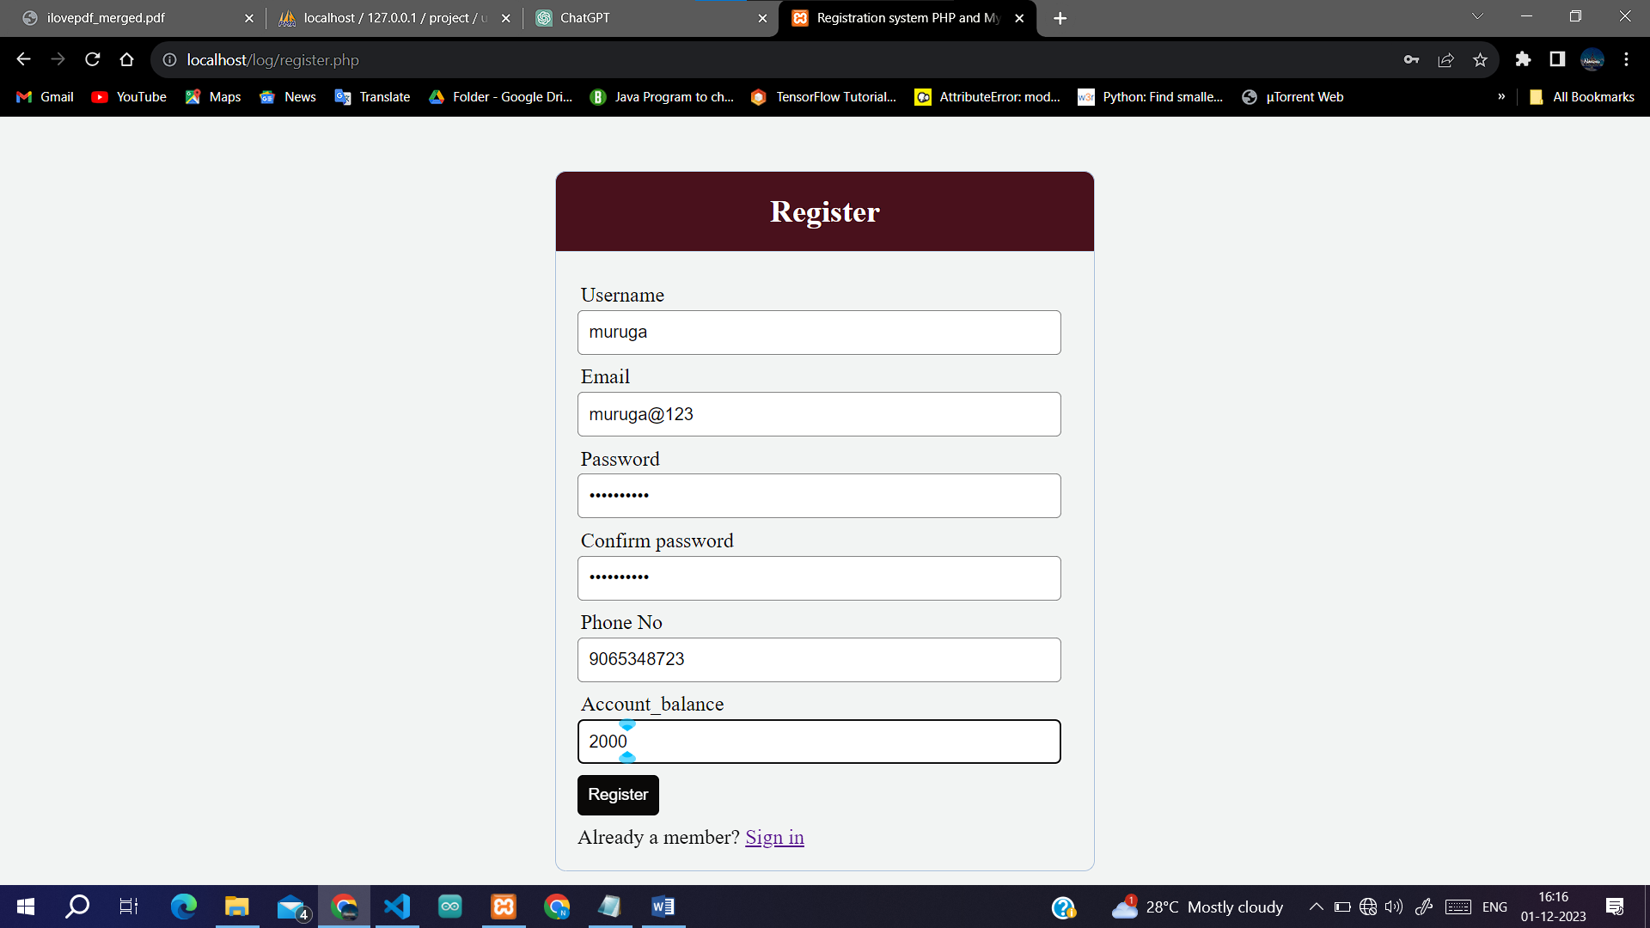

Fig 10.1

**LOGIN PAGE**

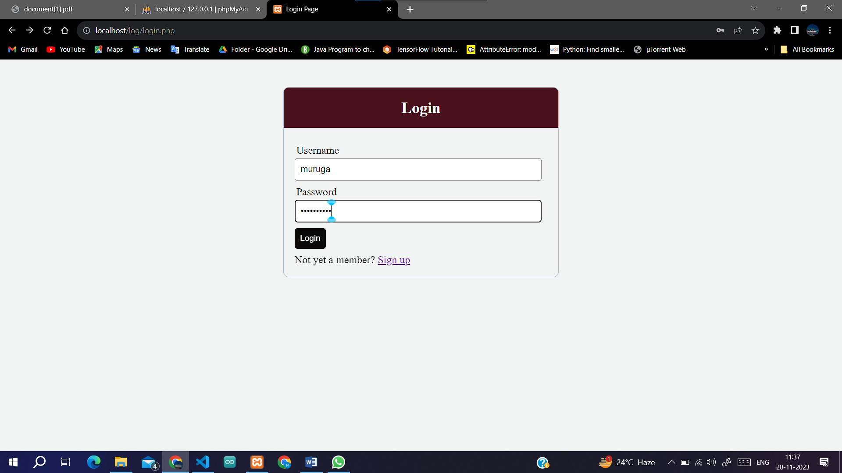

Fig 10.2

**PRIOR TO PLACING YOUR ORDER**

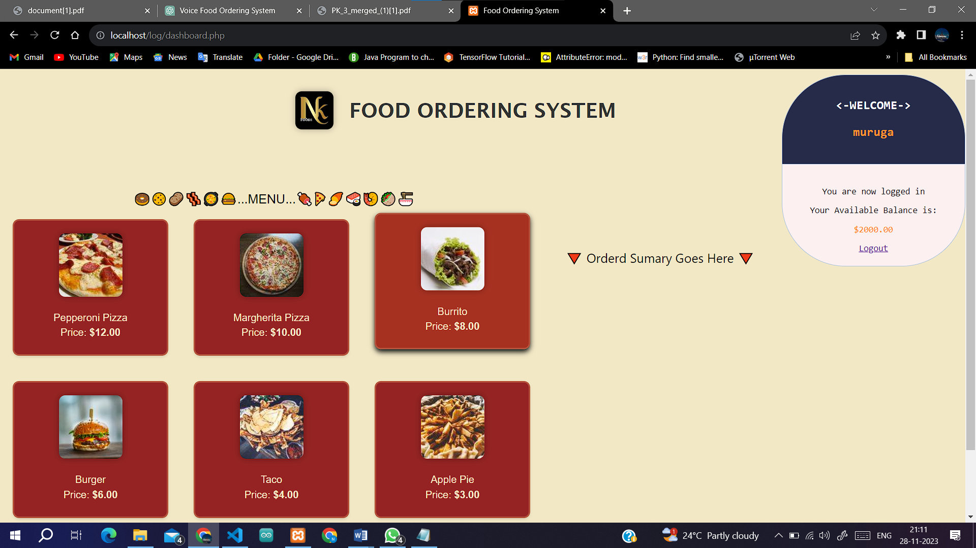

Fig 10.3

**FOLLOWING THE ORDERING OF FOOD** 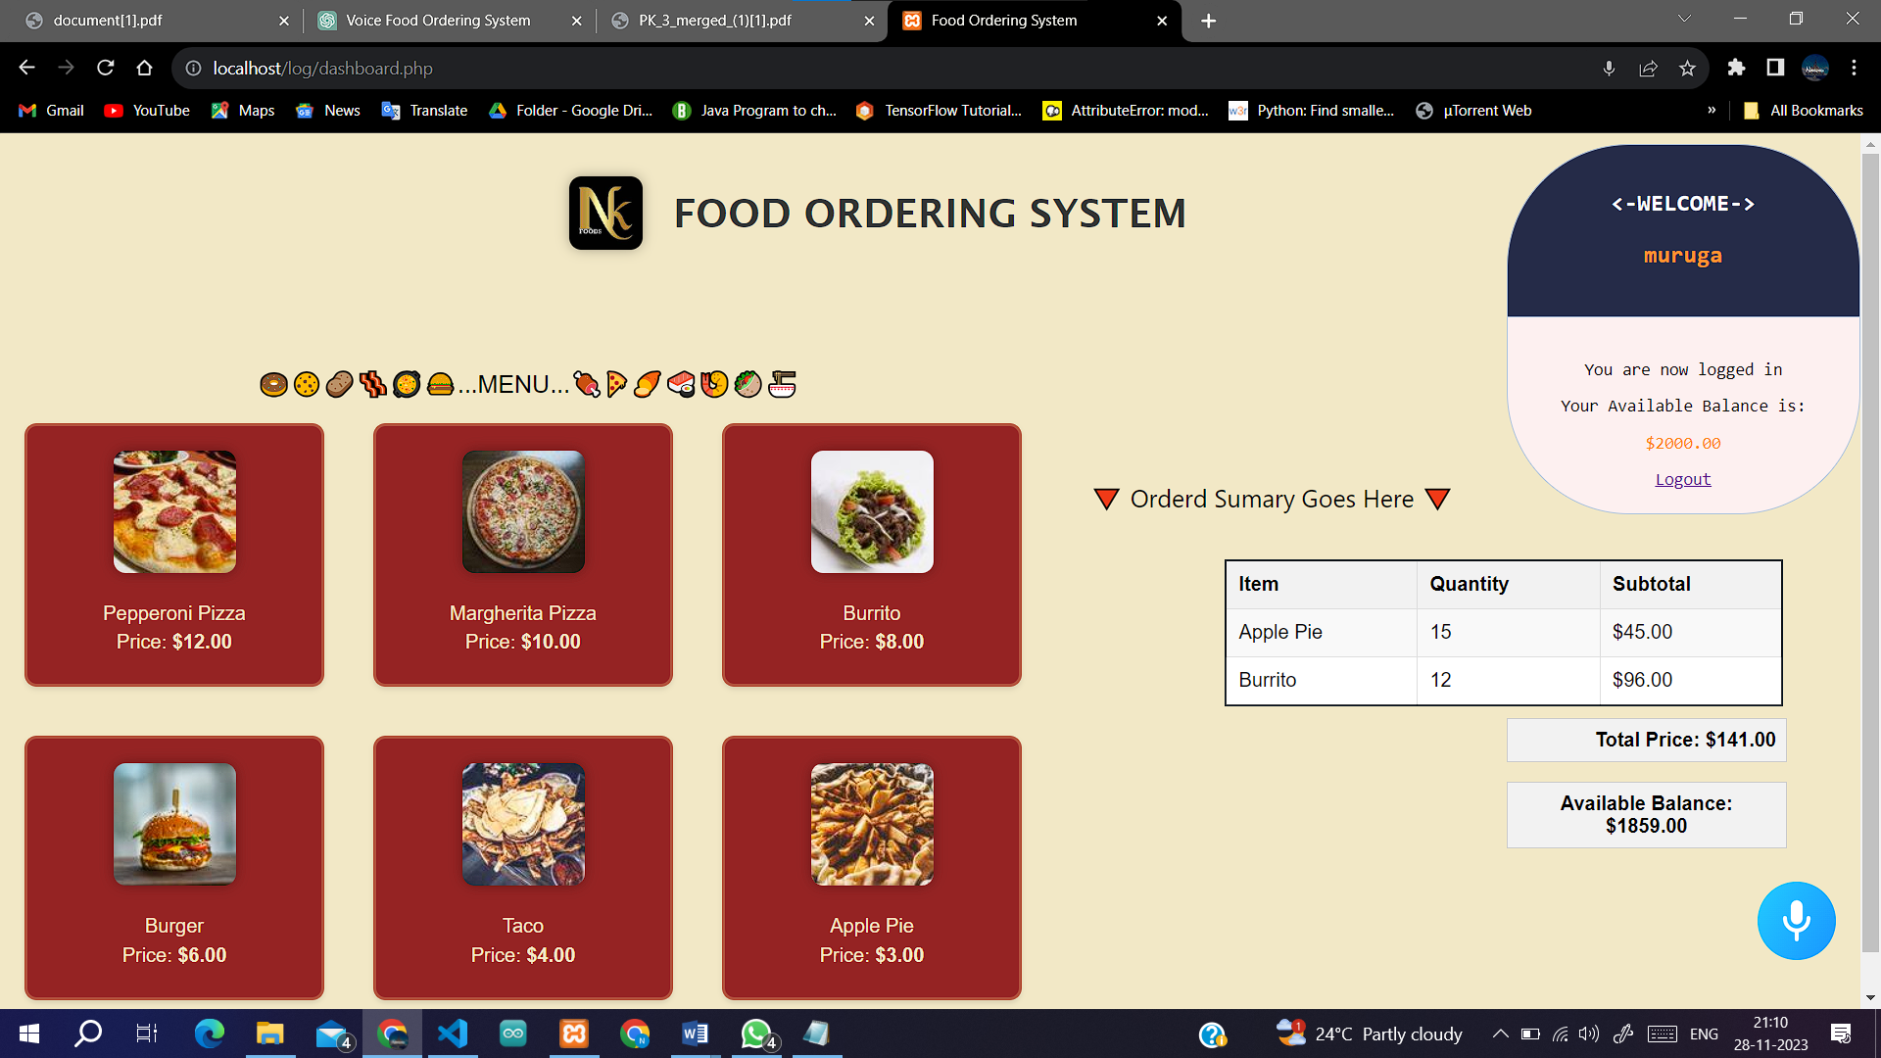

Fig 10.4

**REMOVING OR UPDATING FROM ORDERED ITEMS**

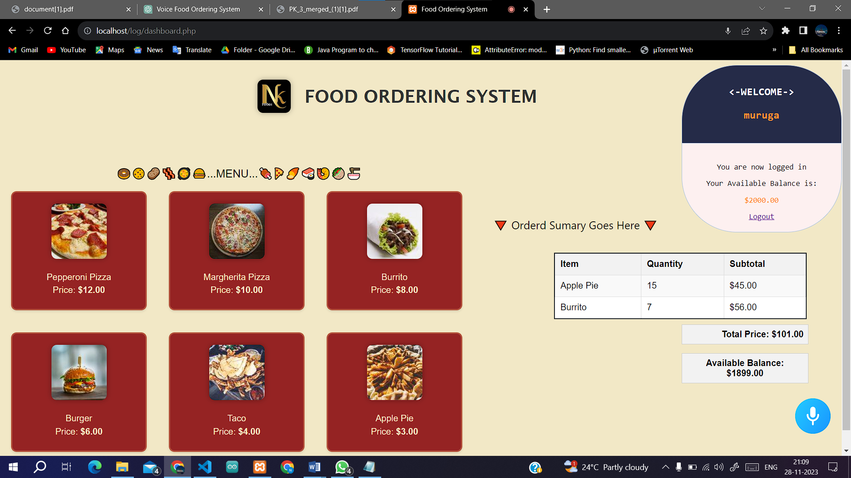

Fig. 10.5