EXPERIMENT 10
LEX PROGRAM TO COUNT IDENTIFIERS IN A C SOURCE FILE

AIM
To write a Lex program to read a C source file and count identifier occurrences while ignoring keywords, constants, comments, whitespace, and special symbols.

ALGORITHM
- Initialize the identifier counter to zero.
- Open the C source file supplied as a command-line argument.
- Scan the source using Lex rules, ignoring comments, strings, character literals, keywords, numbers, whitespace, and symbols.
- Print each identifier and increment the counter.
- Display the total identifier occurrences and close the file.

PSEUDOCODE
START
count ← 0
OPEN input.c
WHILE tokens remain
IF token is an identifier (not a keyword) THEN
PRINT token
count ← count + 1
ELSE
IGNORE token
END IF
END WHILE
PRINT count
CLOSE file
STOP

LEX PROGRAM (identifier.l)
%{
#include <stdio.h>
int count = 0;
%}
KEYWORD (auto|break|case|char|const|continue|default|do|double|else|enum|extern|float|for|goto|if|inline|int|long|register|restrict|return|short|signed|sizeof|static|struct|switch|typedef|union|unsigned|void|volatile|while|_Bool|_Complex|_Imaginary)
ID [A-Za-z_][A-Za-z0-9_]*
%%
"//"[^\n]* ;
"/*"([^*]|\*+[^*/])*\*+"/" ;
\"([^\\\n]|\\.)*\" ;
'([^\\\n]|\\.)*' ;
{KEYWORD} ;
[0-9]+(\.[0-9]+)? ;
{ID} { printf("Identifier: %s\n", yytext); count++; }
[ \t\r\n]+ ;
. ;
%%
int main(int argc, char *argv[]) {
if (argc != 2) { printf("Usage: %s input.c\n", argv[0]); return 1; }
yyin = fopen(argv[1], "r");
if (!yyin) { printf("Cannot open file!\n"); return 1; }
yylex();
printf("Total Identifiers: %d\n", count);
fclose(yyin);
return 0;
}
int yywrap(void) { return 1; }

SAMPLE INPUT (input.c)
int main()
{
int a,b;
a=10;
b=a+5;
return 0;
}

EXECUTION COMMANDS
lex identifier.l
gcc lex.yy.c -o identifier
./identifier input.c

OUTPUT IMAGE
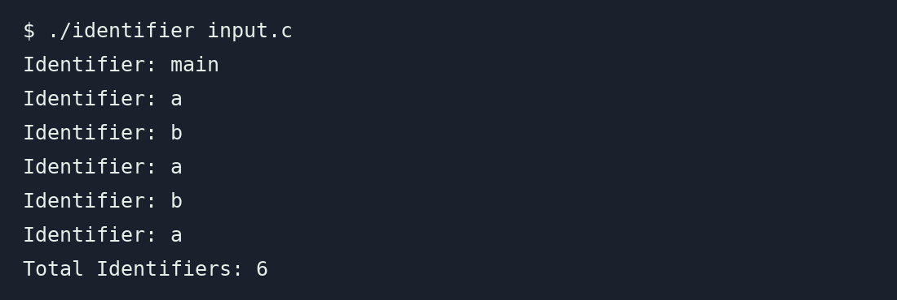

RESULT
Thus, the Lex program to read a C source file and count identifiers was written. For the given input, 6 identifier occurrences were found (3 unique identifiers: main, a, b).

