COMPILER DESIGN – EXPERIMENT 12
LEX PROGRAM TO COUNT ALPHABETS AND DIGITS
AIM
To write a Lex program to read an input file and count the total number of alphabetic characters and digits.
ALGORITHM
Start and initialize alphabet and digit counters to zero.
Open the input text file and check whether it exists.
Read characters using the Lex scanner.
Increment the alphabet counter for A–Z or a–z.
Increment the digit counter for 0–9.
Ignore spaces, newlines, and special symbols.
Display both totals, close the file, and stop.
PSEUDOCODE
START
SET alphabets = 0, digits = 0
OPEN input.txt
IF file cannot be opened THEN PRINT error; STOP
WHILE input remains
READ character
IF alphabet THEN alphabets = alphabets + 1
ELSE IF digit THEN digits = digits + 1
ELSE IGNORE
END WHILE
PRINT alphabets, digits
CLOSE file
STOP
LEX PROGRAM (count.l)
%{
#include <stdio.h>
int alphabets = 0;
int digits = 0;
%}
%%
[a-zA-Z] { alphabets++; }
[0-9] { digits++; }
.|\n ;
%%
int main(int argc, char *argv[])
{
if (argc != 2) {
printf("Usage: %s input.txt\n", argv[0]);
return 1;
}
yyin = fopen(argv[1], "r");
if (yyin == NULL) {
printf("Cannot open file!\n");
return 1;
}
yylex();
printf("Total Alphabets: %d\n", alphabets);
printf("Total Digits: %d\n", digits);
fclose(yyin);
return 0;
}
int yywrap(void) { return 1; }
SAMPLE INPUT (input.txt)
student 23
class 2026
EXECUTION COMMANDS
lex count.l
gcc lex.yy.c -o count
./count input.txt
OUTPUT IMAGE
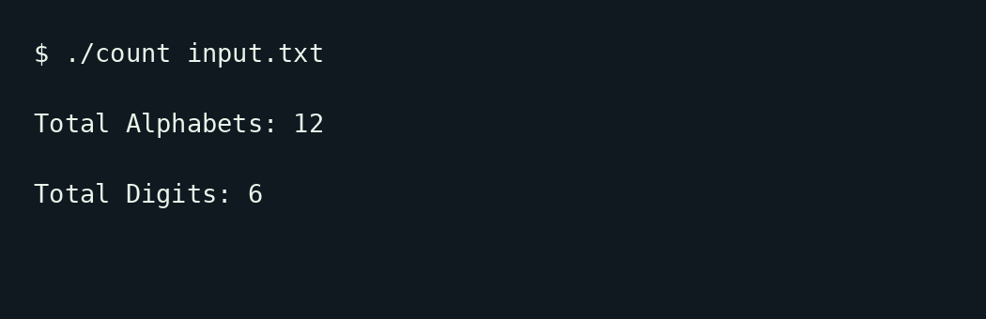
RESULT
Thus, the Lex program to count alphabetic characters and digits in an input file was written. For the given sample input, the output is 12 alphabets and 6 digits.

