EXPERIMENT 8
LEX PROGRAM TO IDENTIFY ASSIGNMENT OPERATORS

Aim
To write a Lex program to identify and print assignment operators present in the given input.

Algorithm
- Start the program and include the required C header file.
- Define Lex patterns for assignment operators (=, +=, -=, *=, /=, %=, &=, |=, ^=, <<=, >>=).
- Read the input using yylex().
- When a pattern matches, display the operator using yytext.
- Ignore all other characters and continue scanning until end of input.
- Stop the program.

Pseudocode
START
DEFINE patterns for assignment operators
READ input using lexical scanner
WHILE input remains:
IF an assignment operator matches:
PRINT the matched operator
ELSE:
IGNORE the character
STOP

Lex Program (assignment.l)
%{
#include <stdio.h>
%}
%%
"<<="|">>="|"+="|"-="|"*="|"/="|"%="|"&="|"|="|"^="|"=" {
printf("Assignment Operator: %s\n", yytext);
}
.|\n ;
%%
int main(void) {
printf("Enter the input:\n");
yylex();
return 0;
}
int yywrap(void) { return 1; }

Output Image
Illustrative terminal output for sample input:
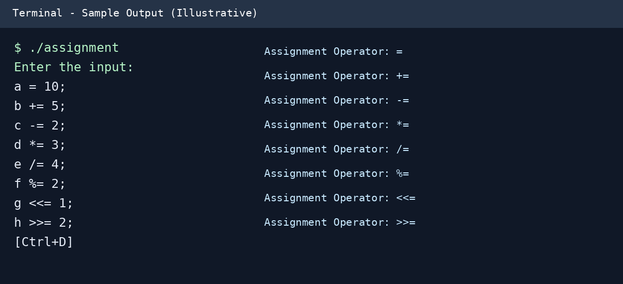

Result
Thus, the Lex program to identify and print assignment operators was written and its expected output was demonstrated.

