COMPILER DESIGN LABORATORY
EXPERIMENT 13
LEX PROGRAM TO REMOVE COMMENTS FROM A C PROGRAM

AIM
To write a Lex program to identify and remove single-line and multi-line comments from a C source file and save the resulting program in an output file.

ALGORITHM
- Start the program and open the C source input file.
- Create the output C file.
- Read input characters using the Lex lexical analyzer.
- Ignore // comments until the end of the line.
- Ignore /* ... */ comments using the COMMENT state while preserving line breaks.
- Copy all other characters, including string and character literals, to the output file.
- Close both files and display the success message.
- Stop.

PSEUDOCODE
START
OPEN input.c
CREATE output.c
WHILE input remains
IF // comment: SKIP to newline
ELSE IF /* comment: SKIP to */
ELSE: WRITE input to output.c
END WHILE
CLOSE files
PRINT success message
STOP

LEX PROGRAM (remove_comments.l)
%{
#include <stdio.h>
FILE *out;
%}
%x COMMENT
%%
"//"[^\n]* ;
"/*" { BEGIN(COMMENT); }
<COMMENT>"*/" { BEGIN(INITIAL); }
<COMMENT>\n { fputc('\n', out); }
<COMMENT>. ;
\"([^\\\n]|\\.)*\" { fputs(yytext, out); }
\'([^\\\n]|\\.)*\' { fputs(yytext, out); }
\n { fputc('\n', out); }
. { fputs(yytext, out); }
%%
int main(int argc, char *argv[])
{
if (argc != 3) {
printf("Usage: %s input.c output.c\n", argv[0]);
return 1;
}
yyin = fopen(argv[1], "r");
if (yyin == NULL) {
printf("Cannot open input file!\n");
return 1;
}
out = fopen(argv[2], "w");
if (out == NULL) {
printf("Cannot open output file!\n");
fclose(yyin);
return 1;
}
yylex();
fclose(yyin);
fclose(out);
printf("Comments removed successfully!\n");
printf("Output saved in %s\n", argv[2]);
return 0;
}
int yywrap() { return 1; }

SAMPLE INPUT (input.c)
#include <stdio.h>
int main()
{
// Declare variables
int a = 10;
int b = 20;
/* Calculate
the sum */
int sum = a + b;
printf("Sum = %d", sum);
return 0;
}

EXECUTION COMMANDS
lex remove_comments.l
gcc lex.yy.c -o remove_comments
./remove_comments input.c output.c
cat output.c

OUTPUT IMAGE
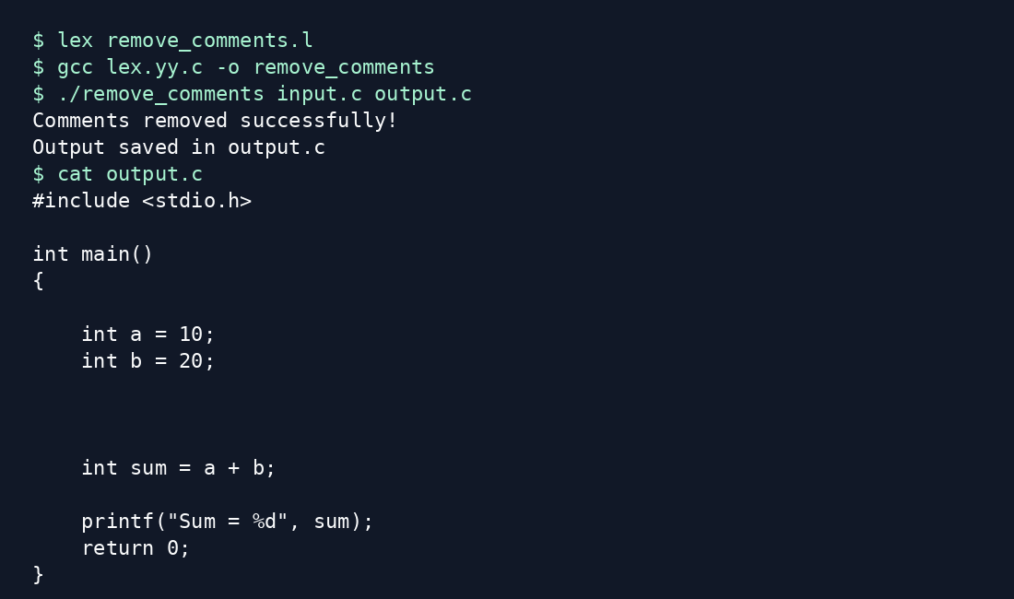

RESULT
Thus, the Lex program to remove single-line and multi-line comments from a C program and write the resulting program into an output file was written and executed successfully.
Note: This laboratory example handles ordinary C comments and quoted strings; it is not a full C preprocessor.

