**LAB 1 - INTRODUCTION TO ENTERPRISE PORTAL**

# OBJECTIVE AND LEARNING OUTCOMES

## OBJECTIVE

The objective of this lab exercise is to provide an overview on SharePoint and how to manage sites using SharePoint Online.

**Estimated time to complete the Lab: 30 minutes**

## LEARNING OUTCOMES

At the end of the lab session, students should acquire the following outcomes:

* Experienced in working with a cloud based enterprise portal solution, SharePoint Online (Office 365)
* Ability to create new sub-sites
* Ability to perform simple customization within SharePoint sites (e.g. contents, navigation features)

## Grading

You must complete the following:

• Configuration of your personal site as per the requirements as stated in the final outcome in this lab. You must complete this lab before the start of next class in the following week. Your TA will be randomly going through some sites each week to verify the completion of the lab exercises.

• Concepts of labs would also be tested during the lab quizzes.

# LAB EXERCISE AND TASK TO ACHIEVE

## Lab resources

The resources required is included in this file as zip file. Follow the instruction below to unzip the files.



* Unzip the content by clicking on the zip file icon above
* Unzip and save the content into c:\ews\lab1resource
* It should contain the 2 files
  + Innoxx.png
  + Welcome.docx

## Lab Dependency (if any)

Not applicable.

## Final outcome

The QAT project team subsite should be created as follows:

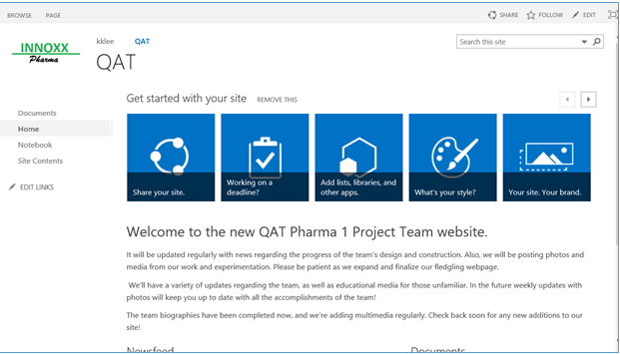

# Lab Procedure and Instructions

## Creating a new personal subsite for your lab

### Use the URL to go into the SharePoint site, this site make use of your SMU credential to login.

https://smu.sharepoint.com/teams/SIS/IS305/<TermX>/<yourname>/SitePages/Home.aspx

Replace <TermX> with the current term and <yourname> with your SMU email id without the “dots” and year of admission, e.g., if your email is [kk.lee.2013@smu.edu.sg](mailto:kk.lee.2013@smu.edu.sg), use “kklee”.

e.g. *https://smu.sharepoint.com/teams/SIS/IS305/Term1/kklee/SitePages/Home.aspx*

You should see your initial page as follows:

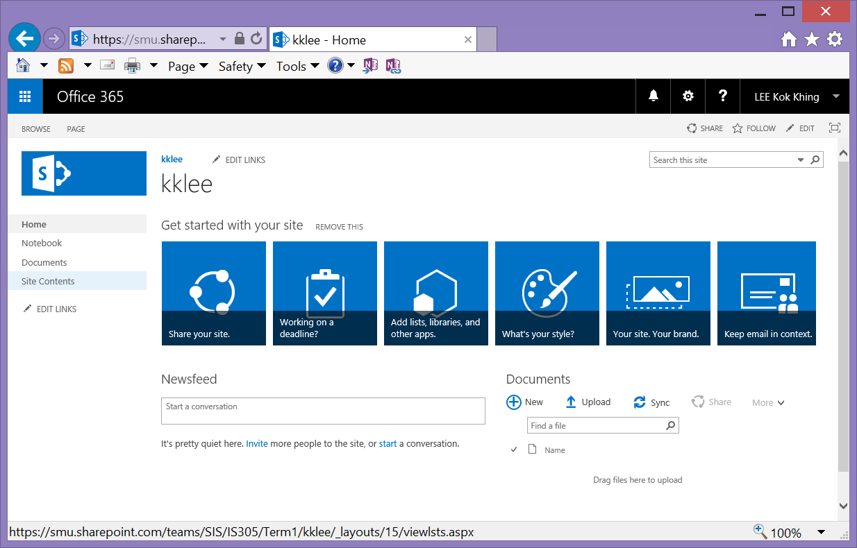

Verify it is your username here

### Click on “*Site Contents”* from the side navigation.



### On the Site Contents page, we will be creating the QAT project team subsite under your personal site. Click “+ New*” -> “Subsite*” to create a new subsite.

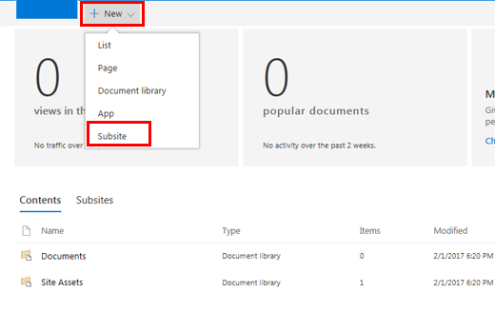

### Follow the settings in the following screens and click on the “Create” to complete the creation of the new subsite

* Enter the title and description of the site
* Enter “QAT” in the URL and take note that you can directly access this subsite using the URL

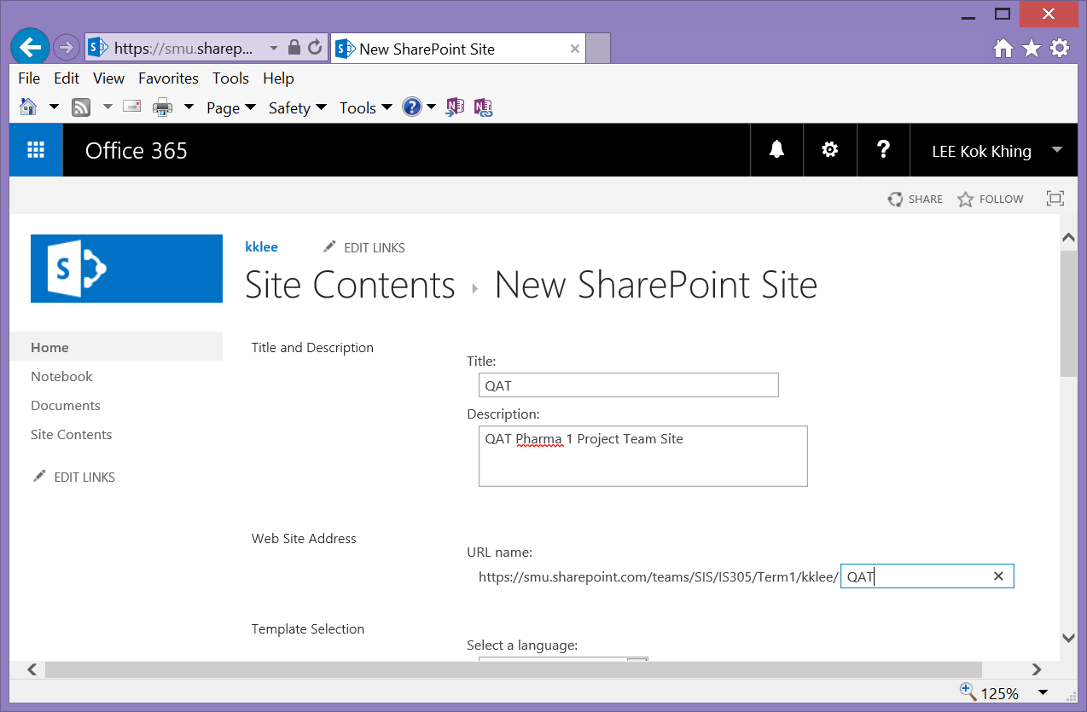

* SharePoint provide many templates that comes with preset functionalities. Since we are creating a project team site, we can make use of the Team Site template from the collection of Collaboration templates. Select “*Team Site”* as the site template for the QAT site
* We will also inherit the permission setting from the parent site, which will be the same as your personal site since QAT is a subsite of your site

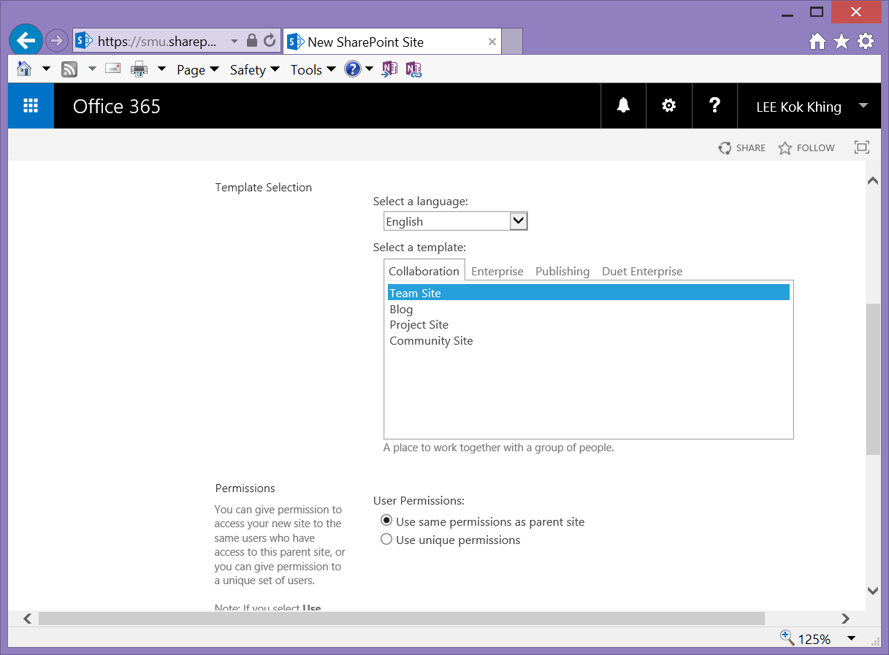

* Enable the same top link navigation bar for this subsite as per your parent site and click on “*Create”* to complete the creation.

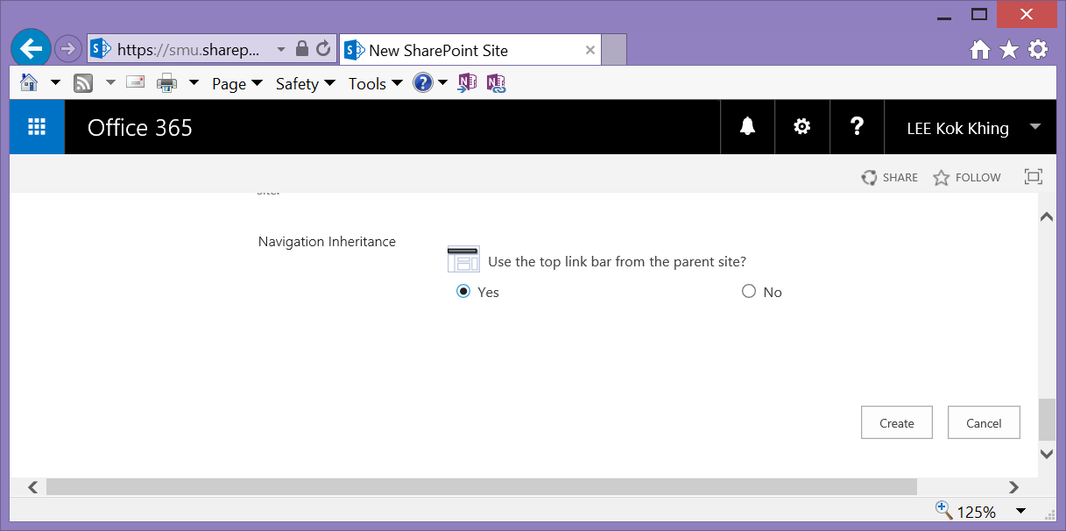

### Your QAT Subsite is created

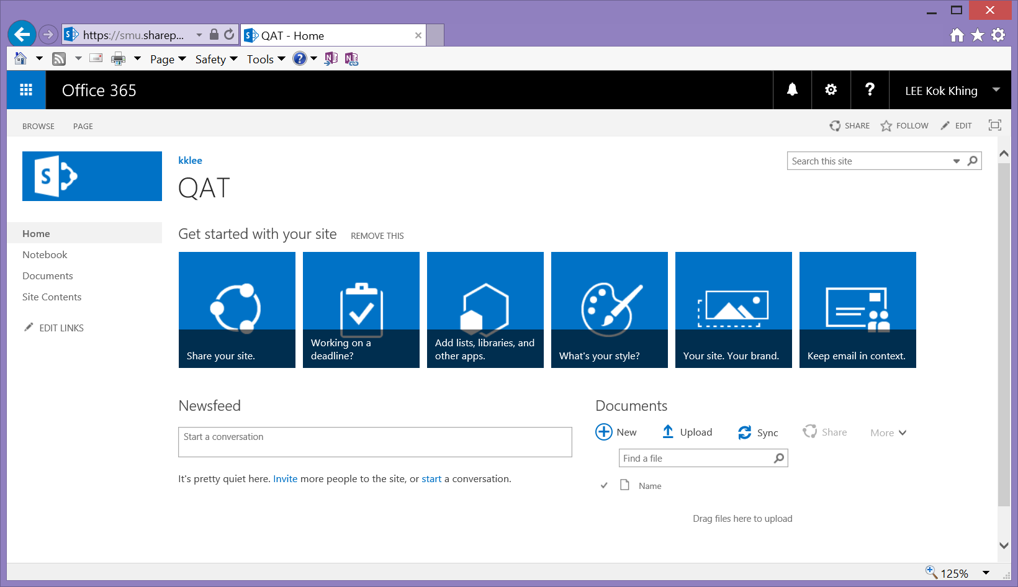

This should reflect that QAT is created under your personal site. You can click on the top link bar to go back to your personal site

## Deleting a subsite (Optional)

The following steps will go through how you can delete a subsite that you have created previously, however, **we will stop at where the deletion can be done and will not delete the site for this lab.**

### Check that you are in your personal subsite, and not the QAT subsite

### Click on “Site Contents” from the left navigation to access your QAT subsite.

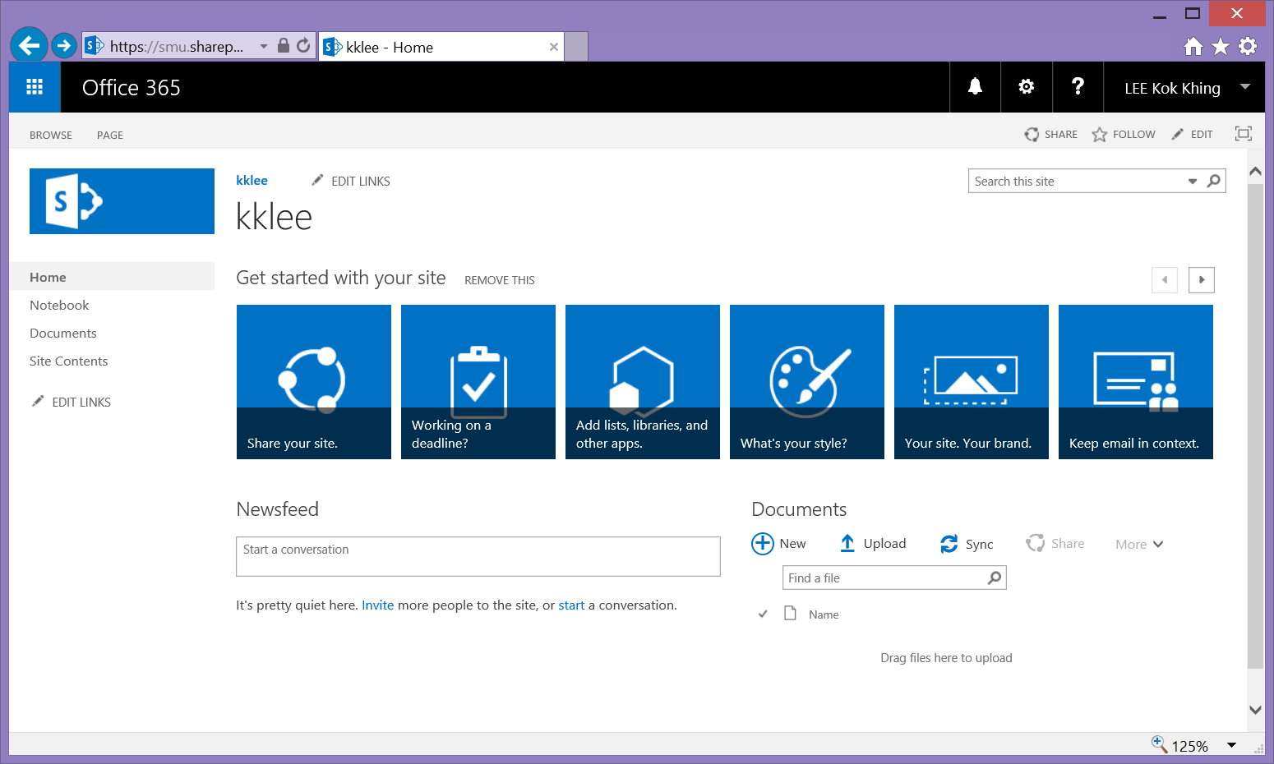

Verify it is your username here

### Click “Subsites” to show the subsites under the current site.

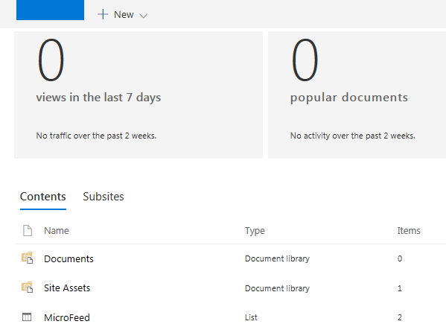

### Click “QAT” to navigate to the site that you intend to delete.

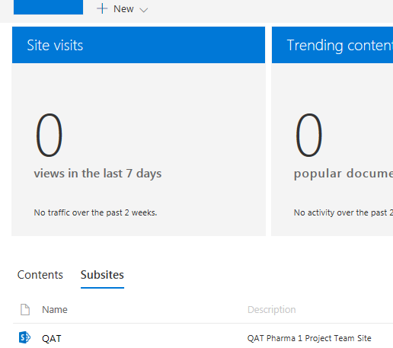

### Once you are in the QAT subsite, click on the Gear icon and click on the Site Settings option from the pull down menu.

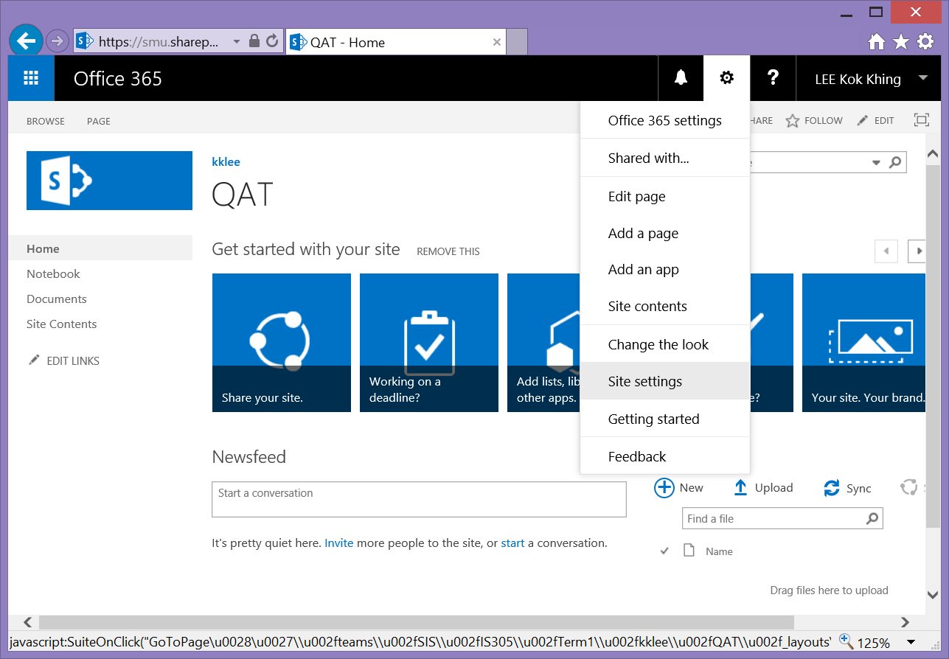

Verify it is your username and subsite before attempt deletion

### From the Site Settings screen, click on the *Delete this site* link

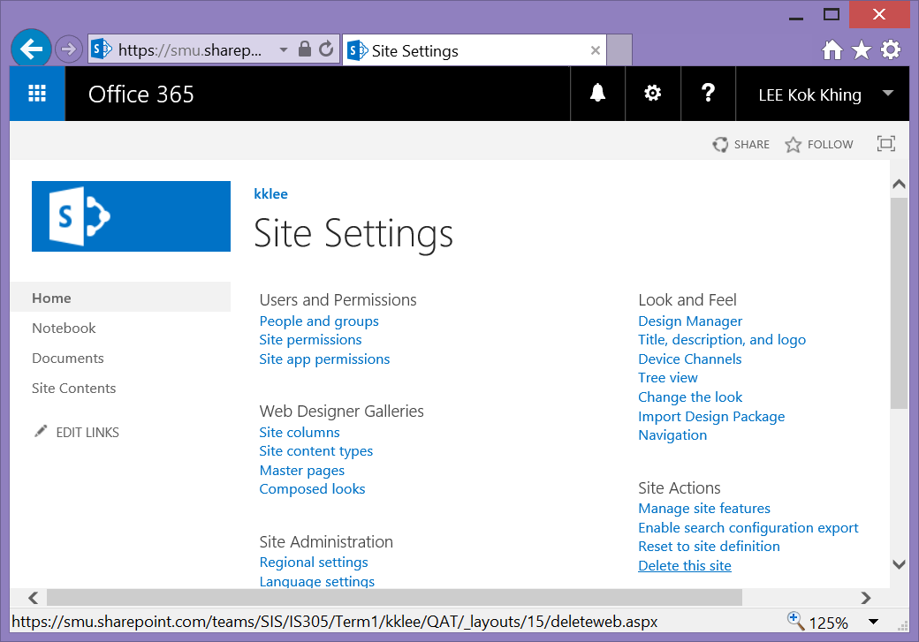

### A warning screen will appear, check that the URL reflect the actual subsite that you are deleting i.e., end with QAT for our exercise. We will stop our deletion exercise here and you should click on Cancel so that your site will not be deleted.

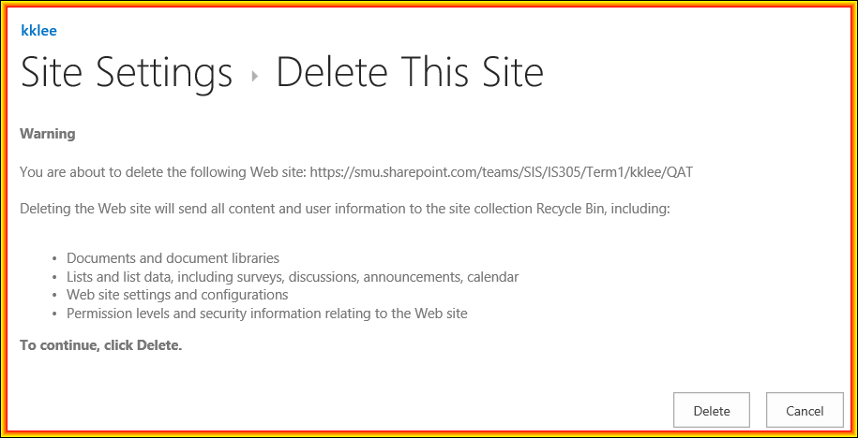

## Setting navigation for QAT project team subsite

### Go back to your personal site by specifying your URL or clicking on your name from the top navigation.



### You should be at your personal site, not the QAT sub-site as in the following screen. Click on the gear icon on the top right and select “*Site Settings”* from the dropdown menu.

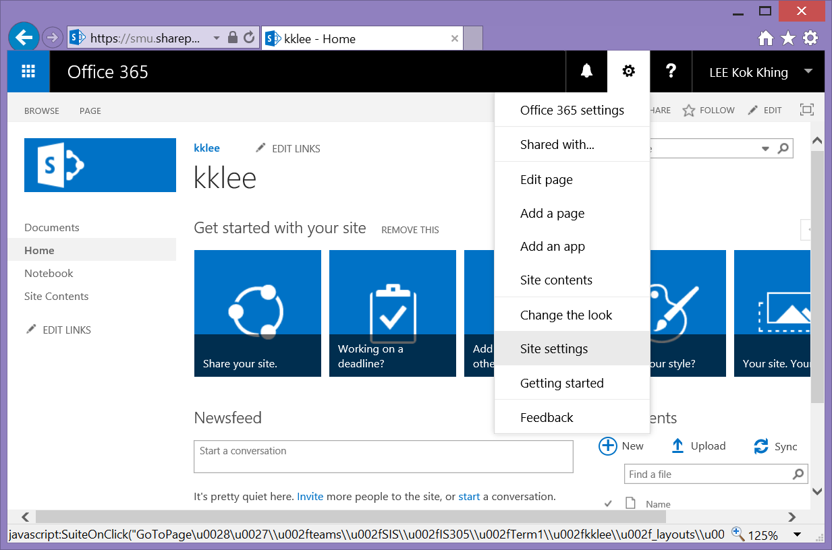

### From the “Site Settings” screen, select “*Navigation*” under “Look and Feel”.

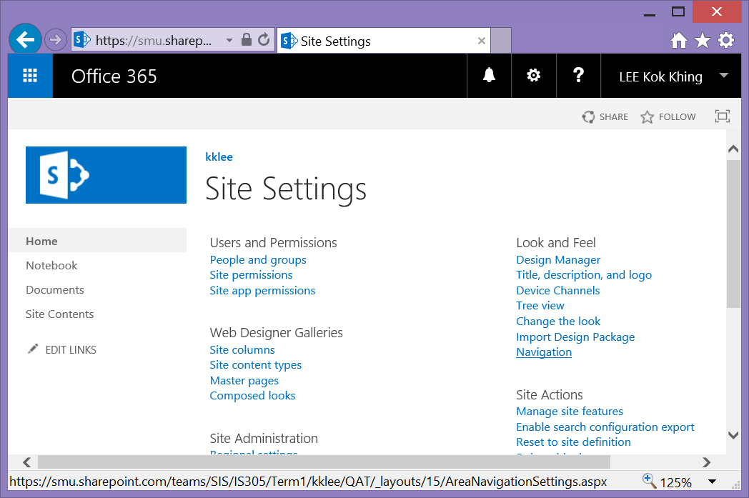

### The following settings allow the subsite to display the links of the sites that are under the current site.

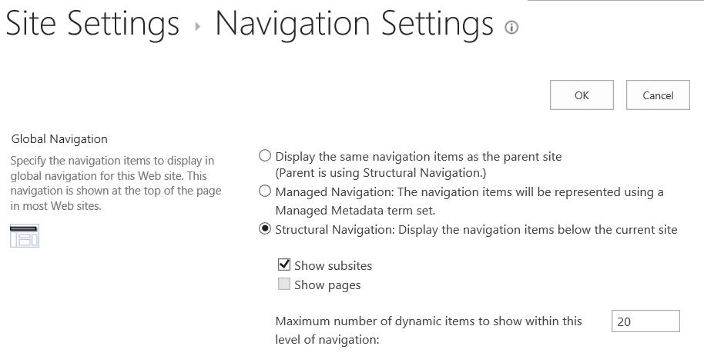

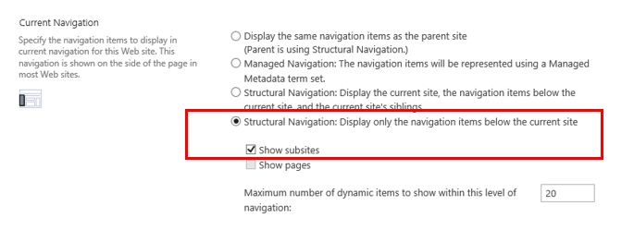

### Click “*OK*” to save the settings.

### You should be able to use the new navigation on the top and side to navigate within your personal site.

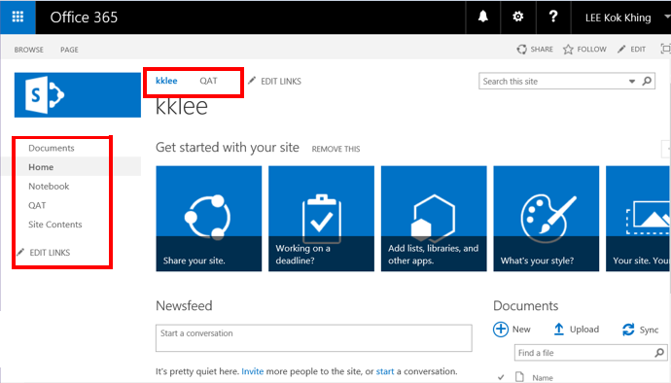

## Modifying the layout of the subsite

### We will be customizing your site by first adding the Innoxx logo to your subsites.

### Go back to your personal subsite with the new navigation.

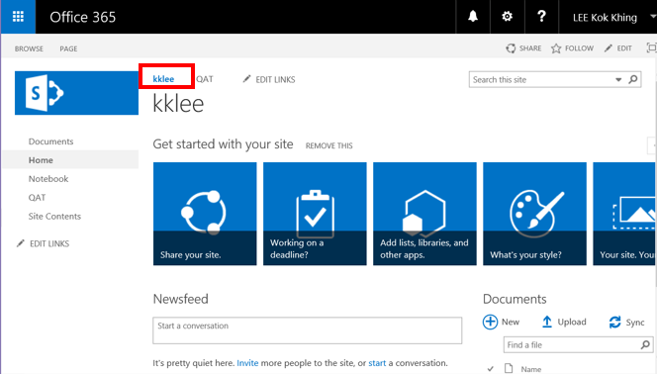

### Click on the big icon “*Your Site, Your brand”.*

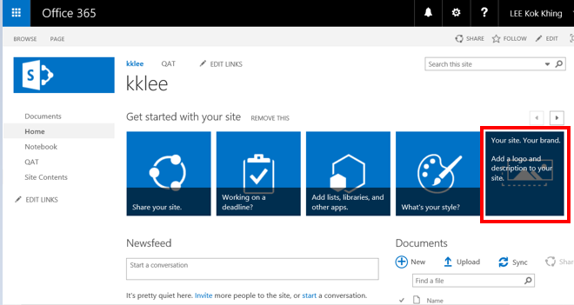

### We will now use the logo from the resource files to customise the subsite to display the Innoxx logo.

### Change the description of your site and click “*From Computer”*.

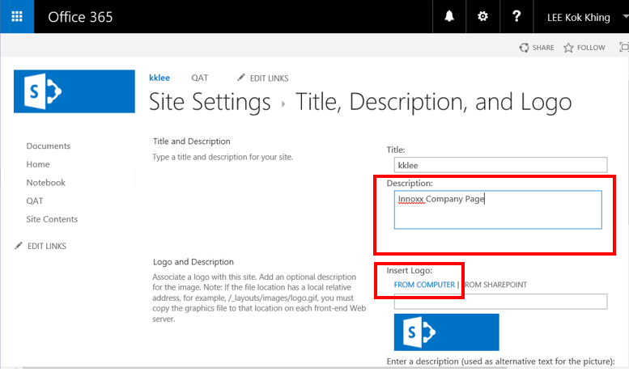

### Click “*Browse”* to locate your logo that you have previously unzipped.

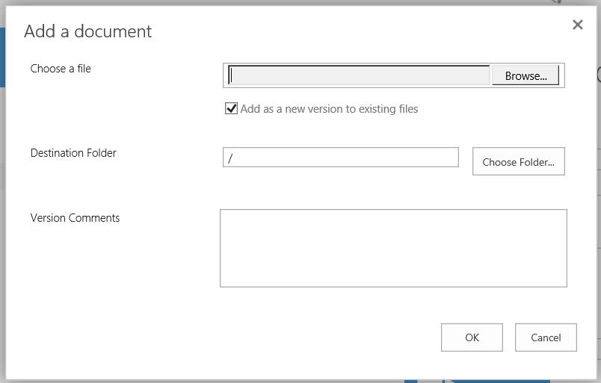

### Browse to the c: \ews\Lab1resource folder and click on the Innoxx.png file. Click “Open”.

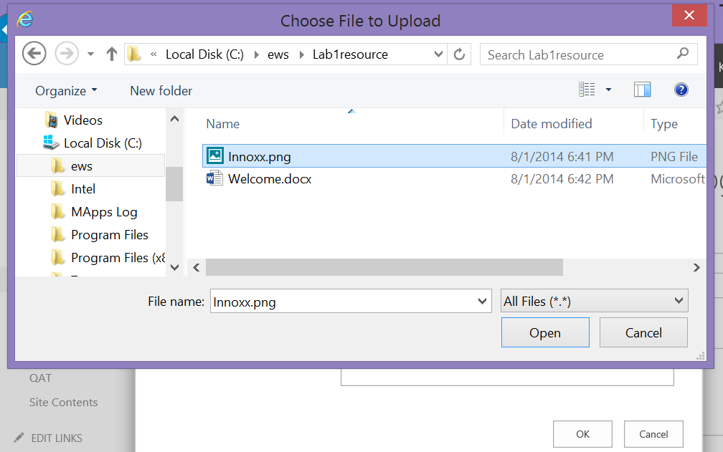

### Click “OK” to import your local Innoxx.png file.

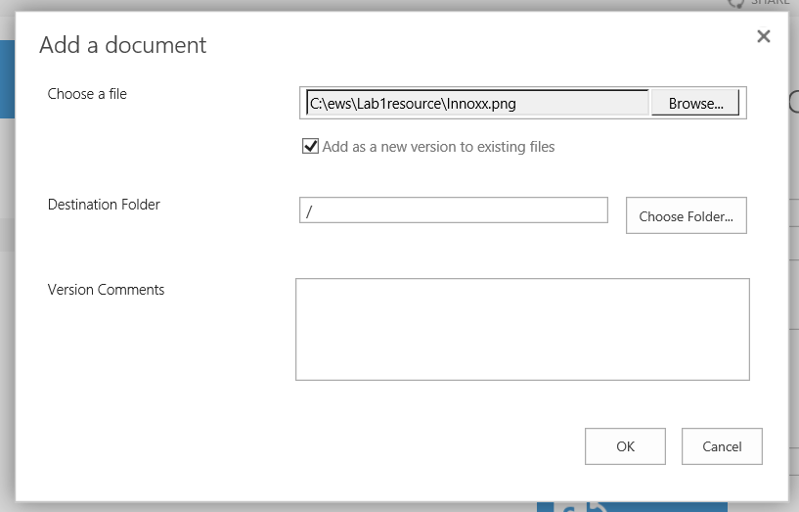

### You should see the new logo displayed on the screen. The screen also shows where the logo png file is stored in SharePoint. You should also enter a description of this logo and click OK.

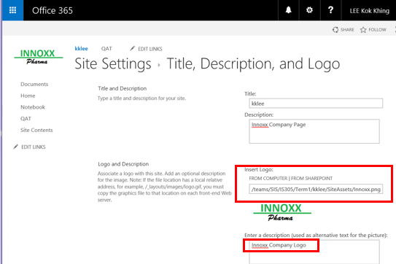

### Next, we will fill in more details about the main Innoxx site.

### Click on the gear icon and select “*Edit Page”* from the drop down menu.

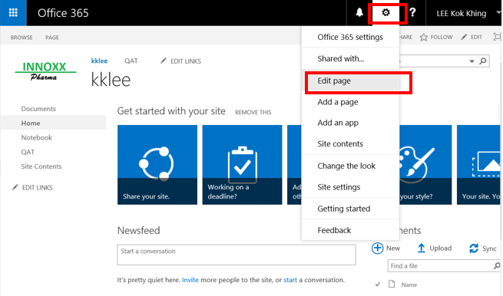

### You are now in the Edit Mode for the page, Click and position the mouse cursor at the location of the red square to enter some descriptive text about your site.

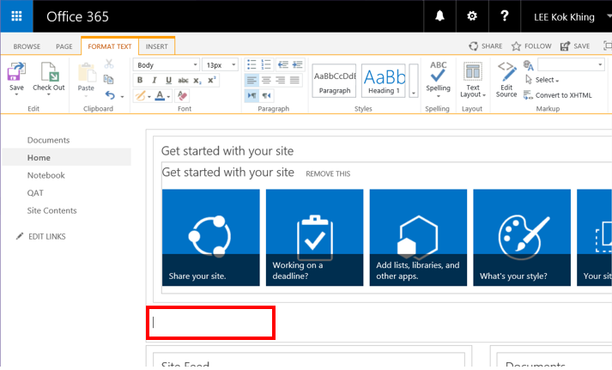

### Enter the following details.

* Innoxx Main Site
* Welcome to the main site of Innoxx Pharma

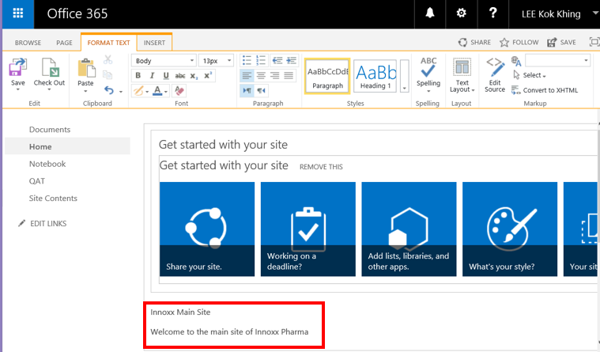

### Change the font size of the “Innoxx Main site” wordings.

### Click “Save” from the ribbon menu to confirm your changes.

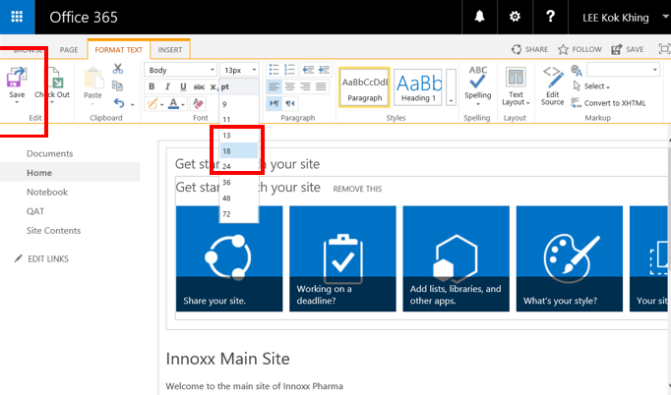

### Your changes are now reflected on your Innoxx site as follows.

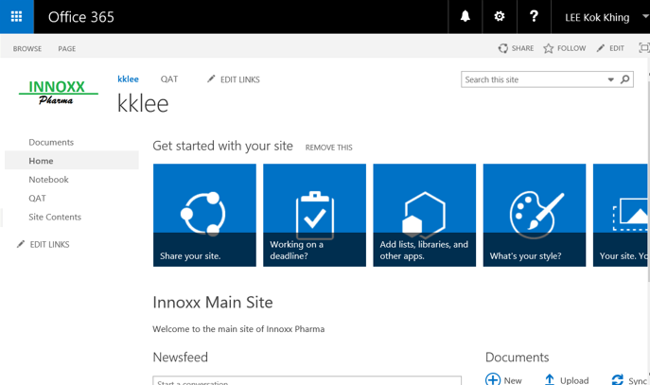

### You should bookmark your current page on your browser so that it is easier for you to access the main Innoxx page for the subsequent labs.

## Changing the QAT subsite

Exercise: Attempt the following by making use of the skills you learnt earlier on.

### Go to your QAT subsite.

### Change the logo of the subsite.

### Using the text contents from the welcome.docx file, change the title and description of the site. You can cut and paste the textual contents from the .docx file.

**3.5.4 Set navigation for QAT subsite such that the navigation bar on the left is as shown in the final layout below.**

### The final layout of the QAT subsite should be as follow:

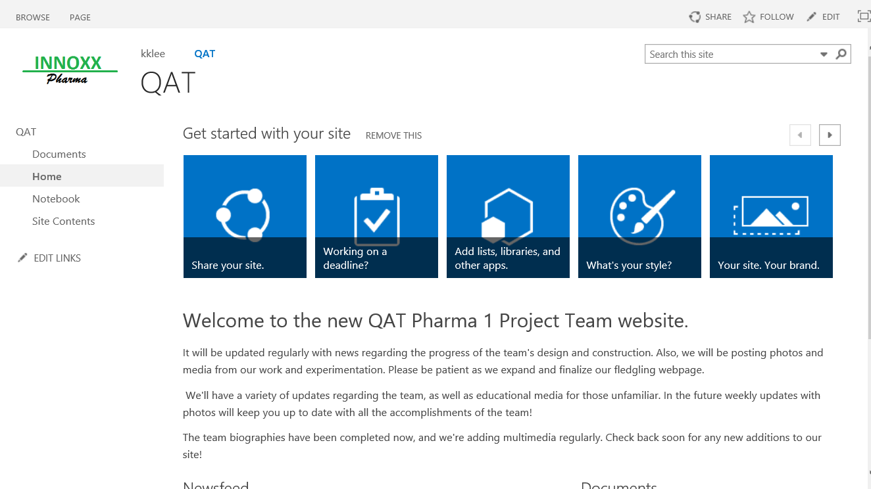

End of Lab 1