

Practices for Secure Software Report

Table of Contents
Document Revision History 3
Client 3
Instructions 3
Developer 4
1. Algorithm Cipher 4
2. Certificate Generation 4
3. Deploy Cipher 4
4. Secure Communications 4
5. Secondary Testing 4
6. Functional Testing 4
7. Summary 4
8. Industry Standard Best Practices 4

Document Revision History

Version | Date | Author | Comments
1.0 | October 18, 2026 | Noah Kersey | Practices for secure software report: SHA-256 checksum, HTTPS/TLS, secondary static testing and functional review of the refactored Artemis Financial code

Client



Instructions

Submit this completed practices for secure software report. Replace the bracketed text with the relevant information. You must document your process for writing secure communications and refactoring code that complies with software security testing protocols.

- Respond to the steps outlined below and include your findings.
- Respond using your own words. You may also choose to include images or supporting materials. If you include them, make certain to insert them in all the relevant locations in the document.
- Refer to the Project Two Guidelines and Rubric for more detailed instructions about each section of the template.

Developer
Noah Kersey

Algorithm Cipher

Artemis Financial needs to prove that a file or message received by a client is exactly the file that was sent. That is a data-integrity problem, so the core recommendation is a cryptographic hash function used as a checksum: SHA-256 (SHA-2 family, NIST FIPS 180-4). SHA-256 is used together with TLS 1.3/1.2 (AES-256-GCM or ChaCha20-Poly1305 for bulk encryption, RSA-2048 or ECDHE for key exchange and authentication), so the data is protected for confidentiality in transit and its checksum can be independently verified at rest.
Overview and justification. SHA-256 takes input of any length and produces a fixed 256-bit (32-byte, 64 hexadecimal character) digest. It is one-way (the input cannot be recovered from the digest), deterministic (the same input always gives the same digest) and shows the avalanche effect (changing one character changes roughly half of the output bits). Because the output space is 2^256, a brute-force collision search needs about 2^128 operations and a pre-image search about 2^256, far beyond any practical attack. SHA-256 is built into the Java platform (java.security.MessageDigest), needs no third-party library or license, is FIPS-approved, and is fast enough to hash large financial files on commodity servers.
Hash functions and bit levels. MD5 (128-bit) and SHA-1 (160-bit) are both broken for collision resistance: practical MD5 collisions have existed since 2004 and the SHAttered attack produced a real SHA-1 collision in 2017 (Stevens et al., 2017). They must not be used for integrity. SHA-256 (256-bit) gives 128-bit collision security, which matches NIST’s guidance for protecting data well beyond 2030 (Barker, 2020). SHA-384/SHA-512 (384/512-bit) give more margin and are faster on 64-bit CPUs; SHA-3-256 (Keccak) is a structurally different alternative if SHA-2 were ever weakened. SHA-256 is the right balance of security, interoperability and performance for Artemis today; the algorithm name is a constant in one class (ChecksumService.ALGORITHM), so moving to SHA-512 or SHA3-256 later is a one-line change.
Use of random numbers. A hash is not secret, so a plain checksum proves integrity only if the expected digest arrives through a trusted channel. Artemis gets this by serving the checksum only over HTTPS. Where keys are involved, randomness is critical: TLS session keys, nonces, RSA key generation and salts must come from a cryptographically secure pseudo-random number generator (CSPRNG) such as java.security.SecureRandom or the operating system’s generator, never java.util.Random or Math.random(), which are predictable. In this project keytool used the JDK’s SecureRandom to generate the RSA-2048 key pair, the keystore password was generated with a CSPRNG (System.Security.Cryptography.RandomNumberGenerator), and the TLS stack generates fresh ephemeral keys for each session. The checksum page also adds a unique per-request value (an ISO-8601 timestamp) to the data so every response produces a different, verifiable digest.
Symmetric vs. asymmetric keys. Symmetric algorithms (AES) use one shared secret key for encryption and decryption. They are very fast and suited to bulk data, but the key has to be distributed safely. Asymmetric (public-key) algorithms such as RSA and elliptic-curve cryptography use a public/private key pair: anyone can encrypt or verify with the public key, and only the private-key holder can decrypt or sign. They solve key distribution and provide identity (digital certificates) but are much slower. TLS combines both: the server’s RSA-2048 certificate (asymmetric) authenticates Artemis and protects an ephemeral key exchange, which then sets up an AES-256-GCM session key (symmetric) for the actual traffic, and a SHA-2 hash (SHA-384 in the negotiated TLS 1.3 suite) supports integrity. A hash function itself uses no key at all, which is why SHA-256 is suitable for a public checksum, and an HMAC-SHA-256 or RSA/ECDSA signature would be the next step if Artemis needed to prove who produced a file.
History and current state. The Data Encryption Standard (DES, 56-bit key, 1977) was broken by brute force in the late 1990s and replaced by AES (Rijndael) in 2001. MD5 (1992) and SHA-1 (1995) were the dominant hashes until collision research made them unsafe; NIST published SHA-2 (including SHA-256) in 2001 and SHA-3 in 2015 (Dworkin, 2015). RSA (1977) is still widely used at 2048 bits or more, while 1024-bit RSA has been retired. Today SHA-256 and AES-256 remain unbroken and are standard in TLS 1.3, code signing, blockchains and file-integrity tools. The emerging issue is quantum computing: Shor’s algorithm would break RSA and ECC, so NIST finalized the post-quantum standards FIPS 203 (ML-KEM), FIPS 204 (ML-DSA) and FIPS 205 (SLH-DSA) in 2024. Grover’s algorithm only halves the effective strength of hashes and symmetric ciphers, so SHA-256 and AES-256 are expected to stay adequate. Artemis should keep its cryptography configurable (crypto-agility) so it can adopt hybrid post-quantum TLS as Java and browsers support it.

Certificate Generation
Insert a screenshot below of the CER file.

A self-signed certificate was created with the Java keytool utility (JDK 26.0.1) in a Command Prompt on the development PC. The key pair is RSA 2048-bit, signed with SHA256withRSA, valid for 365 days, stored in a PKCS12 keystore (the current Java default, replacing the proprietary JKS format) under the alias artemis, and includes a Subject Alternative Name for localhost and 127.0.0.1 so modern browsers and TLS clients can match the host name. The keystore password was never typed on the command line: keytool read it from an environment variable (-storepass:env SSL_KEYSTORE_PASSWORD), so it does not appear in the screenshot, shell history or source code. The public certificate was then exported to server.cer.
keytool -genkeypair -alias artemis -keyalg RSA -keysize 2048 -sigalg SHA256withRSA -validity 365 -storetype PKCS12 -keystore src\main\resources\keystore.p12 -storepass:env SSL_KEYSTORE_PASSWORD -dname "CN=Noah Kersey, OU=Software Development, O=Global Rain Software, L=Manchester, ST=New Hampshire, C=US" -ext SAN=dns:localhost,ip:127.0.0.1
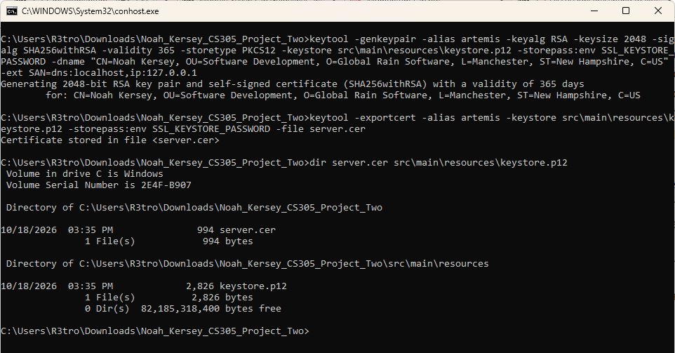
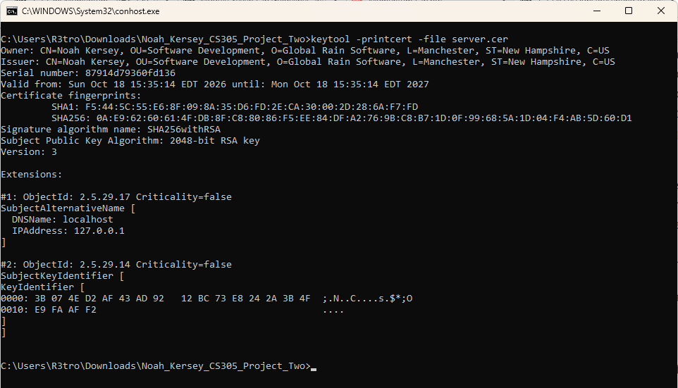
Because the certificate is self-signed, the owner and issuer are the same and browsers will not trust it automatically. This is acceptable for development and testing. For production, Artemis should create a certificate signing request (keytool -certreq) and have the certificate signed by a trusted certificate authority, store the keystore in a secrets vault, and rotate it before it expires.

Deploy Cipher
Insert a screenshot below of the checksum verification.

The skeleton SslServerApplication had only a //FIXME for the checksum route. I refactored it into a small layered design:
• ChecksumService encapsulates hashing. It calls MessageDigest.getInstance("SHA-256") on each request (MessageDigest is not thread-safe, so it is not shared), encodes the input as UTF-8 explicitly so results are the same on every platform, rejects null input, returns lowercase hex using java.util.HexFormat, and wraps the checked NoSuchAlgorithmException in an IllegalStateException instead of swallowing it.
• ServerController exposes GET /hash. The data is the required static string "Hello World Check Sum! Noah Kersey" plus a unique ISO-8601 UTC timestamp, so every request produces a new checksum. The page shows the data, the algorithm name (SHA-256) and the 64-character hex checksum. All values are HTML-escaped with Spring HtmlUtils as defense in depth against cross-site scripting, and an @ExceptionHandler logs failures server-side and returns a generic error with no stack trace.
To verify the checksum independently, I wrote scripts\verify-checksum.ps1. It downloads the /hash page over HTTPS, takes the exact data string the server hashed, recomputes SHA-256 with a different implementation (.NET System.Security.Cryptography.SHA256), and compares the two values. They match exactly (Figure 5), which shows the Java implementation is correct. The same comparison was also done for the browser response in Figure 7 with a third tool (GNU sha256sum: ecd52428ad72b1dc6219eb36ddf0ee26ee3da591f3b99e6ad732667df160f579). A JUnit known-answer test also checks the NIST FIPS 180-4 test vector SHA-256("abc") = ba7816bf…f20015ad.
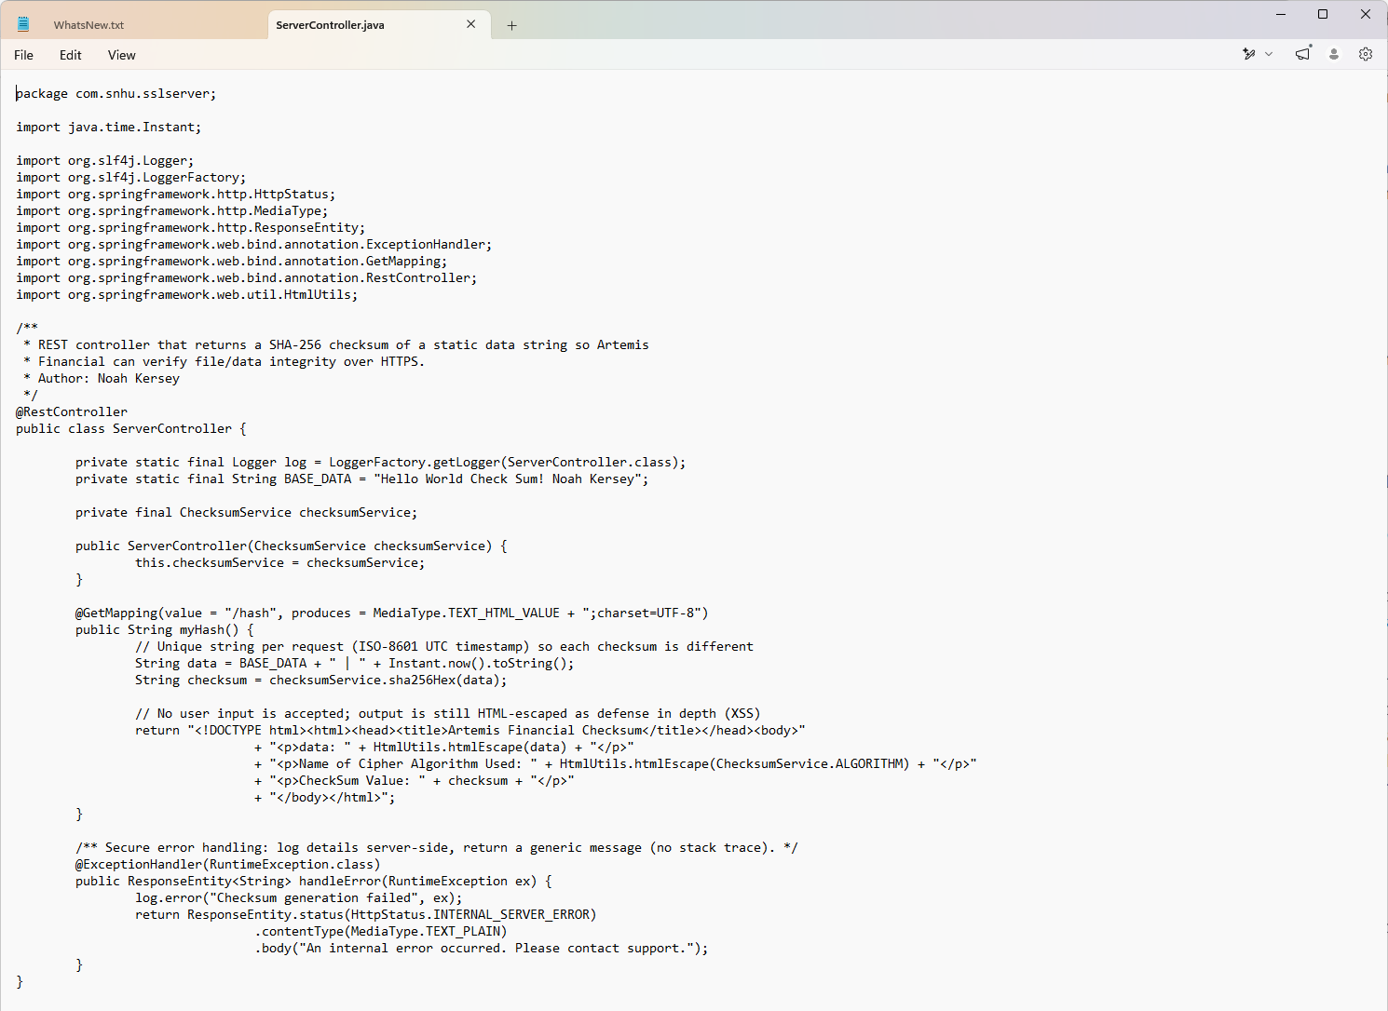
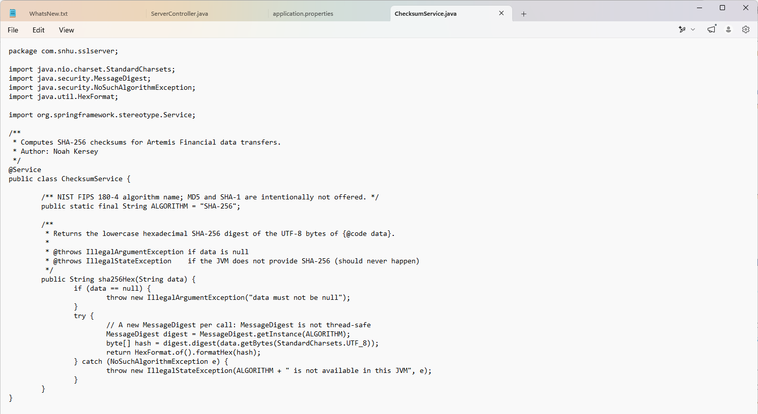
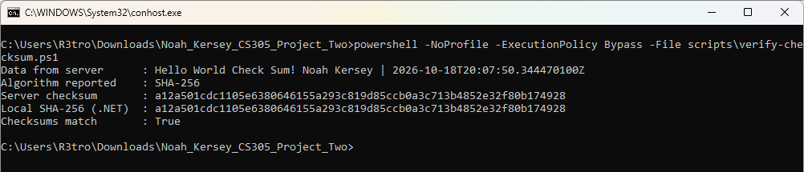

Secure Communications
Insert a screenshot below of the web browser that shows a secure webpage.

The application was moved from plain HTTP to HTTPS by completing application.properties: server.port=8443, server.ssl.enabled=true, key-store=classpath:keystore.p12, key-store-type=PKCS12, key-alias=artemis, and enabled-protocols=TLSv1.3,TLSv1.2 so SSLv3, TLS 1.0 and TLS 1.1 are refused. The keystore password is not stored in the file. It is resolved at runtime from the SSL_KEYSTORE_PASSWORD environment variable (${SSL_KEYSTORE_PASSWORD}), so the secret never reaches source control or the zipped deliverable. For local testing the server binds only to the loopback address (server.address=127.0.0.1), and the Tomcat server header and error details are suppressed.
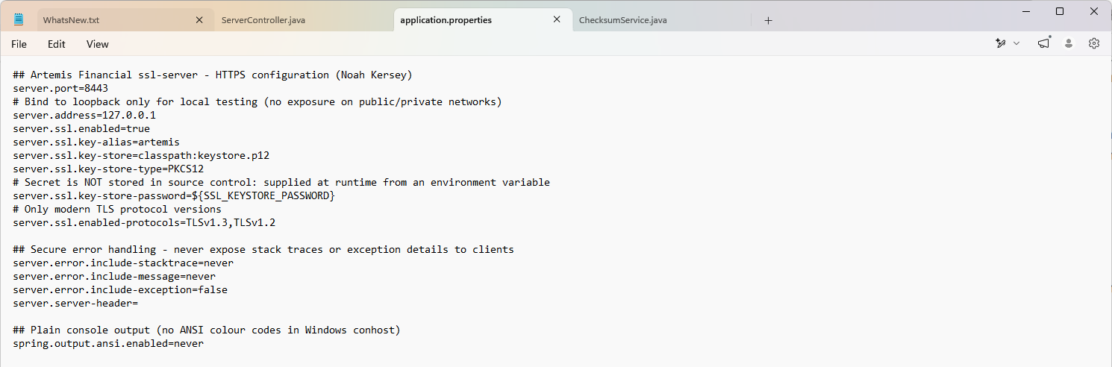
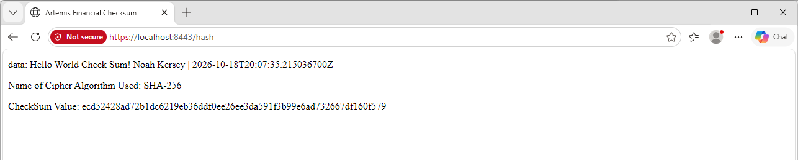
Edge displays "Not secure" only because the certificate is self-signed and not issued by a CA in the Windows trust store. The connection itself is encrypted. To confirm this without simply trusting the browser, scripts\tls-check.ps1 connects with .NET SslStream and pins the server certificate to the exported server.cer thumbprint. It reports TLS 1.3 with a 256-bit AES cipher and the Noah Kersey RSA-2048 SHA256withRSA certificate (Figure 8). In production, a CA-signed certificate would remove the browser warning, and HTTP Strict Transport Security (HSTS) should be enabled.
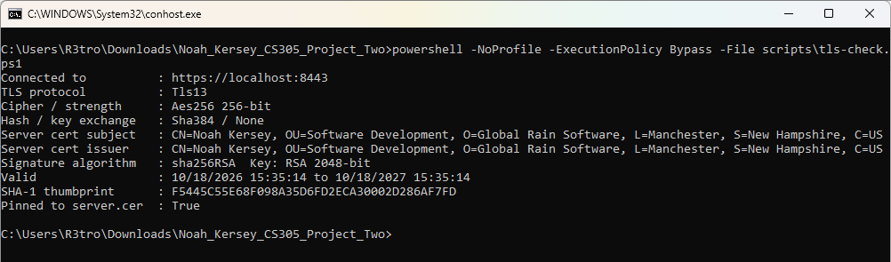

Secondary Testing
Insert screenshots below of the refactored code executed without errors and the dependency-check report.

After refactoring, I ran the application and the OWASP Dependency-Check Maven plug-in again to make sure no new vulnerabilities had been introduced. The application starts on HTTPS port 8443 with no errors and serves /hash (Figure 9). The original pom.xml still used dependency-check-maven 5.3.0, which can no longer download NVD data after the NVD API 2.0 change, so I upgraded the plug-in to 13.0.0 and passed the NVD API key through an environment variable (nvdApiKeyEnvironmentVariable). The key is not in pom.xml.
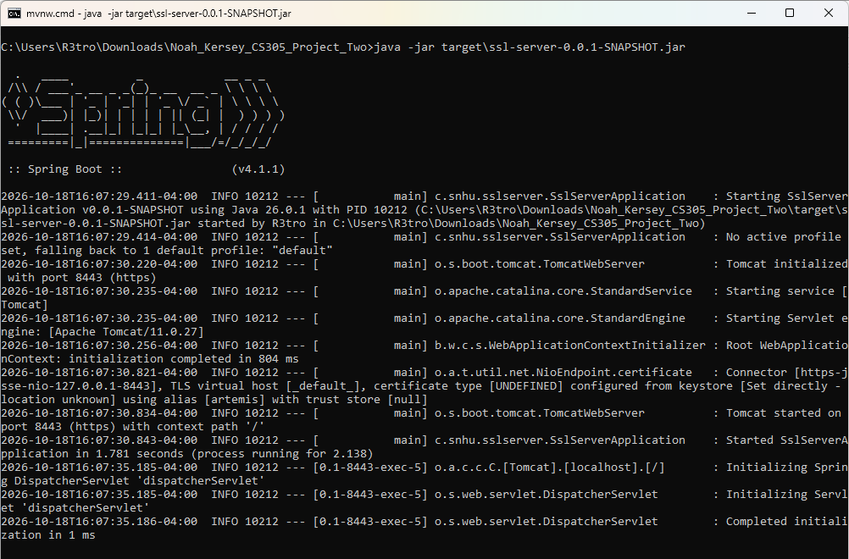
Findings and mitigation. Upgrading only the build to Spring Boot 3.5.16 (Java 17) gave 40 CVEs in 4 dependencies: spring-core 6.2.19 (17, including 6 Critical), tomcat-embed-core 10.1.55 (19, including 8 Critical), log4j-api 2.24.3 (3 Medium) and jackson-databind 2.21.4 (1 Medium) (Figure 10). Spring Framework 6.2.20+ fixes are not published as open source, so I mitigated this by upgrading again to Spring Boot 4.1.1 (Spring Framework 7.0.9, log4j 2.25.5) and overriding the embedded Tomcat to the patched 11.0.27 (tomcat.version property), because Boot 4.1.1 ships 11.0.24, which is still affected by CVE-2026-65637 and related issues.
False-positive review. The rescan then reported two CVEs (CVE-2026-47849, CVE-2026-47850) against spring-boot-data-rest-4.1.1.jar. I reviewed them by hand. They are false positives: the tool matched the Spring Boot auto-configuration module to the spring_data_rest CPE using the Boot version number 4.1.1, while the real Spring Data REST library is spring-data-rest-core 5.1.1, which is newer than the fixed release 5.1.0.1 and is not flagged. I added a narrow suppression (one package URL plus one CPE) to dependency-check-suppressions.xml with a written justification and an expiry date of 2027-04-18 so it gets reviewed again. The final scan reports 0 vulnerable dependencies and 0 vulnerabilities across 55 scanned dependencies, with BUILD SUCCESS (Figures 11 and 12).
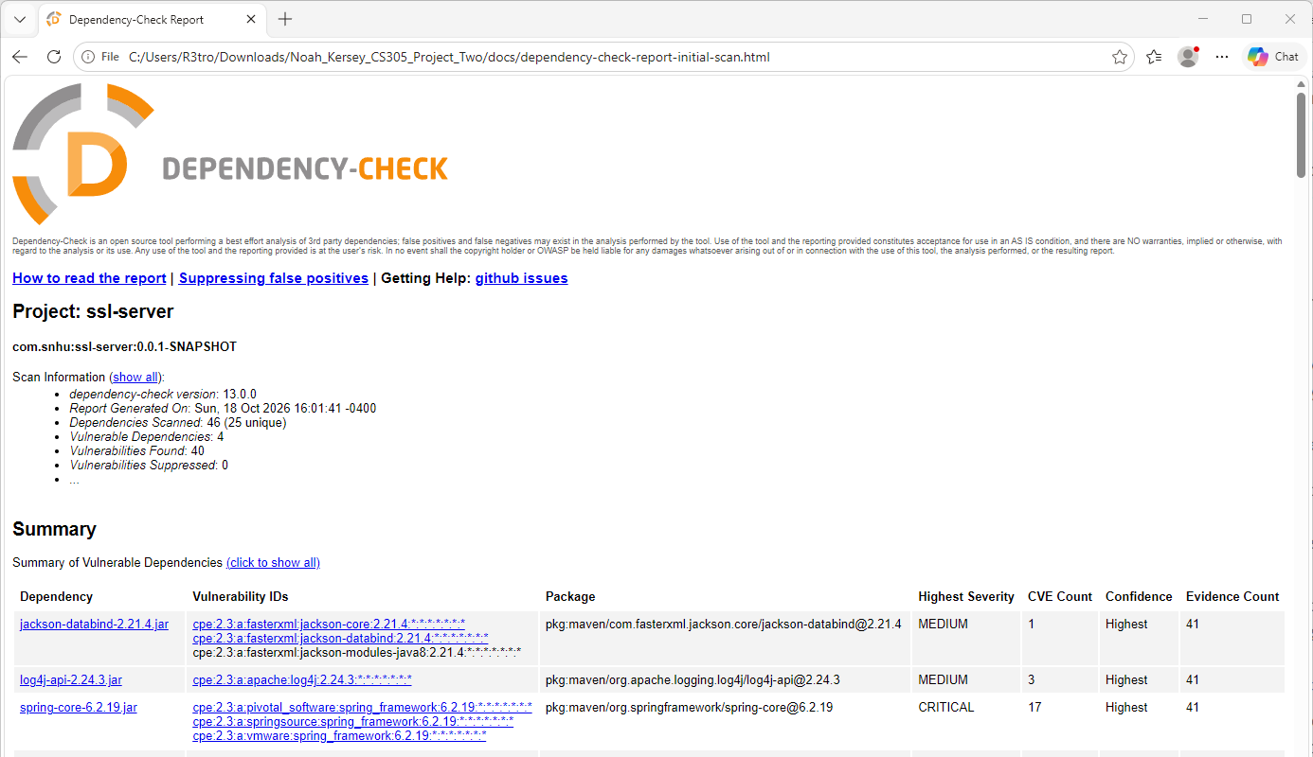
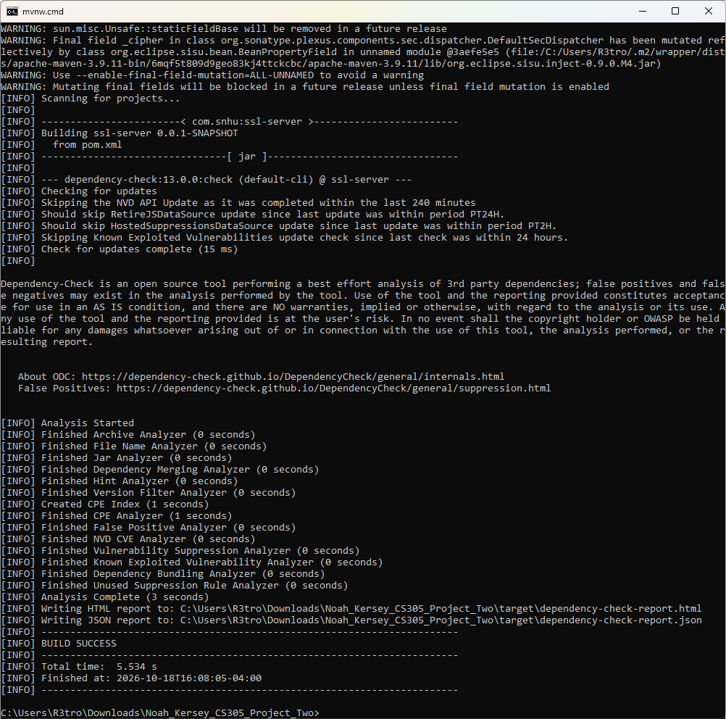
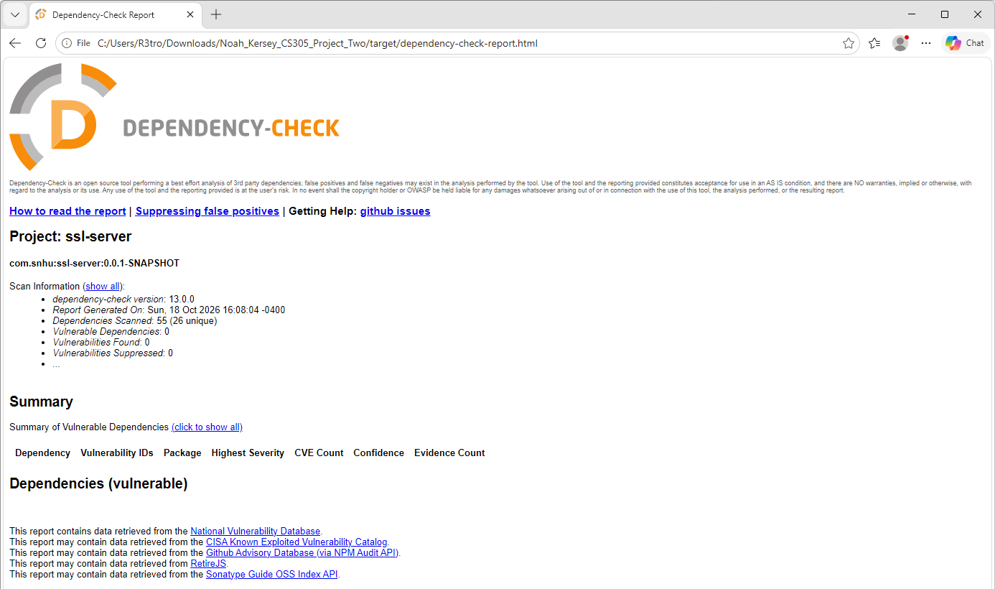
Comparison with Project One. In Project One the Artemis REST service (Spring Boot 2.2.4.RELEASE, bcprov-jdk15on 1.46) had about 150 unique CVEs, including Spring4Shell (CVE-2022-22965), Tomcat Ghostcat (CVE-2020-1938), SnakeYAML deserialization RCE (CVE-2022-1471) and several jackson-databind and Bouncy Castle flaws. The Project Two code base began from the same Spring Boot 2.2.4 generation. After the refactor none of those components remain: Spring Boot 4.1.1, Tomcat 11.0.27, SnakeYAML 2.6, Jackson 3.1.5/2.21 annotations and log4j-api 2.25.5 have no known CVEs in the NVD as of October 18, 2026. The new code (hashing, HTTPS configuration and helper scripts) added no new dependencies beyond the Spring Boot starters, so no new vulnerabilities were introduced.

Functional Testing
Insert a screenshot below of the refactored code executed without errors.

Functional testing combined automated tests with a manual line-by-line review of every changed file. mvnw clean package compiles the code and runs four JUnit 5/MockMvc tests: a NIST known-answer test for SHA-256, a check that different input gives a different digest, a check that null input is rejected, and an endpoint test confirming /hash returns HTTP 200, the required data string, "SHA-256" and a 64-character lowercase hex checksum. All four pass and the build succeeds (Figure 13). The Mockito/JDK warnings in the log are informational notices from the test tooling on Java 26 and are not errors.
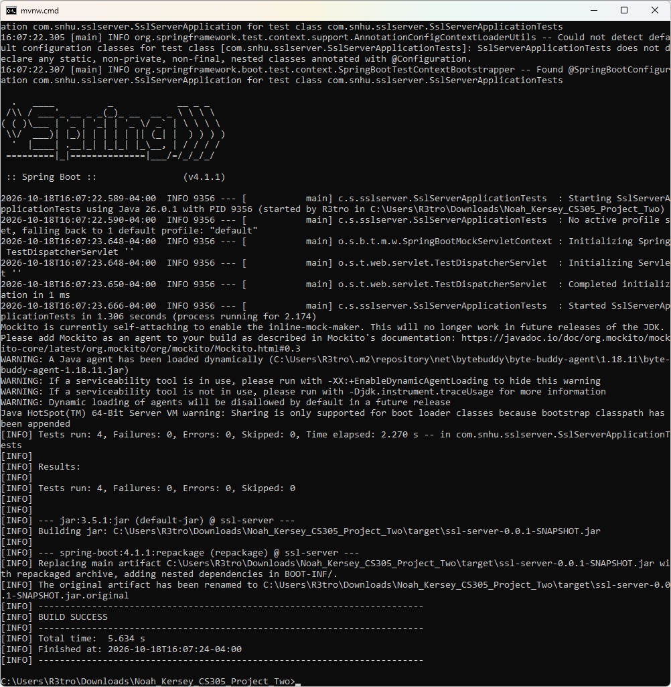
Manual code review results:
• Syntax: Code compiles cleanly on Java 17 language level (JDK 26 toolchain). The broken skeleton entries (server.ssl.*=????) and the //FIXME placeholder that would not compile as a properties comment were removed.
• Logic: The digest is computed over the exact string displayed, using explicit UTF-8, and the hex encoding keeps leading zeros (HexFormat), avoiding the common BigInteger.toString(16) bug that drops them. A new MessageDigest per request avoids race conditions between threads. Three independent implementations (Java, .NET, sha256sum) produce identical values.
• Input validation: /hash takes no user input, which removes the injection surface. Null input to the service is rejected with IllegalArgumentException, and all output is HTML-escaped.
• Error handling: NoSuchAlgorithmException is not swallowed. Errors are logged server-side and the client gets a generic message. server.error.include-stacktrace/message=never and include-exception=false stop internal details from leaking (Project One Finding 3).
• Secrets: No passwords or API keys are stored in application.properties, pom.xml or the zip. The keystore password comes from SSL_KEYSTORE_PASSWORD and the NVD key from NVD_API_KEY (Project One Finding 1 pattern addressed).
• Transport and configuration: Only TLS 1.3/1.2 is allowed, the server binds to loopback for testing, and the server header is blank.
• Remaining recommendations: The project still has no authentication layer because /hash is a public integrity service. If Artemis later exposes account data, Spring Security with authentication, authorization and HSTS must be added before release. The data-rest starter is unused by this service and could be removed to shrink the attack surface; it was kept to match the client’s original dependency set.

Summary

The Artemis Financial code was refactored to add a SHA-256 checksum service, move all traffic to HTTPS/TLS with a Java keystore certificate, upgrade end-of-life dependencies, and add automated security testing. The process followed the Vulnerability Assessment Process Flow Diagram: I started with an architecture review, then worked through each security area, completed manual code reviews, ran static testing, and produced a summary of findings with a mitigation plan. The table-style mapping below shows how each area was addressed.
• Architecture Review: Reviewed the client/server trust boundary (browser to embedded Tomcat) and the dependency tree. Result: HTTPS only, loopback binding for testing, and a supported Spring Boot 4.1.1/Tomcat 11 platform.
• Input Validation (secure input and representations): /hash accepts no user input, the service validates null input, UTF-8 encoding is explicit, and all output is HTML-escaped.
• APIs (secure API interactions): The REST endpoint returns a fixed content type with charset, only GET is mapped, and the API is reachable only over TLS. The dependency check covers the API libraries (Spring Web MVC, Data REST).
• Cryptography (encryption use and vulnerabilities): SHA-256 for integrity; RSA-2048/SHA256withRSA certificate; PKCS12 keystore; TLS 1.3/1.2 with AES-256; CSPRNG-generated keystore password. No deprecated MD5/SHA-1/DES.
• Client/Server (secure distributed composing): Plain HTTP replaced with HTTPS on port 8443. Certificate pinning verification script for clients. Tomcat patched to 11.0.27.
• Code Error (secure error handling): @ExceptionHandler with server-side logging and generic client messages; stack traces, messages and exception names suppressed.
• Code Quality (secure coding practices/patterns): Separation of controller and service, constructor injection, constants for the algorithm, unit and integration tests, FIXME/placeholder removal.
• Encapsulation (secure data structures): Private final fields, immutable constants, and the hashing logic hidden behind one service method.
Manual code reviews from the diagram were applied to Controllers (ServerController), Services (ChecksumService), Plug-ins (dependency-check, spring-boot-maven-plugin, Maven wrapper upgraded from 3.6.3 to 3.9.11) and APIs (the Spring dependency set). Views, Models and Data Access do not apply because this service has no templates, entities or database. Static testing went from about 150 CVEs in Project One to 40 after a first upgrade and to 0 after the final upgrade and one documented false-positive suppression. The mitigation plan going forward is to run Dependency-Check in every CI build with failBuildOnCVSS set to 7, replace the self-signed certificate with a CA-signed one, add Spring Security and HSTS before any customer data is exposed, and re-review the suppression by its 2027-04-18 expiry.

Industry Standard Best Practices

I applied industry-standard practices so that security is built in from the start rather than added at the end. Cryptography follows NIST: SHA-256 from FIPS 180-4, RSA-2048 keys and 128-bit-plus security strength per SP 800-57, and TLS 1.2/1.3 only per SP 800-52 Rev. 2 (McKay & Cooper, 2019). I used vetted platform libraries (java.security, Spring, JSSE) instead of writing my own algorithms. The OWASP Top 10 (2021) guided the review: A02 Cryptographic Failures (strong hash and TLS), A03 Injection (no user input, output encoding), A05 Security Misconfiguration (no stack traces, no server header, loopback binding), and A06 Vulnerable and Outdated Components (Dependency-Check with NVD data and patched versions). Secrets management follows the twelve-factor and OWASP Secrets Management guidance: no credentials in code, properties or the submission zip.
Layers of security (defense in depth) were added step by step: encrypted transport, validated and encoded data, secure error handling, patched dependencies, automated tests and a documented, time-limited suppression policy. Each layer reduces the chance that a single mistake becomes a breach. Following these practices protects Artemis Financial’s overall wellbeing. Customers’ financial data stays confidential and its integrity can be proven, the company lowers its regulatory exposure under frameworks such as GLBA and PCI DSS, the cost of fixing vulnerabilities is lower because they are caught in the build, and customers and partners have more reason to trust Artemis.

References
Barker, E. (2020). Recommendation for key management: Part 1 – General (NIST Special Publication 800-57 Part 1 Rev. 5). National Institute of Standards and Technology. https://doi.org/10.6028/NIST.SP.800-57pt1r5
Dworkin, M. J. (2015). SHA-3 standard: Permutation-based hash and extendable-output functions (FIPS PUB 202). National Institute of Standards and Technology. https://doi.org/10.6028/NIST.FIPS.202
McKay, K. A., & Cooper, D. A. (2019). Guidelines for the selection, configuration, and use of Transport Layer Security (TLS) implementations (NIST Special Publication 800-52 Rev. 2). National Institute of Standards and Technology. https://doi.org/10.6028/NIST.SP.800-52r2
National Institute of Standards and Technology. (2015). Secure hash standard (SHS) (FIPS PUB 180-4). https://doi.org/10.6028/NIST.FIPS.180-4
National Institute of Standards and Technology. (2024). Module-lattice-based key-encapsulation mechanism standard (FIPS 203). https://doi.org/10.6028/NIST.FIPS.203
OWASP Foundation. (2021). OWASP Top 10:2021. https://owasp.org/Top10/
OWASP Foundation. (2026). OWASP Dependency-Check (Version 13.0.0) [Computer software]. https://owasp.org/www-project-dependency-check/
Oracle. (2026). keytool (Java SE 26 & JDK 26 tool reference). https://docs.oracle.com/en/java/javase/26/docs/specs/man/keytool.html
Rescorla, E. (2018). The Transport Layer Security (TLS) protocol version 1.3 (RFC 8446). Internet Engineering Task Force. https://doi.org/10.17487/RFC8446
Stevens, M., Bursztein, E., Karpman, P., Albertini, A., & Markov, Y. (2017). The first collision for full SHA-1. In J. Katz & H. Shacham (Eds.), Advances in Cryptology – CRYPTO 2017 (pp. 570–596). Springer. https://doi.org/10.1007/978-3-319-63688-7_19

