CS 255 System Design Document: DriverPass

Prepared by Noah Kersey, October 2026

DriverPass is a new company that helps students pass their driving test at the Department of Motor Vehicles (DMV). This document describes the design of the DriverPass system, a cloud-based web and mobile application that lets customers buy training packages, book and manage two-hour driving lessons, take online classes and practice tests, and follow their progress. It also gives DriverPass staff the tools they need to run the business: the secretary can register customers and book lessons by phone, the IT officer can manage accounts, and the owner can review activity reports and control which packages are offered. The UML diagrams below model the system's users, workflows, interactions, and data, and the Technical Requirements section explains what is needed to build and run the system.

UML Diagrams

UML Use Case Diagram
The use case diagram shows everything the DriverPass system lets people do and who does each task. The system boundary contains 21 use cases. Five human actors (the customer, secretary, IT officer, owner, and driver trainer) inherit from an abstract DriverPass User actor. This generalization means every person must log in, and anyone can recover a forgotten password through the Reset Forgotten Password extension. Two external systems sit outside the boundary: the payment processor, which authorizes card payments, and the DMV system, which sends updates to rules, policies, and sample questions.
Customers can register, purchase a package, schedule, modify, or cancel lessons, take the online class and practice tests, view their test progress and driver notes, and contact DriverPass. The secretary shares the registration, purchase, and scheduling use cases, so customers who call or visit the office get the same service as customers who book online. Scheduling and modifying a lesson include Assign Driver and Car because Liam needs to know which driver, car, and time each student is matched with. Scheduling, modifying, and canceling all include Record Reservation Activity, which captures who made each change so the owner can print an activity report. The IT officer manages user accounts, with extensions for resetting a user's password and blocking or unblocking access. The owner can disable a package, view and print activity reports, download reports for offline use, and receive DMV update notifications. Driver trainers record lesson notes, which appear in the Driver Notes section of the customer's page. Compared with my Module Six version, this diagram adds the driver trainer and the abstract user, separates modifying from canceling, and makes the activity tracking requirement visible.
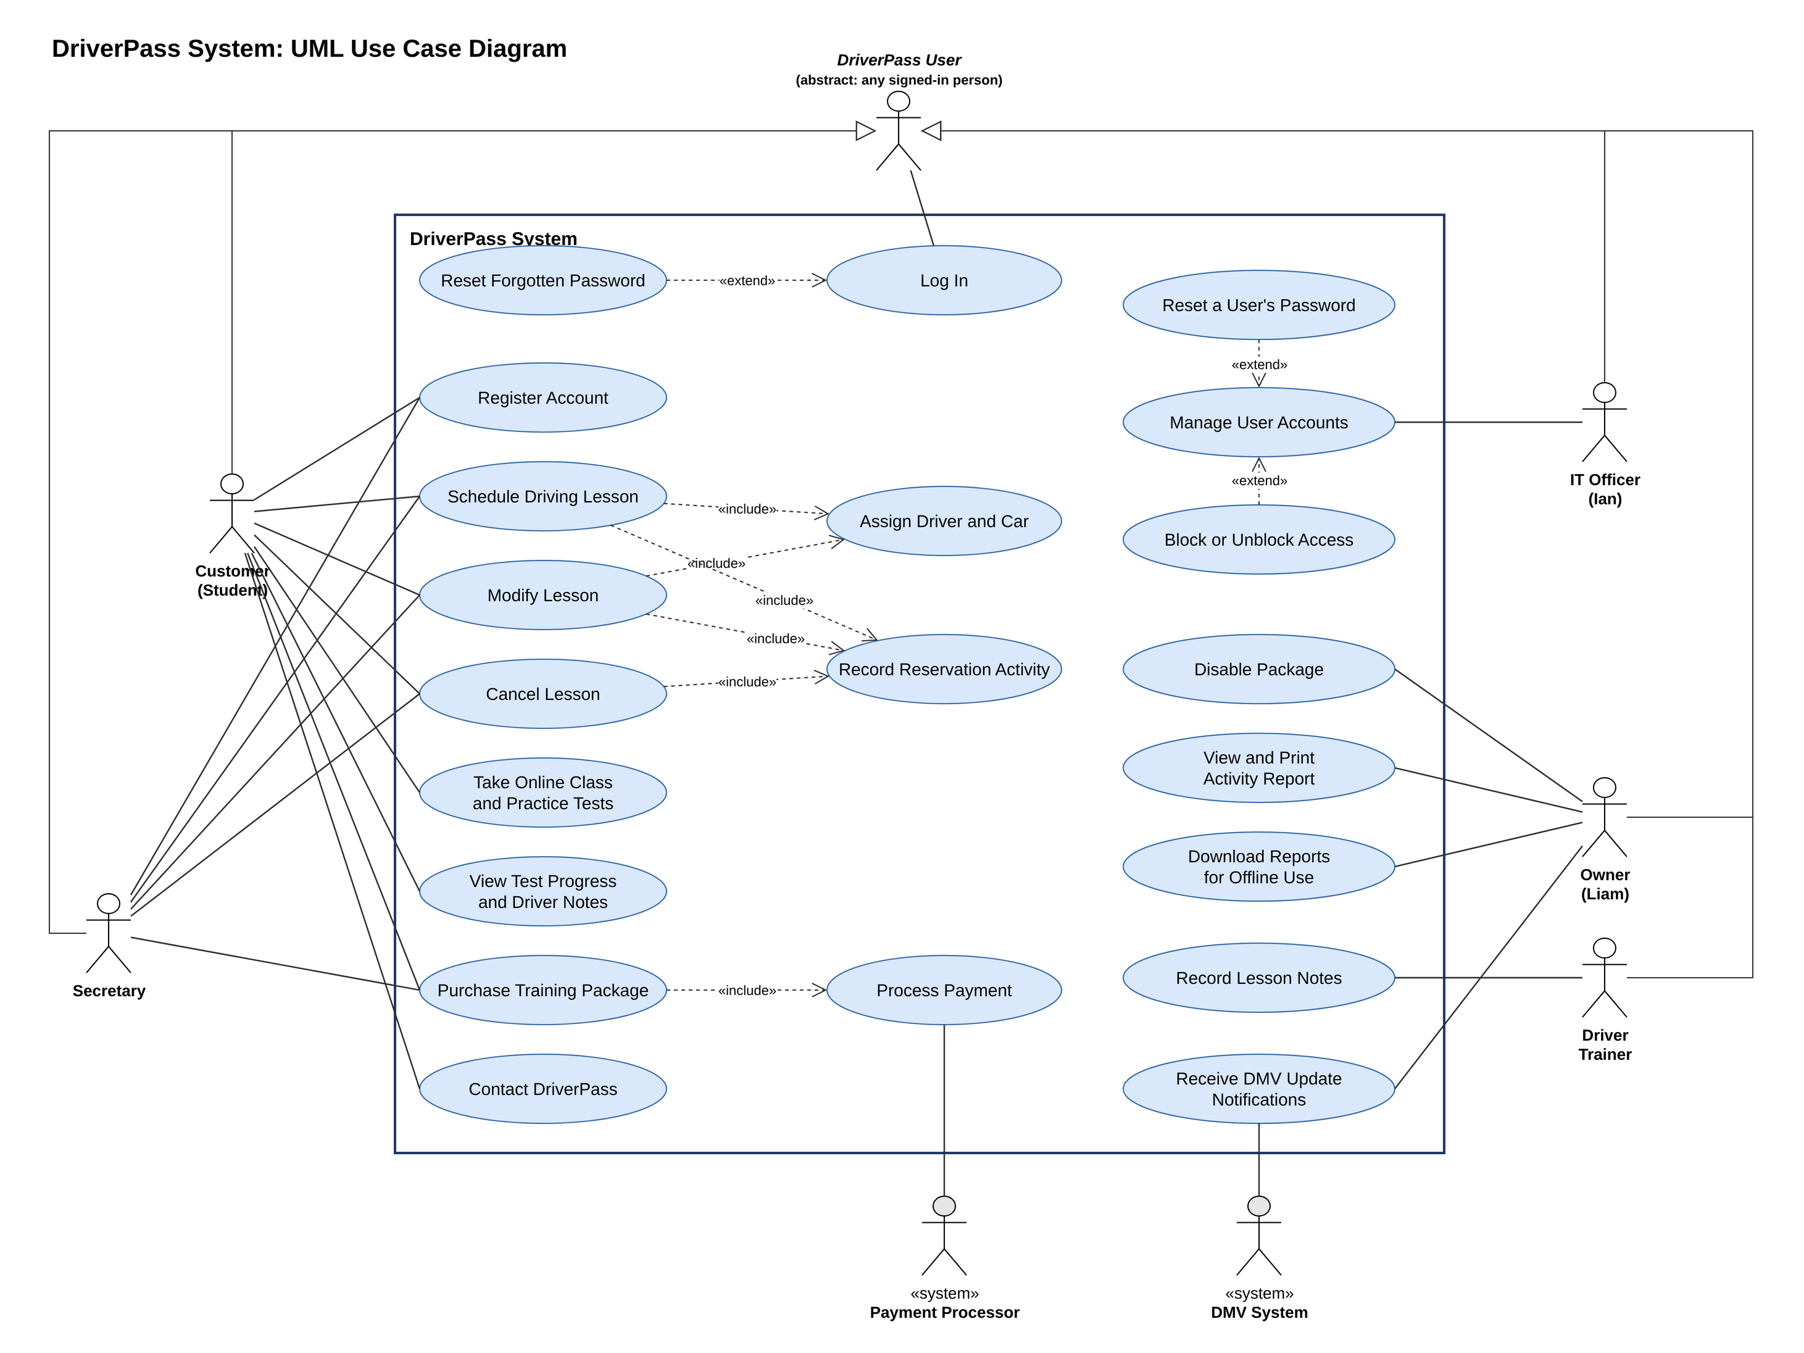
Figure 1. DriverPass UML use case diagram (created in draw.io; the .drawio source imports into Lucidchart).

UML Activity Diagrams
I chose two use cases that are central to the DriverPass business: scheduling a driving lesson and registering a customer account. Each diagram uses swimlanes to show who performs every step, a solid start node and bullseye end nodes, rounded action boxes, decision diamonds with guard conditions in square brackets where the flow branches, and merge diamonds where the flow loops back to an earlier step.
Activity Diagram 1: Schedule a Driving Lesson. The person booking, either a customer online or the secretary during a phone call, logs in, and the system verifies the credentials. Invalid credentials return the user to the login step with an error message and a password reset link. After a successful login, the user selects Schedule a Lesson, and the system checks whether the customer's package still has driving hours left. If no hours are left, the system prompts the customer to purchase a package and the flow ends. Otherwise, the system shows open dates and two-hour time slots, the user picks a date, time, and pickup location, and the system searches for an available driver and car. If none is free, the system suggests other times and the user chooses again. Once a driver and car are found, the system reserves the slot, assigns the driver and car, records who booked the lesson and when in the activity log, and sends a confirmation by email and text message.
Activity Diagram 2: Register a Customer Account. Registration can start online or during a phone call with the secretary. The system displays the registration form and lists only the packages that the owner has left enabled. The customer or secretary enters the customer's name, address, phone number, state, and email, followed by the pickup and drop-off locations, the chosen package, and the card number, expiration date, and security code. The system checks that every required field is complete and valid. If anything is missing, it highlights those fields and the flow returns to the data entry steps. Valid card details go to the payment processor. A declined card returns the user to the card entry step, while an approved payment lets the system create the account, keep only a secure token instead of the full card number, assign the Customer role, record the registration in the activity log, and send a welcome email with a link to set a password.

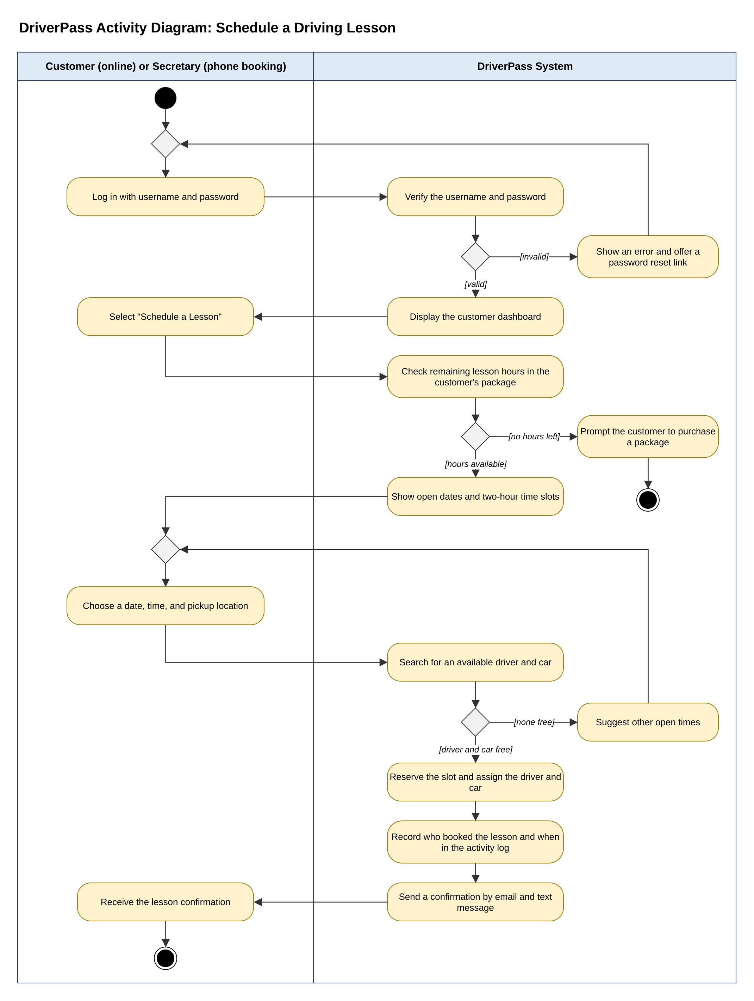
Figure 2. Activity diagram for scheduling a driving lesson.

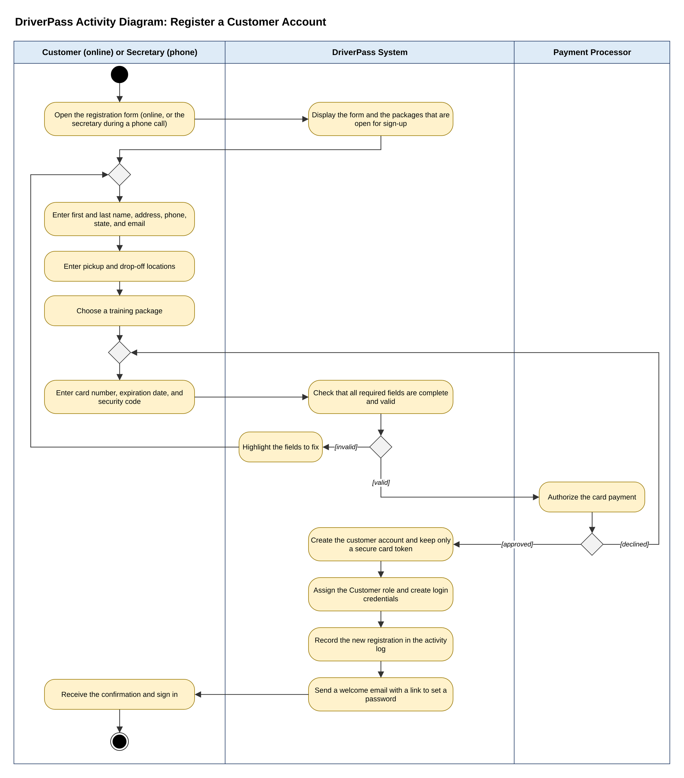
Figure 3. Activity diagram for registering a customer account.

UML Sequence Diagram
The sequence diagram breaks the Schedule a Driving Lesson use case into the messages exchanged over time between five objects: the customer, the DriverPass app (web or mobile), the scheduling service that applies the business rules, the database, and the notification service. Solid arrows with filled heads are synchronous calls, dashed arrows are return messages, and solid arrows with open heads are asynchronous messages. Activation bars show when each object is busy.
After the app asks the scheduling service how many hours remain in the customer's package, an alt fragment splits the flow. If no hours remain, the app prompts the customer to purchase a package. If hours remain, the app retrieves the open slots, the customer chooses one, and the scheduling service saves the appointment with its driver and car, writes an activity log entry, and asks the notification service to send a confirmation. Because the notification service works asynchronously, the customer sees the confirmation on screen right away while the email and text message are sent in the background.
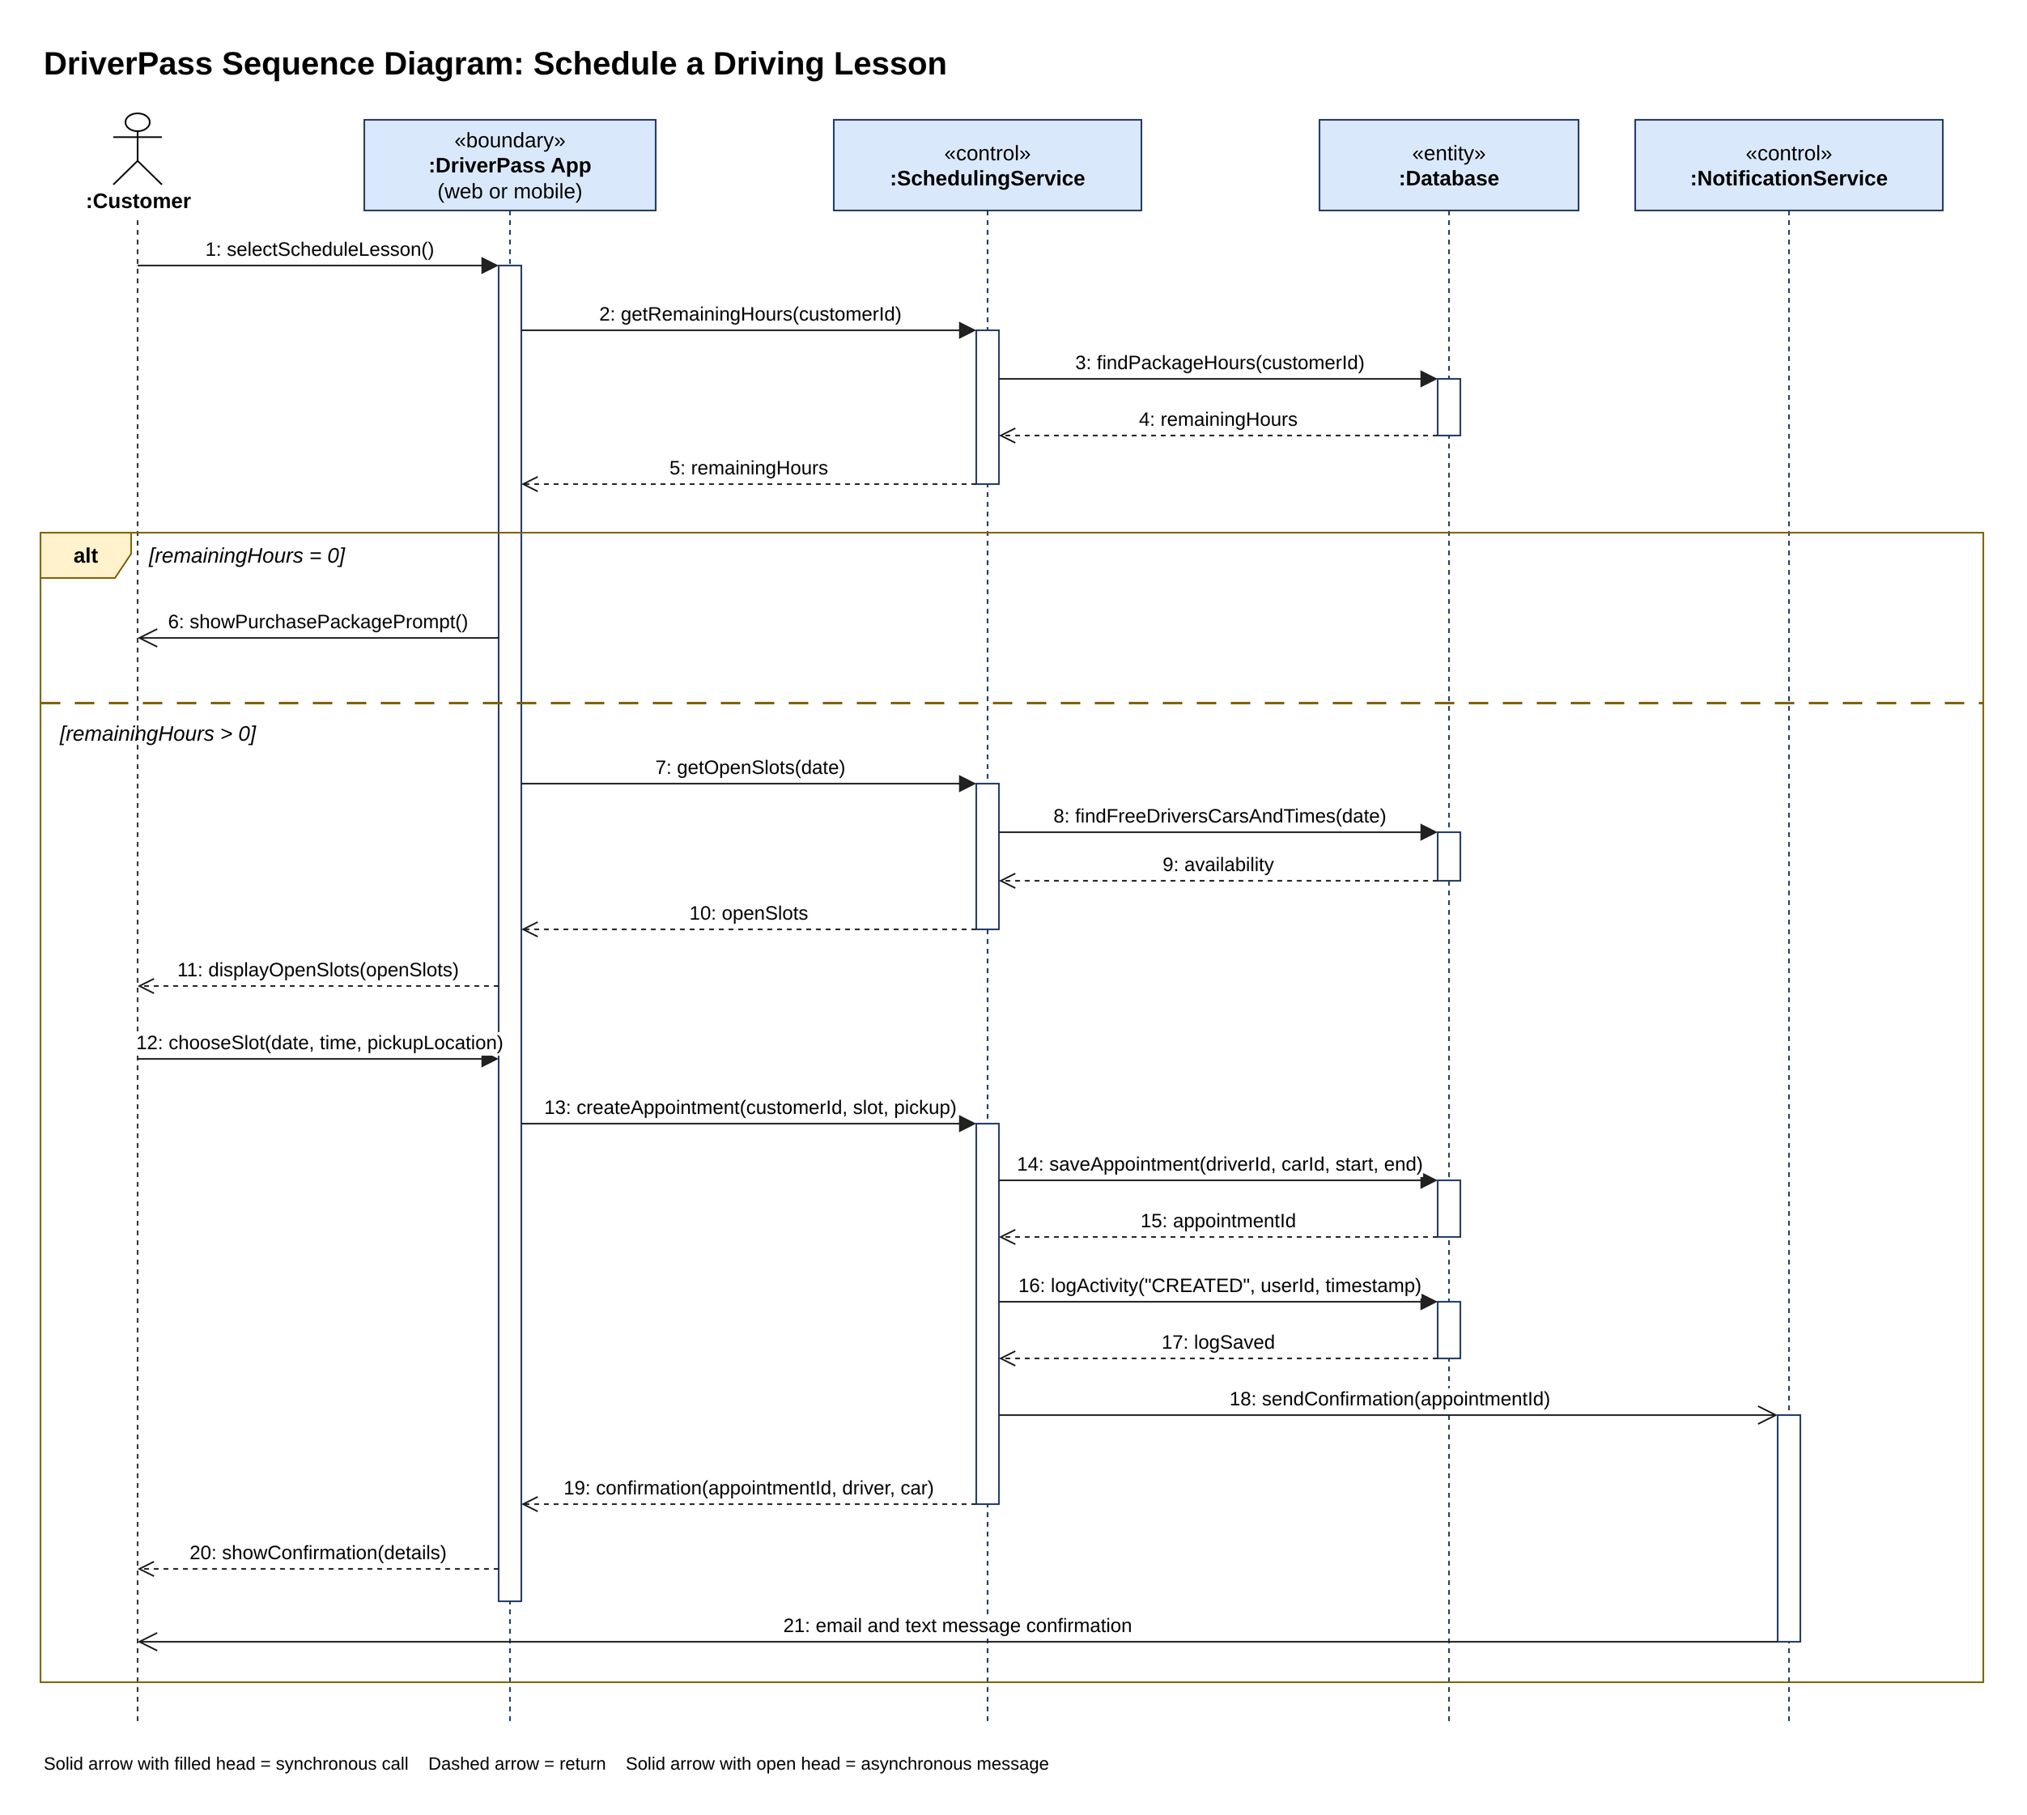
Figure 4. Sequence diagram for scheduling a driving lesson.

UML Class Diagram
The class diagram shows the main classes in the DriverPass system, their attributes with data types, their key operations, and the relationships among them. A minus sign marks a private attribute and a plus sign marks a public operation. User is an abstract class that holds the information every person needs to sign in, including a role used for role-based access and an isActive flag that the IT officer can turn off to block access. Customer, Secretary, ITOfficer, Owner, and DriverTrainer inherit from User.
A customer makes zero or more payments, and each payment pays for exactly one package. The isEnabled attribute on Package lets the owner disable a package. A customer books zero or more appointments, and each appointment links one customer, one driver trainer, and one car, which meets Liam's need to track which student is matched with which driver, car, and time. Each driver trainer drives one car. An appointment can own one lesson note (shown with a filled diamond for composition) that stores the lesson date, start hour, end hour, and driver comments for the Driver Notes section. TestAttempt records each practice test with its time taken, score, and status, and DMVUpdate keeps the online tests current. ActivityLog records every action a user performs, such as creating, modifying, or canceling an appointment. Enumerations define the allowed values for roles, appointment statuses, and test statuses (not taken, in progress, failed, and passed).

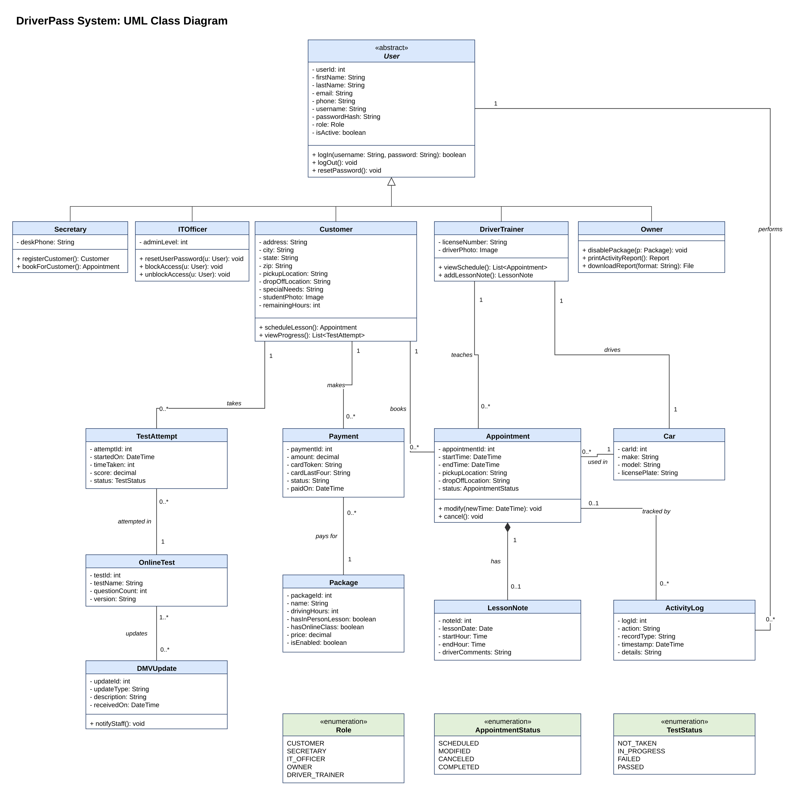
Figure 5. DriverPass UML class diagram.

Technical Requirements
The diagrams above describe a system that customers, staff, and drivers will use from computers and phones, that must protect personal and payment information, and that must stay current with DMV requirements. Ian asked for a cloud-based system so that DriverPass does not have to manage its own backups or security. The requirements below cover the hardware, software, tools, and infrastructure needed to build and run that system.

Hardware
Servers. DriverPass will not buy or maintain physical servers. The application will run on virtual servers from a cloud hosting provider such as Amazon Web Services (AWS). At launch, two application servers (for example, two virtual CPUs and 8 GB of memory each) placed behind a load balancer in separate data centers are enough for a business with 10 cars and a growing student base, and the provider can add capacity automatically during busy periods. A managed database server with solid-state storage and an automatic standby copy will hold the data.
Client devices. Customers, staff, and drivers will use devices they already own. The web application must work on desktop and laptop computers running current versions of Windows or macOS, and on iOS and Android smartphones and tablets. Each driver trainer needs a smartphone or tablet to view the schedule and enter lesson notes. The office needs at least one computer for the secretary, a phone line for booking calls, and a printer so Liam can print activity reports.
Network. Every user needs a reliable broadband or mobile data connection. Because records can only be changed while online, the office connection should be dependable, and a mobile hotspot is recommended as a backup.

Software
Front end. A responsive web application built with HTML5, CSS, and JavaScript using a framework such as React. Responsive design lets the same pages fit desktop and mobile screens, so customers can book lessons from any device. The pages include the customer dashboard from Liam's sketch (online test progress, personal information, driver notes, special needs, and driver and student photos), the registration form, the scheduling pages, a contact page, and staff pages for account management and reports.
Back end. A web application programming interface (API) built with a mainstream framework such as Java with Spring Boot or C# with ASP.NET Core, running on a Linux server operating system. The back end holds the business rules shown in the diagrams: two-hour lessons, package hour limits, driver and car matching, role permissions, and activity logging.
Database. A relational database such as PostgreSQL or MySQL, hosted as a managed service such as Amazon RDS, with tables that follow the class diagram. A relational database fits because reservations depend on accurate, connected records of customers, drivers, cars, and times, and database transactions prevent two customers from booking the same driver and car at the same time.
Browsers. Current versions of Google Chrome, Microsoft Edge, Mozilla Firefox, and Apple Safari on desktop and mobile devices.
Reports and offline access. Reports and activity logs can be exported as Excel, CSV, or PDF files so Liam can download them and work offline. Downloaded files are read-only copies. Changes are made only while online, which prevents duplicate or conflicting data.
Notifications. An email service and a text messaging service (for example, Amazon Simple Email Service and Twilio) send booking confirmations, password reset links, and DMV update alerts.

Tools
Design and modeling. Lucidchart or draw.io for the UML diagrams, and Microsoft Office for documentation and client presentations.
Development. An integrated development environment (IDE) such as IntelliJ IDEA or Visual Studio Code, Git for version control with a hosted repository such as GitHub, and a continuous integration pipeline such as GitHub Actions that runs automated tests before each deployment.
Database tools. A database management tool such as pgAdmin or MySQL Workbench for designing tables, running queries, and checking data.
Testing. Unit testing frameworks such as JUnit, browser testing tools such as Selenium or Cypress, and Postman for API testing. Testing must cover different browsers and screen sizes.
Project management. A task tracking tool such as Jira or Trello to manage the work against the project schedule.

Infrastructure
Cloud hosting. AWS, or a comparable provider such as Microsoft Azure, hosts the application, database, and file storage. This meets Ian's request that DriverPass not handle backups and security on its own.
Availability and performance. A load balancer spreads traffic across the application servers, and automatic scaling adds servers when demand rises. The target is at least 99.9 percent availability, with pages loading in under three seconds on a typical connection.
Backups and recovery. The managed database takes automatic daily backups with point-in-time recovery, keeps backups for at least 30 days, and copies data to a standby in a second location. Driver and student photos and exported reports are kept in durable cloud storage such as Amazon S3.
Security. All traffic uses HTTPS with Transport Layer Security (TLS) 1.2 or higher, and stored data is encrypted. Passwords are stored only as salted hashes. Role-based access control limits each user to the functions of their role. The IT officer can reset passwords and block accounts, accounts lock temporarily after five failed login attempts, and customers can reset their own passwords through an emailed link. A web application firewall filters malicious traffic.
Payments. Card payments go through a payment processor that meets the Payment Card Industry Data Security Standard (PCI DSS), such as Stripe or Square. DriverPass stores only a token and the last four digits of each card, never the full card number or security code.
DMV integration. A secure connection to the DMV, through an API or data feed if the DMV provides one, delivers new rules, policies, and sample questions. The system checks for updates on a schedule, stores each update, refreshes the online tests, and notifies the owner.
Activity logging and monitoring. Every create, modify, and cancel action is logged with the user and a timestamp, and regular users cannot edit the logs. Cloud monitoring tools alert the IT officer to outages or unusual activity.
Together, these choices give DriverPass a system that customers can reach from any device, that keeps personal and payment data protected, and that leaves backups, scaling, and server maintenance to the cloud provider. This lets Liam and Ian focus on running the business, as they requested in the interview.

