clear all;close all;

fm=1000;

t_step=1/(1000*fm);

t_step_one=1/(5*fm);

t=t_step:t_step:1/fm;

t1=t_step_one:t_step_one:1/fm;

v=sin(2*pi*fm.*t);

v1=sin(2*pi*fm.*t1);

subplot(3,1,1);

plot(t,v);

subplot(3,1,2);

plot(v);

subplot(3,1,3);

plot(v1);

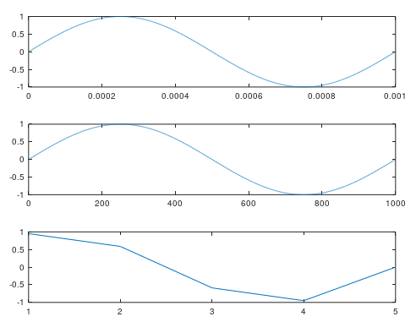

clear all;close all;

fm=10^3;

t_step=1/(10^3*fm);

t=t_step:t_step:1/fm;

v=sin(2*pi*fm*t);

sample_rate=20;

fs=sample_rate*fm;

pw=20;

size_vv=size(v,2);

p=[];

for i=1:1:round(fs/fm)

p=[p zeros(1,round(size_vv/sample_rate)-round(pw)) ones(1,round(pw))];

endfor

vp=v.*p;

subplot(3,1,1);

plot(t,v);

subplot(3,1,2);

plot(t,p);

subplot(3,1,3);

plot(t,vp);